Name: Ishrat Nasar
Student Number: 2508311
Module Code and title: The Research process
Lectures name: Justin Okli
Assignment title: How dose late diagnosis in autism affect a child’s mental health?

How does late diagnosis in autism affect a child’s mental health?

Introduction
Autism is a developmental condition present from birth and not immediately visible. As a result, many cases go undetected or undiagnosed during early childhood. While children with autism may display behaviors such as hyperactivity or challenges in social interaction, these signs are frequently misinterpreted as misbehavior, especially within school settings. Despite receiving trained teachers may struggle to identify hidden disabilities like autism. (WHO, 2023)
This assignment explores concerns within the care system, focusing on the barriers to early diagnosis and support. The research highlights the challenges faced by both parents and children when hidden disabilities remain unfamiliar, and the implications of delayed intervention.

Task 1
Autism has long displayed challenges within the educational sector and has significantly impacted families over the years. Children with autism may exhibit signs such as hyperactivity and challenging behavior, which are often misinterpreted as deliberate misbehavior. This misunderstanding can make it difficult for parents to manage their child's needs, and in many cases, social services become involved.
However, support from social services is often limited, leaving families without enough help or resources. Despite ongoing training and awareness, both education and social care systems have previously overlooked the importance of early diagnosis. Miscommunication between multi-agency teams further complicates the process, highlighting a critical need for improved collaboration and investigation into current practices.
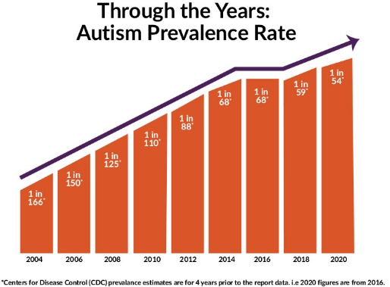
Between 2004 and 2020, there has been a 10% increase in diagnosed cases of autism (refs). This rise has significantly affected the educational experiences of autistic children and young people, many of whom have missed vital learning opportunities due to poor support systems.
A 2025 report by Lasota highlights that “Government statistics provide only a narrow view of this issue, but the reality is striking: our research found nearly three-quarters (71%) of autistic pupils experience some form of lost learning through official and unofficial mechanisms, whether they are physically in or outside school.” This lost learning can occur through exclusions, absences, or lack of tailored educational provision.
I have chosen this report as it highlights the consequences of lost learning extend beyond learned achievement. Autistic pupils may experience delays in developing social and communication skills. When misunderstood, they may become agitated, leading to emotional outbursts. These reactions vary some children may display disruptive behavior, while others may withdraw and remain quiet. Such challenges can result in school avoidance and place additional strain on families, with parents often unfairly judged based on their child’s behaviors.
Early detection of autism is crucial. Without timely diagnosis and appropriate interventions, children are denied access to personalised learning curriculum that meets individual needs. This can have long-term effects, impacting their educational progress well into adolescence and limiting future opportunities.
There is also an issue in the lack of coordination between schools and social services. Communication barriers between these organisations delay the development support plans, leaving many autistic pupils without the consistent care they require. Addressing these gaps is essential to ensure that all children receive fair access to education and support.
Nursing Direct issued two reports between 2004 and 2005 highlighting significant challenges faced by autistic children in the education system. The reports stated: “Education is another battleground, with three-quarters of parents believing their autistic children’s school places do not meet their needs. Many families wait years for support or are forced into SEND Tribunals, where most cases favor parents, exposing systemic failures. Meanwhile, over 200,000 people await autism assessments, with little support before or after diagnosis.” (Nursing Direct, 2005)
This Report shows issues within the education and healthcare systems. Time delays and financial budgets continue to delay access to appropriate schools and support services. Despite the growing awareness of autism and its impact on learning, many children and young people still face delayed waits for assessments.
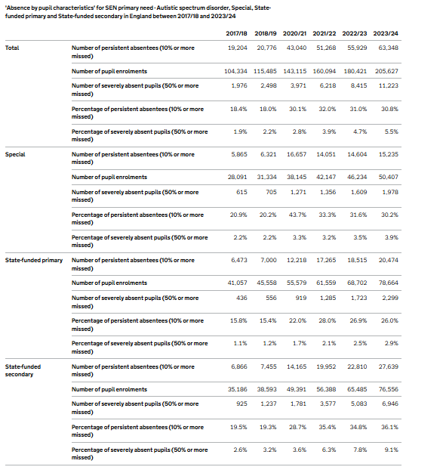
The have chosen this report as it shows the importance of early identification through Special Educational Needs and assessments. Without these measures, children are denied timely access to education that meets their individual needs. The fact that it has taken over 15 years to begin addressing these barriers reflects the scale of failure.

Task 2
An NHS Data revealed the following data:

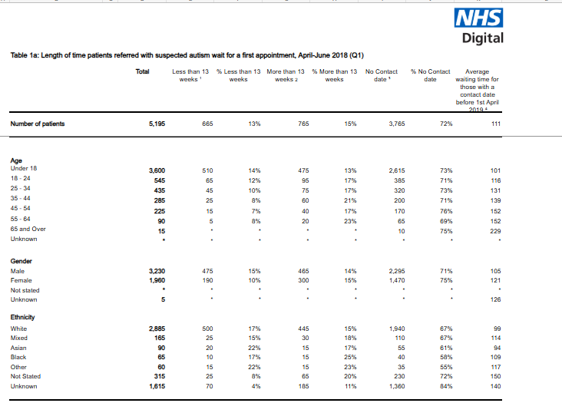
Autism Statistics - NHS England Digital Accessed: 11/09/2025.
The report indicates that referrals took up to 91 days to be submitted approximately three months. During this period, the NHS did not contact 3,765 patients. Notably, 72% of children and young people aged 0–18 was still awaiting initial contact, highlighting a significant delay in service delivery during the first quarter. In comparison, data from Quarter 4 (October to December) reveals that by the end of the year, 5,040 patients equivalent to 77% were still awaiting referral. This marks a significant increase in pending cases and reflects a doubling in the number of children without an autism diagnosis, indicating a worsening backlog in assessments and service access.
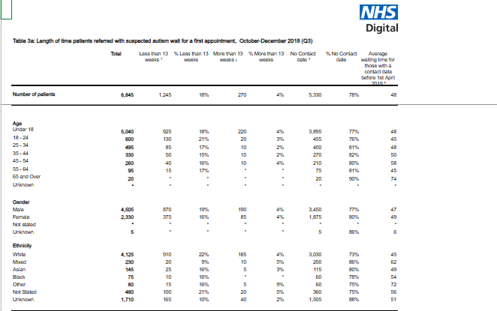

Autism Statistics - NHS England Digital Accessed: 11/09/2025.
I researched case studies of children navigating school without adequate support, as well as interviews published by the British Educational Research Journal.
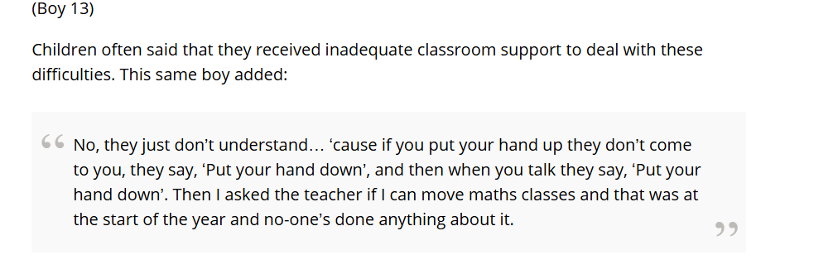
School experiences of Children in Need: Learning and support - Berridge - 2021 - British Educational Research Journal - Wiley Online Library Accessed: 11.09.2025.
This interview showed that young people wanted to be heard and despite the school being aware of that the child needed additional needs.

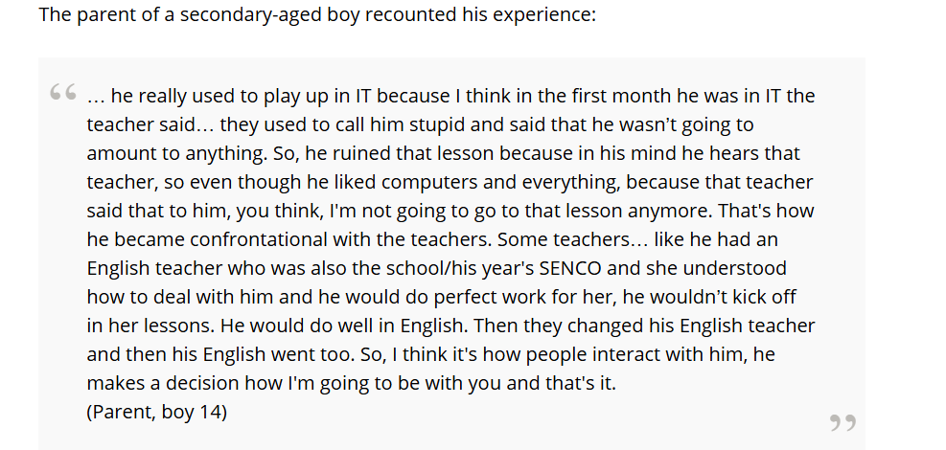
School experiences of Children in Need: Learning and support - Berridge - 2021 - British Educational Research Journal - Wiley Online Library Accessed: 11/09/2025.
A parent's insight revealed that her child received meaningful support when a trained SENCO understood how to engage with them effectively. Interviews indicated that children awaiting diagnosis or those without one faced greater challenges compared to those who had been diagnosed and were receiving appropriate support.
The National Autistic Society shared interviews with diagnosed children, highlighting how diagnosis positively impacted their development. It supported their emotional, social, and intellectual growth, and access to a tailored curriculum helped them achieve more in school and better understand themselves.

Task 3:
Primary data is collected directly by the researcher to explore a specific topic. Methods such as case studies, interviews, and focus groups are commonly used. This type of data is highly relevant to the chosen research area, as it provides direct insights. However, collecting primary data can be time consuming and requires careful planning.
Secondary data refers to information previously gathered by other researchers. It can be sourced from books, online databases, archived files, and official reports. This data offers valuable context and background, helping to identify trends and support findings.
For this study on how late autism diagnosis affects a child’s mental health, I have chosen a mixed-methods approach.
Primary data will be used to capture personal experiences through interviews, helping to uncover the real emotional and psychological challenges faced by children and families. This approach ensures that the research reflects authentic, lived experiences that are often missing from statistical reports.
Secondary data will help analyse the historical and systemic impact of autism diagnosis. Reviewing past studies and official records such as NHS data can reveal patterns in diagnosis delays and highlight the long-term effects on mental health.
For example, NHS reports from 2018 to 2025 indicate a significant number of children and young people are still awaiting diagnosis. This underscores the need for improved support systems, which secondary data can help identify.
By applying both types of data, this methodology ensures a balanced and insightful exploration of the issue, combining emotional depth with practical evidence.

Conclusion
My findings demonstrate that autism is now widely recognised as a neurodiverse condition. However, when autism goes undetected, it can have long term effects on a child’s development, mental health, and overall family life. The research highlights that many children and families have been let down by multi-agency systems, where delayed diagnoses have contributed to ongoing emotional and psychological challenges.
It is essential that children’s behavior and developmental patterns are monitored closely to identify potential special educational needs early. Agencies must collaborate effectively to ensure that tailored educational support is provided and that diagnoses are delivered promptly. Timely intervention, coupled with appropriate family support, is critical to improving outcomes and safeguarding the wellbeing of children and young people affected by autism.
Multi agencies such as schools, social services and NHS England need to improve communication to safeguard children and protect their mental health and wellbeing.

References

Southwest Autism Research & Resource Center. Prevalence of Autism Increases by 10% to 1 in 54 Children. Autism Center, 26 Mar. 2020, https://autismcenter.org/prevalence-autism-increases-10-1-54-children. Accessed 11/03/2025.

Ambitious About Autism. When Will We Learn: Lost Learning Report. Ambitious About Autism, 2021, https://www.ambitiousaboutautism.org.uk/sites/default/files/files/ambitious-about-autism-when-will-we-learn-lost-learning-report.pdf. Accessed 11/03/2025.
Nursing Direct. (2025). Autistic people struggle amid broken support systems, report finds. [online] Nursing Direct. Available at: https://www.nursingdirect.co.uk/news/news/autistic-people-struggle-amid-broken-support-systems-report-finds [Accessed 3 Nov. 2025].
Learning Disability Today. (2023, November 2). Autistic children and young carers are missing too much school. Learning Disability Today. https://www.learningdisabilitytoday.co.uk/news/autistic-children-and-young-carers-are-missing-out-on-too-much-school/

The learning disability today charity informs us that department of education issued a report showing how 11,200 children pre-diagnosed or diagnosed with autism were absent from school.
I have chosen this to support my research as it indicates real time data produced by the government.

“If the Government is serious about tackling what it calls an absence epidemic, it needs to recognize why children & young people are missing so much school. Autistic children and young carers are missing out on too much school - Learning Disability Today accessed 11/03/2025.
Autism Statistics - NHS England Digital Accessed: 11/09/2025.

