Amgylcheddau Dysgu Amgen

Alternative Learning Environments

ECES5014C

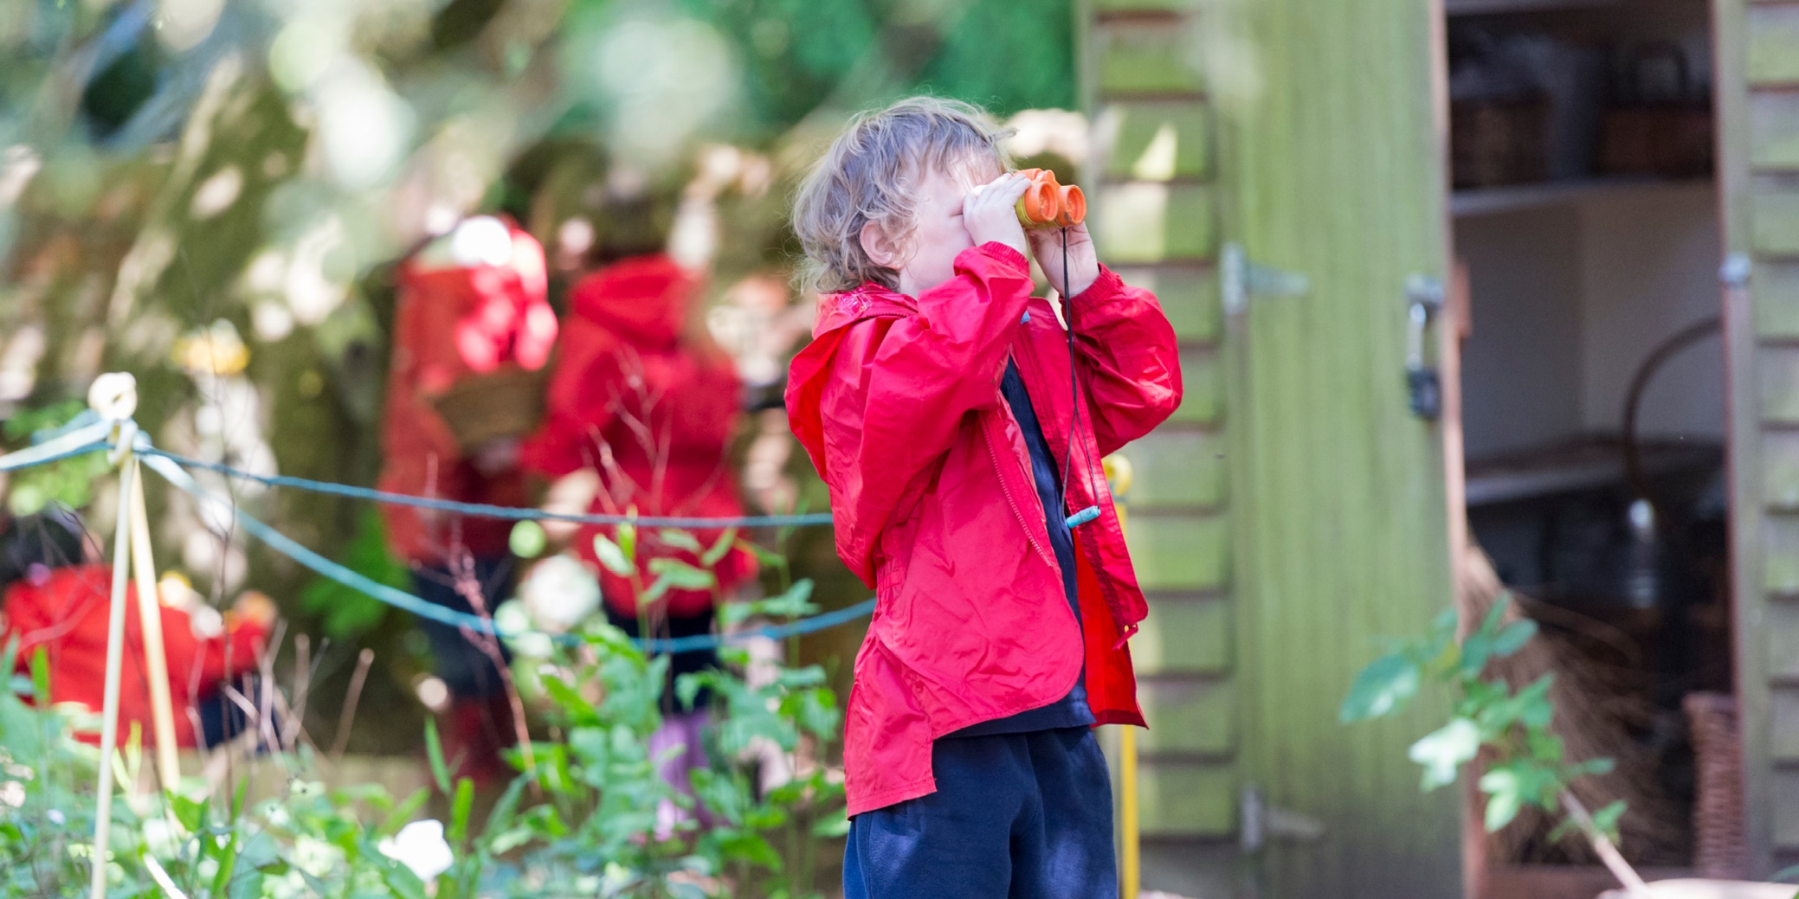

Tiwtoriaid / Tutors:

Helen Griffiths
helen.a.griffiths@uwtsd.ac.uk
Saskia Stocks
1802572@student.uwtsd.ac.uk

AIM(S)

The aims of the module are:
- To critically develop an understanding of a diverse range of alternative education ideas, theories and practices.
- To develop a personal exploration of outdoor and experiential learning and critically compare a range of alternative learning environments.

LEARNING OUTCOMES

Upon the successful completion of this module, the student should be able to:
- Engage with and have a broad and balanced knowledge of the fundamental aims, concepts, values and contexts of experiential learning.

- Reflect upon the role and status of outdoor learning and experiential learning within educational policy and practice.

- Develop imaginative and innovative approaches to schooling, curriculum, assessment, the classroom and other learning and teaching materials.

Teaching and Learning Strategy
The module aims to maintain a balance between the theory and practice of education through a range of strategies. Discussion, lecture, group work and self-directed study are used to meet this need. Tutorials also give the students the opportunity to discuss relevant issues and to gain individual, formative feedback regarding their work and assignment.
The sessions for this module will consist of face to face lectures, synchronous learning and asynchronous activities. The lectures will give students the opportunity to develop the skills of careful listening, reflecting, summarising and analysing. They will cover the major theories, debates and areas of research critical to the module.
The tasks and reading provided need to be completed in order to support your knowledge and understanding of the topics covered in this module. It is vitally important that students study the reading and complete these tasks as they will be used in the seminar. The strategies in this module have been selected on the basis that they will not only help you to learn but provide models for different approaches to learning.

Teaching and Learning Tools

Moodle
This is our central repository for all module materials you will need for this module. Please ensure that you check this regularly.
Microsoft Teams
This is the platform we will use to support your online learning with us. All students have access to Teams as part of their Office 365 student subscription and module tutors will allocate you into a team ahead of you beginning your studies with us on the module. We will use this primarily for any synchronous online teaching sessions as well as for any online tutorials or additional apps we would like you to have access to. We may also use the chat function of Teams to communicate with you and we also encourage you to use this as a way of peer support also.

MODULE SCHEDULE

Wythnos | Sesiwn | Pwnc | Topic
1 | 1 | Cyflwyniad ac Asesiad | Introduction and Assessment
 | 2 | Pan nad yw ysgol yn ysgol | When school isn’t school
 | 3 | John Holt | John Holt
2 | ASYNCH | Darlleniadau: Gweler Moodle | Readings: See Moodle
 | 4 | John Taylor Gatto | John Taylor Gatto
 | 5 | Dysgu Awyr Agored | Outdoor Learning
 | 6 | Dysgu Awyr Agored - campws | Outdoor Learning - campus
3 | ASYNCH | Freire: Gweler Moodle | Freire: See Moodle
 | 7 | Ysgolion Amgen | Alternative Schools
 | 8 | Ysgol Goedwig/Taith Coedwig a Thraeth | Forest School/Forest and Beach Visits
 | 9 | Tiwtorialau | Tutorials
 | ASYNCH | Asesu Dysgu Awyr Agored: Gweler Moodle | Outdoor Learning Assessment: See Moodle

Please note: All materials for the sessions will be available via Moodle (Please familiarise yourself with these before and after each session), online teaching sessions will take place via TEAMS

MODULE ASSESSMENT

PORTFOLIO:

Assessment Component 1 – 100%

Equivalent to 4000 words

- Portfolio – (4000 words equivalent)

- Critically evaluate up to 6 different activities to develop learning in alternative learning environments.
- You should support your arguments with a diverse range of ideas, theory and professional practice.

- Consider a relevant presentation for your portfolio. You can use sections, sub-headings, tables, diagrams, bullet points etc where suitable but not too often.

- Suggested structure

- Front cover page

- Table of contents

- Introduction and overview
- Introduce the topic (set the scene). Discuss what will be included in your portfolio. What is the main aim of your portfolio? Include any relevant background information relating to the activities that you will include.

- An analysis of terminology for any key terminology that you will be using in your portfolio e.g. ‘experiential learning’, ‘alternative learning environment’….

- Consider different definitions using a range of relevant scholarly texts and policy documents to support your argument.

- A critical analysis of up to 6 different activities to promote learning within an alternative learning environment/s. It is important that you make robust links between theory, policy and practice throughout your work.

- Conclusion

- Reference List

Reading:

It is important to remember that you are reading for a degree in education. The more you read, the more the concepts and ideas will make sense to you. Teaching sessions are not exhaustive; they are designed to provide you with an insight into a particular aspect of the topic and will not give you all the answers. It is up to you as a student to maximise your learning experience by reading around the subject in addition to regular attendance in class.
In addition to this, you may be asked to come to sessions having read particular material or having undertaken certain tasks. When this occurs, it is essential that this is done.

INDICATIVE READING LIST

Module Code | ECES5014C
Module Title | Amgylcheddau Dysgu Amgen / Alternative Learning Environments
Classification | Reading List entry | Electronic*
Essential | Carnie, F. (2017) Alternative Approaches in Education: A guide for teachers and parents. Abingdon: Routledge | ☒
Essential | Parry, J. and Allison, P. (2016) Experiential Learning and Outdoor Education. London: Routledge | ☒
Essential | Rosaleen, J. (2012)Outdoor Learning: Past and Present. Berkshire: Open University Press | ☒
Further | Freire, P., (2004) Pedagogy and Hope: Reliving Pedagogy of the Oppressed. London: Routledge | ☐
Further | Knight, S. (2011) Risk and Adventure in Early Years Outdoor Play : Learning from Forest Schools. London :SAGE, 2011 | ☐
Further | Knight, S. (2011). Forest School for All. London: SAGE Publications | ☐
Further | Neill, A.S. (1960) Summerhill: A Radical Approach to Child-Rearing. Oxford: Hart. | ☐
Further | Wilson, R. (2011) A. Nature and Young Children : Encouraging Creative Play and Learning in Natural Environments. 2nd ed. Abingdon: Routledge | ☒
Further | Woods,P. and Woods, G. Alternative Education for the 21st Century Philosophies, Approaches, Visions. 1st ed. London: Palgrave | ☒
Further | Becker, P., Humberstone,B.,Loynes,C and . Schirp. J (2018) The Changing World of Outdoor Learning in Europe. London: Routledge, | ☒
Further | DCELLS (2009) Foundation Phase Outdoor Learning Handbook, Cardiff: WAG also available online at http://learning.gov.wales/resources/collections/foundation-phase?lang=en | ☒
Further | Wales: Welsh Government (2015) Wellbeing of Future Generations Act (Wales) 2015. Cardiff: HMSO. Available at http://gov.wales/topics/people-and-communities/people/future-generations-act/?lang=en | ☒

