

Master of Business Administration
International Business pathway

Designing a Human Capital Architecture for Strategic Renewal (Helios Urban Mobility (HUM))
Assessment 1: Individual report. Weight: 50%

Module name: Human Capital Management
Module code: LCMB7023
Lecturer name: Dr Lakshani Mendis

Student name: Chahil Maheshbhai Italiya
Student ID: 2535771

Word count: Approx.2500
Submission date: 15th July 2026

Table of Contents
1. Task A 2
1.1 Traditional Onboarding vs Strategic Organisational Socialisation 2
1.1.1 The Van Maanen and Schein Tactics Framework 2
1.1.2 Psychological Contract Theory 3
1.1.3 Identity Construction Theory 5
1.2 A Structured Socialisation Framework for Helios 5
1.2.1 Phase One 5
1.2.2 Phase Two 6
1.2.3 Phase Three 7
1.2.4 Justification 7
1.3 Mechanisms for Cultivating Identity, Ethics and Activism 7
1.3.1 Organisational Identification 7
1.3.2 Ethical Professionalism 7
1.3.3 The Business Activist Mindset 8
2. Task B 9
2.1 Helios's Engagement Position 9
2.2 An Innovative Job Design Strategy 10
2.2.1 The Job Characteristics Model 10
2.2.2 Job Crafting 11
2.2.3 Skills-Based Architecture and Internal Talent Marketplace 12
2.3 Stimulating Intrinsic Motivation and Supporting Innovation 13
2.3.1 How the 3 Layers Interact 13
2.3.2 Impact on Retention 13
2.3.3 Impact on Innovation 13
2.3.4 Recommended Implementation Sequence 13
3. Task C 14
3.1 Reflective Report 14
References 16

1. Task A

1.1 Traditional Onboarding vs Strategic Organisational Socialisation
Helios's 8-month ramp-up period indicates a category error typical of fast-scaling businesses: viewing "onboarding" as an administrative HR event rather than a socialization process (Bauer and Erdogan, 2010).

1.1.1 The Van Maanen and Schein Tactics Framework
The fundamental lens here is still Van Maanen and Schein's (1977) tactics framework. They distinguish 6 bipolar dimensions, collective/individual, formal/informal, sequential/random, fixed/variable, serial/disjunctive, and investiture/divestiture. They argue that institutionalised tactics (collective, formal, sequential, serial, investiture) produce custodial role orientation and predictable conformity, whereas individualised tactics (informal, random, disjunctive, divestiture) produce innovative role orientation but higher anxiety.
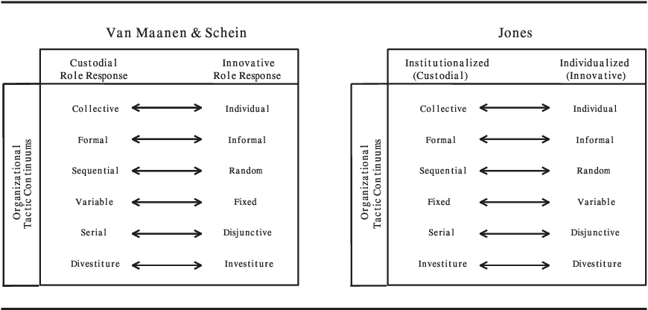
Source: https://doi.org/10.1177/1534484302011004
Outcomes are determined by the combination of tactics, not just the program's existence. Socialization tactics employed in onboarding programs have been demonstrated to influence newcomer work engagement and wellbeing through mechanisms like job embeddedness and perceived organizational support (Costa and Rodrigues, 2025; Callaghan and Collins, 2023).
Didion et al.'s (2024) bibliometric mapping of more than 450 studies confirms that this field has developed well beyond orientation checklists into five active research fronts, including psychological contracts, network formation, and changing work contexts (digitization, virtualization). These fronts reflect how organizations around the world are increasingly using onboarding and socialization to address retention and the growing digitization of work.
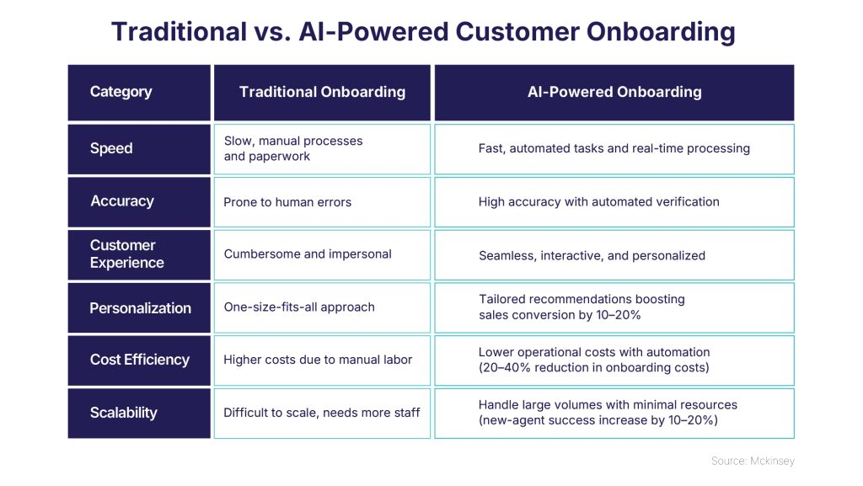
Source: https://www.binarysemantics.com/blogs/automated-customer-onboarding-frictionless-edge-in-insurance/
According to Van Maanen and Schein (1977), traditional onboarding at Helios is probably disjunctive and individualized; new engineers are given laptops and left to "figure it out," with no serial mentorship network. This results in an 8-month "sink or swim" adjustment period instead of the 90-day competency window that best-practice organizations get, which is precisely the failure mode that Helios reports.

1.1.2 Psychological Contract Theory
Beyond productivity, this is expensive, as explained by psychological contract theory (Rousseau, 1989). Implicit expectations of growth, autonomy, purpose, and voice are ingrained in new personnel from the recruitment process. Thin onboarding increases the likelihood of perceived breach since the employer does not actively shape the contract, leaving it to be deduced piecemeal from unclear cues.
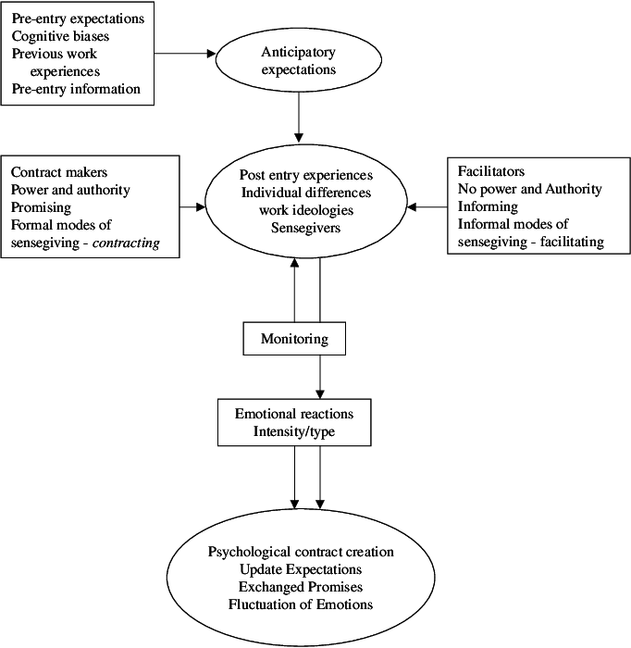
Source: https://www.researchgate.net/figure/A-model-of-psychological-contract-creation_fig1_235318799
Disengagement and voluntary departure are caused by a breach rather than just an unfulfilled expectation (Rousseau, 1989). Because organizational socialization shapes newcomers' expectations, unmet expectations resulting from inadequate onboarding have both short-term and long-term negative consequences for both the individual and the organization (Çlebarska and Soucek, 2020). This is the exact method to target in light of Helios's graduate attrition issue.

1.1.3 Identity Construction Theory
A third layer is added by identity construction theory. Newcomers must balance their pre-entry identity with an evolving organizational identity during socialization, which is an identity shift (Kowtha, 2018). People either "encapsulate" their previous identities (low identification, quick escape) or endure extended liminality (the anxiety and sluggish ramp-up Helios is observing) when this transition is not controlled. In contrast, strategic socialization is not a two-day induction but rather a purposefully designed identity-transition process.
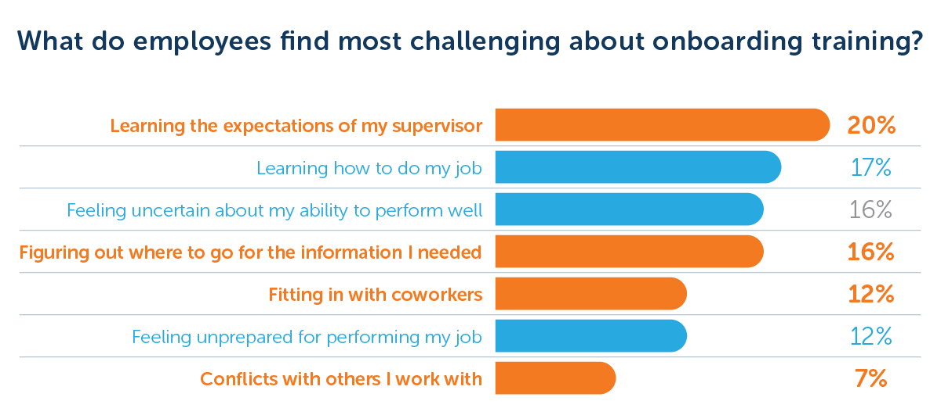
Source: https://www.talentlms.com/blog/new-employee-onboarding-study/
To put it briefly, strategic socialization views socialization as identity and contract formation, whereas standard onboarding views it as knowledge transfer. The former is structurally insufficient for a 450-person, 3-country, quickly expanding company like Helios; it cannot make up for the informal loss of "osmotic" cultural transfer that tiny start-ups depend on.

1.2 A Structured Socialisation Framework for Helios

1.2.1 Phase One
Install a digital "Helios Compass" portal that offers role-specific microlearning, pre-populated 30-, 60-, and 90-day goals that were co-drafted with the recruiting manager, and a designated "cultural buddy" (a peer, not a manager) assigned prior to the start date.
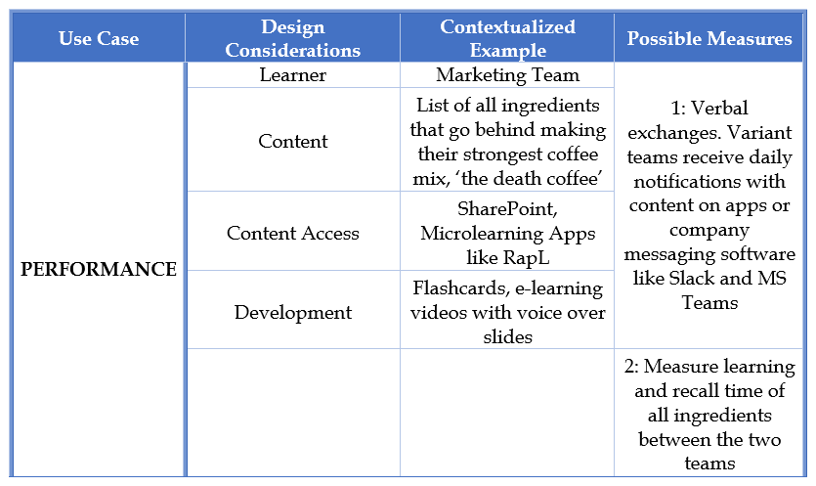
Source: https://getrapl.com/guide/what-is-microlearning-an-in-depth-guide-for-beginners/
AI-based onboarding platforms lessen role ambiguity prior to entry because they further reduce ambiguity, highlighting the significance of structured onboarding, regular mentorship, and feedback loops for successful adjustment (McKinsey & Company, 2025; Olaniyan et al., 2025; França et al., 2025). This reduces the possibility of a later perceived breach by addressing the psychological contract early on and outlining expectations in writing.

1.2.2 Phase Two
This stage should purposefully blend serial tactics (assigned senior mentor) and investiture messaging (explicitly affirming the recruit is existing expertise as valuable, not to be "reset") with collective tactics (cohort induction across London/Berlin/Singapore, creating a pan-regional identity rather than three silo cultures). One HR-owned induction week is replaced by weekly management check-ins (Mitschelen and Kauffeld, 2025; Costa and Rodrigues, 2025).
The biggest lever associated with role clarity and task mastery is consistently found to be structured, consistent mentorship and feedback loops; stronger task mastery, role clarity, job performance, and commitment are all correlated with uncertainty reduction. For example, functional competence and psychological safety by day 90 should be the objective outcome, almost halving the 8-month ramp-up.

1.2.3 Phase Three
Stretch projects, internal mobility taster rotations, disjunctive/individualized elements, and a formal "identity check-in" at months 6 and 12 that evaluates role orientation (custodial vs. innovative) and psychological contract health via pulse survey should be the focus of tactics starting in month 4 (Lapointe, Vandenberghe and Boudrias, 2014; Safitri, 2024).
This tiered sequential-to-individualized design is in line with recent meta-analytic research, which suggests front-loading structure and gradually handing over agency as identification and competence grow.

1.2.4 Justification
Helios's 3 symptoms are specifically targeted by this sequencing. Ramp-up time is shortened by structured first-90-day content; cross-site cohorts and serial coaching foster organizational identity.
Likewise, the 1st year individualization phase lowers early attrition by providing high-potential graduates with autonomy and a clear career path. This is significant since 94% of workers would remain with a company that made clear investments in their professional growth (LinkedIn, 2024).

1.3 Mechanisms for Cultivating Identity, Ethics and Activism

1.3.1 Organisational Identification
It is best achieved through the "corporate welcome / manager welcome / coworker welcome" triad, which, according to recent research, functions as 3 separate, additive mechanisms rather than a single, undifferentiated "onboarding experience," with identification and wellbeing serving as the links through which onboarding lowers the intention to leave. All three should be formalized by Helios: buddy-led social integration (coworker), a CEO-hosted "why we exist" narrative session (corporation), and a required manager 1:1 in week one (manager).

1.3.2 Ethical Professionalism
Since Helios provides city governments with AI-enabled infrastructure, ethics should be integrated as a socialization content stream rather than a compliance module. Engineering leads should co-facilitate a case-based discussion of algorithmic bias in mobility-routing decisions, data governance, and public-sector accountability so that ethics is viewed as fundamental professional competence rather than an HR overlay.

1.3.3 The Business Activist Mindset
Draws from Ulrich's evolving HR business partner model (Lust and Ulrich, 1998; Ulrich and Dulebohn, 2015), which outlines the evolution of HR from administrative expert to "human capital curator" and, in Ulrich's most recent definition, "business activist", a person who combines a keen understanding of business with the guts to question decisions based on stakeholder concerns.
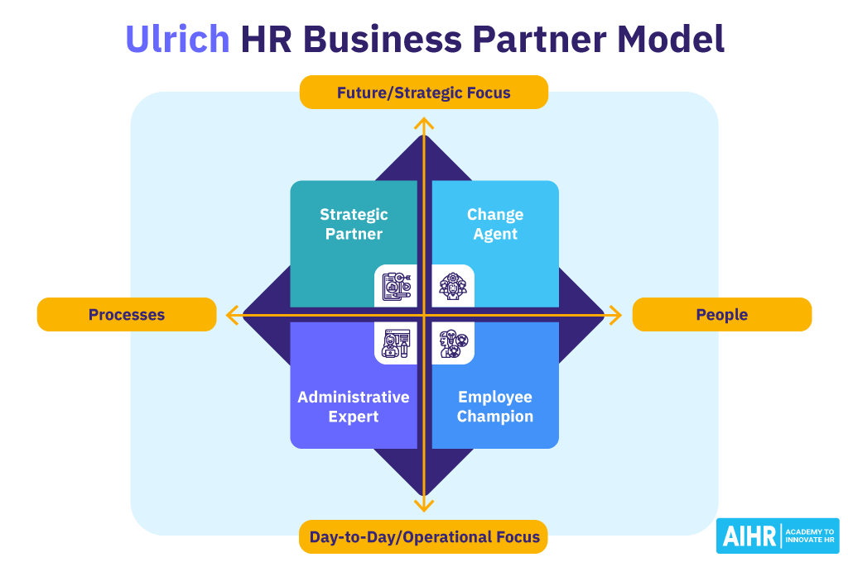
Source: https://www.aihr.com/blog/human-resources-models/
In line with stakeholder capitalism theory (Freeman, 1984), which reframes the firm's purpose as balancing multiple stakeholder claims, rather than shareholder value alone, socialization content should explicitly link each function's daily work to stakeholder outcomes (riders, city partners, regulators, and environment) in order to cascade this mindset to all new hires, not just HR.
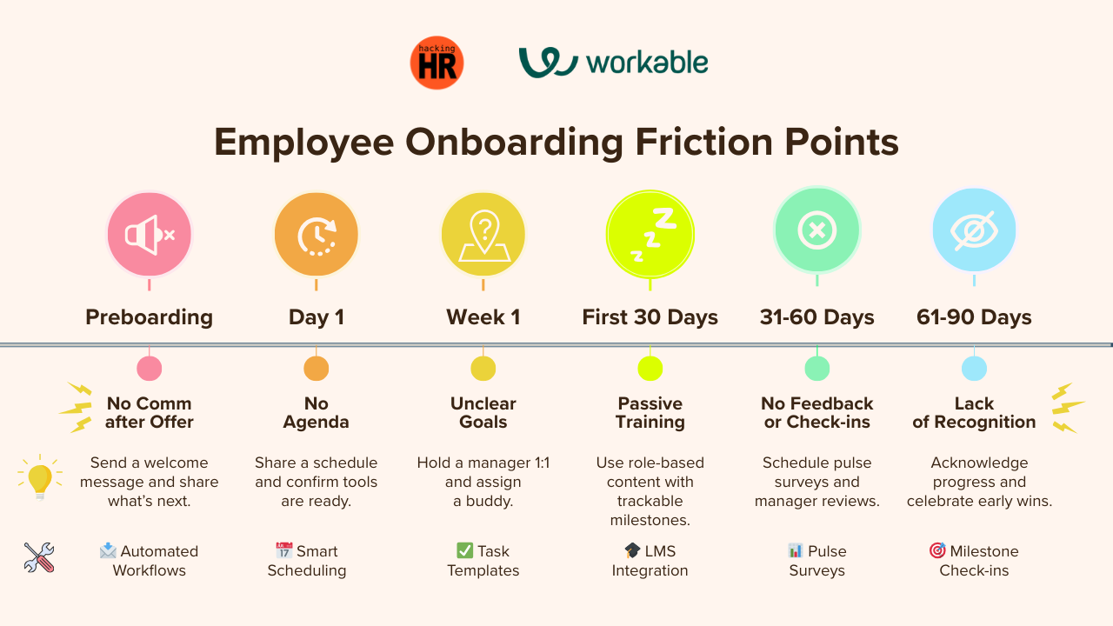
Source: https://www.linkedin.com/pulse/employee-onboarding-design-strategic-tech-enabled-human-centered-y3kkc
In order to make "activism" a habit rather than just aspirational rhetoric, each new hire's 90-day goals should practically include one stakeholder-impact objective that is examined alongside technical objectives.

2. Task B

2.1 Helios's Engagement Position
Helios's 54% engagement rate needs to be put in perspective because it is far higher than the current global Gallup standard of only 20% engaged workers worldwide, with Europe having the lowest regional engagement at just 12% (Gallup, 2026).
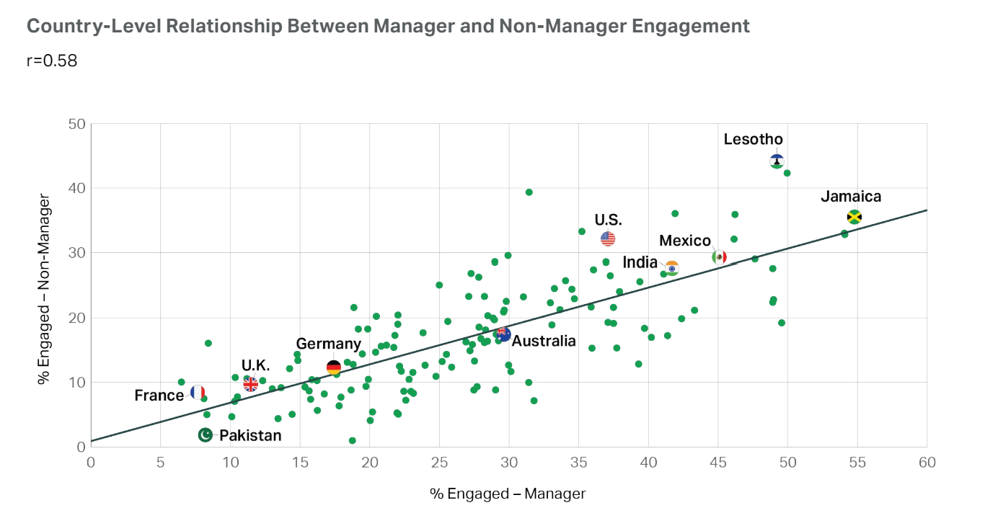
Source: https://5app.com/resources/5-findings-from-gallups-2024-state-of-the-global-workforce-report
This implies that Helios is not drastically lagging behind international standards, but rather is losing ground to its own aspirations as a high-growth deep-tech company vying for limited specialized talent, where the appropriate benchmark is best-in-class tech companies rather than the worldwide average. The main lever here is job design, not benefits.

2.2 An Innovative Job Design Strategy

2.2.1 The Job Characteristics Model
5 key job dimensions, skill variety, task identity, task significance, autonomy, and feedback, are outlined in Hackman and Oldham's (1976) JCM. These dimensions drive 3 psychological states, meaningfulness, responsibility, and knowledge of results, which in turn predict internal motivation, satisfaction, and performance.
Low task identity (engineers working on specific micro-components of AI systems with little visibility of end-to-end impact on a city's mobility outcomes) and limited autonomy, typical of quickly scaled start-ups that impose process rigidity as they grow, are likely problems for Helios's engineering and analytics roles.
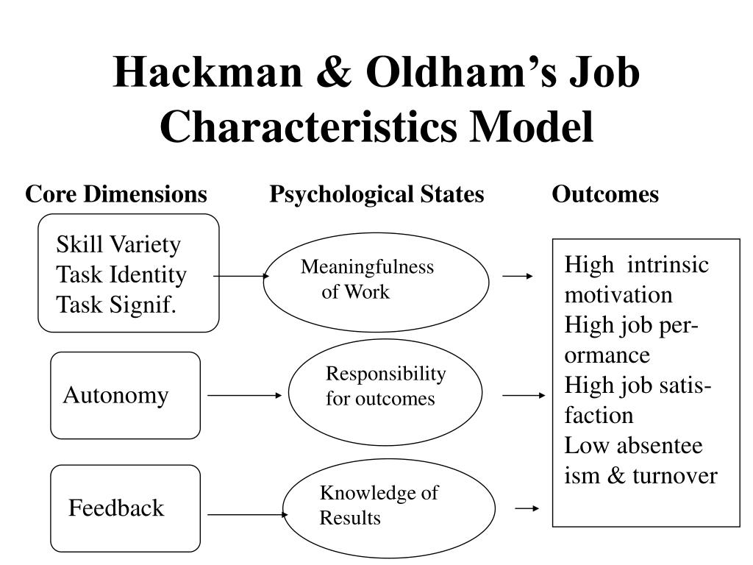
Source: https://www.slideserve.com/bernad/hackman-oldham
Redesign should specifically re-engineer around all 5 dimensions: switching from command-and-control sprint assignment to outcome-based autonomy within OKRs; reorganizing teams around complete deliverables rather than broken tickets (task identity); and rotating engineers through client-facing deployment visits (task significance, feedback).

2.2.2 Job Crafting
According to Wrzesniewski and Dutton's (2001), employees actively modify task limits (task crafting), connections (relational crafting), and the meaning they attach to work (cognitive crafting), rather than being passive beneficiaries of created occupations.
This quarterly 'craft your role' dialogue, which is part of the performance cycle, should be formalized by Helios rather than just tolerated. In this dialogue, employees suggest task or scope modifications that fall within acceptable bounds.
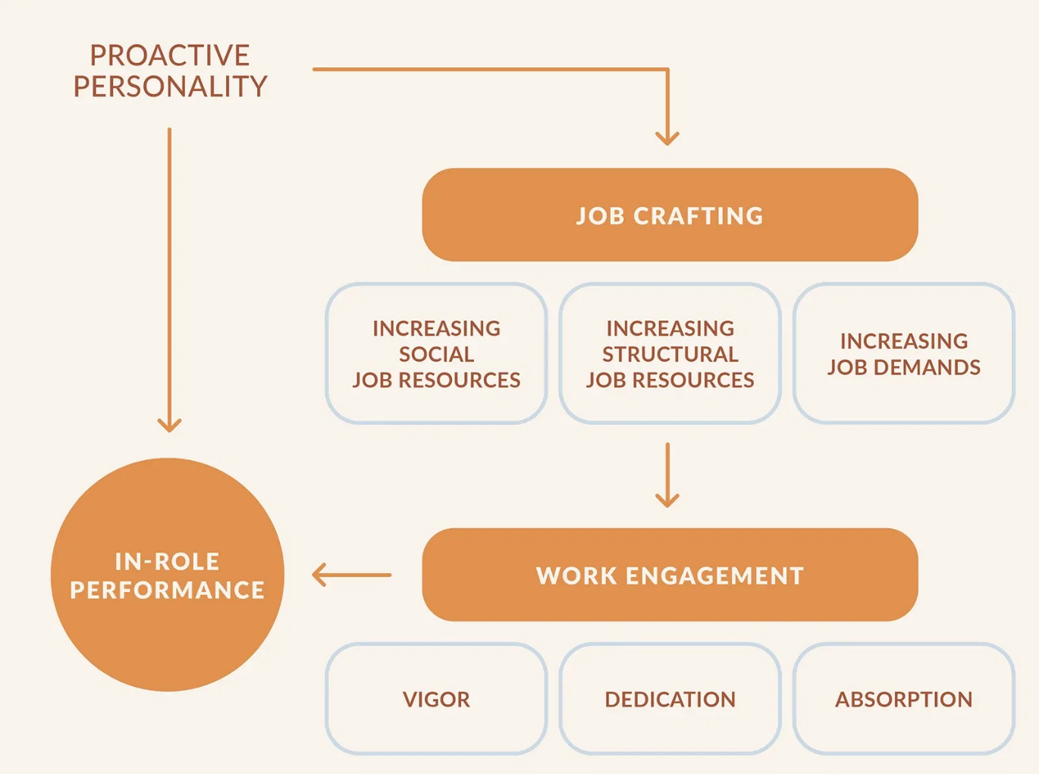
Source: https://positivepsychology.com/job-crafting/
For high-potential graduates, who Task A sees as an attrition risk, this is especially effective because crafting allows them to explore areas of interest (for example, an infrastructure analyst crafting toward sustainability modelling) without having to leave the company to do so.

2.2.3 Skills-Based Architecture and Internal Talent Marketplace
Skills shortage might result in up to 85 million unfilled jobs worldwide by 2030, making internal talent mobility a retention requirement rather than a luxury perk (McKinsey & Company, 2025). Also, 4 operating principles are identified by Deloitte's skills-based organization research: redefining workers by capability rather than title, rewarding skill development, matching talent to work dynamically, and releasing work from fixed job descriptions into a flexible portfolio of tasks and projects (Deloitte, 2022).
Unilever's internal marketplace serves as an example of this, allowing skills to flow freely between projects and responsibilities throughout the company rather than being restricted to functional silos (Deloitte, 2022). Given its 450-person workforce, Helios could create a simple internal marketplace that maps employee abilities to immediate project requirements. This might even start with a structured spreadsheet plus quarterly rotation mechanism.
It should expand to Singapore, Berlin, and London, allowing a Berlin battery systems engineer to dedicate 20% of his time to a smart infrastructure pilot in Singapore. Companies that prioritize internal talent development are 33% more likely to be recognized as industry leaders, and that 85% of employees feel more motivated when they can see a clear internal progression route (Deloitte, 2022; Gallup, 2026).

2.3 Stimulating Intrinsic Motivation and Supporting Innovation

2.3.1 How the 3 Layers Interact
Instead of being separate interventions, the 3 layers are intended to reinforce one another. The skills marketplace guarantees that crafting and growth do not stall against rigid job titles, allowing an employee to pursue an interest across a project boundary, not just within their fixed role; JCM redesign raises the ceiling of what any given role can offer in meaningfulness and autonomy; job crafting allows individuals to personalize that ceiling to their own strengths and interests, generating self-determined (intrinsic) motivation because the work is partially self-authored.

2.3.2 Impact on Retention
This directly addresses Helios's attrition issue: skills-based internal mobility has been demonstrated to decrease the "quiet flight risk" period between year one and year three, when the initial onboarding novelty (Task A) fades but promotion timelines remain far off. High-potential graduates disproportionately value visible growth and autonomy over compensation.

2.3.3 Impact on Innovation
Cross-functional and cross-site project mobility increases the diversity of knowledge recombination available to any individual, while task-identity redesign (whole-deliverable ownership) increases individuals' felt responsibility for outcomes.

2.3.4 Recommended Implementation Sequence
Pilot the JCM redesign and crafting conversations within one function (e.g., AI/analytics engineering) for 2 quarters, instrument it with pulse-survey engagement and time-to-productivity metrics, then extend the internal marketplace across London-Berlin-Singapore once cross-site logistics (visa, project governance) are resolved.

3. Task C

3.1 Reflective Report
Completing this report improved my understanding of how artificial intelligence (AI) should support, rather than replace, strategic HR decision-making. While creating recommendations for Helios, I realized that AI is far faster than humans at processing massive amounts of workforce data, spotting trends, and producing predictive insights.
Nonetheless, professional judgment, moral reasoning, and organizational knowledge are still necessary for making wise HR decisions. As a result, I would employ AI as a tool to assist in decision-making while making sure that the ultimate choices are still grounded in human judgment and facts.
For instance, my report suggested an AI-powered onboarding platform to track early productivity, mentorship involvement, and learning development. Employees that are likely to face early turnover or delayed integration can be identified using this data (McKinsey & Company, 2025).
Before choosing interventions, I would integrate these findings with manager feedback, mentorship conversations, and employee interviews rather than depending only on algorithmic forecasts.
According to Rousseau (1989) and Kowtha (2018), although AI-powered pulse surveys can identify falling involvement, they are unable to adequately explain psychological contract violations or identity doubt, which necessitate face-to-face discussions with employees. This demonstrates that rather than taking the place of crucial human judgment, AI should enhance the calibre of evidence that managers have access to.
My understanding of responsible AI governance has also increased as a result of the report. HR specialists must guarantee equity, openness, and responsibility when using AI for hiring, onboarding, or workforce planning as Helios builds AI-enabled public infrastructure.
Incomplete or unrepresentative historical labour data might lead to hidden bias in predictive models. Therefore, before putting suggestions into practice, HR directors should routinely audit AI outputs and assess ethical consequences (Ulrich and Dulebohn, 2015).
This project also brought to light a number of skills I need to hone in order to increase my employability in the future. My top goal is to increase my data literacy by using programs like Excel and Power BI to better analyse workforce dashboards, engagement metrics, and predictive HR analytics.
Second, rather than relying only on conventional HR procedures, I will get experience in AI augmentation within HR by comprehending intelligent recruitment systems, digital onboarding platforms, and people analytics.
I also want to improve my strategic influencing abilities. My suggestions, which included job redesign, organized organizational socialization, and an internal skills marketplace, showed that effective HR professionals need to use business data rather than just HR theory to convince top management.
Lastly, by learning about international collaboration, global talent deployment, and cross-cultural workforce management, I will increase my awareness of global mobility. Future HR professionals will need to manage geographically distributed and culturally varied personnel, as demonstrated by Helios's operations in Singapore, Berlin, and London.
Overall, this report has reaffirmed that long-term professional success will depend on integrating AI capabilities with analytical thinking, moral leadership, and strategic judgment.

References
Bauer, T.N. and Erdogan, B. (2010) 'Organizational socialization: The effective onboarding of new employees.,' in American Psychological Association eBooks, pp. 51–64. https://doi.org/10.1037/12171-002.
Callaghan, D. and Collins, H. (2023) '“If only these conversations had happened in induction.” Influencing employee aspiration with action learning-led inductions in the Big Four,' Employee Relations, 46(1), pp. 19–35. https://doi.org/10.1108/er-03-2023-0120.
Costa, B. and Rodrigues, R.I. (2025) 'The Invisible Bond: exploring the sequential mediation of interpersonal connections and engagement in the relationship between the onboarding process and talent retention,' Administrative Sciences, 15(7), p. 281. https://doi.org/10.3390/admsci15070281.
Deloitte (2022) The Skills-Based Organisation. https://www.deloitte.com/gr/en/issues/work/skills-based-organizations.html (Accessed: July 14, 2026).
Didion, E. et al. (2024) 'Mapping the organizational socialization and onboarding literature: a bibliometric analysis of the field,' Cogent Business & Management, 11(1). https://doi.org/10.1080/23311975.2024.2337957.
França, T.J.F. et al. (2025) 'Beyond algorithms: Artificial intelligence driven talent identification with human insight,' Intelligent Systems With Applications, 28, p. 200604. https://doi.org/10.1016/j.iswa.2025.200604.
Freeman, R.E. (1984) Strategic management a stakeholder approach. https://doi.org/10.1017/cbo9781139192675.
Gallup (2026) State of the Global Workplace Report, Gallup.com. https://www.gallup.com/workplace/349484/state-of-the-global-workplace.aspx (Accessed: July 14, 2026).
Hackman, J.R. and Oldham, G.R. (1976) 'Motivation through the design of work: test of a theory,' Organizational Behaviour and Human Performance, 16(2), pp. 250–279. https://doi.org/10.1016/0030-5073(76)90016-7.
Kowtha, N.R. (2018) 'Organizational socialization of newcomers: the role of professional socialization,' International Journal of Training and Development, 22(2), pp. 87–106. https://doi.org/10.1111/ijtd.12120.
Lapointe, É., Vandenberghe, C. and Boudrias, J. (2014) 'Organizational socialization tactics and newcomer adjustment: The mediating role of role clarity and affect‐based trust relationships,' Journal of Occupational and Organizational Psychology, 87(3), pp. 599–624. https://doi.org/10.1111/joop.12065.
LinkedIn (2024) 2024 Workplace Learning Report. https://learning.linkedin.com/resources/workplace-learning-report-2024 (Accessed: July 14, 2026).
Lust, J.A. and Ulrich, D. (1998) 'Human Resource Champions: The next agenda for adding value and delivering results,' Academy of Management Review, 23(1), p. 178. https://doi.org/10.2307/259108.
McKinsey & Company (2025) Superagency in the workplace: Empowering people to unlock AI’s full potential. https://www.mckinsey.com/capabilities/tech-and-ai/our-insights/superagency-in-the-workplace-empowering-people-to-unlock-ais-full-potential-at-work (Accessed: July 14, 2026).
Mitschelen, A. and Kauffeld, S. (2025) 'Workplace learning during organizational onboarding: integrating formal, informal, and self-regulated workplace learning,' Frontiers in Organizational Psychology, 3. https://doi.org/10.3389/forgp.2025.1569098.
Olaniyan, D. et al. (2025) 'A lightweight and scalable conversational AI framework for intelligent employee onboarding,' Applied Sciences, 15(21), p. 11754. https://doi.org/10.3390/app152111754.
Rousseau, D.M. (1989) 'Psychological and implied contracts in organizations,' Employee Responsibilities and Rights Journal, 2(2), pp. 121–139. https://doi.org/10.1007/bf01384942.
Safitri, D. (2024) 'Psychological Contract: A Systematic Literature Review,' International Journal of Scientific Multidisciplinary Research, 2(4), pp. 261–288. https://doi.org/10.55927/ijsmr.v2i4.8495.
Ślebarska, K. and Soucek, R. (2020) 'Change of organizational newcomers’ unmet expectations: Does proactive coping matter?' PLoS ONE, 15(12), p. e0243234. https://doi.org/10.1371/journal.pone.0243234.
Ulrich, D. and Dulebohn, J.H. (2015) 'Are we there yet? What’s next for HR?' Human Resource Management Review, 25(2), pp. 188–204. https://doi.org/10.1016/j.hrmr.2015.01.004.
Van Maanen, J.Eastin. and Schein, E.H. (1977) 'Toward a theory of organizational socialization,' RePEc: Research Papers in Economics, 1, pp. 209–264. https://EconPapers.repec.org/RePEc:mit:sloanp:1934.
Wrzesniewski, A. and Dutton, J.E. (2001) 'Crafting a job: Revisioning employees as active crafters of their work,' Academy of Management Review, 26(2), p. 179. https://doi.org/10.2307/259118.
Yang, Z., Liu, P. and Cui, Z. (2021) 'Strengths-Based job crafting and employee Creativity: The role of Job Self-Efficacy and Workplace status,' Frontiers in Psychology, 12, p. 748747. https://doi.org/10.3389/fpsyg.2021.748747.

