Name: Hannah Bernadette Graham
Module Title: The Philosophy and Practice of Social Research
Module Code: ECGE7004Q
Student Number: 1302881

The Perception of Reasonable Adjustments in the Workplace by Non-Disabled Employers and Disabled Employees.

Introduction

The focus of this research proposal will be to present a cohesive collection of data in relation to reasonable adjustments in the work place, and the perception of its effectiveness. The objective will be to promote awareness in the way reasonable adjustments are perceived by non-disabled employers compared to disabled employees, with the aim to stimulate change. To justify the need for this research and explain how this research will be undertaken; a thorough examination of multiple sections will follow. Firstly, the Introduction will provide a logical rationale for this proposal, while intending to capture the aims and objectives, clearly drawing upon current laws in place to protect disabled employees (Equality Act 2010). Reference to current statistics, such as reports by Scope (2018) and the Trade Union of Congress (2018), will be consulted to better understand the current percentage of disabled people in the UK who are in employment, compared to those who are not in employment, and whether these figures are impacted due to discrimination against disabled workers. The following section will focus on Methodology and will aim to critically evaluate the chosen research paradigm and research design, drawing upon experts in relevant subjects such as John W. Creswell (b. unknown), Vicki L. Plano Clark (b. unknown) and Martyn Denscombe (b. 1949). The key concepts of pragmatism as a research paradigm will also be explored and debated, with input from pragmatists such as Charles Sanders Peirce (1839-1914), William James (1842-1910) and John Dewey (1859-1952) and more current sources such as Abbas Tashakkori (b. unknown) and Charles Teddlie (b. unknown). Additionally, a section on measurement process will follow providing insight and justification to the research tools chosen, with the aim to clarify why these tools were chosen using sources such as Keith F. Punch (b. unknown) and David L. Morgan (b. unknown). Moving on, data analysis will be studied, with emphasis on how the data will be analyzed and why, as well as acknowledgement of any limitations that may be encountered in the logistics of data collection, and how they may impact the validity of the data. A summary of ethical considerations will then be provided, before addressing budgeting, timeline and dissemination. Finally, concluding the need for this study to be carried out and the positive outcomes of engaging with this research.

To define a disabled person under current law, the person must have ‘a mental or physical impairment … [and] the impairment has a substantial and long-term adverse effect on [their] ability to carry out normal day-to-day activities’ (Equality Act 2010). With the introduction of the Equality Act 2010, disability is now classed as a protected characteristic, thus making it unlawful for an employer to directly or indirectly discriminate against a disabled employee. It is also worth noting that Section 20 (Equality Act 2010) is dedicated to adjustments for disabled people, including a legible and coherent breakdown of reasonable adjustments, directly followed by Section 21 (Equality Act 2010) Failure to Comply. Despite the existence of established laws, intended to simplify, streamline and replace previous laws (Disability Discrimination Act 1995, Equal Pay Act 1970) the perception of disability by disabled persons versus non-disabled persons still differs dramatically. According to The Disability Perception Gap policy report (Dixon, et al., 2018, p. 6) only one in five non-disabled people believe there are elevated levels of prejudice towards disabled people, however one in three disabled people believe they face prejudice. With this report, using data collected by the British Social Attitudes Survey 34 (2017) funded by Scope, it is clear that there is a variance in perception depending on the individuals’ standpoint. Within this study when asked ‘How much prejudice do you think there is in Britain against disabled people in general?’ (Dixon, et al., 2018, p. 5) the results showed a substantial difference of 10% between disabled respondents and non-disabled respondents beliefs. Many rationalizations, such as personal experiences and lack of association with disabled persons, could contribute towards these discrepancies, but it must be taken into account that without having first hand experience of a disability, there may be multiple subconscious preconceptions towards disabled people or a lack of awareness of the injustices disabled people face. While according to the recent report People with Disabilities in Employment (House of Commons Library, 2019), the most recent unemployment rates for people with disabilities was 7.3%, with 43.3% of disabled people economically inactive, 52.6% disabled people are in employment, resulting in a 28.9% disability employment gap. Logically, not all disabled people of working age are able to work. However, if we look at this figure paralleled to the public’s perception of disabled people, the comparison presents more queries as to why this figure is so high.

As quantified in the Public Perceptions of Disabled People produced by the Office for Disability Issues (Staniland, 2009, p. 27), 38% of participants believe that disabled people are less productive than non-disabled people, with 76% believing that disabled people need to be cared for some or all of the time. With a sample size of 1877 participants, this equals to around four in ten people, and over three quarters, respectively. This information brings forth multiple questions regarding disabled people in employment. It is likely that out of these participants at least some were in a position of managing, supervising or recruiting employees. Does this attitude translate to the work place? With research undertaken in reports such as The Disability Pay Gap (Longhi, 2017) and the Disability Employment and Pay Gaps (Trade Unions Congress (TUC) 2018), it is evident that there is a distinct difference in wages received by disabled employees compared to non-disabled employees, varying between 7% to 40% depending on the disability. While these figures can be partially explained with issues such as part time employment, there are also findings that those employees that are in jobs, such as management or as directors, are less likely to also be disabled. Yet there are a higher number of disabled workers in occupations such as customer service and sales. These figures could suggest that disabled workers are not being given full access to the job market, and are therefore missing opportunities for promotion and career development. With this in mind, the Equality Act 2010 is intended to protect disabled workers from this type of discrimination, with reasonable adjustments offering a solution to impediments that may arise from hiring a disabled person.

Methodology

While many high quality studies have been completed on reasonable adjustments, such as The implementation of equality legislation: the case of disabled graduates and reasonable adjustments (William, 2016), and Disabled people’s experiences of accessing reasonable adjustments in hospital: a qualitative study (Read et al. 2018), the majority of these studies are carried out using qualitative research methods. The applications of these methods make sense, especially when used within social research. Qualitative research puts emphasis on words rather than quantifiable results, however it does not provide the researcher the opportunity to gain a wider look at the situation from different vantage points, in this case, the employer and the employees. To expand on this theory further, and to gain a deeper and fuller understanding of the perception of reasonable adjustments by disabled employees and non-disabled employers, pragmatism will be adopted as the research paradigm, thus using a mixed methods research design. There is much perplexity surrounding the origins of pragmatism, with the three main founding philosophers disagreeing on even the preliminary stance of pragmatism. According to Tallisse and Aikin (2008, p.5) pragmatism originated in the United States in the late 1800s and is often credited to Peirce (1839-1914), before growing in popularity in the mid twentieth century through the work of James (1842-1910) and Dewey (1859-1914). Falling in popularity after world war two, later being revitalized by Rorty (1931-2007). The key differences in Pierce and James’ views on pragmatism stem from a dispute surrounding the pragmatic maxim, specifically the concept of truth. Later, Dewey and James were in agreement that ‘the pragmatic method is primarily a method of settling metaphysical disputes that otherwise might be interminable’ (James, 2013 p. 21). The impact of the issues resulting from disagreements between philosophers on the pragmatic maxim is summed up succinctly in Pragmatism Endures (Misak and Talisse, 2019) where their conclusion states:

‘The pragmatic maxim is itself a kind of indictment against the power that labels can exert over our intellect. Rather, pragmatism has always been a series of disputes among a certain stripe of empiricist philosophers about truth, meaning, enquiry and values’.

Nevertheless, taking into consideration the importance that there may be particular benefits in examining each philosopher’s viewpoints in depth, it must be taken into account that pragmatism is not dedicated to a single system of philosophy. Therefore it is more important to not get subjugated by the question of authenticity surrounding pragmatism. This is supported in Pragmatism Old and New (Haak, 2004) when stating that:

‘It is easy to get hung up on the question of which variants qualify as authentic pragmatism; but probably it is better – potentially more fruitful, and appropriately forward-looking – to ask, rather, what we can borrow from the riches of the classical pragmatist tradition’.

Justification can also be drawn from other writers such as Tashakkori and Teddlie (2002, p. 713) who define pragmatism as a

‘… deconstructive paradigm that debunks concepts such as “truth” and “reality” and focuses instead on “what works” as the truth regarding the research questions under investigation. Pragmatism rejects the either/or choices associated with the paradigm wars, advocates for the use of mixed methods in research, and acknowledges that the values of the researcher play a large role in interpretation of results’.

In light of examining two groups of research participants, a mixed method approach will provide the researcher with the ability to collect and integrate two sets of data, one quantitative and one qualitative, to gain a better understanding of the situation. An early definition of mixing methods can be seen from Greene, Caracelli, and Graham (1989). They describe the fundamental theory of mixed methods as:

‘… those that include at least one quantitative method (designed to collect numbers) and one qualitative method (design to collect words), where neither type of method is inherently linked to any particular inquiry paradigm.’

In the current field of social research, it is noteworthy to refer to the definition provided by Tashakkori and Teddlie (2002, p. ix) that ‘mixed methods research has evolved to the point where it is a separate methodological orientation with its own worldview, vocabulary, and techniques’. Nevertheless, this research will be carried out under the umbrella of pragmatism. Justification for this can be evident in Creswell’s explanation of current mixed method practice when he states:
‘Many mixed methods scholars today have moved beyond questions of mixing paradigms to the search for a single paradigm as a foundation for mixed methods. For some, this foundation is pragmatism’ (Creswell, Plano Clark, 2008, p. 27).

Using a quantitative technique will allow the researcher to gather descriptive statistics concerning the non-disabled employer’s response. Contrastingly, the disabled employees will be approached with a qualitative technique, with the aim to gather a more in depth look at their perception and application of reasonable adjustments in the work place. Consequently, using a mixed methods approach will enable the collected data to not just be cross-validated, but will also improve the researcher’s standpoint of a single problem with the strength of various aspects (Bryman, 2016, p. 32), in this case to discover whether there is a gap in the perception of reasonable adjustments in the work place, despite the legal obligations to protect disabled workers. As a result of the epistemological nature of pragmatism, the methods that will be applied will be chosen by the researcher with the aim to solve the problem, with the objective to promote change. Utilising the freedom of a mixed methods approach, as previously mentioned, the research will be carried out using both qualitative and quantitative methods. The framework behind this mixed method approach will follow a triangulation design. Cited in the Encyclopedia of Research Design (Salkind, 2010, p. 1537) Denzin (b. 1941) identified four different types of triangulation: Data Triangulation, Investigator Triangulation, Theory Triangulation and Methodological Triangulation. Working under the framework of methodological triangulation, a minimum of two different methods will be engaged to study a single phenomenon (Salkind, 2010, p. 1537). With multiple designs of triangulation available to researchers, concurrent/ convergent triangulation design is arguably one of the most familiar (Creswell, Plano Clark, 2008, p. 183), and also the most suitable for the chosen line of enquiry. Qualitative and quantitative data will be collected with equal importance, analysed separately then compared and merged. The Data Analysis section will explain this further. Choosing this design provides the researcher with the opportunity to examine reasonable adjustments from multiple vantage points, consequently minimizing the weaknesses of using a single method for each set of participants. Despite their equal importance, to simplify the application of the concurrent/convergence model, each method will be broken down into quantitative and qualitative. Firstly, the quantitative research will consist of using a research method that will be used to gather descriptive statistics, as opposed to numerical, from a non-disabled employer’s perception of reasonable adjustments at work. The respondents for this research will be residents of the United Kingdom, excluding Northern Ireland where the Equality Act 2010 does not apply. A sample size of 385 will be the aim for this research; this includes a confidence level of 95% and a margin of error of 5%. This number was generated using a population number of 32.75 million, the current number of the population who are of working age and in employment according to the Office for National Statistics (Labour Force Survey, 2019). To achieve the desired sample size the number of surveys sent out will be higher to give flexibility to circumstances beyond the researchers control, such as respondent withdrawal. Quantitative data collection will be applied due to the sample size, with the aim to produce a generalization of non-disabled employers perceptions of whether reasonable adjustments are effective within the UK. Moreover, it would be unrealistic to produce valuable qualitative data with such a large sample size in a short time frame. Respondents in this research will only be eligible if they are employed in a position that includes hiring, recruiting or managing employees, of working age, do not identify as a disabled person, and are currently residing in the UK. Respondents will not be required to disclose their age, gender, or specific job title as the Equality Act 2010 does not require these characteristics in its application.

The qualitative research will be applied to gather data from the disabled employees in the form of a semi-structured focus group. Eligibility of participants will use the same demographic principals as the quantitative research. Participants must also be employed in the UK, be of working age, adhere to the Equality Act 2010’s definition of a disabled person, and have requested or received reasonable adjustments within their employment. Participants in this focus group will also not be required to disclose their specific age, gender, job title or disability.

Measurement Processes
As explained in the previous sections, this study will be examined through the lens of quantitative and qualitative data, with both playing an equal role. This section will aim to justify the data collection tools chosen. In relation to the quantitative aspect of the research design, quantitative research has three key points:

- It conceptualises reality in terms of variables;
- Measures these variables;
- Studies relationships between these variables; (Punch, 2014, p. 206)

These key points, when applied in the right way, result in quantifiable strength. In contrast, qualitative research is naturalistic. This is not to say that quantitative research cannot be naturalistic (Punch, 2014, p. 118), much like qualitative data is related strongly to words, quantitative data is related to numbers, neither are bound to these axioms. Qualitative data:
‘… attempts to capture data … through a process of deep attentiveness, of empathetic understanding and of suspending or ‘bracketing’ preconceptions about the topics under discussion’ (Punch, 2014, p. 119).

Evidently, where qualitative data lacks strengths, such as measuring quantities, quantitative data exceeds, and vice versa.

To carry out the quantitative side of the research, an online survey will be used. A survey is summed up using four key characteristics (Denscombe, 2014, p. 7 and 8). Firstly, empirical research; a survey pursues the needed information from the appropriate sources, instead of relying on theories and concepts. Secondly, at a specific point in time; surveys provide current data and are rarely used to gather data for longitudinal studies. Thirdly, wide and inclusive coverage; a survey is an appropriate tool to gather data from a wider population to gain sufficient data to apply a generalisation to a larger demographic. Lastly, detailed scrutiny; although detailed scrutiny may be better applied to a smaller demographic, a survey provides the researcher with the opportunity to emphasise the issue being researched and focus on what information is needed. Subsequently, the importance of choosing which type of survey presents itself. With an increasing number of surveys in the twentieth century ‘each has strengths and weaknesses, allowing it do things other modes cannot do’ (Dillman et al. 2009, p. 495). Given the sensitive nature of this research, where the non-disabled employers may not want to give their true feelings, an indirect contact survey can increase the likelihood of honest and open answers, rather than the feeling of social pressure and morality that could impose upon direct contact. Although there are multiple indirect ways to contact participants, such as postal surveys and email surveys, Sue and Ritter (2011, p. xvi), call attention to ‘the advent of free and easy-to-use survey software [that] has rendered e-mail questionnaires an unappealing choice for most purposes’. Web-based questionnaire surveys pose a proficient resolution in the digital-centered twentieth century. This would be undertaken using a survey web host such as Survey Monkey. Not only is this choice more efficient in cost, design and environmental responsibility, it also provides a scope of participants that can be targeted through pre-determined eligibility. Furthermore, the website offers anonymous responses, enabling the survey host to act as a gatekeeper, assuring confidentiality to the participants. Although there is no opportunity for the researcher to gather oral consent, there is the option to add a digital consent form at the start of the survey, thus giving the researcher the opportunity to obtain digital consent (Appendix A). This consent form will contain everything that would be on a paper-based consent, and will follow onto an introduction explaining the basis of the research. For the ease of the participants, radio buttons will be used to answer questions, allowing respondents to choose one answer for each question. Participants will also have the option to skip any question they do not want to answer, or to not submit the survey at all. The questions asked in the survey will be made up of closed questions (Appendix B), enabling the collection of quantitative data analysis.

Moving onto the qualitative aspect of this study, a single semi-structured focus group, where the researcher acts as the facilitator, will be conducted to gather disabled employees perceptions and experiences around reasonable adjustments in the work place. Although one to one interviews are a well-accepted choice for qualitative research, the desired data will be better collected through group discussion with the researcher acting as a facilitator rather than moderator, and a ‘well-facilitated group interaction can assist in bringing to the surface aspects of a situation that might not otherwise be exposed’ (Punch, 2014, p. 147). However, there are possible downsides to consider when conducting a focus group such as:

‘Group culture may interfere with individual expression, the group may be dominated by one person, the group format makes it difficult to research sensitive topics, “groupthink” is a possible outcome, and the requirements for the interviewer skills are greater because of group dynamics’ (Fontana and Frey, 1994, p. 365).

To address these issues, ethical consideration will be of high importance in the planning stage. The focus group will be conducted following a semi-structured format, with the recommended sample size of 6-8 participants (Creswell, 2014, p. 190) and the recommended time of 90 minutes covering 10-12 questions (Lavrakas, 2008, p. 288). The questions asked will be open ended giving the participants the opportunity to discuss the subject, as the researcher will facilitate rather than moderate the discussion. To reach eligible prospective research participants, a union such as Unite the Union that already works with disabled workers will be contacted to act as a gatekeeper, providing safe and ethical access to the potential participants (Lavrakas, 2008, p. 299). (Appendix C) For the safety of both the researcher and the participants, the focus group will be held in a rented room at the University of Wales Trinity Saint David, Carmarthen campus, and will be documented using audio recording equipment. Participants will be provided with a concise and easy to read introduction letter explaining the research being undertaken and their participation, along with a consent form, including their right to withdraw from the study at any time. (Appendix D and E)

Data Analysis

To justify the analysis of the data collected, it must remain separated into quantitative and qualitative research as data will be analysed separately, and each adhere to different scrutiny. In relation to questionnaire data, using Survey Monkey as a host provides the researcher with the option of using their in-house data analysis. Considering the triangulation design of the research and the need to analyse two sets of data before merging, this provides a time efficient solution. The data collected will be instantly available, and presented using a customizable chart, in this case a simple bar graph. Not receiving enough respondents is the main issue that may be encountered in the logistical collection of data. Having taken this into account, adjusting the number of participants accordingly will aim to eradicate this concern.
In the analysis of qualitative data it is important to identify and understand the researcher’s bias. One of the most read articles on this subject is Verification Strategies for Establishing Reliability and Validity in Qualitative Research (Morse et al., 2002), which argues ‘that qualitative researchers should reclaim responsibility for reliability and validity by implementing verification strategies integral and self-correcting during the conduct of inquiry itself.’ This protects the execution of objectivity during qualitative research, and gives the responsibility of validity and reliability to the researcher. However;

‘the rigor of qualitative research is particularly vulnerable when it lacks some of the devices that have been employed in quantitative research to ensure that what is produced is not just well-composed rhetoric of a well-meaning, but biased, researcher’s opinion’ (Thirsk and Clark, 2017).

This poses the question of whether how much bias, or even should bias, be a contributing factor to the findings of qualitative research? During qualitative research, the researcher is essential in all aspects of the study, so to detach their own morality would not be possible. The critical issue is not the whether the researcher has bias, but rather if the researcher has produced data that is transparent and reliable (Galdas, 2017). With this in mind, the researcher identifying their bias, in this case wanting to stimulate change and improve the quality of reasonable adjustments for disabled workers, is crucial in the validity of this research. By employing a mixed methods design, the researcher cannot impose their bias on the quantitative data, but instead will have be trusted not to produce a final report encompassing their views, but instead the honest findings of the research. To analyse the data from the focus group, the researcher will employ a thematic/coding analysis. This framework of analysis enables the researcher to identify the themes brought up in the focus group after the fact, rather than identifying the themes first. Firstly, the raw data will first be transcribed from the researchers audio recording of the focus group. Once transcribed, the researcher will employ a cutting and sorting method to identify themes. To achieve this, numerous readings of the transcript will take place before identifying important quotes. These quotes will be colour coded and highlighted. Each quote will be marked to identify them to each participate. In keeping with protecting their anonymity, a number system will be used to recognize each participant in all steps of the analysis. After all quotes have been highlighted, the researcher will cut them out and separate them into piles, before naming each pile, thus identifying the themes (Ryan and Bernard, 2005). Lastly, the researcher will write up a ‘compelling narrative about the data’ (Bryman, 2016, p. 588). Although, transcribing and identifying the themes of the raw data are important, writing up the findings are crucial to the credibility and understanding of the research once released for consumption.

Once analysed separately, results from the non-disabled employers and disabled employees will then be compared and contrasted. Working on the assumption that these findings will be corresponding in complimentary manner, non-corroboration of data is an anticipated risk. To mitigate this risk, non-corroboration of data will not be regarded as a setback but as a chance to undertake further research in the subject matter or dispel any preconceptions the researcher may have prior to the data collection (Denscombe, 2014, p. 157).
This data will create a merged cohesive report measuring the perception of reasonable adjustments in the workplace from two different vantage points, thus creating a more accurate depiction on the perception of reasonable adjustments by both non-disabled employers and disabled employees.

Ethical Considerations

In social research, ethics are of high priority and research must be carried out using a ‘variety of moral, legal, and safety considerations’ (Denscombe, 2014, p. 305), therefore ethical approval will be obtained before collecting any data. All data collection performed during this study will adhere to the British Sociological Association’s (BSA 2017) Statement of Ethical Practice and the University of Wales Trinity Saint David (UWTSD) Research Ethics & Integrity Code of Practice (2017) guidelines. Additionally, the General Data Protection Regulation (GDPR) (2018) will be adhered to where applicable. Each choice of method presents its own ethical considerations. Firstly, quantitative data will be collected using a web-based questionnaire. As explained in the GDPR (2018) ‘…‘personal data’ meaning any information relating to an identifiable person who can be directly or indirectly identified in particular by reference to an identifier’. However, as surveys are customizable, the creator can add many features that also protect the participants, thus protecting themselves. Firstly, respondents can remain anonymous, as there is the option to not collect IP addresses, rendering research respondents untraceable. Although there is no opportunity for the researcher to gather oral consent, there is the option to add a digital consent form at the start of the survey, thus giving the researcher the opportunity to obtain digital consent. This consent form will contain everything that would be on a paper-based consent form. Participants should always be aware of their right to withdraw or their right to not answer any specific questions. This can be obtained by providing the respondent with an option to skip on every question, or the choice to not submit the survey. However, any submitted responses would not be reversed, this will be explained to participants in the digital consent form. Moving onto the qualitative aspect of this research, a single semi structured focus group will take place. To expand on what has previously been discussed under measurement process, data protection will be of the upmost importance. All data will remain on the researcher’s password protected work laptop with a clear audit trail until the data is no longer needed after data analysis has been conducted, at which point it will be permanently destroyed. Although these ethical considerations are addressed during the planning phase, ethical issues can present themselves at any time during qualitative research (Appendix F). With this in mind, ethical issues will continue to be examined in all phases of the research process (Creswell, 2014, p. 56) and any changes will be documented within the reflection process.
The ethical guidelines being adhered to in this research aim ‘to protect the rights and welfare of participants and minimize the risk of physical and mental discomfort, harm and danger from research procedures, [and] protect the welfare of researchers’ (UWTSD, 2017) with the objective to ‘enhance the quality and integrity of research’ (UWTSD, 2017).

Timeline, Budget and Dissemination

This research will be undertaken within the timeline of an academic year. An academic year will provide enough time for the researcher to submit the research proposal, gain ethical approval, contact a gatekeeper and recruit respondents/participants, carry out the data collection in the form a questionnaire and a focus group, perform data analysis, and finally, report the findings of this research.
Budget is an important item to consider as the researcher is resourcing the project. Although many steps have been taken to be cost efficient, the budget still needs to be recorded to confirm the capability. This can be done by breaking down funds needed for all aspects of the research project such as what equipment will be used and web host costs.

Finally dissemination is an imperative consideration in any research. The study will be undertaken with the target audience in mind. To achieve the objective of stimulating change, the final report of data collected will be shared amongst trade unions and disability charities within the UK. These organisations will be given the freedom to share this information as they wish. Respondents and participants will also be given the option to request the findings, be given details on who will be given access to the final report and how it will be shared.

Conclusion

The originality of this research will provide a contemporary review of reasonable adjustments in the workplace from a pragmatist mixed methods point of view. Not only will this research demonstrate the perception and experience of reasonable adjustments by disabled employees, it will also provide the vantage point of the non-disabled employer. Combining these two elements will build upon current knowledge in this field by providing a multifaceted analysis of the same phenomenon. The positive outcomes of engaging in this study will aim to provide a new perspective on reasonable adjustments in the workplace and an insight into its effectiveness, thus giving a platform to build upon current legislation and methods currently used to provide reasonable adjustments to disabled employees.

Reference List

British Sociological Association (2017) BSA Statement of Ethical Practice Available at: https://www.britsoc.co.uk/media/24310/bsa_statement_of_ethical_practice.pdf (Accessed: 25th November 2019)

Bryman, A. (2016) Social Research Methods Oxford: Oxford University Press

Creswell, J. W. (2014) Research Design Qualitative, Quantitative, & Mixed Methods Approaches United States of America: SAGE Publications

Creswell, J., Plano Clark, V. (2008) The Mixed Methods Reader California: SAGE Publications

Denscombe, M. (2014) The Good Research Guide For small-scale social research projects London: Open University Press

Dillman, D.A., Smyth, J.D., Christian, L.M. (2009) Internet, Mail, and Mixed –mode Surveys: The Tailored Design Method Hoboken: Wiley

Disability Discrimination Act 1995 Available at: http://www.legislation.gov.uk/ukpga/1995/50/contents (Accessed: 14th November 2019)

Dixon, S. et al. Scope (2018) The Disability Perception Gap Available at: https://www.scope.org.uk/campaigns/disability-perception-gap/ (Accessed: 15th November 2019)
Equality Act 2010, c 2. Available at: http://www.legislation.gov.uk/ukpga/2010/15/contents (Accessed: 14th November 2019)
Equal Pay Act 1970 (repealed) Available at: http://www.legislation.gov.uk/ukpga/1970/41/contents (Accessed: 15th November 2019)

Fontana, A. and Frey, J. (1994) Interviewing The Art of Science United States of America: SAGE Publications

Galdas, P. (2017). ‘Revisiting Bias in Qualitative Research: Reflections on Its Relationship With Funding and Impact.’ International Journal of Qualitative Methods. Available at: https://journals.sagepub.com/doi/full/10.1177/1609406917748992#articleCitationDownloadContainer

General Data Protection Regulation (GDPR) (2018). General Data Protection Regulation (GDPR) Available at: https://gdpr-info.eu/ (Accessed: 20 November 2019)

Greene, J., Caracelli, V., Graham, W. (1989) ‘Toward a Conceptual Framework for Mixed-Method’, Educational and Evaluation and Policy Analysis, 11(3), pp. 255-274 Available at: http://citeseerx.ist.psu.edu/viewdoc/download?doi=10.1.1.1004.4570&rep=rep1&type=pdf

Haack, Susan. (2004) ‘Pragmatism, Old and New’ Contemporary Pragmatism. 1. Available at: https://www.researchgate.net/publication/263303152_Pragmatism_Old_and_New_2004 (Accessed on: 20th November 2019)

House of Commons (2019) People with disabilities in employment (7540) Available at: https://researchbriefings.parliament.uk/ResearchBriefing/Summary/CBP-7540#fullreport (Accessed: 18th November 2019)

James, W. (2013) Pragmatism A New Name For Some Old Ways Of Thinking Worcestershire: Read Books LTD

Lavrakas, P. (2008) Encyclopedia of Survey Research Methods United States of America: SAGE Publications

Longhi, S. Equality and Human Rights Commission. (2017) The Disability Pay Gap Available at:
https://www.equalityhumanrights.com/en/publication-download/research-report-107-disability-pay-gap (Accessed on: 16th November 2019)

Misak, C., Talisse, R. (2019) ‘Pragmatism Endures’ Aeon Available at: https://aeon.co/essays/pragmatism-is-one-of-the-most-successful-idioms-in-philosophy (Accessed: 20th November 2019)

Morgan, D. (1996) Focus Groups as Qualitative Research (Second Edition) United States of America: SAGE Publications

Morse, J., Barrett, M., Mayan, M., Olson, K., Spiers, J. (2002) ‘Verification Strategies for Establishing Reliability and Validity in Qualitative Research’, International Journal of Qualitative Methods, 13-22, Available at: https://journals.sagepud.com/doi/10.1177/160940690200100202
NatCen (2017) British Social Attitudes 34 Available at: https://www.bsa.natcen.ac.uk/media/39196/bsa34_full-report_fin.pdf (Accessed on: 15th November 2019)

Office for National Statistics (2009) Labour market overview, UK: November 2019 Estimates of employment, unemployment, economic inactivity and other employment related statistics for the UK. Available at:
https://www.ons.gov.uk/employmentandlabourmarket/peopleinwork/employmentandemployeetypes/bulletins/uklabourmarket/november2019 (Accessed 23rd November 2019)

Punch, K. (2014) Introduction to Social Research Quantitative and Qualitative Approaches California: SAGE Publications

Read, S., Heslop P., Turner, S., Mason-Angelow, V., Tilbury, N., Miles, C., Hatton, C. (2018) ‘Disabled people’s experiences of accessing reasonable adjustments in hospital: a qualitative study’ BMC Health Services Research 18.1 Available at: https://bmchealthservres.biomedcentral.com/track/pdf/10.1186/s12913-018-3757-7 (Accessed: 17th November 2019)

Ryan, G. W., Bernard, H. R. (2005) Techniques to Identify Themes in Qualitative Data Available at: https://pdfs.semanticscholar.org/a31e/c3652f3f1b6df31423883a1fc7fbf8509ce4.pdf (Accessed: 2nd December 2019)

Salkind, N. (2010) Encyclopedia of Research Design California: SAGE
Staniland, L. Office for Disability Issues. (2009) Public Perceptions of Disabled People Available at: https://assets.publishing.service.gov.uk/government/uploads/system/uploads/attachment_data/file/325989/ppdp.pdf (Accessed on: 16th November 2019)

Sue, M., Ritter, L. (2011) Conducting Online Surveys California: SAGE Publications

Survey Monkey (2019) We’re more than survey software Available at: https://www.surveymonkey.com/ (Accessed: 27th November 2019)

Talisse, R. and Aikin, S. (2008) Pragmatism A Guide for the Perplexed London: Continuum

Tashakkori, A., Teddlie, C. (2002) Handbook of Mixed Methods in Social & Behavioral Research California: SAGE Publications

Thirsk, L. M., Clark, A. M. (2017) ‘Using Qualitative Research for Complex Interventions: The contributions of hermeneutics.’ International Journal of Qualitative Methods, 16, Available at: https://journals.sagepub.com/doi/pdf/10.1177/1609406917721068

Trade Unions Congress (TUC) (2018) Disability Employment and Payments Gaps 2018 Available at:
https://www.tuc.org.uk/sites/default/files/Disabilityemploymentandpaygaps.pdf (Accessed on: 17th November 2019)

Unite The Union (2019) Who We Are and What We Stand For Available at: https://unitetheunion.org/who-we-are/ (Accessed: 25th November 2019)

University of Wales Trinity Saint David (2017) Research Ethics & Integrity Code of Practice Available at: https://www.uwtsd.ac.uk/media/uwtsd-website/content-assets/documents/research/research-ethics-integrity-code-practice.pdf (Accessed: 21st November 2019)

William, Laura (2016) ‘The implementation of equality legislation: the case of disabled graduates and reasonable adjustments’ Industrial Relations Journal 47 Available at: https://www.researchgate.net/publication/304065298_The_implementation_of_equality_legislation_the_case_of_disabled_graduates_and_reasonable_adjustments_Reasonable_adjustments_and_the_implementation_gap/citation/download (Accessed: 17th November 2019)

Appendices

Appendix A:
Sample of Digital Consent Form

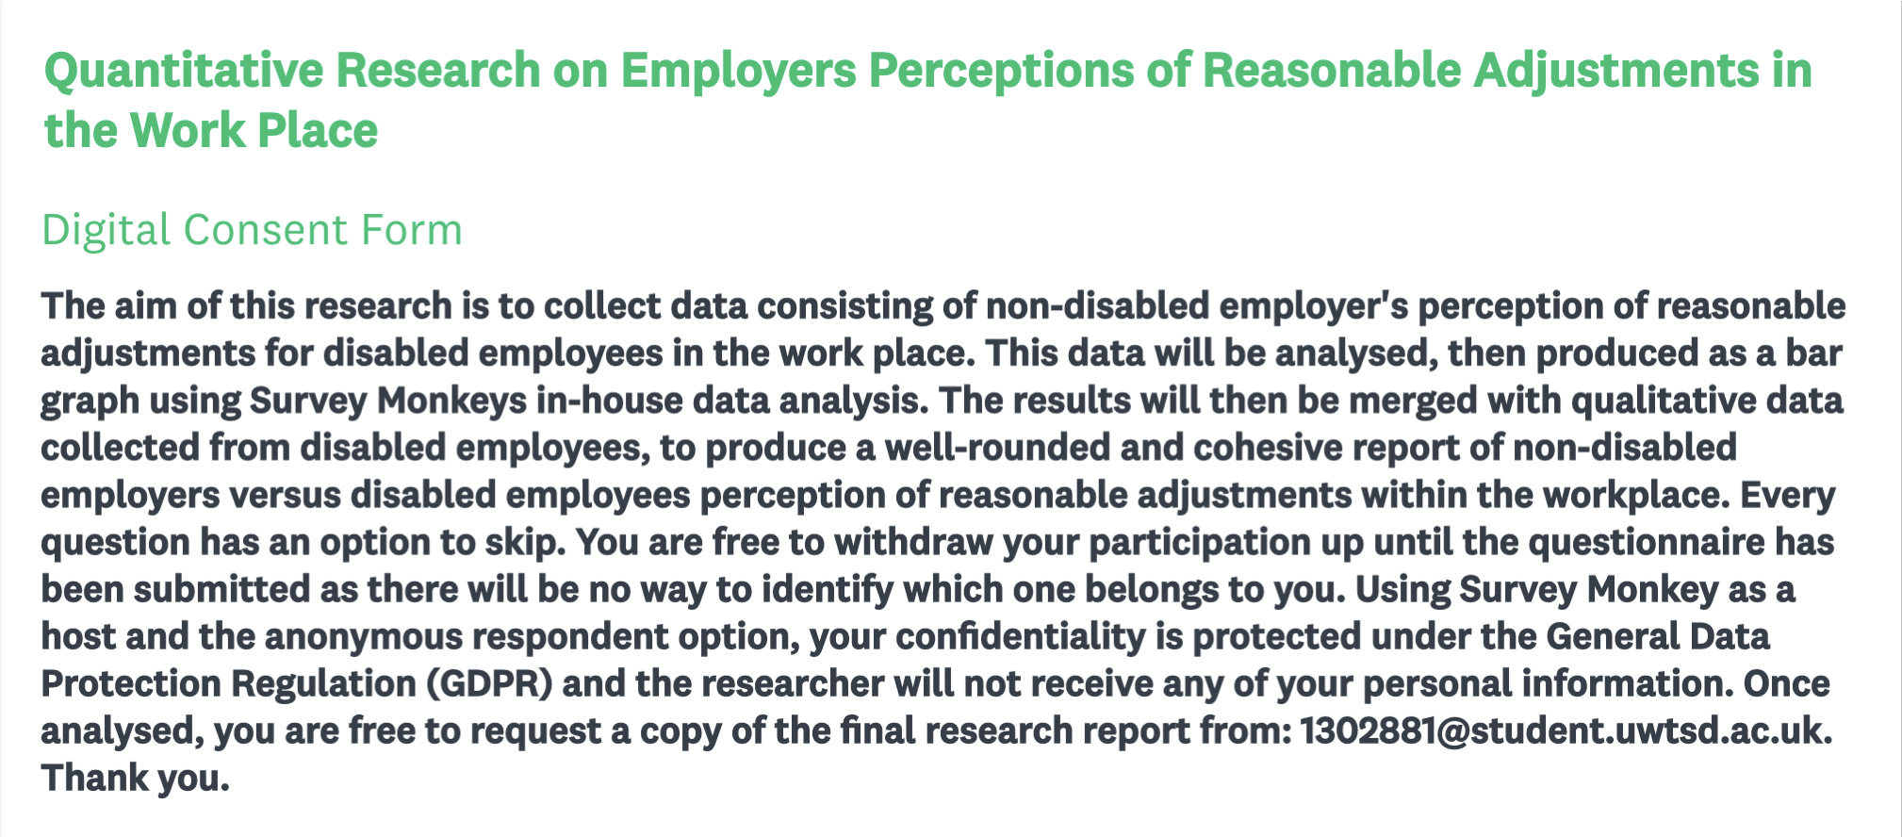
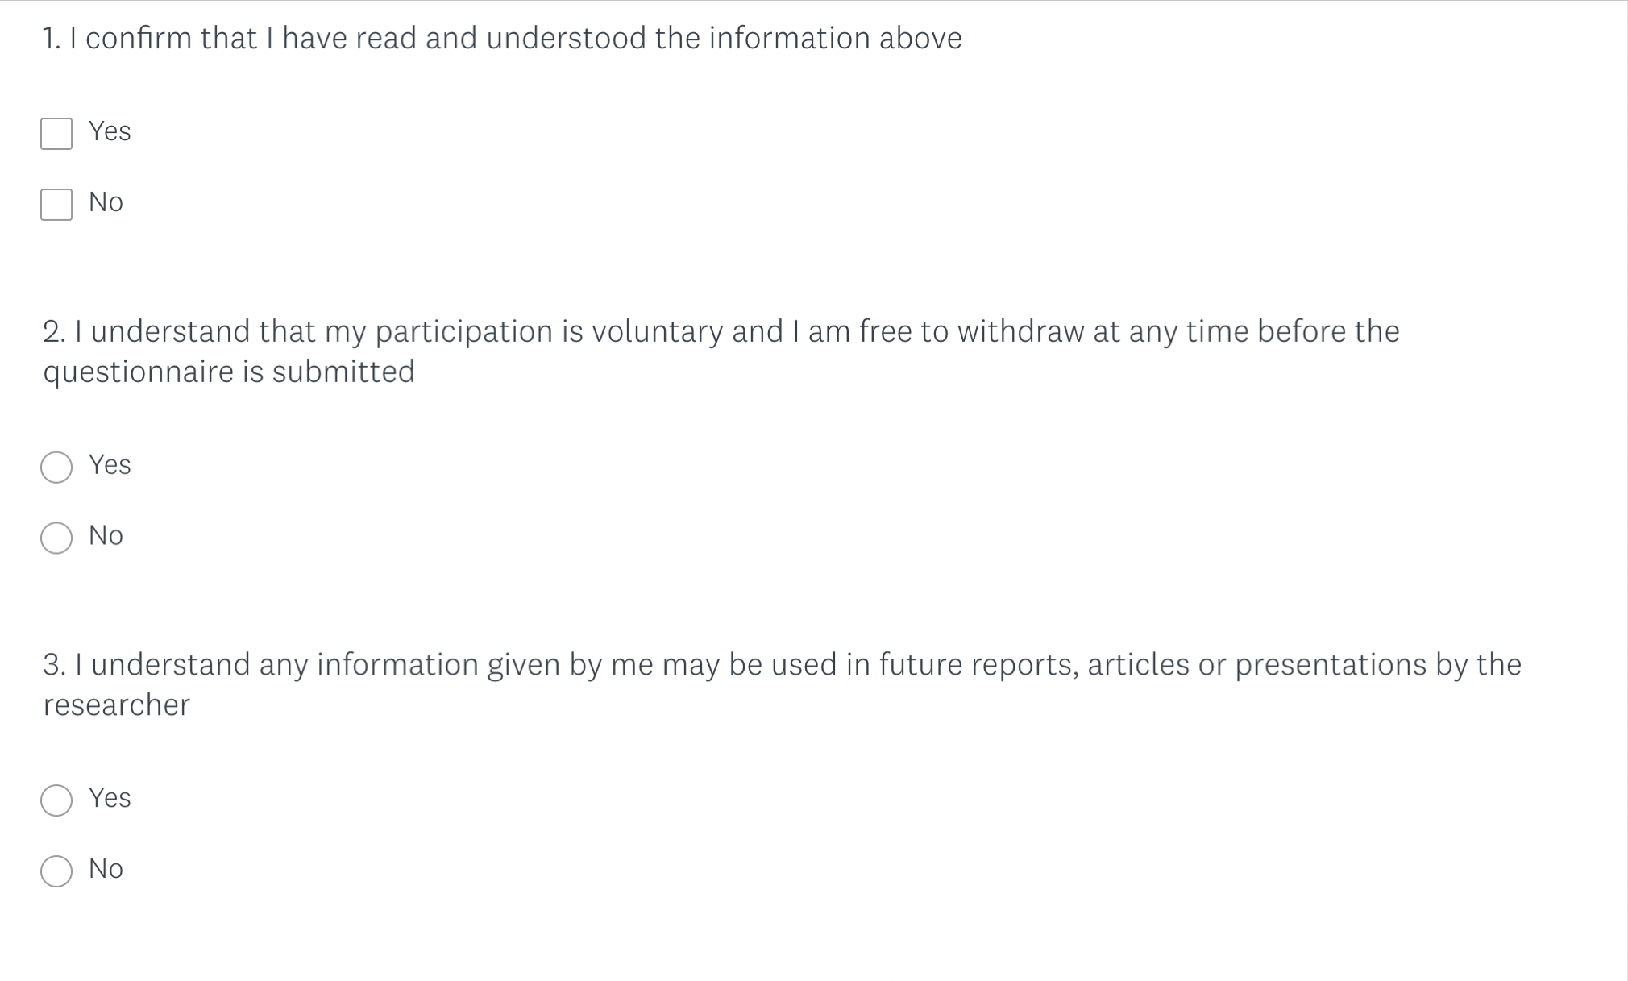
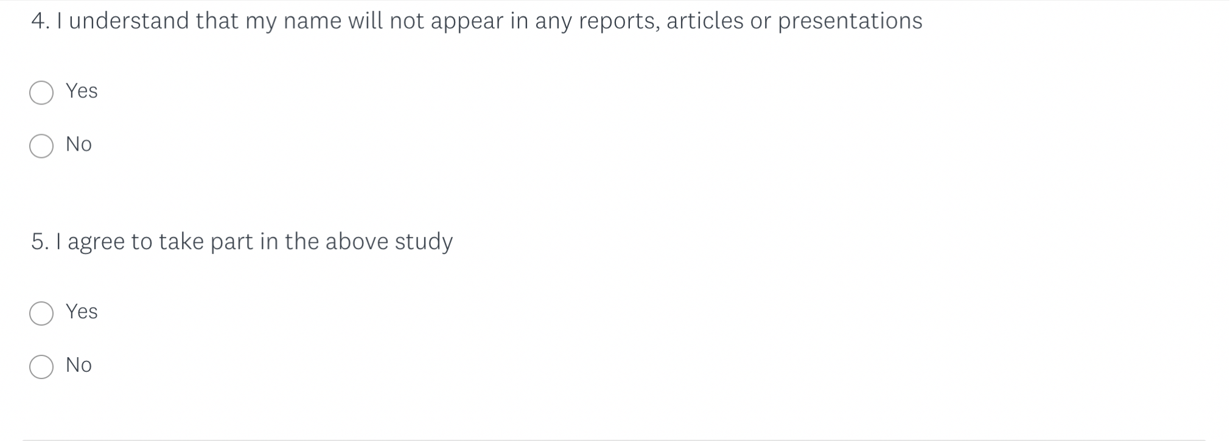

Appendix B:
Sample of Online Questionnaire Questions
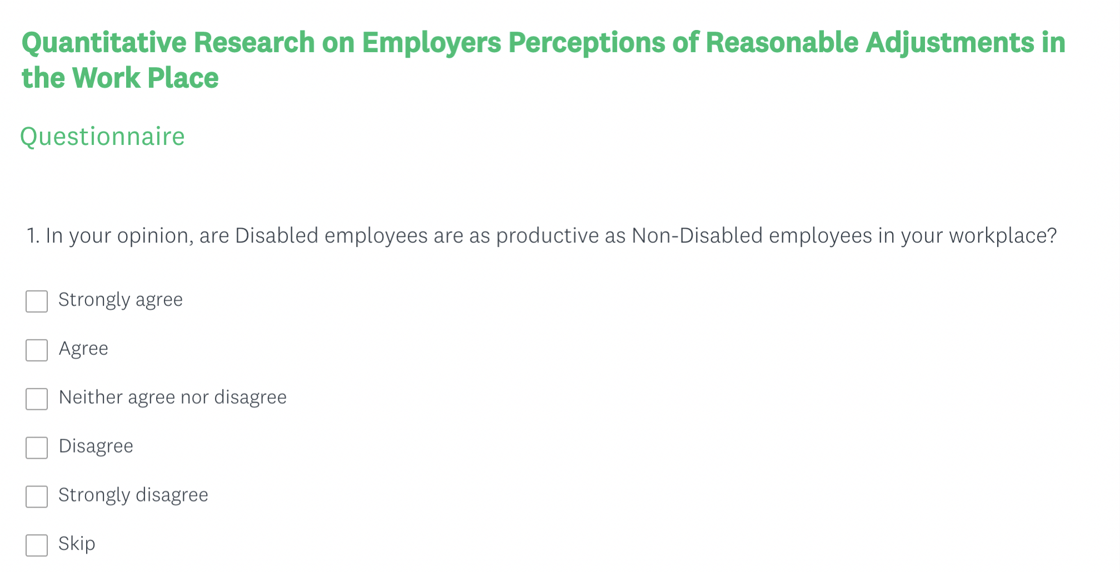
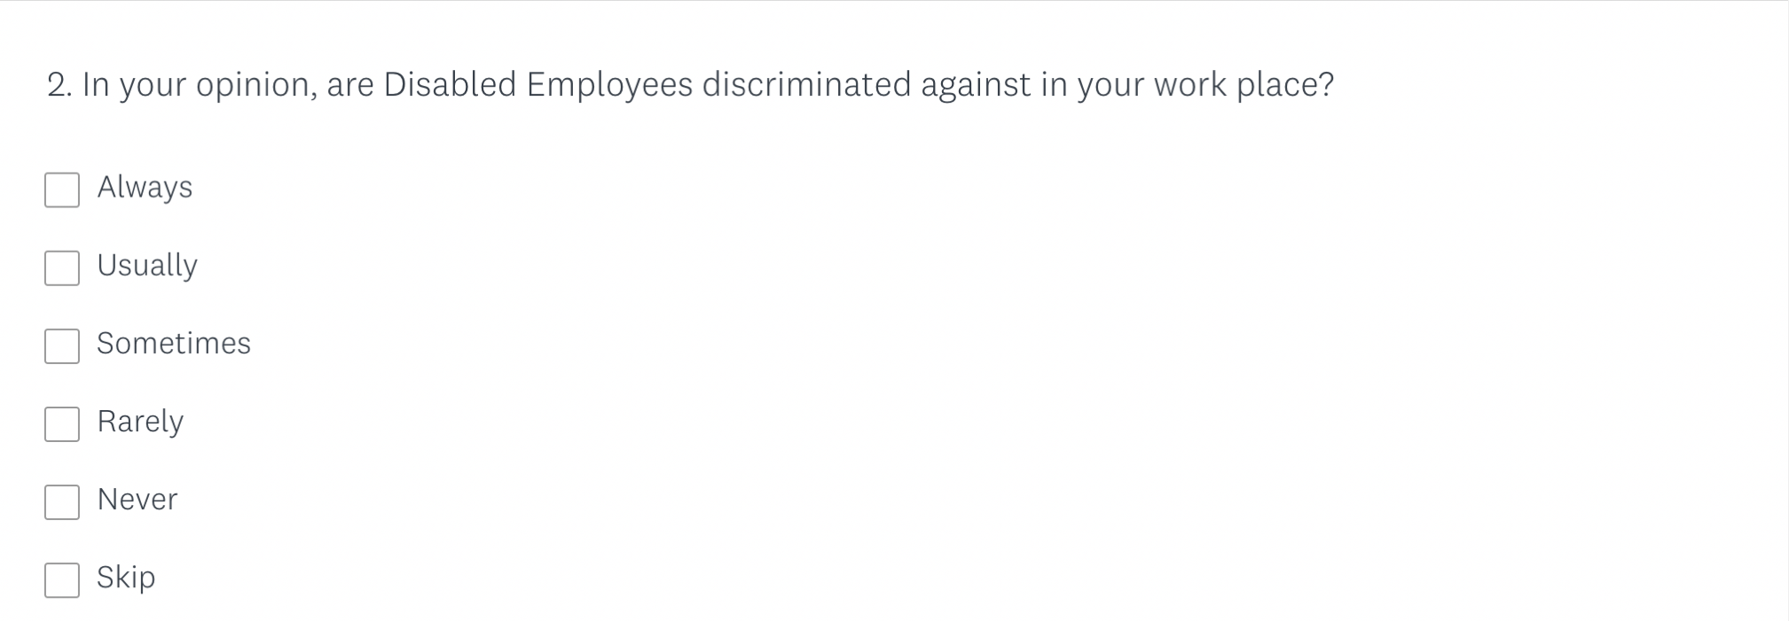
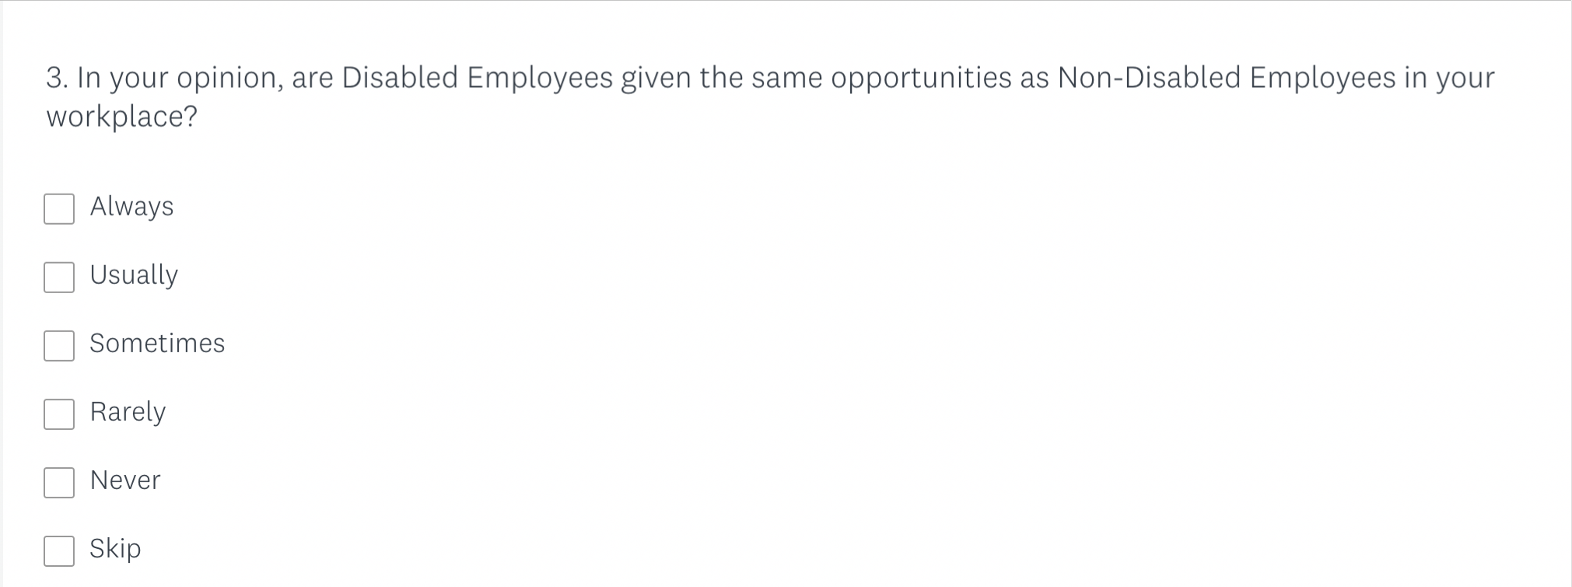
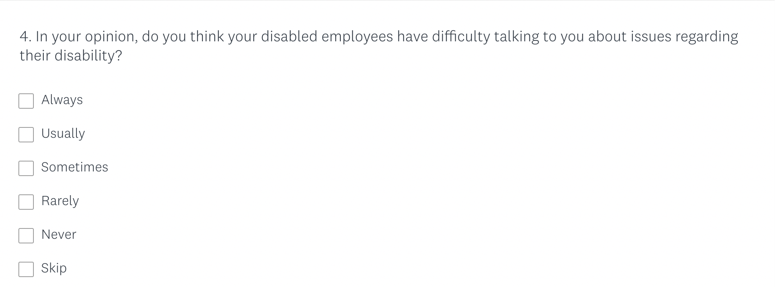
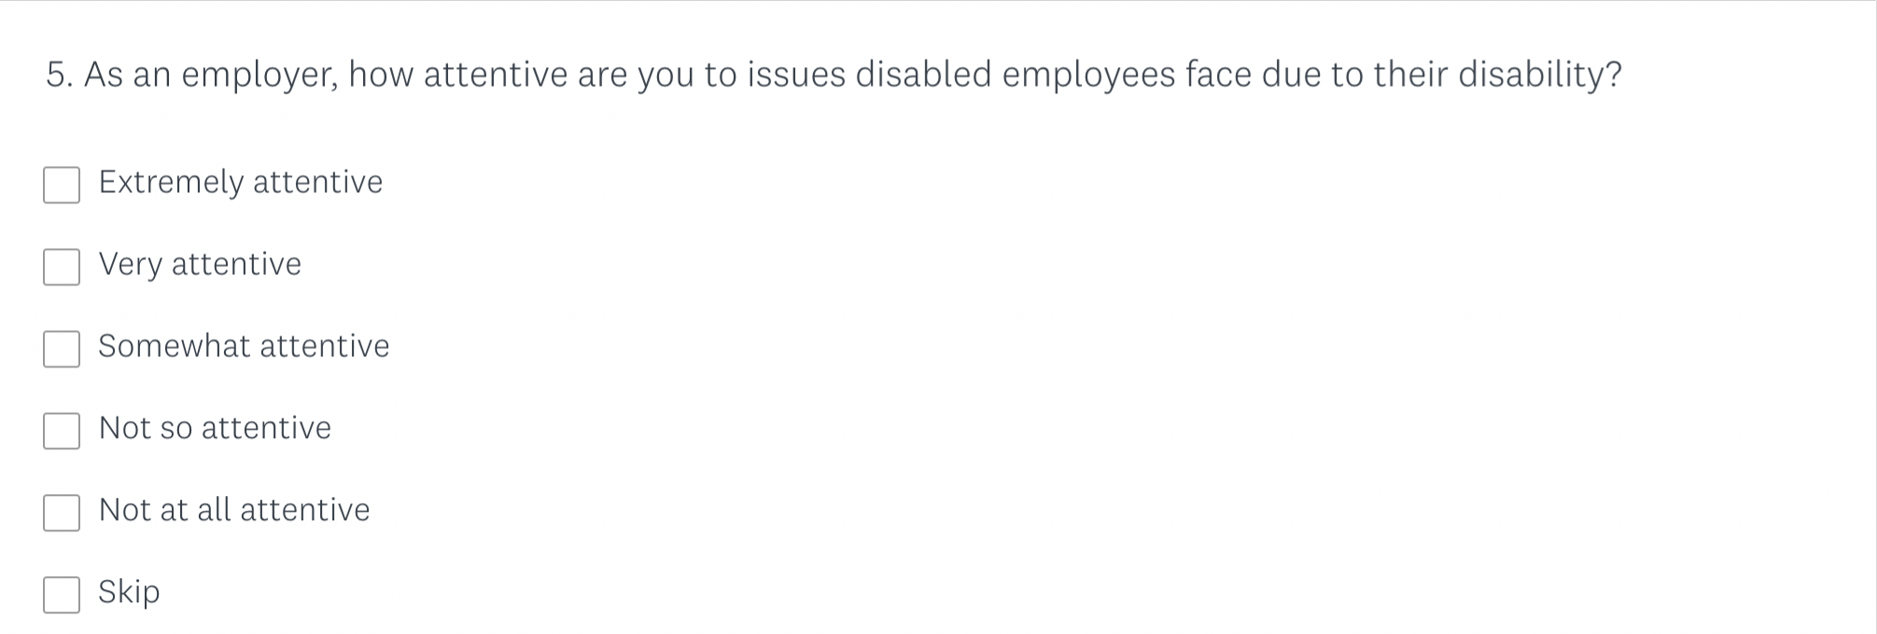
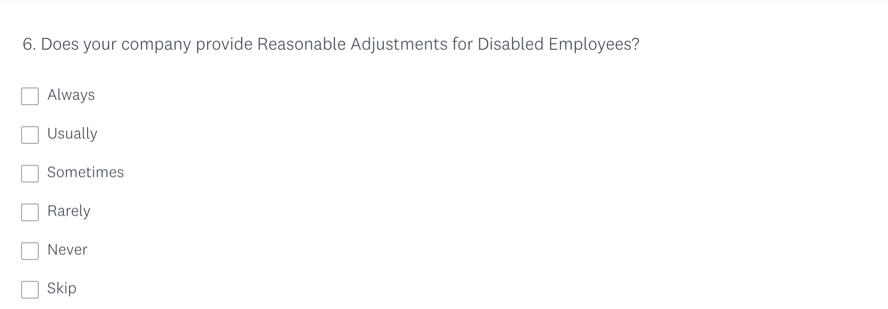

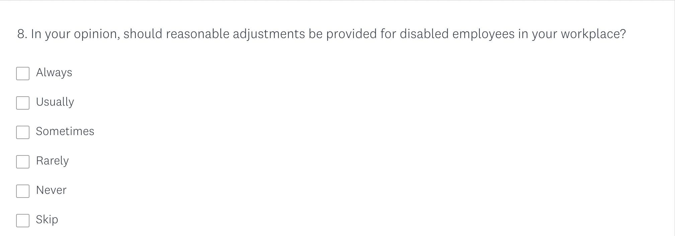
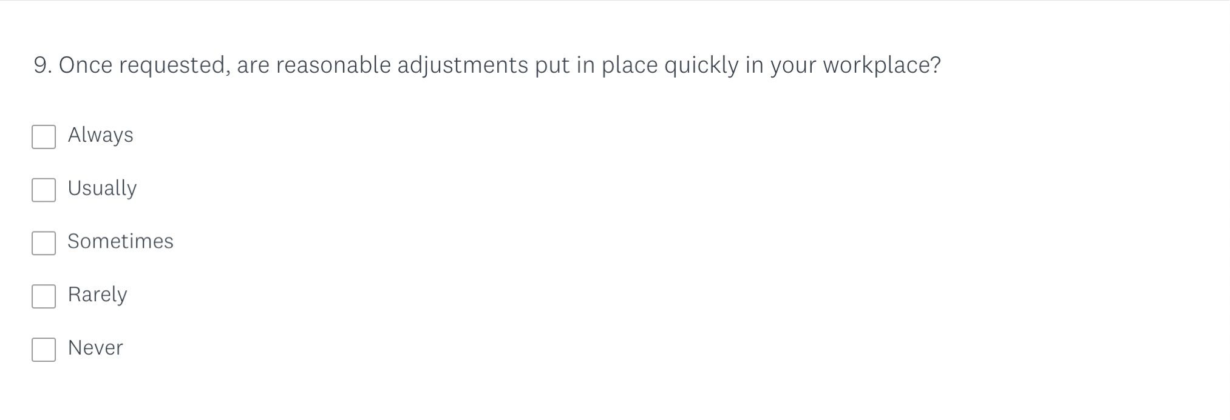
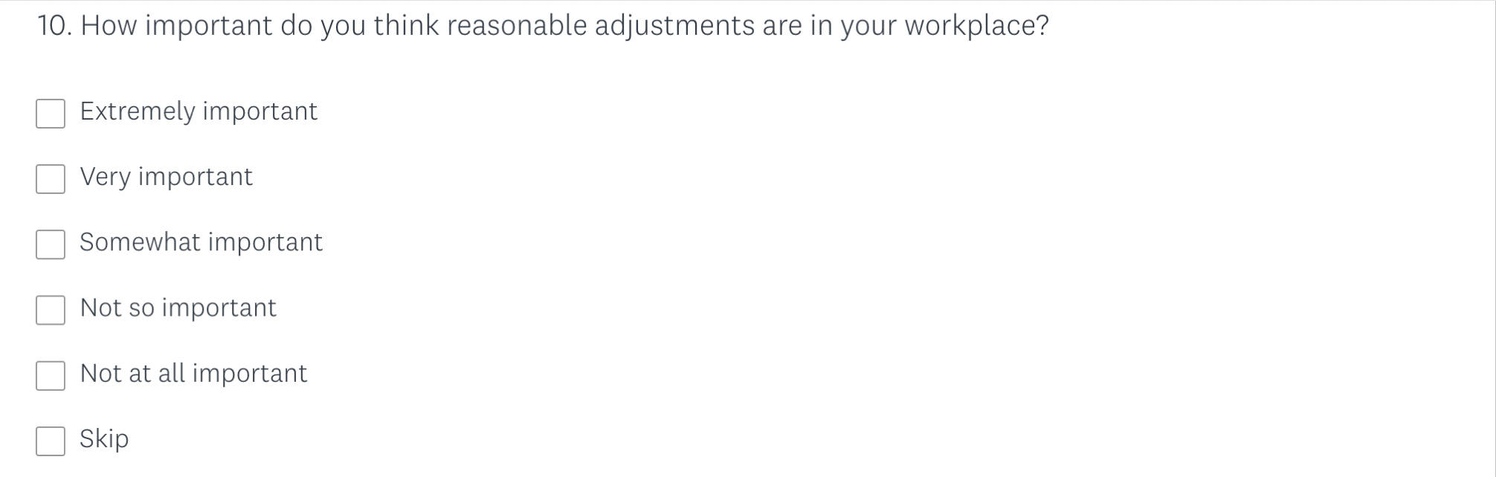
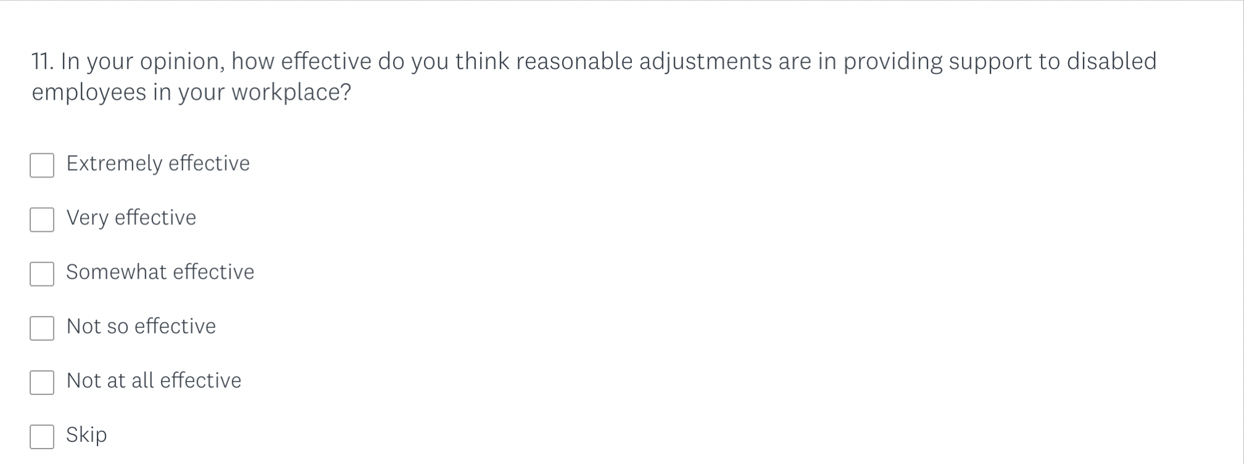

Appendix C:
Letter to Gatekeeper

Unite House
128 Theobalds Road
Holborn, London
WC1X 8TN

20th September 2019

Dear whomever this may concern,

I am a first year MA Equity and Diversity student at the University of Wales Trinity Saint David and as part of my studies I am required to conduct a research project. I have identified a need for research into reasonable adjustments in the workplace and I am writing to ask if it would be possible to recruit participants for this study from your organisation. This study will include the perception and experience of reasonable adjustments in by disabled employees, and the perception of reasonable adjustments by non-disabled employers. I am approaching your organisation, as I am aware of the successful work you do with disabled workers, and the trust they place in you.

I have prepared a description of the study and what is involved in it for potential participants, and I will attach a copy for you to read. Ideally, I would like to begin data collection in November 2019.

I would anticipate that the project would take no more than 90 minutes, and I would have a quiet place on my University’s premises to conduct the study.

Many thanks for taking the time to read this and I hope to hear from you soon.
Yours faithfully,

Hannah Graham
1302881@student.uwtsd.ac.uk

Appendix D:
Letter of Introduction to Participant

 | Participant Identification Number: | 1
 | PARTICIPANT INFORMATION SHEET
Project Title:
The Perception of Reasonable Adjustments in the Workplace by Non-Disabled Employers and Disabled Employees.

Dear Participant:

My name is Hannah Graham and I am student studying MA Equity and Diversity at the University of Wales Trinity Saint David.

I would like to invite you to participate in my research project. This project aims to present a cohesive collection of data in relation to reasonable adjustments in the work place, and the perception of its effectiveness. The objective will be to promote awareness in how non-disabled employers perceive reasonable adjustments compared to disabled employees, with the aim to stimulate change.

Through your participation in the focus group, I hope to discover more on how you perceive reasonable adjustments and experiences you have had requesting or receiving reasonable adjustments in the workplace.

All questionnaires will be kept strictly confidential to the researchers involved and at NO time will personal data be released to the general public. This gives you a chance to express your views confidentially and anonymously and still be able to make a difference. Your participation in this study is completely voluntary so you can withdraw at any stage.

The focus group should take no longer than 90 minutes to complete and will consist of 6-8 participants. You will not be required to share any personal characteristics with other participants or the research, and will be identified as a number through the data collection and data analysis process.

After careful and precise analysis of the data obtained from this focus group, I will be happy to provide you with a copy of the findings at your request. The results of this questionnaire will hopefully enhance the understanding of reasonable adjustments within the workplace and will be stored on the researchers personal password protected laptop. The focus group will be recorded using audio recording. There will be a clear audit trail while the research is on going, but once analysed the raw data will be destroyed. The results of the research will be shared with disability charities within the UK, and trade unions that work with disabled workers. Once shared, these organisations will have the freedom to share the final report as they wish.

We thank you in advance for your time and participation. If any questions do arise, feel free to contact me at your convenience.

NAME & ADDRESS OF RESEARCHER
Hannah Graham
5 Old Oak Lane
Carmarthen
Carmarthenshire
SA31 1NY

Appendix E:
Participant Consent Form
 | Rhif Adnabod Cyfranogwr:  Participant Identification Number: | 1
FFURFLEN GANIATÂD CYFRANOGIAD | PARTICIPATION CONSENT FORM
Teitl Y Prosiect: / Project Title: The Perception of Reasonable Adjustments in the Workplace by Non-Disabled Employers and Disabled Employees.

Enw'r Ymchwilydd / Name of Researcher: Hannah Graham

Blwch Cychwynnol / Please initial box
1 | Cadarnhaf fy mod wedi darllen a deall y daflen wybodaeth dyddiedig ar gyfer yr astudiaeth uchod. Rwyf wedi cael y cyfle i ystyried y wybodaeth, gofyn cwestiynau, ac rwyf wedi cael ateb boddhaol i’r rhain. |  | I confirm that I have read and understand the information sheet dated for the above study. I have had the opportunity to consider the information, ask questions and have had these answered satisfactorily.
2 | Deallaf fy mod yn cymryd rhan o’m gwirfodd a bod croeso i mi dynnu’n ôl ar unrhyw adeg, heb roi rheswm. |  | I understand that my participation is voluntary and that I am free to withdraw at any time, without giving any reason.
3 | Deallaf y gellir defnyddio unrhyw wybodaeth a roddir gennyf mewn adroddiadau, erthyglau neu gyflwyniadau gan y tîm ymchwil. |  | I understand that any information given by me may be used in future reports, articles or presentations by the research team.
4 | Deallaf na fydd fy enw’n ymddangos mewn unrhyw adroddiadau, erthyglau neu gyflwyniadau. |  | I understand that my name will not appear in any reports, articles or presentations.
5 | Cytunaf i gymryd rhan yn yr astudiaeth uchod. |  | I agree to take part in the above study.
Enw’r Cyfranogwr Name of Participant |  |  |  | Llofnodwyd  Signature
Ymchwilydd  Researcher |  | Hannah Graham |  | Llofnodwyd  Signature: H. Graham

Cewch wrthod cymryd rhan yn yr astudiaeth hon. Cewch ddod â’ch cyfranogiad yn yr astudiaeth hon i ben unrhyw bryd. Os penderfynwch barhau’n ddienw, bydd sicrhau hynny’n flaenoriaeth a chymerir pob cam ymarferol i guddio pwy ydych. Os yw’n well gennych fod yn anhysbys, ni fydd unrhyw wybodaeth yn eich enwi ar dapiau sain na thrawsgrifiadau o’r cyfweliad hwn nac o unrhyw un arall. Ni fydd neb yn clywed unrhyw dapiau sain nac yn gweld unrhyw drawsgrifiadau heb eich cydsyniad o flaen llaw. Bydd deunyddiau a grëir yn sgil y cyfweliad hwn neu unrhyw gyfweliad arall yn aros yn gyfrinachol. | You may decline to participate in this study. You may end your participation in this study at any time. If you decide to remain anonymous, maintaining your anonymity will be a priority and every practical precaution will be taken to disguise your identity. If you prefer anonymity, there will not be any identifying information on audiotapes or transcripts of this or any interview. No-one will hear any audiotapes or see any transcripts without your prior consent. All materials generated from this or any interview will remain confidential.

Ar ôl llenwi’r ffurflen, dychwelwch hi yn yr amlen a ddarperir (lle bo’n berthnasol). Rhoddir un copi i’r cyfranogwr a chedwir y gwreiddiol yn ffeil y tîm ymchwilio yn: | When completed please return in the envelope provided (if applicable). One copy will be given to the participant and the original to be kept on the file of the research team at:
ENW A CHYFEIRIAD YR YMCHWILYDD | NAME & ADDRESS OF RESEARCHER  Hannah Graham  5 Old Oak Lane,  Carmarthen  Carmarthenshire  Wales  SA31 1NY

Appendix F:
Completed Ethics Form

APPLICATION FOR ETHICAL APPROVAL

In order for research to result in benefit and minimise risk of harm, it must be conducted ethically. A researcher may not be covered by the University’s insurance if ethical approval has not been obtained prior to commencement.

SECTION A: About You (Principal Researcher)
Full Name: |  | Hannah Bernadette Graham
Tick all boxes which apply: |  | Member of staff: | ☐ | Honorary research fellow: | ☐
Undergraduate Student | ☐ | Taught Postgraduate Student | - ☐ | Postgraduate Research Student | ☐

Institute/Academic Discipline/Centre: | University of Wales Trinity Saint David
Campus: | Carmarthen
E-mail address: | 1302881@student.uwtsd.ac.uk
Contact Telephone Number: | 07837626100
For students:
Student Number: | 1302881
Programme of Study: | MA Equity and Diversity in Diversity
Director of Studies/Supervisor: | Dr Nichola Welton

SECTION B: Approval for Research Activity
Has the research activity received approval in principle?  (please check the Guidance Notes as to the appropriate approval process for different levels of research by different categories of individual) |  | YES | - ☐ | NO | ☐
 |  |  |  | Date
If Yes, please indicate source of approval (and date where known): Approval in principle must be obtained from the relevant source prior to seeking ethical approval | Research Degrees Committee |  | ☐
 | Institute Research Committee |  | ☐
 | Other (write in) |  | - ☐ | Approval from Supervisor (26/11/2019)

SECTION C: Internal and External Ethical Guidance Materials
Please list the core ethical guidance documents that have been referred to during the completion of this form (including any discipline-specific codes of research ethics, and also any specific ethical guidance relating to the proposed methodology). Please tick to confirm that your research proposal adheres to these codes and guidelines.
UWTSD Research Ethics & Integrity Code of Practice | - ☐
UWTSD Research Data Management Policy | - ☐
General Data Protection Regulation
British Sociological Association Statement of Ethical Practice (2017) | - ☐

SECTION D: External Collaborative Research Activity
Does the research activity involve collaborators outside of the University? |  | YES | ☐ | NO | - ☐
Institution
Contact person name
Contact person e-mail address

Has this individual consented to sharing their details on this form? |  | YES | ☐ | NO |  |  | ☐
Are you in receipt of a KESS scholarship? |  | YES | ☐ | NO |  |  | ☐
Is your research externally funded |  | YES | ☐ | NO |  |  | ☐
Are you specifically employed to undertake this research in either a paid or voluntary capacity? | Voluntary | YES | ☐ | NO |  | ☐
 | Employed | YES | ☐ | NO |  | ☐
Is the research being undertaken within an existing UWTSD Athrofa Professional Learning Partnership (APLP) | If YES then the permission question below does not need to be answered. | YES | ☐ | NO |  |  | ☐
Permission to undertake the research has been provided by the partner organisation | (If YES attach copy)  If NO the application cannot continue | YES | ☐ | NO |  |  | ☐

Where research activity is carried out in collaboration with an external organisation
Does this organisation have its own ethics approval system? | YES | ☐ | NO | ☐
If Yes, please attach a copy of any final approval (or interim approval) from the organisation

SECTION E: Details of Research Activity
Indicative title: | The Perception of Reasonable Adjustments in the Workplace by Non-Disabled Employers and Disabled Employees.
Proposed start date: | September 2019 | Proposed end date: | July 2020
Purpose of Research Activity

The purpose of this research will provide a contemporary review of reasonable adjustments in the workplace.
Not only will this research demonstrate the perception and experience of reasonable adjustments by disabled employees, it will also provide the vantage point of the non-disabled employer. Combining these two elements will build upon current knowledge in this field by providing a multifaceted analysis of the same phenomenon.

Research Question

The Perception of Reasonable Adjustments in the Workplace by Non-Disabled Employers and Disabled Employees.

Aims of Research Activity
This research will aim to provide a new perspective on reasonable adjustments in the workplace and an insight into its effectiveness.

Objectives of Research Activity

The objective of this research is to stimulate change. To do this, the research activity will give a platform to build upon current legislation and methods currently used to provide reasonable adjustments to disabled employees.

Proposed methods
This study will use methodological triangulation, working within a convergent/concurrent triangulation framework. This means that the research will be examined through the lens of quantitative and qualitative data, with both playing an equal role.
To carry out the quantitative side of the research, an online questionnaire will be used. Given the sensitive nature of this research, where the non-disabled employers may not want to give their true feelings, an indirect contact survey can increase the likelihood of honest and open answers, rather than the feeling of social pressure and morality that could impose upon direct contact. This research will be using a web questionnaire, using an online survey web host endorsed by the University.
Moving onto the qualitative aspect of this study, a single semi-structured focus group, where the researcher acts as the facilitator, will be conducted to gather disabled employees perceptions and experiences around reasonable adjustments in the work place.
For the safety of both the researcher and the participants, the focus group will be held in a rented room at the University of Wales Trinity Saint David, Carmarthen Campus, and will be documented using audio recording equipment belonging to the researcher. Participants will be provided with a concise and easy to read introduction letter explaining the research being undertaken and their involvement, along with a consent form including their right to withdraw from the study at any time.

Location of research activity
Identify all locations where research activity will take place.
All data from the web questionnaire will be obtained from persons residing in the UK.
The focus group will take place in a private room at The University of Wales Trinity Saint David, Carmarthen Campus.

Research activity outside of the UK
If research activity will take place overseas, you are responsible for ensuring that local ethical considerations are complied with and that the relevant permissions are sought. Specify any local guidelines (e.g. from local professional associations/learned societies/universities) that exist and whether these involve any ethical stipulations beyond those usual in the UK (provide details of any licenses or permissions required). Also specify whether there are any specific ethical issues raised by the local context in which the research activity is taking place, for example, particular cultural and/or legal sensitivities or vulnerabilities of participants.
Use of documentation not in the public domain: Are any documents NOT publicly available? | NO | - ☐
 | YES | ☐
If Yes, please provide details here of how you will gain access to specific documentation that is not in the public domain and that this is in accordance with prevailing data protection law of the country in question and England and Wales.

SECTION F: Scope of Research Activity
Will the research activity include: | YES | NO
Use of a questionnaire or similar research instrument? | - ☐ | ☐
Use of interviews? | - ☐ | ☐
Use of diaries? | ☐ | - ☐
Participant observation with their knowledge? | ☐ | - ☐
Participant observation without their knowledge? | ☐ | - ☐
Use of video or audio recording? | - ☐ | ☐
Access to personal or confidential information without the participants’ specific consent? | ☐ | - ☐
Administration of any questions, test stimuli, presentation that may be experienced as physically, mentally or emotionally harmful / offensive? | ☐ | - ☐
Performance of any acts which may cause embarrassment or affect self-esteem? | ☐ | - ☐
Investigation of participants involved in illegal activities? | ☐ | - ☐
Use of procedures that involve deception? | ☐ | - ☐
Administration of any substance, agent or placebo? | ☐ | - ☐
Working with live vertebrate animals? | ☐ | - ☐
Other primary data collection methods, please explain in this box  For example, ‘focus groups’. Please indicate the type of data collection method(s) in this box and tick the accompany box. | ☐ | - ☐
Details of any other primary data collection method: | ☐ | - ☐

If NO to every question, then the research activity is (ethically) low risk and may be exempt from some of the following sections (please refer to Guidance Notes).

If YES to any question, then no research activity should be undertaken until full ethical approval has been obtained.

SECTION G: Intended Participants
Who are the intended participants: | YES | NO
Students or staff at the University? | ☐ | - ☐
Adults (over the age of 18 and competent to give consent)? | - ☐ | ☐
Vulnerable adults? | - ☐ | ☐
Children and Young People under the age of 18? (Consent from Parent, Carer or Guardian will be required) | ☐ | - ☐
Prisoners? | ☐ | - ☐
Young offenders? | ☐ | - ☐
Those who could be considered to have a particularly dependent relationship with the investigator or a gatekeeper? | ☐ | - ☐
People engaged in illegal activities? | ☐ | - ☐
Others (please identify specifically any group who may be unable to give consent) please indicate here and tick the appropriate box. | ☐ | - ☐
Other – please indicate here: | ☐ | - ☐

Participant numbers and source
Provide an estimate of the expected number of participants. How will you identify participants and how will they be recruited?
How many participants are expected? | A maximum of 500 questionnaires will be sent out with the aim to receive 385 respondents.  The focus group will contain 6-8 participants.
Who will the participants be? | The respondents for the questionnaire will be a random sample provided by the web host’s survey panel. This sample will be made up of non-disabled employers who reside in the UK.  The participants for the focus group will be disabled employees who have received or requested reasonable adjustments, also residing in the UK.
How will you identify the participants? | The web host will identify the questionnaire respondents, using their survey panel of voluntary members.  The researcher will not be made aware of their personal details or any personal characteristics.  The focus group participants will be identified on all documents and data using numbers. Aside from the eligibility criteria described above, participants will not be required to share any personal characteristics including age, specific job title or nature of their disability. The participants will be recruited through a union, Unite the Union, and the union will act as a gatekeeper, providing access to the researcher to potential participants.

Information for participants: | YES | NO | N/A
Will you describe the main research procedures to participants in advance, so that they are informed about what to expect? | - ☐ | ☐ | ☐
Will you tell participants that their participation is voluntary? | - ☐ | ☐ | ☐
Will you obtain written consent for participation? | - ☐ | ☐ | ☐
Will you explain to participants that refusal to participate in the research will not affect their treatment or education (if relevant)? | ☐ | ☐ | - ☐
If the research is observational, will you ask participants for their consent to being observed? | ☐ | ☐ | - ☐
Will you tell participants that they may withdraw from the research at any time and for any reason? | - ☐ | ☐ | ☐
With questionnaires, will you give participants the option of omitting questions they do not want to answer? | - ☐ | ☐ | ☐
Will you tell participants that their data will be treated with full confidentiality and that, if published, it will not be identifiable as theirs? | - ☐ | ☐ | ☐
Will you debrief participants at the end of their participation, in a way appropriate to the type of research undertaken? | - ☐ | ☐ | ☐
If NO to any of above questions, please give an explanation

Information for participants: | YES | NO | N/A
Will participants be paid? | ☐ | - ☐ | ☐
Is specialist electrical or other equipment to be used with participants? | - ☐ | ☐ | ☐
Are there any financial or other interests to the investigator or University arising from this study? | ☐ | - ☐ | ☐
Will the research activity involve deliberately misleading participants in any way, or the partial or full concealment of the specific study aims? | ☐ | - ☐ | ☐
If YES to any question, please provide full details
An audio recording device will be used to record the focus group. This device is personal property of the researcher, and participants will be informed that it is being used.

SECTION H: Anticipated Risks

Outline any anticipated risks that may adversely affect any of the participants, the researchers and/or the University, and the steps that will be taken to address them.

If you have completed a full risk assessment (for example as required by a laboratory, or external research collaborator) you may append that to this form.
Full risk assessment completed and appended? |  | Yes | ☐
 |  | No | - ☐
Risks to participants
For example: emotional distress, financial disclosure, physical harm, transfer of personal data, sensitive organisational information
Risk to Participant:  As the researcher will not be made aware of the personal details of questionnaire respondents, the risks to the respondents are minimal. Any breach of data protection is an anticipated risk to the respondent.  The focus group participants will consist of disabled adults therefore may be vulnerable. Confidentiality is also an anticipated risk for focus group participants. Misinterpretation may also be a risk for focus group participants. | How will you mitigate the Risk to Participant  The researcher will mitigate the risk to participants by adhering to the GDPR. The researcher will not receive any personal details or defining characteristics from the web host about the respondent. Using a web host protects the respondents further by maintaining anonymity and adhering to their own privacy policy.  The focus group participants will be recruited through a union acting as a gatekeeper. This adds an extra lay of protection to the participants. All participants will be given an introductory letter and consent form before any research is taken place. Participants will be made aware their participation is voluntary, and they may withdraw at any time. Participants will not be required to supply the researcher with their specific age, gender, job title or disability and will be identified by a participant number at all stages of the research protecting their confidentiality. Participants will be debriefed and able to request a copy of the final report.  The ethical guidelines being followed during this study will help protect and mitigate risks to all participants.
If research activity may include sensitive, embarrassing or upsetting topics (e.g. sexual activity, drug use) or issues likely to disclose information requiring further action (e.g. criminal activity), give details of the procedures to deal with these issues, including any support/advice (e.g. helpline numbers) to be offered to participants. Note that where applicable, consent procedures should make it clear that if something potentially or actually illegal is discovered in the course of a project, it may need to be disclosed to the proper authorities
Risks to investigator

Risk to Investigator:  There are not many anticipated risks to the researcher during this study. One anticipated risk is the possibility of participants accusing the researcher of unethical conduct. | How will you mitigate the Risk to Investigator:  The researcher keeping in constant contact with an academic supervisor will mitigate this risk. The focus group will be held in the University of Wales Trinity Saint David, Carmarthen Campus, providing a safe place for this to take place. Audio recording of the focus group will also provide the researcher with evidence of the discussion during the focus group. Using a gatekeeper to recruit the participants will also provide protection for the researcher, as well as the participants.
University/institutional risks

Risk to University:  Minimal risks are anticipated for the University. | How will you mitigate the Risk to University:  The researcher will follow all ethical guidelines referred to.

Disclosure and Barring Service
If the research activity involves children or vulnerable adults, a Disclosure and Barring Service (DBS) certificate must be obtained before any contact with such participants. | YES | NO | N/A
Does your research require you to hold a current DBS Certificate? | ☐ | ☐ | - ☐

SECTION I: Feedback, Consent and Confidentiality
Feedback
What de-briefing and feedback will be provided to participants, how will this be done and when?
The consent forms will contain contact details for the researcher and participants will be made aware they are entitled to request all findings of the research, and be free to withdraw from the study at any time.

Informed consent
Describe the arrangements to inform potential participants, before providing consent, of what is involved in participating. Describe the arrangements for participants to provide full consent before data collection begins. If gaining consent in this way is inappropriate, explain how consent will be obtained and recorded in accordance with prevailing data protection legislation.
To inform potential participants and respondents before providing consent, a letter of introduction will be provided to inform them what is involved in participating, what the research will involve and their right to withdraw from the study at anytime. Participant’s full consent will be obtained using a paper based consent form, and respondent’s full consent will be obtained using a digital consent form.

Confidentiality / Anonymity
Set out how anonymity of participants and confidentiality will be ensured in any outputs. If anonymity is not being offered, explain why this is the case.
All information collected will be confidential, with participants and respondents providing limited defining characteristics, this will lessen the possibility of identifiable records. The paper based consent forms will be stored in a locked drawer on the researcher’s private property. Digital consent forms will be stored on the researcher’s personal laptop which is password protected. In reference to the focus group, participants will be informed before participation that an audio recording device will be used. The audio recording device is personal property of the researcher and will be kept with the paper based consent forms, and the recording will be transferred to the researcher’s password protected laptop before being deleted from the audio recording device. Numbers will identify all participants, protecting their anonymity. All data collected and all research will be done using the researcher’s personal laptop with password protection, and all data will be destroyed once the study is completed.

SECTION J: Data Protection and Storage
In completing this section refer to the University’s Research Data Management Policy and the extensive resources on the University’s Research Data Management web pages (http://uwtsd.ac.uk/library/research-data-management/).
Does the research activity involve personal data (as defined by the General Data Protection Regulation 2016 “GDPR” and the Data Protection Act 2018 “DPA”)? | YES | NO
“Personal data” means any information relating to an identified or identifiable natural person (‘data subject’). An identifiable natural person is one who can be identified, directly or indirectly, in particular by reference to an identifier such as a name, an identification number, location data, an online identifier or to one or more factors specific to the physical, physiological, genetic, mental, economic, cultural or social identity of that natural person. | - ☐ | ☐
If YES, provide a description of the data and explain why this data needs to be collected:
The only personal data collected from respondents/participants will be the signature of the focus group participants that will be signed on the consent form.

Does it involve special category data (as defined by the GDPR)? | YES | NO
“Special category data” means sensitive personal data consisting of information as to the data subjects’ –  (a) racial or ethnic origin,  (b) political opinions,  (c ) religious beliefs or other beliefs of a similar nature,  (d) membership of a trade union (within the meaning of the Trade Union and Labour Relations (Consolidation) Act 1992),  (e) physical or mental health or condition,  (f) sexual life,  (g) genetics,  (h) biometric data (as used for ID purposes), | ☐
If YES, provide a description of the special category data and explain why this data needs to be collected:
Will the research activity involve storing personal data and/or special category data on one of the following: |  | YES | NO
Manual files (i.e. in paper form)? |  | ☐ | - ☐
University computers? |  | ☐ | - ☐
Private company computers? |  | ☐ | - ☐
Home or other personal computers? |  | - ☐ | ☐
Laptop computers/ CDs/ Portable disk-drives/ memory sticks? |  | - ☐ | ☐
“Cloud” storage or websites? |  | ☐ | - ☐
Other – specify: Audio Recording Device |  | - ☐ | ☐
For all stored data, explain the measures in place to ensure the security of the data collected, data confidentiality, including details of password protection, encryption, anonymisation and pseudonymisation:
All data collected will be stored on the researcher’s password protected personal laptop. Paper based consent forms, and the audio recording device, will be stored in the researcher’s private property in a locker drawer. Participants and respondents will be identified using numbers to protect their anonymity. All data will be permanently destroyed once the study is completed.

All Data Storage
Will the research activity involve any of the following activities: |  | YES | NO
Electronic transfer of data in any form? |  | ☐ | - ☐
Sharing of data with others at the University? |  | ☐ | - ☐
Sharing of data with other organisations? |  | ☐ | - ☐
Export of data outside the European Union or importing of data from outside the UK? |  | ☐ | - ☐
Use of personal addresses, postcodes, faxes, emails or telephone numbers? |  | ☐ | - ☐
Publication of data that might allow identification of individuals? |  | ☐ | - ☐
Use of data management system? |  | ☐ | - ☐
Data archiving? |  | ☐ | - ☐
If YES to any question, please provide full details, explaining how this will be conducted in accordance with the GDPR and DPA (and/or any international equivalent):
List all who will have access to the data generated by the research activity:
The researcher.

List who will have control of, and act as custodian(s) for, data generated by the research activity:
The researcher.

Give details of data storage arrangements, including security measures in place to protect the data, where data will be stored, how long for, and in what form. Will data be archived – if so how and if not why not.
The data will be stored on the researcher’s personal laptop. This laptop is password protected. The paper based consent form and audio recording device will be stored on the researcher’s private property in a locked drawer. All data, digital or paper based, will be permanently destroyed once the study is completed. The data will not be archived once the final report is produced as the report will contain the analysis of the data collected, therefor there is no reason to archive the raw data.

Please indicate if your data will be stored in the UWTSD Research Data Repository (see https://researchdata.uwtsd.ac.uk/ ). If so please explain. (Most relevant to academic staff)
No

Confirm that you have read the UWTSD guidance on data management (see https://www.uwtsd.ac.uk/library/research-data-management/) | YES |  | - ☐
 | NO |  | ☐
Confirm that you are aware that you need to keep all data until after your research has completed or the end of your funding | YES |  | - ☐
 | NO |  | ☐

SECTION K: Declaration
The information which I have provided is correct and complete to the best of my knowledge. I have attempted to identify any risks and issues related to the research activity and acknowledge my obligations and the rights of the participants.

In submitting this application I hereby confirm that I undertake to ensure that the above named research activity will meet the University’s Research Ethics and Integrity Code of Practice which is published on the website: https://www.uwtsd.ac.uk/research/research-ethics/
Signature of applicant: | H. Graham | Date:  23/12/2019

For STUDENT Submissions:
Director of Studies/Supervisor: |  | Date:
Signature: |  | Date:

For STAFF Submissions:
Academic Director/ Assistant Dean: |  | Date:
Signature: |  | Date:

Checklist: Please complete the checklist below to ensure that you have completed the form according to the guidelines and attached any required documentation:
- ☐ | I have read the guidance notes supplied before completing the form.
- ☐ | I have completed ALL RELEVANT sections of the form in full.
- ☐ | I confirm that the research activity has received approval in principle
☐ | I have attached a copy of final/interim approval from external organisation (where appropriate)
☐ | I have attached a full risk assessment (and have NOT completed Section H of this form) (where appropriate) ONLY TICK IF YOU HAVE ATTACHED A FULL RISK ASSESSMENT
- ☐ | I understand that it is my responsibility to ensure that the above named research activity will meet the University’s Research Ethics and Integrity Code of Practice.
- ☐ | I understand that before commencing data collection all documents aimed at respondents (including information sheets, consent forms, questionnaires, interview schedules etc.) must be confirmed by the DoS/Supervisor, module tutor or Academic Director.
- ☐ | I have deleted the guidance notes before submitting the PG2 for consideration

RESEARCH STUDENTS AND STAFF ONLY
All communications relating to this application during its processing must be in writing and emailed to pgresearch@uwtsd.ac.uk , with the title ‘Ethical Approval’ followed by your name.
You will be informed of the outcome of your claim by email; therefore it is important that you check your University and personal email accounts regularly.

STUDENTS ON UNDERGRADUATE OR TAUGHT MASTERS PROGRAMMES should submit this form (and receive the outcome) via systems explained to you by the supervisor/module leader.

This form is available electronically from the Academic Office web pages: https://www.uwtsd.ac.uk/academic-office/appendices-and-forms/

