Coursework Title
Module Name: Operating Systems and CLI Report
Module Code: ACCA4022
Student Name: Jawad Safi
Student ID: 2511168
Lecturer Name: Md Shantanu Islam
Submission date: 27 March 2026

Introduction
Modern computing systems are inseparable without operating systems which provide a interface between hardware and users as well as manage system resources effectively. They offer the fundamental services like scheduling of processes, allocation of memory, file management, and security control. The report looks at the most important services of general-purpose, operating systems and also looks at how command-line interfaces (CLI) can be practically used both in Windows and Linux environments. In addition, it also shows how repetitive tasks in the administration can be automated through scripting. There are various academic and technical sources that support the discussion to prove the research interest and awareness of the operating system concepts.

Key functions of general Operating Systems
Operating systems do several fundamental tasks which make computers to work effectively and safely. Process management which is one of the main functions and entails creation, scheduling and termination of processes is involved. The operating system makes sure that the various processes can run at the same time without conflict through effective allocation of the CPU time. Applications like the windows task manager or tough Linux commands like top enable the user to view running processes and use of resources. Their usage illustrates visually how the CPU and memory resources are allocated between the active tasks and the role of the OS in the multitasking and optimisation of the performance [1].
The other very important role is memory handling where the operating system assigns and frees memory space on demand. It guarantees that processes do not interfere but have adequate memory capacity. Virtual memory methods expand physical memory by incorporating disk space in which the systems can execute larger applications effectively. This would be seen in system monitors where memory allocation and paging status is shown in real time [2].
Operating systems also have file system management as one of the core functions. The OS arranges data in files and directories, in control of storage, access and retrieval permissions. Windows and Linux have file systems like NTFS and ext4 respectively which offer ordered methods to store and safeguard data. Users can see and modify file properties using graphical programs such as file explorer or by using the command-line applications, this explains how the OS manages access and provides data integrity.
Another necessary functionality is device management since the operating system interacts with hardware devices via device drivers. This enables the applications to communicate with hardware without the need to know about its internal functionality. Applications like the Device Manager of Windows also offer an understanding of the hardware connected and the state of drivers, and this is how the OS coordinates the input and the output activities [3].
Unlike in the past, security and user management are becoming more significant features of the contemporary operating systems. The OS provides authentication and authorisation controls to allow only authorised users to access resources in the system. Sensitive information is secured by the use of user accounts, passwords and permissions which ensure the system stability. These capabilities are either controllable via system settings or command-line programs, which depict the role of the OS to ensure security [4].
Lastly, there are giving user interfaces, graphical user interfaces (GUI) and the command-line interface (CLI) which are provided by operating systems. Although GUIs are easier to use, CLIs are more dominant and allow more control among advanced users. Networking services also expand the functions of OS by providing the possibility of inter-system communication, which also gives users access to the resources of other systems and provides an effective exchange of information. These collective functions show that operating systems serve as resource managers and user interfaces, which make computing environments to be efficient and secure.
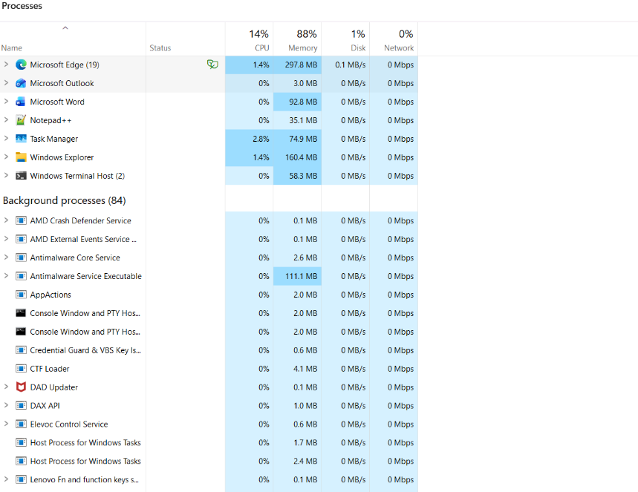
Figure 1: Task management
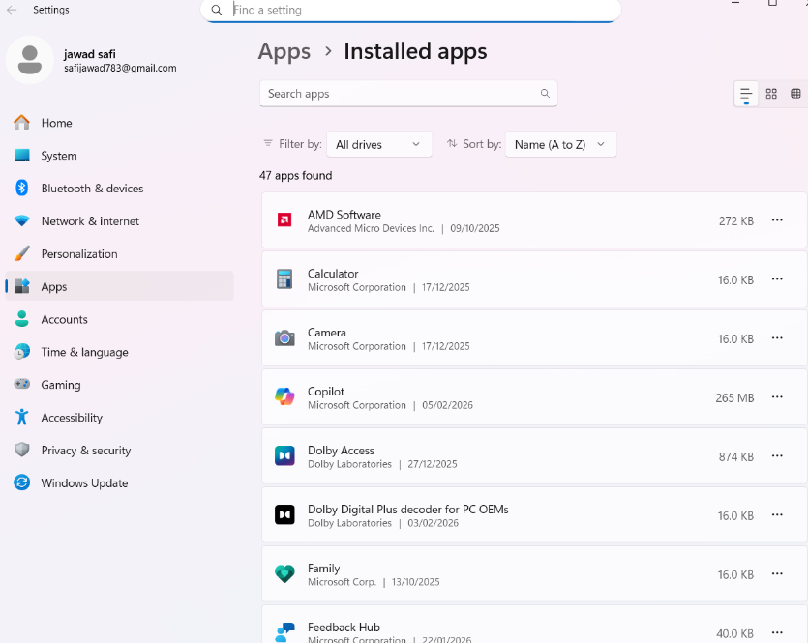
Figure 2: Description

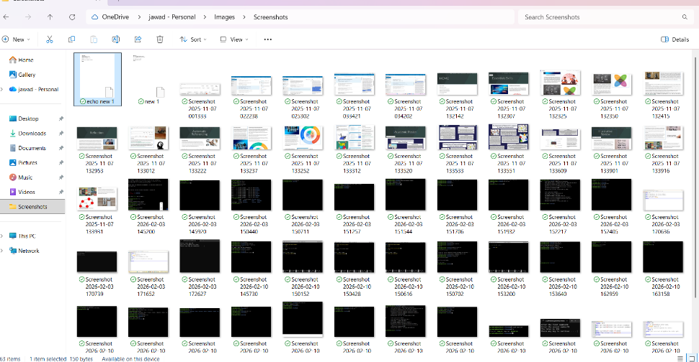
Figure 3: Description changing your location
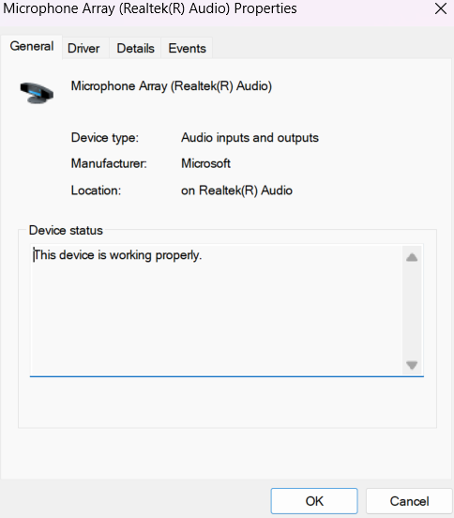
Figure 4: Description

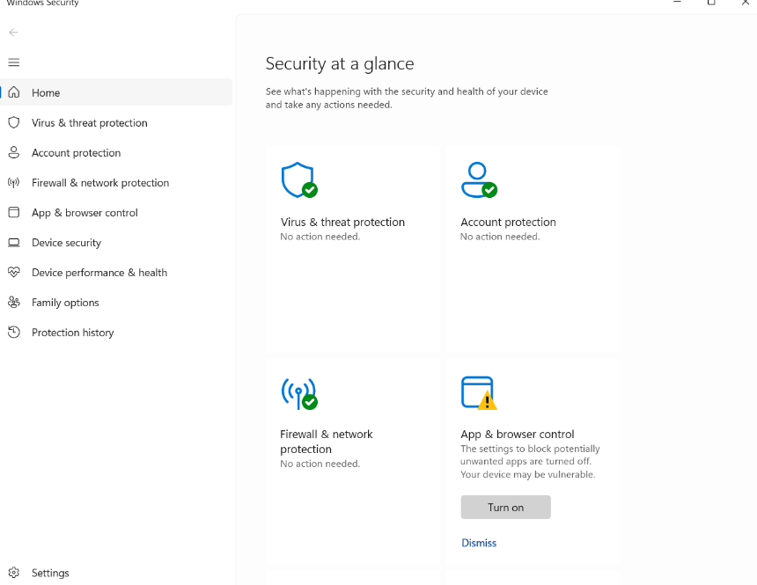
Figure 5: Description

Use of Windows OS CLI commands
Windows operating system offers effective command-line programs using Command Prompt and PowerShell which allows an individual to carry out administrative duties effectively. Such commands as task list may be used to manage processes and it will show all running processes together with process id and memory consumption. Task kill /PID <id> /F command enables one to cancel the processes in a forceful manner which proves to be in control of how the system runs. The following commands are especially applicable in terms of troubleshooting applications that are not responsive [3].
Management of files and directories is done using commands like dir which lists the contents of the directory and copy which copies the files. Del command is utilized to delete files and there are extra switches that enable a user to set the conditions of deletion recursively or confirmation prompt. These commands explain the way users can easily manipulate file systems without the use of graphical systems.
It requires network testing and monitoring to help in diagnosing the connectivity problems. The ipconfig /all command gives detailed configuration of a network such as IP addresses and DNS configuration. Ping command is used to check the connection between systems and the netstat and is used to show the active connections and ports that are listening. This combination of commands allows the users to monitor and troubleshoot the network performance [5].
User management in Windows can be done with the help of a net user command. An example of possibilities is - net user username password /add creates a new user account and user remove deletes a user account. These commands show how administrators can handle the access of users and keep the system secure.
Task scheduling is another key feature and routine tasks can be automated. The schtasks command: It can be used to create, query and delete scheduled tasks. For example, schtasks /create enables users to define a task that operators when it goes as scheduled instance or regularly. This functionality is critical to make maintenance activities like backups and updates automatic.
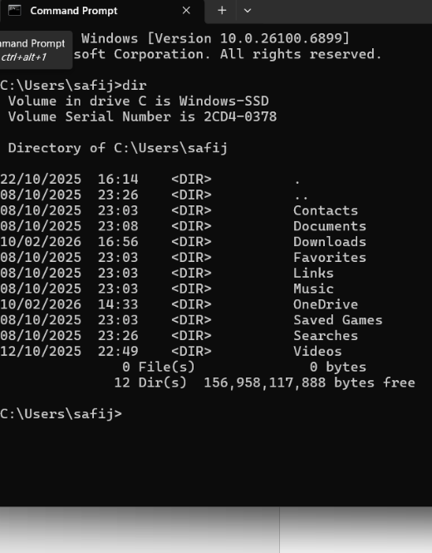
Figure 6: Description
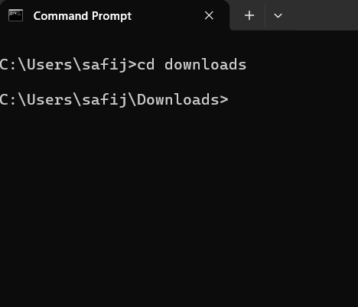
Figure 7: Description
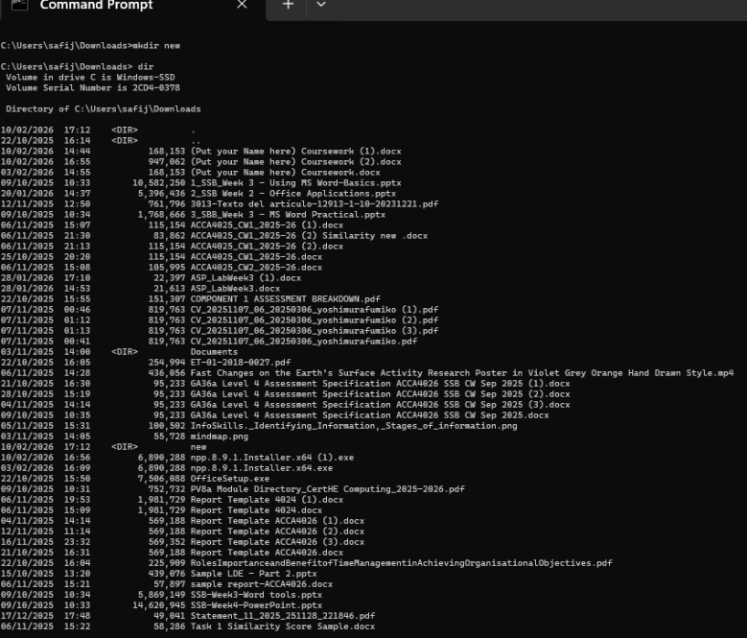
Figure 8: Description example cat
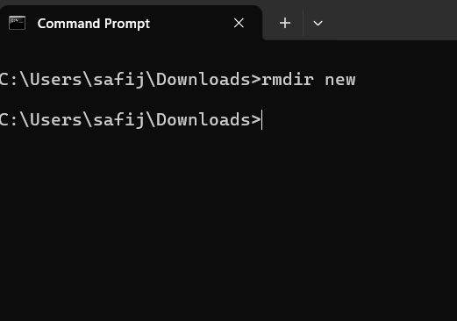
Figure 9: Description

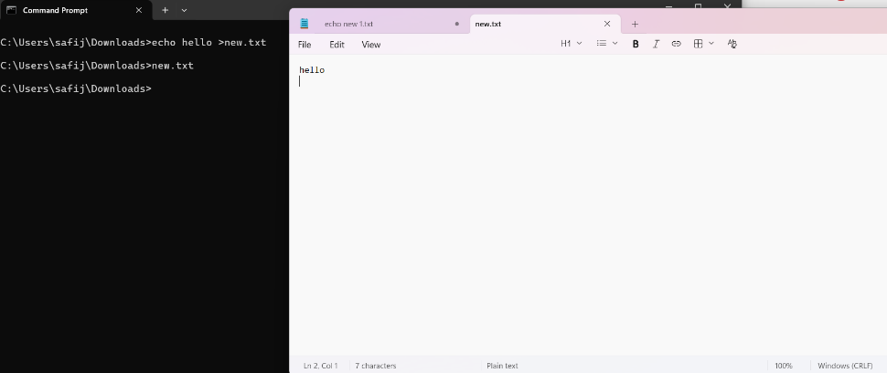
Figure 10: Description whom and date it shows you which use your login

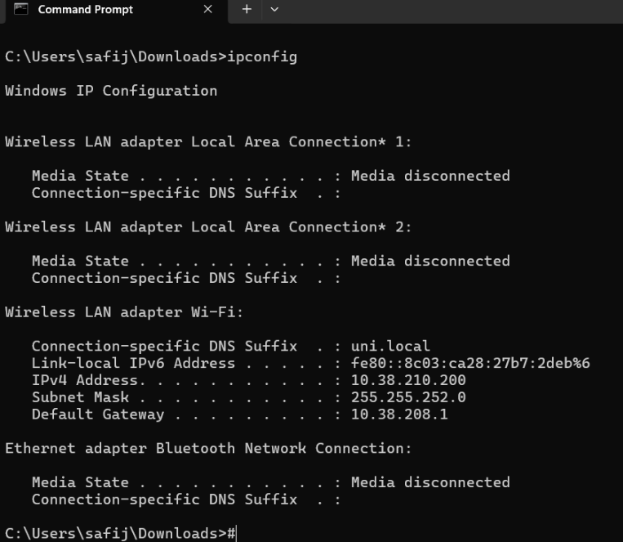
Figure 11: Description
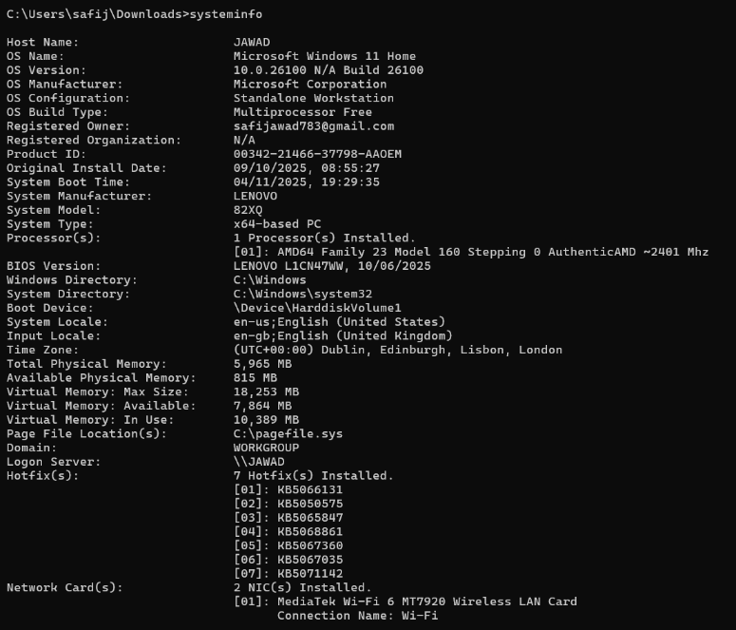
Figure 12: Description
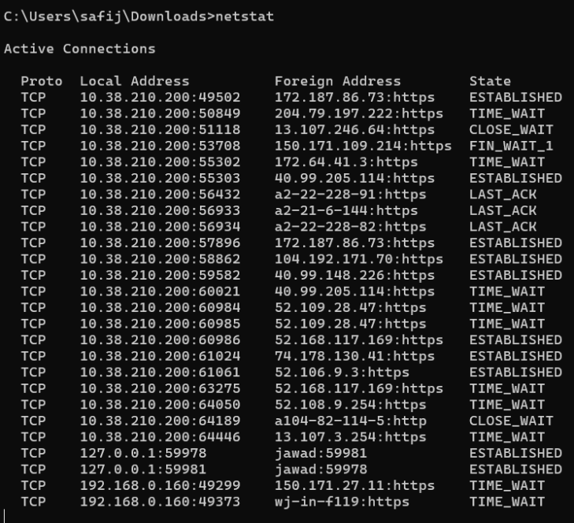
Figure 13: Description
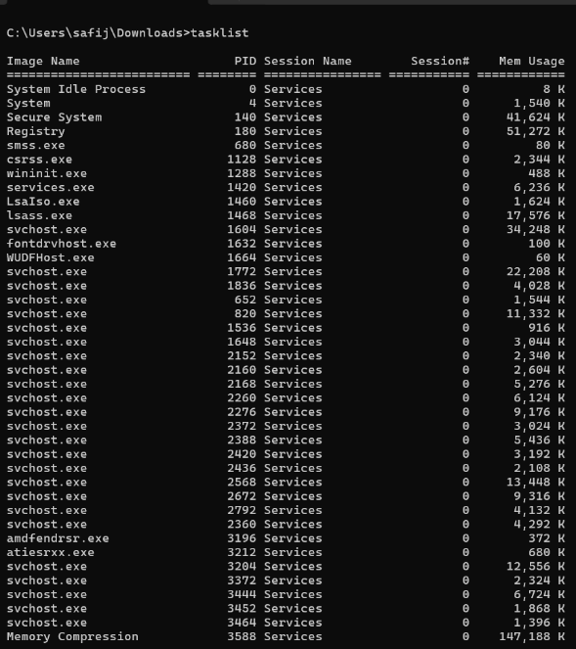
Figure 14: Description
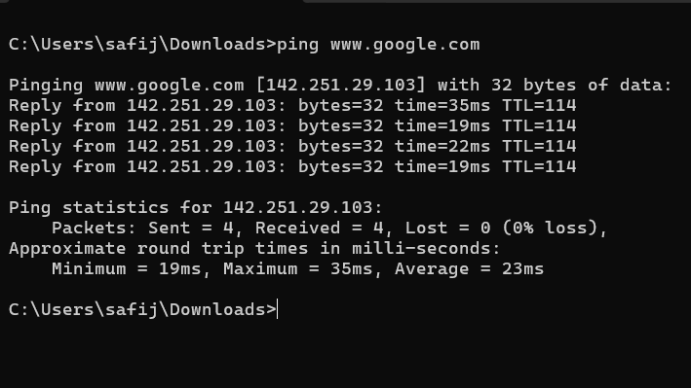
Figure 15: Description

Use of Linux OS CLI commands
Linux offers a powerful command-line interface by means of Bash, powerful system management tools are available. Process management is achieved with certain commands like ps aux which gives list of all running processes and top which gives a real-time monitoring of the system. The kill -9 <PID> command is used to terminate process is a command that can show the user which can operate precisely on the system [4].
File and directory management in Linux is done by using various commands like ls -l to list the files with detailed information, cp to make a copy of the files, rm to delete files from directory etc. The mkdir command is used to create directories and additional options are available for running the command recursively as well as for permissions. These commands could be summed up as expressions of the flexibility and efficiency of the Linux file management system.
There are network monitoring tools either defined already in Linux System like ifconfig or ip #a for displaying network configurations and ping for testing connectivity. The netstat -tuln command exhibits live active network connections as well as open ports, or "listers" that are open and valuable information regarding system activity and security.
User management commands like sudo adduser, passwd, deluser etc. enable administrators to create, modify and remove user accounts. These commands show you the way Linux systems apply security, giving good control over the access of users.
Task scheduling in Linux is normally done through the use of cron. The crontab -e is a method to control the scheduled tasks to specify the task execution times and commands. This feature is very commonly used for automating repetitive tasks such as backups and system updates.
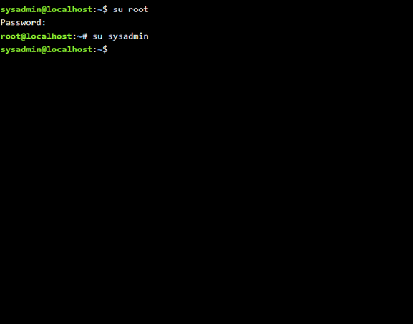
Figure 16: su
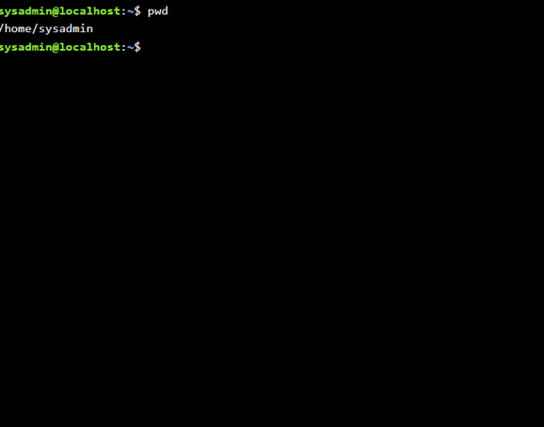
Figure 17: pwd
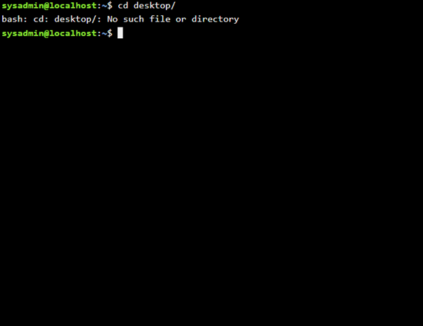
Figure 18: cd
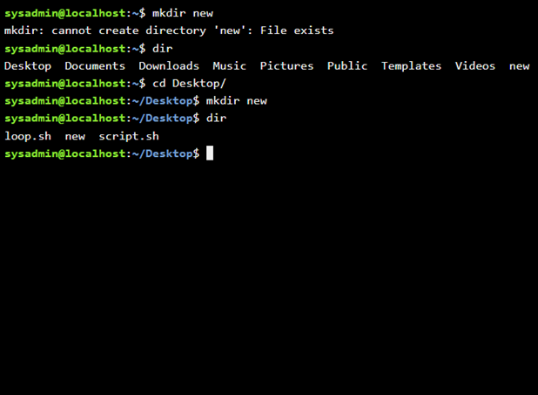
Figure 19: mkdir

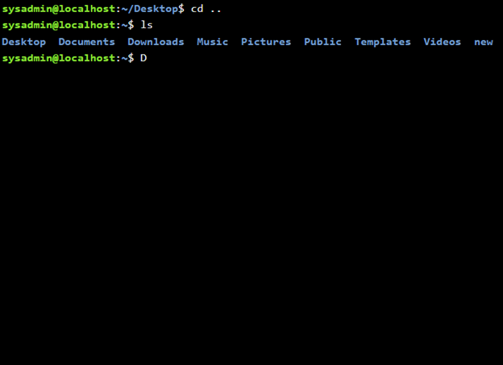
Figure 20: ls
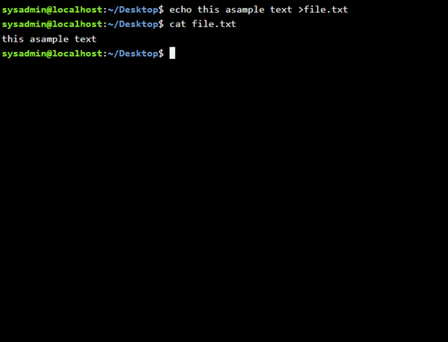
Figure 21: echo and cat
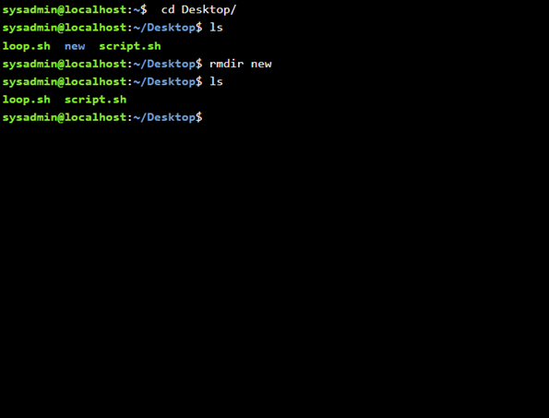
Figure 22: rmdir
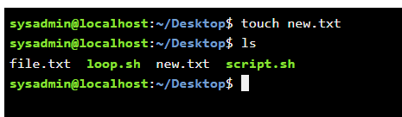
Figure 23: touch
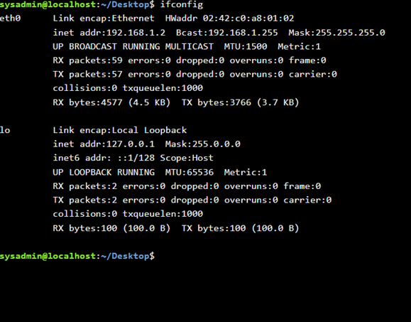
Figure 24: ifconfig
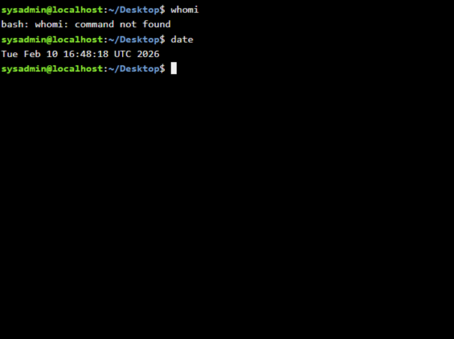
Figure 25: who am I and date

Use of Windows OS scripts
Batch scripting in Windows allows you to automate repetitive tasks which will make you more efficient and help you cut back on manual tasks. One such example would be a backup script to take files from a source directory and copy them to a destination directory. This script uses the variable to store the directory path and the condition to count if the directory to be created already exists or not. Such automation ensures that the backups are done on a consistent basis without any interference from the user.
Another example is a simple calculator script which takes input from the user and performs mathematical addition, subtraction, multiplication, and division. This script shows how variables, the input command of the user and mathematical calculations can be used. By asking the user to input some values and displaying the result of those inputs, the script reveals the use of an interactive aspect of batch programming.
These examples demonstrate the use of batch scripts to bring in control structures such as conditionals and loops, which can establish dynamic and flexible automation. Screenshots of the script code and the output when the script is executed should be involved in order to establish the functionality.
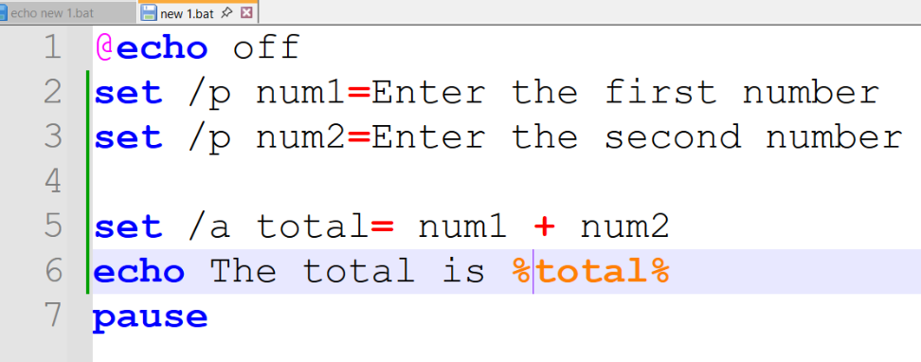
Figure 26: Description
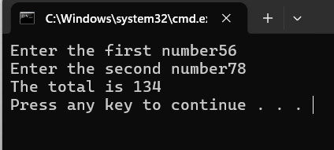
Figure 27: Description
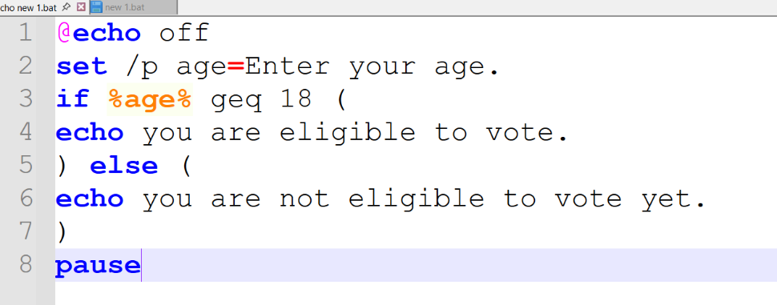
Figure 28: Description
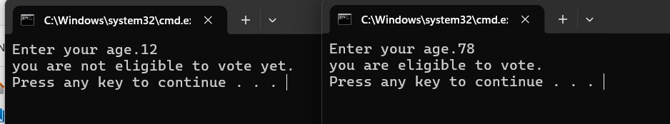
Figure 29: Description

Use of Linux OS scripts
Bash in Linux works as powerful automation as possible and you can make many scripts to perform the tasks with the efficiency. One example is a file backup script which asks the user for source and destination directories and copies files accordingly. This script shows the ways of using variables, getting input from users, and using functions such as file operations, showing the flexibility of a bash script.
Another example is a number checking script which uses conditional statements to check whether a given number is more than a certain value. This script shows how to control the flow and decision making of a Script, to make the Script customize according to user Introduction.
Bash scripts can also be used for loops, arithmetic operations, and system commands which make them a very versatile tool when it comes to system administration. When providing screen captures of execution of scripts is helpful to demonstrate individual use of these scripts.
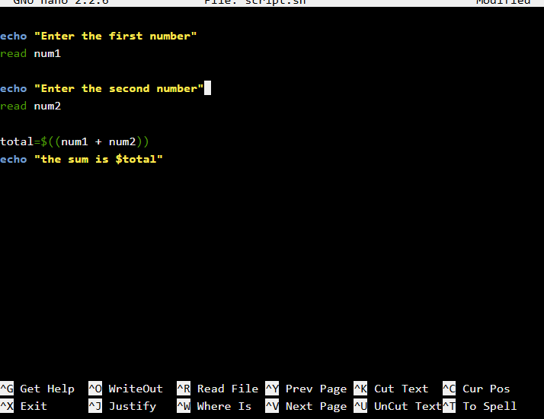
Figure 30: Description
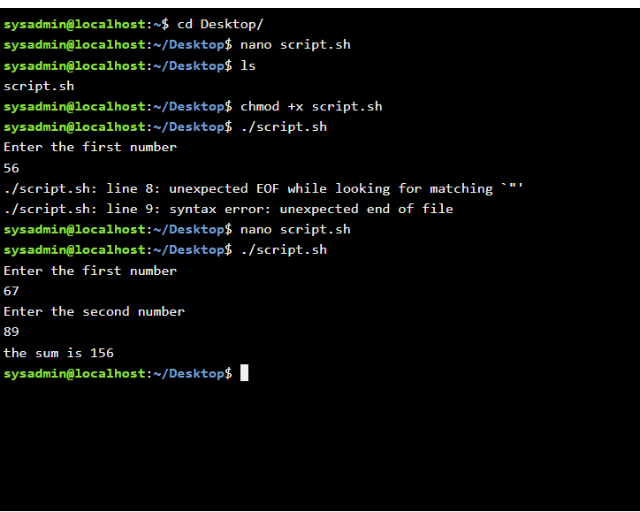

Figure 31: Description

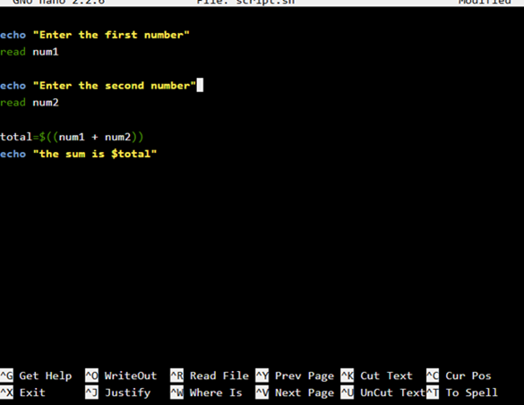
Figure 32: Description
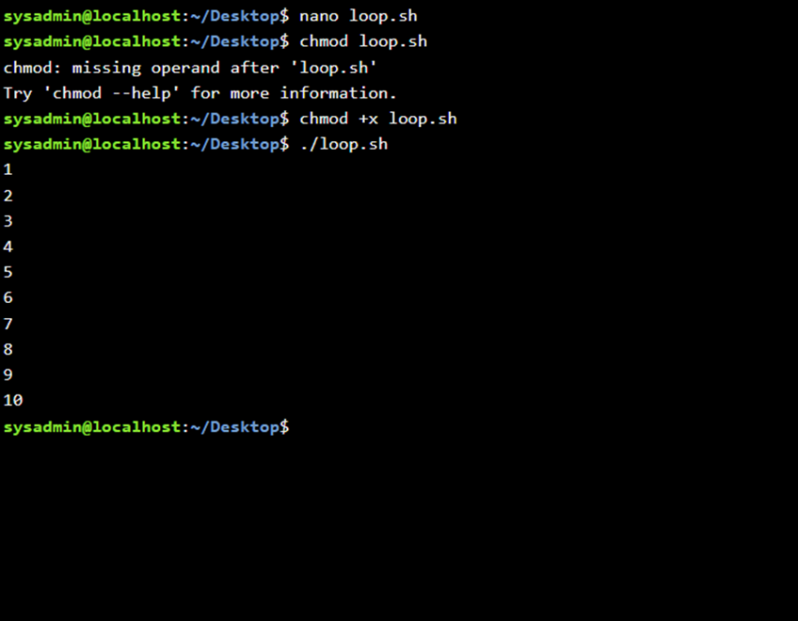
Figure 33: Description

Conclusion
In conclusion, operating systems are a crucial component of the computer resource management system and offer platform for the execution of applications. This report has been able to prove the key roles of the operating system, such as process management, memory management, file systems, and security. It has also discussed the usefulness of command-line interfaces in Windows and Linux and their significance in system administration and troubleshooting.
The examples of command line interface (CLI) commands and scripting provided are good examples of how one can effectively manage systems and automate tasks. Windows and Linux have their own advantages, with Windows being user-friendly and Linux having flexibility and control. The use of scripting gives another boost to productivity in terms of cut down on the manual effort and ensuring consistency.
Overall, keeping the operating systems and knowing how to use the CLI tools are essential skills for an IT professional. These skills are what enable effective management of the systems, problem-solving and automation - a skill critical in today's computing environment.

References

[1] A. Silberschatz, P. B. Galvin, and G. Gagne, Operating System Concepts, 10th ed. Wiley, 2018.
[2] W. Stallings, Operating Systems: Internals and Design Principles, 9th ed. Pearson, 2018.
[3] Microsoft, “Windows Commands Documentation,” 2024.
[4] Linux Foundation, “Introduction to Linux,” 2023.
[5] R. Love, Linux System Programming, O’Reilly, 2019.

Appendices
Appendix A: OS Types
- Batch OS
- Time-sharing OS
- Distributed OS
- Real-time OS
Appendix B: Lecture Activities
- Process scheduling notes
- Memory allocation examples
Appendix C: Online Course Evidence
Online Course name: Linux unhatched cisco
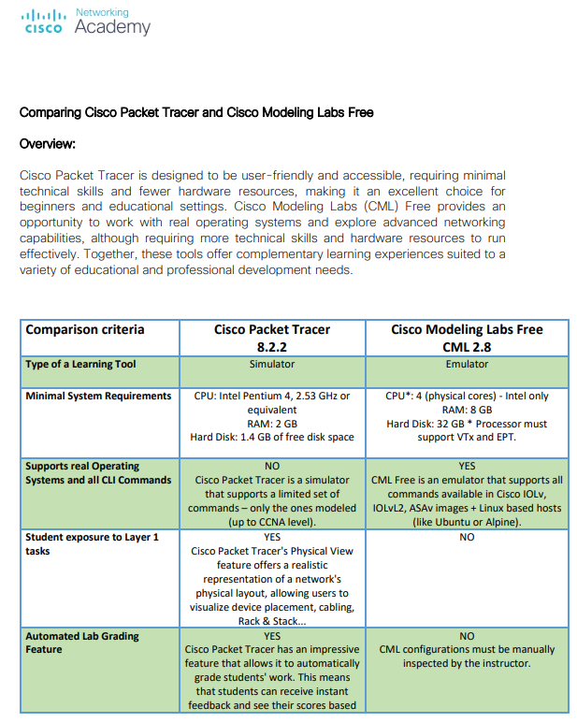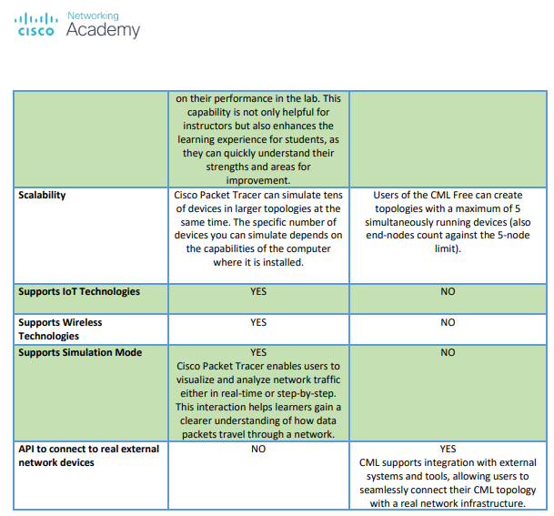
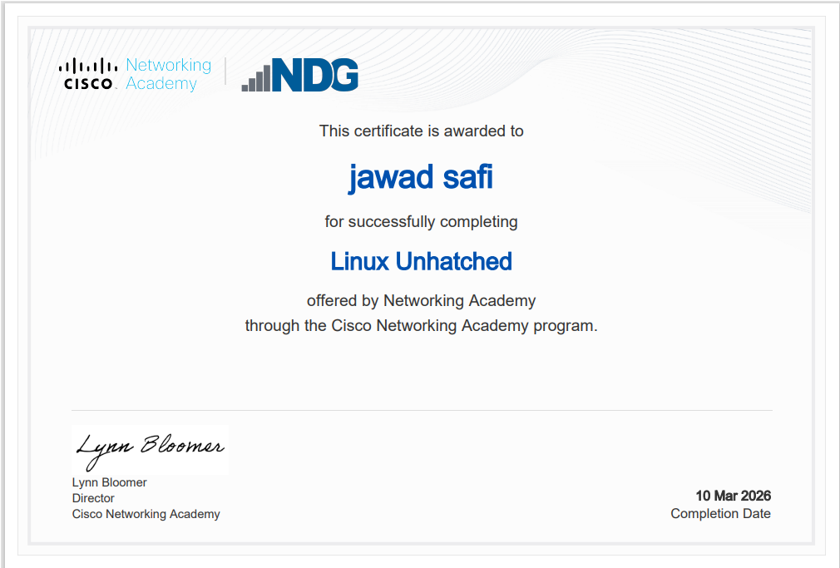
Figure 34: Certificate of completion

