Creativity and Value Creation Assignment 2
Part 1
The sports industry is undergoing rapid transformation due to advances in technology, increased demand for data driven performance, and a shift towards more engaging and personalised user experiences. Golf, a sport traditionally associated with heritage and consistency, has begun to embrace innovation through technologies such as launch monitors, wearable devices, and mobile applications. However, despite these advancements, one of the most fundamental pieces of equipment, the golf tee, has remained largely unchanged. This project proposes the development of Smartees, a smart adjustable golf tee designed to enhance performance, improve engagement, and contribute to sustainability within the sport.
A golf tee serves a very simple purpose, which is to maximise distance when taking their first shot of a hole since the ball's friction with the ground is reduced when it is elevated. Additionally, it makes it possible to strike the upward swing more cleanly, which can also minimise spin aswell. The problems often lie within the tee itself, with perhaps the main problem being setting the correct height of the tee for the shot you are looking to play with the appropriate club in hand. With this product however, this problem exists no more. Depending on the club being used, golfers can consistently establish the ideal tee height thanks to the product's adjustable height mechanism. The idea also incorporates simple sensor technology that can gather information on tee location and strike consistency, which can be synchronised with a mobile phone app. This invention is in line with the expanding smart sports equipment trend, in which commonplace objects are given digital capabilities to boost performance and offer feedback (Ratten, 2020). Smartees closes the gap between expensive performance tools and widely available everyday products by integrating technology into a piece of equipment that is frequently disregarded.
The growing significance of data analytics in sports is one of the main arguments in favour of this theory. Athletes today, particularly professional athletes, mostly rely on statistics to guide their training and increase consistency. Data driven decision making, which allows athletes to spot inefficiencies and maximise performance, has emerged as a distinguishing characteristic in modern sport, according to Davenport (2014). Particularly in golf, even small setup errors can have a big effect on how a shot turns out. Despite being frequently disregarded, tee height is crucial for launch angle, ball contact, and overall shot quality. Smartees enables players to remove a factor that may have a detrimental impact on performance by offering a consistent and quantifiable approach to tee height, supporting more dependable and repeatable outcomes.
Additionally, the idea of Smartees represents more general shifts in how people participate in sports. Digital technology is driving the replacement of traditional participation models with more tailored and engaging experiences. According to Pine and Gilmore (2011), the sports business is a clear example of how consumers are increasingly looking for experiences rather than straightforward goods. By tracking progress factors such as strike consistency and angle impact, offering feedback, and possibly gamifying practice sessions through app integration, Smartees improves the user experience.
Furthermore, the need to increase accessibility to sports technology is another important motivation for the creation of Smartees. Although great players may have access to sophisticated tools like swing analysis software and launch monitors such as Trackman, these technologies are usually costly and unaffordable for amateur or recreational players. Wilson et al. (2019) state that accessibility is still a major obstacle to playing golf and other sports. Smartees democratises access to data driven improvement by providing a reasonably priced product with performance tracking features. This is in line with more general sport development objectives that seek to boost involvement and diversity.
Another crucial factor in modern sports innovation is sustainability. Traditional wooden golf tees contribute to needless waste because they are frequently used just once before being thrown away due to them being easily breakable. There are millions of golfers in the world, and disposable equipment has a significant negative influence on the environment. The sports business is under increasing pressure to embrace more sustainable practices and lessen its environmental impact, as noted by Trendafilova and McCullough (2018). By providing a sturdy, reusable substitute that lessens dependency on single use items, Smartees tackles this problem. This increases the product's commercial potential by helping the environment and appealing to consumers who care about the environment.
From a business standpoint, there is a lot of room for innovation in the worldwide golf sector. Recent years have seen a resurgence of interest in recreational play and engagement in the sport. There are more than 66 million golfers in the world, making up a sizable and varied market, according to the R&A (2023). Furthermore, new markets for technology driven items have been made possible by the growth of driving ranges, golf simulators, and social golf venues such as Topgolf. Smartees can be positioned within this growing ecosystem as a tool for improving performance as well as a training aid, making them interesting to a broad spectrum of users, from beginners to professionals.
The integration of technology into sport is also closely linked to the concept of innovation diffusion. Rogers (2003) explains that new ideas and technologies spread through social systems over time, influenced by factors such as perceived usefulness and ease of use. Smartees has strong potential for adoption due to its simplicity, affordability, and clear performance benefits. Unlike more complex technologies, it does not require extensive knowledge or training to use, making it accessible to a broad audience.
In addition to performance and engagement benefits, Smartees also has potential applications in coaching and skill development. The tool can be used by coaches to assist athletes in creating regular routines and tracking their development over time. Effective coaching depends on the capacity to give concise, useful feedback, according to Cushion et al. (2010). Smartees facilitates this process and improves the coaching experience by providing quantifiable statistics on tee height and strike consistency.
In conclusion, Smartees represents a contemporary innovation that has the potential to transform how golfers interact with one of the most basic elements of the game. By combining adjustable design, data tracking, and sustainable materials, the product addresses key trends within the sports industry, including technological integration, enhanced user engagement, and environmental responsibility. Its accessibility and simplicity make it suitable for a wide audience, while its performance benefits provide clear value to users. As the sports sector continues to evolve, innovations such as Smartees demonstrate how even the smallest changes can have a significant impact on participation, performance, and the overall sporting experience.
Reference List:
- Cushion, C., Armour, K. and Jones, R. (2010)

- Davenport, T.H. (2014)

- Pine, B.J. and Gilmore, J.H. (2011)

- PwC (2018)

- Ratten, V. (2020)

- Rogers, E.M. (2003)

- Statista (2023)

- The R&A (2023)

- Trendafilova, S. and McCullough, B. (2018)

- Wilson, B., Plumley, D. and Ramchandani, G. (2019)

Part 2

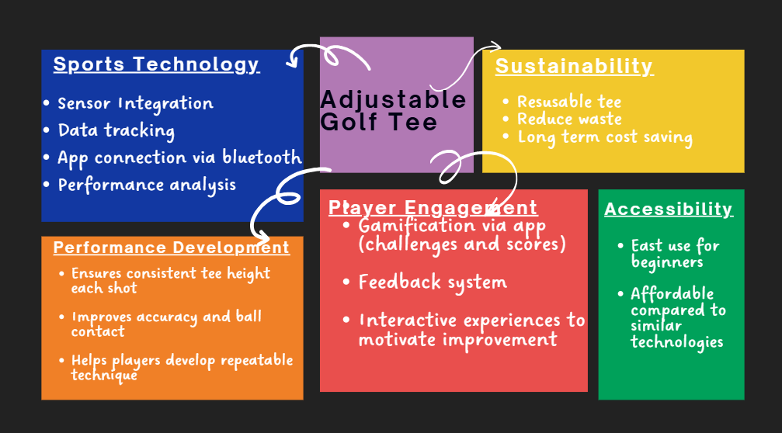

Part 3




