HNC Process Operations Engineering -
Process Engineering Practice
PCPO4007

Operation of Processes

University of Wales Trinity Saint David
Pembrokeshire College
Luke Vaughan
2320126

Assessor: Rhys Hutton

Table of Contents
Introduction 3
Task 1 4
Heat Exchangers 4
Task 2 8
Crude Distillation Unit 8
Vacuum Distillation Unit 10
Fluid Catalytic Cracking Unit 12
Alkylation Unit 14
References 15
Bibliography 16

Figure 1 - Heat Exchangers 6
Figure 2 - Exchanger Bundle Being Pulled 7
Figure 3 - Tube and Shell Exchanger Diagram 7
Figure 4 - Tube and Shell Internal 7
Figure 5 - Crude Unit Process 9
Figure 6 - Crude Distillation Column 9
Figure 7 - Vacuum Unit Process 11
Figure 8 - Vacuum Distillation Column 11
Figure 9 - FCCU Catalyst Cycle 13
Figure 10 - FCCU Process Setup 13
Figure 11 - Alkylation Unit Process Diagram 14

Introduction
First task of this assignment is a detailed review of how a heat exchanger is used within the refinery process and the different potential hazards that can occur whilst in operation and the framework that is in place to minimise this.
The second task is a process description of some of the different units at an oil refinery, detailing the initial feed coming into the refinery and being broken down into different streams as it gets sent to different units for further refining.

Task 1

Heat Exchangers
Heat exchangers are important pieces of process equipment found in oil refineries. They are used for transferring heat between two different process streams. This function is important to maintaining energy efficiency, controlling process temperatures, and enabling effective integration between upstream and downstream operations. The most commonly used exchanger design is a shell and tube heat exchanger.
Heat exchangers operate based on the principles of conduction and convection. Heat is transferred from the hot fluid to the cold fluid through the metal walls of the tubes, typically made from stainless steel or other corrosion-resistant alloys.
In most refinery applications, the process streams flow in a counter flow configuration to maximise the thermal gradient and increase heat transfer efficiency (Towler & Sinnott, 2013). Baffles within the shell promote turbulence, improving thermal exchange and prevent flow stagnation.
During operation, the heat exchanger maintains specific pressure, temperature, and flow parameters as required for the process in question. Pressure and flow rates are closely monitored to ensure that optimal heat transfer is achieved while preventing mechanical or thermal damage to the equipment.
Excessive pressure is a hazard that can occur with heat exchangers, particularly if caused by upstream blockages, failed control valves, or unexpected changes in the process fluids. Overpressure conditions may result in damage of the shell or a rupture of the tubes, potentially causing mixing of fluids. According to the American Petroleum Institute these vessels must be inspected regularly, and pressure relief systems must be designed and tested to ensure they remain operational under upset conditions (API, 2021).
Changes in temperature or exposure to high temperature differentials across the tube bundle can introduce thermal stresses that may lead to fatigue cracking. This is more prevalent in services where hot hydrocarbons interact with cooling water or process condensates. The choice of materials, such as low alloy steels or austenitic stainless steels, is based on their thermal conductivity, expansion coefficients, and resistance to stress corrosion cracking.
Reduced flow rates can result in laminar flow conditions which reduce heat transfer efficiency and promote fouling on heat transfer surfaces. Excessive flow rates can cause erosion of tube inlets or baffles. Erosion and corrosion is an issue in areas where protective oxide films are stripped away by high-velocity streams.
Vibration due to the flow can occur when the streams velocity or pressure drops causing oscillations within the tube bundles. Over time, this can result in fatigue failures and tube wear. The issue is managed by ensuring sufficient tube support, appropriate spacing of baffles, and routine inspection using vibration analysis or acoustic monitoring tools.
Mechanical deterioration over time happens due to use and the operating environment. Common forms of degradation include general wall thinning due to corrosion, localised pitting, fouling, and scale build up, all of which reduce thermal performance and may become more severely damaged. Indications of deterioration may include reduced heat transfer efficiency, increased pressure drop across the exchanger, or unexpected fluctuations in outlet temperatures. Non-destructive testing methods such as ultrasonic thickness testing, and thermographic imaging are used when the exchanger is offline to assess the internal condition of the equipment and prioritise maintenance that is required.
Changes in other operating condition can also potentially cause hazardous scenarios, such as a pump or valve issue upstream of one side of the exchanger meaning there is a sudden change in flow causing less heat exchange happening, potential temperature shock or issues with the structural integrity of the exchanger.
To minimise risks there are health and safety guidelines from the HSE in place. From the design stage, safety is embedded into the equipment selection and installation process. Heat exchangers are designed in accordance with ASME and API standards, which define allowable stresses, corrosion allowances, and safety factors. Relief valves and thermal expansion joints are incorporated to handle abnormal pressure and temperature excursions.
Routine preventive maintenance is important for keep the exchanger in correct condition, the use of risk based inspection is used as outlined in API 580 to determine inspection frequencies based on the criticality and degradation rate of each unit (API, 2016). This ensures that heat exchangers with higher risk profiles are prioritised during maintenance planning. Cleaning schedules are also established to minimise fouling, such as in exchangers handling crude oil or heavy hydrocarbons.
Operationally, process conditions are monitored in real time using distributed control systems. These systems track temperature, flow, and pressure across key points and initiate alarms if limits are hit. Operators are trained in process safety and emergency response procedures, ensuring that any deviation is swiftly addressed. Additionally, all maintenance work on heat exchangers will need a permit to work to carry out the maintenance required. All isolations, gas tests, and task specific risk assessments are completed prior to starting work.
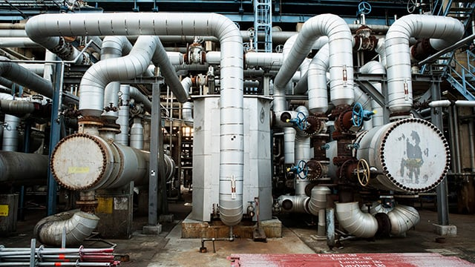
Figure 1 - Heat Exchangers

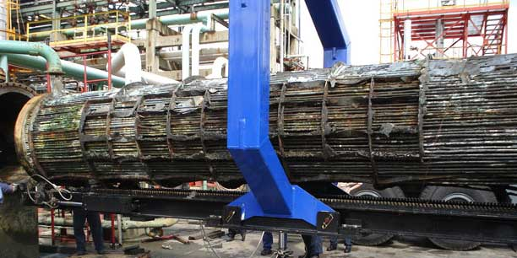
Figure 2 - Exchanger Bundle Being Pulled
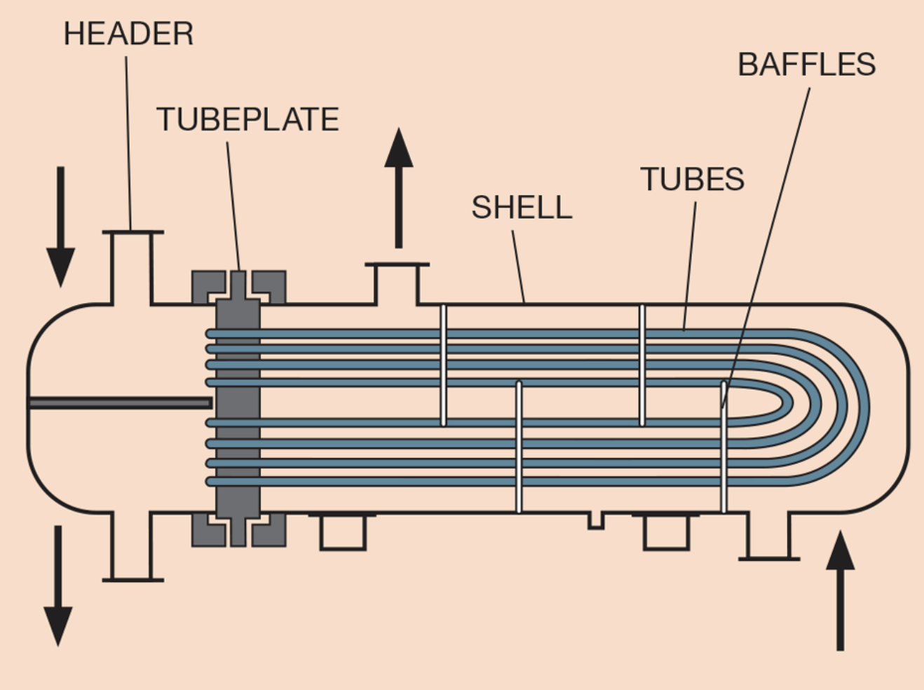
Figure 3 - Tube and Shell Exchanger Diagram
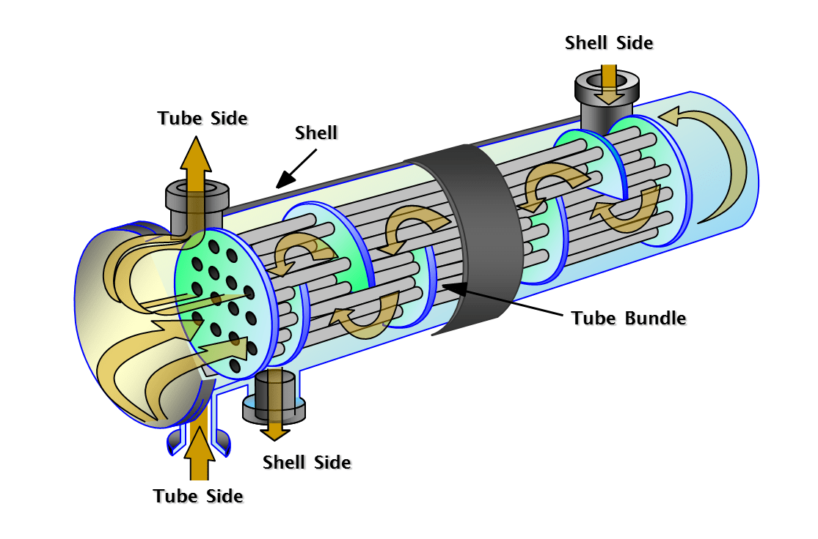
Figure 4 - Tube and Shell Internal

Task 2
At an oil refinery such as Valero Pembroke the crude oil will be imported into the refinery by being shipped into the jetty, here it will be unloaded so it is ready as a feed to the crude unit.

Crude Distillation Unit
A Crude Distillation Unit (CDU) is the first processing unit in an oil refinery that separates crude oil into different fractions based on their boiling points. Operating under atmospheric pressure, the CDU is a physical separation process, rather than a chemical reaction, and it prepares feedstocks for further refining in other units.
As the crude feed comes into the unit it first goes through desalters, these are used for removing any impurities such as salt that can be found in the crude oil mix.

The crude feed gets heated up with the use of heat exchangers and will then be heated further to approximately 400°C in a fired heater before entering the distillation column near the bottom. Inside the column, vaporised hydrocarbons rise while heavier fractions condense on trays creating product streams such as Overhead naphtha, Kerosene, Diesel/gas oil and Atmospheric residue. (Valero, 2018)
As part of the crude unit these streams may need to be stripped further to remove any unwanted hydrocarbon that has been entrained in the stream. The atmospheric residue, which does not vaporise at operating temperatures, is sent to the Vacuum Distillation Unit (VDU) for further recovery of valuable gas oils. The other products such as the diesel will be sent to hydrotreater units for further refining and treatment.
As the crude is the beginning of the process in the refinery it controls the flow of feedstock to other refinery units, it needs to be working at optimal levels to ensure all streams are producing enough for the other units to continue to run as well.
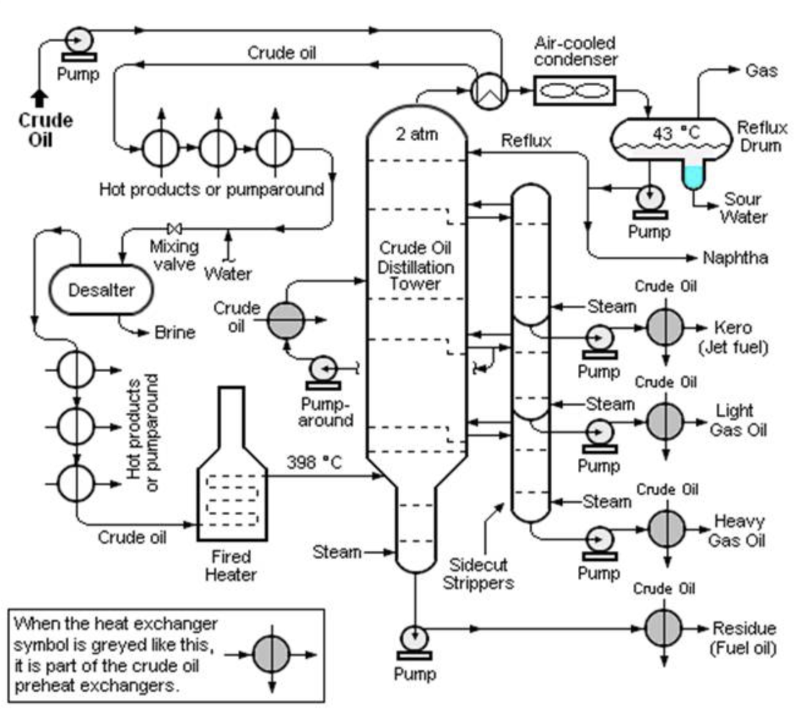
Figure 5 - Crude Unit Process
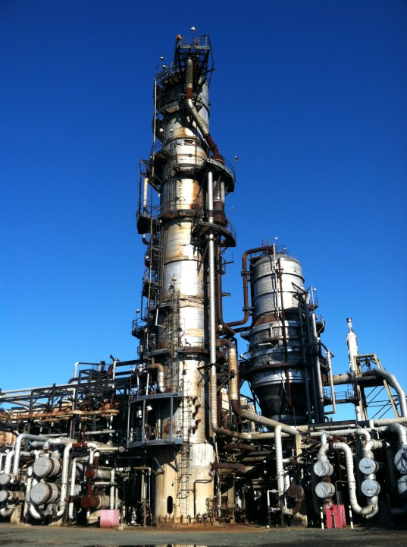
Figure 6 - Crude Distillation Column

Vacuum Distillation Unit

The Vacuum Distillation Unit (VDU) processes the heavy residue from the CDU to recover valuable gas oil fractions without causing thermal cracking. As in the crude column the products are drawn off at the different levels to be sent for further refining around the other refinery units.
Operating under a vacuum at approximately 20 mmHg the unit lowers the boiling points of hydrocarbons weakening the bonds, allowing separation at temperatures below 400°C. when under a vacuum with this heavier crude residue and being at a lower temperature it will avoid the formation of coke, which would occur at higher temperatures under atmospheric pressure.
Preheated reduced crude enters a fired heater, then flows into the vacuum column near its base. Inside, the reduced pressure enables vaporisation of lighter components, while heavier fractions condense on trays as they descend. The rising vapours undergo fractionation, producing key product cuts such as Light Vacuum Gas Oil (LVGO), Heavy Vacuum Gas Oil (HVGO),Vacuum Residue (VR) and diesel. Steam is injected at the base to assist in stripping lighter components. (Valero, 2018)
LVGO, HVGO and VR are the feed going to the Fluid Catalytic Cracking Unit (FCCU) for further refining to break down these heavy hydrocarbons. Any diesel will be sent to the hydrotreater unit as it does from the CDU.
The VDU ensures further distillation and product yield form the initial crude feed rather than the atmospheric residue from the crude bottoms going to waste. Within the VDU efficient operation requires precise temperature control to prevent fouling and ensure yield optimisation. The vacuum is maintained using ejectors or vacuum pumps, and the columns internals are designed to minimise any pressure drop whilst maximising efficiency.
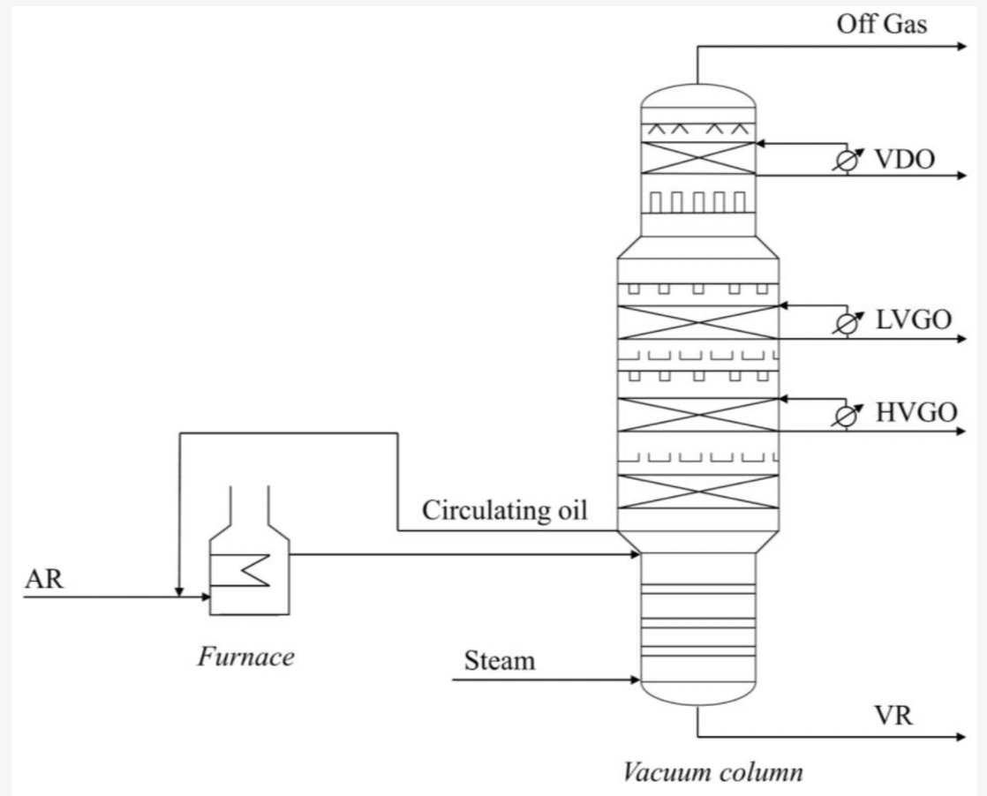
Figure 7 - Vacuum Unit Process
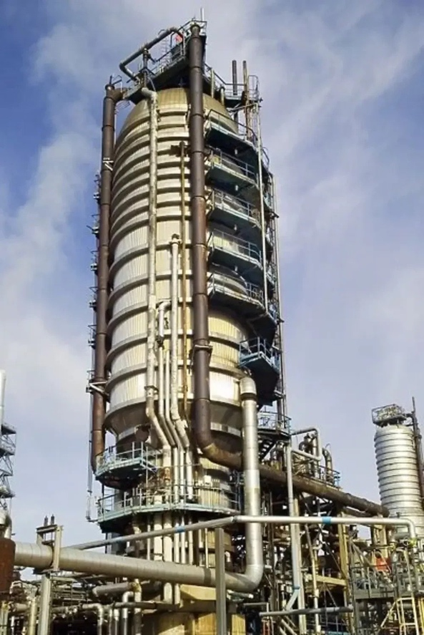
Figure 8 - Vacuum Distillation Column

Fluid Catalytic Cracking Unit

The Fluid Catalytic Cracking Unit (FCCU) is used to breakdown heavy long chained hydrocarbon feed into shorted chain hydrocarbons to create more valuable products, being HCGO and LCGO for further refining in hydrotreaters, and light and products such as naphtha and olefin. (Valero, 2018)
The process is done by using a catalytic reaction with the use of a zeolite catalyst used to breakdown the long chain hydrocarbon into smaller chained hydrocarbon so it can go through a distillation column and be separated into its product streams.
The feed comes from the VDU using the resid, LVGO and HVGO. This feed is heated to approximately 650–700°C with the use of exchangers and sent to a riser, here catalyst is injected allowing the reaction to happen, the reaction happens going up the riser with the catalytic cracking of the hydrocarbon happening in 2 - 5 seconds. From the riser it goes into a reactor, there is a plate in the reactor that will deflect the hydrocarbon to be sent to the main fractionator column, with the catalyst being knocked off and sent down the reactor to a regenerator due to gravity, there are also cyclones that will remove any other hydrocarbon vapours from the catalyst to go the main fractionation column. In the regenerator any coke that is left on the catalyst will be burned off and the catalyst can then be sent back around this system to be reused at the bottom of the riser.
The hydrocarbon vapours in the main fractionator are condensed and separated into the different streams as done in the CDU and VDU. HCGO and LCGO are two of the take offs that get sent to other parts of the refinery for further refining. The light end products from the top of the column are olefin and naphtha to be sent to an alkylation unit and ultralow sulphurisation unit.
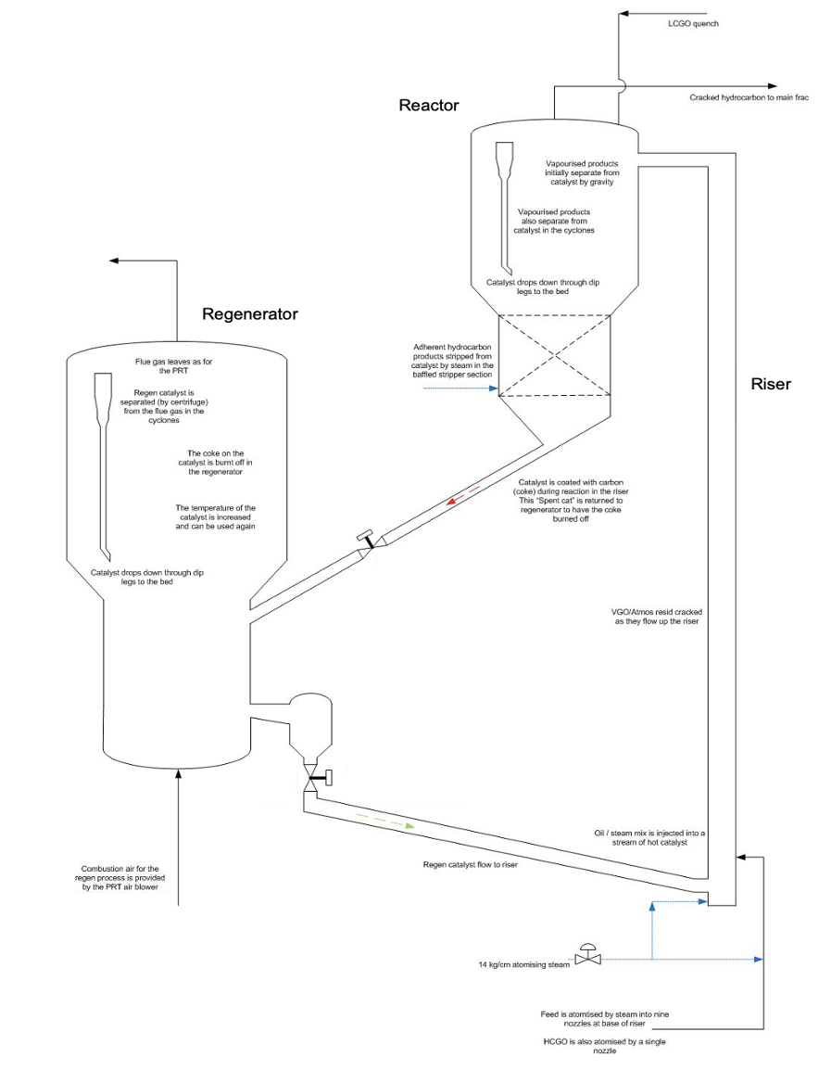
Figure 9 - FCCU Catalyst Cycle
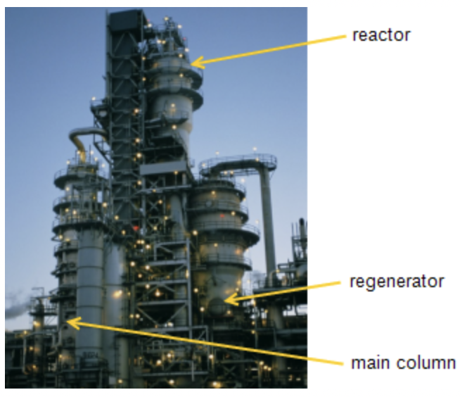
Figure 10 - FCCU Process Setup

Alkylation Unit
The Alkylation Unit produces high-octane, low sulphur blending components for gasoline by combining light olefins with isobutane with a strong acid catalyst. The process forms alkylate which is a premium high octane gasoline.
The reaction is carried out using hydrofluoric acid (HF) as the catalyst. The olefin and isobutane mixture is chilled and mixed with the acid catalyst in a reactor, maintained at low temperatures to minimise side reactions and polymerisation.
After the reaction, the hydrocarbon and acid phases are separated. The acid is recycled, while the hydrocarbon stream is sent to a caustic wash and then to a fractionation section. The fractionator separates light ends such as propane and butane from the alkylate product. (Valero, 2018)
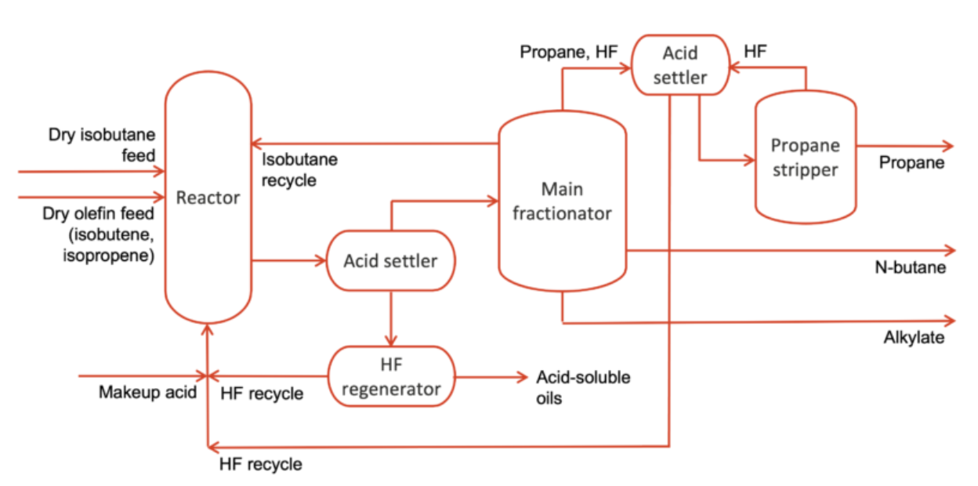
Figure 11 - Alkylation Unit Process Diagram

References
API, 2016. API 580: Risk-Based Inspection. Available at: https://www.api.org/products-and-services/individual-certification-programs/certifications/api580 [Accessed 24 Apr. 2025].
API, 2021. API 510: Pressure Vessel Inspection Code. Available at: https://www.api.org/products-and-services/standards/ [Accessed 24 Apr. 2025].
Towler, G. and Sinnott, R., 2013. Chemical Engineering Design. 2nd ed. Oxford: Butterworth-Heinemann. Available at: https://www.sciencedirect.com/book/9780080966595/chemical-engineering-design [Accessed 24 Apr. 2025].
Valero. (2018). Alky Operator Manual. Pembroke: Valero Energy Corp [Accessed 26 Apr. 2025].
Valero. (2018). Crude Operator Manual. Pembroke: Valero Energy Corp [Accessed 26 Apr. 2025].
Valero. (2018). FCCU Operator Manual. Pembroke: Valero Energy Corp [Accessed 26 Apr. 2025].
Valero. (2018). Vac Operator Manual. Pembroke: Valero Energy Corp [Accessed 26 Apr. 2025].

Bibliography
Arveng Training, n.d. Basics of Shell & Tube Heat Exchangers. Available at: https://arvengtraining.com/en/basics-of-shell-tube-heat-exchangers/ [Accessed 24 Apr. 2025].
Broadleaf, n.d. Identifying failure modes in an oil refinery process unit. Available at: https://broadleaf.com.au/work/identifying-failure-modes-in-an-oil-refinery-process-unit/ [Accessed 24 Apr. 2025].
Deaconu, A., 2024. Chemical cleaning of oil refinery heat exchangers. EPCM. Available at: https://epcmholdings.com/chemical-cleaning-of-oil-refinery-heat-exchangers/ [Accessed 24 Apr. 2025].
EIA, 2013. Crude oil distillation and the definition of refinery capacity. U.S. Energy Information Administration. Available at: https://www.eia.gov/todayinenergy/detail.php?id=9150 [Accessed 26 Apr. 2025].
Ex-pect, n.d. The crude oil distillation unit. [online] Available at: https://www.ex-pect.com/process-plants/the-crude-oil-distillation-unit/ [Accessed 26 Apr. 2025].
MDPI, 2022. Processes: Vol. 10, Issue 2, Article 359. Available at: https://www.mdpi.com/2227-9717/10/2/359 [Accessed 26 Apr. 2025].
Rosacweb, 2019. Heat exchanger maintenance procedure - by Idrojet. Idrojet. Available at: https://idrojet.com/heat-exchanger-maintenance/ [Accessed 24 Apr. 2025].

