Effective Teamwork and Communication
Assignment 1
Module code: BMSW4002
Student Name: Marcelo Santos Neves
Table of Contents
Introduction 3
Models of communication 3
Shannon and Weaver (1948/49) 4
Schramm (1954) 5
Berlo (1964) 6
Communication skills 7
Conclusion 8
References 9

Introduction
Effective communication is always important and essential so that one person can understand the feelings of others. The concerned study has been discussing the models of communication which has been demonstrated in relation to the case study. The study helps to understand the importance of effective communication skills in the present world so that an appropriate relationship can be incorporated. In addition, the effect of poor communication in a particular workplace has also been discussed in the study which can be improved further with several strategies.
Communication can be defined as the transmission of a message which also involves shared understanding between two people. As stated by Khan et al., (2017), communication skills involve speaking and listening as well as reading and writing.

Models of communication
The level of communication can be accessed through an appropriate model of communication which can be well demonstrated through “A day with the chief” case study. Three models have been included in this section which are “Shannon and Weaver model of communication”, “Schramm’s model of communication” and “Berlo’s SMCR model of communication” to understand the what can be done while Mark met with Mrs. Brown.

Shannon and Weaver (1948/49)
It is one of the most basic and earliest models in the communication line which was developed together by Claude Elwood Shannon who was a mathematician and Warren Weaver who was a scientist. Both of them gave their own ideas that got integrated to give rise to this model that seems to be more technological than the rest of the linear models.

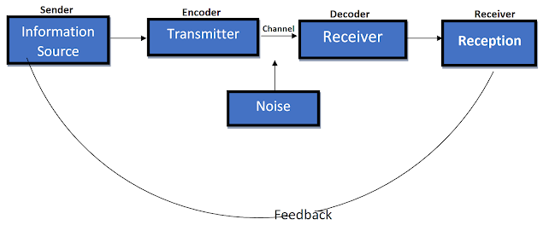
Figure 1: Shannon and Weaver model of communication
(Source: As influenced by Konstantinov, 2017)
The figure shown above shows that there is a clear technological basis that upholds the aspects of this model such as the involvement of data transmitters that take the data from the source and handle the process of encoding and send the encoded information to the receiver that decodes the information and finally gives it to the recipient who is to be finally delivered the message. As stated by Konstantinov (2017), the model is linear. It has depicted the flow of information from the sender to the receiver but has not mentioned clearly about the process in the other way round.

The model also incorporates the factor of noise that degrades the quality of the message to be delivered. Noise cannot be completely done with and is inevitably present in some or the other form either to an extent that causes significant changes to the sent information.
As per the case study, Mark is the sender here who speaks with Mrs. Brown and gives his opinion on operational difficulties. On the other hand, Mrs. Brown is the receiver and she understood the information which has been transmitted through the attitude of Mark. However, Mrs. Brown did not receive the proper feelings of Mark which he wanted to state due to his cruel and over smart behaviour. Therefore, the concerned attitude can be identified as Noise. In that case, Mrs. Brown also can give feedback to Mark so that he can get conscious about his behaviour in front of the CEO. however, the attitude of Mrs. Brown as she stated to leave to Mark also can be identified as a feedback that the attitude of Mark was harsh and he cannot speak like this in front of the CEO of the organization.
The Shanon Weaver model has not mentioned much about the removal of the noise factor that tends to destroy the message sent by the sender but it has definitely highlighted its inevitability.
Here is a personal example from the workplace that I work in or better to say the atmosphere that I take my lessons in. I was in the lecture hall busy completing my pending work that the professor had asked to submit the same day not defining the deadline time exactly. Students were speaking in a volume too high for the lecture hall and it was then that the professor has called out my name and I failed to hear it. She might have been called out for me twice when I could finally get some portions of her message which actually stated that I must get my work submitted within half-an- hour. Since I could not get the entire message correctly due to noise, I took the time period mentioned by her as one hour instead of half-an-hour which was the actual time allotted. This did cause me lot of trouble.

Schramm (1954)
This model of communication developed by Wilber Schramm and presented in 1954 focuses on the important aspects of appropriate encoding and decoding of the information. It advocates that the information sent after encoding is of no use to the recipient if he lacks the fundamental tools needed to decode that information. The model unlike the Shannon which is linear, presents a circular flow of information from the sender to the receiver and back to the sender with change in the change and structure containing a response.
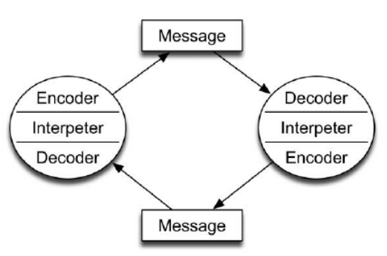
Figure 2: Schramm model of communication
(Source: Mitra et al., 2020)

The above figure helps to understand the factors which are involved in the concerned model of communication. As opined by Lin and Lin (2020), the concerned model emphasizes more importance of sender and receiver interactions. As per the given figure of the model, interpreters are an important part of communication where people are intended to interpret thoughts of others..
As per the case study, Mrs. Brown interpreted the behavior of Mark wrongly which introduces a problem and makes an unpleasant situation for Mark. Mark had no intention to disrespect the CEO but Mrs. Brown thought that he was disrespecting her and cannot instruct what to do or not to do. On the other hand, Mark was aware about the attitude of Mrs. Brown and most of the people stated that she has a rude personality. As influenced by Mitra et al., (2020), Schramm includes “field of experience” for both receiver and sender and it can be commonly shared. Therefore, sometimes the environment also impacts the communication process and the appropriate message is failed to deliver properly. Therefore, it can be stated from the concerned “Schramm model of communication” that Mark needs to understand the situation and position of the receiver before showing over smartness and getting too free with her.

Berlo (1964)
Developed by David Berlo from Shannon Weaver’s Model of Communication (1949), the model is referred to as the Berlo’s Sender-Message-Channel-Receiver (SMCR) model. Through the model, Berlo clearly stated about the components of communication that tend to make it more efficient. According to Muyanga and Phiri (2020), Berlo argued that each of the four major components that he identified gets affected by a number of factors like communication skills, attitude, knowledge, culture, etc.

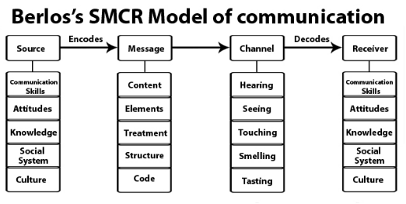
Figure 3: Berlos's SMCR model of communication
(Source: As influenced by Muyanga and Phiri, 2020)
The above model depicts source, message, channel and receiver are the important components in the communication. Furthermore, factors like culture, attitude, communication skill, and knowledge can help to proceed the discussion. According to Muyanga and Phiri (2020), culture and communication can be identified as inseparable as culture not only dictates about the person and concept but also helps in determining the encoded message. A person behaves according to instincts that are shaped by the roots of culture of the atmosphere where he has spent most parts of his life. This gets reflected in his manners of interpreting or receiving the information from any known or unknown person.
As per the case study, the friendliness of Mrs. Brown helps Mark to initiate the meeting process. Mark felt comfortable with Mrs. Brown and stated all his feelings about the supervisor. Therefore, the feeling of Mark about the sales of the organizations and immediate supervisor was the message as per the case study. Mrs. Brown listens to everything carefully and maybe she didn't like the approach of Mark so she told him to leave. Therefore, the attitude and the way of communication also matter in providing appropriate understanding. The communication can be much better if Mark can behave like a professional and understand the position of CEO of the organization. The attitude of Mark was the problem in the concerned case study. The concerned model also helps to understand that people can appropriately communicate if all requirements can be fulfill

Communication skills
Two or more than two people can communicate through different activities such as verbal, non-verbal, active and empathetic listening. An effective communication skill is very necessary which helps to improve the relationship between two or more than two people. Moreover, it also helps to provide appropriate knowledge about the feelings which need to be developed through the concerned activities.
Verbal activity: The verbal activities are basically stated as the written, spoken concept. In this activity, one person verbally communicates with others through tone and pitch. As per the case study of “A day with the chief”, Mrs. Brown and Mark have been persuaded by verbal activity in communication and it helps them to understand the attitude of both people. The concerned case study is an example of poor communication which impacts on the attitude of both Mark and Mrs Brown.
Non-verbal activity: Body language, facial expression and gestures play an important role in non-verbal activity for communicating with the other person. In some cases, I can understand that body language has an important part while working as a support worker. Moreover, I also understand the nature of team leaders while communicating through body language and facial expression. As per the case study, Mark also felt safe due to the friendly behaviour of the CEO but he needed to understand how to behave in front of her. In addition, Mark’s physical appearance also changed while he got comfortable with Mrs Brown so it helped him to express his feelings appropriately.
Active listening: Listening is also a major part of communication and active listening is important for people so that they can understand each other. In addition, people need to understand the feelings of each other while communicating. As per the case study, Mrs. Brown was an active listener and she understood all the situations that Mark described. However, Mrs. Brown needed to understand that Mark had no intention to disrespect her and she could tell him the part which was inappropriate. Active listening is also a major part of team work which can help to improve the capacity and understanding of people’s knowledge and attitude.
Empathetic listening: It is also an activity of listening where the listener needs to put themselves in the speaker's shoes. Furthermore, the concerned listening can help to understand the situation of the speaker. As a support worker, I also need to understand customers' problems through empathetic listening and it helps me to understand their problem. It also helps me to provide proper solutions so that the problem can be easily solved. As per the case study, Mrs Brown also can put herself in the position of Mark so she can understand that what kinds of problems Mark is facing from the supervisors.

Conclusion
The above study can be concluded through understanding teamwork and communication with different models. Moreover, the reason for poor communication and strategies to improve the state of poor communication has also been discussed in this study. Furthermore, the study has been discussed in relation to case study which helps to understand the appropriate communication. At last, the communication skills have been discussed which incorporate through different activities.

References
Claramita, M., Prabandari, Y.S., Graber, A. and Scherpbier, A.J., (2020). Challenges of communication skills transfer of medical students in the cultural context of Indonesia. Interdisciplinary Journal of Problem-based Learning, 14(1), p.n1.
HERNANDEZ, M.H. (2017), THE NATURE AND PROCESS OF COMMUNICATION.
Karnieli-Miller, O., (2020). Reflective practice in the teaching of communication skills. Patient education and counseling, 103(10), pp.2166-2172.
Khan, A., Khan, S., Zia-Ul-Islam, S. and Khan, M., (2017). Communication Skills of a Teacher and Its Role in the Development of the Students' Academic Success. Journal of Education and Practice, 8(1), pp.18-21.
Konstantinov, M., (2017). Model of Communication Act in Art by Ju. M. Lotman. European Philosophical and Historical Discourse, 3(1), pp.98-104.
Lin, X. and Lin, C., (2020), March. Communication theories applied in mentimeter to improve educational communication and teaching effectiveness. In 4th International Conference on Culture, Education and Economic Development of Modern Society (ICCESE 2020) (pp. 870-875). Atlantis Press.
Mitra, A., Ahmed, N., Pramanik, P. and Nandi, S., (2020). Language Studies and Communication Models. International Journal of English Learning & Teaching Skills, 3(1), pp.1776-1794.
Muyanga, C.C. and Phiri, J., (2020). Assessment of Effective Communication in International Schools in Developing Countries Based on the Berlo’s SMCR Model. Open Journal of Business and Management, 9(1), pp.448-459.
Okoro, N., (2017). Strategies for remedying poor communication skills of students.
Puscas, L., Kogan, J.R. and Holmboe, E.S., (2021). Assessing Interpersonal and Communication Skills. Journal of graduate medical education, 13(2s), pp.91-95.

