

1902865
PGCE Primary with QTS
ECAD7003: Learners, Schools & Communities: Where am I teaching?
Level 7
Yr Athrofa
2019-2020

How school develops one aspect of the SDP: a report that critically reflects on the actions, impact and evidence base.
 | Targed / Target | Yr hyn yr wyf wedi’i wneud yn yr aseieniad hwn / What have I done in this assignment …
Targed / Target 1 | Use a wider range of literature | To extend my knowledge reading various types of literature
Targed / Target 2 | Be critical of your observations | Use literature to avoid making assumptions and ensure any observations are seen in different perspectives.
How school develops one aspect of the SDP: a report that critically reflects on the actions, impact and evidence base.
In this report I will be focusing on the strategies to support the implementation and progress of one chosen priority from the School Development Plan (SDP) from PTE1. I will be referring to this school throughout the report as School A to provide anonymity following BERA (2015) guidelines. I will be focussing on a priority of raising the standards across the Language, literacy and communication (LLC).
School A is an English medium school on the outskirts of a Welsh city. It is a new build with contemporary layout and facilities to meet the needs of every individual. It is a large Primary School with 580 pupils on roll with around 30% entitled to free school meals (Estyn, 2017). This statistic is above the national average of 19% free school meals (FSM) in Wales which suggests the school is in a low-income area. It is proven that low-income areas lack in parental support with the school and children’s learning (Moles, 1999). As a part of a school development plan, this issue may arise as parents are often involved through giving opinions, advice as well as the execution (Hanover Research, 2014)
The purpose of an SDP is to share a common goal between every stakeholder involved within the school in order to improve learner outcomes. An SDP is unique to every school (Welsh Government, 2014), however there are often common grounds within family schools such as provision for English as an Additional Language (EAL) students, or national schools due to national aims such as the implementation of the new Curriculum for Wales. This should be a working document (Welsh Government, 2014), which suggests that it is to be monitored and updated throughout the year, and should be made accessible to all staff. Although it is deemed to be a working document, decision-makers should also indicate a timeline for completion (Hanover Research, 2014).
In order to identify the priorities that will be the focus of the development, considerations such as recommendations from Estyn inspections. An SDP should not be an extensive piece however, it should have enough detail to demonstrate a clear vision that can be understood by all whilst avoiding any confusion. This includes the vital information such as funding, responsibilities, action points and most importantly the measurement to determine the effectiveness of the plan. Additionally, the amount of priorities is recommended to be capped at 5 in order to avoid tedium (Hanover Research, 2014) which can lead to a lack of motivation and energy.
Although there is government guidance to construct an SDP, including SDP regulations, there are different approaches to complete an SDP from a theoretical perspective. Hanover Research (2014) supports that for effective school improvement, there must be a clear goal that can be measured using qualitative or quantitative data. ‘Acting without data is often not effective’ (Schildkamp, 2019: 257). The ‘balanced scorecard model’ suggests that if a goal cannot be measured, it causes issues with the management and improvement (Hanover Research, 2014). As well as this, having a measurable outcome provides a clearer image of the goal and therefore build motivation for the stakeholders to participate.
Another important aspect of the decision-making process to identify the priorities are there is a fine balance between challenging and achievable, which sets a realistic vision that includes short-term goals in order to have a clearer image of the process to achieve the outcome.
School A identified 6 priorities to focus on for this academic year, three of which are on going from the previous year. Hanover Research (2014) states that it takes around 4 years for a complete ‘turn around’, meaning a whole reform of priorities. However, it must be considered that change to circumstances could mean that priorities are not forgotten about when achieved, and therefore could again become a priority.
Although as previously mentioned, it is advised to have a maximum of 5 priorities, I believe as a big school, the number of staff is greater, which suggests that there are more individuals to take on responsibilities. This could be the reason behind more than the recommended amount of priorities.
The priority I will be focusing on is the standards across the LLC; including raising standards of reading, writing and oracy. As seen in appendices 1, the measurable outcomes include increasing the percentage achieving a certain level (e.g. level 4 or above) in each aspect of the LLC. This appears to be realistic and clear approach to track progress, as it is common and compulsory to collect this data. However, as suggested by Hanover Research (2014), a common priority will focus on one aspect across the LLC such as reading, therefore it could be argued that this priority is condensed and perhaps too vast, and therefore vague. Although every component of the LLC is as important as each other in one’s development (Brighouse & Woods, 2013), this suggests that when focussing on a single aspect it is more specific and therefore more likely to be achieved. As suggested by Hanover Research (2014) too many components to a plan can become confusing and therefore weaken the energy to achieve.
Referring back to the assumption that School A is situated in a low-income area according to the statistics on FSM, Brighouse & Woods (2013) state that there is a considerable underperformance on literacy in such areas. This therefore highlights the importance of this priority in order to ‘improve children’s life chances’ (Ibid, 2013:96)
According to literature, there are different approaches towards goal setting and data collection. The iterative process of improvement as explained by Schildkamp (2019) suggests that the initial goal set, influences the type of data that is required to be collected. Arguably, the approach could consist of initial data analysis identifies areas of strength and areas of improvement; henceforth determines the goal set. As SDPs are a continuous cycle, it is difficult to recognise which approach School A adopted. However, it does include current formal data such as levels and the goal. As well as the review from previous year’s SDP that states ongoing targets for this current academic year. It also suggests that goals are set based on data to determine whether previous goals were achieved.
Data is vital to collect evidence whether goals are being reached (Schildkamp, 2019) and therefore the effectiveness of the schools’ actions. The collection of data can be done in a variety of ways including formal and informal, qualitative and quantitative data (Ibid, 2019). As stated by Tulowitski (2016) data has been collected in schools for years, however, does not always have a purpose. It is important that the data that is collected must always be meaningful and relevant to the overall goal (Ibid, 2016).
Furthermore, whilst data collection strategies develop, staff could lack in competency with new changes. The importance of the recognition of the support staff using new tools arises (Schildkamp, 2019); therefore, any time and funding for any staff training should be considered.
Hanover Research (2014) demonstrates a model that is appropriate to the approach utilised in School A. The Results-Orientated Cycle of Enquiry (ROCI) includes a five-step continuous cycle in order to set and reset goals, as seen in figure 1:

[Results-Orientated Cycle of Inquiry: Hanover Research, 2014:26]
During a bridging experience, I was fortunate to have the opportunity to enquire about the development of School A’s SDP. As seen in appendices 2, there is a clear process that they follow when creating the priorities. It begins with a meeting with the senior management who decide together on the priorities based on Estyn inspection areas. However, the Estyn inspection took place in 2017 and it is apparent that some recommendations have already been achieved and there appears to be an inconsistency against these recommendations and the current SDP. This demonstrates the process of reflection in order to adjust the priorities for the following academic year and promoting continuous school improvement.
Following this, the priorities and actions are reviewed by the whole senior management team, who then have the opportunity to express further opinions and ideas. Finally, it will be accessible for all staff and governors. Park & Daly et al (2013) suggests that allowing every member of staff to have a voice when construct an SDP builds better relationships and therefore staff will show a more positive attitude as well as commitment and willingness to achieve the goals. Additionally, it is suggested that governors also have an essential role to ‘establish a collaborative culture that encompasses staff, pupils, parents and the wider community’ (Brighouse & Woods, 1999:114). Every member of staff should be involved equally, Ibid (1999) suggests that those who are support staff or lunchtime supervisors are more likely to live locally and therefore have a greater influence on the school’s reputation.
From the information provided, I gathered that the pupils at the school did not have a voice when constructing the SDP. Zala-Mezo et al (2018) studies on pupil involvement with the SDP proved that allowing student participation for school improvement is a significant influence on their commitment.
Supporting this, as mentioned previously, many Estyn recommendations have been a priority, and through self-evaluation, new priorities are identified. One recommendation from Estyn (2017) is improve pupils’ attendance. While looking back at School A’s previous SDP, it appeared that pupils had responsibility in the actions taken place to meet this target. School A created ‘Senedd groups’ which involved Key Stage 2 (KS2) pupils to have a voice in strategies which the school would consider and in fact, implemented as a whole school approach. Pupils suggested rewards for classes with the best attendance at the end of each week to have extra play time. As this priority primarily involved of the pupils’ commitment, it appeared very effective and the goal was achieved. Thus, suggests that allowing learners to take responsibility promotes a sense of belonging and therefore a positive attitude towards the action plans.
‘High-quality leadership at all levels is crucial...in order for the SDP to be implemented efficiently and effectively’ (Welsh Government, 2014:16). School A actions to improve standards across the LLC include planning text-types, handwriting sessions, and develop Talk for Writing (TFW) (Appendices 1). All of which consist of monitoring through LLC learning team undertaking work and book scrutiny. Welsh Government (2014) highlights the importance of including the appropriate staff with professional development training and knowledge to have responsibility of an action towards the goal, further promoting good leadership through delegating responsibilities within the senior management team therefore sharing the possible pressure.
Book scrutiny allows the LLC learning team staff to review work taking place across the school and proved to be an effective approach to monitor the progression of pupils’ work Riches, 2019). This helps identify effective approaches towards teaching and learning. This is then followed by whole staff meetings to have the opportunity to share good practice and learn from colleagues with ‘specialised’ knowledge and training, promoting collaboration. Through this improving teaching and learning throughout the school is achieved.
As an example of this, I experienced during PTE1 in an ADDS session was the informative presentation on two-page editing; where a piece of work would be completed across two pages in an open book to allow pupils to edit their work (such as spelling mistakes or replacing common adjectives with adventurous ones). This was then practiced throughout the school by all teachers at the appropriate level of their class and supporting children’s involvement and awareness in achieving these goals.
Handwriting sessions can appear controversial when the focus is on increasing LLC levels in school. Although, presentation of work is important, the absence of mentioning handwriting and presentation of work in Donaldson’s statements of the Nee curriculum for Wales could lead to believing that it is not a main concern. Additionally, it suggests that content of work is more important that the presentation. However, sessions such as handwriting could be geared towards other advantages, such as improving fine motor skills and promoting mindfulness. Another suggestion could be that handwriting sessions develop new and appropriate vocabulary that could be used to improve written and oral work.
To conclude, the importance of collaboration to construct and develop an SDP cannot be understated. Teachers and Learning support staff bring their own unique insight in order to develop an SDP that benefits their school. In addition, pupils also considered being main contributors to raising the standards as well as teachers, therefore through developing a desirable attitude by giving learners’ responsibility and a sense of belonging. Pupil voice is useful whilst trying to implement an SDP as they share information that will only benefit the data gathered by members of staff. It is evident that an SDP evolves as the school does, learning and making sense of processes through trying different models impacts how the SDP can develop for further improvement and development. I took great interest in researching the models referred to in the assignment, as they built my confidence towards SDPs. Being part of the environment in School A certainly highlighted which direction the school wanted to improve and develop, and how they implemented strategies to achieve their targets. I realise in the near future I will be contributing toward another unique SDP in my own school, and therefore will be able to share my thoughts and strategies shown to me by School A that may be able to help that school improve and develop.
References

BERA (2018) Ethical Guidelines for Educational Research. Available at: https://www.bera.ac.uk/publication/ethical-guidelines-for-educational-research-2018online#community (Accessed on: 6th April 2020).
Brighouse, T. & Woods, D. (1999) How to improve your School. London: Routledge.
Brighouse, T. & Woods, D. (2013) The A-Z of school improvement: principles and practice. London: Bloomsbury.
Estyn (2017) A report on Burlais Primary School. Available at: https://www.estyn.gov.wales/sites/www.estyn.gov.wales/files/documents/Burlais%20Primary%20School.pdf (Accessed on: 11th March 2020)
Hanover Research (2014) Best Practices for School Improvement. Available at: https://padlet-uploads.storage.googleapis.com/82566160/6f971d6a28463777a22a65717dd55dd6/Best_Practices_for_School_Improvement_Planning.pdf (Accessed on 3rd April 2020)
Moles, O. (1999) ‘Overcoming barriers to family involvement in low-income area schools’, in Smit, F., Moerel, H., derWolf, K. & Sleegers, P. (eds.) Building bridges between home and school. Netherlands: Institue for Applied Social Sciences.
Park, V., Daly, A. & Guerra, A. (2013) ‘Stretegic Framing: How Leaders Craft the Meaning of Data Use for Equity and Learning’, Educational Policy, 27(4), pp. 645-675.
Riches, A. (2019) Book Scrutiny: A tool for support or monitoring? Available at: https://www.tes.com/news/book-scrutiny-tool-support-or-monitoring (Accessed on: 8th April 2020)
Schildkamp, K. (2019) ‘Data-based decision-making for school improvement: Research insights and gaps, Educational Research, 61(3) pp. 257-273.
Tulowitzki, P. (2016) ‘Educational Accountability around the Globe. Challenge and Possibilities for School Leadership’, in Easley, J. & Tulowitzki, P. (Eds.) Educational Accountability: International Perspectives on challenges and possibilities for school leadership. London: Routledge.
Welsh Government (2014) School Development Plans. Available at: https://gov.wales/sites/default/files/publications/2018-03/school-development-plans.pdf (Accessed on: 6th April 2020)
Zala-Mezo, E., Strauss, N., Muller, D., Habig, J., Kuster, R., Herzig, P. & Unterweger, G. (2018) ‘Use of research results to improve student participation’, Paper presented at the international congress on School Effectiveness and Improvement, Singapore.
Appendices 1
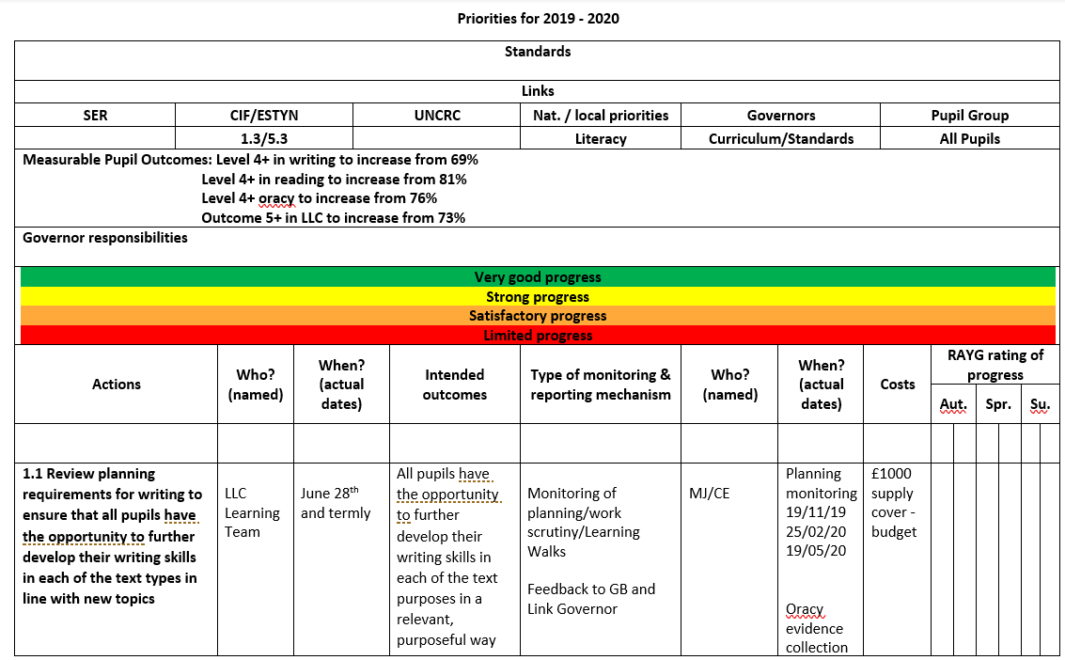
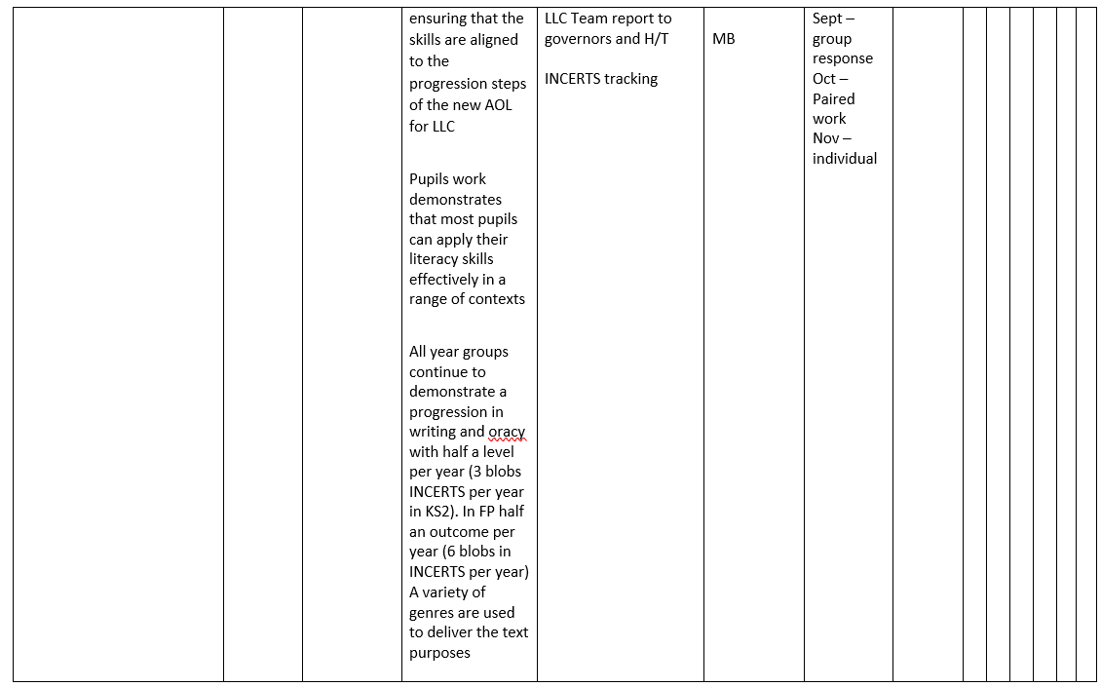
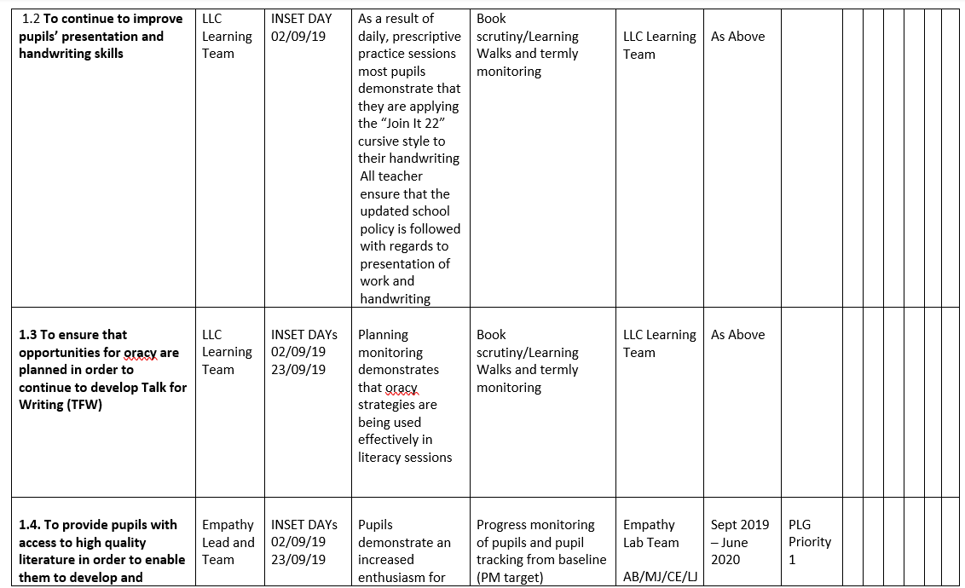
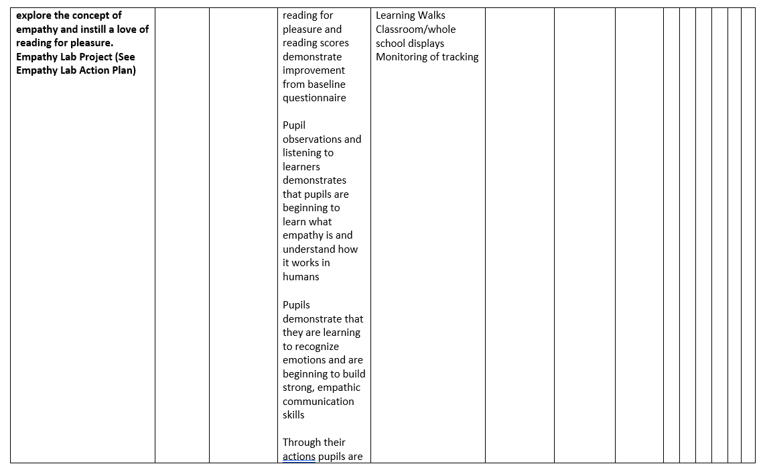
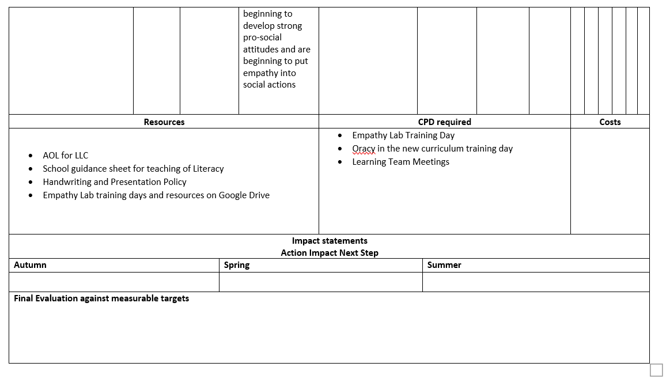
Appendices 2 – Bridging Research


