Management Accounting
By Cosmin Daniel Popa

UNIVERSITY OF WALES TRINITY SAINT DAVID STUDENT ID:1919080
MAY 3, 2022

Contents
Introduction 2
Part A 3
Control Report 3
Report on the performance of Amana 4
Recommendation 6
Part B 7
Conclusion 9

Introduction

The main purpose of this assignment is to determine and discuss the role of management accounting in decision making. It discusses how management accounting aids to control the performance of the business. It will determine the variance in the performance. This report will recommend determining the performance of the business. In addition to this, it will measure the alternatives of offline and online modes to sell out the products by taking into consideration the volume, cost, and profit.

Part A

Control Report
Control of the performance of the business is a very important task and function of the enterprise which may aid to keep eye on the performance and track the progress of the business. The performance of the entity can be led in the right direction by ensuring good control over the performance which in turn can raise the level of the performance. The sustainability of the entity may be improved by monitoring the deviation in the performance and ensuring proper management of the business and effective planning. The controlling function may improve the sale revenue and business profit because it cut down the cost and expenses and improve the efficiency of the operation. The control report is prepared after a proper audit of the statement and accounts of the organization that aided to determine the variance in the performance and it provides the information regarding the variance. It may enable the business manager to develop an action plan to achieve the business objectives and meet the interest of the stakeholder in the organization (Ward, 2012).
For effective monitoring and control over the business performance, the degree of the change in the environment and degree of variance in the performance alongside the nature of the variance is needed to be determined. The nature of variance may be negative or positive. If the actual revenue and other measures of the performance of the organization are high as compared to the budgeted, it may be stated as a positive variance. If the actual measures of the performance of the organization are less than the budgeted, it may be a negative performance variance. Therefore, revealing the information on the performance and variance in the progress of the organization can affect the decision of the business about the strategies and tactics. The monthly basis control report may ensure regular review of the progress which may aid the check the negative variance in the bud that can keep the business performance on track (Taschner, 2016). Therefore, it can be aid that the control report may aid to raise the business profit and productivity.

Particular | Original budget | Flexed budget | Variance
Units of products | 100000 | 80000 | -20000 | U
Selling price of the products | 25 | 20 | -5 | U
Sales revenue of the company | 2500000 | 1600000 | -900000 | U
Variable cost |  |  | 0
Material used in production | 250000 | 280000 | 30000 | U
Labour employed | 400000 | 440000 | 40000 | U
Overhead and other expenses | 150000 | 120000 | -30000 | F
Contribution | 1700000 | 760000 | -940000 | U
Fixed overhead |  |  | 0
Warehouse rent | 200000 | 170000 | -30000 | F
Insurance of company | 100000 | 100000 | 0
Supervisor salary in the organization | 50000 | 35000 | -15000 | F
profit | 1350000 | 455000 | -895000 | U

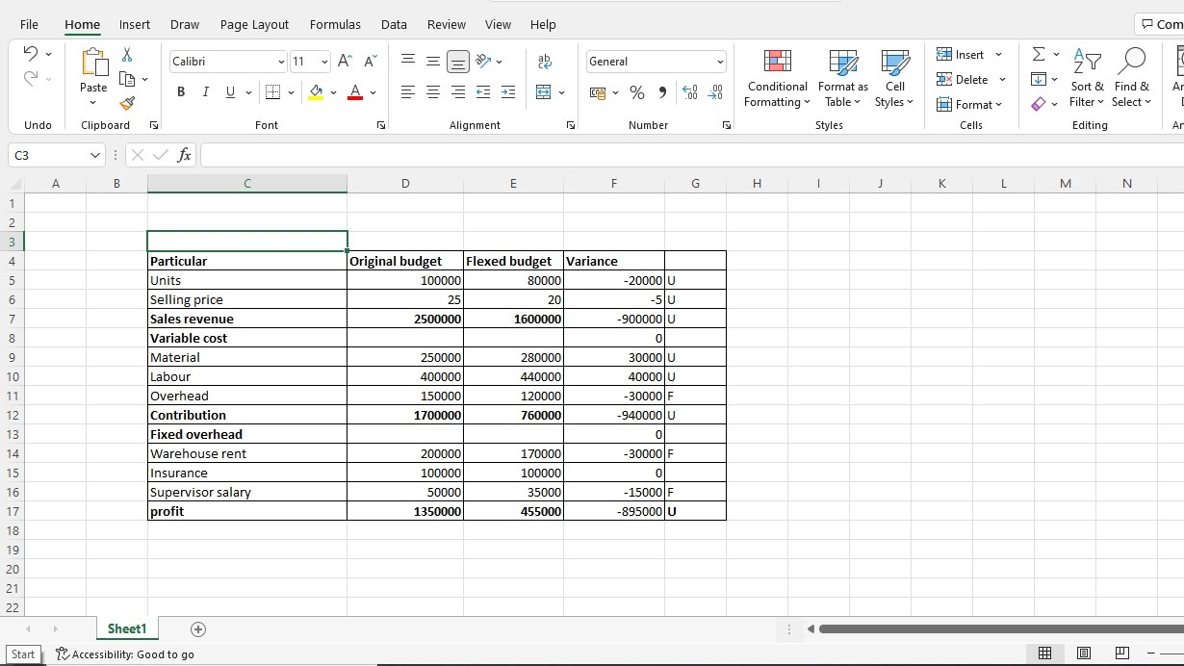

Report on the performance of Amana
The control report including different measures is given below:
Sales revenue
Amana Ltd aimed to raise the profit by selling products through the physical stores but the COVID-19 pandemic influenced the operation of the physical stores and the goals of the entity. Sales revenue is a very important requirement of the firm to ensure sustainability and gain profit, but lack of sales revenue may cause less profit that can influence the affordability of the company to bear expenses. The sales revenue of Amana Ltd went down because it assumed the sales revenue up to £2,500,000 but it achieved only £1600000. It means the actual sales of the organization are less than the estimated sales because of the reduction in the demand for the products. the high price of the product and less income of the consumer during the COVID-19 influenced the sales of the reorganization. The high price of the product may influence the affordability of the buyers which affects the variance of the sales revenue negatively (Astrill and McLaney, 2012). It can be said that sales units expected to be out from the organization were 100000 units, but the actual units sold out were 80000 which means unit sales. The reduction in the demand and high price competition in the market put pressure on Amana Ltd to reduce the price to £20 from £25 per unit. Hence, the variance in the sales revenue is unfavorable that may put pressure on the firm to cut down the cost to maintain sustainability (Drury, 2018). Along with this, lack of the marketing activities and promotion of the products of Amana Ltd may also be the reason behind the reduction in demand and sales of the entity.
Variable cost
The cost is also an important factor that affects the performance of the enterprise because the high cost of the product may reduce the profit margin of the entity. The cost is a very important factor in decision making on the price of the product and selection of the alternatives (Vanderbeck, 2012). The variable cost may be moving up or down as per the increase in the production and business activities, but it may influence the profit of the business.
Material cost
This is a good contributor to the production cost in the organization. Hence, a change in the cost and price of the materials may trigger a change in the cost of the product which may affect the pricing decision of the business. Hence, it is found that the material cost of Amana ltd was expected to be around £250000 but it reached £280000 (2.80 per unit). Hence, it can be said that material variance is unfavorable in Amana ltd that may influence the cost of products and the profitability of the business (Drury, 2018). During COVID-19, the supply of materials ran shortage which increase the material cost.
Labour Cost
This is also contributed to the cost of the production as the labour force is recruited to produce the products and operate the business activities. In Amana Ltd, the actual cost spend on labour force was £440000 while the budgeted cost was £400000. It means the labor cost of the company increased during a pandemic. The shortage of labour force during the pandemic increased the wages rate to attract the workers. It influenced the cost and caused a negative variance in the labour cost (Warren et al., 2011).
Overheads
The expenses of the organization other than the direct cost of labour and material cost may also influence the prices of the product and business performance. The overheads in Amana Ltd were controlled which helped the organization to keep them at £120000 while the expected expenses were £150000. Hence, it may be said that the good control over overheads enabled Amana Ltd to control its cost and improve its revenue (Drury, 2013).
Fixed cost
It can be defined as the cost that ignores the change in the production volume and business activities. The fixed cost may be lower per unit if the production volume increases. Hence, Amana Ltd realized a decrease in the warehouse rent and an increase in the salaries of the supervisor. The budgeted rent for the warehouse was 200000 that decreased to 1700000 while the supervisor’s salary was 50000 which was budgeted at 35000. It means the budget cost of rent was high that indicates positive variance while the actual salary of the supervisor exceeds the expected salary which indicates negative variance (WEYGANDT, 2013).
Profit
The business profit defines the efficiency of the organization to cut costs and enhance sales revenue. The actual profit of the organization was 455000 in 2020 while the budgeted profit was 1350000. It means the profit of the organization declined because of the high cost of production, high operating cost, and reduction in the sales revenue of the organization (WEYGANDT, 2013).

Recommendation
Some recommendations for Amana ltd are delineated below:
Amana Ltd should increase the promotional activities to increase the awareness of the product among the targeted audience. The marketing of the product and communication of the discount offers, advertisement of offers, and social media marketing may improve the sales of the organization. Social media may improve public relations and can aid to improve the effectiveness of customer relationship marketing. It can be useful in building a base of satisfied customers that must enhance the sales revenue and profitability of Amana ltd (Drury, 2013). It can be a good strategy to improve the loyalty of the buyers that the company can leverage in long term.
Along with this, Amana ltd should ensure the proper safety of the employees in the workplace because safety and a healthy working environment can increase the motivation of workers. During the COVID-19 pandemic, the employee was afraid of the infection which affected their engagement in jobs adversely. Hence, regular inspection and safety tools and measures may aid to improve the confidence of the employees and their commitment to the work (Vanderbeck, 2012). It can ensure the availability of the workforce abundantly which may lower the cost of the workforce.
Additionally, Amana can build a strong relationship with the supplier and can sign the contract to keep the cost minimum and improve the profit margin. If the material cost is kept low, it may increase the profitability of the organization (WEYGANDT, 2013). Therefore, Amana should focus on nurturing a good relationship with the suppliers.

Part B
Ecommerce marketing and selling are trending among the businesses in the global market because the attitude of the buyer has changed towards online shopping. Customers have moved towards online shopping more during the pandemic and it improve the performance of online and e-commerce retailing companies. It is an internet-based system that provides the platform for consumers to buy products or services without visiting the store of the companies. Offline marketing is the traditional method of marketing in which the companies sell their product in physical stores, and it does not require a website or internet. On the other side, online marketing is based on virtual stores, and it requires designing and developing the website to attract consumers and improve sales. In the context of Amana Ltd, this organization is fighting against the competitors, but the competition is influencing the performance of the business. The trend of online shopping and marketing has been high in the USA, Europe and other parts of the world which has shifted the attention of the companies toward digital marketing. Digital platforms enable consumers to easily browse a range of products on the website of the company and choose the product that they need. It also saves the cost customer that they spend on travelling to the stores (Collier, 2015). The use of third-party platforms and e-commerce sites for selling the product can aid the firms to reach the market but may not provide good control of the performance marketing and practices of the organization. The development of the cost, promotion and other costs of the expenses may influence the online marketing while using a third-party website for the marketing may save the expenses and cost in the company (Beechy et al., 2011). Hence, cost and benefit analysis can be used for assessing the options and to determine the right option for investing money (Epstein and Lee, 2014). IT programs, website quality, network delivery, market research, salaries and others are the factors that may influence the decision of the company.
Selling through the website: | Third-party website: Amazon
The cost of a network can be £150,000  Website upgrading cost will be £50,000  Salary can be £35,000 per annum  The sales volume can be 100000 units  Hence, the total cost of the company can be £235000 (150000+50000+35000) to sell out 100000 units according to the information by conducting the research in the market. | A full-time fee of the company can be £50,000 required for registration on Amazon. The potential of the company to sell out 65000 units may influence the operation.

Hence, it is found that website development costs and operating costs are quite higher in comparison to the third-party website at Amazon to distribute the product in the market. It means the cost is a very important factor that can affect the operation of the organization and can influence the price of the products. Hence, the high cost of using the own website of the company to sell and distribute the product in the market may increase the product price which may influence the profit margin adversely (Keller, 2015). Amana needs to focus on the maximization of the sales revenue to improve the market share and improve the profit. The cost of developing a website can be higher but it may provide full control of the operation and marketing while a third-party website may not provide control over the distribution of products. It cannot be a long-term operation option and the sales revenue of the company in this option is also less. Therefore, it can be said that Amana can choose the option of developing its website for marketing and distribution of its products or service in the market instead of the website of Amazon. It may raise the sales volume as well as sales revenue of the organization in the market (Needles et al., 2013). Furthermore, the control over the price of the product can be lost by the company if it uses a third-party website because it cannot change the prices accordingly but the use of the website of the organization may aid it to manage the price as per the fluctuation in the demand or supply of the products. Hence, it may ensure a good exercise of the price movement to accommodate the change in the market (Edwards, 2013). Thus, Amana can use its website for the distribution of the product to consumers.

Conclusion
It can be summarized that management accounting plays a very important role in planning and controlling business performance. A controlling report is an important report of the management accounting that reveals the variance in the performance of the business. Furthermore, management accounting tools can be helpful in the determination of the make or buy decision. Hence, Amana ltd can use its website for increasing sales revenue and profitability.
References
Astrill, P. and McLANEY, E. (2012) Accounting and Finance for Non-Accounting Specialists. 8th Ed. Harlow: Pearson.
Beechy, T. H., Conrod, J. E. D., Farrell, E., and McLeod-Dick, I. (2011) Intermediate accounting. UK: McGraw-Hill Ryerson.
Collier, M. (2015) Accounting for managers: Interpreting accounting information for decision making. New York: John Wiley & Sons
Drury, C. (2018) Cost and management accounting. USA: Cengage Learning.
Drury, C. M. (2013) Management and cost accounting. USA: Springer.
Edwards, J. R. (2013) A history of financial accounting (RLE Accounting). London: Routledge.
Epstein, M. J., and Lee, J. Y. (2014) Advance in Management Accounting. UK: Emerald Group Publishing.
Keller, W. (2015) Cost and Managerial Accounting II Essentials. New York: Research & Education Assoc.
Needles, B. E., Powers, M., and Crosson, S. V. (2013) Principles of accounting. USA: Cengage Learning.
Vanderbeck, E. J. (2012) Principles of cost accounting. USA: Cengage Learning.
Ward, K. (2012) Strategic management accounting. UK: Routledge.
Warren, C., Reeve, J., and Duchac, J. (2011) Financial & Managerial Accounting. USA: Cengage Learning
Weil, R. L., Schipper, K., and Francis, J. (2013) Financial accounting: an introduction to concepts, methods and uses. USA: Cengage Learning.
WEYGANDT, J. et al (2013) Financial Accounting, IFRS edition. 2nd Ed. Oxford: Wiley.

