Raziel Miracle Business Plan

Program of study: Certificate in Higher Education Business Skills for the Workplace

Module name and Code: Enterprise and Entrepreneurship (LCLM4006_BIRM)

Assignment Title: Task 1: Individual Written Business Plan.

Lecturer name: Taonga Kaonga Sobere-Snithers

Student Name: Razvan Pojar (2423339)

Contents
Raziel Miracle Business Plan 1
1.Overview of the Business Idea 3
2.Legal Format: Sole Trader 3
3. Environmental Analysis (PESTEL) 4
4. Marketing Strategies 5
5. Funding and expenses 7
Cash flow 8
Reference List 9
Appendices 10

1.Overview of the Business Idea
Raziel Miracle is a fragrance brand offering artisanal, small-batch perfumes crafted with trusted sources of essential oils for a customised blend of the fragrance. The brand blends poetic storytelling, symbolic packaging to create emotionally resonant sensory experiences.
Raziel Miracle’s mission is to offer high-quality, artisanal fragrances that reflect individuality values.
Core Offering: Limited-edition (unique) perfumes, discovery sets, and scent rituals (e.g., oil infusions, aroma therapy). Having as new collection “The 4 Elements” inspired of the five elements of the nature: Earth, Fire, Water, Air, (see the Appendices).
USP (unique selling point): Its USP lines in the poetic layering of rare oils—each blend tells a symbolic story, crafted with both technical precision and emotional depth. This fusion of artistry and alchemy creates an experience that no mass-market brand can replicate (Gov.uk, n.d)
Positioning:
Raziel Miracle will be positioned as a luxury, ethical, and mystical brand. The brand narrative will draw from angelic symbolism and spiritual themes, creating a unique emotional connection. having as new collection “The 4 Elements” inspired of the five elements of the nature: Earth, Fire, Water, Air, (see the appendices).

Target Market: Perfume lovers aged 20 and above seeking authenticity, sustainability, and emotional depth in luxury fragrances.
This entrepreneurial idea is viable due to its alignment with consumer trends toward sustainability, personalization. The brand’s storytelling approach customer loyalty and emotional engagement, which are critical in the competitive luxury fragrance market. According to the Business Population Estimates (2024), over 5.6 million SMEs operate in the UK, with artisanal and wellness sectors showing steady growth.
Location Strategy: Birmingham’s Jewellery Quarter offers high foot traffic, creative demographics, and proximity to artisanal communities. According to Birmingham City Council (2023), the area attracts over 1 million visitors annually, making it ideal for experiential retail. Most of the shops in the Jewellery Quarter are Jewellers, Gold dealers, Watchers, Restaurants, Pubs and Coffee shops. The nearest competitors are within 5 miles which is: The Perfume Shop, The Fragrance Shop, The Jewellery Quarter Birmingham
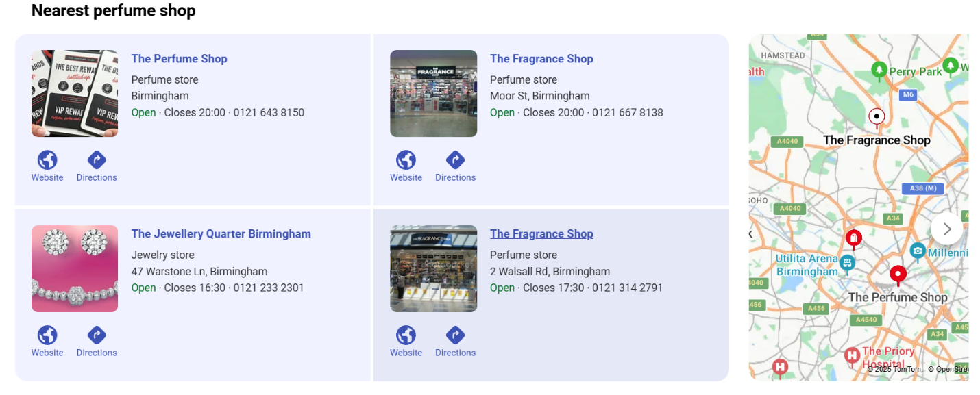
Image 1 – Direct Competitors within a 5-mile radius of Jewellery Quarter. Source: Bing Maps (n.d.)
2.Legal Format: Sole Trader
A sole trader is a type of business is a person who runs the business by themself. It’s the simplest business structure to set up and keep records for work for yourself, are classed as self-employed, make all the business decisions. Being a Sole Trader the individual is not separate from the business and has sole unlimited personal liability for the business, its debts and contractual obligations, and any claims against it (GOV.UK, 2025).
They own all the assets of the business and can dispose of them as they wish and may employ staff and trade under a business name. Regulation for the Sole Trader is minimal: there is no requirement for a formal constitution for the business, and no need to register or file accounts and returns with Companies House (money.co.uk, 2024).
Sole Traders are treated as self-employed by HMRC and must register and make an annual self-assessment tax return – profits from the business are treated as personal income subject to income tax and national insurance contributions (unbiased.co.uk, 2025

The business operates as a Sole Trader offering customized blends of fragrances for unique olfactive experience. Registered as TM (trademark) I can trade under my own name or the brand name. The management structure will include the founder as CEO, supported by freelance marketing and operations consultants.

Management Structure:
Founder & Creative Director: Razi – oversees formulation, branding, and strategic direction.
Operations Lead: Manage compliance, logistics, and supplier coordination.
Marketing Consultant: Freelance – supports digital campaigns and customer engagement.

3. Environmental Analysis (PESTEL)
Political:
UK regulations on cosmetic safety and labeling are strict, requiring compliance with REACH and Cosmetic Regulation (EC) No 1223/2009 1. Brexit has introduced complexities in sourcing ingredients from EU suppliers, increasing costs and lead times .
Economical:
Inflation pressures raw material costs: niche luxury markets remain resilient.
The UK fragrance market reached the revenue generated in the amounts to US$2.19bn in 2025.
It is projected that the market will experience an annual growth rate of 0.56% (CAGR 2025-2030). Despite inflation, luxury fragrance sales remain resilient due to consumer preference.
Social:
Consumers increasingly seek ethical and sustainable products. Unisex fragrances are gaining popularity, especially among younger demographics who value inclusivity and personalization. Raziel Miracle will use social media to promote the brand on Facebook, Instagram, LinkedIn, TikTok, Pinterest.
Technological:
E-commerce platforms and AI-driven scent profiling enhance customer experience.
Raziel Miracle will explore and AI integration to enhance customer engagement for customizing the visual impact.
Technological analysis can be linked with social analysis where social media can be used as advanced technology pole.
Environmental:
Sustainability is a key concern. Raziel Miracle will use recyclable packaging, cruelty-free ingredients, and offer refillable bottles to reduce waste. Eco-packaging and carbon- emission shipping align with consumer values.
Legal:
Compliance with UK and EU cosmetic laws is essential. The brand will ensure all products are dermatologically tested and labeled accurately to meet legal standards.
Article 4 of Regulation 1223/2009 provides that a cosmetic product cannot be placed on the GB market unless there is a Responsible Person established in the UK in respect of that cosmetic product.

4. Marketing Strategies
Raziel Miracle will adopt a multi-channel marketing strategy focused on storytelling, sensory engagement, and digital reach.
Digital Channels:
•Website: Pinterest, optimized for storytelling, product discovery, and conversion.
•Social media: Instagram and Pinterest for visual branding; TikTok for behind-the-scenes content and scent rituals.
•Email Marketing: Monthly poetic newsletters, exclusive drops, and loyalty rewards.
Experiential Marketing:
•Pop-Up Events: Collaborations with local boutiques, art galleries, and wellness spaces in Birmingham’s Jewellery Quarter.
•Scent Workshops: Interactive sessions to educate customers on fragrance formulation and ritual use.
Brand Positioning: Raziel Miracle will position itself as a poetic, emotionally intelligent brand. Visual storytelling, symbolic packaging, and cultural references will differentiate it from competitors. Influencer collaborations and user-generated content will amplify reach and authenticity.
This strategy leverages both digital and physical touchpoints to build a loyal customer base. It also aligns with the founder’s strengths in branding, emotional intelligence, and visual design.
Target Market:
Affluent individuals aged 20 and above, primarily urban customers, who value exclusivity and emotional storytelling.
Positioning:
Raziel Miracle will be positioned as a luxury, ethical, and mystical brand. The brand narrative will draw from angelic symbolism and spiritual themes, creating a unique emotional connection, having as new collection “The 5 Elements” inspired of the five elements of the nature: Earth, Fire, Water, Air, Eter.
Promotion:
- Influencer collaborations on Instagram and TikTok
- Story-driven content showcasing ingredient sourcing and crafts making.
- Launch events and pop-up experiences
- Email campaigns with personalized scent recommendations
Digital Strategy:
Given the sensory nature of perfume, Raziel Miracle will use mood-based scent descriptions, AI-powered quizzes, and immersive video storytelling to bridge the digital gap.
Also using platforms such as TikTok, Facebook, Instagram, LinkedIn to attract customers and have a better perspective about /customized perfume are made.
Pricing:
Premium pricing will reflect the brand’s artisanal quality:
- Miracle Essence (50ml): £60
- Limited Editions (50ml): £150–£200
Distribution: Direct-to-consumer via social media
In UK by Royal Mail
Seasonal pop-up stores with special formula

5. Funding and expenses
The funding source chosen for my business idea is personal savings and government grant. Grants are sources of funding which don’t need to be paid back. Personal funding is attractive as I don’t need to pay anyone back.
Why These Sources: Grants align with the brand’s creative and sustainable ethos
Personal investment reflects founder commitment
Justification: The UK Start-Up Loan offers low-interest financing and business mentoring.

Funding & Startup Expenses
Funding Required: £8,000
Sources:
£3,000 personal savings
£5,000 from a startup grant (e.g., Prince’s Trust)

•Startup Expenses (First Month):
Raw materials (essential oils, alcohol, bottles): £1,500
Packaging and label production: £800
Website and branding assets: £1,000
Legal registration fees: £500
Marketing and launch campaign: £2,000
Rent: £500
Utilities: £300
Insurance: £500
Telephone and Internet: £50
Vehicle cost: £300
Postage and printing: £500
Transport, delivery: £200
Cost of product: £2000

Cash flow
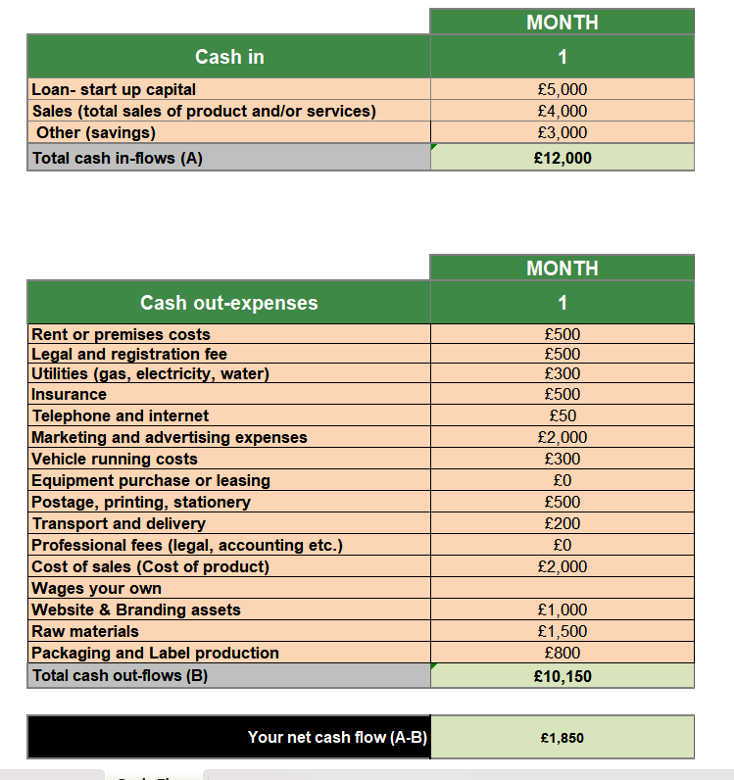

Reference List
Bing Maps (N.d) Nearest Perfume Shop. Available from: nearest perfume shop from jewellery quarter - Bing Maps
Birmingham City Council (2023) Jewellery Quarter Visitor Statistics.
Companies House (2024) Guide to Company Formation. London: UK Government.

Department for Business and Trade (2024) Business Population Estimates for the UK and Regions. Available at: gov.uk
European Commission (2023) REACH Compliance for Cosmetics.
European Parliament and Council. (2009). Regulation (EC) No 1223/2009 of 30 November 2009 on cosmetic products, Official Journal of the European Union, L 342, pp. 59–209. Available from: https://eur-lex.europa.eu/eli/reg/2009/1223/oj/eng
Gov.uk (n.d) Find and Update Company information. Available from :Raziel Miracle - Find and update company information - GOV.UK
GOV.UK. (n.d.). Become a sole trader: What a sole trader is. Available from: https://www.gov.uk/set-up-sole-trader
GOV.UK. (n.d.). Regulation 1223/2009 and the Cosmetic Products Enforcement Regulations 2013: Great Britain. Available from: https://www.gov.uk/government/publications/regulation-12232009-and-the-cosmetic-products-enforcement-regulations-2013-great-britain
HMRC (2024) Start Up Loan Scheme Overview.
Kotler, P. and Keller, K.L. (2016) Marketing Management. 15th den. Pearson Education.
Mintel (2023) UK Fragrance Trends Report.
money.co.uk. (n.d.). 7 need-to-know legal requirements for sole traders. Available from: https://www.money.co.uk/business/sole-trader-legal-requirements
Piccolo, V. (2025). Marketing strategies for perfume brands in 2025. Callin. Available from: https://callin.io/marketing-strategies-for-perfume-brands/
Prince’s Trust (2024) Enterprise Programme Guide.
Solomon, M.R. (2018) Consumer Behaviour: Buying, Having, and Being. 12th edh. Pearson.
Statista. (2025). Fragrances - United Kingdom Statista Market Forecast. Available from: https://www.statista.com/outlook/cmo/beauty-personal-care/fragrances/united-kingdom
TikTok. (n.d.). Creator Academy: Empowering Creators to Grow and Succeed. Available from: https://www.tiktok.com/creators/creator-academy
Unbiased. (n.d.). What is a sole trader and how do I register as one? Available from: https://www.unbiased.co.uk/life/what-is-a-sole-trader-and-how-do-i-register-as-one

Appendices

Earth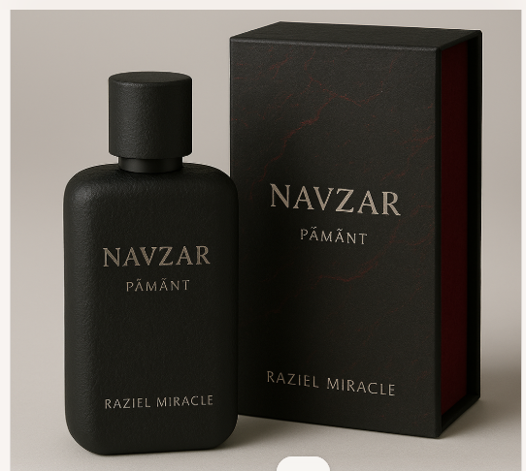 Fire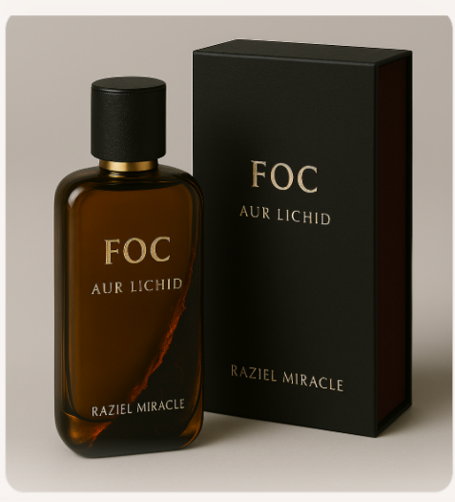 Water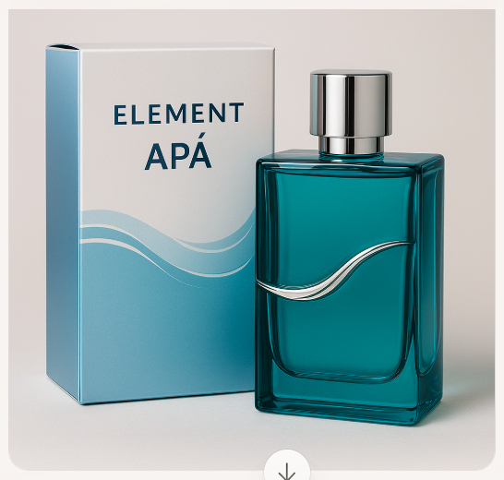 Air 

