Geodemographic analysis using GIS Software
Geographical Information
jonathan wilcox - 2206641
2025

Cancer incidents

within Wales

Abstract – Cancer is a leading cause of mortality worldwide, with over 20 million new cases diagnosed annually. This report focuses on cancer incidents in Wales, using geodemographics to analyse socioeconomic data and identify influences such as socioeconomic status, environmental factors, and lifestyle choices.
The report uses Geographic Information System (GIS) software to visualise and analyse data through thematic maps, geocoding, and spatial queries. The findings highlight areas with higher cancer rates due to factors like deprivation, poor health, and pollution. Interestingly, the Vale of Glamorgan U003 was identified as the areas with the highest cancer rates and has many factors correlate to the higher rate.
The report identifies the need for additional data to enhance analysis and support the conclusion. The study will aid healthcare professionals in making strategic decisions, allowing healthcare providers to focus on specific areas for cancer care and prevention.

Contents
1 – Introduction 5
2 – Analysis 6
2.1 Cancer Incidences 6
2.2 Townsend Index 9
2.3 General Health 11
2.4 Adult Lifestyles 12
2.5 Age Demographic 15
2.6 Ethnic Minority 17
2.7 Pollution 19
2.8 Urban Vs Rural 21
2.9 GP Surgeries and Hospitals 23
2.10 Motorway 24
3 - Conclusion 26
Appendix 1. Development Log (Task 1 - Part B) 27
Setting up a workspace 27
Software & File Types 27
GIS Build 28
Boundary Data 28
Cancer Incidences 29
Towsend Index 31
General Health 33
Adult Lifestyles 35
Age Demographics 36
Ethnic Minority 38
Pollution 39
Urban Vs Rural 40
Roads and Motorways 41
GP and Hospital 43
Exporting 45
Build Conclusions 46
Appendix 2. Map References 47
Wales USOA 47
Wales LA 48
Wales Regions 49
Abbreviations 50
References 51

Table of Figures

Figure 1: Cancer incidences across Wales between 2011-2019. 6
Figure 2: Cancer incidences across Wales in 2011. 7
Figure 3: Comparison between highest and lowest rates. 7
Figure 4: Cancer trends between 2011 to 2019 identifying areas with highest percentage change. 8
Figure 5: Townsend index comparison against cancer rates in Wales by USOA 9
Figure 6: Townsend index South Wales against areas of higher cancer rates (USOA) 10
Figure 7: Bad general health comparison against cancer rates in Wales by USOA 11
Figure 8: BMI 25+ comparison against cancer rates in Wales by LA 12
Figure 9: Annual alcohol consumption (units) comparison against cancer rates in Wales by LA 13
Figure 10: Smokers (including Ex smokers) comparison against lung cancer rates in Wales by LA. 14
Figure 11: Lung cancer rates in Ceredigion 2011, 2015 and 2019 14
Figure 12: Average age by against cancer rates in Wales by USOA 15
Figure 13: Mid Wales average age against cancer rates in Mid Wales by USOA 16
Figure 14: Ethnic minority comparison against cancer rates in Wales by USOA 17
Figure 15: Ethnic minority within Cardiff against cancer rates in Cardiff by USOA 18
Figure 16: Pollution PM10 & PM2.5comparison against lung cancer rates in Wales by USOA 19
Figure 17: South Wales Lung cancer rates compared to air pollution 19
Figure 18: Urban & rural comparison against cancer rates in Wales by USOA. 21
Figure 19: Urban comparison against cancer rates in South Wales by USOA. 21
Figure 20: GP surgeries and hospital average travel distances compared to cancer rates. 23
Figure 21: M4 Corridor in South Wales comparison against lung cancer rates 24
Figure 22: M4 Corridor in South Wales comparison against lung cancer rates and urban areas 24
Figure 23: A55 in North Wales comparison against lung cancer rates and urban areas 25
Figure. 24. Project file structure \ workspace 27
Figure. 25. Dataset log created in Microsoft Excel 27
Figure. 26. Project workspace showing USOA Boundaries and labels.. 28
Figure. 27. Project workspace showing cancer incidences by USOA 29
Figure. 28. Creating thematic map. Selecting type and colour range. 30
Figure. 29. Creating thematic map customise ranges 30
Figure. 30. Project workspace showing cancer incidences by USOA 30
Figure. 31. Project workspace showing cancer incidences over time with a trend graph 31
Figure. 32. Workspace showing areas with largest percentage increases between 2011 and 2019 31
Figure. 33. Boundary mapping lookup file. 32
Figure. 34. Townsend index calculated in Microsoft Excel. 33
Figure. 35. Project workspace showing Townsend Index by USOA 33
Figure. 36. SQL Query to limit the data to bad health only 34
Figure. 37. Project workspace showing people with bad health by USOA 35
Figure. 38. Project workspace showing local authority’s areas with an overweight population 36
Figure. 39. Project workspace showing local authority’s areas with rates of smokers 36
Figure. 40. Project workspace – Example of data table view as a browser tab. 37
Figure. 41. Project workspace showing age demographics within Wales by USOA 37
Figure. 42. Calculation to identify percentage of people within an ethnic minority by USOA 38
Figure. 43. Project workspace showing ethnic minority within Wales by USOA 39

Figure. 44. Project workspace – PM10 and PM2.5 Pollution overlay. 40
Figure. 45. Project workspace – urban areas layer 41
Figure. 46. Project workspace M4 Motorway overlayed with 2km buffer zone included 42
Figure. 47. Buffer objects tool within MapInfo 43
Figure. 48. Project Workspace – Road network overlay. 43
Figure. 49. Project workspace – GP and Hospital sites across Wales. 44
Figure. 50. SQL query to calculate distance within each region. 44
Figure. 51. Thematic map to identify variances in average travel distance. 45
Figure. 52. Project workspace – GP travel distances overlayed over cancer rates in Wales 45

1 – Introduction
Cancer is a health problem that affects the world, resulting in one of the leading causes of mortality, with over 20 million new cases diagnosed each year [1]. Cancer rates are rising each year in the UK. The latest statistics from the UK National Health Service (NHS) indicate 346,216 new cases in 2022, an increase of 5% from 2021 [2].
Treatment of cancer is becoming more effective, with deaths falling from 345 deaths per 100,000 people in 2011 to 299 deaths per 100,000 people in 2022 [2]. However, the key to reducing incidences is prevention. To understand how to prevent cancer, we must understand better what impacts the incidences.
This report will focus on cancer incidents in Wales using geodemographics to analyse socioeconomic data, comparing numbers throughout different geographic areas to identify influences, such as socioeconomic status, environmental factors, and lifestyle choices. Geodemographics separates people into groups based on their geographic and demographic characteristics to help understand the population based on where they live [3].
The report uses a Geographic Information System (GIS) to visualise, spatially compare, and analyse data using thematic maps, geocoding and spatial queries to aid in identifying trends, relationships and patterns. The discussions and results of this report will help understand where cancer is most prevalent in Wales and the key factors that cause the disease; this will help the NHS allocate and prioritise resources to aid in the war against cancer.

2 – Analysis
The analysis is based on the whole of Wales, comparing regions by upper supper output area (USOA) where data is available; where USOA is not available, local authority (LA) will be used for analysis. USOA is a boundary grouping of 94 boundaries as part of an Output Areas (OAs) grouping created by the ONS for Census statistics. Wales USOA is based on splits of approximately 31,000 people, varying from 24,000 to 47,000. Wales has 22 local authority boundaries, and the USOAs are nested within each LA [4].

Appendix 2 identifies a detailed view of all USOA, Local Authorities and regions in Wales, which will be used throughout the discussion. Due to the scale of Wales, only key labels will be shown on example maps; full access is available via the MapInfo software.

2.1 Cancer Incidences
Before analysing what influences cancer rates, an initial analysis and comparison of cancer rates throughout Wales was completed. Statistics from Health Map Wales [5] show that cancer rates have decreased from 2011 to 2019, peaking in 2013 before reducing yearly. For this report, 2011 statistics will be mainly used for comparison as they match 2011 census population data.

Figure 1: Cancer incidences across Wales between 2011-2019

The thematic map below highlights the areas with higher rates of cancer incidences across Wales in 2011. The map below identifies higher levels in the North and South with significantly lower rates across mid-Wales. At first glance, the North may appear worse due to the larger scale boundaries due to the lower population in these areas. North Wales has 11 USOAs within the higher brackets of incidences, 9 Red and 2 Orange; South Wales has significantly higher, 10 falling in the red bracket and 16 within orange.

Figure 2: Cancer incidences across Wales in 2011.
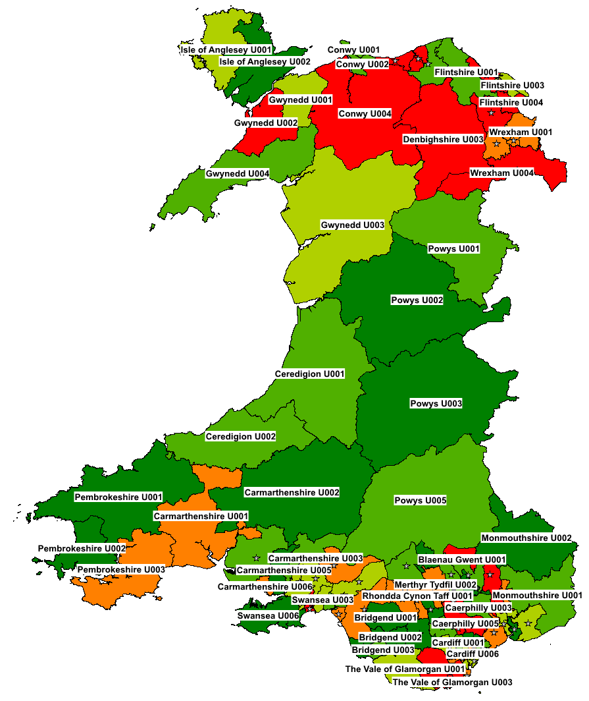 | 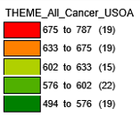
© Crown Copyright Upper Super Output Area Boundary

The Vale of Glamorgan U003 has the highest cancer levels compared to the rest of Wales, with Cardiff U002 showing the lowest; interestingly, these are within close proximity, as shown in Figure 3
Figure 3: Comparison between highest and lowest rates
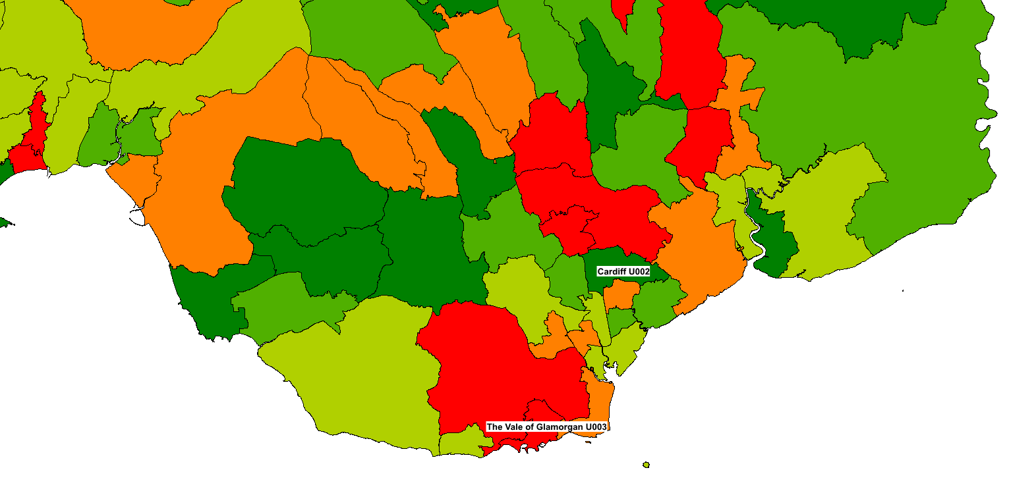
© Crown Copyright Upper Super Output Area Boundary

Although the report focuses on 2011 cancer rates, some analysis has been completed on the trends since 2011. With the overall statistics in Wales reducing, some areas have seen significant increases. Figure 4 below highlights areas with substantial increases of 11 per cent or more.
Figure 4: Cancer trends between 2011 to 2019 identifying areas with highest percentage change.
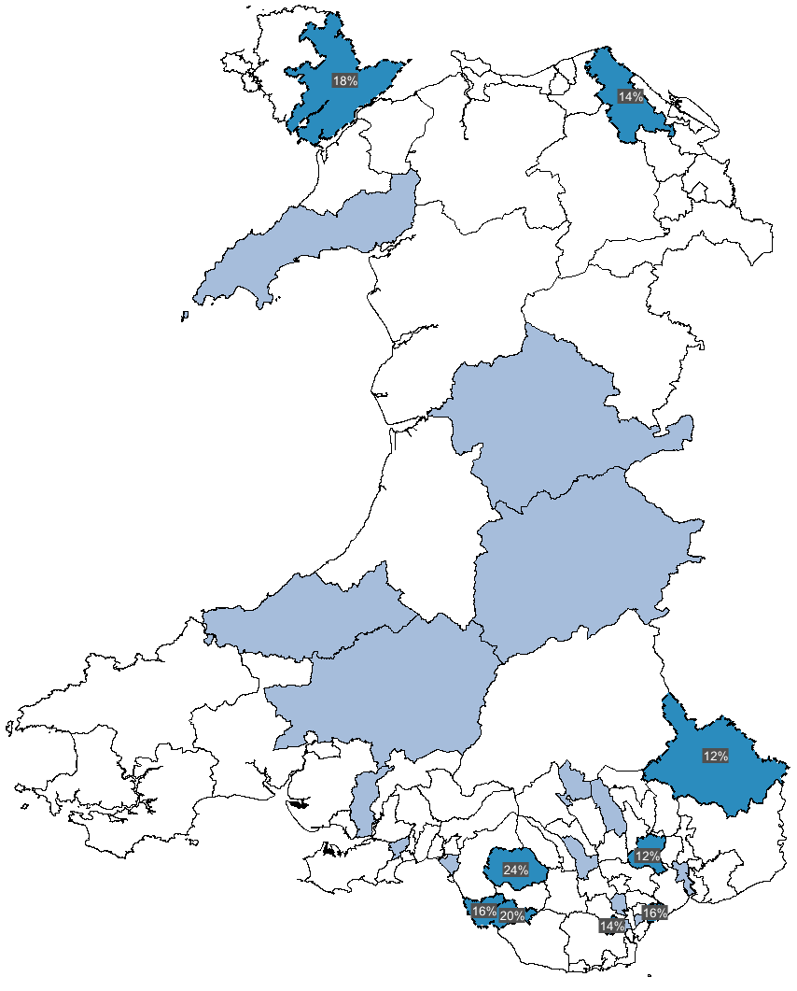 | 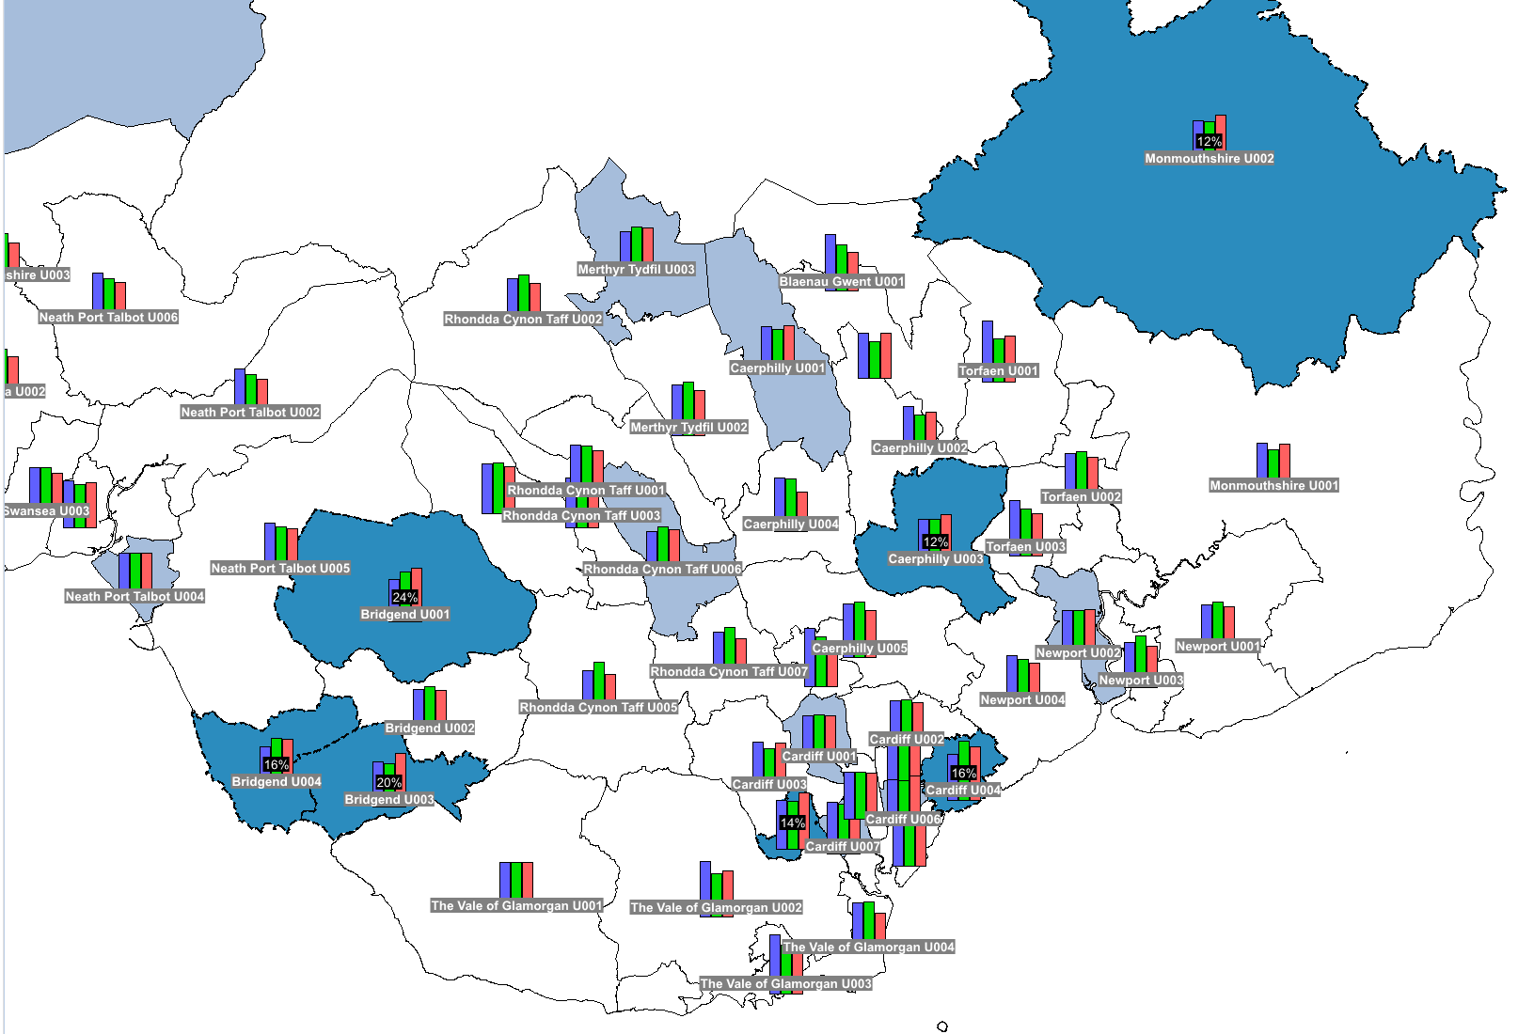 | % Change since 2011  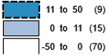  Change trends  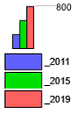
Areas with high percentage  change from 2011-2019 | Southeast Wales cluster of areas  with significant change between 2011-2019
© Crown Copyright Upper Super Output Area Boundary
Similar to the higher cancer rates in the South identified previously, Figure 4 shows a cluster in the southeast of Wales with a greater than 11 per cent increase between 2011 and 2019. The area with the highest rates (Vale of Glamorgan U003) observed in 2011 has reduced by 25 per cent since 2011, one of the significant decreases seen across Wales. Cardiff U002 remains the area with the lowest levels of incidence in Wales in 2019 with a further decrease from 2011.

With cancer Incidence data collected and geocoded to the Wales map, we can now investigate possible causes of higher or lower rates identified throughout Wales.

2.2 Townsend Index
The Townsend Index is a score given to measure deprivation, with higher scores representing higher levels of deprivation. The Townsend Index score is based on a calculation of four variables: unemployment, overcrowded households, non–car ownership, and non–home ownership [5].
A study from the National Library of Medicine Socio-economic identifies that the Townsend index shows a significant correlation with the risk of developing cancer amongst people within deprived areas [7]. Socio-economically deprived areas have increased rates of poor lifestyle choices, for example, smoking, poor diets and reduced access to healthcare. Deprivation can also correlate with later diagnosis when it is too late to treat and cure cancer or even detect pre-cancer cells before they become a problem.
Figure 5 below shows affluence and deprivation throughout Wales based on the Townsend index. Dark orange indicates deprivation, with yellow indicating affluence. Data to complete the Townsend calculation was obtained from UK data service [8].
Figure 5: Townsend index comparison against cancer rates in Wales by USOA

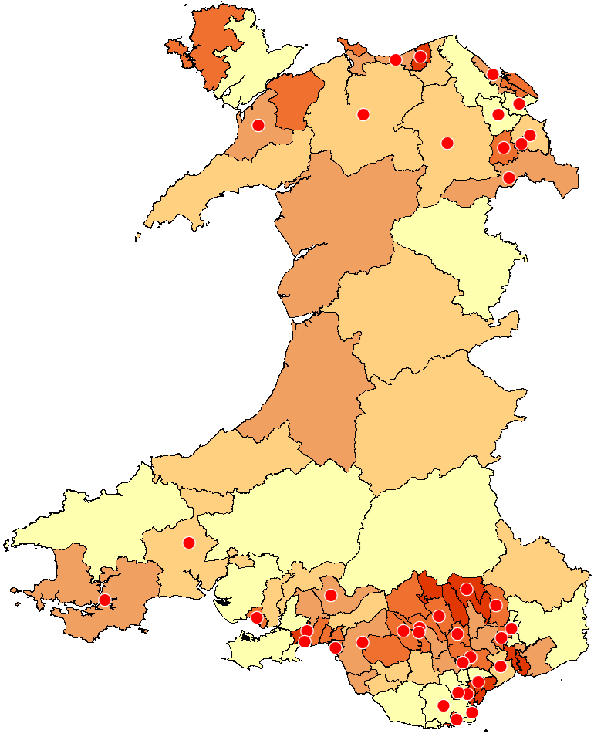 | 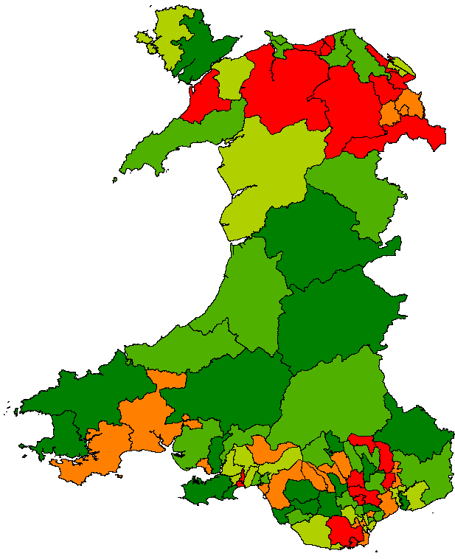 | Townsend Index (USOA)  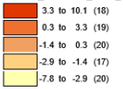
Cancer rates 2011 (USOA)

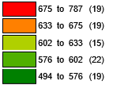

Townsend Index (USOA) | Cancer rates 2011 (USOA)
© Crown Copyright Upper Super Output Area Boundary

The Townsend Index map above includes a red indication overlay to help indicate areas with higher cancer rates. The Townsend Index map mostly correlates to the cancer rates map, with areas of higher deprivation seen in the south and north, with higher cancer rates. Lower cancer rates in Mid Wales also correlate with areas of higher affluence.
Focusing on the south, Figure 6 below identifies the area with the highest Cancer rates; Vale of Glamorgan U003 also stands out as an area with a higher Townsend score of 8.6. Likewise, Cardiff U002, with the lowest rates of cancer, have a much lower Townsend score of -4.1.

Fig. 6. Townsend index South Wales against areas of higher cancer rates (USOA)

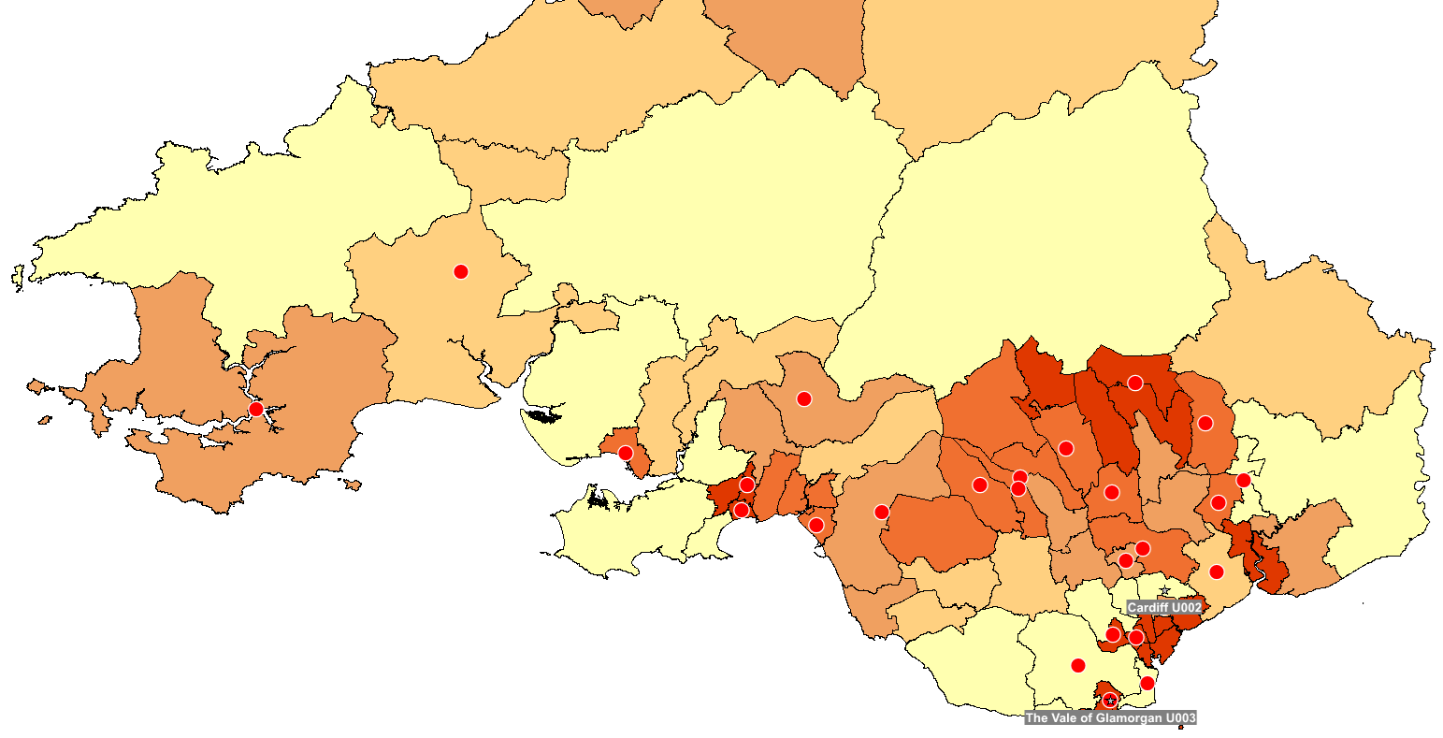 | Townsend Index (USOA)  Higher Cancer Rates Markers 633+ per 100,000 population
Townsend index (USOA) cancer rates 2011 (USOA)

© Crown Copyright Upper Super Output Area Boundary

Swansea U007 has the highest Townsend score, which also corresponds to a higher level of cancer. However, some outliers were observed; for example, the Vale of Glamorgan U002 is Wales's 8th most affluent area but has increased cancer rates.
The Townsend Index is a valuable tool for identifying areas with higher deprivation, which can be correlated with higher cancer rates in most instances. Government and healthcare providers could target deprived areas, for example, with regular screening programs and lifestyle education to reduce the rates within these areas.

2.3 General Health
Macmillan Cancer Support identifies that health is a significant factor in developing cancer. However, a healthy lifestyle does not prevent all cancers; it can reduce the risk for many [9].
Figure 7 below shows where people considered themselves in bad general health. Dark purple indicates a higher amount of people. General health data was obtained from the UK data service [8] based on the 2011 census of people's opinion of their own general health.
Figure 7: Bad general health comparison against cancer rates in Wales by USOA

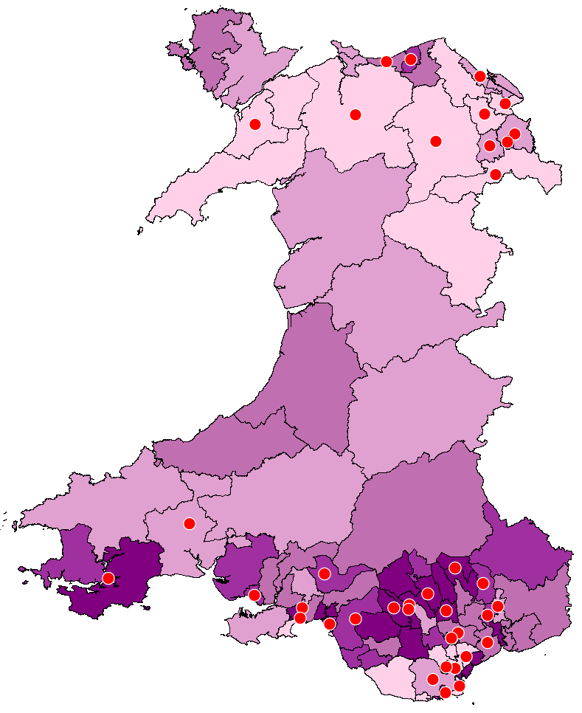 |  | People total of general health recorded as bad (USOA)  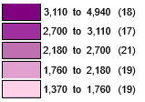
 |  | Cancer rates 2011 (USOA)
General health recorded as bad (USOA) | Cancer rates 2011 (USOA)
© Crown Copyright Upper Super Output Area Boundary

The general health map shows a significant divide between the south compared to the rest of Wales, with the south having many more areas with people in bad health. The areas with higher cancer rates (633 and above) have been overlapped with a red circle for easier comparison. In the south, the people considered unhealthy mostly match areas with higher rates of cancer with a few outliers. However, in North Wales, we see the opposite, with many areas categorised as healthier, yet there are still high cancer rates.
As the health data is based on people's views of their own health, it is likely to contain many biased opinions, making it more challenging to use as a comparison. Later in the report, further analysis will dive deeper into adult lifestyle data closely related to general health.
Targeted schemes to promote a healthy lifestyle will undoubtedly lead to lower cancer rates and improve outcomes across all communities.

2.4 Adult Lifestyles
Medical experts estimate that approximately 42% of newly diagnosed cancers are caused by preventable lifestyle factors [10]. Bad general health identified an association with higher rates of cancer; this section looks deeper into the different aspects that affect a poor health lifestyle. Local Authority (LA) boundaries with lifestyle data from Stats Wales [11], USOA data was not publicly available.

Diet and physical activity hugely impact obesity levels, which is linked with an increased risk of many types of cancers, for example, bowel, liver and pancreas [10]. Figure 8 below compares areas in Wales where people have a BMI of 25+.

Figure 8: BMI 25+ comparison against cancer rates in Wales by LA

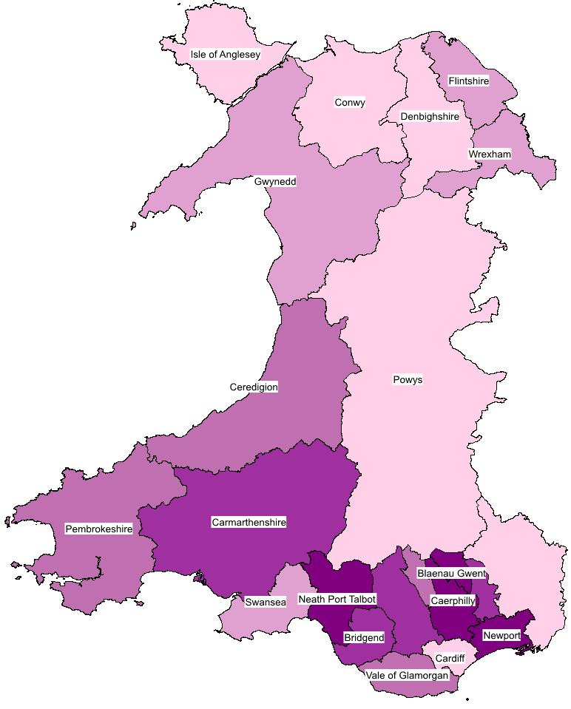 | 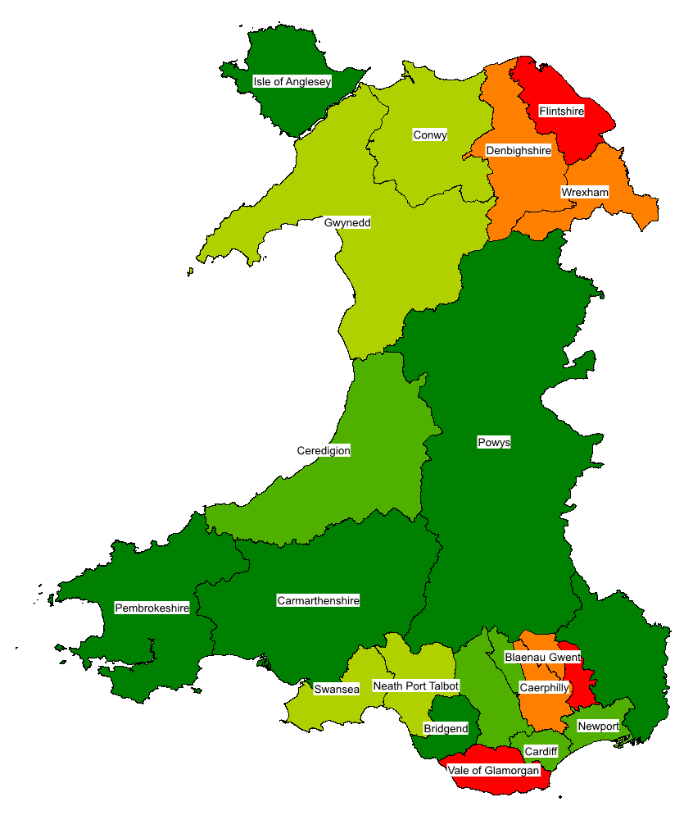 | Percentage of people with a total BMI of 25+ (LA)  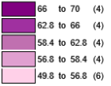
Cancer rates 2011 (LA)

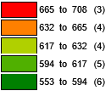

Percentage of people with  a total BMI of 25+ (LA) | Cancer rates 2011 (LA)
© Crown Copyright Upper Super Output Area Boundary

South Wales shows areas where more of the population are classified as overweight. There is some evidence to suggest that, in Blaenau Gwent and Caerphilly, the higher rates match the increased cancer rates. However, there are several areas with no correlation. For example, Neath Port Talbot has a lower level of cancer rates but has high obesity in that area. Figure 9 below shows a comparison of average annual alcohol consumption, showing areas with higher rates.

Figure 9: Annual alcohol consumption (units) comparison against cancer rates in Wales by LA

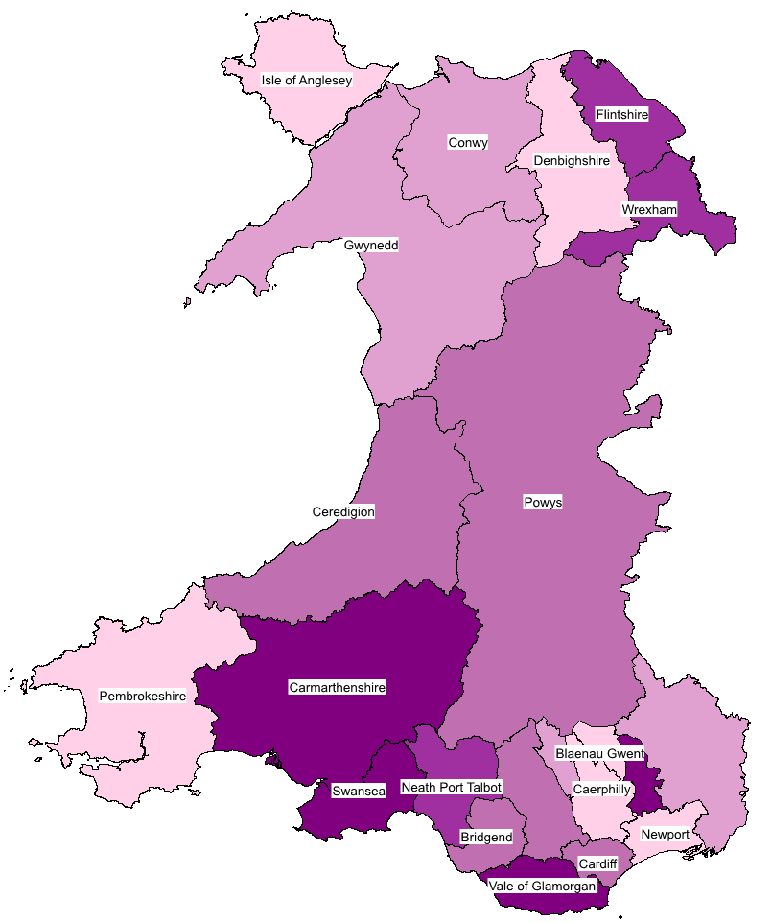 |  | Average units of alcohol consumption (LA)  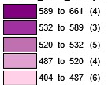
 |  | Cancer rates 2011 (LA)
Average units of alcohol consumption (LA) | Cancer rates 2011 (LA)
© Crown Copyright Upper Super Output Area Boundary

In the North, there is a noticeable comparison between cancer rates and alcohol consumption. The south again has some areas showing high correlation; the Vale of Glamorgan was identified as the area with the highest alcohol consumption and cancer rates, which was also previously determined to contain an area with the highest Townsend Index.

Again, there are some outliers within this data, with some areas, such as Carmarthenshire, consuming more alcohol but having lower cancer rates; further research and access to a lower level of detail may help understand these outliers.

Smoking is estimated to be responsible for nearly 20% of all new cancer cases per year and results in 27% of cancer deaths in the UK [12]. Figure 10 compares smoking to lung cancer; smoking is responsible for approximately 80% of lung cancer deaths [13].

Figure 10: Smokers (including Ex smokers) comparison against lung cancer rates in Wales by LA

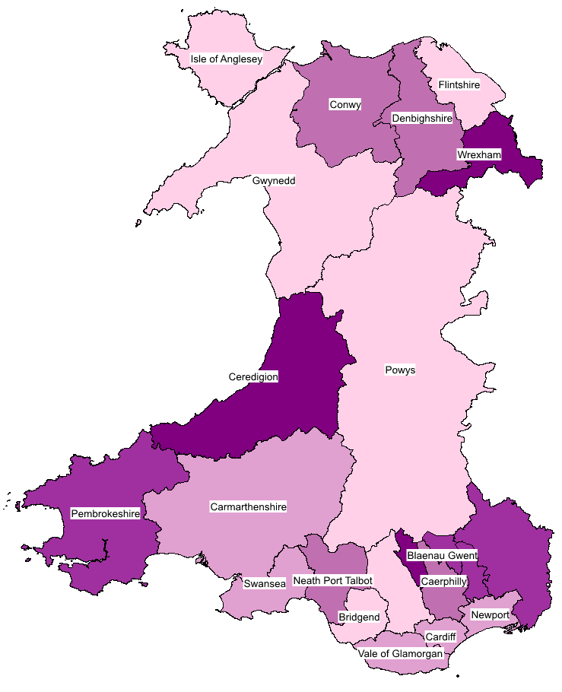  Percent of smokers (LA) | 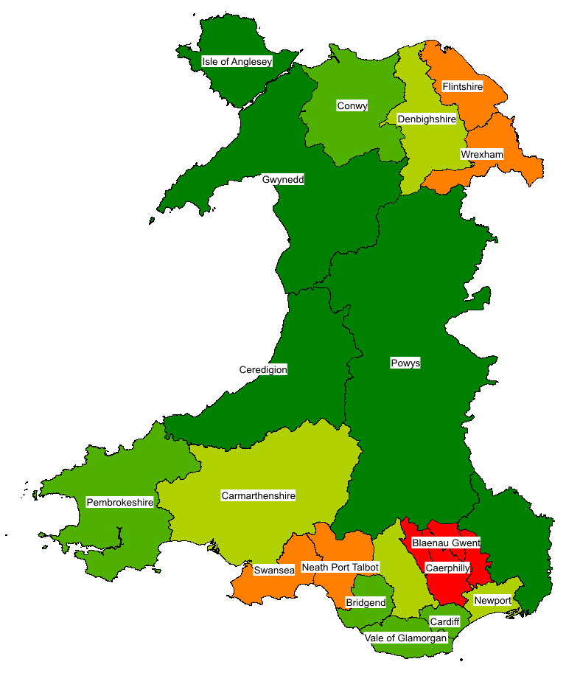  Lung cancer rates 2011 (LA) | Percent of smokers (LA)  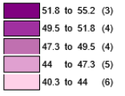
Lung cancer rates 2011 (LA)

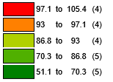

© Crown Copyright Upper Super Output Area Boundary

Powys and Gwynedd have the lowest population of smokers and the lowest level of lung cancer. Interestingly, Ceredigion has the highest percentage of smokers but the lowest percentage of lung cancer in 2011. However, figure 11 shows the changes in lung cancer between 2011 and 2019, which has increased from 51 to 72 per 100,000 population.
Figure 11: Lung cancer rates in Ceredigion 2011, 2015 and 2019
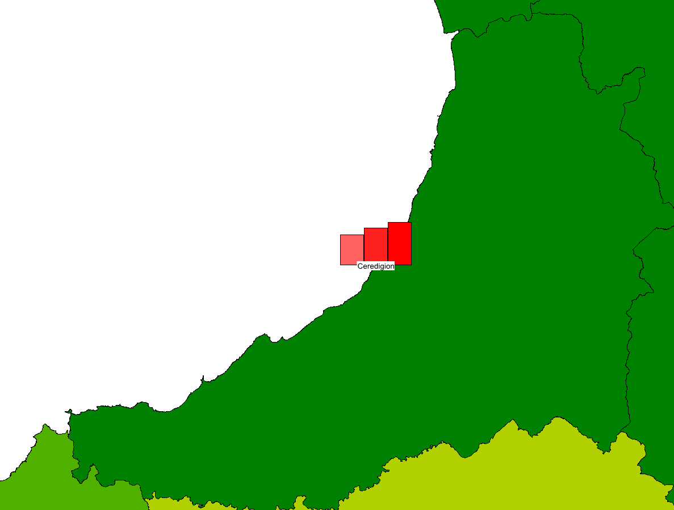 | 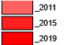

© Crown Copyright Upper Super Output Area Boundary

By combining all the healthy lifestyle factors, it is clear that lifestyle can have an impact on cancer rates. Target lifestyle campaigns, for example, offering free gym membership to areas with higher rates, such as the Vale of Glamorgan, could be a factor in improving cancer rates and outcomes.

2.5 Age Demographic
Age can be a significant factor for people with cancer, with the majority of newly diagnosed being older adults. A report from NHS Wales identified that in 2019, approximately 80% of new cases were people over 60 [14]. Cancer develops when damage in the same cell builds up and turns into cancer. As people age, there’s more time for damaged cells to build up, therefore increasing the risk of cancer [15].

Figure 12: Average age by against cancer rates in Wales by USOA

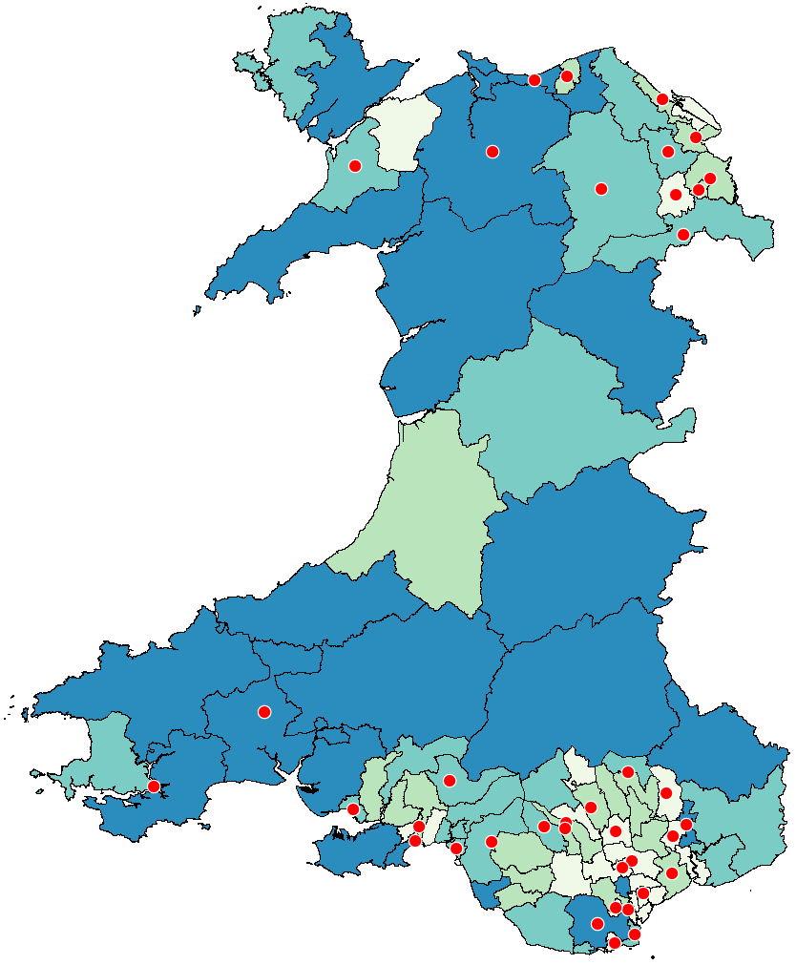 |  | Average age (USOA)  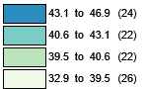
 |  | Cancer rates 2011 (USOA)
Avergage age (USOA) | Cancer rates 2011 (USOA)
© Crown Copyright Upper Super Output Area Boundary

Figure 12 above shows the average age of population data from UK Data Services [8]. Comparing the higher average age data, most do not correlate to areas with higher cancer rates. Figure 13 compares Mid Wales, showing areas with low cancer rates, yet there are some of the highest average age groups in all of Wales.
Figure 13: Mid Wales average age against cancer rates in Mid Wales by USOA

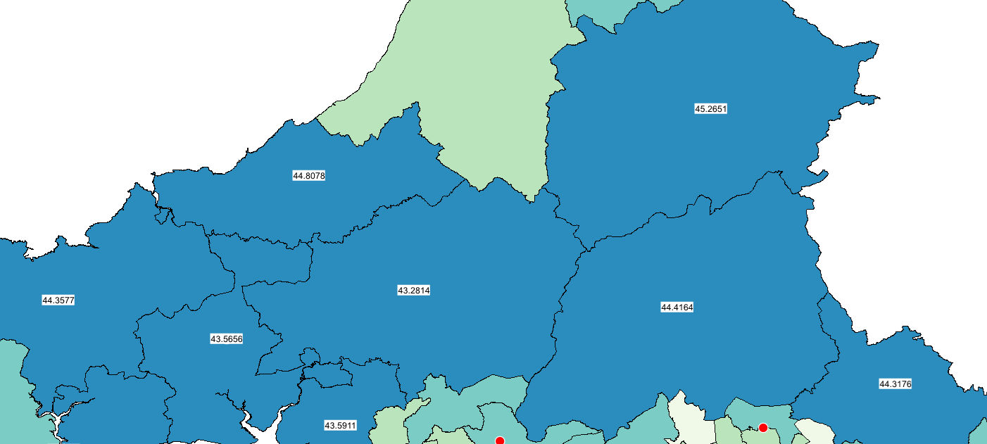  Average age across Mid Wales (USOA)  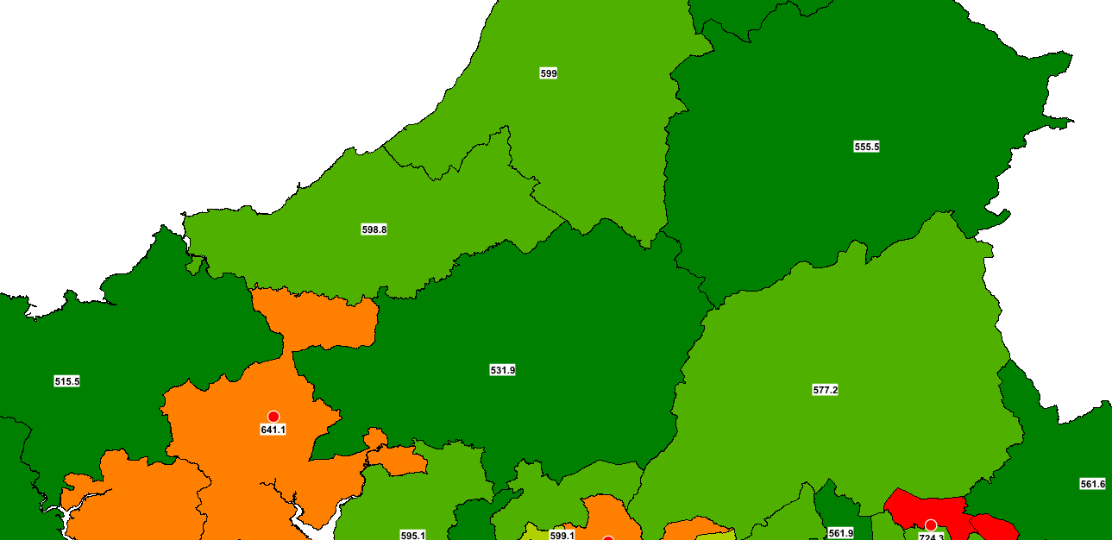 | Average age (USOA)
 | Cancer rates 2011 (USOA)
Cancer rates Mid Wales 2011 (USOA)

© Crown Copyright Upper Super Output Area Boundary

There are some key areas in which the maps correlate; for example, Cowey 001 in north Wales, which has the highest average age of 46.9, is also one of the highest rates of Cancer. Cardiff U002 also shows the lowest cancer rates in Wales and a lower average age of 38.

2.6 Ethnic Minority
An article by C. Fang [17] identifies that ethnic minority status can affect cancer rates and outcomes due to several factors. These include socioeconomic issues, as ethnic minorities often face poverty-related challenges that contribute to poor diets and lifestyles. Additionally, cultural beliefs can influence health behaviours, such as the willingness to seek medical help.
Figure 14 below shows data from Data Map Wales [16] identifying the population percentage in each USOA that falls into the ethnic minority group.

Figure 14: Ethnic minority comparison against cancer rates in Wales by USOA

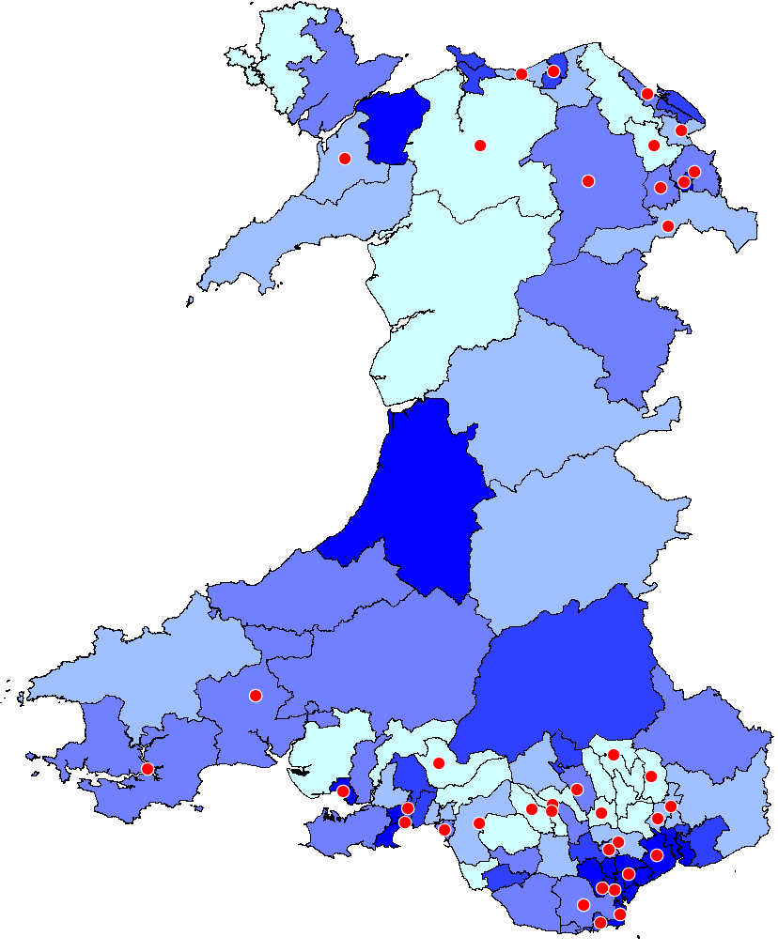 |  | Percentage of population within the ethnic minority group  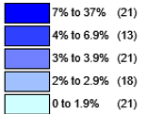
 |  | Cancer rates 2011 (USOA)
Percentage of population with the  ethnic minority group (USOA) | Cancer rates 2011 (USOA)
© Crown Copyright Upper Super Output Area Boundary

Cardiff, located in southeast Wales, has some of the highest ethnic minority populations in the region. Figure 15 below compares this area and indicates that there is no evidence to suggest that ethnic minority groups are at higher risk for cancer. Notably, Cardiff U002, which has the lowest cancer rates in Wales, has a high ethnic population of 12.1%. Despite this higher percentage of ethnic minorities, the risk of cancer in this area remains lower.
Figure 15: Ethnic minority within Cardiff against cancer rates in Cardiff by USOA

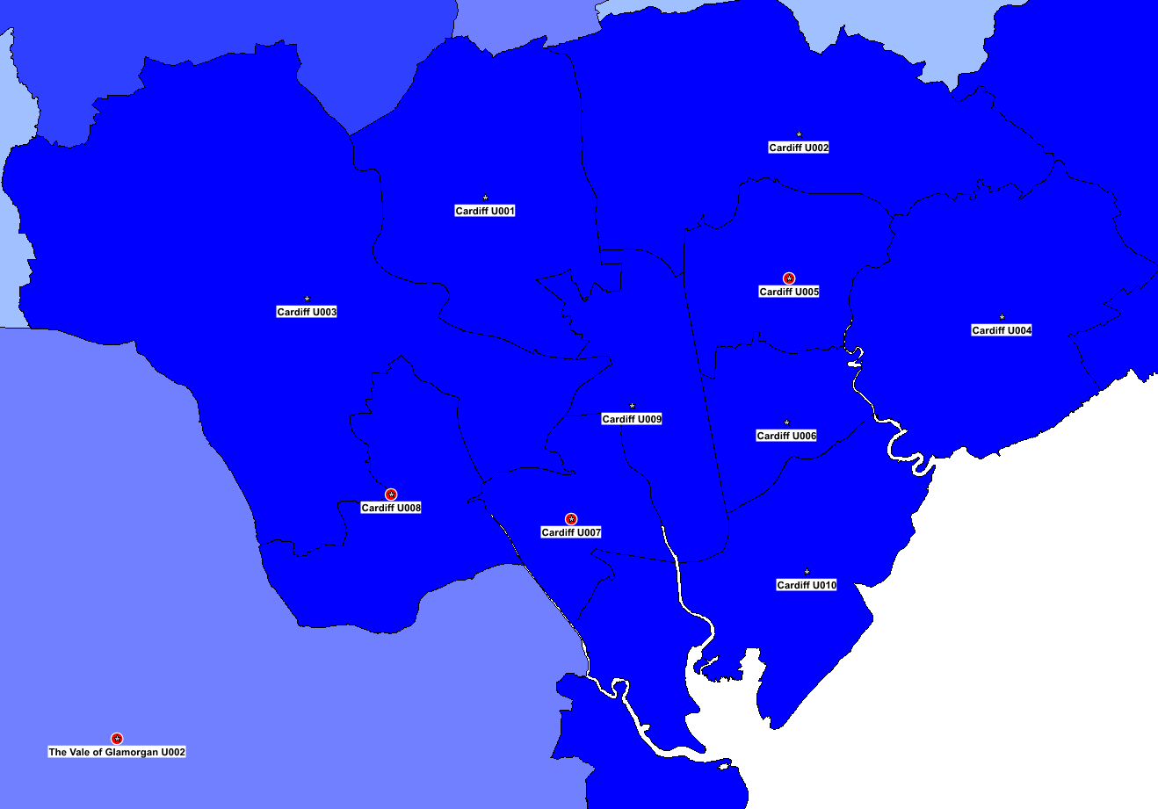  Ethnic minority within Cardiff (USOA)  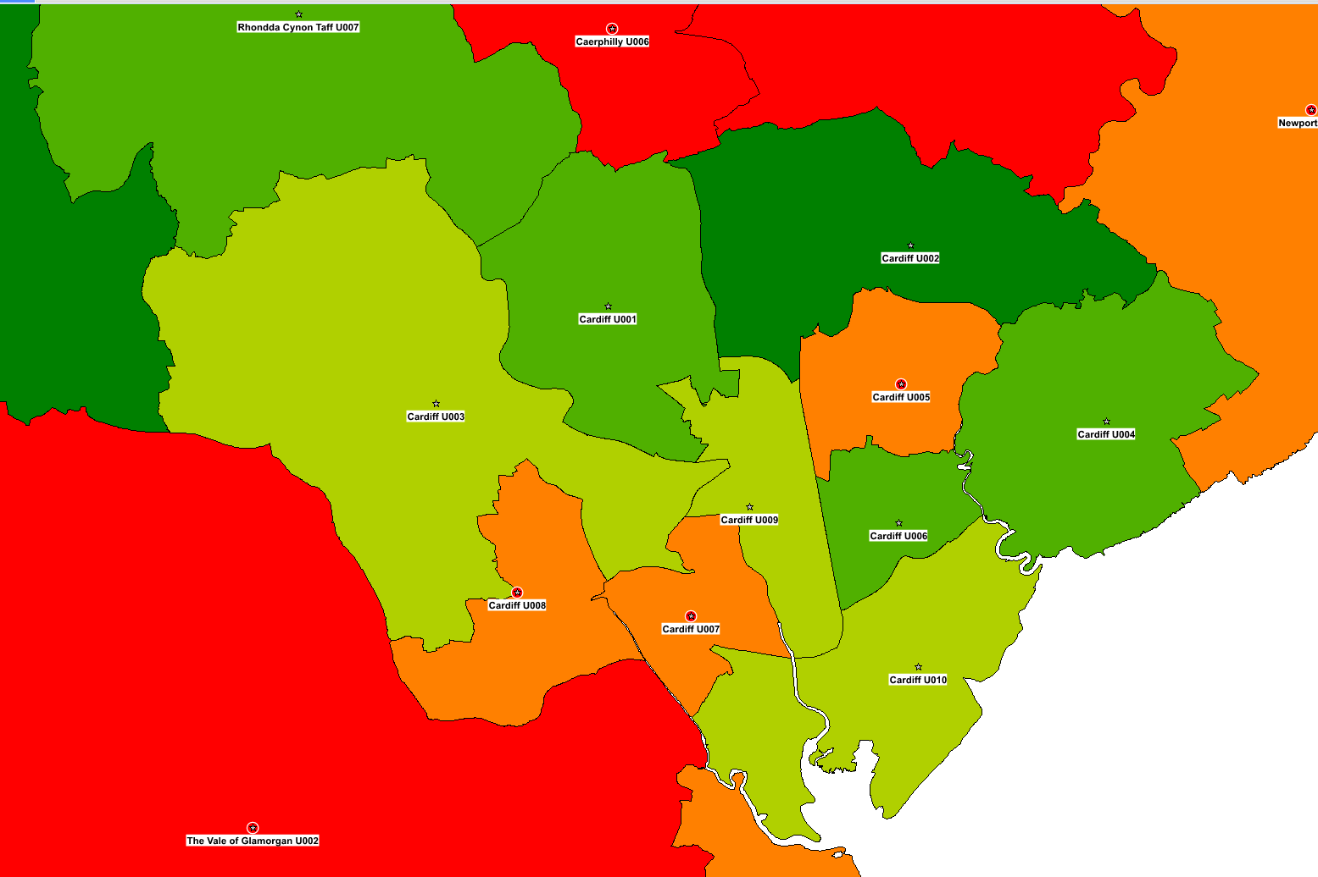 | Percentage of population within the ethnic minority group
 | Cancer rates 2011 (USOA)
Cancer rates Mid Wales 2011 (USOA)

© Crown Copyright Upper Super Output Area Boundary

In conclusion, Cardiff's analysis reveals findings that contradict the original hypothesis, indicating that cancer rates are lower in areas with a higher percentage of ethnic minorities. Additional factors need to be explored; for instance, the dietary habits and lifestyles of certain ethnic groups may reduce cancer risk, as some are less likely to engage in smoking and drinking. Further research is necessary to examine the specific breakdown of these groups and their cultural characteristics to better assess the correlation between ethnic minority status and cancer rates.

2.7 Pollution
Cancer Research UK identifies that outdoor air pollution accounts for one in ten lung cancer cases in the UK [18]. Various factors contribute to air pollution, including emissions from vehicles and industries, as well as natural sources like radon and ozone gases. Specifically, PM10 and PM2.5 pollution are closely linked to lung cancer; PM10 is primarily produced from dust particles, while PM2.5 is largely produced by automobile emissions and industrial activities [19].
Figure 16 below presents data from Data Map Wales [20], illustrating the levels of PM10 and PM2.5 pollution across Wales in relation to lung cancer rates.
Figure 16: Air Pollution PM 10 and PM 2.5comparison against lung cancer rates in Wales by USOA

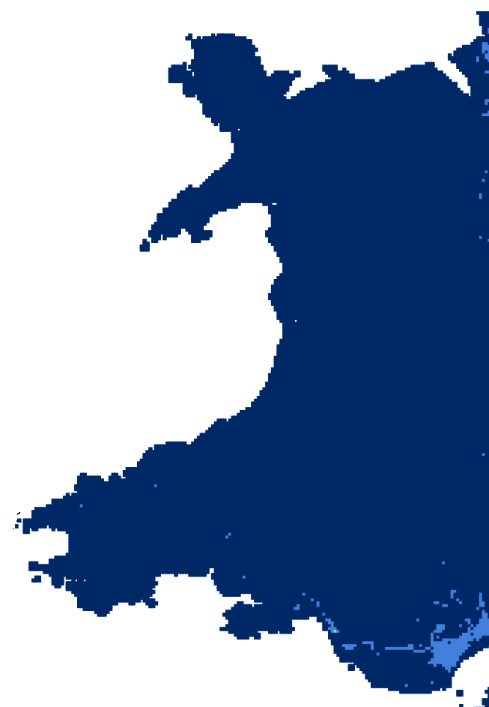  Heatmap PM 10 and PM 2.5 (Wales) | 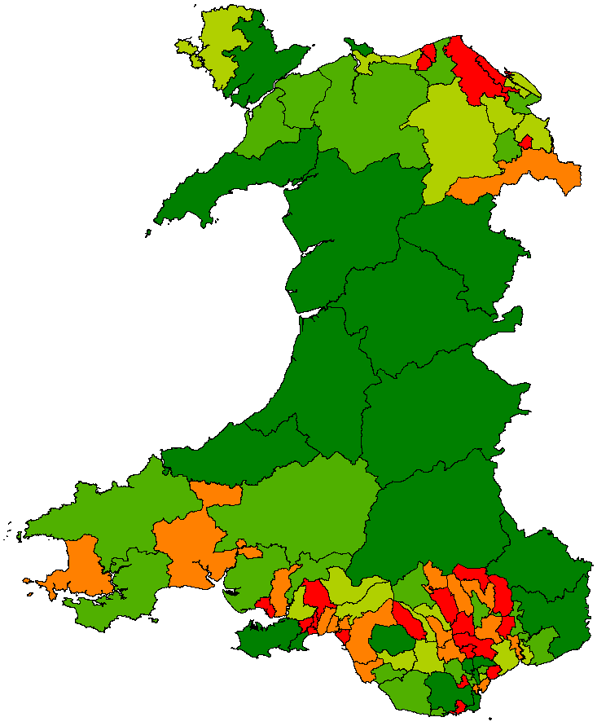  Lung cancer rates 2011 (USOA) | Lung cancer rates 2011 (USOA)  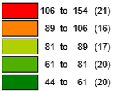

© Crown Copyright Upper Super Output Area Boundary

The lighter patches on the heatmap above represent the areas of higher pollution; the image identifies the southeast as the only area in Wales with high air pollution. Figure 17 below takes a closer look at the air pollution in this area, overlapping with lung cancer rates. Interestingly, many areas with high pollution cross with regions with the lowest lung cancer rates. There are some hot spots; for example, Swansea U004 and the Vale of Glamorgan U003 have the highest rates of lung cancer and higher rates of air pollution.
Figure 17: South Wales Lung cancer rates compared to air pollution
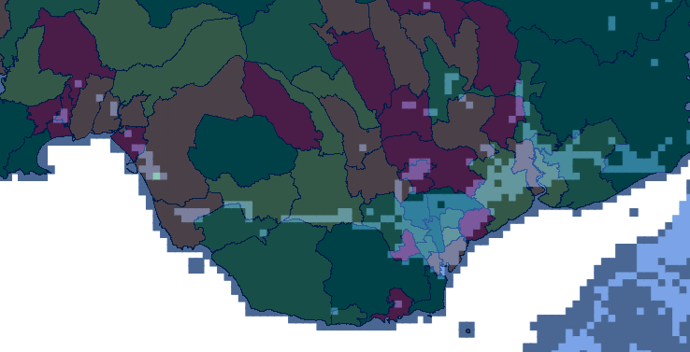

© Crown Copyright Upper Super Output Area Boundary

The images above indicate that air pollution has a limited impact on lung cancer rates in Wales. Reducing exposure to air pollution will benefit public health and could help lower the cancer risks in certain areas but does not have as significant an impact as other factors such as smoking rates.

2.8 Urban Vs Rural
Several factors link cancer rates to the area in which people live. Urban areas have a higher rate of unhealthy habits such as smoking and alcohol intake. In contrast, rural areas often see lower access to health care, including longer travel times and shortages of specialist doctors [21].
Figure 18 below shows urban and rural classifications from Digi Map [22] compared to cancer rates throughout Wales.
Figure 18: Urban & rural comparison against cancer rates in Wales by USOA

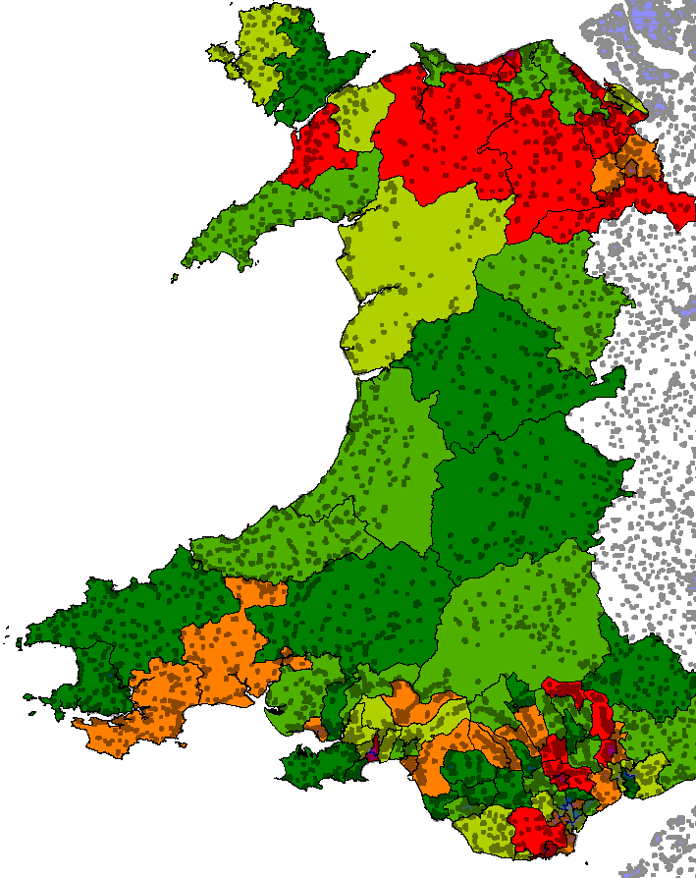 |  | Cancer rates 2011 (USOA)  Urban Areas  
Urban areas (Wales) | Cancer rates 2011 (USOA)
© Crown Copyright Upper Super Output Area Boundary

It is difficult to identify the impact of urban and rural areas across the whole of Wales. The comparison above shows that there are many areas within each USOA classified as urban. When examining areas with higher cancer rates more closely, there appears to be a correlation with densely populated urban areas. The Vale of Glamorgan U003 and Swansea U004/U007 both consist of large urban regions and have some of the highest rates of cancer across Wales.
Figure 19: Urban comparison against cancer rates in South Wales by USOA

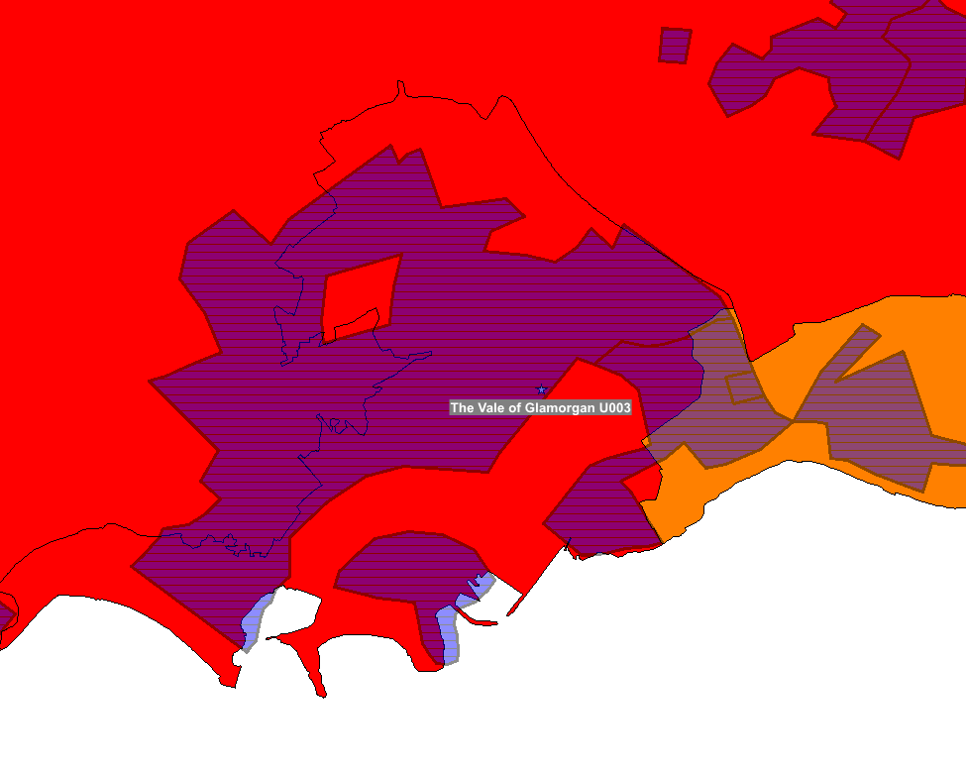 | 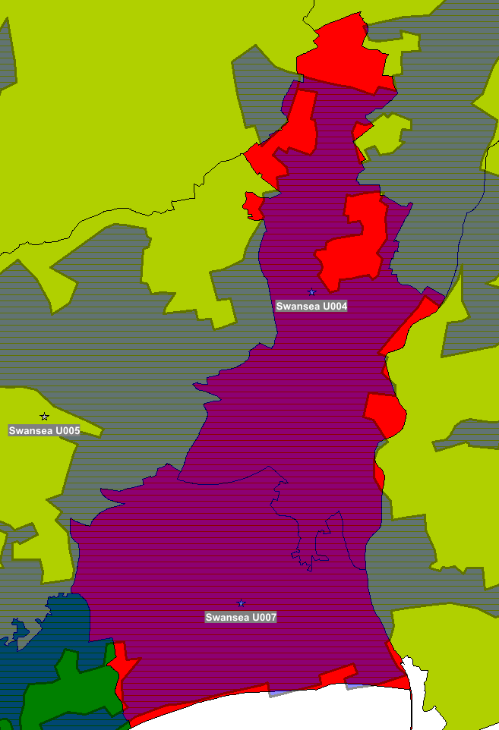 | Cancer rates 2011 (USOA)
Urban areas in Swansea and Vale of Glamorgan (Wales)
© Crown Copyright Upper Super Output Area Boundary
To expand this analysis, more detailed data is needed at a lower level to compare cancer rates in middle super output areas and identify trends in relation to urban areas, unfortunately USOA is the currently the lowest level of data publicly available. Additionally, to understand the impact of rural communities, further analysis in the next section will examine healthcare access across Wales.

2.9 GP Surgeries and Hospitals
Access to health care can prove to be a significant issue for many people, with studies showing that a travel burden can result in delays in early diagnosis and preventative cancer treatment, with people living in rural areas showing to be twice as likely to have unstaged cancer compared to urban residents [23].
Figure 20 below illustrates GP surgeries and hospitals across Wales, as provided by Digi Map [22], compared to cancer rates throughout the region. The map on the left compares travel distances within each area, with red indicating a higher average travel distance for people living in the USOA.
Figure 20: GP surgeries and hospital average travel distances compared to cancer rates

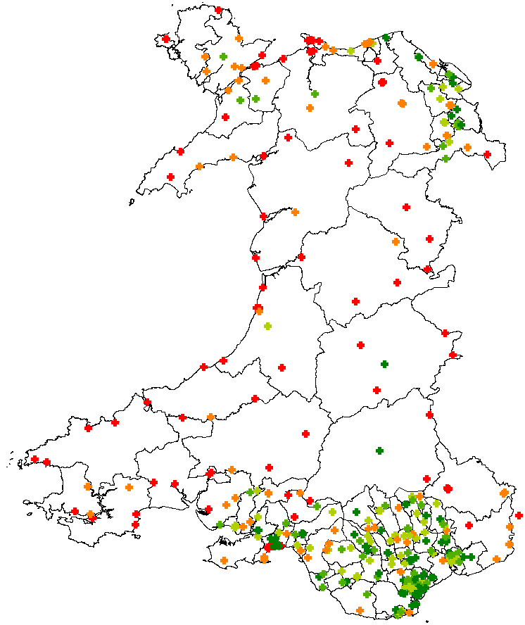 |  | Average distance to travel to GP surgery / hospital  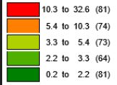
 |  | Cancer rates 2011 (USOA)
GP surgeries and hospitals across Wales with average travel distance colour indicators. | Cancer rates 2011 (USOA)
© Crown Copyright Upper Super Output Area Boundary

The results above show across all of Wales, a greater average distance to access healthcare does not appear to correlate to a higher rate of cancer. Mid Wales have some of the lowest cancer rates within Wales but have the highest travel distances. Again, looking into some of the cancer hotspots in the south also have some of the shortest travel distances to healthcare, showing no signs of issues.
The north does have some higher travel distances within higher cancer rate areas; however, this is likely due to a smaller population, resulting in fewer surgeries and hospitals.
While access to healthcare could be a contributing factor to cancer rates, it does not seem to be a significant issue in Wales. More data on diagnostics on a case-by-case basis could be used to further investigate any concerns.

2.10 Motorway
A study by King’s College London identified that living within 50 meters of a major road could increase the risk of developing lung cancer by 10 per cent [24].
Using road network data from Digi Map [22] and lung cancer data [5], figure 21 below shows the M4 motorway running through several USOAs across South Wales. The map includes a 2KM buffer zone from the M4 to help identify hotspots with higher lung cancer incidences near the road.
Figure 21: M4 Corridor in South Wales comparison against lung cancer rates

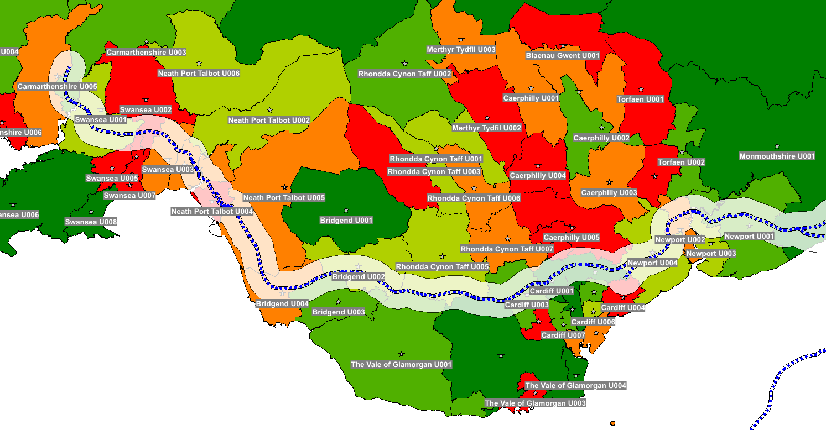 | Lung cancer rates 2011 (USOA)
© Crown Copyright Upper Super Output Area Boundary

Where the road runs through Bridgend up to Swansea, there are higher instances of lung cancer; in these areas, the road runs closer to villages such as Port Talbot.
Neath Port Talbot U004 and Swansea U002 have the highest levels of lung cancer along the M4 Corridor. Figure 22 below shows how the road runs through large urban areas in these USOAs, where a larger population would be more likely to live and work closer to the road.
Figure 22: M4 Corridor in South Wales comparison against lung cancer rates and urban areas
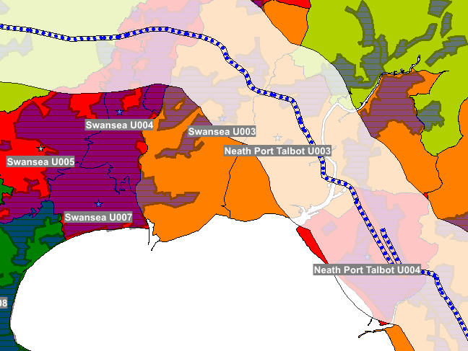 | Urban Areas  Lung cancer rates 2011 (USOA)
Lung Cancer rates withing urban areas in close proximity to the M4 Motorway
© Crown Copyright Upper Super Output Area Boundary
Further investigation with data from the MSOAs would help identify specific areas near the road. Unfortunately, data at this level is not currently publicly available. Figure 23 identifies another major road (A55) that runs through North Wales, where there are three areas with high lung cancer rates; this image shows a similar story to the M4, with higher lung cancer rates in urban areas near the highway.
Figure 23: A55 in North Wales comparison against lung cancer rates and urban areas

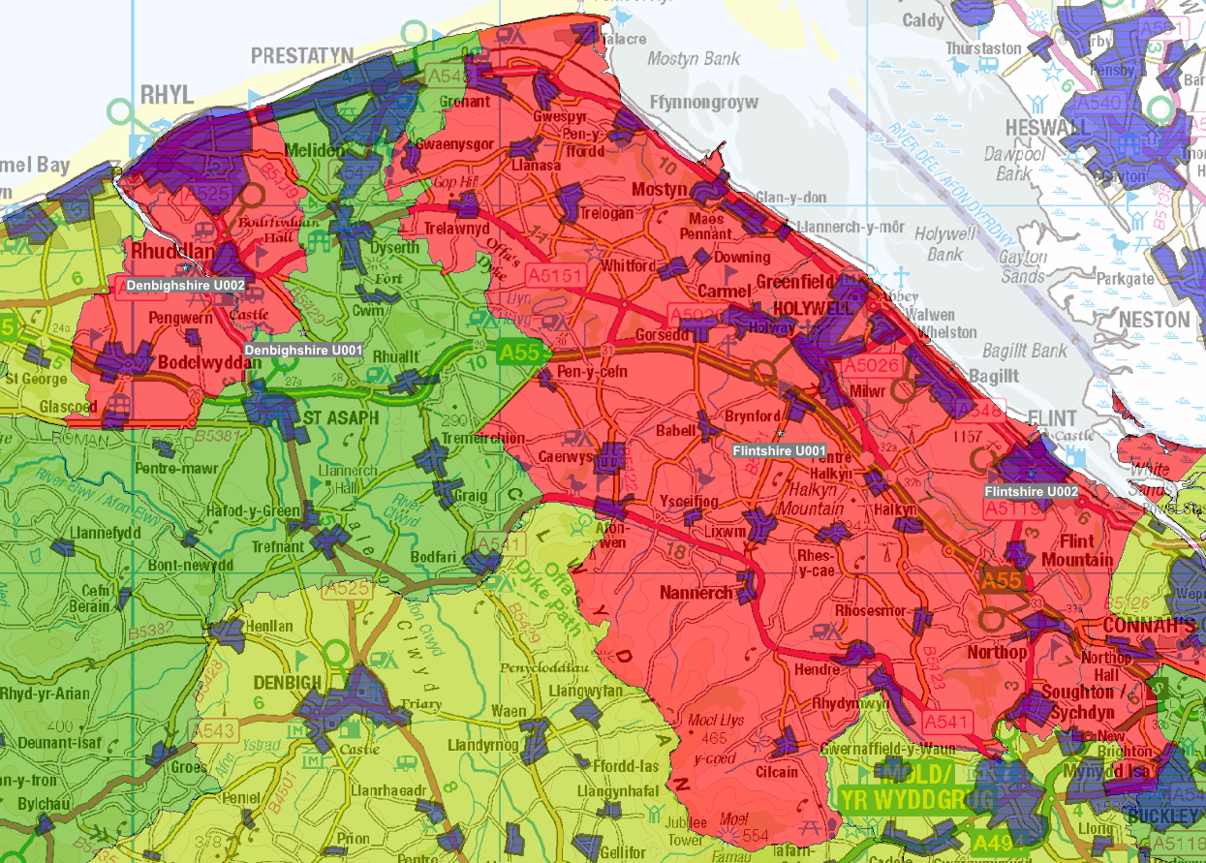 | Urban Areas  Lung cancer rates 2011 (USOA)
Lung cancer rates in North Wales near the A55

© Crown Copyright Upper Super Output Area Boundary

3 - Conclusion
Using GIS Software for Geodemographic analysis has aided in visualising and highlighting key areas across Wales where several factors cause higher cancer rates.
The maps presented identify several factors that increase cancer risk depending on location. Living in an area with higher deprivation is associated with an increased risk of developing cancer. A closer analysis of these areas identifies that poorer general health and lifestyle choices directly impact cancer risk.
The report highlights areas where a higher average age population correlates with increased cancer rates. Additionally, areas with higher pollution levels in Wales show increased rates of lung cancer, particularly in urban areas with more dense populations and potentially heavy traffic. Some evidence suggests that living near major roads, such as motorways, can also affect lung cancer rates; however, further data would benefit a more in-depth investigation.
Finally, the analysis identified that access to healthcare does not appear to impact cancer rates in Wales significantly. More data regarding diagnostics on a case-by-case basis could help understand potential hotspots in rural areas where access to healthcare is limited. While access to healthcare may be a contributing factor, it is not a significant issue in Wales.
An interesting theme identified throughout the analysis was the Vale of Glamorgan U003 data, which has the highest cancer rates in Wales. This area was identified to have the highest levels of deprivation, as well as poor health, such as poor diets, increased alcohol consumption, and high smoking rates. The Vale of Glamorgan is densely populated and situated within a large urban area, experiencing higher pollution levels than other regions in Wales. These factors are the most substantial evidence of a correlation between the researched factors and elevated cancer rates.
Access to additional NHS data could enable a more detailed analysis of Wales, for example, at the Middle Layer Super Output Areas (MSOAs) level. This information would assist in making recommendations for targeted campaigns in hotspots across Wales. This level of detail could also provide further insights, for example, looking closely into the surrounding area of high pollution sites such as the Port Talbot steel works. Details on cancer screening takeup could help identify any healthcare access issues, especially in rural areas.
This completed analysis will assist in making strategic decisions, enabling healthcare professionals to concentrate their efforts on specific regions in Wales for cancer care and prevention. This includes setting up initiatives to educate and promote the benefits of a healthy lifestyle as part of the fight against cancer.

Appendix 1. Development Log (Task 1 - Part B)
This section outlines the development of the GIS build, including the data collection process, data processing, cleaning, visualisation, querying techniques and challenges faced throughout the build.

Setting up a workspace
Setting up a suitable workspace was essential when working with multiple maps, files and data. GIS projects often involve large datasets, and implementing a structured workspace reduces the time spent locating required data.
Figure 24 shows the centralised workspace that was created, grouping data into the categories required for the build. Files were renamed using a consistent naming convention, clearly identifying the different file formats available.
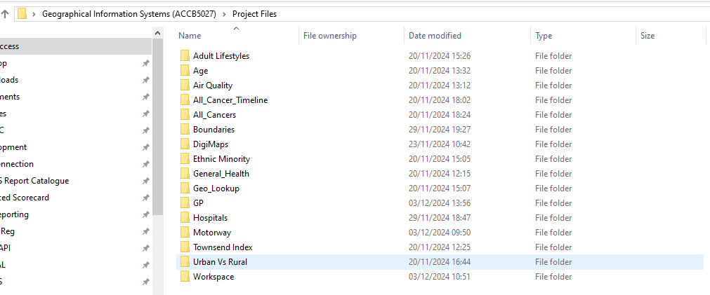
Fig. 24. Project file structure \ workspace
A log was created in Microsoft Excel to keep track on all the data collected, including data source, file types and purpose.
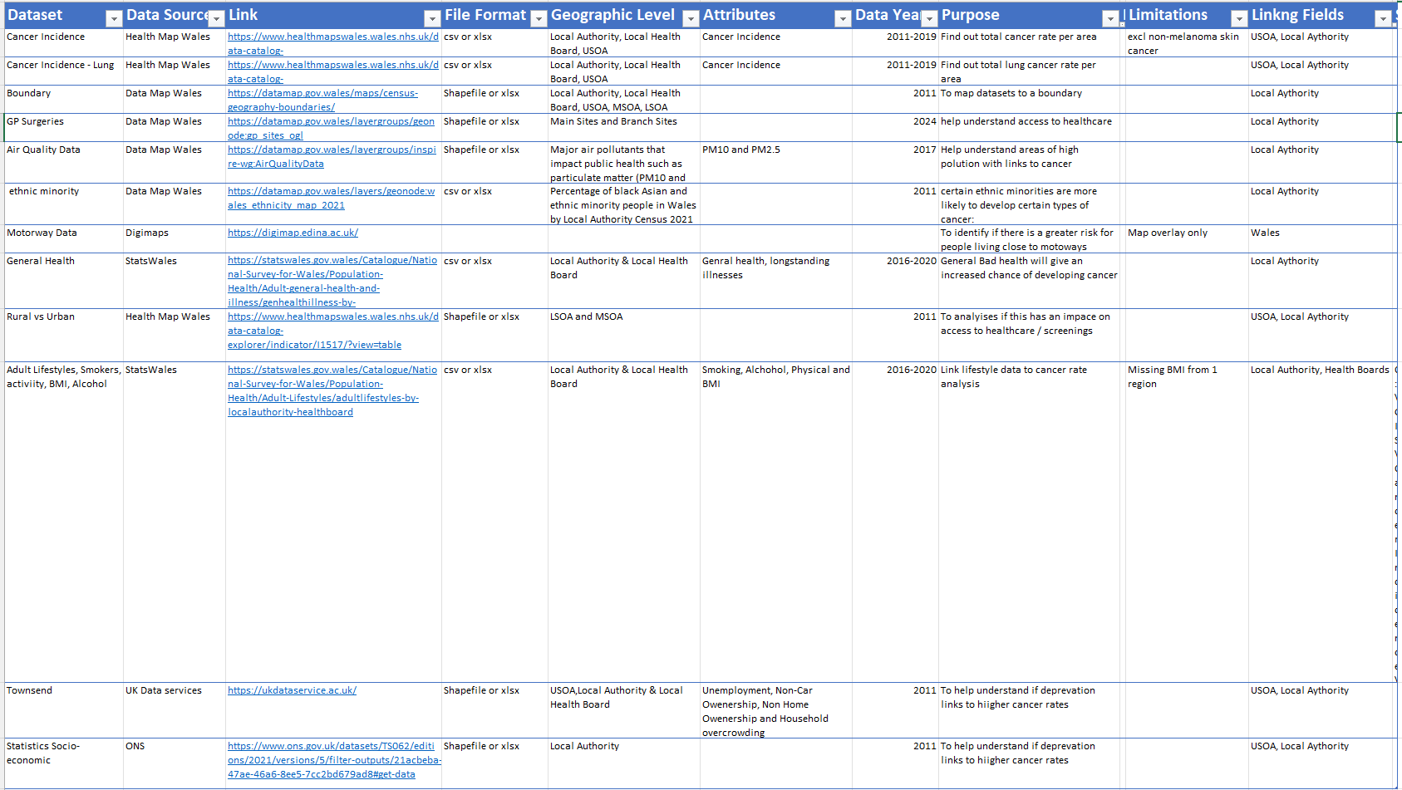
Fig. 25. Dataset log created in Microsoft Excel

Software & File Types
The build was created in MapInfo, a desktop mapping GIS solution designed for analysts to visualise, model and analyse location data. The build consists of many file types, including shapefiles, vector images, CSV and Excel documents. To prepare some of the datasets, Microsoft Excel was used to cleanse and calculate metrics before importing.

GIS Build
The build consists of multiple layers which can be turned on/off depending on what the user is trying to illustrate. Below outlines each layer of the build and the techniques used to create the solution.

Boundary Data
Boundary data is crucial to a GIS build as it provides the base framework for the analysis, allowing another dataset to be overlayed and geocoded within the selected boundaries.

Data description:
- Upper Layer Super Output Areas (USOAs)
- Local Authority Boundaries

USOA was selected as the lowest level of boundary parameter because this was the lowest level of cancer incidence available.

Data source:
Data Map Wales [25]

File types:
Shapefile

Spatial areas:
USOA and Local Authority

Data processing and cleaning:
No pre-processing required

Import and Visualisation:
Boundary data was into MapInfo as a shapefile. Boundary label was edited to be more visible with a halo effect. Labels can be toggled on an off.

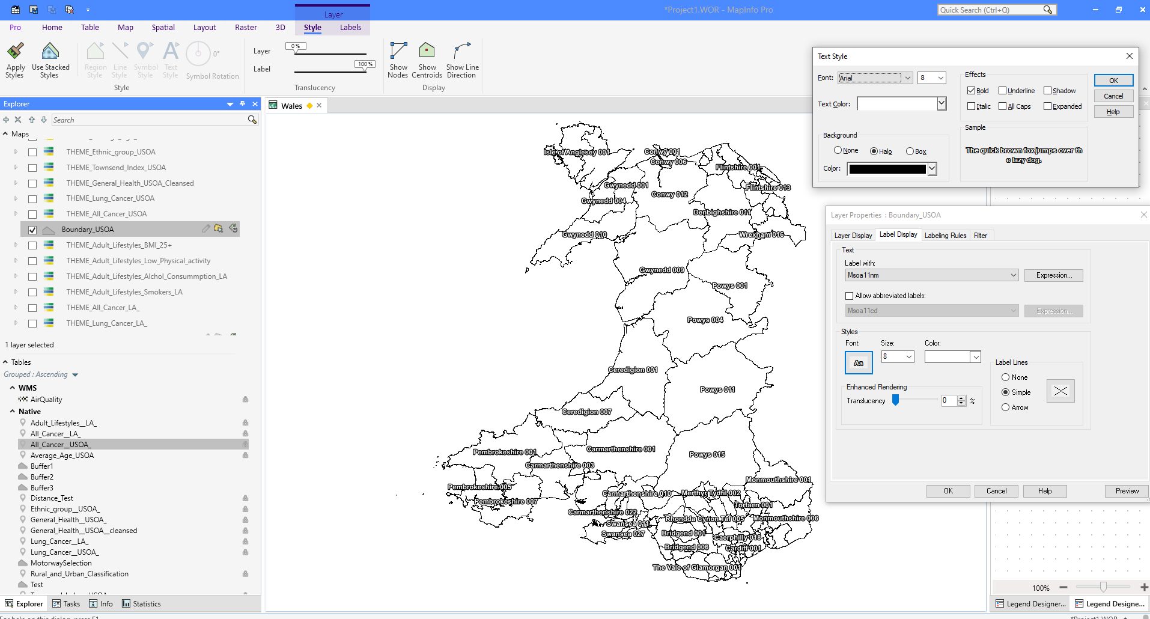
Fig. 26. Project workspace showing USOA Boundaries and labels.

Cancer Incidences
To measure and visualise what influences the incidences of cancer in Wales, it was vital to initial find the incidence data for each area of Wales.
Data description:
- All cancers, excluding non-melanoma skin cancer) per 100k population (2011-2019)
- Lung cancers per 100k population (2011-2019)

Data source:
Health Map Wales [5]

File types:
CSV, convert to excel .xls 97-23

Spatial areas:
Wales USOA and Local Authority. USOA was used as the primary dataset because it shows Wales's lowest level of detail. Local authority's data was also selected to provide another option if other datasets used for comparison were unavailable at the USOA level.

Data processing and cleaning:
Converted CSV to excel .xls 97-2003. Renamed row headers to remove spaces

Import and Visualisation:
Dataset was imported into MapInfo as a table. The data was then geocoded to the associated boundary dataset. The example below shows cancer rates by USOA geocoded against the USOA boundary map.

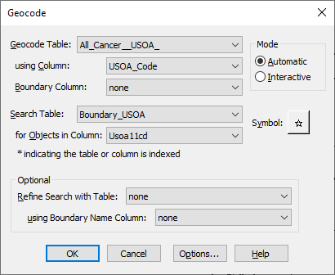
Fig. 27. Project workspace showing cancer incidences by USOA
Following Geocoding, a thematic map was created to represent where cancer cases are more prevalent. The figures below demonstrate the creation of a thematic map process.
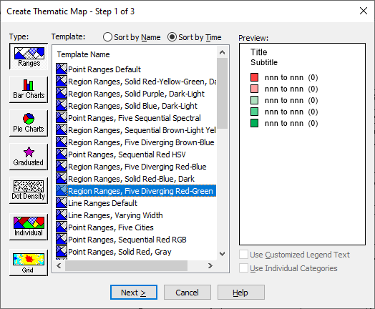 | 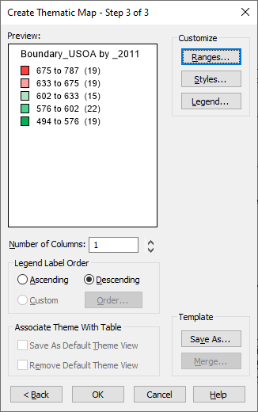
Fig. 28. Creating thematic map. Selecting type  and colour range | Fig. 29. Creating thematic map customise ranges
Finally, the dataset is geocoded to the boundary and a thematic map is applied with a legend added.
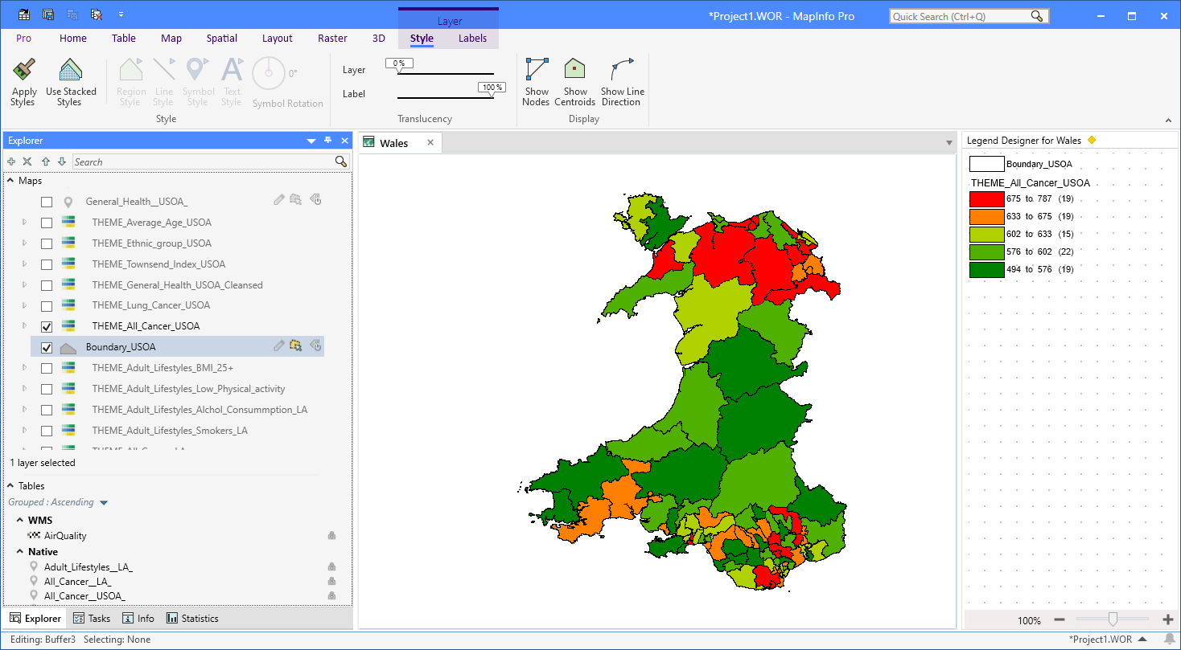
Fig. 30. Project workspace showing cancer incidences by USOA
To expand this further a trend graph was added to identify the trends over time (2011, 2015, 2019).
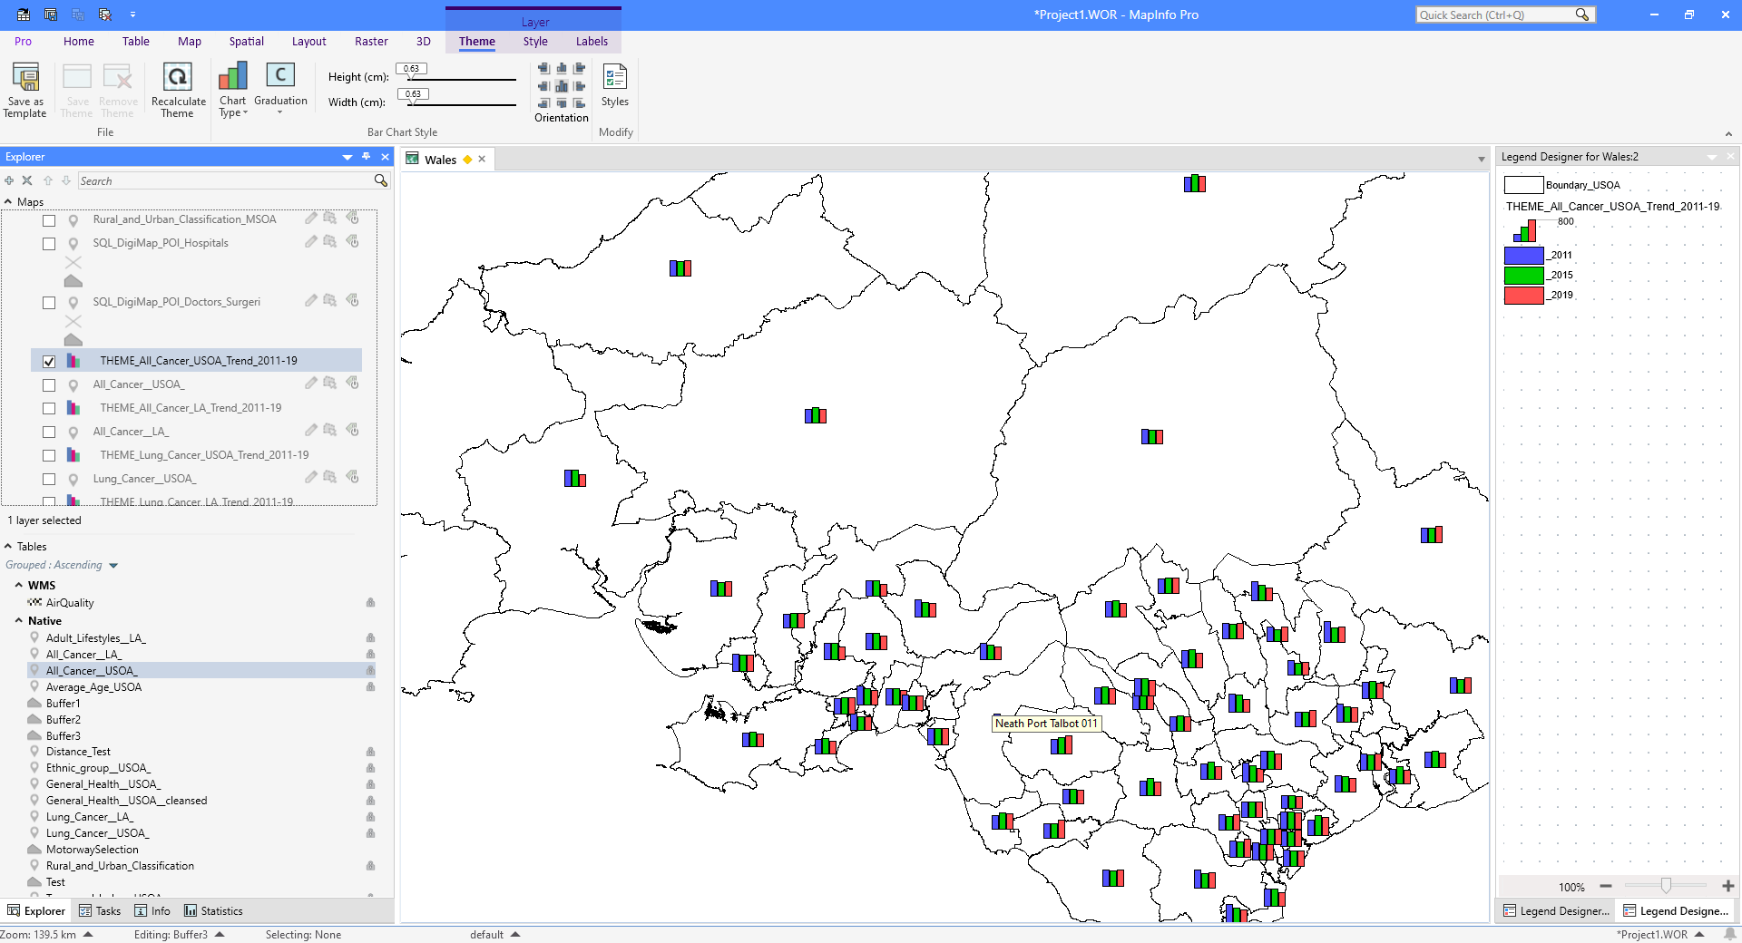
Fig. 31. Project workspace showing cancer incidences over time with a trend graph
Finally, to highlight the areas where there was the most significant percentage change in rates between 2011 and 2019, a theme was added with a custom range to highlight the areas with the largest increase only.
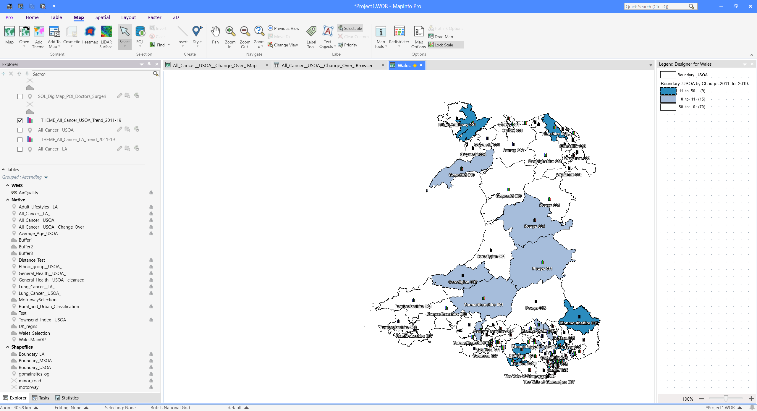
Fig. 32. Project workspace showing areas with largest percentage increases between 2011 and 2019

Towsend Index
A Townsend index score was added to measure deprivation. The Townsend index provides a score calculated based on the percentage of unemployment, non-car ownership, non-home ownership, and household overcrowding.

Data description:
- Total occupancy rating, bedrooms -1 and -2 or less.
- Tenure total, owned outright and owned with mortgage.
- Age 16-74 – Economic activity, working full-time, part-time, student and unemployed.
- Car or van availability total per household.

Data source:
UK Data Services [6]
Data Map Wales [25]

File types:
CSV

Spatial areas:
MSOA, USOA and Local Authority

Data processing and cleaning:
The data was unavailable in the USOA area to match the cancer incidence data. To overcome this, the data was downloaded at the MSOA level and then aggregated to USOA.

To enable this, a mapping file was obtained from Data Map of Wales to identify how the MSOA are grouped into USOA. Using Microsoft Excel and VLOOKUPs against the mapping file, USOA grouping was added to the data.

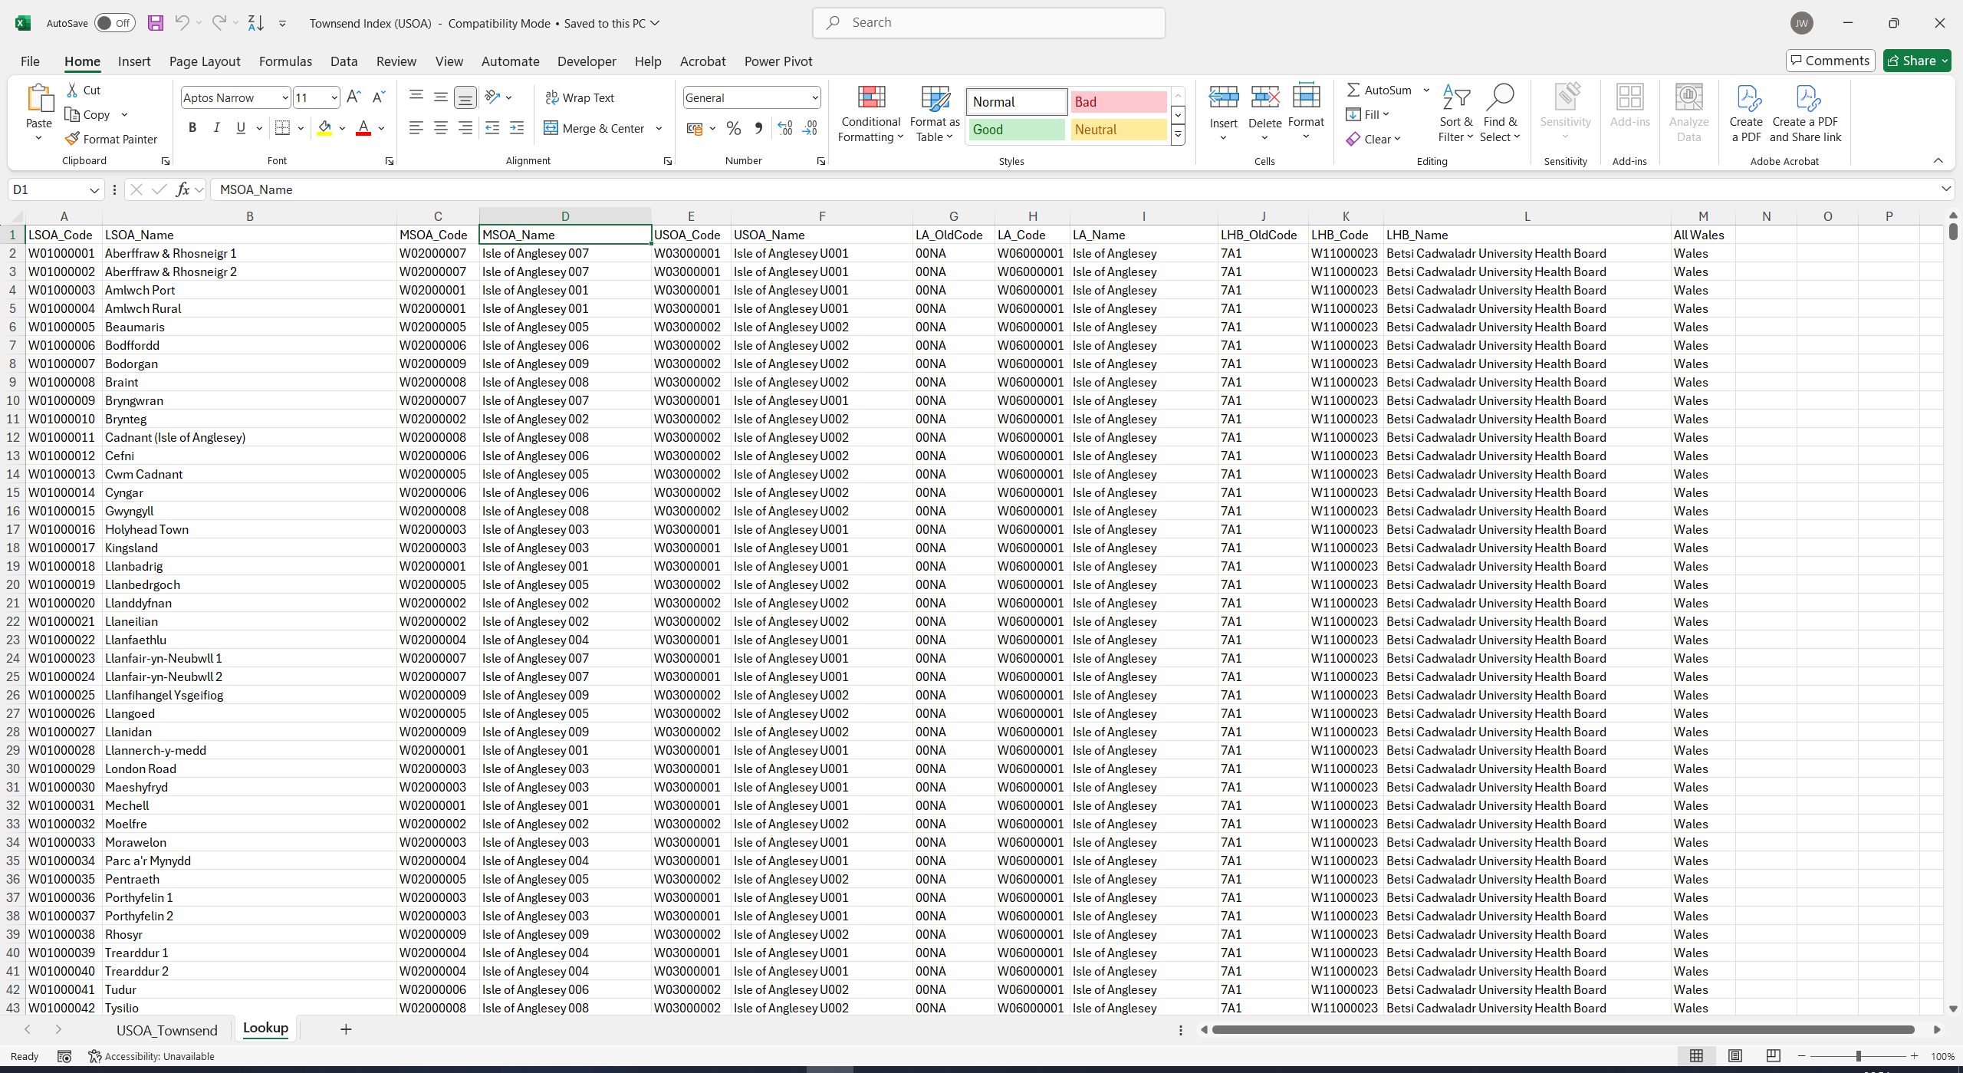

Fig. 33. Boundary mapping lookup file.
Excel was used to calculate the percentage of overcrowding, unemployment, non-home owning, and non-car owning to achieve the Townend index score. The percentages were normalised, and Z scores were calculated. Finally, the scores were added together to give a Townsend deprivation score. A screenshot of the data processing and cleaning can be found in the figure below:

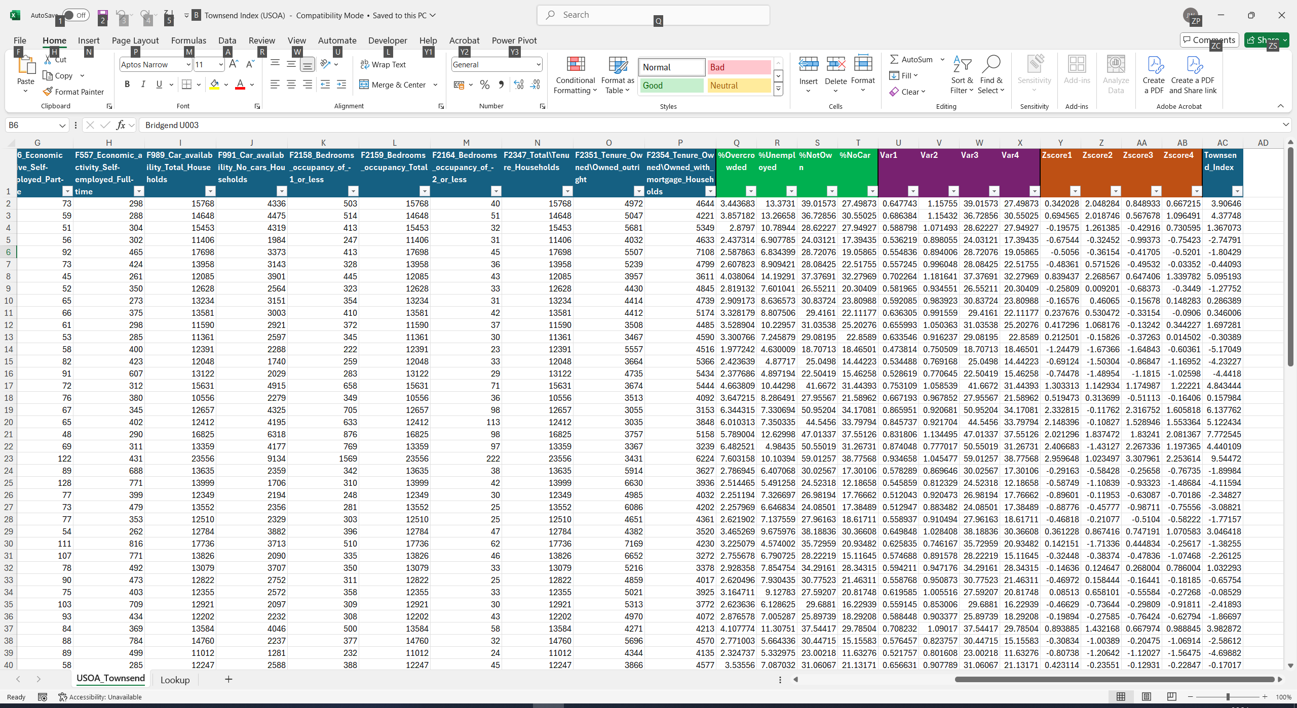

Fig. 34. Townsend index calculated in Microsoft Excel
Import and Visualisation:
The final dataset was imported into MapInfo as a table. The data was then geocoded to the associated boundary dataset and a theme added to highlight areas of high deprivation. The example below shows the Townsend index score geocoded against the USOA boundary map.
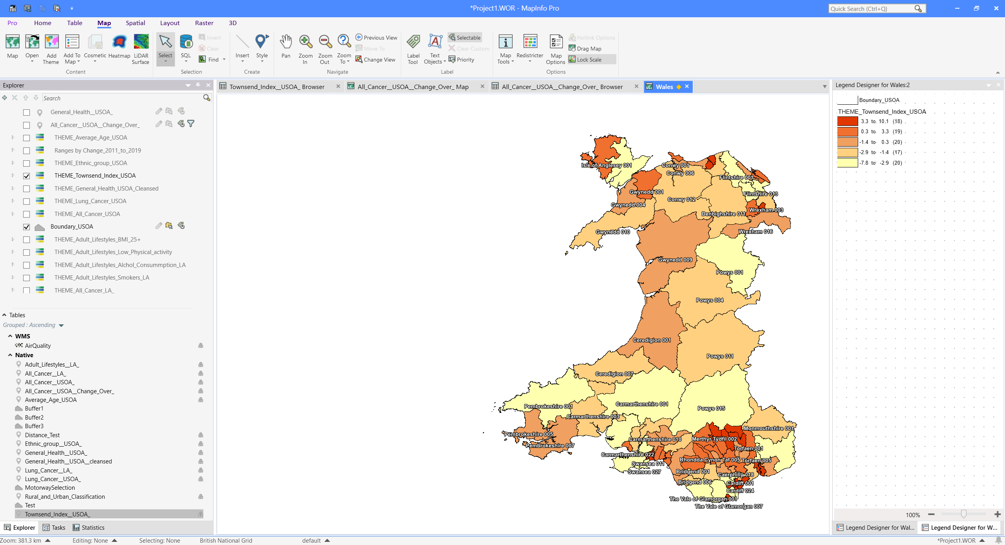

Fig. 35. Project workspace showing Townsend Index by USOA

General Health
General Health data was added from the 2011 census to understand how health impacts cancer rates.
Data description:
- General health – A person’s assessment of the general state of their health. Split up into six categories from very good to very bad. Based on the person health at the point in time of the 2011 census.

Data source:
UK Data Services [6]

File types:
CSV, convert to excel .xls 97-23

Spatial areas:
Wales MSOA, USOA and Local Authority.

Data processing and cleaning:
Data was not available at USOA, data was collected at MSOA and aggregated to USOA area using the boundary mapping file (previously discussed).

Import and Visualisation:
The dataset was imported into MapInfo as a table. To show only the people with bad / very bad health, an SQL query was completed to separate and sum up these two options only.
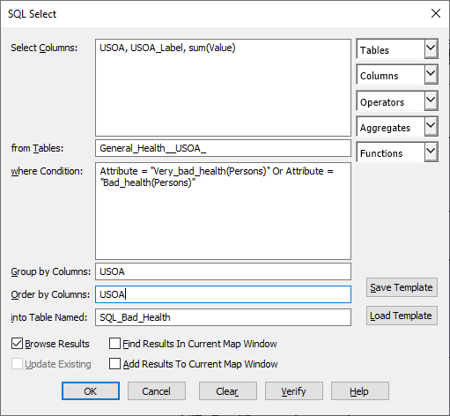
Fig. 36. SQL Query to limit the data to bad health only
The data was then geocoded to the associated boundary dataset, and a theme was added to highlight areas with the highest percentage of bad health.

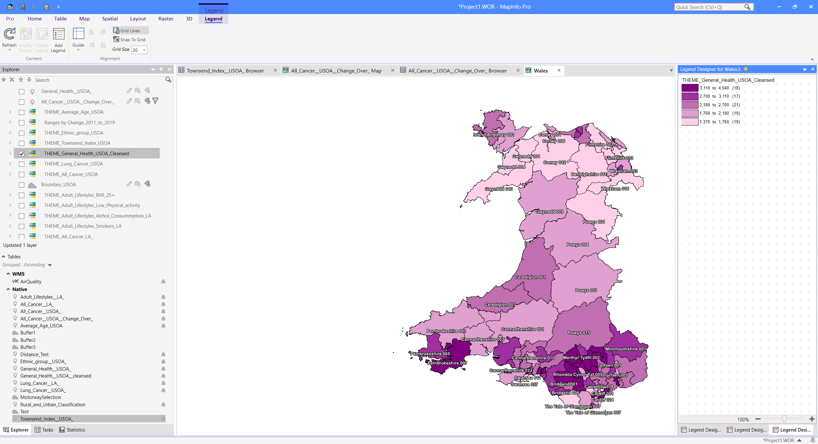
Fig. 37. Project workspace showing people with bad health by USOA

Adult Lifestyles
Adult lifestyles potentially have a high impact on Cancer rates. To understand this better, data was gathered on smokers, activity levels, alcohol consumption and BMI within each area of Wales.
Data description:
Adult lifestyles by local authority and health board, 2016-17 to 2019-20

Data source:
Stats Wales [11]

File types:
CSV, convert to excel .xls 97-23

Spatial areas:
Local Authority – Lowest level of data available.

Data processing and cleaning:
The dataset contained information not related to topic. A SQL query was used to select:

- Percentage of smokers.
- Percentage of people with low activity levels.
- Percentage of people with high alcohol consumption.
- People with BMI 25+ only.

Import and Visualisation:
The dataset was imported into MapInfo as a table. The data was then geocoded to the associated boundary dataset, and themes were added to highlight areas with the highest smokers, lowest activity level, highest alcohol consumption and overweight people.

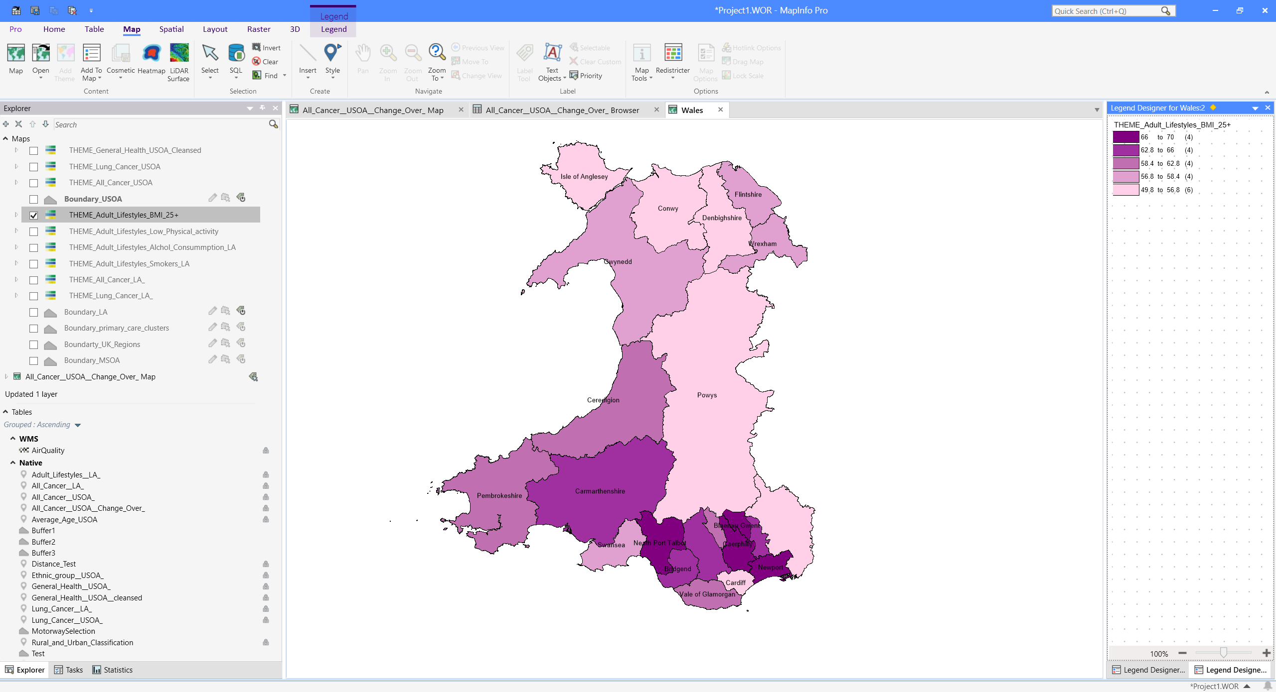
Fig. 38. Project workspace showing local authority’s areas with an overweight population

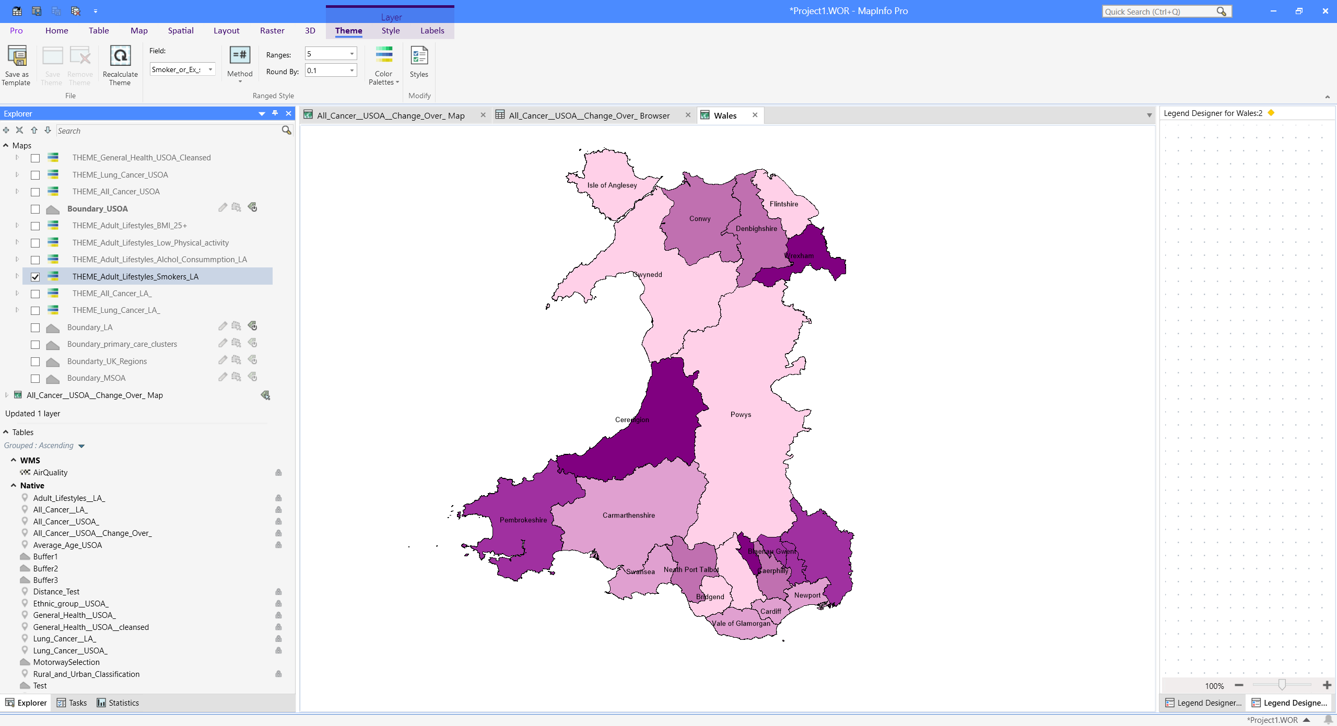
Fig. 39. Project workspace showing local authority’s areas with rates of smokers

Age Demographics
Age demographics can be related to cancer incidences, older people are more likely to develop cancer. To better understand this, the average of people within each area was collected for comparison.
Data description:
The average age of all people on Census Day, 2011 in Wales.

Data source:
UK Data Services [6]

File types:
CSV, convert to excel .xls 97-23

Spatial areas:
Wales MSOA, USOA and Local Authority.

Data processing and cleaning:
Data was not available at USOA, data was collected at MSOA and aggregated to USOA area using the boundary mapping file (previously discussed). Average age was calculated in Excel based on all age data for each area.

Import and Visualisation:
The dataset was imported into MapInfo as a table.

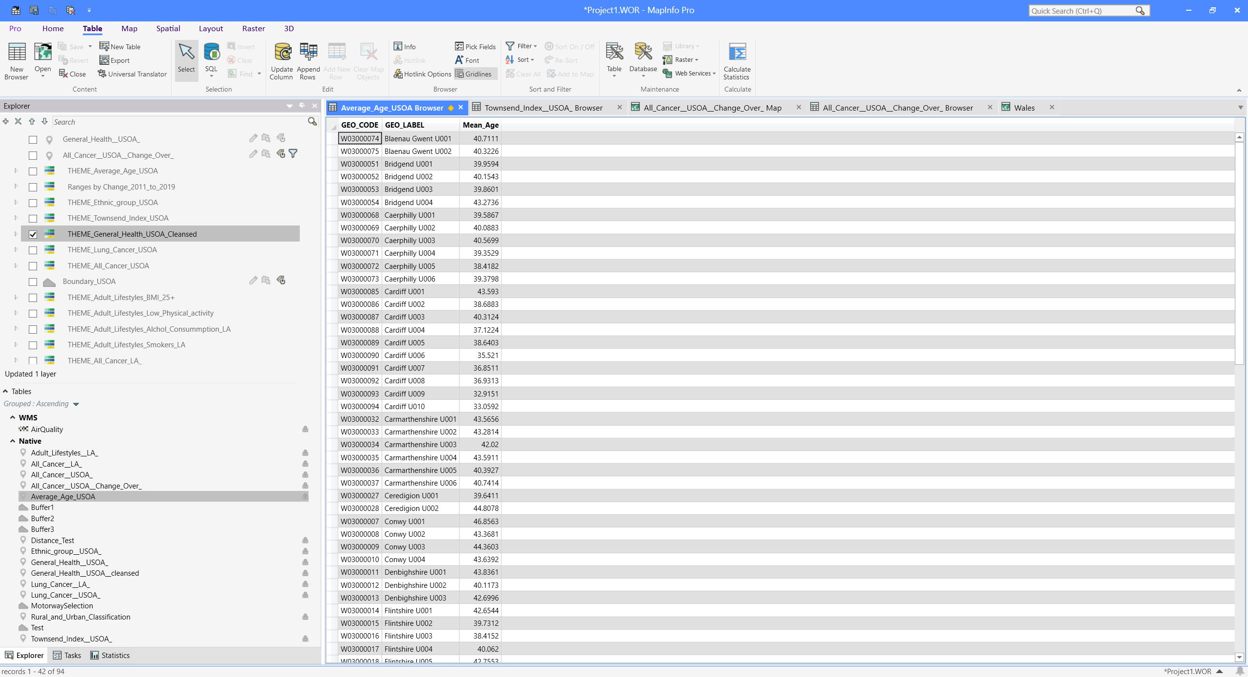
Fig. 40. Project workspace – Example of data table view as a browser tab.
The data was then geocoded to the associated boundary dataset, and a theme was added to highlight areas with the highest age demographic.

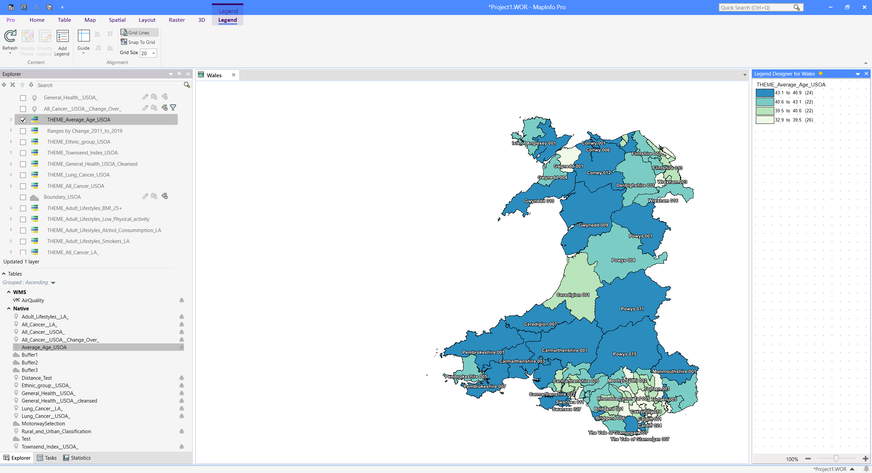
Fig. 41. Project workspace showing age demographics within Wales by USOA

Ethnic Minority
Some cancers are more common in certain ethnic groups. To compare this against cancer numbers, data was collected to identify areas where there is a large amount of people within an ethnic minority group.
Data description:
Ethnic group - The ethnic group that the person completing the 2011 census feels they belong to.

Data source:
UK Data Services [6]

File types:
CSV, convert to excel .xls 97-23

Spatial areas:
Wales MSOA, USOA and Local Authority.

Data processing and cleaning:
Data was not available at USOA, data was collected at MSOA and aggregated to USOA area using the boundary mapping file (previously discussed). Percentage of people within an ethnic minority was calculated in Excel before import into Mapinfo.

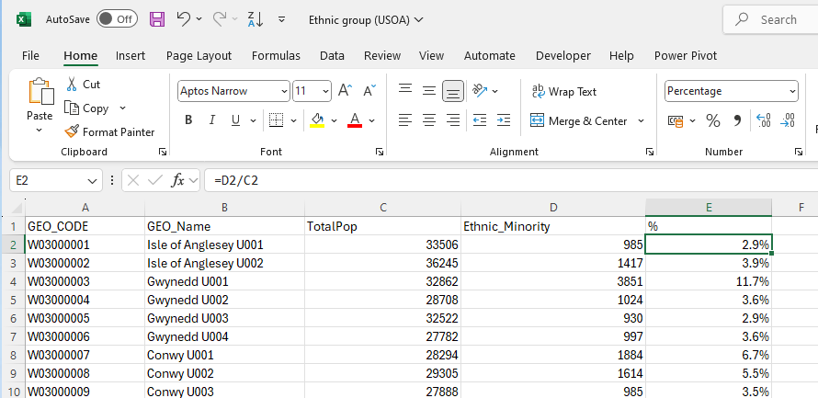
Fig. 42. Calculation to identify percentage of people within an ethnic minority by USOA

Import and Visualisation:
The dataset was imported into MapInfo as a table. The data was then geocoded to the associated boundary dataset, and a theme was added to highlight areas with the highest percentage of ethnic minority.

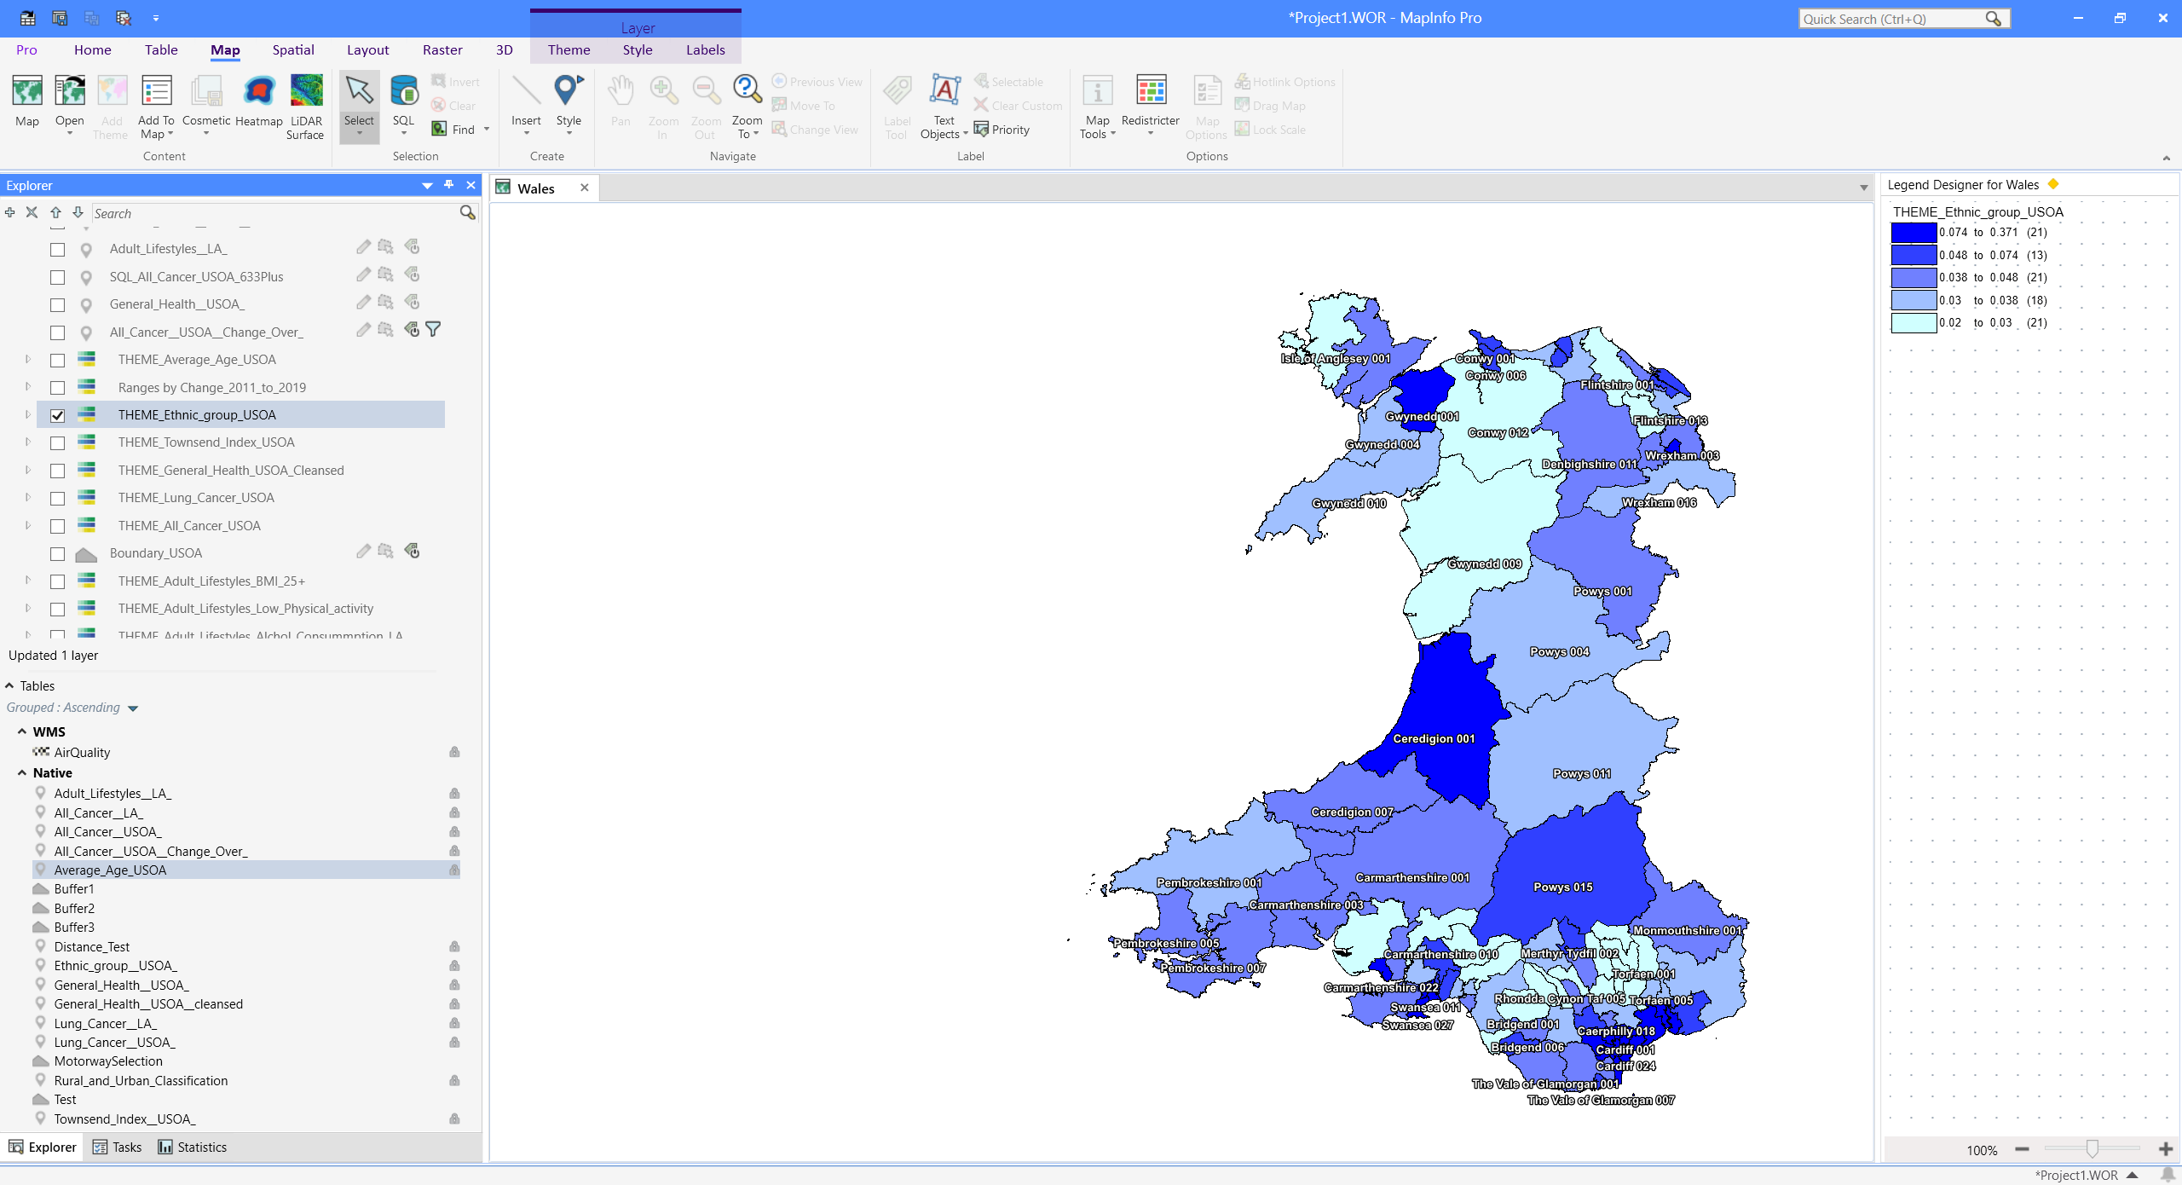
Fig. 43. Project workspace showing ethnic minority within Wales by USOA

Pollution
Pollution and air quality may impact lung cancer rates. To investigate this further, two types of pollution data related to cancer rates will be overlayed to help identify spikes within higher cancer rate areas.
Data description:
Air quality data – PM 10
Air quality data – PM 2.5

Data source:
Data Map Wales [25]

File types:
Shapefile

Spatial areas:
Wales

Data processing and cleaning:
No preprocessing required

Import and Visualisation:
The shapefiles were imported into MapInfo. The data was then overlayed over Wales map to help identify hotspots.

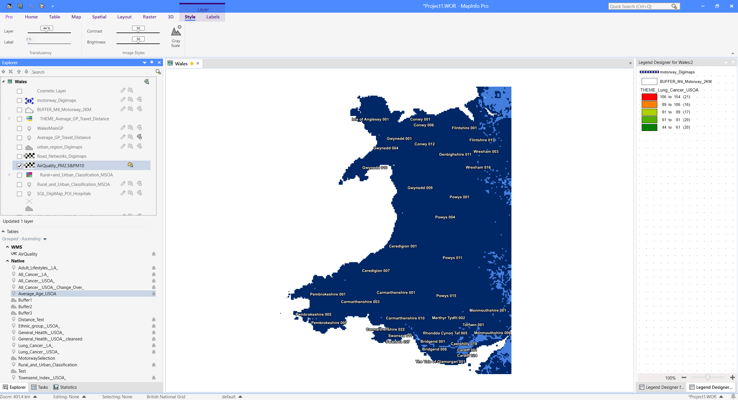
Fig. 44. Project workspace – PM10 and PM2.5 Pollution overlay

Urban Vs Rural
Identifying urban and rural areas in Wales was needed to help understand and relate to cancer rates in built-up urban areas, such as busy cities or towns.

Data description:
Rural and Urban Classification (Census 2011 based)

Data source:
Digimap [22]
Health Map Wales [5]

File types:
Shapefile

Spatial areas:
Wales

Data processing and cleaning:
No preprocessing required

Import and Visualisation:
The data was then overlayed over the cancer data with transparency set to 50%, and custom borders and colours were added to help urban areas stand out. Data from health map Wales was also added to identify the classification of each MSOA.
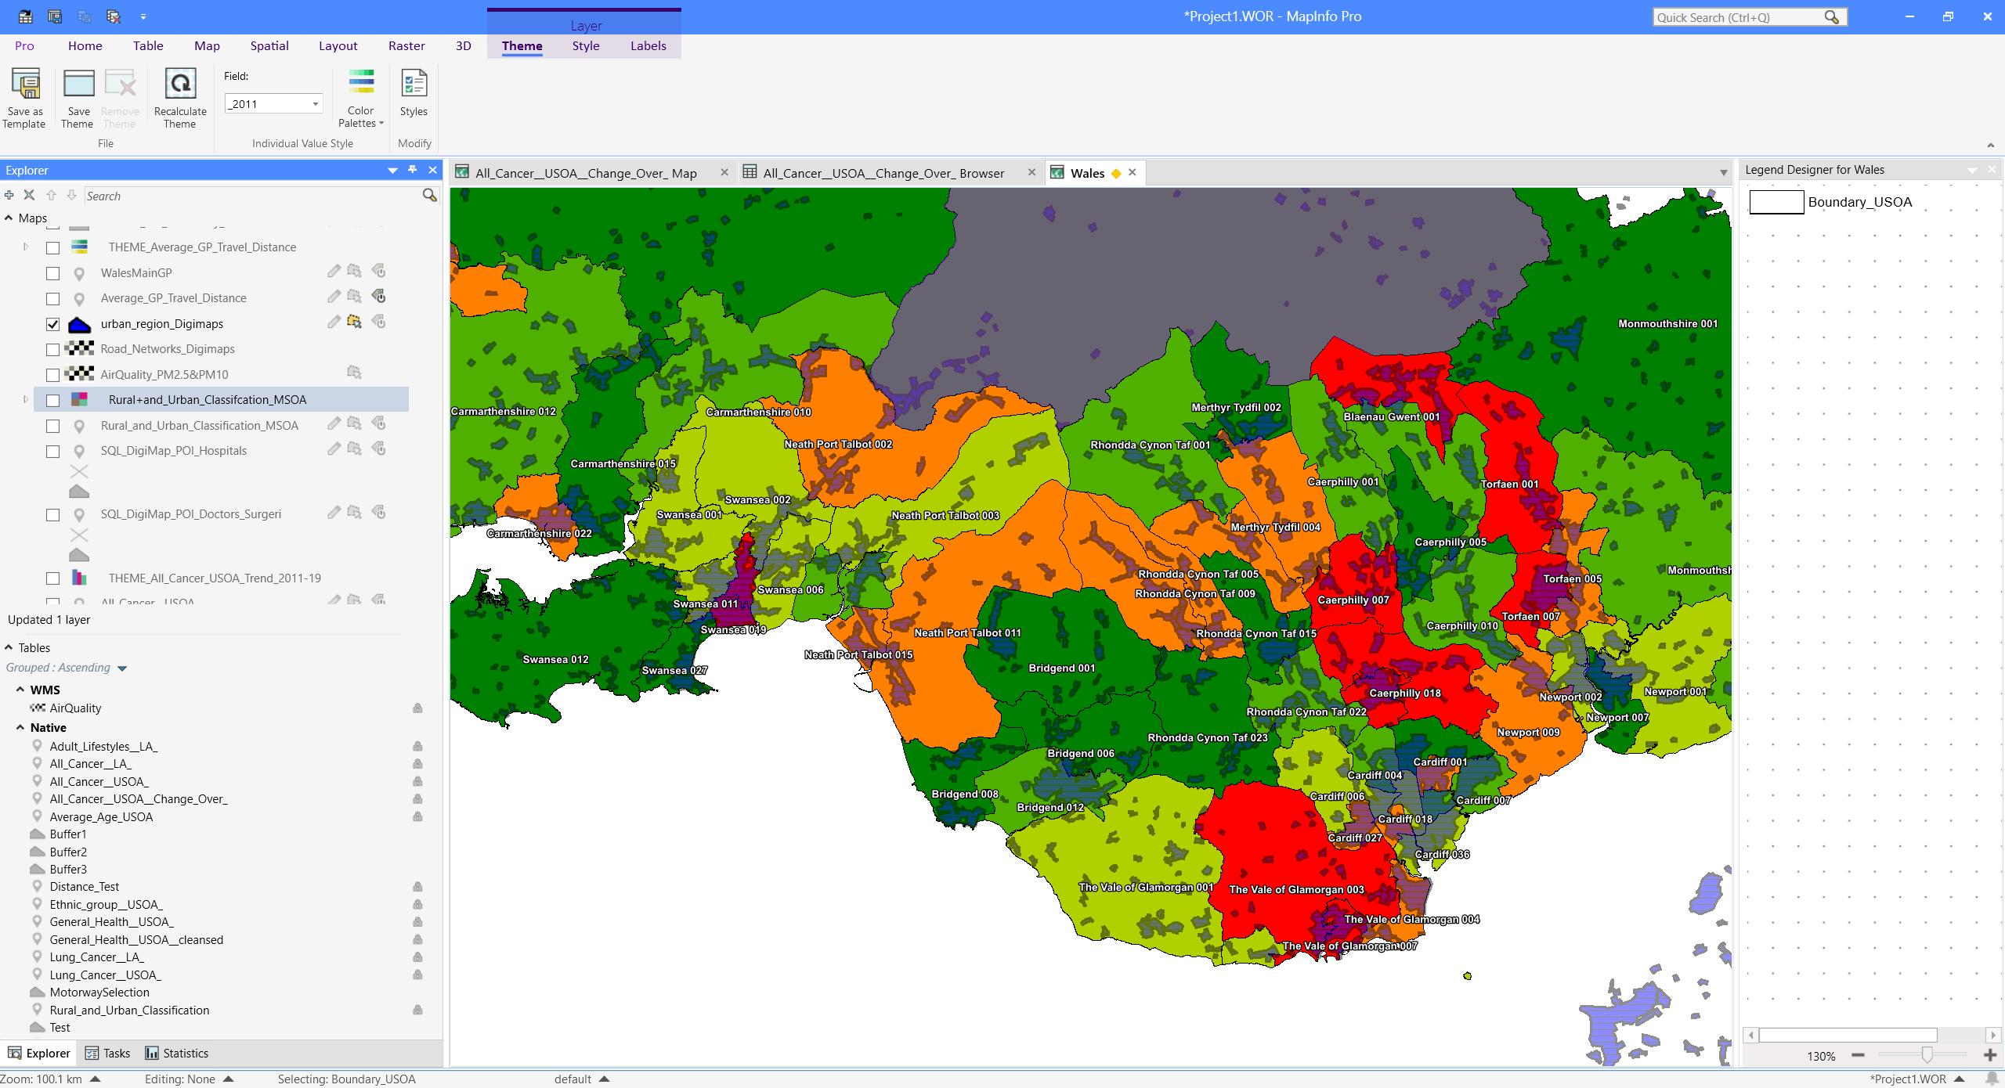
Fig. 45. Project workspace – urban areas layer

Roads and Motorways
Roads and motorway data was gathered to research both how pollution and traffic may impact lung cancer rates and how the available road networks people have to nearby hospitals/surgeries may impact cancer diagnostics and screen test accessibility for some vulnerable people.
Data description:
Motorway Network
OS Open Roads

Data source:
Digimap [22]

File types:
PNG and Shapefile

Spatial areas:
Wales

Data processing and cleaning:
No preprocessing required

Import and Visualisation:
The vector images were imported into MapInfo. The data was then overlayed over the lung cancer incidence layer.

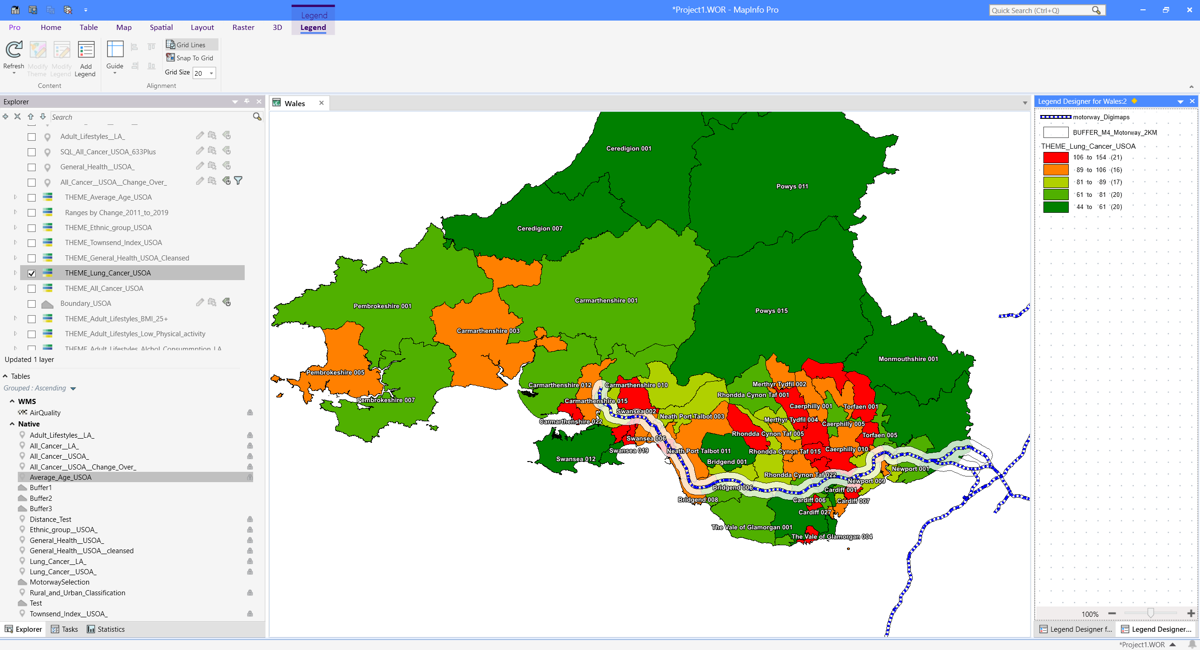
Fig. 46. Project workspace M4 Motorway overlayed with 2km buffer zone included
A buffer zone of 2km included to identify areas which could be affected by pollution from the motorway. The buffer zone was created with a SQL query and by using the buffer zone tool with MapInfo.

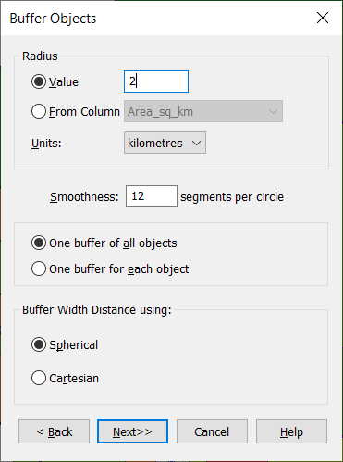
Fig. 47. Buffer objects tool within MapInfo
Finally, a raster image of all the road networks within Wales was imported and overlayed to better understand the transport links available to people in certain areas. Transparency was set to 75% to allow the cancer rates layer to be visible.
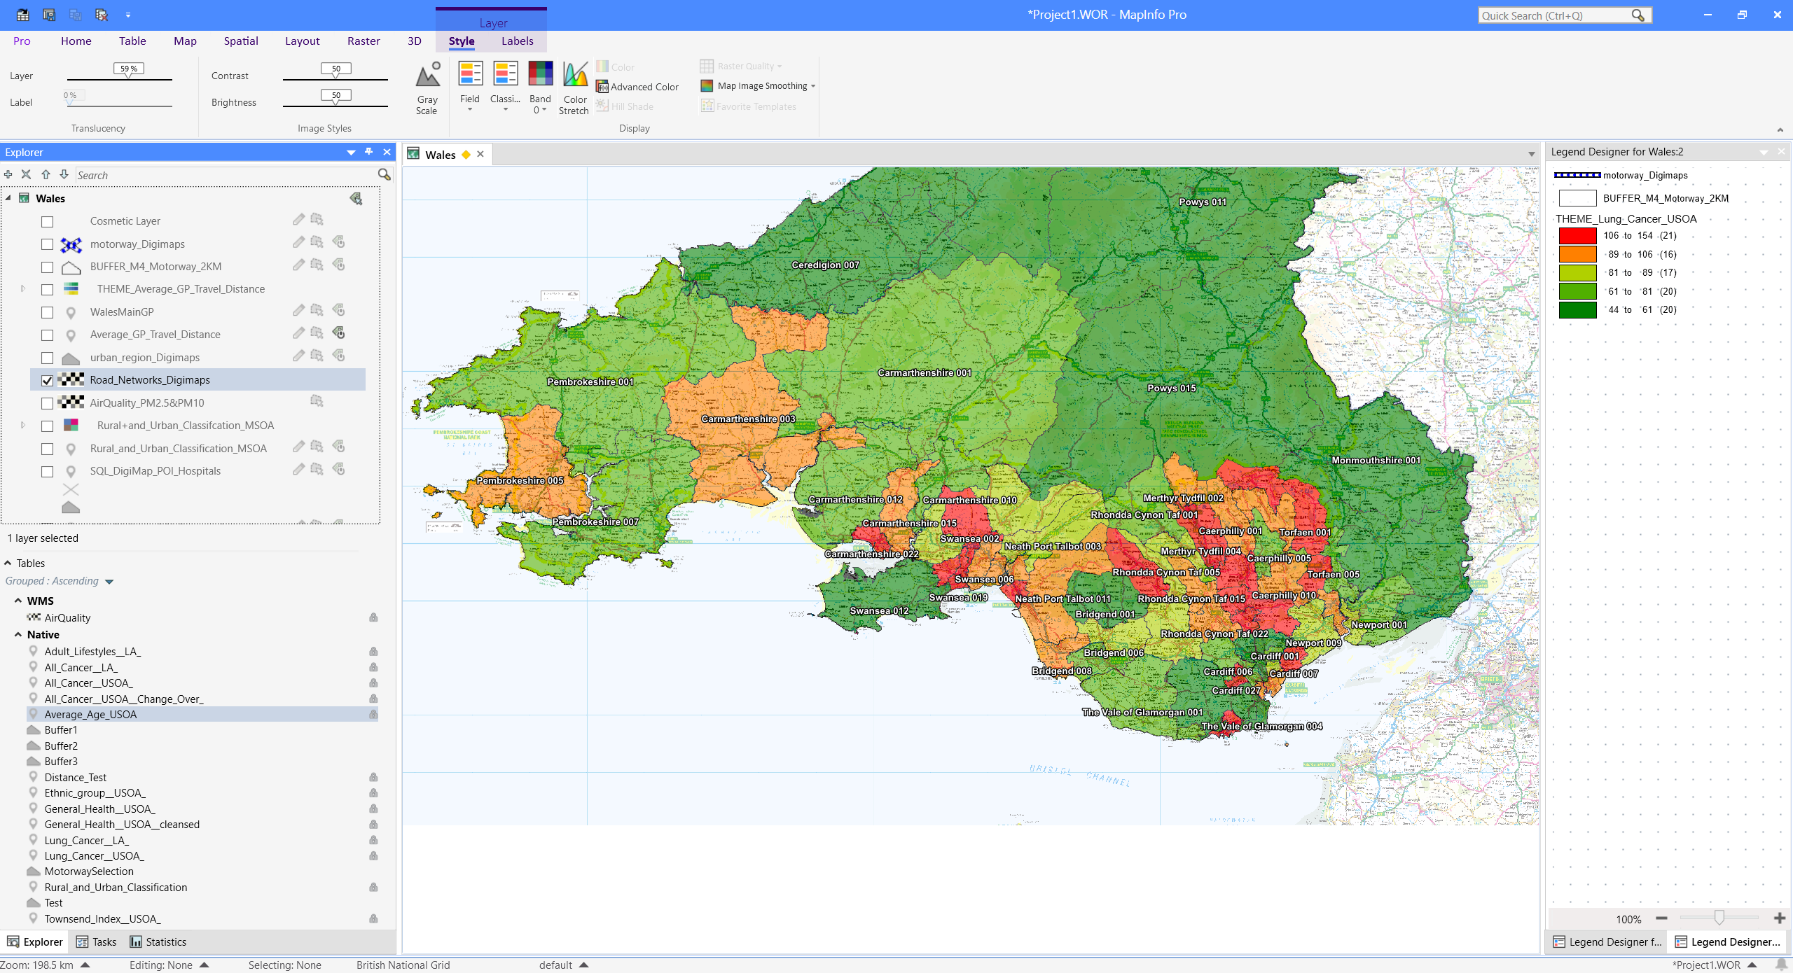
Fig. 48. Project Workspace – Road network overlay

GP and Hospital
Having access to GPs and Hospitals could potentially affect not only the diagnostics numbers of cancer but also limit people’s access to preventive measures such as cancer screenings. GP and Hospital data throughout Wales was imported to help understand if there is a correlation in areas with limited access.
Data description:
Points of interest data – shows all POI across Wales, including hospitals.
GP surgeries - shows the locations of all active GP surgery sites, as of 29th November 2024.

Data source:
Digimap (Hospitals) [22]
Data Map Wales (GP Surgeries) [25]

File types:
Shapefile

Spatial areas:
Wales

Data processing and cleaning:
A SQL query was run in MapInfo to separate hospitals from all the points of interest data provided by Digi map

Import and Visualisation:
The dataset was imported into MapInfo as a table. The data was then geocoded to the associated boundary dataset. The style override mode was used to clearly show the hospital and surgery markers in each area.

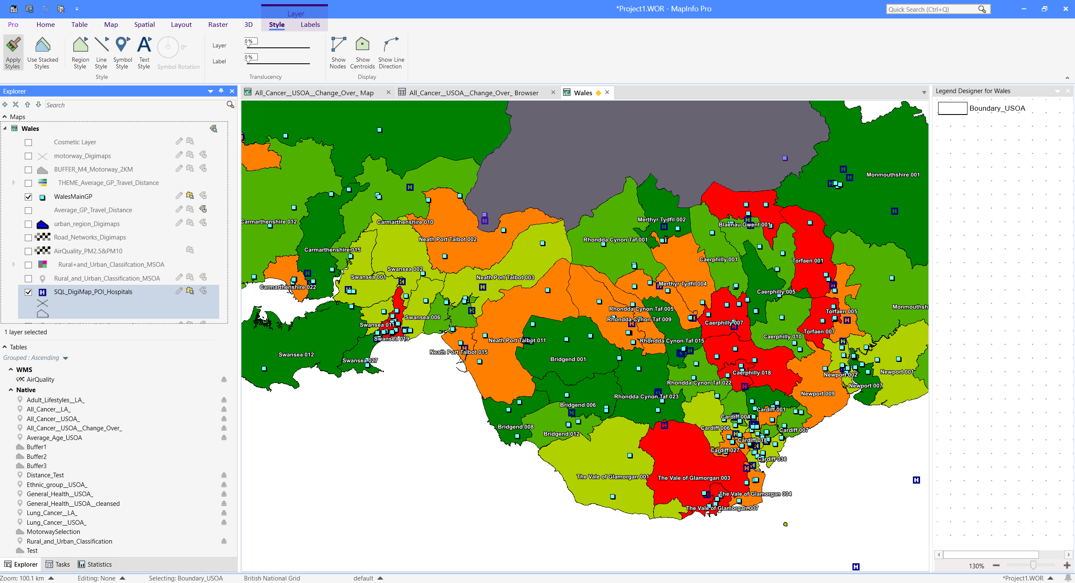
Fig. 49. Project workspace – GP and Hospital sites across Wales.
A distance calculation was added to each area to calculate the average distance people need to travel to a GP surgery. An SQL query was completed to calculate the distance within each region.

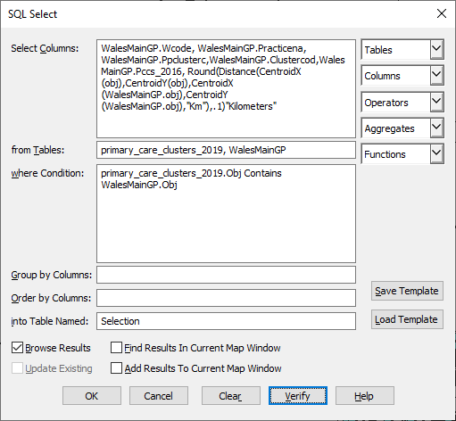
Fig. 50. SQL query to calculate distance within each region.
A thematic theme was then added to identify areas with higher distances.

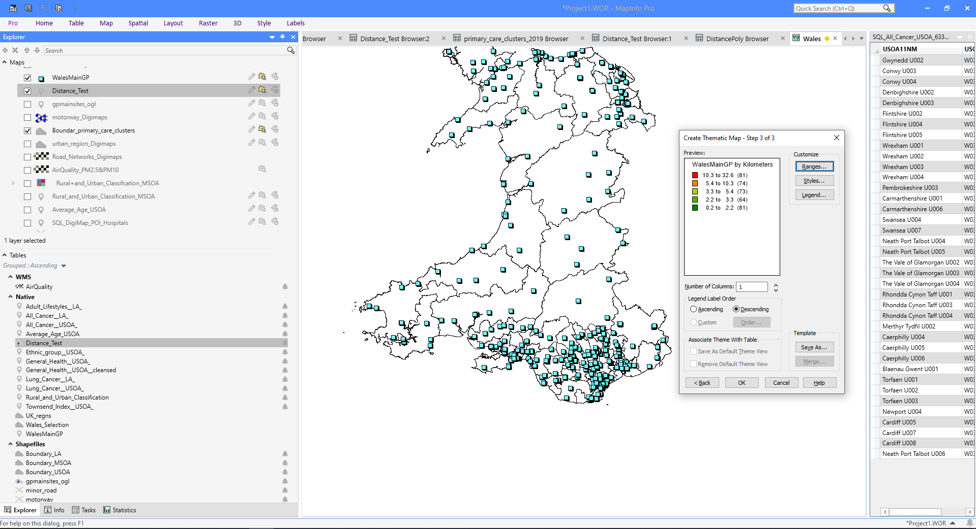
Fig. 51. Thematic map to identify variances in average travel distance.
Finally, the map is overlayed over the cancer dates to help illustrate the average travel distances within areas with higher cancer rates.

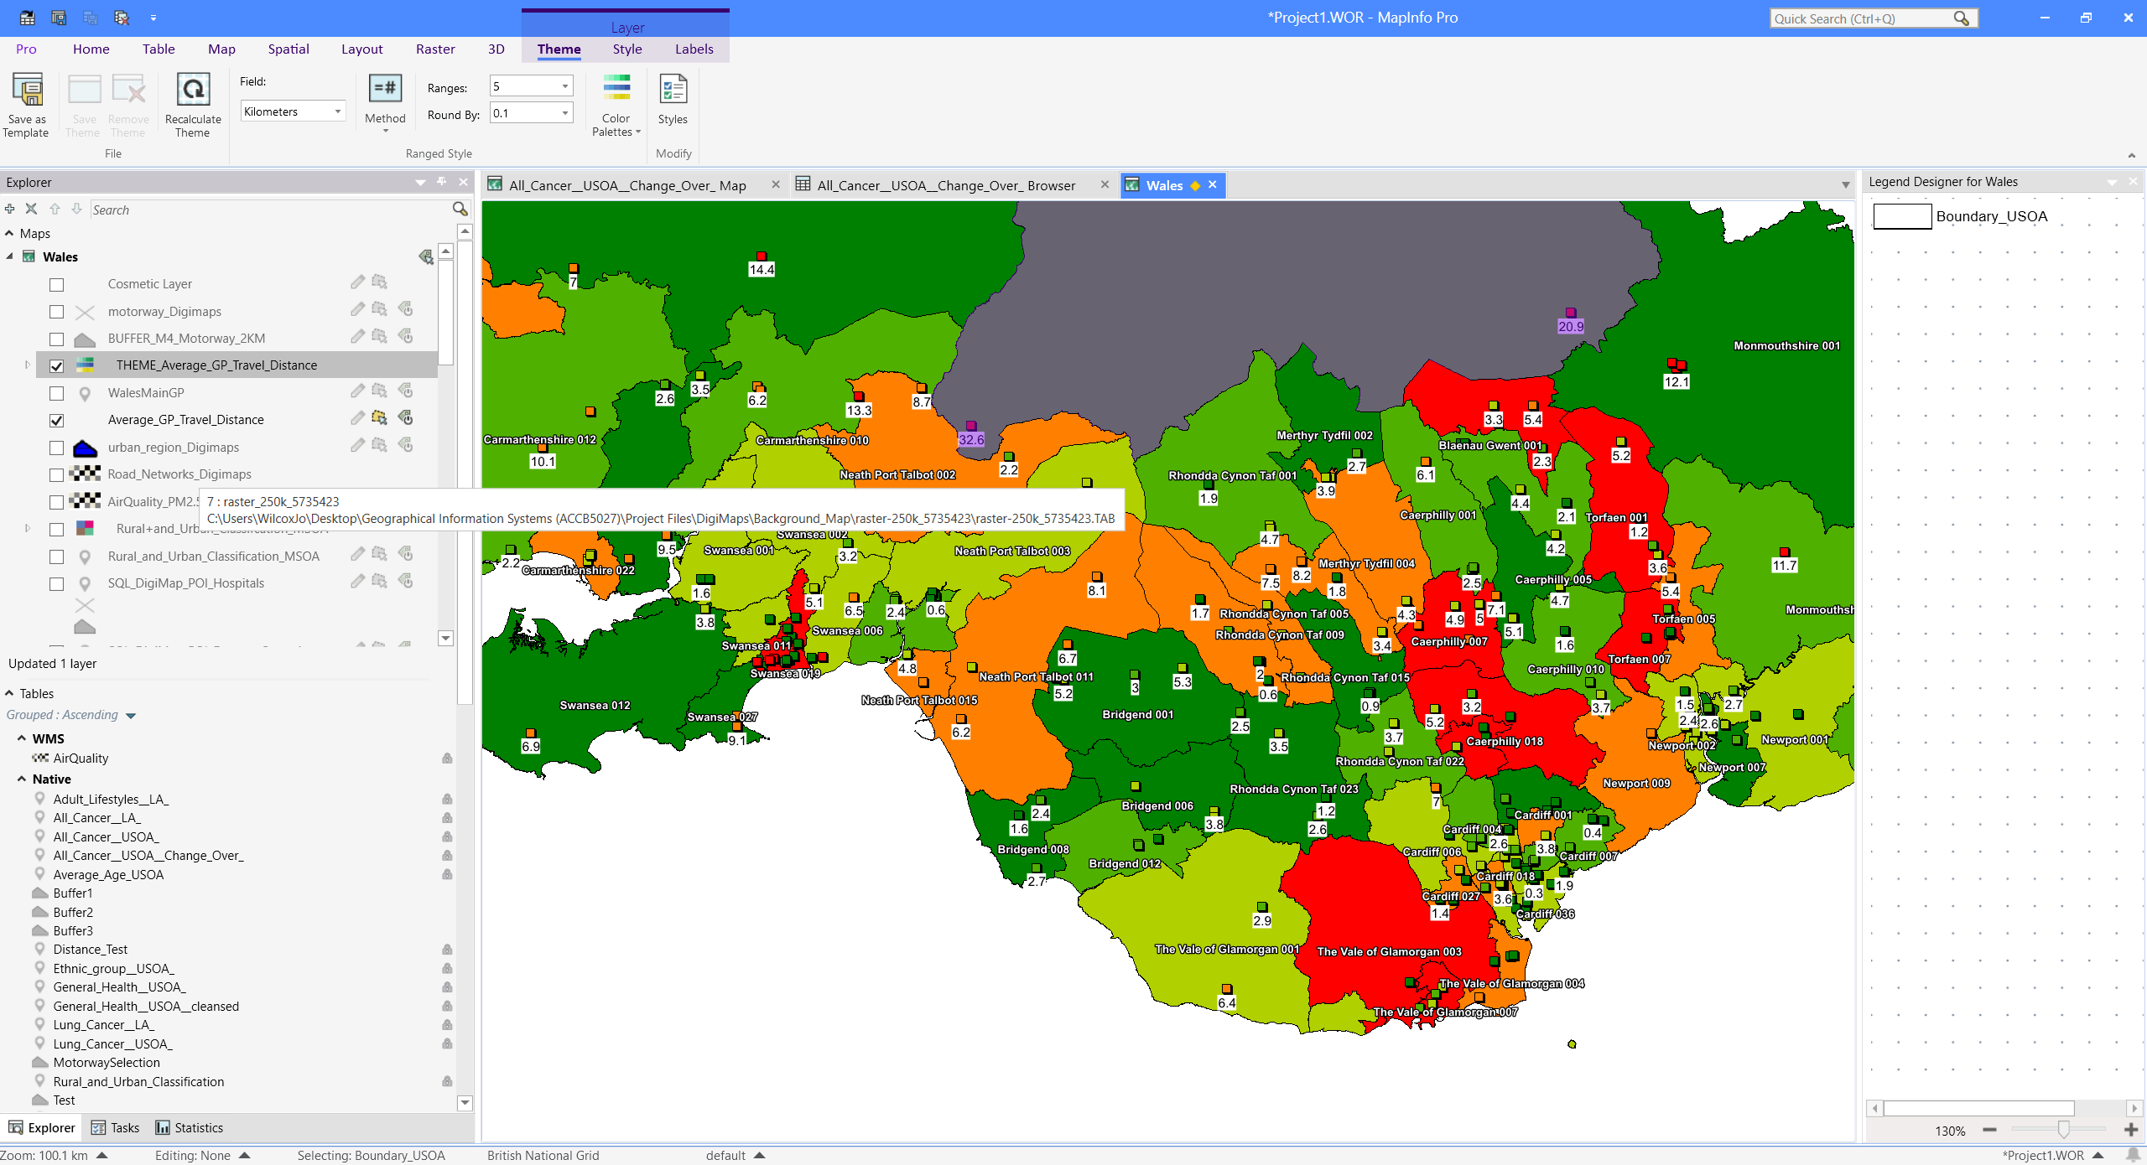

Fig. 52. Project workspace – GP travel distances overlayed over cancer rates in Wales.

Exporting
The completed build was exported to a PDF with the ability for a non-MapInfo user to hide/show each layer of the map. The PDF offers a simplified environment for individuals to explore the data without the need to run specialist software and have access to all the underlying data.

Build Conclusions
Overall, the software was fit for purpose and offered the tools needed to effectively demonstrate the subject matter and data. There were some issues with long loading delays, possibly due to hardware restrictions when dealing with larger datasets.

To develop this project further, the software could be explored to make use of some of the advanced features. For example, there is a time series feature which could be used to create a video timeline of change through time; this will be useful when analysing changes in cancer rates over the years compared to other metrics for example changes in BMI amongst the population.

Appendix 2. Map References

Wales USOA

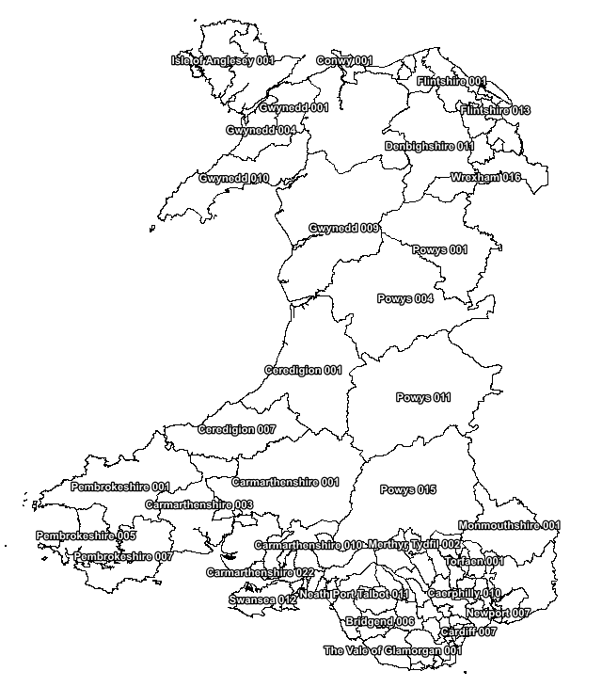
© Crown Copyright Upper Super Output Area Boundary

Wales LA

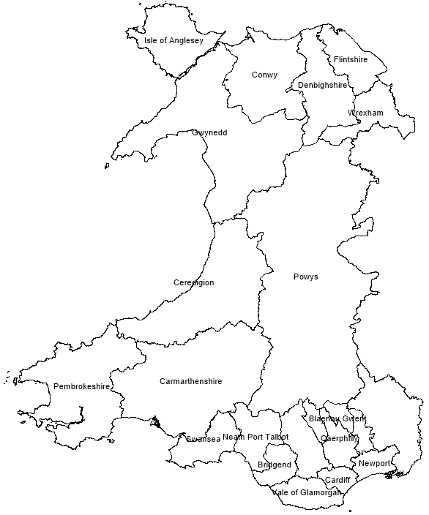
© Crown Copyright Local Authority boundaries

Wales Regions
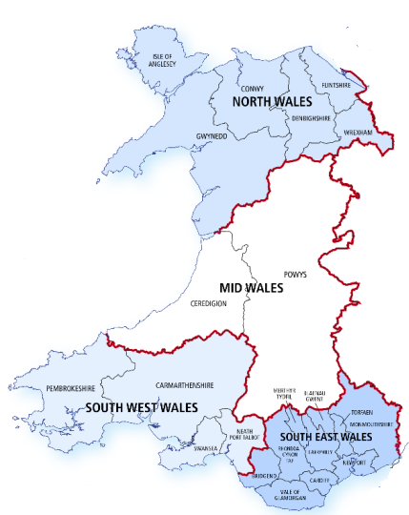
© Crown Copyright Regions Wales

Abbreviations

Abbreviation | Definition
USOA | Upper Super Output Area
MSOA | Middle Super Output Area
LSOA | Lower Super Output Area
LA | Local Authority
GIS | Geographic Information System
BMI | Body Mass Index
NHS | National Health Service
GIS | Geographic Information System
ONS | Office Of National Statistics
OA | Output areas

References

[1] Publisher John Wiley & Sons, sponsor Samuel Waxman Cancer Research Foundation, publisher John Wiley & Sons, and sponsor Samuel Waxman Cancer Research Foundation, Aging and cancer. Hoboken, New Jersey: Wiley Periodicals Inc., 2020.
[2] "NHS diagnoses thousands more cancers as cases rise by 5%”, National Health Service [Online], Available: https://www.england.nhs.uk/2024/10/nhs-diagnoses-thousands-more-cancers-as-cases-rise-by-5, [Accessed 07/12/2024].
[3] Y. Lin, “You are where you live? Evaluating the racial and ethnic (mis)representation in geodemographic classification,” Applied geography (Sevenoaks), vol. 165, pp. 103244-, 2024, doi: 10.1016/j.apgeog.2024.103244.
[4] " Geographies in Wales”, National Health Service [Online], Available https://www2.nphs.wales.nhs.uk/PubHObservatoryProjDocs.nsf/61c1e930f9121fd080256f2a004937ed/3b8079b7c790215680257e51004e0bd5/$FILE/20150422_WalesGeographies_Web.pdf, [Accessed 09/12/2024].
[5] "All Cancers (excl non-melanoma skin cancer), Incidence (Age-standardised) per 100k pop, Persons, All Ages", HealthMap Wales [Online], Available https://www.healthmapswales.wales.nhs.uk/data-catalog-explorer/indicator/I63/?geoId=G108&view=table. [Accessed 01/12/2024].
[6] J. Ye et al., “Socioeconomic Deprivation Index Is Associated With Psychiatric Disorders: An Observational and Genome-wide Gene-by-Environment Interaction Analysis in the UK Biobank Cohort,” Biological psychiatry (1969), vol. 89, no. 9, pp. 888–895, 2021, doi: 10.1016/j.biopsych.2020.11.019.
[7] L. J. Rice, C. Jiang, S. M. Wilson, K. Burwell-Naney, A. Samantapudi, and H. Zhang, “Use of segregation indices, Townsend Index, and air toxics data to assess lifetime cancer risk disparities in metropolitan Charleston, South Carolina, USA,” International journal of environmental research and public health, vol. 11, no. 5, pp. 5510–5526, 2014, doi: 10.3390/ijerph110505510.
[8] Office for National Statistics ; National Records of Scotland ; Northern Ireland Statistics and Research Agency (2017): 2011 Census aggregate data. UK Data Service (Edition: February 2017). DOI: http://dx.doi.org/10.5257/census/aggregate-2011-2
[9] "Causes and risk factors ", Macmillan Cancer Support [Online], Available: https://www.macmillan.org.uk/cancer-information-and-support/worried-about-cancer/causes-and-risk-factors [Accessed 01/12/2024].
[10] R. Sharman, Z. Harris, B. Ernst, D. Mussallem, A. Larsen, and K. Gowin, “Lifestyle Factors and Cancer: A Narrative Review,” Mayo Clinic proceedings. Innovations, quality & outcomes, vol. 8, no. 2, pp. 166–183, 2024, doi: 10.1016/j.mayocpiqo.2024.01.004.
[11] "Adult lifestyles by local authority and health board, 2016-17 to 2019-20”, Stats Wales [Online], Available https://statswales.gov.wales/Catalogue/National-Survey-for-Wales/Population-Health/Adult-Lifestyles/adultlifestyles-by-localauthority-healthboard [Accessed 29/11/2024].

[12] "Smoking and Cancer”, Ash – action on smoking and health [Online], Available https://ash.org.uk/resources/view/smoking-and-cancer#:~:text=Up%20to%20two%20in%20three,cancer%20deaths%20in%20the%20UK. [Accessed 21/12/2024].
[13] T. J. Williamson, D. M. Kwon, K. E. Riley, M. J. Shen, H. A. Hamann, and J. S. Ostroff, “Lung Cancer Stigma: Does Smoking History Matter?,” Annals of behavioral medicine, vol. 54, no. 7, pp. 535–540, 2020, doi: 10.1093/abm/kaz063.
[14] "Trends in cancer incidence and stage at diagnosis in Wales up to 2019", NHS Wales[Online], Available: https://phw.nhs.wales/news/trends-in-cancer-incidence-and-stage-at-diagnosis-in-wales-up-to-2019/ [Accessed 23/12/2024].
[15] "Age and cancer", Cancer Research UK [Online], Available: https://www.cancerresearchuk.org/about-cancer/causes-of-cancer/age-and-cancer#:~:text=Often%20our%20body%20repairs%20the,up%2C%20making%20cancer%20more%20likely. [Accessed 23/12/2024].
[16] "Percentage of black Asian and minority ethnic people in Wales by Local Authority Census 2021", Data Map Wales [Online], Available: https://datamap.gov.wales/layers/geonode:wales_ethnicity_map_2021. [Accessed 23/12/2024].
[17] C. Y. Fang and M. Tseng, “Ethnic density and cancer: A review of the evidence,” Cancer, vol. 124, no. 9, pp. 1877–1903, 2018, doi: 10.1002/cncr.31177.
[18] "How can air pollution cause cancer?”, Cancer Research UK [Online], Available: https://www.cancerresearchuk.org/about-cancer/causes-of-cancer/air-pollution-radon-gas-and-cancer/how-can-air-pollution-cause-cancer [Accessed 30/12/2024].
[19] M. C. Turner et al., “Outdoor air pollution and cancer: An overview of the current evidence and public health recommendations,” CA: a cancer journal for clinicians, vol. 70, no. 6, pp. 460–479, 2020, doi: 10.3322/caac.21632.
[20] "Air Quality data (2016)”, Data Map Wales [Online], Available: https://datamap.gov.wales/layergroups/inspire-wg:AirQualityData [Accessed 30/12/2024].
[21] L. Sharp et al., “Risk of Several Cancers is Higher in Urban Areas after Adjusting for Socioeconomic Status. Results from a Two-Country Population-Based Study of 18 Common Cancers,” Journal of urban health, vol. 91, no. 3, pp. 510–525, 2014, doi: 10.1007/s11524-013-9846-3.
[22] "Digimap - online resource that provides access to maps and geospatial data”, Digimap [Online], Available https://digimap.edina.ac.uk/ [Accessed 05/12/2024].
[23] M. Ambroggi, C. Biasini, C. Del Giovane, F. Fornari, and L. Cavanna, “Distance as a Barrier to Cancer Diagnosis and Treatment: Review of the Literature,” The oncologist (Dayton, Ohio), vol. 20, no. 12, pp. 1378–1385, 2015, doi: 10.1634/theoncologist.2015-0110.
[24] T.Bret, "Living near a busy road can increase risk of lung cancer”, Kings Collage London [Online], Available https://www.kcl.ac.uk/news/living-near-a-busy-road-can-stunt-childrens-lung-growth [Accessed 05/01/2025].
[25] "Boundary Areas (Wales)”, Data Map Wales [Online], Available https://datamap.gov.wales/ [Accessed 01/12/2024].
[26] "Summary statistics for Wales, by region: 2020?", gov.wales [Online], Available https://www.gov.wales/sites/default/files/statistics-and-research/2020-05/summary-statistics-regions-wales-2020-629.pdf [Accessed 07/12/2024].

