Guidance for Aston Martin Sim Data Exercise

- For each setup, determine the roll stiffness distribution of the car

Do this by creating using your spreadsheet with the A-M data in. This will calculate the front roll stiffness and the rear roll stiffness.

Front Roll stiffness percentage
= Front Roll Stiffness *100 / Total Roll Stiffness

Rear Roll stiffness percentage
= Rear Roll Stiffness * 100/ Total Roll Stiffness

This will give you the roll stiffness distribution – a percentage that should add to 100!

- Run the car at very low speed round the circle to determine the neutral steer angle.
This was done in the lab session

- Create an U/S channel as the difference between neutral steer and the actual steer angle.

Look at the Steering Wheel Pct [%] Channel.
There is a low speed part of the data set for each setup. Zoom in to a short steady state period of this. Look at the mean value (The furthest right) for that short period .
This will be the neutral steer % value. It is a single value for this car at the radius of turn chosen.

(NB To show the measurements at the top right for each channel:-
Right Click
Display
Measurement
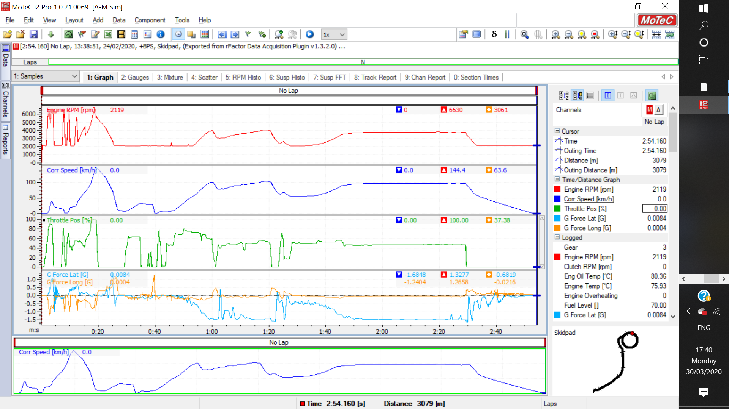
To create the U/S Channel use the expression:-

Steering Wheel Pct [%] - Neutral steer % value

- Select a period of steady state cornering.

For each data set zoom into a period of steady state cornering at high speed with a significant lateral acceleration look at this U/S Channel

Record the mean value

If the value is +ve the car is understeer if -ve it is oversteer.
The magnitude indicates the level of understeeer.

- Compare the average steady state handling balance achieved for that period with each roll stiffness distribution.

Find the mean value of U/S Channel in the same way for each of the three setups

- Using the previously constructed Measured FRLSD channel with this data set for the same steady state cornering period find the average FRLSD for each setup.

Use the channel expression you created for the MCR. You will need to re-enter it for the Aston Martin exercise as it is a different version of the software

Again, zoom into the steady state high speed section and find the mean value of FRLSD

Create a simple table

Set up | U/S Channel Value | Front Roll Stiffness %/ Rear Roll Stiffness % | FRLSD
1
2
3

- Discuss the relationship between roll stiffness distribution, FRLSD and the resulting handling balance.

To do this you may find it helpful to answer these questions:-
- If the front is stiffer than the rear is the U/S greater or less than when the rear is stiffer than the front?
- The grip at each end of the car is determined by the FRLSD. (Front Load Split – Rear Load Split). When the Front is stiffer than Rear this should lead to a larger FRLSD than when the Rear is stiffer than the Front? Do the results you get confirm this?
- Have you any further comments about the relationships between the values obtained?

