

TITLE OF THE ASSIGNMENT- ENVIRONMENT ANALYSIS OF CAR MANUFACTURING INDUSTRY
TITLE OF THE MODULE- THE GLOBAL BUSINESS ENVIRONMENT
ASSESSMENT 1
STUDENT NAME- Iulia Teodora BOBOs
STUDENT ID-1921543
MODULE LECTURER’S NAME- Rexon Nting

Introduction
The significant macro and micro-environmental elements influence the global car manufacturing industry. The internal and external environment of the industry helps in shaping the prospect of the industry that depends on substantial factors like the price of the raw materials, government laws and policies, competition in the market, availability of human resources, demand for the commodities like luxury or value variants, and the demand and supply of the commodities. The recent years in the car manufacturing industry has witnessed efficacious leadership of various levels introducing higher strata of research and development, the introduction of advanced technology in production and innovation in their respective companies.
The aim of the essay highlights the global business environment persistent for the last few years in the car manufacturing industry. It brings out the opportunities and challenges of the industry facing while growing globally. The internal and external forces are depicted through the evaluation tools like PESTLE, SWOT, and Porter’s Five Forces model. The tools like Product Life Cycle and positioning of the companies are critically evaluated to decipher the competitive advantage of the companies gained while they exist in the same industry.

Analysis of the major forces determining the business environment and the changes witnessed in the car manufacturing industry
The significant forces are categorised as macro and micro-environmental forces which helps in shaping the future course of action undertaken by the respective industries. The car manufacturing industry has to consider the price of raw materials like steel and aluminium, fibre, and other parts that are installed in vehicles. The recent economic fluctuations due to the BREXIT issue in the European countries, COVID-19 led lockdown. It severed ties with China has a strong influence on the demand and supply for cars (Grinsteins, 2018). The unemployment rates, uncertainty in business operations and falling economy may not support the increased level of car manufacturing as the power of purchasing by the customers will automatically reduce. The government laws and policies of different nations have varied influence on the growth of the firms in the industry. The import duties, tariffs, entry of foreign automakers, adaptation of advanced technology and the infrastructure required is highly influenced by the supportive measures taken by the government of the nation (Abdi et al. 2018). The adverse policies, on the other hand, maybe fatal for the growth of the firms investing in car manufacturing with varied models and price.
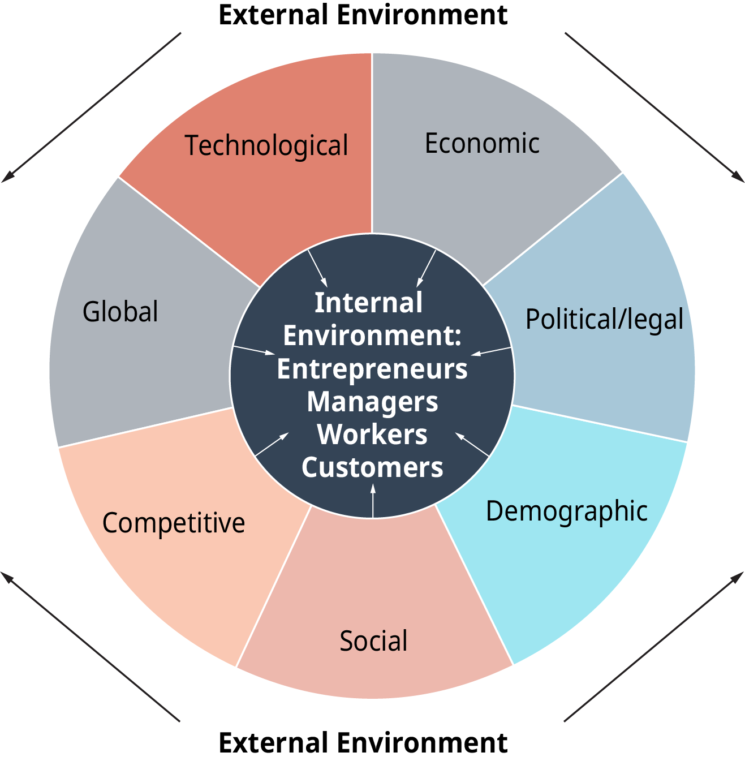
Figure 1: The internal and external environment of the car manufacturing industry influencing the growth.
(Source: Abdi et al. 2018)

Analysis of the macro-environmental factors affecting the work culture of the car manufacturing industry
The car manufacturing industry is one of the highest revenues earning industry in the global arena. The tool for evaluating the business environment and its impact on the companies can be measured through PESTLE Analysis which is attempted in the following points:

PESTLE Analysis
Political Factors
The policies and laws formulated by the government of several nations and the profit-earning motive of the car manufacturing industry have a direct role in the augmentation of this industry. Most of the countries in significant summits agree on low carbon emission vehicles (Kotabe and Helsen, 2020). The policies support the leniency in labour wages and better working conditions for the labour. Moreover, the taxation is reasonably fixed by the government, which may not make a hole in the pockets of the buyers. The international presence of brands is also favoured through FDI in the countries.
Economic Factors
The recent years have witnessed a fall in the economic conditions in several third world countries which has an adverse impact on the sales of cars. However, the power train technology used in the global manufacturing of cars has witnessed the improved efficiency of the vehicles that have increased the sales of cars by 60%. This, in return, has engaged employment with trained and skilled labours from various countries (Coe and Yeung, 2019). The purchasing power of the customers' believed to be low due to the COVID 19 situation while losing the jobs. The companies hence focused on energy and cost-efficient manufacturing while producing low-cost cars to attract the buyers on a large scale.
Socio-cultural Factors
Socio-culture forces play a vital role in determining the sales of cars. The demography, location, age factors and preference of the customers vary to a large extent (Parra et al. 2018) The youth relies on sports utility vehicle while the aged people or big family relies on multi-utility vehicles accommodating everyone. Newer models are always on the trend while the old ones go out of fashion quickly.
Technological Factors
The recent power train technology adopted has reflected turbo-boosted gasoline engines with higher speed and low on emission. The light vehicles are preferred in the market with fuel efficiency, added technical advantage, and implementation of better software in the models for assistance. The figure given below shows the surge of low carbon transmission power train engines inducted in the lightweight vehicles produced in recent years.
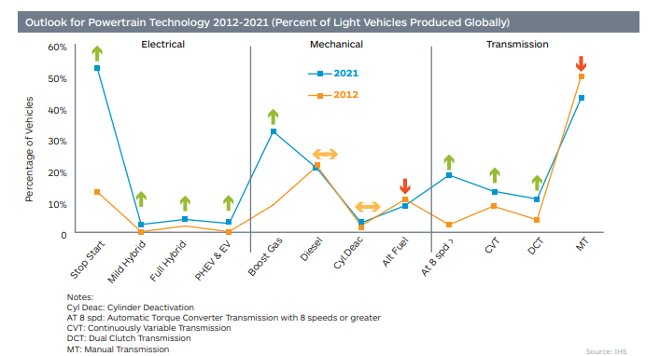
Figure 2: The latest power train technology used in the car manufacturing industry
(Source: Fulthorpe, 2019)
Legal Factors
The legal compliances determine the vital factor associated with manufacturing and selling of cars in the international market. The laws of every country are strict on controlling pollution and safety features installed with the models. Toyota, one of the reputed car manufacturing companies, has to recall its model due to faulty airbags installed prone to accidents (Chodakowska, 2018). Similarly, the laws and policies on taxation, environmental compliance and other laws have to be followed by the companies engaged in international manufacturing and trading.
Environmental Factors
The recent change witnessed in the global climate has urged the nations to adopt stricter environment policies favouring the manufacturing and selling of the cars. The primary focus of the car manufacturing companies is always on fuel efficiency technology and following low carbon emission. U.K. and U.S. favour both the fuel-efficient and low emitting carbon cars for which they provide tax subsidies (Andriantsiferana, 2019). Testing the efficiencies are the major focuses of most of the nation’s promoting eco—friendly and pollution-controlled cars.

Analysis of the micro-environmental factor affecting the work culture of the car manufacturing industry
The operational areas that come in immediate focus for the companies involving their decision-making capabilities which create an impact on the functioning of the manufacturing industry comprise the micro-environmental factors. The tools for evaluating those factors are presented below:

SWOT Analysis
Strength  - Innovation and research and development is the constant source of growth for the industry.  - The growth shifting towards American and Asian market is the primary focus of the industry where notable disposable income and a higher level of lifestyle changes has been witnessed. | Weaknesses  - The companies are liable to recall the models which are giving mass dysfunctional or technical issues in operations  - Many companies manufacturing cars have reported on low gross margins due to low working capital, increased rate of interest on credit and citing the possibilities of bankruptcy.
Opportunities  - Innovating new technology on fuel efficiency and low carbon emission  - Expansion of the market in BRIC and Asian nations with a shift in the customers' group preferring value-added cars | Threats  - The price of the fuel remains volatile while the use of C.N.G. is limited to models and restricted by government rules.  - Unemployment, natural calamities like COVID 19, sluggish economic growth are other high threats for the progress of the car manufacturing industry.

Critical analysis of the opportunities and challenges of the forces in shaping the business environment of the industry
The opportunities of the industry involved in manufacturing cars are multifarious. The green marketing concept has been adopted in the industry. As illustrated by Laju, (2019), the Hyundai Company from Korea has adopted zero waste in the discharge system of water used for manufacturing. The environment management system comprises of the plan for reducing greenhouse gas emission, and other discharge of pollutants. Bajaj Auto emerged with the DTSi (Digital Twin Spark Emission) technology that provides high efficacy in the consumption of fuel. The expansion of markets in Asia and America is considered one of the lucrative opportunities for the manufacturers of car companies.
The challenges recognised for the upsurge of this industry emerges as obstacles like overcapacity of the companies investing more materials and payroll, the sustainability of the models produced by the companies, spare parts production, and engaging skilled talents to innovate better models with constant changes in the taste and preferences of the consumers (Covarrubias and Perez, 2019). The trade unions, geographical challenges and policies of the government become obstacles in the flourishing of the car companies at various international locations.

Porter’s Five Forces Model
The analytical tool proposed by Michael Porter helps in evaluating the competitive advantage of the companies through five forces.
The threat of new entrants in the market
The new brands in car manufacturing face obstacles in the entry. Hence, the assumed threat from the entrants is low in this industry (Bhatia, 2016). The product engineering and delivering the best model in the competitive market needs substantial financial and human resource investment which becomes difficult for the start-up companies.
Bargaining power of the buyers
The bargaining power of the buyers is considered sufficiently strong to influence the companies. The options of switching brand or changing totally towards the new mode of transportation are quite common. The customers prefer lower end prices with best quality model offered by the companies.
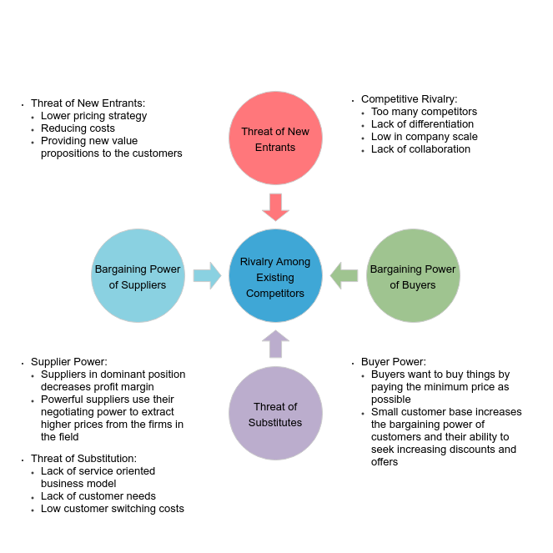
Figure 3: The depiction of Porter's Five Forces Model in the car manufacturing company.
(Source: Ariffin and Sahid, 2018)
Bargaining power of the suppliers
The bargaining power of the suppliers is considered adequately low in contrast to that of the buyers. The suppliers cannot pose a threat of forwarding integration as the availability of the raw materials is plenty while the size of the suppliers is small. Hence the companies do not hesitate in switching from one supplier to another as resources are sufficient in availability.
The threat of substitute commodities
The substitutes considered against the private or commercial cars are train, aircraft, buses and three-wheeled vehicles. These cannot provide the level of comfort which is provided by the cars. Hence the threat from the commodities in substitute is considered low.
Competitive rivalry in the market
The competition among the manufacturing companies is substantially high with the intense and influential competitors (Ferràs-Hernández et al. 2017). The rivalry is evident in the R&D, digitalisation and marking the presence of the competitors in the international market.

Discussing the Product Life Cycle of the manufacturing industry and positioning while gaining competitive advantage
The product life cycle is determined by the stages through which the models of the cars are introduced and exited. The introduction phase of the various models of the cars enjoys a monopoly market as the product launched is new with the latest technology and built. The growth phase enjoys better sales of the models with reasonable pricing strategies. Here the competition grows intense (Kovács and Petunin, 2016). The maturity stage shows the start of saturation in the sales of the models, while profit starts dipping low. The decline stage reflects the outdated models are recalled, and the companies take the decision on remodelling or restricting the models with advanced technology. The value-added segment positioning of the cars in the present scenario is recommended to gain a competitive advantage over other firms.

Critical evaluation of the reasons for engaging in car manufacturing organisations in international trade
Internationalisation of the car manufacturing industry has its advantage and disadvantage. As criticised by Thomas, (2019), local selling in the nations of the U.K. and U.S. has been slumped due to BREXIT and the recent outbreak of coronavirus. The last few years the industry has witnessed tumults due to less credit offered by financial institutions to the manufacturers, unemployment in the nations, less demand for private vehicle owing to climate changes, and emission disasters affecting the sales that dipped to 7% in the U.K. in 2018 (Pavelink, 2020). The biggest market in China has witnessed a slump in the economic growth that possibly affected the international trade of car manufacturers across the globe.

Conclusion
In conclusion, it may be portrayed that the models are used to present the current market scenario and the changes witnessed in the functioning of the companies are majorly influenced by the macro and microenvironment elements of the market. The tools used for measuring the competitive advantage gained by the industry supports the growth and development of the existing companies in the cutthroat competition.

References
Abdi, K., Mardani, A., Senin, A.A., Tupenaite, L., Naimaviciene, J., Kanapeckiene, L. and Kutut, V., (2018). The effect of knowledge management, organisational culture and organisational learning on innovation in automotive industry. Journal of Business Economics and Management, 19(1), pp.1-19.
Andriantsiferana, K.M., (2019). Decarbonising the global supply chain: Which fuel alternative should shipping companies turn into a feasibility study of the implementation of biofuels.
Ariffin, A.S. and Sahid, M.L.I., (2018). Competitiveness analysis of ASEAN automotive industry: a comparison between Malaysia and Thailand. Journal of Science, Technology and Innovation Policy, 3(2).
Bhatia, J., (2016). Porter's Five Forces Industry Analysis of Indian Passenger Car Industry. Pacific Business Review International, 8(7), pp.113-123.
Chodakowska, A., (2018). The mobility revolution in the automobile industry. Electric cars and battery management.
Coe, N.M. and Yeung, H.W.C., (2019). Global production networks: mapping recent conceptual developments. Journal of Economic Geography, 19(4), pp.775-801.
Covarrubias, A. and Perez, S.M.R. eds., (2019). New Frontiers of the Automobile Industry: Exploring Geographies, Technology, and Institutional Challenges. Springer Nature.
D'Costa, A., (2016). Institutional change, industrial logics, and internationalisation. dans Begley J., Coffey D., Donnelly T. & Thornley C.(dir.), Global Economic Crisis and Local Economic Development: International Cases and Policy Responses, New York: Routledge, pp.95-119.
Ferràs-Hernández, X., Tarrats-Pons, E. and Arimany-Serrat, N., (2017). Disruption in the automotive industry: A Cambrian moment. Business horizons, 60(6), pp.855-863.
Ford, J., (2017). Profiting From Brexit: Mclaren Shifts Supply Chain Back To The UK. [online] Ft.com. Available at: https://www.ft.com/content/b3d67800-9475-11e7-bdfa-eda243196c2c [Accessed 12 August 2020].
Fulthorpe, M., (2019). [online] Cdn.ihs.com. Available at: http://cdn.ihs.com/www/pdf/AUT-TL-WhitePaper-5.pdf [Accessed 12 August 2020].
Grinsteins, G., (2018). Room For Growth In A Time Of Uncertainty: The U.K. Luxury Automotive Industry And Brexit.
Kotabe, M.M. and Helsen, K., (2020). Global marketing management. John Wiley & Sons.
Kovács, G.L. and Petunin, A., (2016). An information technology view of manufacturing automation-product life-cycle management. Pollack Periodica, 11(2), pp.3-14.
Laju, P., (2019). A STUDY TO ANALYSE GREEN MARKETING CONCEPT IN AUTOMOBILE INDUSTRY. Journal of the Gujarat Research Society, 21(8), pp.223-233.
Parra, D.C., De Sá, T.H., Monteiro, C.A. and Freudenberg, N., (2018). Automobile, construction and entertainment business sector influences on sedentary lifestyles. Health promotion international, 33(2), pp.239-249.
Pavlínek, P., (2020). Restructuring and internationalisation of the European automotive industry. Journal of Economic Geography, 20(2), pp.509-541.
Thomas, D., (2019). Five Reasons The Car Industry Is Struggling. [online] BBC News. Available at: https://www.bbc.com/news/business-48545733 [Accessed 13 August 2020].

