

Student name: Abdulai Kamara
Student ID: 2328050
Module name: Changemakers: Building Your Personal Brand for Sustainable Employment
Module code: BMHP5015
Lecturer name: Caroline Salami
Submission Date: 5th December 2025 14:00 (2PM)
Component 1: Assignment (Portfolio)

Table of Contents
Introduction 3
Reflection on Unit 1: Brand You 3
Who I am and what I stand for 3
Ambition and motivation 3
Skills to practise and evidence 3
Evidence from online activities 4
Reflection on Unit 2: It’s a Small World 5
Understanding networks and culture 5
Building external links 5
Digital presence and professional conduct 5
Evidence from online activities 6
Reflection on Unit 3: Opportunity Knocks 7
Seeing and creating opportunities 7
Stretch goals and planning 7
Presenting value 7
Evidence from online activities 8
Reflection on Unit 4: The Pursuit of Happiness 9
Resilience and mindset 9
Handling setbacks and change 9
Mentors and role models 9
Evidence from online activities 10
Conclusion 10
References 11

Introduction
This assignment offers a new reflection on four units from the Changemakers module and explains how they shaped my personal brand for a future role as a Social Prescribing Link Worker. This role supports people to improve daily life by linking them with local activities, advice services, and practical help. It fits my strengths in patient listening, simple clear communication, and careful planning. In the pages that follow I set out what I learned about ambition and motivation, flexible careers and skills, community networks, and the habits that protect wellbeing. I will describe how these ideas became action and how they now guide my next steps. I keep a natural tone, use plain words, and focus on what I can do in real settings.

Reflection on Unit 1: Brand You

Who am I and what I stand for
Unit 1 helped me write a short and honest description of the worker I want to be. I value dignity, inclusion, and patience. I believe small steps done well can lead to big change. I bring a calm manner, friendly style, and tidy notes. I also know where I need to improve. I can hesitate when tasks feel vague, and I sometimes take on too much in order to please everyone (Melam, 2024). To manage this, I ask for clear outcomes, set simple time limits, and give regular updates on progress. These choices reduce stress and help others to trust me.

Ambition and motivation
My ambition is to support people to take control of the social side of health. I want to help someone join a walking group, speak with a debt adviser, or find a safe place to meet others. These are modest aims on paper, but they can transform mood, routine, and hope (World Health Organization, 2022). To move from passion to practice I wrote a SMART goal. Within twelve months I will gain a Social Prescribing Link Worker post or a trainee role within a primary care network. I will measure progress each month by the number of applications, interviews, shadowing hours, and new skills. The goal is realistic because I am building the right habits and evidence (Bertotti, 2024). It is relevant to my values, and it is bound by time with monthly reviews.

Skills to practice and evidence
I chose three daily skills to practice for twenty minutes each weekday. First, active listening with short summaries at the end of a call. Second, motivational style questions that respect choice and pace. Third, safe record keeping is factual, kind, and useful to the next reader. I use short role plays to rehearse common situations such as first calls, follow up checks, and closing a case. I rewrite notes until they are simple and specific. I ask the person to reflect back what they heard to test my summary (Oster et al., 2023). I also track proof of progress, such as feedback from peers, checklists from tasks, and short reflections that show what I changed and why.

Evidence from online activities
Figure 1 shows my values grid with linked actions.
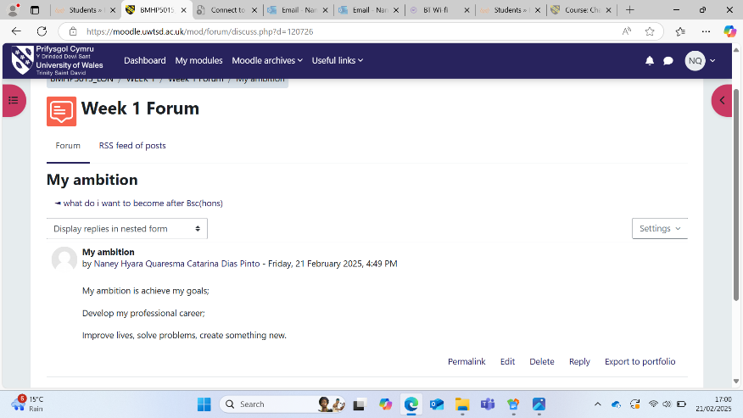
Figure 2 shows my SMART goal with monthly milestones.
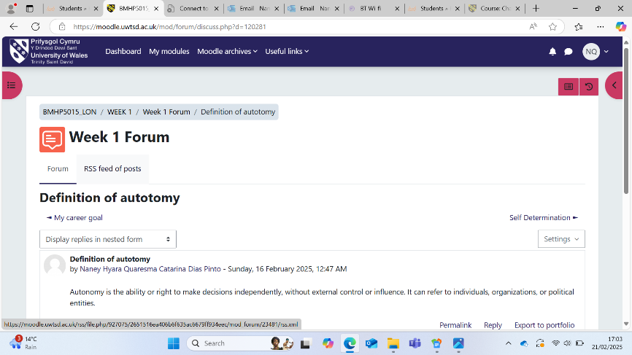

Figure 3 shows a short script I use to practice end of call summaries.
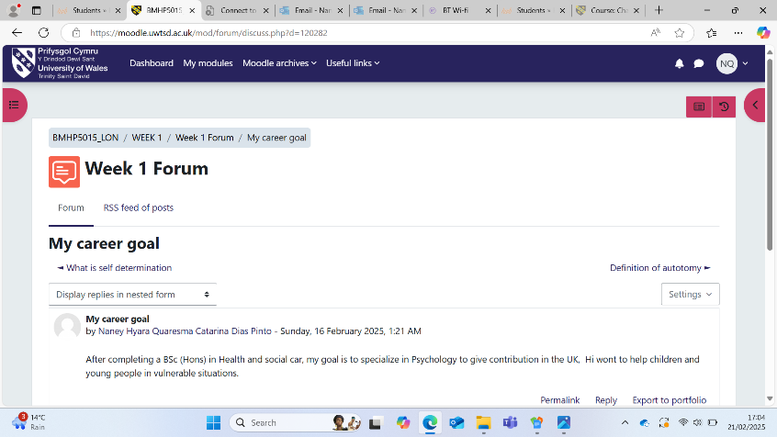

Reflection on Unit 2: It’s a Small World

Understanding networks and culture
Unit 2 changed my view of networking. A network is not a list of contacts. It is a living web of relationships that grow through service and trust. I mapped the people and groups I may work with in a local area (Dacre-Pool, 2020). I included GPs, practice managers, care coordinators, community nurses, social workers, housing officers, librarians, faith leaders, sports clubs, food projects, colleges, and advice lines. I looked at how language, identity, and culture shape access. I practiced open questions that do not lead the person. I learnt to check understanding and to use interpreters or advocates when needed. I also reflected on power and voice (NHS England, 2023). A warm welcome and plain words help people feel safe enough to take the first step.

Building external links
I created a weekly outreach routine. Each week I learn about one local service and connect with a named contact. I record what they offer, who they support, how to refer, and any access rules. I check transport routes and cost. I note barriers such as digital sign up or long waits and write down tested workarounds. I prepare people before a referral, so they know what to expect. Over time this builds a practical library of options (Ghosh et al., 2021). It also makes me more confident during conversations because I can suggest choices that fit the person’s needs, budget, and location.

Digital presence and professional conduct
Modern networks include online spaces. I reviewed my profile, so it is neat, respectful, and useful. I added a short summary that explains my aim and values. I listed skills that matter in this work, such as conversation tools, data handling, partnership work, and safeguarding awareness. I removed anything that could confuse or harm. I follow a simple rule (NHS England, 2020). If I would not say it in a clinic or a community hall, I will not post it online. This protects trust and supports a steady professional identity.

Evidence from online activities
Figure 4 shows my relationship map with key partners.
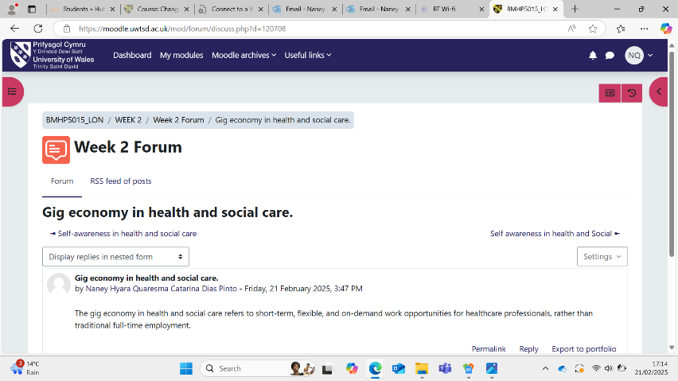
Figure 5 shows a reflection on a community meeting with two clear actions.
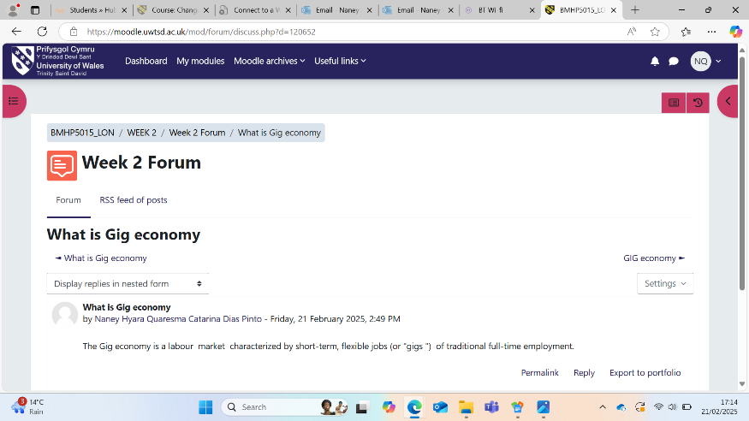
Figure 6 shows a before and after view of my online summary and skills section.
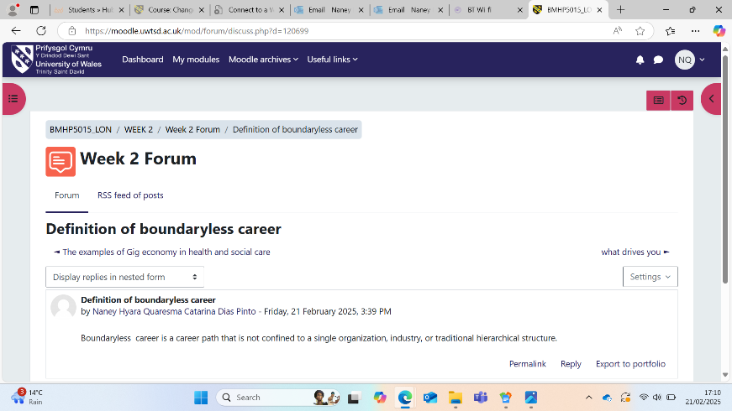

Reflection on Unit 3: Opportunity Knocks

Seeing and creating opportunities
Unit 3 taught me to notice small openings and take the next right step. I built a weekly plan that includes study, outreach, job search, and rest. I keep a pocket card with prompts that help me start good conversations. I ask what helps a person feel heard. I ask which local group they trust and why. I ask what a realistic first step would be for them this week. These prompts turn brief meetings into learning moments (Ivziku et al., 2021). I wrote three clear messages to request shadowing, and one led to a morning with a community team. I observed first calls, saw how consent was recorded, and learned how the team closed a case with care.

Stretch goals and planning
I set a stretch goal to design a ten-minute briefing on social prescribing for a student group. I wanted to explain what the role is and what it is not. I wrote three core points. I prepared one short story that shows a safe and ethical approach. I practiced until my timing was smooth and my tone was calm. I asked for feedback and made changes. The task took courage, but it lifted my confidence and sharpened my message (Weller et al., 2024). I also updated my study routine. I blocked time for reading policy, time for practicing scripts, and time for rest. This balance helps me show up with energy and focus.

Presenting value
We explored how to present value without overselling. I updated my CV and made a one-page profile. It includes a clear personal statement, a skills list, two brief examples of impact, and a simple values section (Mulfiyanti and Satriana, 2022). I chose evidence that fits the Link Worker role. One example is a small project that linked a student to a peer group and reduced isolation. Another is a resource sheet I built for a family under financial stress which helped them reach the right adviser. I also wrote down my top work values and how they show up in action (Kolb, 2015). Respect appears as careful listening and plain words. Safety appears as clear consent and tidy notes. Reliability appears as doing what I said I would do.

Evidence from online activities
Figure 7 shows my weekly plan with time blocks for outreach and rest.
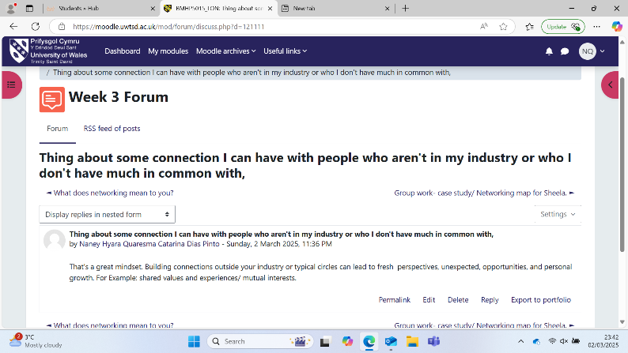
Figure 8 shows the outline for my briefing with speaking notes.
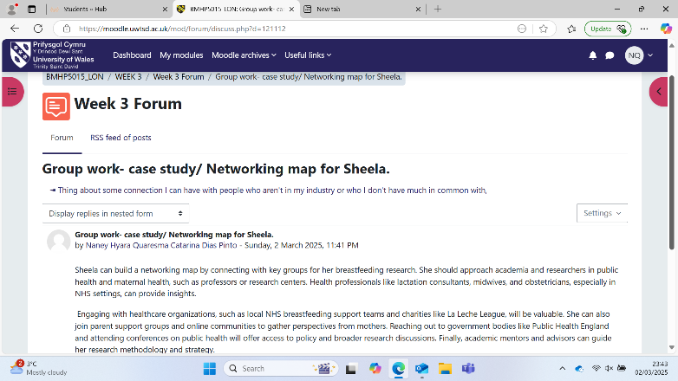
Figure 9 shows my one page profile with examples and values.
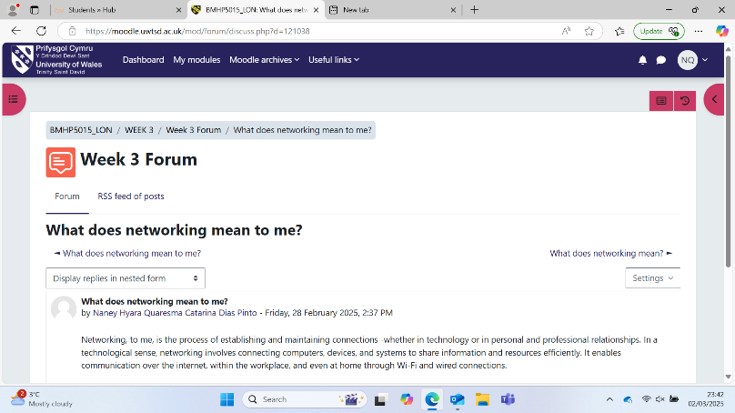

Reflection on Unit 4: The Pursuit of Happiness

Resilience and mindset
Unit 4 focused on resilience and healthy routines. I began by spotting beliefs that hold me back. One thought said I must fix every problem at once (Min et al., 2021). This left me tense and tired. I replaced it with a fairer view. My job is to listen, guide, and connect. I can offer steps and support. The person owns their choices. This shift eased pressure and improved the quality of my conversations (Tortosa-Alted et al., 2021). I set a daily rhythm to protect energy. I sleep at regular times, prepare food, drink water, and take brief walks. I use start and end of day checklists so that I open and close my study time with care.

Handling setbacks and change
I wrote a three-step plan for difficult days. First, I pause and name how I feel. Next, I write what happened in clear words (Miller and Rollnick, 2013). Then I chose one lesson and one action. I tested this after a practice call where I rushed the summary. I took a breath, reviewed my notes, and set a timer for future calls. The next day my pacing was much better. I also prepared for change. New services and tools appear often. I set aside weekly time to learn one process or map one new service (McCormack and McCance, 2017). I keep a simple index of what I have learned. This makes it easier to share knowledge with colleagues and keeps my practice fresh.

Mentors and role models
Guidance speeds up growth. I listed people I admire and what they do well. I wrote to two contacts to ask for advice on first roles and training. One offered a short call. We discussed boundaries, safeguarding, and how to avoid promising results that are outside my control. They encouraged me to keep a folder with evidence of learning and to reflect after hard conversations (Rapo et al., 2023). I now hold a monthly review where I record what worked, what was hard, and what I will try next. I share one insight with a peer so we both improve.

Evidence from online activities
Figure 10 shows a journal note where I reframed an unhelpful thought.
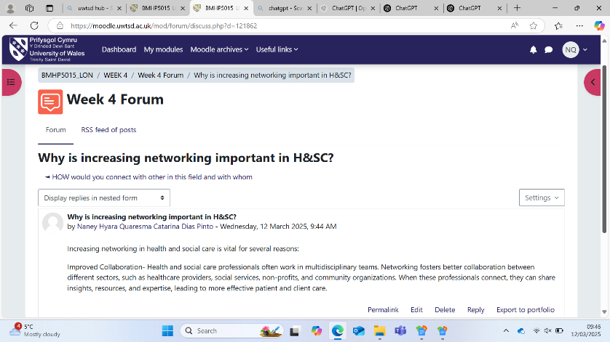
Figure 11 shows my daily rhythm with start and end of day checklists.
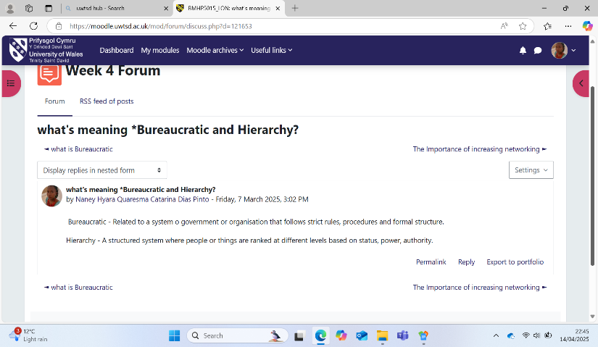

Conclusion
Across these four units I shaped a personal brand that fits the work of a Social Prescribing Link Worker. Unit 1 helped me define who I am, set a SMART goal, and build daily practice. Unit 2 helped me grow a living map of partners and improve my cultural awareness and online presence. Unit 3 helped me turn small openings into next steps, design a stretch task that lifted my voice, and present value with modest confidence. Unit 4 helped me protect energy, handle setbacks with a steady plan, and seek guidance when I need it. Together these lessons give me a simple promise to carry into practice. I will listen with respect, act with care, record with clarity, and keep my word. My next steps are to finish my program, keep weekly outreach, and apply for Link Worker or trainee posts in local networks. I will attend community meetings to learn about barriers and opportunities. I will maintain my daily rhythm and monthly reviews so that progress builds over time. In this way my personal brand is not a slogan. It is the pattern of actions that others can recognise and trust.

References
Bertotti, M. (2024). Social Prescribing Policy, Research and Practice. Springer Nature.
Christiana Melam MBE (2024). The Social Prescribing Link Worker Model. Class Professional Publishing.
Dacre-Pool, L. (2020). Revisiting the CareerEDGE model of graduate employability. Journal of the National Institute for Career Education and Counselling, [online] 44(1), pp.51–56. doi:https://knowledge.lancashire.ac.uk/id/eprint/33178/10/33178%20NICEC%20CareerEDGE%20article%20April%202020%20%28FINAL%29.pdf.
Ghosh, S., Ramamoorthy, L. and Pottakat, B. (2021). Impact of structured clinical handover protocol on communication and patient satisfaction. Journal of Patient Experience, 8(1), pp.1–6. doi:https://doi.org/10.1177/2374373521997733.
Ivziku, D., Ferramosca, F.M.P., Filomeno, L., Gualandi, R., De Maria, M. and Tartaglini, D. (2021). Defining nursing workload predictors: A pilot study. Journal of Nursing Management, 30(2), pp.473–481. doi:https://doi.org/10.1111/jonm.13523.
Kolb, D. (2015). Experiential learning: Experience as the source of learning and development. 2nd ed. Upper Saddle River, New Jersey: Pearson Education, Inc.
McCormack, B. and McCance, T. (2017). Person-centred Practice in Nursing and Health Care: Theory and Practice. 2nd ed. Wiley Blackwell.
Miller, W.R. and Rollnick, S. (2013). Motivational interviewing: Helping people change. 3rd ed. London ; New York: The Guilford Press.
Min, A., Hong, H.C. and Kim, Y.M. (2021). Work schedule characteristics and occupational fatigue/recovery among rotating‐shift nurses: A cross‐sectional study. Journal of Nursing Management, 30(2). doi:https://doi.org/10.1111/jonm.13511.
Mulfiyanti, D. and Satriana, A. (2022). The Correlation between the Use of the SBAR Effective Communication Method and the Handover Implementation of Nurses on Patient Safety. International Journal of Public Health Excellence (IJPHE), 2(1), pp.376–380. doi:https://doi.org/10.55299/ijphe.v2i1.275.
Rapo, E., Johansson, E., Jönsson, F., Åsa Hörnsten, Anna Sofia Lundgren and Nilsson, I. (2023). Critical components of social prescribing programmes with a focus on older adults - a systematic review. Scandinavian Journal of Primary Health Care, 41(3), pp.326–342. doi:https://doi.org/10.1080/02813432.2023.2237078.
Tortosa-Alted, R., Reverté-Villarroya, S., Martínez-Segura, E., López-Pablo, C. and Berenguer-Poblet, M. (2021). Emergency handover of critical patients. A systematic review. International Emergency Nursing, 56(1), p.100997. doi:https://doi.org/10.1016/j.ienj.2021.100997.
Weller, J.M., Mahajan, R., Williams, K.F. and Webster, C.S. (2024). Teamwork matters: Team situation awareness to build high-performing healthcare teams, a narrative review. British Journal of Anaesthesia, 132(4), pp.771–778. doi:https://doi.org/10.1016/j.bja.2023.12.035.
NHS England (2020). Personalised Care Social prescribing and community-based support Summary guide. [online] Available at: https://www.england.nhs.uk/wp-content/uploads/2020/06/social-prescribing-summary-guide-updated-june-20.pdf?utm.
NHS England (2023). NHS England» Workforce development framework: social prescribing link workers. [online] England.nhs.uk. Available at: https://www.england.nhs.uk/publication/workforce-development-framework-social-prescribing-link-workers/?utm.
Oster, C., Skelton, C., Leibbrandt, R., Hines, S. and Bonevski, B. (2023). Models of social prescribing to address non-medical needs in adults: A scoping review. BMC Health Services Research, [online] 23(1). doi:https://doi.org/10.1186/s12913-023-09650-x.
World Health Organization (2022). A Toolkit on How to Implement Social Prescribing. [online] World Health Organisation. Available at: https://www.who.int/publications/i/item/9789290619765.

