

Graduate Diploma in Professional Police Practice

LEVEL 6 - 40 Credits

Workbook title: Competency Based Workbook 1 (DHEP)

(SOUTH WALES POLICE, GWENT POLICE AND UWTSD)

Learner name: Sally Jones

Learner’s University Registration Number: 1922464

FACULTY OF BUSINESS AND MANAGEMENT
PUBLIC SERVICE PROGRAMME

Module title: Policing in the Workplace 3 (DHEP)
Workbook Guidance

Please read these notes carefully; they provide essential information.

What is the workbook for?

The purpose of this workbook is to enable learners to demonstrate and provide evidence of how they meet the learning outcomes set by the College of Policing, for the Graduate Diploma programme. Essentially, you are being asked to outline your experiential learning based upon your theoretical understanding in a range of operational situations.

Area of Professional Practice covered, (called elements in your module descriptor):

- Wellbeing and Resilience
- Communication Skills
- Managing Conflict
- Valuing Difference and Inclusion
- Criminal Justice
- Decision making, discretion
- Conducting Investigations
- Criminal Justice (Managing offenders)
- Problem Solving
- Evidence Based Policing
- Maintaining Professional Standards
- Public Protection.

You may wish to use the same incidents as you’ve outlined in the Occupational Competence Portfolio.

How should the workbook be presented?

Blank electronic copies can be found on Moodle of this workbook. You must submit this document electronically therefore it is important that you save your work regularly and upload the final typed version through Turnitin on Moodle.

Word count policy can be found in chapter 7 of the Academic Quality under section 7.7 (this applies to presenting work above and under the specified word count).
(https://www.uwtsd.ac.uk/media/uwtsd-website/content-assets/documents/academic-office/aqh-chapters/chapters---en/Chapter_07_Assessment_Taught_Programmes_Pages_72-79-UPDATED-05-11-2019.pdf)

Reflective practice is a core aspect for your workbooks and although there is a variety of useful resources on Moodle, there is one particular book, that is specifically based on reflective practice in policing, here is a link to one chapter from Selina Copley’s Reflective Practice for Policing Students:
https://moodle.uwtsd.ac.uk/pluginfile.php/298870/mod_resource/content/1/Reflective%20Practice%20for%20Policing%20Students%20-%20Selina%20Copley%20Chapter5.pdf

How is the workbook assessed?

Advice and support about the completion of this workbook will be provided by university staff as part of your initial training day. Your tutor constable and in-force training staff will not be involved in assessing or marking your workbook after it has been submitted.

Dates of workbook submission will be made available during the initial training day and posted on Moodle.

Once submitted your workbook will be assessed and marked independently.

Confidentiality

It is important that no individual can be identified either directly or indirectly from the information in the workbook. Therefore, you must:

- adhere to guidance in the Student Handbook about unfair practice and plagiarism;
- not identify individuals including witnesses, victims or offenders by name;
- not write information that enables any individual to be identified indirectly through the description you provide. This includes references to names, colleagues, places (including hospitals, schools, town, villages, streets) specific incidents which were high profile and could be identified due to past publicity, other professionals or any other personal information including medical or other conditions;
- take personal responsibility for adhering to confidentiality rules.
- not include any dates of any incidents or anything that specifically identifies an actual incident.

NOTE

Your workbook will be submitted electronically via Turnitin on Moodle. Guidance on this is in the Student Handbook.

Remember that the workbook is YOUR responsibility you must not rely on the assessor or anyone else to pick up any confidentiality breaches as this is your work and you must accept full responsibility for confidentiality. Meeting all the confidentiality requirements is very important.

Dyslexia and other special circumstances

If you have any condition that you feel may affect your ability to deal with any part of the programme, please see the Student Handbook for further guidance. The University has a Student Services Unit that may be able to help but it is the learner’s individual responsibility to contact them.

Guidance:

- Your workbook must contain the items specified in the table below (clearly identified and in the order given);
- You should use this particular document to insert your text / answer within each section of this workbook;
- You should upload your completed document as a saved pdf file of this workbook; if this is not possible then a Worddoc file is acceptable. Do not send a scanned file from a photocopier, an apple.dot file or a Microsoft publisher file as Turnitin will not be able to assess them, despite you being able to upload them.

Contents

Workbook | Area of Professional Practice | Word count
Task 1 | Wellbeing and Resilience | 1500
Task 2 | Communication Skills, Managing Conflict, Valuing Difference and Inclusion | 2500
Task 3 | Criminal Justice, Valuing difference and inclusion | 2500
Task 4 | Decision making and discretion, Conducting Investigations and Criminal Justice (managing offenders) | 2500
 | Bibliography
Task 5 | Development Plan | Equivalent to 500 words
Task 6 | Recognition and confirmation of the progress of your Occupational Competency Portfolio (OCP) | Equivalent to 500 words
Confirmation of Confidentiality and Plagiarism
Confirmed by submission through `Turnitin

Task 1

Relevant areas of the National Policing Curriculum:
Developing Resilience

Guidance:

Focussing on your initial 6 months of learning and since being attested as a Police Constable, discuss and compare the coping strategies you have applied to develop resilience and minimise stress.

1500 words (+/- 10%: include your actual word count at the end of each section)

In this essay I am going to discuss and compare the coping strategies I have applied to develop resilience and minimise stress since being attested as a Police Constable. I will also be discussing what I have personally found to be beneficial in minimising stress and building resilience but also what I have not found to be very beneficial. Whilst writing this essay, I am going to refer to Borton’s development framework model (Borton 1970).

Our bodies respond to stress as it recognises any change, threat, or pressure put upon it, externally or internally. (Hans Selye, 1957)

Initially the thought of sitting in a classroom for six months was fairly daunting as I have always had active job roles including, waitressing and personal training prior to joining South Wales Police. The pace of learning in class was quick and intense, which could become overwhelming at times. I also had to consider ensuring that I made time for extra learning and revision at home to prepare for the exams, which was essential in passing the course. In addition to this, part of the training was to partake in practical days where we were put on the spot to demonstrate our newly learned knowledge as well as showcasing our reactive skills and common sense.

The training also took part in lockdown due to the covid-19 pandemic. This was a worry for me as I am a visual learner and have found that I like to be taught by other’s referring to personal encounters, to make the context visual. It was daunting knowing I would have to teach myself and plan my day to fit around the lessons, and not to spend too much time on one topic.

I was experiencing more academic activity than usual so I would often feel tired and stress that I would not have enough time to complete my work and revise. A positive from lockdown was that it enabled me to work and revise without the usual distractions from outside life, which I found to work in my advantage. After some failed attempts of taking too long on one subject or not planning my day better, I learned how to manage the workload. I believe experiencing failures is what’s key in developing resilience.

One coping mechanism I use and is a very important factor to reducing my stress is exercise, so I knew I would need to introduce this into my new schedule. Luckily I find myself to be a very motivated and a determined person when it comes to exercise. I maintain this determinism as I know that the aftermath rewards I feel after exercise is greater than the thought of doing it.

Since joining training I had to use my time more wisely. I qualified as a personal trainer a few years ago and by having this knowledge, it taught me how to train more efficiently, so I could plan a schedule around my new timetable. This helped me immensely as being rushed for time is one of my biggest stress triggers.

Scientific evidence supports the notion that exercise has a huge benefit to a person's mood. Research shows that it can effectively treat depression to a similar level as medication. Furthermore someone who regularly exercises can expect to feel a decrease in any stress, anxiety or even hostility that they may be suffering from. (Otto and Smith, 2011)
I believe the body can produce natural methods of achieving better mental health, and exercise is the main ingredient. Exercise has proven to release endorphins and to reduce cortisol levels in the body, which is a stress hormone. I definitely feel the mental effects exercise has on the body by feeling uplifted, energised and generally happy when I have completed a workout.
During and after a person has exercised studies have shown that the body will release endorphins and importantly also reduce the level of cortisol in the body. Cortisol is a stress hormone produced by the body and the correct regulation of this hormone is vital to a person's health and wellbeing both physically and mentally. (Esposito, A., Bianchi, V. 2012)

Numerous studies have produced evidence that concentrated serums of endogenous opioids increase in response to a person undertaking a training or exercise programme. This is especially seen clearly in B-endorphin and B-lipotrophin (Harber, V and Sutton, J 2012).

Since being in training with gyms closed, I have found many different exercises that work for me and are therapeutic. This includes weight training, HIIT (which stands for high intensity interval training) and going for a simple walk in the fresh air.
Simply opting for walking instead of transport will keep your brain healthier in the long run. (Williams, R. 2020).

I have also learned that I like to exercise before I begin my day as I am more alert and energised. As exercise releases tension, anger and stress, it allowed me to start the day in a positive mood. A coping mechanism I have found is that I like to punish myself in order to feel better as it feels like I have done conquered something difficult and won.

A negative to training can be the use of over training. This means when you train too often or too intensely and can actually do your body more harm than good. Over training can leave someone feeling, exhausted, deflated, suffering muscle soreness and potentially have an injury. Overtraining can increase the production of cortisol in the body, resulting in inducing the body with more stress than it previously had. (Urhausen, A., Gabriel, H., Kindermann, W 1995)

At the beginning of training, I found I was guilty of over training and it left me feeling more stressed and tired. Luckily I realised this quickly and adapted what I was doing. I have learned that I put a lot of pressure on myself and push myself too hard sometimes. Being able to limit myself whilst still maintaining training and a working life is challenging but it is essential not to become overworked which leads to a very high amount of stress.

Another addition into reducing my stress is nutrition. I have experimented with diet and I have found that if I have consecutively healthy ’good’ days, I have a lot more energy and find myself to be more productive. If I have a ‘bad’ day, which includes an unhealthy over use of saturated fats and sugars, I find myself to be lethargic and not feeling myself. There are many foods that are proven to help with reducing stress. I believe this contributes not only physically on the body, but mentally, especially for me as a big stress trigger for me is guilt. Whilst in training the repeated schedule, allowed me to maintain a healthy diet.

Other experiments I have tried have been yoga and using the mindfulness app which is another form of meditating. These were not as beneficial to me as I am more of an active person and find it difficult to relax. Even though I have attempted other things, I have stuck with what works well for me but adapted it slightly. This is all a part of trial and error and getting to know yourself.

As I reflect on my time in training, I look at Borton’s development framework (1970). Borton’s development framework is a fairly simple reflective model that asks three questions. Those questions are ‘what? So what? And now what?’ These are good questions to ask yourself to learn from a situation.

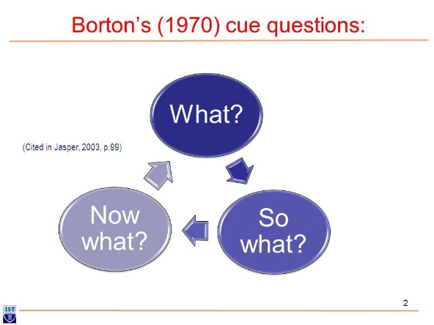
Figure 1: Borton’s Development Framework (Jasper, M 2003)

This model allowed me to reflect on:
- My coping mechanisms and ask myself how did I apply or change these in training to reduce stress and build resilience.
- What went well and what did not and how do I learn from this? And,
- What do I need to do moving forward and taking these learning experiences with me out on division?

I believe in the saying “If at first you don’t succeed, try, try, try, again” (Hickson 1836). By experiencing setbacks in my life and former careers, I have had to re assess and persist. I have always had to work hard for what I want to accomplish, and things have never been given to me without earning them. I believe this the reason I succeeded in the application process and the initial 6 months of training as these were a true test of resilience.

Resilience is a very important trait to have as a police officer, as I will expect to be tested many times, whilst learning through mistakes and frustrating moments. Police officers must have resilience as we will face difficult challenges and trying moments which all need to be dealt with professionally by achieving the best possible outcome, or the side effects could be detrimental. Resilience is a strength that most people can develop through practice and experience. (Flach, Flynn and Sciortino, 2020).

In conclusion, I have trialled varied tactics in attempting to and minimise stress and develop resilience. I have had to adapt old approaches and try new ones. Some have worked out well for me, like the training I have mentioned, and some not so much, like meditating. I found that classroom training was overwhelming at times, so I had to try to not jump too far ahead and instead, handle what was directly in front of me. I considered this approach after experiencing stress through overthinking and making things a lot worse than they were. I will continue to use exercise as my main coping mechanism when dealing with stress as it’s proven to work for me, but must be careful not to over train. I have always learned from mistakes and setbacks. I believe this moulds people into a stronger person and I am sure this will definitely help me throughout my career.

Word count: 1641

Task 2

Relevant areas of the National Policing Curriculum:
Communication Skills, Managing Conflict, Valuing Difference and Inclusion

You must choose a policing incident involving conflict in which you played a significant role with an offender/service user/victim and reflect on what happened.

Critically assess the incident including social and legislative contexts and any relevant cultural, ethnicity and language issues.

Reflect on your application of the fundamental elements of effective communication used (verbal, non-verbal, active listening skills, open and closed questions, building rapport and negotiation skills).

Describe the process for determining whether the use of force was necessary in a conflict situation (including a critical evaluation of any theories or models underpinning the causes of conflict within policing interventions – e.g. Betari’s Box, The Drama triangle, Emotional versus rational brain) and provide a reflection on the outcome of the incident.

Your reflection must illustrate your understanding and application of core principles of ethics, equality, diversity and human rights, as well as any relevant Code of Practice considerations, culturally sensitive practice and language preference.

2500 words (+/- 10%: include your actual word count at the end of each section)

ANSWER:

In this essay I am going to discuss a policing incident that I participated in involving conflict. I will explain the situation, what actions were considered and taken, the outcome and reflect on what went well and what could have been better. In this essay I will be referring to Betari’s Box, the CUDSA Model, the Five Step Appeal Model, and the Gibbs Reflective Cycle Model (1988) to further explain my thought process during conflict and to reflect on the incident.

Officers responded to an incident where a female reported that her partner had stabbed her in the face with a pen knife. Upon arrival the female was outside of her flat in hysterics. She was shouting, visibly upset and appeared to be in pain. Officers approached the ‘victim’ cautiously and sensitively whilst trying to dissect important information. The female was intoxicated and upset so it was difficult to understand what she was attempting to communicate. We patiently allowed the ‘victim’ to tell us what happened, whilst attempting to calm her down by comforting her and listening to what she was trying to say. After the female had informed officers what had happened, my colleague and I decided to enter the flat to speak with the ‘suspect’ involved, while our other colleague waited outside with the female.

Upon entering the flat, it was evidentially visible that this call was not as it first appeared. The flat was covered in blood and so was the male inside, (who the caller initially named the suspect). It was identified that he suffered a serious injury to his head. Officers spoke with the male and he informed us that it was in fact his partner who assaulted him. He told officers that they had been drinking alcohol together and gotten into an argument, which resulted in the female hitting the male over the head with a bottle of vodka. The bottle of vodka had smashed and cut the male’s head open. It was important for officers to adapt quickly and be professional by not displaying to the male that there were any pre conceived judgements or unconscious bias after the call suggested he was the suspect.

Officers asked the male many open questions like “Where were you hit?” “What else happened?” “Why do you think this happened?” We did this not only to establish the truth and get as much detail as possible from the incident, but also to see if the male was able to communicate properly after experiencing a head injury. The male appeared confused and dazed but he also disclosed he was partially deaf. This made communicating slightly more difficult as it was imperative to ensure he was ok. Officers had to adapt quickly again to ensure the male felt comforted and understood what we were saying. Officers had to speak calmly and slowly and be mindful that the male had hearing difficulties, especially given the government guidelines of wearing a face covering. Officers clarified with the male if he was comfortable speaking English and was told to interrupt us if he needed anything repeated.
With an injury this severe, time was crucial but it was important not to startle the male and to remain calm and patient whilst communicating with him. Officers used hand gestures to explain to the male as well as speaking loudly and clearly without sounding panicked. We used relaxed body language ensuring not to cross our arms or appear hostile as this could give the male anxiety and distrust. We ensured to ask open questions to keep the male talking, but when he was starting to phase out, we would change these to more closed questions where he could quickly answer ‘yes or no.’

Officers rang an ambulance. The male was intoxicated and believed his injuries were not as serious as they were, and asked officers if he could be left alone. Officers had to convince the male that we had to stay with him and informed him that he would need to go to hospital. Even though the male was within his human rights (Human Rights Act 1988) to decline, officers knew if he would not cooperate, he could potentially die from his injuries. Tactical communications played a vital role in the incident to ensure this would not happen. Officers took a sympathetic but assertive approach with the male and informed him that we could not, under any circumstances leave him or not seek medical help.
Officers helped the male to locate his belongings as he was struggling with the pain. Whilst this was helping the male, it was a tactic to build trust with him to ensure he would agree to go to hospital, as his safety was the main priority. Once the male was communicating, I wanted to allow him to continue talking to build rapport with him. I considered nonverbal (like head nodding and hand gestures) and paraverbal techniques (like the use of “uh-huhs”) showing him that I was listening and not to talk over him. This is a good tactic to allow persons to know you value what they are saying and it is a good attribute to building rapport. Rapport is crucial in managing conflict in policing as it humanises a police officer, making them more relatable to the persons, to build trust and to cooperate with them.
The male opened up to officers, telling us that his partner has done this far too many times and could not defend her any longer. Officers reassured and supported the male in his decision. We were honest and direct with him that this could happen again if he allowed it, which I believe he respected. The male kept apologising to officers for the inconvenience, but we ensured him that he did not need to. By being open and direct and treating the male with respect, it built a rapport with him and it was clear he was grateful for officers’ help. As a result of this, the male agreed to go to hospital.
I had to inform my other colleague (who was outside with the suspect) of the events. Whilst mindful of the public gathered outside, I quietly informed our colleague of the situation by considering the sensitive information being disclosed. Officers then decided to arrest the female on suspicion of causing Grievous Bodily Harm (section 18 of the Offences Against the Person Act 1861.) Powers used in her arrest were section 24 of the Police and Criminal Evidence Act 1984, Code G. As soon as the suspect was placed in handcuffs, she immediately started screaming and resisting. We tried to calm the suspect down and inform her the reasons for the arrest and what steps officers had to take in doing this.

Following the arrest I had to search the suspect, under section 32 of PACE 1984 before she could enter the marked police vehicle. The suspect was actively resisting and not complying. I tried to communicate with the suspect and calm her down. I did this by talking to her assertively, seeming confident in what I was saying and constantly reassuring her. I was conscious of my body language so I tried open handed gestures to try and reason with the female. She then calmed down briefly and allowed me to search her.

I then tried calming the suspect by considering the Beatri’s Box model. Betari’s Box model is a straightforward theory where a person’s attitude affects their behaviour, which then affects the subject’s attitude, which affects their behaviour by influencing them. This is a great interpersonal skill for police officers (Clements and Jones, 2002).

It is a repeated cycle, which is important to consider during conflict and many policing incidents, as an officer’s initial contact with a subject may affect the subject’s actions and outcomes. By having a calm, respectful attitude and behaviour, it hopefully projects onto the subject. Please see figure 1 below. (Betari’s Box Model).

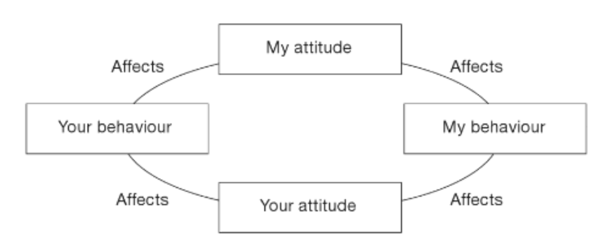
Figure 1: Betari's Box (Blagden, 2012, p. 45)

This is not always affective and may only work in small doses, as it did in this situation. I managed to calm the suspect down and her attitude did change for a small amount of time, allowing me to search her, but inevitably she retracted back to being non-compliant and aggressive.

Another model I always consider during conflict is the CUDSA model as it easy to remember as the acronym stands for each action involved. The idea behind the model is for an individual to confront the behaviour and understand the subject’s views, define the problem and search for a solution and then agreeing with the best solution. (CUSDA Model). This is where communicating effectively will help an incident, which it did here as I could find out the suspect’s main concern.
The suspect was worried about her dog who was epileptic and could not be left alone. The suspect was shouting that she wanted her mother to collect the dog whilst she was trying to sit on the floor so officers could not move her. We reassured the suspect that her dog would not be left alone.
I believe that an important factor in building a rapport with somebody is through finding a common ground with them so you can agree on something. I love dogs and alliterated that I would not leave her dog unattended whilst asserting honesty and integrity. The female wanted to phone her mother to collect the dog before she would leave. Officer’s negotiated with the female that they would ring her mother on her behalf and ensure that her dog would be safe. I considered by offering her a favour like this, she would comply as this can sometimes work as a negotiation.

Once officers tried to convey the suspect to the marked police van, she began resisting once again. The suspect was aggressive in her communication by shouting and being actively resistant by refusing to move. Officers decided to escort the female to the police van using force (section 3 of the Criminal Law Act 1967). Officers did this by holding the female by her arms and escorting her. The female then started to kick out to resist, this is where I considered using limb restraints but thought I would try communicating firstly.

Officer discretion plays a vital role in policing. This is where officers can use their professional judgement to deescalate or to find a better solution to an incident, as long as they can justify it. I used discretion here, deciding not to place the female in limb restraints to see if communicating would make her comply instead. I also considered if she did not listen, she would be placed in the restraints. The female then decided to comply after officers took their time and explained thoroughly what she needed to do or what would be the alternative if she would keep resisting. The female was then placed in the rear of the marked police van and escorted to custody.

Throughout this incident, I was mindful that the suspect was in the street, attracting a lot of attention to herself from the public. As she was intoxicated and in handcuffs, I did want to try and protect her dignity somewhat and respected her human rights. I considered using the ‘Five Step Appeal Model’ to try and get her to comply with officers, and into the police van safely.
The ‘Five Step Appeal’ is a tactic used in policing where officers will first ask the subject if they could comply with instructions, which is titled the ‘Simple Appeal’. In this incident, the female was simply asked to follow officers, but she would not.
The next step is the ‘Reasoned Appeal’, where officers explained to the female that she had committed and offence of causing Grievous Bodily Harm resulting in her arrest and that she needed to comply with officers.
The third component of the model is the ‘Personal Appeal’, where officers tried telling the female that she could potentially harm herself by resisting, and that there were members of the public watching her.

The fourth step is the ‘Final Appeal’, where officers asked the suspect once again if she could cooperate and reassured her that they would ring her mother if she complied.
The final stage of the model is to take action, here is where we had no other choice but to use force and escort the female to the police van.

This model is a good guide to follow in policing as it allows you to consider many options before taking the most drastic one. It also allows the subjects plenty of reasonable chances to cooperate and justifies any force that may need to be used. This may not always work and some officers may need to skip stages as some people are too aggressive and non-compliant.

After the suspect was detained, I then re-joined my other colleague in the flat with the male. We were then tasked with phoning the suspects mother to ask if she would take care of the dog. Extra officers finally arrived, who were asked to take the dog. The dog was distressed and did not want to leave his owner to go with officers. The dog was of heavy build and did not want to move. I then attempted my communication skills on the dog by speaking softly and encouraging to try and lure the dog inside the marked police van, which he finally did.

As we were waiting for the ambulance, the victim’s bleeding got significantly worse. My colleague swiftly took control and placed a compress on the victim’s head while I rang the ambulance to update them. Whilst on the phone with the ambulance service, officers were trying to keep the male calm and awake as he was finding it difficult to keep his eyes open. Luckily the paramedics arrived and the male was then escorted to the ambulance and conveyed to hospital.

I have identified a number of areas that officers dealt with conflict in this incident. Conflict is something that many people experience, but more so for police officers. Confict range from a small neighbour dispute, a domestic between family members or it can result in a serious crime. As police officers, we deal with conflict at almost every call we attend. Having strong listening and communications skills is vital as this can deescalate or escalate a situation and therefore have serious consequences. As police officers it is important to recognise that not everybody deals with serious conflict often and it can be a traumatic experience for them so we must be able to show empathy. There are many techniques available when dealing with conflict as discussed above.

By using the Gibbs reflective cycle model to reflect on the situation described above, some things went well and some could have been better. The model (see figure 2) has 6 stages. The first stage asks the reflector to describe the situation, then the feelings involved, evaluate it, analyse in more depth, and come to a conclusion and then develop an action plan moving forward, which were stated above.

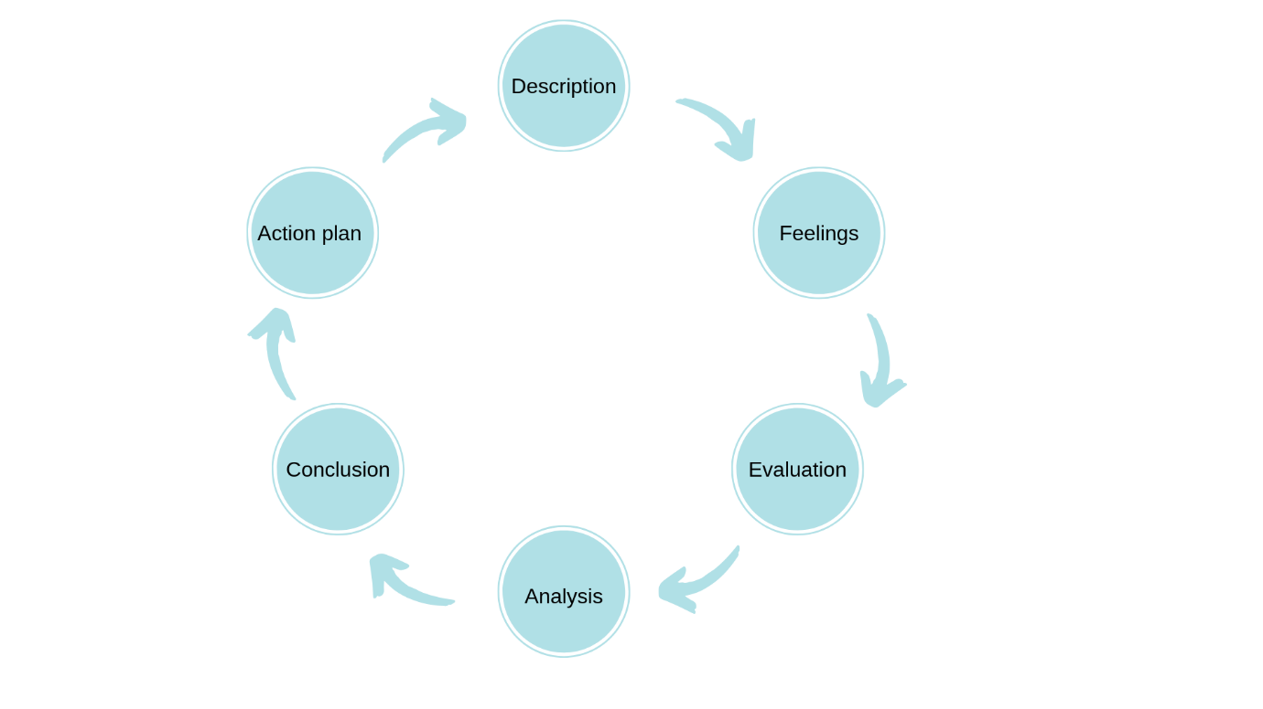

Figure 2: Gibbs Reflective Cycle model (Gibbs 1988)
In this incident, officers were tasked with misleading information and a chaotic situation. Some things could have been avoided such as the male losing less blood if officers held the compress sooner, there could have been more officers present at the scene to assist and the female may have complied sooner.

On the other hand, the situation could have been much worse, especially without considering any conflict management skills. I believe having experience in good communication skills and tactics helped the situation immensely and I would definitely apply these to any other incident. Officers managed to take control the situation, save the victim and detain the suspect in the end, which was the main goal.

In conclusion, there are many theories and models to assist in conflict management. Some models can apply all phases to a situation, some may only apply a few, and others, none at all. With conflict there is never one approach that will resolve every scenario and this is why it is good to have knowledge of the different models and guides. Unfortunately conflict is difficult to manage as a whole, depending on the situation and who is involved, but officers have a duty to resolve conflict even if it is on a temporary basis. It is important to consider the ethics of these models when approaching conflict and remain professional at all times.

Word Count: 2741

Task 3

Relevant areas of the National Policing Curriculum:
Criminal Justice, Valuing difference and inclusion

You must choose a policing incident in which you played a significant role with an offender/service user/victim and reflect on what happened.

Critically assess a relevant incident including social and legislative contexts and any relevant cultural, ethnicity and language issues.

Consider and reflect on your responsibilities and procedures in line with the relevant Codes of Practice to support victims and witnesses through the criminal justice system.

Illustrate how policing values were engaged, as well as any other considerations including culturally sensitive practice and language preference.

2500 words (+/- 10%: include your actual word count at the end of each section)

ANSWER:

In this essay I am going to discuss and reflect on a policing incident in which I played a significant role with an offender and a victim. I will be assessing the incident in which included social and legislative contexts and relevant cultural, ethnicity and language issues. I will also be reflecting on my responsibilities as a police officers in line with the Codes of Practice in order to support victims and witnesses throughout our criminal justice system and illustrating how policing values were engaged. I will be referring to the Driscoll Model of Reflection (2007) in this essay.

In today’s modern society, it is imperative to consider the many diversities that make up our communities. The world is a smaller place and there are many different cultures, races, religions that have integrated together, which I believe is a positive thing, but we have to be mindful that not everybody shares this opinion. Unfortunately this has led to some negativity such as racism, hate crimes and exclusion, with some people not embracing this diversity. A positive from this is that we have had to adopt new laws, including the Equality Act (2010). This has also educated the public and it allows people to be mindful of inclusion and diversity.
The world is changing rapidly and we must keep up to ensure diversity and equality are pursued with urgency. (Jessica McGreal, 2017)

The Equality Act (2010) states that it is “unlawful to discriminate on the grounds of certain ‘protected characteristics.’ These characteristics are: age, disability, race, religion or belief, sex, gender reassignment, sexual orientation, marriage and civil partnership, pregnancy or maternity.”

This is linked in with the College of Policing; Code of Ethics (2014), which includes a set of 9 principles and a list of standards of professional behaviour “which aims to support each member of the policing profession to deliver the highest possible standards in their service to the public.” (College of Policing, 2014).

As police officers, we must value differences and inclusion and ensure we are always considering these when dealing fairly in any situation within the criminal justice system. Officers may have their own prejudice without being aware, but it is extremely important that we do not allow this to lead to any discrimination. In the codes of practice, officers must treat everybody fairly and professionally. We are solely evidence gatherers and not the Crown Prosecution Service, who decides if a person is guilty or innocent. Officers must not have any pre conceived judgements and must be aware of their unconscious bias, which could result in favouritism and not treating an incident fairly.

The Competency and Values Framework model below includes the standards, values and behaviours officers should demonstrate. They are all as equally important and work together to achieve the best outcome. In relation to valuing difference it is very important to be open-minded and emotionally aware of our conduct and others.

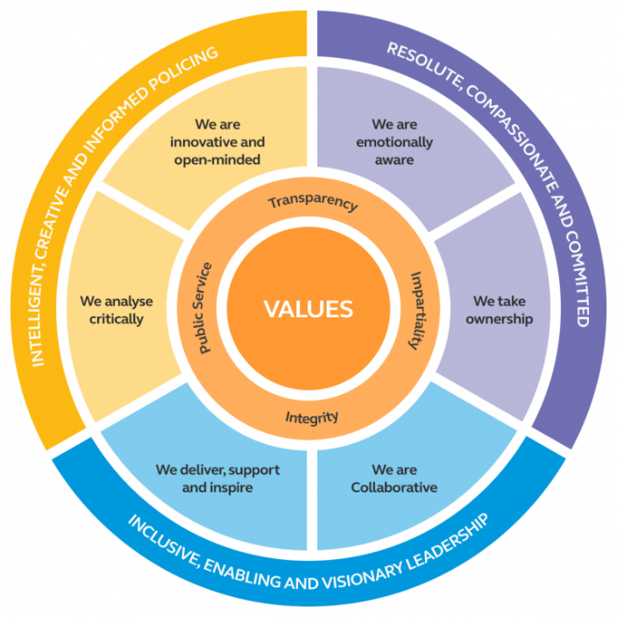

Figure 1: The Competency and Values Framework (CVF)
(College of Policing 2017)

The Human Rights Act (1998) states that everyone has ‘a right to have a fair trial’, which would not be fair if an officer had an unconscious bias. Another right is ‘a freedom of thought, conscience and religion’, where others should respect the views others may have, this including officers.

An incident I was involved in recently where it was essential to consider the importance of difference and inclusion was that of a theft. The victim was an Indian female who only spoke Punjabi. She was also defined as vulnerable and was living in sheltered accommodation. The victim thought she had befriended somebody that was living in the same accommodation as her, but this suspect manipulated her by gaining her trust and taking advantage of her by stealing her belongings.

If a person is deemed to be unable to look after themselves or protect themselves from harm or being exploited by others then they may be deemed a vulnerable person. (College of policing, 2014)

Officers received a phone call from a worker at the accommodation on behalf of the victim as the victim could not speak much English. The reporting person stated that they believe the suspect has stolen a number of items from the victim and that they knew who the suspect was. The reporting person had informed officers that the victim could not speak English and that she was very nervous and hostile towards police attending, but accepted help as she could not afford to lose her possessions. The reporting person also mentioned that the victim was not comfortable speaking with a male and that her husband used to speak for her. Often other cultures will have different tendencies and it is vital to respect this or you may disrespect somebody unintentionally.

Particular awareness must be shown when meeting and greeting people from different cultures. In certain Arab and African cultures that are particularly conservative in their nature, greetings such as hugs or handshakes can be offensive if given to someone of the opposite sex and may be seen as ill-mannered or even a form of moral crime. This is opposed to most western cultures which will carry out these forms of greetings as natural matter of course. (Cultural barriers of communication)

Officers accepted the information and agreed that I would speak with the female and be mindful of considering her vulnerability and hoping that the victim would feel comfortable. Officers considered using a verified interpreter from ‘language line’ for this incident to allow the victim to be able to communicate all that she wanted and for her to hear what the officers were going to do on her behalf. Officers used the interpreter for the initial phone-call to arrange an appointment with the victim face-to-face. It was extremely important to have a good first impression with the victim even over the phone, as I immediately wanted her to feel that we wanted to help and that she would feel less anxious about the next meeting.

Being sympathetic towards the victim and doing something as easy as allowing them to speak is very important as it is crucial that officers treat victims with respect and let them feel that they are important. This can be difficult as a response officer as the workload can be very demanding, but officers must consider their conduct and not display to a victim that they are rushing or stressed, as this can lead to negative impacting results on a victim with a bad outlook on the police. Being courteous and patient will gain the trust of the victim and also build a good relationship between officers and the community. Not only as an officer but as a human being, it is extremely important to embrace diversity and equality and to treat everyone impartially and fairly.

Officers arranged for an appointment to be made with the reporting person and the victim with the interpreter. Upon arrival to the appointment, the victim was very shy and looked concerned despite building a good rapport with her on the initial phone-call. I initially wanted to try and help the victim feel comfortable and supported. I introduced ourselves and was very conscious of my tone of voice and body language. I was trying to engage by smiling, using a soft speaking, calm tone of voice and open and relaxed body language without appearing too ‘authoritative or serious’. I thought that these were important as she could not understand what I was saying but she could see how I was saying it. I believe this is really important in portraying your conduct and how it comes across.

Research has revealed that up to 90% of human communication is non-verbal. The way that people use their body or hand movements and their facial expressions all make more of an impact than the words that are coming out of their mouth. (Nonverbal communication.)

The interpreter was asked to question the victim but also to let her talk freely, as she did not have anybody living near that she could speak to in Punjabi, and we wanted to make her feel relaxed. Officers appreciated that this could have been the victims first time in a long time of speaking with somebody else in Punjabi.

The victim appeared frightened as she has been used to males making the decisions in the past, so officers explained how we could help and reassured the victim whilst considering her feelings and appreciating her culture throughout. The victim wanted the suspect punished as she wanted her possessions returned, but she was unsure how as she did not understand the procedure. Officers were open and honest with the victim and explained to her the entire process patiently, outlining that once the suspect has been located, she would be arrested and interviewed. Following that, evidence would be gathered such as CCTV and searches for the possessions and possible DNA. Then she would be likely to be released on bail until her court date and that the court may call the victim to attend the suspect may be sentenced if found guilty.

The victim appeared anxious at the thought of appearing in court so officers explained special measures to her, stating that she may not need to enter the court room as it can now be done via video link or a screen that covered her if she did need to attend the court room. A victim personal statement was also explained to the victim so she would be able to voice how this incident has made her feel and the court would hear that and it could impact the sentencing of the suspect. The victim appeared a lot more comforted and happier once they were explained to her. The victim also voiced concerns about the suspect being on bail and knowing where the victim lived. Safeguarding measures and the victim referral scheme were also explained to the victim, stating that outside agencies can offer more support and could potentially move her into other accommodation if needed.

The victim described to officers what had happened. She informed officers that she believed the suspect had befriended her and taken advantage as they spoke different languages and were from different backgrounds. She believed the suspect stole a number of her belongings. The victim also informed officers that this suspect was verbally aggressive towards her but was unsure of what she said. Officers considered that there could be more offences disclosed than theft, such as fraud and racially and religiously aggravated offences.
It could not be identified that the suspect was committing any racially or religiously aggravated offences as the victim could not identify if the suspect was using her religion or faith against her. The CCTV did not pick up any sound and there were no witnesses who heard anything. This was important to consider as we cannot tolerate this conduct, but there was no evidence to suggest that it was anything other than a theft. Officers considered a restorative justice approach as the victim’s main concern was having her possessions returned but upon looking at the suspect’s history on ‘Niche’ – the police database, it was evident that she could not qualify for this as she had a long history of experiences with the police.

After obtaining the statement through the interpreter, officers had enough grounds to arrest the suspect. Under the Criminal Justice Act 1998, it is officer’s duty to ‘prevent, pursue, protect and prepare’. By establishing the grounds for arrest as early as possible this is abiding by this standard by preventing the suspect from doing this again, to pursue the suspect in order to arrest, to protect the vulnerable and prepare for an arrest and interview.
Upon locating the suspect, officers arrested the suspect on suspicion of Theft under section 1 of the Theft Act 1968. The suspect immediately started denying the offence and started resisting. Officers used force under section 3 of the Criminal Law Act 1967 by restraining the suspect and placing her in handcuffs. The suspect was escorted to custody where she was detained and then interviewed. The victim’s belongings were found in the flat of the suspect after officers searched in order to find evidence under section 32 PACE 1984. The suspect admitted that she had stolen from the victim as she needed money.

Officers submitted a PPN to safeguard the victim as she was vulnerable and officers would not like for her to be taken advantage of again. It is a duty for a police officer to share with the Public Protection Unit if a person is vulnerable so they can receive support and include any other partner agencies. The victim was extremely grateful to officers and was happy to have received her belongings. Officers could see the difference in the victim and she was no longer appearing anxious, which was rewarding to witness.
I believe as officers treated the victim with respect, patience and seemed to genuinely care for her, it built a good relationship with the victim. This is a positive for the organisation as word of mouth travels fast and if we are building strong relationships and leaving good contact with different communities, it will allow them to feel included and work alongside the police.
As mentioned before we are living in a widely cultural society and with recent events, this has become a very sensitive topic that police have a responsibility and duty to make sure that every person from different backgrounds are treated equally and fairly. Police cannot have any pre-conceptions or assume anything and must stay impartial at all times.
As I reflect on this incident, I use Driscoll’s reflective model (2007) to assist. Driscoll’s reflective model is a fairly simple model that asks the reflector: ‘What? So what? And Now what?’ This is a helpful model to use whilst reflecting as it asks you to explain what has happened, then analyse the event and then what lessons were learned from the event.

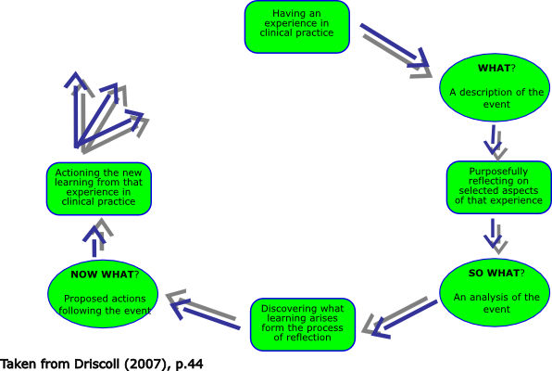

Figure 2: Driscoll’s reflective model (2007)

In conclusion, as I reflect on this incident, it goes to show how much officers conduct can have a severe impact on whoever they come into contact with, which could be good or bad. Bad experiences tend to be spoken about more than good ones, so it is very important that officers always deliver high professional standards and adhere to the codes of ethics. If officers were not as patient and inclusive in this incident, perhaps the victim would have not proceeded with her complaint and would not have her items returned to her. This would have been a very negative experience for the victim and she would likely not have much faith in the police or the Criminal Justice system. Some things in this incident could have been better, like officers should have sent two female officers but could only send myself and a male officer at that time. I believe that many things went well like building such a good rapport with the female despite language and cultural barriers, and I will learn from how well it was dealt with and take it to the next incident.

Word Count: 2518
Task 4

Relevant areas of the National Policing Curriculum:
Decision making and discretion, Conducting Investigations and Criminal Justice (Managing offenders)

You must choose a policing incident in which you played a significant role with an offender/service user/victim and reflect on what happened.

Critically assess the situation including social and legislative contexts and any relevant cultural, ethnicity and language issues. Reflect on how you applied the National Decision Model (NDM) to assist in resolving this incident. Evaluate the role of discretion in the decision-making process.

Determine your responsibilities with regards to the provision of the CPIA when conducting this investigation including when managing the offender and suspects and recording and retaining significant information.

Illustrate how policing values were engaged particularly through an assessment of the potential impact of bias on the decision-making process.

2500 words (+/- 10%: include your actual word count at the end of each section)

ANSWER:

In this essay I will discuss a policing incident in which I was involved in and reflect on what happened by referring to the National Decision Making Model (2012) and discuss how this assisted me in making decisions in the incident. I will also be referencing to the Gibbs Reflective Cycle (1988) in order to reflect fully on this incident. The Five Step Appeal Model will also be referred to in this essay.
Officers were called to a housing accommodation venue where they received reports that a female was refusing to leave. Weeks prior to this incident, my team were called to this same venue which resulted in a number of them being assaulted. The venue is known to police for having violent residents.
On route to this incident, I considered this fact so I prepared myself to be on high alert, more than usual. In every daily circumstance, police officers consider the National Decision Model (NDM) without even realising it. The NDM is a very useful model that police officers use to assess a situation as best they can. The NDM is used as it ensures the most ethical way of decision making in policing is made. (Blackstones, 2020)

As police officers must make many difficult decisions in a fast paced environment, with outside distractions and members of the public deliberately sabotaging them, the National Decision Making Model is designed to assist officers in reacting quickly and making these difficult decisions. (Blackstone’s, 2020)
The NDM is designed for police officers specifically. It is used to consider every step surrounding the code of ethics to take the best action and have the best outcome. This model is a useful tool to use in policing and can be applied to many different circumstances. Please see figure 1.

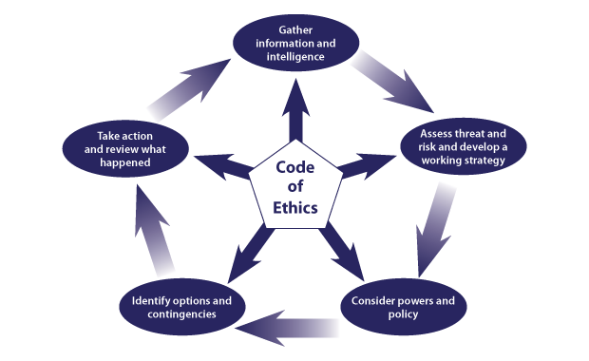

Figure 1: NDM, College of Policing (2012)

The first step of the model is to gather information and intelligence. In this incident, I was already prepared for conflict to take place as the location was known to officers as being home to violent individuals, who are anti-police. On route to the call, I conducted all necessary checks on NICHE and the Police National Computer to check who was involved. The reporting person was known to officers for being an aggressive person. This call suggested he was not the suspect. I was prepared that he may become violent but also had to consider not to be biased and treat him as a potential victim.

The second step of the NDM is to assess threat and risk and then develop a working strategy. Here is where I considered that officers may need further units and planned exit routes if the situation escalated. The other steps of the model would be identified as the incident takes place but typically, an officer is constantly thinking of what powers and policies could be used in theory to be prepared.

Upon officers’ arrival, the staff at the venue informed officers that a female had been temporarily placed in their housing accommodation for a few days. This female was supposed to share the two bedroom flat with a male but she was refusing to let him in, resulting in him having nowhere else to stay as the venue was at full capacity. The staff wanted officers to physically remove the female.
The staff directed the officers to the flat where the female was and entered to speak with her. The female had disclosed to officers that she was not aware that she would have to share the flat with an unknown male and was not comfortable doing this. The female disclosed to officers that she was previously sexually assaulted by a male in her previous hostel. Here, officers were gathering information and intelligence by asking the female to speak freely. The female also showed officers that the flat she was staying in was not a two bedroom as the staff had placed a bed in the living area, so the occupant of the ‘second’ bedroom would have access to the living room and need to enter if they wanted to use the kitchen.
At this point, officers were assessing the threat and risk to this female which is all contributing to using officer’s discretion and making the decisions. Police discretion is the ‘freedom of the individual officer to act according to his or her own judgement in particular situations. (Newburn and Neyoud, 2008)
Officers must be mindful when using discretion and it must only be used to make realistic judgements, achieving the best outcome in the interest of the public and to support the victim. There are many methods of disposals in which an officer can use their discretion. An officer may decide that an arrest may not be necessary and instead offer words of advice or a penalty notice disorder. These may not be the best disposal method and an arrest may only suffice. Every situation is different, and officers must ensure to use discretion tactically and fairly. Officers must ensure that they are not being biased or discriminative when using discretion or be led by any other influences as this is breaching the codes of ethics. The outcome is supposed to be what is best for the victim and the public, not the officer. Every individual has a right to a fair trial, (Human Rights 1988).

After retrieving the information and using their discretion, officers decided that this was not safe or fair to force this female to sleep in the same room as a male. As this male still had nowhere else to stay, officers asked the female if she had anywhere else she could go which she did not.

The female was being cooperative with officers and officers did not feel like she should be removed from the property, nor did we have the power to do so. Officers considered their options and contingencies by ringing another housing accommodation unit for the female, but there was no space available. The female had already been staying at the venue for a few nights and was going to leave in the morning in any case. Officers decided that they were happy to leave the female as she was. The next course of action was to ask the male if he could stay somewhere else.

Upon approaching the male at the lobby, I recognised him as the reporting person. In this incident, the male was asking for help and I could not let any pre conceived judgements or an unconscious bias lead to unfair treatment, so I conversed with the male, trying to help him find accommodation.
As I was conversing with the male I noticed he smelt of alcohol, his eyes were glazed and he was losing his balance. I kept asking the male to take a step back or sit down as he was becoming very close to my face. I could tell that the male was very intoxicated but he still needed help, which I was there to give. The male quickly became agitated and aggressive with staff members, who could also clearly identify that he was intoxicated.
The male then started shouting at staff members and making threats which escalated very quickly. We asked him to leave the premises. The male refused to leave, so officers used justified forced to escort him out of the building. Officers may use reasonable force as is necessary under section 3 of the Criminal Law Act 1967 and section 117 of the police Criminal Evidence Act 1984.

The male was still resisting and shouting aggressively. Officers asked the male to leave the area but he was refusing. The male was given plenty of opportunities to leave the area, but he did not. Again, discretion was being used as it is only fair to give people a chance at first to see if they will comply.
The male began shouting at the staff again and waving his arms around. It was at this point where I turned to the male and told him to put his hands behind his back to handcuff him for everybody’s safety. I could justify putting the male in handcuffs as he was resisting officers requests, he was highly intoxicated and well known to getting violent and he was entering peoples personal space. Initially the male was refusing to put his hands behind his back. We managed to get his hands into handcuffs and then I arrested him on suspicion of being drunk and disorderly. Drunk and disorderly is the only occasion where police can use their opinion to judge if somebody is intoxicated. Utilising Body Worn Video is important here in capturing evidence and it is important to categorise this as evidential to support the decisions made.

As mentioned above, the NDM is always unconsciously considered. It was considered in a calm, slow time incident like the first one mentioned above and again in a fast paced, potentially dangerous environment. The NDM was used here as information and intelligence was gathered by conducting the relevant background checks and actively listening and responding to the surroundings. Analysing risk and threat was clearly considered as I placed the male in handcuffs so he could not hurt anybody or himself whilst this was also considering my powers and policies, using reasonable force. I considered placing him in the handcuffs for safety reasons and contemplated options that he may be liable for arrest of assault or for being drunk and disorderly if he did not conform.

An alternative to an arrest considered here were suitable words of advice or a penalty notice disorder. However, this male did not qualify for these given his previous criminal record and the way he continued to behave. Other alternative’s to an arrest is a Voluntary Attendee Interview under the Police and Criminal Evidence Act (PACE) or Restorative Justice. Restorative justice can only be used when the suspect admits their guilt and is remorseful of their actions and if the victim agrees. These again did not apply to this male, but the arrest alternatives are always considered in the NDM when officers attend incidents.

During this incident, another male caught officers’ attention as security staff asked him to leave and he was also refusing. The second male was told by security staff that he was banned from his flat for two hours, as he was being aggressive towards other residents inside. The male was advised to take a two hour walk to cool off and then he could return. This male and the first male were both Somalian and they were encouraging each other to behave worse and finding the incident amusing.

Officers attempted to use the ‘Five Step Appeal model’ in aiding to get the second male to be compliant. Officers asked the male to simply leave but he refused. Officers then asked the male to reasonably leave by reinstating what has been asked of him. The male again refused so officers used the personal appeal asking the male how he would feel if someone was behaving like that towards him. Again, refusing to leave and becoming more aggressive, officers then ordered that the male leave or he will be arrested. Officers then took action in the final appeal by walking the male away from the venue.
Officers were still trying to control the first male who needed to be searched under section 32 of PACE 1984, before being escorted to custody. Without officers knowing, the second male returned and started arguing with the security guard. The security guard then told officers that the second male had assaulted him, therefore I arrested him on suspicion of assault. The arrest necessity was to prevent further physical injury to somebody. Code G of PACE 1984 states that an officer must have a necessity for an arrest. At this point officers asked for further assistance as the incident was escalating and there were only two officers. The extra units arrived and we had another van to convey the two men into custody.

After escorting the prisoners to custody. My colleague and I returned back to the scene as the ‘Golden hour’ is the best time to preserve evidence. The male had a cut lip which was photographed as evidence. Officers also had to take a statement from the victim. He informed us that the male who was arrested for assault had said to him “Our Somali brothers will find you and I know which part of Africa you’re from to find his family.” Officers asked the victim if he considered this to be a hate crime, to which he did not. Officers continued to support the victim and asked if he felt intimidated and offered him special measures, where vulnerable or intimidated victims/witnesses can use a video link to speak with the court or to have a screen in court. The victim wanted to support police action and a victim personal statement was also explained to him, where it gives the victim an opportunity to explain to the courts how incidents impact them, which may decide on the sentencing of the suspect. Officers also mentioned victim referral schemes and offered the victim any additional support. Whilst taking the victim’s statement, he mentioned to officers that he pushed the suspect first as he was getting close to him and then the suspect hit him.

Officers requested a copy of the CCTV and considered it may show that the victim could have assaulted the suspect first or a different side to the story completely. Officers knew that if this was the case that they would still have to retain and reveal information to the CPS under the Criminal Procedure and Investigation Act. This act was updated in 2015, stating that all relevant material must be disclosed to the court, even if it undermines the victim’s case. Officers must adhere to this and uphold their honesty and integrity and keep in accordance with the codes of ethics. (Criminal Procedure and Investigation Act 1996).

As I reflect on this incident, using the last step of the NDM it showed how quickly things can escalate and I wondered in this instance, if this was needed or if I could have prevented it. The call was not as expected and that is why it is very important as a police officer to always be prepared. I have mentioned the three incidents which were linked as they all played a part in the decision making process and how each outcome led to the other. I will also tie in the Gibbs Reflective Cycle below to reflect on the incident.
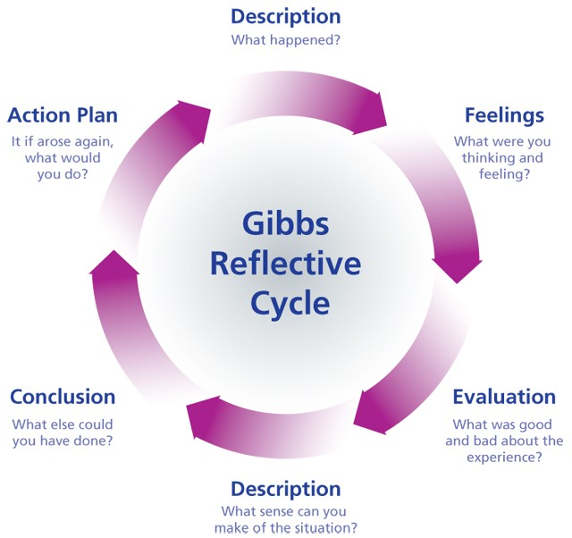

Figure 2: Gibbs Reflective Model (Gibbs, 1988)

As I reflect and evaluate, I use the Gibbs Reflection Model as it assists me to digest and dissect a very fast pace, high stress incident and learn from it. The incident described above made me constantly think and assess what I was doing and to stay alert as it was high stress for a long period of time with violent individuals. Many things could have been better in this incident as it resulted in two males being arrested and one male being assaulted. Officers could have controlled the situation quicker if there were extra officers to assist to prevent somebody getting hurt. I believe I was being fair to the males, offering them plenty of chances but as I reflect, I should not have given them as many chances, as it resulted in the victim being assaulted. I also know that we cannot predict outcomes so I will not dwell on the incident and rather learn from it instead. The incident taught me not be afraid of asking for extra unit’s quicker next time.

Word Count: 2607

Task 5
Personal Development Plan (PDP)

As part of your reflective process, please use this table to aid you in identifying the next steps for development.

This is equivalent to 500 words towards the overall wordcount, please note this is not the actual number of words used in completing the table, the count reflects the thought and research behind it.

Area of Development | How it will be achieved | Who can provide support | Timeline
The area of development is to develop my English skills further, especially grammar. As I have attended Welsh school and studied my university degree through the medium of Welsh, my English skills have been somewhat compromised. I have always been conscious of this and believe improvement would give me more confidence in my writing. | This will be achieved by reading and practicing writing skills. I am already finding that writing updates and statements at work are assisting me in writing better English than I was before. | I can ask the University for help and guidance on writing skills.  I can also ask my team members and supervisor at work to assist. | The timeline for this area of development is by my next submission date in my second year of study. I would like to see this improvement by then.
The area of development is to gain more knowledge within my role as a Police Constable. | This will be achieved by re-reading my revision notes from training and reading the Blackstone’s book again. | The library can assist me in learning more, through reading extra material. My sergeant can also help if I asked. | The timeline for this area of development is within the next 6 months. Having more experience will aid me in this.
This area of development is to become better at taking a statement.  It is really important to include a lot of detail in a statement and I believe this will come with time. | This will be achieved by taking any opportunity I can from taking a statement from a victim or a witness. | My Sergeant and senior team members can assist me with this. If I have failed to mention a detail that they might pick up on, I have confidence that they would tell me to include it and I can learn from it for the next time. | The timeline for this area of development is within the next 2 months as statements are always being taken.
This area of development is for taking the lead and control when dealing with incidents rather than letting my more experienced colleagues. | This will be achieved with gaining more confidence and pushing myself out of my comfort zone when dealing with incidents. I will make effort to lead on every call I attend. | My team members will assist me in succeeding this area of development. I will ask them to take a back seat and they will allow me to use my initiative. | The timeline for this area of development is for next month as there are many incidents to attend on a daily basis.
This area for development is to gain more knowledge on what to include in a case file. | This will be achieved by volunteering to complete more case files even if it is not on my workload. | I can ask my sergeant to go through a few more case files with me if he has the time. I could also ask my team members if they would be willing to help. | The timeline for this area of development is within the next 2 months as many files need to be completed.
The area of development is to have more experience in dealing with Missing Persons as I have only attended a couple of these incidents. | This will be achieved by asking my Sergeant for any MISPER that comes in on shift to be allocated to me to gain more experience. | I can ask my Sergeant or ask a team member who is happy to help me go through what needs to be done. | The timeline for this area of development is within the next month or two as I am in a busy station and MISPERS are becoming more frequent.
This area for development is to become more confident conducting an interview. | This will be achieved asking my Sergeant or my team members if I can assist with any interview or voluntary attendee interview. | I will ask my Sergeant and team members if they have time to help me prepare for the interview. If not I can research the internet and revise my previous revision notes for what makes a good interview and which questions to ask. | The timeline for this area of development is within the next 6 months as it takes more of a skill to become a good interviewer.

Bibliography
The bibliography should only include sources referenced within the workbook using the Harvard referencing system. Information about referencing in written assignments and how to avoid plagiarism can be found on Moodle. It is important that you are aware of the importance of ensuring that the work submitted is your original work.

Blagden, N. (2012). Policing and Psychology. Exeter: Learning Matters. Pp. 45.
Bronitt S, Stenning P. (2011). Understanding Discretion in Modern Policing. Criminal Law Journal. The Univeristy of Queensland, Australia. Pp 320
Bryant, R & Bryant, S. (2020). Blackstone’s Handbook for Policing Students. 14th ed. Oxford: Oxford University Press. Pp 64-66.

Bryant, R., Bryant, S. (2020). Blackstone’s Handbook for Policing Students. 14th ed. Oxford: University Press. Pp 79.

Bryant R, Bryant S, (2020). Blackstones Handbook for Policing Students. 14th ed. Oxford: University Press. Pp 82.
Codes of Practice. (2015). [Online]. Available at: Criminal Procedure and Investigations Act 1996 (section 23(1)) Code of Practice (publishing.service.gov.uk) [Accessed 8 March 2021].
College of policing. (2020). Conflict management skills. [Online]. Available at: Conflict management skills | College of Policing [Accessed 9 March 2021].
College of Policing Limited. (2019). Conflict Management Using De-escalation, Communication and Negotiation. [Online] Available at: Conflict_management_consultation260219.pdf (college.police.uk) [Accessed 21 January 2021], pp.12.
College of Policing, (2017). College.police.uk. [Online]. Available at: Competency and Values - College of Policing p3. [Accessed 6 February 2021].

College of Policing, (2017). College.police.uk. [Online]. Available at: How do you deal with the vulnerable? | College of Policing [Accessed 6 February 2021].
College of Policing. (2013). [Online]. Available at: National Decision Model (college.police.uk) [Accessed 20 January 2021]

Communication Theory [Online]. Available at: Cultural Barriers of Communication (communicationtheory.org) [Accessed 6 February 2021].

Criminal Justice Act, (2003). [Online]. Available at: https://www.legislation.gov.uk/ukpga/2003/44/contents [Accessed 6 February 2021].

Driscoll, (2007). Driscoll Cycle. [Online]. Available at: Driscoll cycle (nottingham.ac.uk) Accessed 6 February 2021].

Ekman, P. (2010) Research on Body Language, Nonverbal communication, Communication Columbia University, New York. pp 3.

Equality Act 2010, c.1. [Online]. Available at: Equality Act 2010 (legislation.gov.uk) [Accessed 6 February 2021].

Esposito, A., Bianchi, V. (2012). Cortisol: Physiology, Regulation and Health Implications. United States: Nova Science Publishers.

Exercise for Stress and Anxiety | Anxiety And Depression Association Of America, ADAA. [Online] Available at: (https://adaa.org/living-with-anxiety/managing-anxiety/exercise-stress-and-anxiety) [Accessed 16 January 2021].

Flach, F., Flynn, M. and Sciortino, R., (2020.) Resilience. Long Island City, NY: Hatherleigh Press.

Gibbs, G. (1998) Learning by Doing: A Guide to Teaching and Learning Methods. Oxford: Further Education Unit, Oxford Polytechic.
Harber, V.J., Sutton, J.R. (1984) Endorphins and Exercise. Sports Medicine. Ontario, Canada. Ed: 1, pp. 154–171

Healthline. (2021). Of The Best Stress-Relieving Foods. [Online] Available at: (https://www.healthline.com/nutrition/stress-relieving-foods) . [Accessed 16 January 2021], pp.18

Hickson, E (1836). The singing master. Woodbridge.

Jasper M, (2003) Beginning Reflective Practice, pp. 99.
Johnstone, G. (2011). Restorative Justice: Ideas, values and debates. Ed: 2 Abingdon, Oxon.
Managing Behaviour: the Five Step Appeal. (2019) [Online]. Available at:
Managing Behaviour: The 5 step appeal – Teaching & Learning Toolbox for Research Informed Education (wordpress.com) [Accessed 21 January 2021]

Managing Volunteer Conflict Using the CUDSA Model. (2019). [Online]. Available at:
CUDSA-volunteer-conflict-management.pdf (codeofgoodpractice.com) [Accessed 21 January 2021]
McGreal, J. (2017). [Online]. Available at: ‘The world is changing rapidly and we must keep up to ensure diversity and equality are pursued with urgency’ - Raconteur [Accessed 6 February 2021].
NHS Conflict Resolution. (2015). [Online]. Available at:
conflict-resolution-level-1-workbook.pdf (newarkandsherwoodccg.nhs.uk) [Accessed 21 January 2021], pp.16
Newburn, T. (2008). Handbook on Policing. Plymouth, Devon. Pp 82
Nadler, J. (2004) Rapport: Rapport in Negotiation and Conflict Resolution [Online]. Available at: Rapport: Rapport in Negotiation and Conflict Resolution (marquette.edu)

Otto, M. and Smits, J., (2011). Exercise for Mood and Anxiety. New York, NY: Oxford University Press, pp. 7

Publishing, H., (2021). Exercising To Relax - Harvard Health. [Online] Harvard Health. Available: (https://www.health.harvard.edu/staying-healthy/exercising-to-relax). [Accessed 16 January 2021].
Remember your rights – Voluntary Interview. (2018) [Online]. Available at: Remember your rights: voluntary interview (accessible version) - GOV.UK (www.gov.uk) [Accessed 9 March 2021].

Scott Westcombe. (2020). [Online]. Overtraining Injuries and the Importance of Rest. Available: (https://bestbody.com.au/overtraining-injuries-and-the-importance-of-rest/). [Last accessed 17 January 2021].

Selye, H., (1957). Stress. Ed. Scientifiche Einaudi, pp.1.
Stewart, S, (2015) [Online] Gibb’s Reflective Cycle | Sarah Stewart's Eportfolio (glowscotland.org.uk) [Last accessed 9 March 2021].

Urhausen, A., Gabriel, H., Kindermann, W. (1995). Blood hormones as markers of training stress and overtraining. [Online] Available: (https://www.healthline.com/nutrition/stress-relieving-foods). [Last accessed 17 January 2021], pp. 261.

Williams, R. (2020). How to Walk Yourself Healthy & Happy: Walking Exercise Advice For A Healthier Body and Mind. (n.p.): M-Y Books Limited, pp.53.

CONFIDENTIALITY and PLAGIARISM – confirmed by submission through Turnitin

Task 6

Recognition and confirmation of progress on the Occupational Competency Portfolio (OCP).

By signing the section below you are acknowledging your continued progress on O.C.P., this is recognised by the university as work that is fully supporting this module. Signing it is equivalent to 500 words towards the overall wordcount.

I confirm that I am progressing with the Occupational Competency Portfolio (OCP) in accordance to the regulations.

Signed: Sally Jones (Learner, Electronic signature or type name)

Date: 11/03/2021

