Pharmacy Database System Report

Table of Contents
1. Introduction
2. Literature Review
3. Entity Relationship Diagram (ERD)
4. Database Design
5. Queries
6. Forms
7. Reports
8. Conclusion
9. References

1. Introduction
This project presents the design and development of a relational database system for a pharmacy.
The purpose of the database is to manage and organize information related to customers, medicines,
suppliers, prescriptions, and sales transactions.

A database system improves the efficiency of storing and retrieving data while maintaining data
integrity. The pharmacy database allows staff to track medicine stock, record customer purchases,
manage prescriptions, and monitor supplier information.

Microsoft Access was used to design and implement the database. The system includes tables, relationships, queries, forms, and reports to support the daily operations of a pharmacy.

2. Literature Review
Database systems are widely used to store and manage structured data efficiently. According to
Connolly and Begg, relational databases organize data into tables and use relationships to ensure
data integrity and reduce redundancy.

Relational database management systems (RDBMS) such as Microsoft Access allow users to create
structured data models using entities, attributes, and relationships. These systems support
querying, reporting, and user-friendly forms for data entry.

Normalization is an important concept in database design. Third Normal Form (3NF) ensures that
data redundancy is minimized and that each table contains data related to a single entity.

3. Entity Relationship Diagram (ERD)
The Entity Relationship Diagram (ERD) represents the structure of the pharmacy database and shows
how the different entities interact with each other.

Entities in the system include:
• Customers
• Medicines
• Suppliers
• Prescriptions
• Sales

Relationships:
• One customer can have many prescriptions.
• One customer can make many sales.
• One medicine can appear in many sales.
• One supplier can supply many medicines.

Insert ERD Screenshot Here
Figure 1: Entity Relationship Diagram of the Pharmacy Database

4. Database Design
The database was implemented in Microsoft Access using several tables. Each table represents a specific entity within the pharmacy system.

Customers Table
Fields:
• Name
• DOB
• Phone
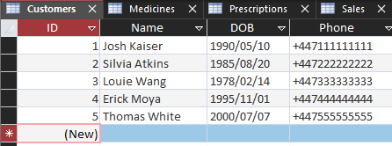

Medicines Table
Fields:
• Name
• Category
• Price
• StockQuantity
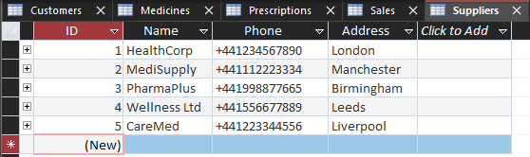

Suppliers Table
Fields:
• SupplierID (Primary Key)
• Name
• Phone
• Address
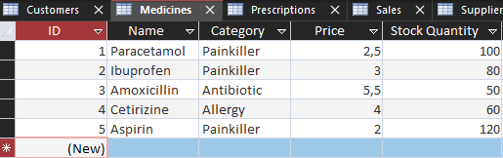

Sales Table
Fields:
• SaleID (Primary Key)
• MedicineID (Foreign Key)
• CustomerID (Foreign Key)
• Quantity
• Date
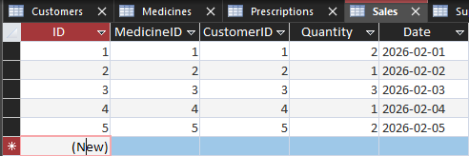

Prescriptions Table
Fields:
• PrescriptionID (Primary Key)
• CustomerID (Foreign Key)
• Date
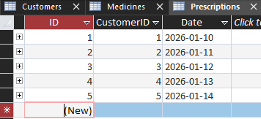

The database follows Third Normal Form (3NF). Each table contains information about only one entity, and relationships between tables prevent duplication of data.

5. Queries
Queries are used to retrieve and analyse information from the database.

1. Customer Purchases Query
Displays which medicines each customer has purchased.
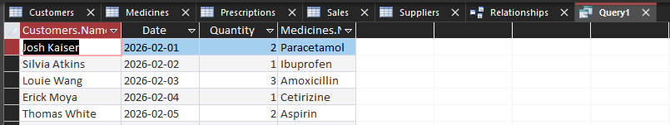

2. Medicine Stock Query
Shows current stock levels for all medicines.
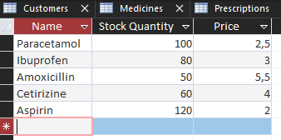
3. Sales Report Query
Displays sales transactions including customer name, medicine name, quantity, and date.
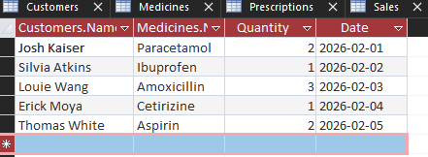

6. Forms
Forms provide a user-friendly interface for entering and viewing data.

Forms created in this system include:

• Customer Form – used to add or edit customer information. 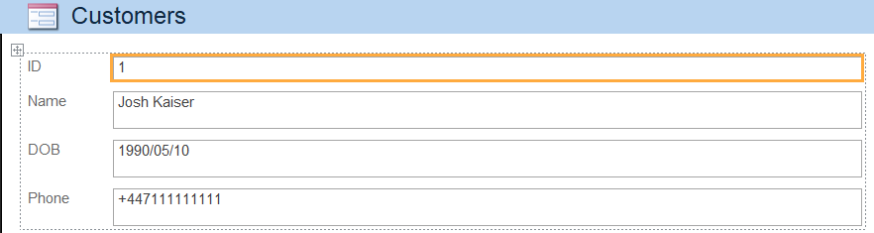
• Medicine Form – used to manage medicine records. 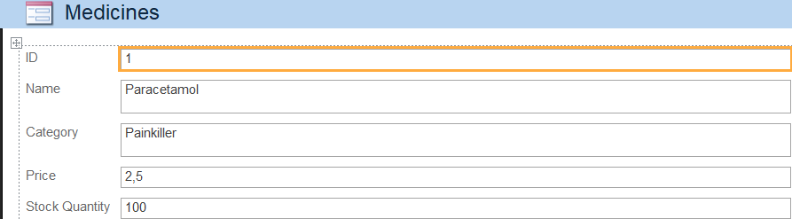
• Sales Form – used to record sales transactions. 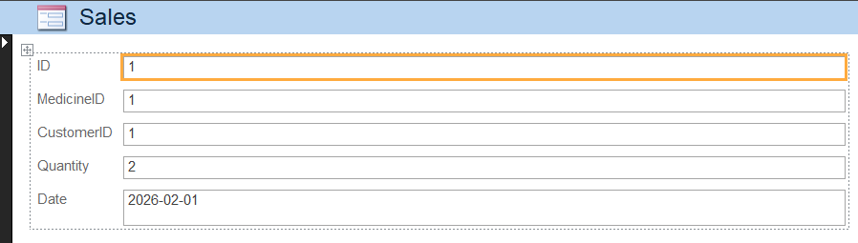

Forms improve usability by allowing staff to interact with the database without directly editing tables.

7. Reports
Reports are used to present data in a structured and printable format.

Reports created in the database include:
• Sales Report – summarises sales transactions. 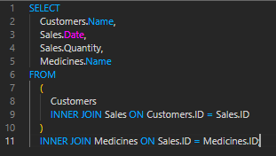
• Medicine Stock Report – displays current stock levels.
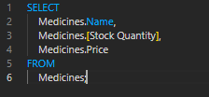
• Customer Purchase Report – shows which medicines customers have purchased.
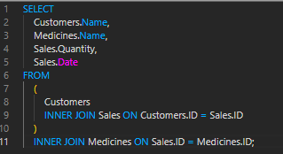

Reports may include calculations such as totals and summaries to provide useful insights.

8. Conclusion
The pharmacy database system successfully organizes information related to customers, medicines,
suppliers, prescriptions, and sales. The use of relational database design ensures that data is
stored efficiently and accurately.

Microsoft Access provides powerful tools such as tables, relationships, queries, forms, and
reports that allow users to manage data effectively. This system demonstrates how database
technology can improve the management of pharmacy operations.

9. References
[1] T. Connolly and C. Begg, Database Systems: A Practical Approach to Design, Implementation,
and Management. Pearson Education.

[2] Microsoft, "Introduction to Microsoft Access," Microsoft Learn.

[3] R. Elmasri and S. Navathe, Fundamentals of Database Systems, Pearson.

