  Component One:  What are the key skills required when working in the housekeeping team? 750 words (+/- 10%)  Contribution to Overall Module Assessment: 25%
  Student Name: | Student No:2208636  Rufsana begum
  Module Title: | Operating hotel facilities
  Module Code: | BMIH4006
  Lecturer: | Muhammad cassamo

Component One
Some of the skills are mandatory to have while working on a housekeeping team, as it requires a lot of abilities to have. These skills involve a few people as well as technical skills, that a person may have to become successful. Some of these are:
Attention to Detail
By using this ability, in my opinion, a housekeeper can make sure that every space is kept to the highest levels of tidiness and cleanliness, from guest rooms to public places. In addition, according to me paying attention to detail includes additional responsibilities associated with the job, such as keeping track of inventory levels, making sure there is a sufficient supply of cleaning supplies, and reporting maintenance issues as soon as they arise to the manager. The success of the institution as a whole and the satisfaction of guests are enhanced by cleaning staff members' meticulous attention to even the tiniest details (Brazil, et al. 2023).
Time Management
The housekeeping profession requires effective time management. I have witnessed housekeepers frequently operating in a fast-paced setting. They must successfully manage their time, prioritise their work, and finish their tasks in the allotted amount of time. I think, they are more productive and guarantee that all areas are cleaned and maintained according to schedule when they have good time management abilities hence why I had made a schedule to avoid any delays.
Knowledge of Cleaning Techniques
A thorough awareness of the numerous cleaning methods, supplies, and tools should be possessed by housekeeping specialists (Alcalde-González, et al. 2021). In my opinion, they must to be acquainted with the many types of surface materials and be aware of the appropriate cleaning solutions and implements for each. Also, I have experienced that effective and safe cleaning practises are ensured by knowledge of the right cleaning methods.
Organizational Skills
As from my current experience, professional housekeepers must have excellent organisational abilities. They must plan cleaning schedules, keep inventory logs up to date, and monitor requests and specific instructions (Shapoval, et al. 2022). Also I have witnessed that they can operate systematically and effectively thanks to their organisational skills, making sure that everything is done correctly.
Physical Stamina
As a housekeeper, physical labour-intensive tasks like lifting heavy objects and performing repetitive motions are part of housekeeping that can keep people on their feet for long periods of time. From my own experience, to complete these jobs successfully and avoid weariness or injury, one must have strong physical stamina.
Communication Skills
For housekeeping team to be successful, communication must be effective. Managers, and other team members must all be regularly interacted with by housekeepers (Jaykumar, 2020). I think, they are better able to comprehend and meet the demands of their guests, plan jobs with co-workers, report maintenance problems, and adhere to orders precisely when there is clear communication. What I have noticed is, essential communication skills include decency, attentive listening, and the capacity to clearly explain information.
Discretion and Confidentiality
As per my understanding, considering that housekeepers frequently have access to the private possessions and rooms of guests, they are always required to act discreetly and in confidence. In my opinion, to uphold trust and professionalism, it is essential to respect guests' privacy, keep sensitive information private, and handle guests' personal things with care.
Problem-Solving Abilities
I think, during their employment, housekeeping specialists face a variety of difficulties, including challenging stains, broken equipment, or unforeseen accidents. In my opinion, critical thinking skills and the capacity to make quick decisions are crucial. In order to deal with unforeseen circumstances successfully, they should be inventive, adaptive, and capable of taking quick judgments.
Teamwork
In larger establishments, housekeeping is sometimes a team effort. In order to maintain efficient operations, housekeepers must cooperate and plan with their coworkers. As per my understanding, they should be able to successfully interact with the team and build a pleasant work atmosphere while also being willing to assist and support others when necessary.
Customer Service Skills
Professional housekeepers play a direct role in the overall satisfaction of visitors in the hospitality sector. As per my understanding, the ability to manage requests and complaints from guests politely, as well as the willingness to go above and beyond to meet their needs, are all qualities that define outstanding customer service.
Whilst being on housekeeping what I have witnessed is there are many different abilities needed to work in a team. Having persistence and determination, ability to use own initiative a keen eye for detail, excellent time management, being flexible organizational skills, communication skills, problem-solving abilities and teamwork. When I was undertaking these tasks in housekeeping, I did making beds, polishing, cleaning, hoovering and tidying as I go. According to me, a clean, cosy, and friendly environment for visitors may be maintained while also ensuring the facility runs smoothly by honing these abilities, which housekeeping specialists can do to help.
Word Count | 810

Component Two:
Contribution to Overall Module Assessment: 25%
In this scenario – You have just been promoted to team leader for a floor within the hotel. A guest complains that on their arrival, their room had not been properly cleaned. Create an action plan and answer the following questions.

Problem | Why did it happen? | What are you going to do? | How will you prevent this from happening in the future? | What measures would you introduce to improve team effectiveness?
Inefficient Cleaning Services | The management of the hotel chain has a common problem with cleaning. Ilyas, G.B., and Mustafa (2022) highlighted that over 50% of the hotel received several complaints from guests regarding the cleanliness of their rooms and common areas. Despite employing a cleaning staff, the hotel is struggling to maintain high standards of cleanliness and satisfy their guests' expectations | As a team leader, I can have the authority to address the issues with proper Countermeasures. Wang et al. (2021) stated that focusing on recurring is highly required for hotel management to ensure cleanliness. Apart from that, the introduction of cleaning standards would have been great to cope with this challenge. | Establish clear cleaning protocols: Create a comprehensive set of cleaning protocols that outline the specific tasks, frequency, and standards expected from the cleaning staff. These protocols should cover all areas of the hotel, including guest rooms, common areas, restaurants, and facilities | To improve the team’s effectiveness, establish a system to monitor and evaluate the cleaning services regularly. This can include surprise inspections, checklists, or feedback from guests. Identify any areas that require improvement and address them promptly
Inconsistent cleaning standards | The hotel's cleaning staff fails to consistently meet the established cleaning standards, resulting in variations in the cleanliness of rooms and common areas. Eygü and Güllüce (2017) stated that guests usually report encountering dusty surfaces, uncleaned bathrooms, and untidy public spaces, undermining the hotel's reputation. | As I believe in Teamwork so primarily, I am going to focus on team building that may help to create a bond between different team members. It can follow by a few quality practices that would have lowered the inconsistency in cleaning services. | As a team leader, I strictly instruct the housekeeping staff to follow the standards and practices. To ensure the best quality I can suggest to them to hang the chart on the wall so that they can see it and learn from the mistakes. | Recognizing and rewarding excellence can improve the housekeeping standards in hotels. Firstly, it is important to acknowledge and appreciate the efforts of the cleaning staff when they consistently deliver efficient and high-quality cleaning services. Incentives, recognition programs, or performance-based rewards can motivate the team to maintain their standards.
Inadequate training and supervision | The cleaning staff lacks comprehensive training and proper supervision, leading to a lack of attention to detail and subpar cleaning practices. Supriadi, Astuti, and Firdiansyah (2017) highlighted that, without clear guidelines and regular monitoring, employees may not prioritize thoroughness and fail to address specific areas requiring attention. | Being a team leader of this group and having experience in it I can ensure the training and development first. I can ask the management to introduce training once a month to make the staff well-equipped. | The introduction of training programs for employers could have saved the financial resources where they can perform for keeping the company's image. Lee et al. (2021) stated that training and supervision should proceed under strong leadership which can create a difference in customer service. | In order to improve team effectiveness, employee empowerment is important within a hotel. As a leader, provide training to the cleaning staff to ensure they understand the cleaning protocols and know how to perform their tasks efficiently. Train them on proper cleaning techniques, the correct use of cleaning products and equipment, and the importance of attention to detail.
Insufficient resources and equipment | Outdated cleaning tools, limited supplies, and insufficient maintenance of equipment hinder the staff's ability to achieve optimal cleanliness levels. Li et al. (2020) conducted a study within the hotel industry asserting that 60% of the hotel management has not provided the cleaning staff with adequate resources and modern equipment to efficiently carry out their tasks. | Firstly, I am going to ensure financial services so that the team can get money whenever they require it. It can help to supply resources and equipment. Apart from that, a feasibility analysis also could have been done to ensure team building. | To avoid any errors in the future, management should ensure that the cleaning staff has access to the necessary resources, such as cleaning supplies, equipment, and protective gear. | It is important for team management to focus more on team effectiveness by employing rewards and incentives. Apart from that, the organization should regularly inspect and maintain the equipment to ensure it's in good working condition. Inadequate or faulty equipment can significantly hamper cleaning efficiency.
Poor coordination and communication | lack of effective communication and coordination between the cleaning staff, front desk, and management (Cherapanukorn and Charoenkwan,2017). As a result, guest requests for room cleaning, specific preferences, or reported cleanliness issues may not reach the relevant staff promptly, leading to delayed or inadequate resolutions. | Firstly, I need to focus on the collaboration between employees so I would ask for establishing a communication network so that it can avoid any conflict. Ali et al. (2021) stated that clear communication helps to facilitate coordination between colleagues while technology may play a key part here. | To avoid any future issues, maintain open lines of communication with the cleaning staff and encourage them to report any issues or challenges they encounter. Establish a culture of feedback and problem-solving to address concerns promptly and improve overall efficiency. | Effectiveness can be improved by exploring technology solutions like chatbots that can streamline and enhance the cleaning process. For example, housekeeping management software can help optimize cleaning schedules, track tasks, and improve overall efficiency.
Staffing challenges | The hotel faces challenges in maintaining an adequate number of cleaning staff, particularly during peak seasons or when facing unexpected spikes in occupancy. Ahmed et al. (2021) highlighted that Understaffing can lead to fatigue, reduced efficiency, and an increased likelihood of overlooking important cleaning tasks. | Conduct regular performance evaluations for the cleaning staff to assess their work quality and identify areas for improvement. Provide constructive feedback and additional training as needed to enhance their skills and address any inefficiencies. | To avoid any challenges further, organization should follow encourage guests to provide feedback on the cleanliness of their rooms and the hotel's overall cleanliness | In order to bring team effectiveness, it is important to monitor guest reviews and address any complaints promptly. Guest feedback can help identify areas of improvement and ensure guest satisfaction.

Component Three:
Contribution to Overall Module Assessment: 50%
Your task is to create and prepare a presentation following the detailed scenario provided below.

As the floor housekeeping manager and given the recent guest complaints you need to put together a basic training presentation for your colleagues within the housekeeping team to get the best out of them, ensure that brand standard is being achieved and that Health and Safety procedures are also being followed.

Component 3

Introduction
The improvement of branding is necessary thing for improving the overall revenue within the hotel. In order to maintain brand improvement, it is required to focus on health improvement. It has assigned a training activity in context to the hotel for making changes in housekeeping formation. The analysis of health and safety factors is required to improve for achieving the hotel business.
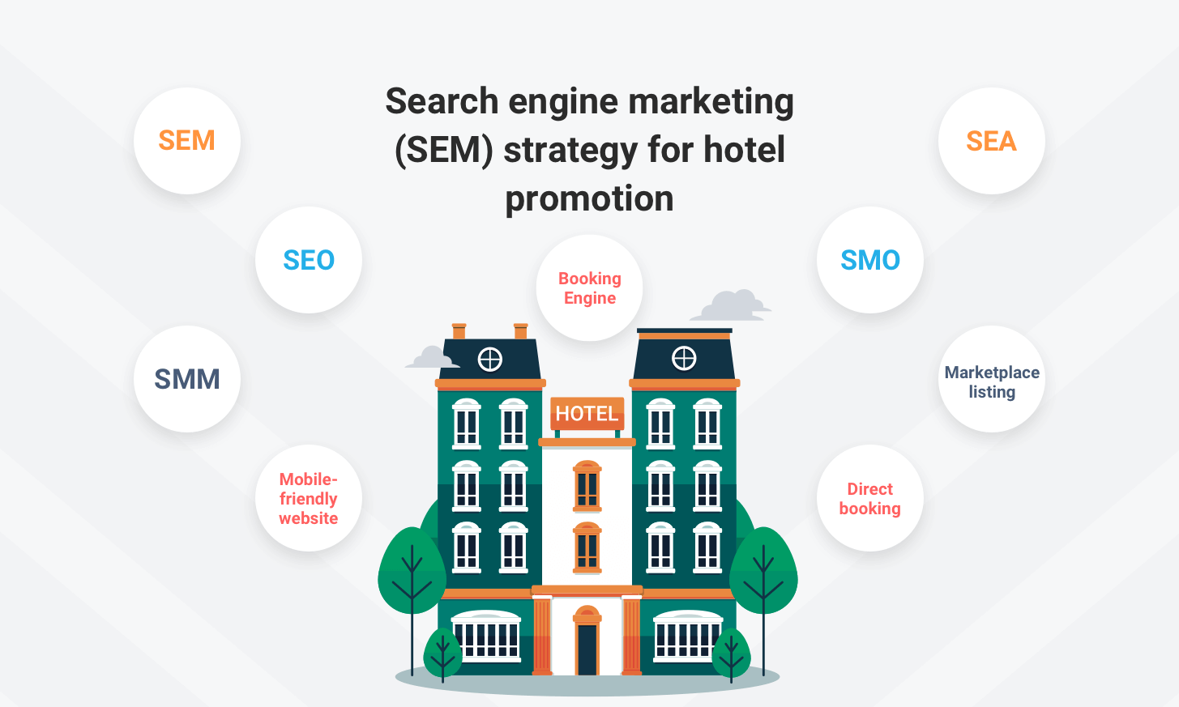

Importance of standards
In order to protect the security of guests, standards are essential to hotel housekeeping. First, standard operating procedures offer an organized and standardized method for maintaining and cleaning guest rooms, public spaces, and facilities (Siaw, 2022). Hazards like slip-and-fall incidents or exposure to dangerous substances are less likely as a result. As per the standard, it can be included operational standard, physical standard which have to maintain by the housekeeping (Cohen-Shacham et al. 2019). Third, consistent cleaning procedures for utensils, surfaces, and linens foster a hygienic environment and prevent the spread of disease.


CONTD…
The safety and wellbeing of hotel guests are prioritized by excellent housekeeping standards, resulting in an environment that is secure and comfortable for everyone (Kusuma et al. 2022). It should be to provide a consistent visitor experience, improve the property's reputation. It can encourage repeat hotel business by making sure the housekeeping team complies with these criteria (Bashir et al. 2020). The management also is needed to recognizes the value of adhering to health and safety regulations to ensure a safe and healthy environment for both visitors and staff.
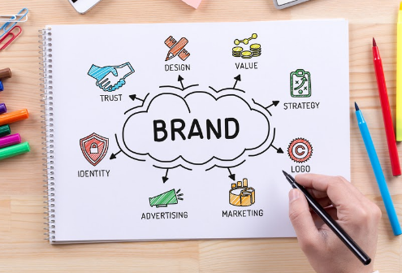

Benefit of health and safety improvement
Numerous advantages come from enhancing client health and safety procedures. First of all, it should improve the company's standing and dependability, luring additional clients and encouraging loyalty. Second, it has provided lessons on the possibility of mishaps or injuries, lowering the likelihood of legal issues and related expenses (Bahcecik et al. 2019). Thirdly, strict hygiene standards and sanitization procedures can be prevented the spread of disease, making for healthier patrons and fewer cases of contagious illnesses. Prioritizing health and safety also foster a welcoming environment that improves the overall consumer experience.
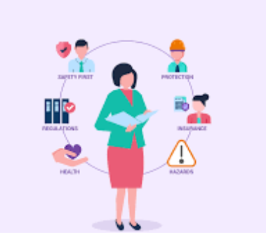

CONTD…
This encourages good word-of-mouth recommendations, which eventually spurs business expansion and success. Overall, putting health and safety first is not just a moral requirement but also a wise business choice with numerous advantages. Higher client retention and advocacy should needed to focus for this (Sadhale, 2021). Finally, a strong position in branding should fetch a premium price because consumers are frequently prepared to pay more for brands they believe to be superior. Overall, a company's long-term success and sustainable growth are influenced by its branding strategy.


Achieving the brand standard
Company must establish and uphold brand standards in order to guarantee consistency and should provide a cohesive brand experience. Company is needed to establish a distinctive identity, unify its messaging and visual components, and strengthen its distinctive value proposition by adhering to brand standards. Customers' trust and loyalty are bolstered by this uniformity across numerous touchpoints, including marketing collateral, customer service encounters, and product quality (Tiwari and Trivedi, 2020). In order for employees to properly represent the brand and comprehend the company's vision and values, brand standards also provide guidelines for them. In the end, upholding brand standards should build a solid basis for a company's reputation and encourages favourable customer opinions.

Training tips on Health and Safety Effectiveness
Considering the training suggestions should need to improve the effectiveness of health and safety for customers. Giving of thorough instruction on safety standards, such as how to use equipment correctly, what to do in an emergency, and how to identify hazards. Second, stress the significance of consistent hygiene routines and cleanliness standards, including waste disposal, sanitization, and handwashing (Yusof et al. 2021). Third, doing of regular drills to simulate emergency circumstances is important and make sure staff members are ready to react appropriately. Fourth, promote open lines of communication so that potential risks or safety issues can be reported right away.

CONTD…
The consideration of employee’s regular refresher training to keep them up to date on the most recent health and safety regulations. Businesses may equip their personnel to establish a safe atmosphere that puts the welfare of customers first by investing in extensive training (Evryastuti et al. 2022). Effective health and safety procedures ultimately add to a hotel business's overall performance and reputation.
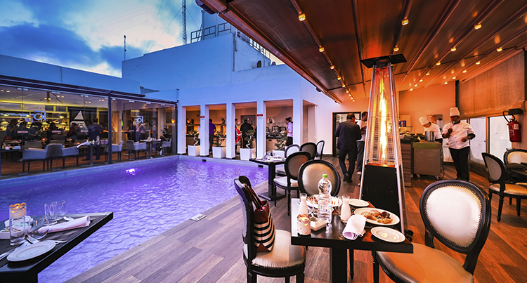

Dealing with customer complaints
The consideration of responding to the customer is pointed as a preliminary step for customer. First, pay attention to what the customer has to say and should show that care about how they are feeling. The training activities express regret for any trouble that may have caused and reassure them that will be noted as a complaint. Conducting a comprehensive investigation, involving pertinent staff members as appropriate is required for making changes (Jaykumar, 2020). Fourth, keep the client informed at every stage of the process and fully explain the conclusions and remedies suggested. Finally, follow up with the consumer should give to guarantee their satisfaction after taking the necessary corrective action. Businesses that handle complaints well not only cure the current problem, but also foster customer loyalty and trust. In the cutthroat hospitality market, a company can stand out from the competition and build a solid reputation for excellence by putting quality first in-room activities.


Conclusion
The analysis has mainly focused on making changes on housekeeping activities as it is showing numerous complaints. Training activities has been performed with the critical measurement which is useful for dealing with the situation. The standard for dealing with the guest and customer has pointed along with other marketing activities. The training activities have been focused on resolving the issues regarding the hotel business operation. Using the responses, it can be proposed the overall factor within the hotel business.

References
Alcalde-González, V., Mozo, A.G. and Bustos, A.V., 2021. No clean rooms, no hotel hotel hotel business: Subversion tactics in Las Kellys’ struggle for dignity in hotel housekeeping. Annals of Tourism Research, 91, p.103315.
Ali, BJ, Gardi, B., Othman, BJ, Ahmed, SA, Ismael, NB, Hamza, PA, Aziz, HM, Sabir, BY, Anwar, G.(2021). Hotel Service Quality: The Impact of Service Quality on Customer Satisfaction in Hospitality. International Journal of Engineering, Hotel hotel business and Management, 5(3), pp.14-28.
Bahcecik, Y. S., Akay, S. S., and Akdemir, A. (2019). A review of digital brand positioning strategies of Internet entrepreneurship in the context of virtual organizations: Facebook, Instagram and YouTube samples. Procedia Computer Science, 158, 513-522. https://www.sciencedirect.com/science/article/pii/S187705091931244X
Bashir, S., Khwaja, M. G., Rashid, Y., Turi, J. A., and Waheed, T. (2020). Green brand benefits and brand outcomes: The mediating role of green brand image. Sage Open, 10(3), 2158244020953156.
Brazil, C.K., Pottorff, T.A., Miller, M. and Rys, M.J., 2023. Using the Rapid Upper Limb Assessment to Examine the Effect of the New Hotel Housekeeping California Standard. Applied Ergonomics, 106, p.103868.
Cohen-Shacham, E., Andrade, A., Dalton, J., Dudley, N., Jones, M., Kumar, C., ... and Walters, G. (2019). Core principles for successfully implementing and upscaling Nature-based Solutions. Environmental Science & Policy, 98, 20-29.
Cohen-Shacham, E., Andrade, A., Dalton, J., Dudley, N., Jones, M., Kumar, C., ... and Walters, G. (2019). Core principles for successfully implementing and upscaling Nature-based Solutions. Environmental Science & Policy, 98, 20-29.
Evryastuti, N.K.A., Komala, I.G.A.M.K., Suarja, I.K., Suja, I.K. and Sudarmini, N.M., 2022. Cleanliness, Health, Safety, and Environment Sustainability (CHSE) Implementation in Housekeeping Department. International Journal of Travel, Hospitality and Events, 1(1), pp.37-53.
Eygü, H. and Güllüce, A., 2017. Determination of customer satisfaction in conservative concept hotels by ordinal logistic regression analysis. Journal of Financial Risk Management, 6.
Ilyas, G.B. and Mustafa, H., 2022. Price, Promotion, and Supporting Facilities on Customer Satisfaction. Golden Ratio of Marketing and Applied Psychology of Hotel hotel business, 2(1), pp.01-11.
Jaykumar, P., 2020. THE TRIUMPHS & CHALLENGES IN THE PATH OF GREEN HOTEL HOUSEKEEPING. Journal of Services Research, 20(1).
Kusuma, B.S., Hasibuan, A., Nasution, S.P., Utami, A.P. and Dalimunthe, A.R., 2022. AN INCREASING KNOWLEDGE ABOUT THE IMPORTANCE OF OCCUPATIONAL SAFETY AND HEALTH (K3) IN HOUSEKEEPING LABOR HOTELS. INFOKUM, 10(5), pp.424-431.
Lee, S.H., Yun, J.J., Díaz, M.M. and Duque, C.M., 2021. Open innovation through customer satisfaction: A logit model to explain customer recommendations in the hotel sector. Journal of Open Innovation: Technology, Market, and Complexity, 7(3), p.180.
Li, H., Liu, Y., Tan, C.W. and Hu, F., 2020. Comprehending customer satisfaction with hotels: Data analysis of consumer-generated reviews. International Journal of Contemporary Hospitality Management, 32(5), pp.1713-1735.
Sadhale, M., 2021. The Changing Role of Housekeeping Department in Hotels Post COVID-19 Pandemic. Eureka Publications.
Shapoval, V., Sönmez, S., Hsieh, Y.C. and Apostolopoulos, Y., 2022. Occupational health and safety of immigrant hotel housekeepers. Workplace Health & Safety, 70(12), pp.566-573.
Siaw, G.A., 2022. Health and Safety Practices in Hotels in Central Region, Ghana: Does Being a TVET-Trained Housekeeper Matter?. European Journal of Health Sciences, 7(5), pp.1-13.
Supriadi, B., Astuti, W. and Firdiansyah, A., 2017. Green product and its impact on customer satisfaction. IOSR Journal of Hotel hotel business and Management (IOSR-JBM), 19(8), p.1.
Tiwari, D. and Trivedi, A., 2020. Awareness of Ergonomics in Housekeeping Employees of Hotels. FUTURE TRENDS IN HOSPITALITY INDUSTRY, p.237.
Wang, J., Zhao, Z., Liu, Y. and Guo, Y., 2021. Research on the role of influencing factors on hotel customer satisfaction based on BP neural network and text mining. Information, 12(3), p.99.
Yusof, M.F.M., Mohammad, R. and Ismail, S.H., 2021. Work-Related Low Back Pain among Hotel Housekeeping Workers at Kuala Lumpur. Journal of Advanced Research in Applied Sciences and Engineering Technology, 25(1), pp.80-93.

