

MBA- Master of Business Administration
International Marketing LCM7006

Name: Shemeka Williams
Student Number: 1913883
Lecturer: Tushara Balendran
Contents
1. Introduction 3
2. Rational 3
3. Company Background 5
4. PESTEL Analysis 7
5. Porter’s 5 Forces Analysis 15
6. SWOT Analysis 20
7. STP Analysis 25
8. Marketing Mix 29
9. Directional Development Strategy 31
10. Recommendations 32
11. Conclusion 38
References 39

Introduction
In this report, the presence and approaches of Burberry in the United Kingdom and Japan will be analysed through different theoretical models and frameworks. The report will contain a situational analysis of both countries by analysing the external environment through PESTEL analysis, market competition through Porter’s five forces analysis and the brand’s strengths and weaknesses in both markets using SWOT analysis. Burberry’s marketing strategies in Japan and UK will be analysed using STP and marketing mix methods. The report will analyse and compare the similarities and differences between market conditions and brand strategies in both countries. The analysis will be used to determine the suitability of the brand’s strategy as per market requirements and recommend new strategies based on the unique requirements of each market.

Rational
Burberry is a famous fashion brand with a strong international presence. The presence analysis of Burberry in the UK and Japan will be helpful in determining the extent to which brand strategies vary or relate to each market. A brief introduction of the selected markets is provided below:
United Kingdom
The United Kingdom (UK) is an island country on the northwestern coast of Europe. The region comprises the whole of Great Britain island that contains Wales, Scotland, England and the northern area of Ireland. London is the capital of the United Kingdom (Atkins et al., 2023). London is also a leading financial, cultural and commercial center in the world (Atkins et al., 2023). The UK’s location on the map is presented below:
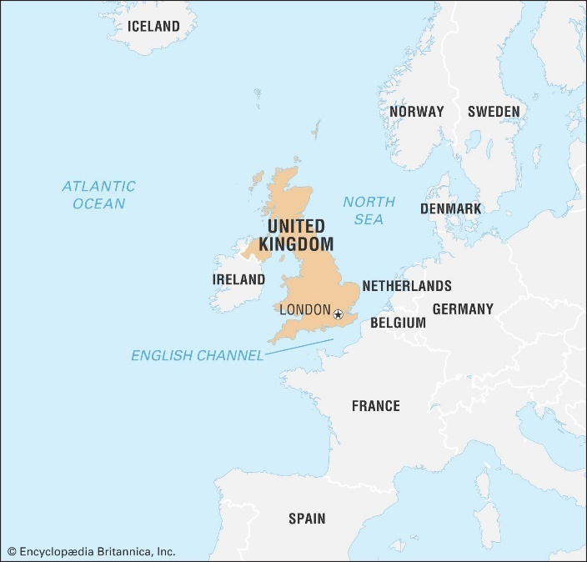
Figure 1 UK location on Map (Atkins et al., 2023)
Japan
Japan is an island country located on Asia's east coast. Almost the entire land area of Japan comprises four Islands from north to south (Toyoda et al., 2023). Tokyo is the capital of Japan, which is Japan’s also among the most populous cities in the world (Toyoda et a., 2023).
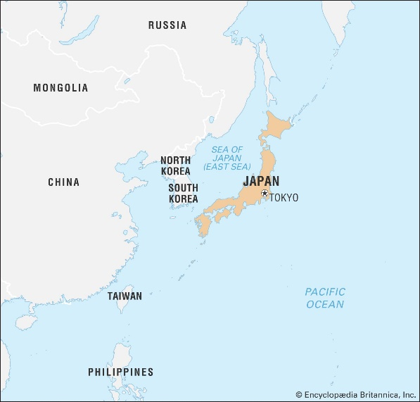
Figure 2 Japan location on map (Toyoda et al., 2023)
Burberry has maintained a prominent position in the UK and Japan's fashion industry. However, further analysis will help in determining the differences in the approaches of the brand in both countries.

Company Background
Burberry was established in 1856 by Thomas Burberry (Burberry, 2023). The brand was initially focused on selling rain-ready fabrics to promote outdoor activities. However, Burberry is now selling a huge variety of fashion items, including clothing, fragrances, accessories and makeup items. The company promotes creativity through its operations (Burberry, 2023). The focus on innovation, creativity and uniqueness guides Burberry’s operations and long-term objectives. In the past five years, Burberry has elevated its product offerings and brand positioning to display its unique characteristics and extraordinary heritage. The company is also focusing on revenue growth in its strategic plan. Burberry set out the next stage of its strategy in November 2022 to enhance its potential as a modern luxury brand in the United Kingdom (Burberry, 2023). For the medium term, the company is targeting £4 billion in revenue with a plan to develop Burberry as a £5 billion revenue brand in the long term (Burberry, 2023).

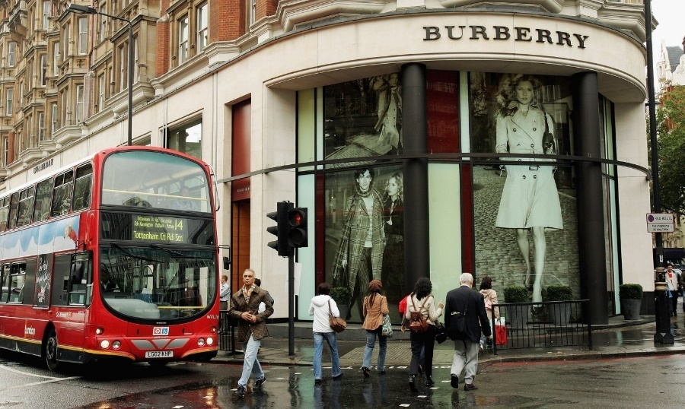
Figure 3 Burberry in United Kingdom (Fortune, 2016)
Burberry is currently operating through licensed stores in Japan. Sanyo Shokai operates more than 300 shops of Burberry, generating approximately 20-30% of its annual sales by almost 100 billion yen (Nikkie Aisa, 2014). However, Burberry has decided to switch from licensed deals in 2020 and shift to running stores directly in Japan.
.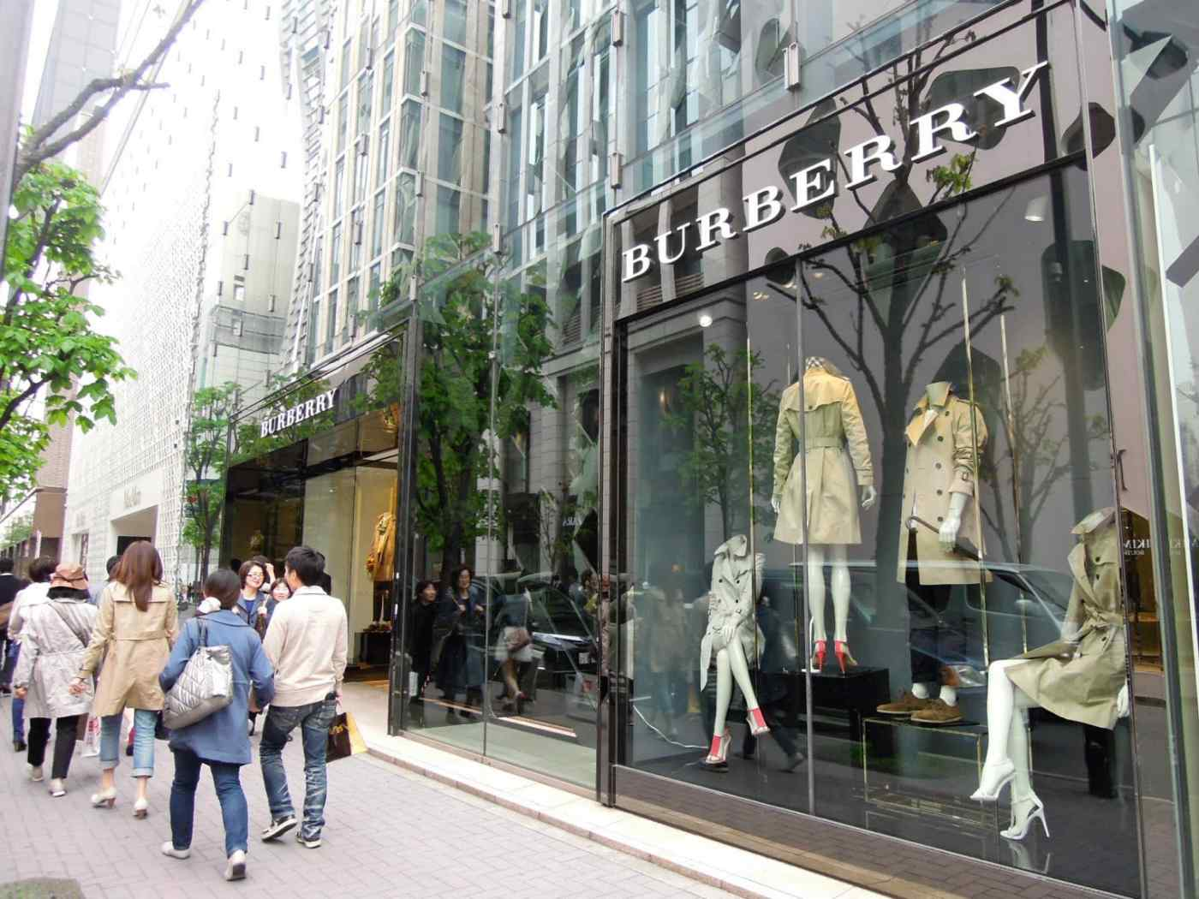
Figure 4 Burberry in Japan (Nikkei Asia, 2014)

PESTEL Analysis
The external environment of Japan and the United Kingdom will be analysed using PESTEL analysis. As displayed in the image below, the PESTEL analysis uses political, economic, social, technological, environmental and legal factors to examine the external environment for a business (Grab et al., 2018).
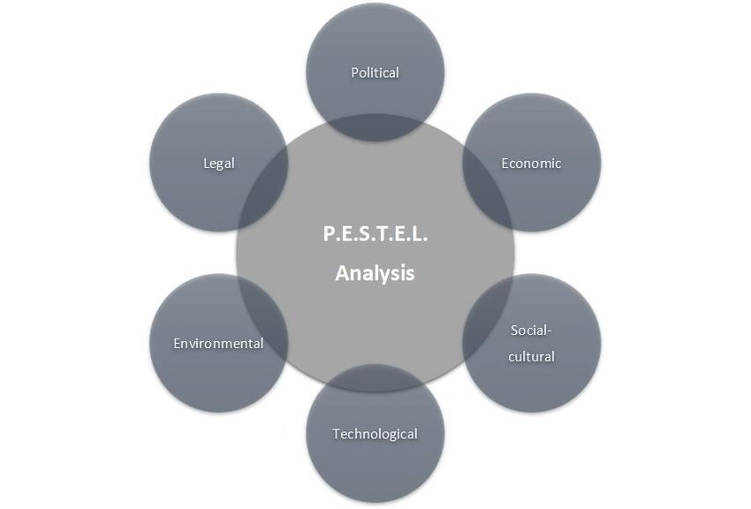
Figure 5 PESTEL Analysis (Grab et al., 2018)
Political
Both Japan and the United Kingdom follow a constitutional monarchy as a political system. However, there is a parliamentary democracy in the UK, where the prime minister rules the government and state. On the other hand, Japan is operating with a parliamentary government with the prominent role of Emperor, whereas the prime minister is responsible for government operations.
The political condition of the United Kingdom can be challenging for Burberry because of the persistent political instability in the region. Jolly and Richard (2022) have mentioned that business leaders have urged the UK’s government to take measures for political stability for business growth and development. The below figure shows the political stability index for the UK. As per the below statistics, the UK minimum points in 2019 and obtained a maximum value of 1.03 points in 2000 (The Global Economy, 2023). Top of Form
Bottom of Form
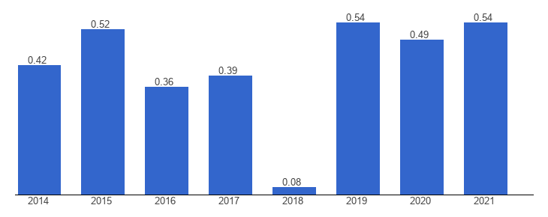
Figure 6 Political stability Index: UK (The Global Economy. 2023)
On the other hand, Japan has established better political stability in recent years. From 1996-2021, Japan’s lowest value on the stability index was 0.88 points in 2010, with a maximum value of 1.25 points in 1998 (The Global Economy, 2023). In comparison to the UK, Japan is more favourable for Burberry because the political stability index of Japan was 1.03 points in 2021 in comparison to 0.54 points of the UK (The Global Economy, 2023).Bottom of Form
Bottom of Form

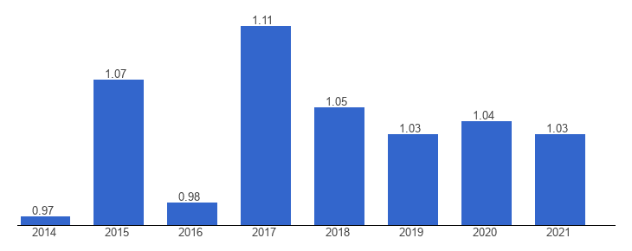
Figure 7 Political Stability Index: Japan (The Global Economy, 2023)
Economic
In comparison to the UK, Japan’s currency (Yen) is extremely weak. However, Yen’s weak value is somehow favorable for Burberry due to the company’s global reach. Nonetheless, the UK’s economic condition is not very favorable for Japan because workers are not paid sufficiently for their services, whereas customers have to pay higher prices for products (The Economist, 2018). The below figure presents statistics for real GDP in the UK from 2018-2022, with predictions till 2028. The real GDP growth of the United Kingdom was around 4.05% in 2022 as compared to 2021 (O’Neill, 2023).
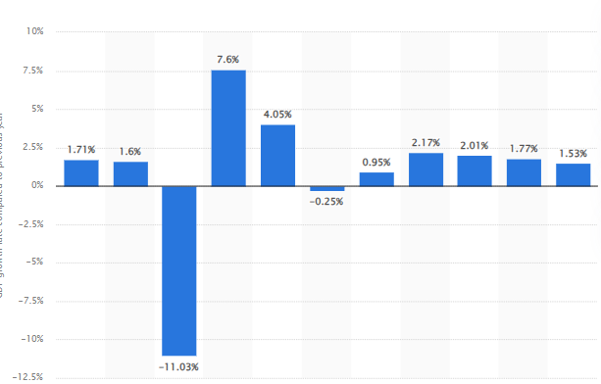
Figure 8 UK's GDP (O'Neill, 2023)
Concerning the UK’s fashion industry and suitability for Burberry, the fashion and textile sector are contributing around £20 billion to the economic growth of the country (UKFT, 2021). Despite a decline in the economic growth of the country, customers are spending around £45 billion on textiles and clothing (UKFT, 2021). The figures are expected to grow in the coming years despite the negative impact of the pandemic on the industry’s performance.
On the other hand, Japan has displayed positive patterns in economic growth. The below figure presents the real GDP in Japan from 2018-2022. It shows that the country’s GDP raised by 2.15% in 2021 as compared to the previous year (O’Neill, 2023).
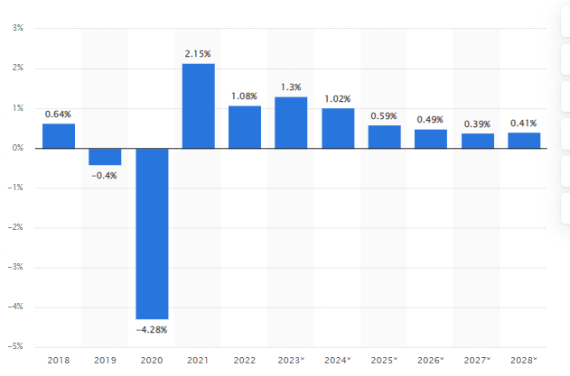
Figure 9 Japan's GDP (O' Neill, 2023)
Japan’s fashion market consists of around 60 leading businesses, which estimates to be almost 5,275.1 billion yen. The domestic apparel industry of Japan is shrinking, which offers an opportunity for Burberry to take over available segments.
Social
Japanese customers are more informed, sophisticated and fashion-obsessed than Britishers. This factor creates a major difference for businesses like Burberry, who are operating on an international scale, because it requires businesses to modify their approach as per the understanding and requirements of customers. In terms of social factors and preferences, there is a visible influence of cultural differences in both countries on their customer preferences (Choi et al., 2022).
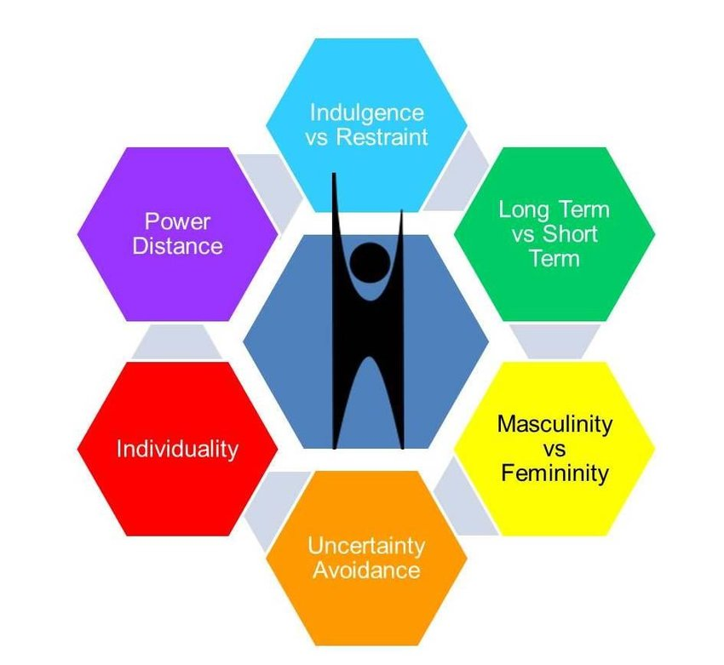
Table 1 Hofstede's cultural dimensions (Joy, 2018)
The cultural preferences and differences between Japan and the UK are highlighted using Hofstede’s cultural dimensions in the below figure. The Hofstede cultural dimensions model is useful in understanding the values, attitudes and beliefs of people belonging to a certain society or cultural segment (Choi et al., 2022).
Dimensions | United Kingdom |  | Japan
Power Distance | Low | The increasing diversity and multiculturalism have reduced the hierarchical mindset in UK’s population. | High | Hierarchy is important in Japanese culture. The social hierarchy also determines the quality of interactions between individuals.
Individualism | High | The British population is focused on achieving individualistic goals where each person is responsible for their own welfare and well-being. | Low | Social norms are strongly integrated into Japanese culture. Due to this, people view themselves as a member of a collective group.
Masculinity | Low | The UK is increasingly supporting gender equality and rejecting the idea of gender roles. More women are taking empowering roles and performing in the corporate sector. | High | There are clear gender roles in Japan where women are considered home caretakers and men take responsibility for the financial situations.
Uncertainty Avoidance | Low | The Britishers appear to be more carefree and comfortable with the idea of having less information about future unpredictability. | High | The Japanese people are less likely to indulge in risky activities and actions that can generate uncertain outcomes. Japanese people maintain a predictable lifestyle to avoid uncertain situations.
Long-term Orientation | Low | The UK is comparatively more short-term oriented, with people changing their goals and behaviours according to social and global requirements. | High | The Japanese people are more predictable in their activities because of their focus on sustaining the culture, norms and values for the long run.
Indulgence | High | The Britishers seem to be more carefree in their activities by promoting an inclusive environment where people can live the way to want, unless the actions are harmful and illegal. | Low | Japan has a more restrained culture where people are expected to control their activities and desire to comply with societal norms.
Table 2 Hofstede's culturel dimensions
Hofstede’s cultural dimensions help us understand diversity and different cultures. Its application will help Burberry expand its international presence efficiently in different regions. However, many theorists consider Hofstede’s model outdated, suggesting that its dimensions are insufficient to understand different cultures.
Technological
Casciani et al. (2022) have identified that advanced technologies are introducing disruptive and transformative changes in the fashion industry resulting in more effective and innovative procedures and business models. The extent to which the UK and Japan’s markets support technological advancements plays a vital role in promoting the services of Burberry. The UK is among the leading information communication technology markets in the world, with second place in ICT spending per head ranking. The digital technology turnover in the UK amounted to more than $240 billion in 2018 (International Trade Administration, 2023). The advanced technological infrastructure of the UK offers opportunities for Burberry to offer unique products and reach a vast range of customers (International Trade Administration, 2023).
The technological environment of Japan is similar to the UK in terms of growth opportunities for fashion brands. Japan is a global leader in technology. Most of the new and advanced products are globally associated with the Japanese market as the market is acknowledged for the quality and innovation of technologically advanced products. Japan also has the largest share of the international market in the science and technology industry (Loony BG, 2017). Moreover, the country is also spending a big sum of its budget on improved research in these fields.
Environment
The global fashion industry is among the leading contributors to climate change. Boykoff et al. (2021) have identified that the fashion industry accounts for 10% of greenhouse gas emissions globally. Burberry has to comply with the climate change policies of both UK and Japan to sustain its performance and avoid legal challenges in both countries. The UK’s six-carbon budget requires the elimination of carbon emissions by 78% by 2035 (Erbach and Szczepanski, 2022). The UK government has implemented strict policies for businesses to ensure compliance with climate change laws and further negative impacts on the environment. The UK Climate Change Act is designed to ensure net zero emissions by 2050.
The climate change policies of Japan are equally strict and rigid for businesses. Japan aims to reduce carbon emissions by 46% from 2013 levels by 2030 (The Japan Times, 2021). The country also aims to obtain complete carbon neutrality by 2050. However, Japan is also one of the leading greenhouse gas producers in the world.
Burberry is dealing with climate change policies by implementing a climate change plan to reduce carbon emissions by 46% within six years and obtain net zero emissions by 2040 (Burberry, 2023).
Legal
The legal system of both Japan and the UK supports business growth and development. The labour laws in the UK are more flexible and liberal than most countries in the European Union. The UK government has established a business environment to help firms in achieving their growth objectives. However, there are certain laws that must be followed by Burberry to avoid legal challenges. These laws are related to the data protection of customers and employees, the health and safety of employees at work, fair treatment of all workers and customers and contribution to an overall sustainable and healthy environment.
Japan offers various opportunities for the success of businesses. Japan has established a civil law system for businesses. Even though there are some statutory regimes, including those related to security protocols, these regimes are, to some extent, related to the regulations in common law jurisdictions (The Global City, 2023). The courts in Japan operate under the supreme court.

Porter’s 5 Forces Analysis
Porter’s five forces analysis will be used to determine the competitive strength of the fashion market of the UK and Japan. As presented in the figure below, Porter’s five forces model analyses the influence of internal rivalry, the threat of new entrants and substitutes and the bargaining power of customers and suppliers on business performance.
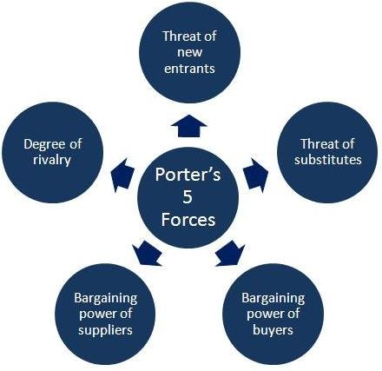
Figure 11 Porter's five forces (Shoeb, M.A., 2013).
Threat of New Entrants
United Kingdom (Moderate)
There is a moderate threat of new entrants in the UK’s fashion and textile industry. As per the statistics of 2020, around 34,045 businesses were functioning in the UK’s textile and fashion industry, with around 30,035 retailers, 8,245 producers, and 8,825 wholesalers (Fashion United, 2023). The UK's overall fashion and textile industry is dominated by small and medium-sized businesses, which shows that entering the fashion market is comparatively easier. However, big brands like Burberry make it difficult for new businesses to retain their performance and compete in the market.
Japan (Low)
The threat of new entrants is comparatively low in Japan because of investment costs. The investment costs range anywhere from 50,000 to millions of yen monthly, depending on the location and quality of products the business is looking to offer its customers. New businesses will have to invest huge sums of money to compete with existing brands. The presence of big brands increases investment requirements for new entrants to at least obtain a moderate competitive position in the market.
Threat of Alternatives
The threat of alternatives is low for Burberry in both UK and Japan. Some possible alternatives for fashion products can include ethical and sustainable clothing, recycling old clothes into new clothing items, donating unwanted clothes, and purchasing wardrobe staples and second-hand clothing. The threat is low for Burberry because of the quality of brand clothes and their sustainable nature, influencing customers to purchase products directly from the brand.
Internal Rivalry
The primary competitive factors in the retail clothing industry are divided into external factors such as brand awareness, financing, goodwill and margin and internal factors such as knowledge of customer requirements, store ambience, customer satisfaction and loyal, supply chain, digitalization solutions and marketing (Gonda et al., 2020). Brands can control their internal factors; however, brand strategies cannot control external factors. The internal rivalry between the UK and Japan’s industry is described below:
United Kingdom (High)
The competition is high in the UK’s fashion and apparel industry. A majority of fashion and apparel brands rely on online sales of their services due to the vast reach of digital mediums to target customer groups. However, Amazon has acquired a major chunk of online sales in the clothing and fashion industry (Lebow, 2021). The competition for Burberry is extremely high in the UK’s fashion industry because of the presence of big brands with strong customer bases.

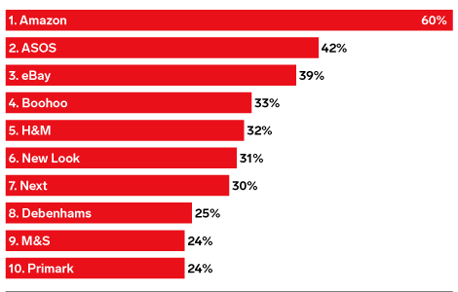
Figure 12 Competition in UK's market (Lebow, 2021)
Japan (High)
The competition in Japan’s fashion and apparel industry is extremely intense due to the presence of several local and international brands. As mentioned in the below figure, Fast Retailing Co., Ltd was a leading fashion brand in Japan in 2021, with more than two trillion yen in sales (Diep, 2022). The prominent role of various fashion brands in Japan’s apparel market increases competition for Burberry.
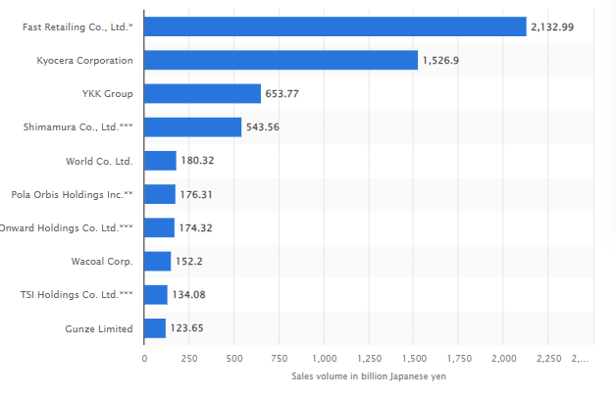
Figure 13 Competition in Japan (Diep, 2022)
Bargaining Power of Customers (High)
The bargaining power of customers is high for Burberry in both Japan and UK. This is because of the importance of customers to the fashion industry. The intense competition in both markets also increases the value of customers to the brand to sustain its position and sell products to the target customer groups. In this context, Kim and Sullivan (2019) have stated that customer loyalty has significantly reduced in recent years due to a high percentage of brand switching and increasing product diversity. Fashion brands like Burberry put effort into distinguishing themselves from other brands by relying on their brand image, product quality, price and other factors differentiating their services from rival brands. As a result, customers get more control over the brands' market strategies in the UK and Japanese fashion industries.
Bargaining Power of Suppliers (Moderate to High)
The bargaining power of suppliers is moderate to high for Burberry in both Japan and UK. This is because of the dependence of the brand on suppliers for the management of its operations. Burberry's supply chain comprises a complex process to ensure the brand's commitment to sustainability throughout its supply channels. The requirement for sustainable practices and Burberry's focus on integrating eco-friendly supply chain practices increases the importance of sustainable suppliers for the brand. While this factor gives an advantage to suppliers over the bargaining process with Burberry, the same suppliers are also flexible in their approach because of Burberry's brand image and reputation.
Similarities and Differences
Except for the threat of new entrants, both UK and Japan's market forces are making similar impacts on Burberry's performance. The key similarities between Japan's and UK's markets are the role and importance of customers and their strong control over the bargaining process in the fashion industry. The internal rivalry is also high in both countries, making it difficult for Burberry to create long-term plans with a clear idea of what the brand expects to achieve in both markets in the future. However, the threat of alternatives is low for the company. The flexible relationship with suppliers also offers growth opportunities to Burberry in Japan and UK.

SWOT Analysis
Burberry's internal strengths and weaknesses and potential opportunities and threats for the brand in Japan and the UK will be determined using SWOT analysis (Cañizares and Bourotte, 2021).

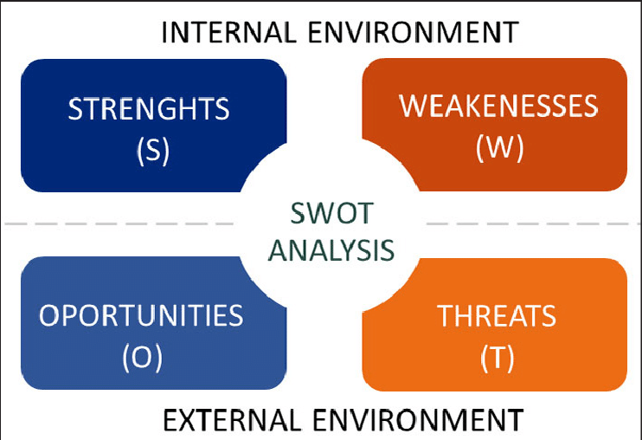
Table 3 SWOT Analysis (Cañizares and Bourotte, 2021)
United Kingdom’s SWOT Analysis
Strengths | Weaknesses
- Burberry has a strong market presence in the UK.  - Almost 88% of British customers are aware of Burberry’s services (Kunst, 2023)  - As a British brand, Burberry’s costs are comparatively low, with no import charges and additional tax for customers.  - Burberry is known in the UK for the quality of its products and services. | - As a premium brand, Burberry is not affordable for most customers.  - Customers are sharing multiple complaints about the poor customer service of the brand (Trust Pilot, 2023).  - Online service quality and order delivery are not good (Trust Pilot, 2023).
Opportunities | Threats
- The UK's apparel industry is also beneficial for the future growth of Burberry. The UK is the 3rd largest market in footwear and apparel segment globally. With a market size of around $70.7 billion, the UK offers extensive opportunities to Burberry for the growth of its business (Fashion United, 2023).  - The UK's apparel market is also predicted to reach around £65 billion by 2026 from less than £55 billion in 2022 (Fashion United, 2023). The positive growth rate of the apparel market makes growth more accessible for Burberry.  - Increasing customer awareness can be helpful for Burberry in expanding its services as per customer requirements and feedback. | - Inflation has become a big concern for businesses in the UK. Currently, the inflation rate in the UK is around 8.7%, resulting in poor customer purchasing power and high costs for businesses in the region (Office for National Statistics, 2023).  - Although the UK is not as vulnerable to natural disasters are Japan, the percentage of floods, heavy rains and heatwaves has significantly increased in the country in recent years.  - Consistent changes in customer behaviour are also a challenge for Burberry in the UK. The market competition makes it easier for customers to seek brands that are offering unique and new services while creating challenges for existing brands to invest in new ideas and experiments continuously.
Table 4 Burberry's SWOT analysis UK

Japan’s SWOT Analysis
Strengths | Weaknesses
- Burberry obtained a positive response in Japan initially through collaboration with local vendors.  - Burberry is expanding in Japan through its flagship stores to be more accessible to customers (Burberry Plc, 2023).  - A positive international reputation is helpful in improving Burberry’s income and customer base in Japan. | - Burberry's prices are much higher for an average Japanese customer.  - Japan has its own culture and preference that are way different from Burberry's fashion and styling practices.  - The image of an international brand makes Burberry less appealing to customers than local brands that specifically design their services for the Japanese population.
Opportunities | Threats
- Japan's apparel market offers growth opportunities to Burberry because of its stability and the decline in the presence of local brands in recent years. Japan's apparel industry is estimated to be around 5,275.1 billion yen (EU Business in Japan, 2023).  - The geographical location of Japan enables Burberry to access the biggest regions of Asian markets.  - As a part of the Trans-Pacific Partnership, Japan contributes 40% to the global GDP, which makes it an attractive option for Burberry. | - Inflation in Japan is currently around 3.3%, which, even though less than the UK, is still challenging for Burberry to reduce its operational costs and set higher prices for its products.  - According to Nippon.com (2023), Japan has faced 9% of global meteorological disasters and 16% of tsunamis and earthquakes since 1900.  - The changes in customer demands are challenging for Burberry in Japan. The market competition makes it easier for customers to seek brands that are offering unique and new services while creating challenges for existing brands to invest in new ideas and experiments continuously.
Table 5 Burberry's SWOT Analysis Japan
Similarities and Differences
Certain similarities are identified in the Japanese and UK markets for Burberry. The positive image of Burberry is helpful for the brand in both regions for the success of its businesses. The apparel market of both countries is growing, which is beneficial for the long-term growth of Burberry in both countries. While the markets offer certain opportunities to Burberry, the high threat of natural disasters and consistent changes in customer demands in both markets are challenging for Burberry’s success in the UK and Japan.
The differences in both markets are reflected in the prices of products because the UK’s customers do not have to pay import charges and additional taxes. In contrast, Japanese customers must pay additional costs for Burberry’s products. In addition, Burberry is a British brand, making it more comfortable and familiar with the UK market. In contrast, the Japanese market requires a more customised approach from Burberry to adapt to customer demands.

STP Analysis

The segmentation, targeting and positioning (STP) model is helpful in determining the market segmentation, targeting and positioning approach of a brand (Syed, 2021).

Table 6 STP Marketing (Syed, 2021)
Segmentation
The segmentation approach helps the brands divide a larger market into smaller customer segments, including demographic, geographic, behavioural and psychographic (Camilleri, 2018).
Burberry’s market segmentation approach in the UK
Demographic | Geographic
- Burberry is targeting teenagers to middle-aged customers.  - Burberry is targeting upper middle to high-income customer groups.  - The company offers products for all gender groups. | - Customers based in the UK are targeted.
Behavioural | Psychographic
- Burberry is targeting fashionable customers who spend high sums of money on fashion products. | - Burberry is targeting style and trend-conscious customers who prefer to shop from premium brands.
Table 7 Burberry’s market segmentation approach in the UK
Burberry’s market segmentation approach in Japan
Demographic | Geographic
- Burberry is targeting young to middle-aged customers.  - Customers belonging to higher income groups are targeted.  - The company is targeting all gender groups. | - Burberry is targeting Japan-based customers.
Behavioural | Psychographic
- Burberry is targeting customers who frequently spend on expensive fashion items and prefer a premium lifestyle. | - Burberry is targeting trend-conscious customers who seek exclusive products from different brands.
Table 8 Burberry’s market segmentation approach in Japan
Targeting
The targeting approach enables brands to increase revenues and reach their target customer groups in different markets (Camilleri, 2018). There are four targeting strategies, as mentioned in the below figure:

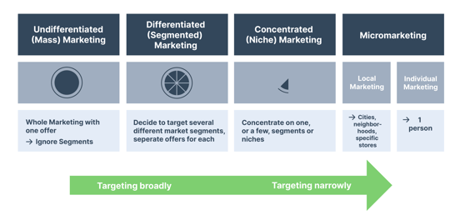
Table 9 Targeting strategies (Hugel, 2022)
Burberry has adopted a differentiated marketing strategy in both Japan and UK. Using this strategy, Burberry is targeting several marketing segments with different offers for each segment. For example, Burberry has various fashion products, including clothes, footwear, perfumes, makeup and accessories. These products are advertised differently to target relevant customer groups interested in each product segment.

Positioning
The positioning strategy shows how a brand is placing itself in a market. The two quality and price parameters were selected to analyse Burberry’s strategy in both markets. The perceptual maps below show Burberry’s position relative to its competitors in Japan and the UK.
Burberry’s Perceptual Map for the UK Burberry’s Perceptual Map for the UK
Prada  Low Quality | Louis Vuitton  Burberry  High Price
Primark  Low Price | ZARA  H&M  High Quality

Burberry’s Perceptual Map for the UK Burberry’s Perceptual Map for the UK
Low Quality
Prada | Gucci  Burberry  High Price
Shimamura  Muji  Low Price | ZARA  High Quality
Similarities and Differences
Burberry is using similar approaches in Japan and the UK, from targeting several customer groups to accessing young and middle-aged customers in both countries. In both regions, Burberry has positioned itself as a high-quality and high-price brand serving as a premium quality brand in both markets. The differences can be observed in the pricing of products because Burberry’s is comparatively cheaper in the UK than in Japan. Other than this, the targeting approach is even though same, but the way the company approaches different segments varies in both markets.

Marketing Mix
The marketing mix approach is helpful in analysing variables that brands use to increase their income and improve the outcomes of their activities in different markets (Pandey et al., 2021).

Table 10 Marketing Mix (Nguyen, 2018)
Similarities
Burberry is using similar approaches in various areas in the UK and Japan to promote its services. When it comes to ‘products’, Burberry is selling its famous trench coats and other fashion products in both Japan and UK. Concerning the ‘place’ element, Burberry operates in Japan and the UK through its flagship stores (Burberry Plc, 2023). The company has also modified its website for different customer groups in Japan and UK to make its services more accessible. The ‘prices’ are also high in both countries as Burberry wants to place itself as a premium quality brand (Burberry Plc, 2023). Burberry uses digital advertisement tools to reach a wider audience in both countries to promote its products and services. Burberry is efficiently using its ‘people’ in both countries by hiring skilled and talented employees in both UK and Japan to sustain the quality of its services. The ‘process’ is also similar as the company uses its stores and online mediums to sell products to customers. Lastly, the physical evidence for services is visible in both countries through physical outlets and websites for customers to purchase services and share their concerns with the brand.
Differences
Despite the similarities in its approach, Burberry is making sure to customise its services as ‘products’ to the requirements of British and Japanese customers due to visible differences in the culture and customer preferences. Burberry is planning to sell very limited and only high-end products in Japan, in contrast to the UK, where a wide range of brand products are available to customers (Chu and Fujikawa, 2015). The ‘prices’ of products vary regarding additional taxes and import charges that Japanese customers pay. So, despite setting similar costs, Burberry has to impose additional charges for its Japanese audience—the differences in ‘promotional’ tactics in Japan. Unlike in the UK, the company uses traditional newspaper and digital marketing in Japan to sell its services (Amed, 2015), where the company focuses more on digital promotion mediums. There are more ‘places’ in the UK where customers can buy Burberry’s services, unlike limited flagship stores in Japan. Concerning the ‘people’ element, Burberry preferably hires local Japanese employees for its stores in Japan because, unlike the UK, Japan is less inclusive, and people are not familiar with many languages. The ‘process’ varies in Japan when it comes to the import of products, while as a British brand, Burberry relies on the UK’s market to perform various activities. The physical evidence is more prominent in the UK, with multiple outlets and connection points of Burberry, unlike Japan, where customers can only access the company through limited channels.

Directional Development Strategy
A directional strategy is a company’s game plan that focuses on implementing strategies for business growth and achieving desired objectives (Welp Magazine, 2020). The direction strategy of Burberry will be analysed using the Ansoff matrix. The Ansoff matrix is a marketing tool that helps brands analyse potential options and threats involved in adopting a new strategic approach. It outlines four possible routes for business growth (Navarra and Scaini, 2016).
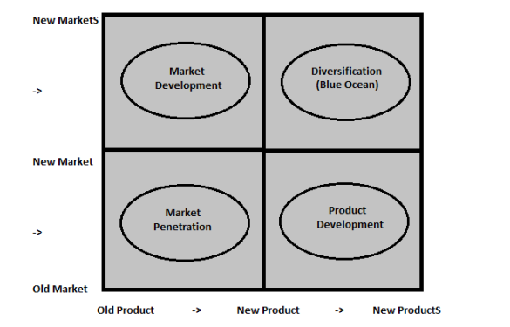
Table 11 Ansoff matrix (Navarra and Scaini, 2016)

A directional development strategy for Burberry in the UK is using a market penetration strategy in the existing marketing to increase revenues from its current customer segment. The company is doing this by investing in improved promotional strategies such as extensive marketing on digital platforms, promoting customer loyalty programs and rebranding the services to emerge as a more modified brand.
On the other hand, Burberry is using market development strategy in Japan to expand its services. Burberry is currently operating at very limited locations in Japan. Thus, expanding to new locations can increase the company’s revenues by accessing new customers.

Recommendations
The SWOT/TOWS matrix will improve Burberry’s performance in the UK and Japan. A SWOT analysis for both markets was conducted above to determine the strengths and weaknesses of Burberry in both markets and examine potential opportunities and threats in the UK and Japan’s markets. The analysis will be further expanded in this section to provide recommendations to Burberry in maximizing the benefits from opportunities and eliminating the impact of threats on its performance.
TOWS for Burberry in the UK
 | Strengths | Weaknesses
 | - Strong market presence  - Customer awareness  - Comparatively low costs for UK based customers  - High quality of products | - Expensive products  - Increasing customer complaints  - Poor online service
Opportunities | SO | WO
- Good performance of UK’s apparel industry  - Positive predicted future of UK’s apparel industry  - Increasing customer awareness | - Burberry can maximise benefits from the improved performance of the UK’s apparel industry by using its market presence and customer awareness.  - The positive growth trends of the apparel industry can be further beneficial for Burberry selling better quality products to customers.  - The increasing customer awareness combined with Burberry’s popularity can be helpful for Burberry in improving its services. | - The high prices of Burberry’s products can restrict its ability to maximise benefits from market growth due to limited customer accessibility.  - The increasing customer complaints and increasing customer awareness threaten Burberry’s long-term growth.  - The poor online services can reduce Burberry’s ability to deal with positive growth in the UK market due to the increasing dependence of customers on digital platforms.
Threats | ST | WT
- Inflation  - Natural disasters  - Changes in customer requirements | - Burberry can rely on high-quality products that customers will still prefer despite inflation.  - Burberry can use its strong market presence and customer awareness to ensure customers that the company will address their requirements through new strategies.  - Burberry can afford to reduce UK-based customers' prices and invest in more sustainable practices to reduce the threat of natural disasters. | - The high prices of Burberry’s products will further increase due to inflation. However, the poor purchasing power of customers will reduce the company’s revenues.  - The increasing customer complaints about online services are not helpful for Burberry, specifically when natural disasters are increasing, and online platforms can help the company in this regard in reaching more customers.  - The changes in customer requirements and increasing customer awareness will eventually threaten Burberry’s long-term growth.
Table 12 TOWS for Burberry in the UK
TOWS for Burberry in the Japan
 | Strengths | Weaknesses
 | - Positive response from Japanese customers  - Flagship stores making Burberry more accessible  - Good international reputation | - High prices  - Differences in Japan’s culture and Burberry’s business model  - Biases associated with not having local presence.
Opportunities | SO | WO
- Positive growth trends of the apparel market  - Japan’s geographical location  - Effective economic performance of Japan | - Burberry can use its resources and good market reputation to identify and obtain growth opportunities in Japan.  - Burberry can open more flagship stores identifying potentially beneficial markets using Japan’s geographic location.  - Burberry can use positive customer feedback to increase the variety and availability of services and efficiently use Japan’s positive economic performance for its benefit. | - The high prices of Burberry’s products can restrict its access to potential customers despite market growth.  - The perceived biases of Burberry having limited knowledge of cultural preferences can restrict its ability to maximise benefits from potential markets.  - The differences in Burberry’s business model and Japan’s culture can reduce the company’s ability to obtain desired benefits from Japan.
Threats | ST | WT
- Vulnerability to natural disasters  - Changes in customer preferences  - Inflation | - Burberry can use available resources to expand in regions that are less likely to face extreme effects of natural disasters in Japan.  - Burberry can use its positive reputation to ensure customers that their preferences are considered by the brand.  - Burberry can utilize its market presence to identify opportunities to reduce product prices without comprising the quality of services. | - Sustaining services in Japan for the long run is unpredictable for Burberry due to the vulnerability of the region to natural disasters.  - The changes in customer preferences combined with associated biases can generate negative impacts for Burberry.  - The high prices of Burberry’s products will become less affordable due to inflation.
Table 13 TOWS for Burberry in the Japan

Conclusion
This report analysed Burberry’s presence in the UK and Japan by applying various models and frameworks. The influence of different environmental factors was examined using PESTEL, Porter’s five forces and SWOT analysis. The brand's marketing approach in both regions was examined using the STP marketing model and the 7 Ps of the marketing mix. The Ansoff matrix was also applied in this report. Lastly, recommendations were provided using TOWS analysis to suggest how Burberry can maximise benefits and reduce the impact of threats on its performance in Japan and the UK.

References
Amed, I., 2015. BoF Exclusive | How Burberry is Rebuilding Its Japan Business. BoF. Available at: https://www.businessoffashion.com/articles/luxury/bof-exclusive-how-burberry-is-rebuilding-its-japan-business/#:~:text=So%2C%20alongside%20several%20new%20flagship,crafted%2C%20reinforcing%20the%20brand's%20luxury. (Accessed on 19 August 2023).
Atkins, R. C., Margaret, H., B.B, Gilbert., P.R, Josephson., L.C, Smith., and M.A, Kishlansky., 2023. United Kingdom. Encyclopedia Britannica. https://www.britannica.com/place/United-Kingdom. (Accessed on 13 August 2023).
Boykoff, M., Chandler, P., Church, P. and Osnes, B., 2021. Examining climate change and sustainable/fast fashion in the 21st century:‘Trash the Runway’. Oxford Open Climate Change, 1(1), p.kgab003.
Burberry., 2023. Modern British Luxury. Available at: https://www.burberryplc.com/. (Accessed on 13 August 2023)
Burberry., 2023. Our Purpose and Value. Available at: https://www.burberryplc.com/company/our-purpose-and-values. (Accessed on 13 August 2023
Burberry., 2023. Company. Available at: https://www.burberryplc.com/company. (Accessed on 13 August 2023)
Burberry., 2023. Burberry to be Climate Positive by 2040.. Available at: https://www.burberryplc.com/news/sustainability/2021/burberry-to-be-climate-positive-by-2040. (Accessed on 13 August 2023)
CAMILLERI, M. A., 2018. Market Segmentation, Targeting and Positioning. In Travel Marketing, Tourism Economics and the Airline Product (Chapter 4, pp. 69-83). Springer, Cham, Switzerland.
CAÑIZARES, A.D. AND BOUROTTE, C.L.M., 2021. Strategic diagnosis of geocommunication using SWOT analysis in the Varvite Geological Park, São Paulo, Brazil. Journal of the Geological Survey of Brazil, 4, pp.89-102.
Casciani, D., Chkanikova, O. and Pal, R., 2022. Exploring the nature of digital transformation in the fashion industry: opportunities for supply chains, business models, and sustainability-oriented innovations. Sustainability: Science, Practice and Policy, 18(1), pp.773-795.
Choi, S.Y., Jo, J., Lee, Y., Ha, J. and Lee, J., 2022. A cross-cultural study of the proximity of clothing to self between millennial women in South Korea and Mongolia. Fashion and Textiles, 9(1), pp.1-23.
Chu, K. and Fujikawa, M., 2015. Burberry Revamps Its Image in Japan. The Wall Street Journal. Available at: https://www.wsj.com/articles/burberry-revamps-its-image-in-japan-1439547804. (Accessed on 19 August 2023)
Diep, C., 2022. Leading domestic fashion companies in Japan as of 2021, by sales value, Statista. Available at: https://www.statista.com/statistics/655806/japan-leading-domestic-fashion-companies/. (Accessed on 13 August 2023)
Erbach, E. and M, Szczepanski., 2022. United Kingdom climate change policies. European Parliament. Available at: https://www.europarl.europa.eu/RegData/etudes/BRIE/2022/738189/EPRS_BRI(2022)738189_EN.pdf. (Accessed on 13 August 2023)
EU Business in Japan., 2023. Fashion & Clothing. Available at: https://www.eu-japan.eu/eubusinessinjapan/sectors/textiles/fashion-clothing#:~:text=Japan's%20fashion%20market%20(apparel%20and,estimated%20at%205%2C275.1%20billion%20yen. (Accessed on 13 August 2023)
Fashion United., 2023. UK Fashion Industry Statistics. Available at: https://fashionunited.uk/uk-fashion-industry-statistics. (Accessed on 13 August 2023)
Fortune., 2016. Tourists Flocking to a Weak British Pound Drives Up Burberry’s UK Sales. Available at: https://fortune.com/2016/10/18/burberry-brexit-uk-sales/. (Accessed on 13 August 2023)
Gonda, G., Gorgenyi-Hegyes, E., Nathan, R.J. and Fekete-Farkas, M., 2020. Competitive factors of fashion retail sector with special focus on SMEs. Economies, 8(4), p.95.
GRAB, B., GELDMACHER, W. and IONESCU, R., 2018, April. Managing the risks associated with the cyber city project-case study of the NEOM Project. In 31st IBIMA conference in Milan proceedings (pp. 25-26).
Hofstede Insights., 2023. Country Comparison Tool. Available at: https://www.hofstede-insights.com/country-comparison-tool?countries=japan%2Cunited+kingdom. (Accessed on 13 August 2023)
HUGEL, M., 2022. Market Targeting: Why it Pays to Differentiate, Hurree. Available at: https://blog.hurree.co/market-targeting. (Accessed on 19 August 2023)
Joy, M., 2018. Organisational Behaviour - T1 MBA - KTU Syllabus.
Kim, Y.K. and Sullivan, P., 2019. Emotional branding speaks to consumers’ heart: the case of fashion brands. Fashion and textiles, 6(1), pp.1-16.
Kunst, A., 2022. Burberry brand awareness, usage, popularity, loyalty, and buzz among luxury fashion owners in the UK in 2022. Statista. Available at: https://www.statista.com/forecasts/1352000/burberry-luxury-fashion-brand-profile-in-the-uk#:~:text=What%20is%20the%20usage%20share,brand%2C%2030%25%20use%20them. (Accessed on 19 August 2023).
Lebow, S., 2021. Amazon is in fashion in the UK, with ASOS trailing behind, Insider Intelligence. Available at: https://www.insiderintelligence.com/content/amazon-fashion-uk-with-asos-trailing-behind (Accessed on 13 August 2023).
Loony BG., 2017. Facts of Japan - Top of the world in technology, HubPages. Available
Navarra, D. and Scaini, L., 2016. Improvements in the strategic use of the marketing matrices applying dynamics parameters based on time: A better analysis of prospect. European Scientific Journal, 12(10).
Nguyen, H., 2018. Marketing Indochina Luxury and Tailored Tour to Finnish Consumers Case: Eviva Tour Vietnam. 10.13140/RG.2.2.22070.14406. at: https://discover.hubpages.com/travel/Facts-of-Japan-Technologically-advanced. (Accessed on 13 August 2023)
Nikkie Asia., 2014. Burberry wont renew licensing deal in deal Japan. Available at: https://asia.nikkei.com/Business/Burberry-won-t-renew-licensing-deal-in-Japan. (Accessed on 13 August 2023)
Nippon.com., 2023. Nearly 20% of large earthquakes happen in Japan. Available at: https://www.nippon.com/en/japan-data/h00549/nearly-20-of-large-earthquakes-happen-in-japan.html#:~:text=The%20materials%20show%20that%2C%20among,of%20the%20earthquakes%20and%20tsunamis. (Accessed on 13 August 2023)
Office for National Statistics., 2023. Inflation and price indices. Available at: https://www.ons.gov.uk/economy/inflationandpriceindices#:~:text=Consumer%20price%20inflation%2C%20UK%3A%20June%202023&text=On%20a%20monthly%20basis%2C%20CPIH,down%20from%208.7%25%20in%20May.. (Accessed on 13 August 2023)
O’Neill, A., 2023. United Kingdom: Real gross domestic product (GDP) growth rate from 2018 to 2028, Statista. Available at: https://www.statista.com/statistics/263613/gross-domestic-product-gdp-growth-rate-in-the-united-kingdom/. (Accessed on 13 August 2023)
O’Neill, A., 2023. Japan: Real gross domestic product (GDP) growth rate from 2018 to 2028, Statista. Available at: https://www.statista.com/statistics/263607/gross-domestic-product-gdp-growth-rate-in-japan/ (Accessed on 13 August 2023)
PANDEY, S., GUPTA, S. and CHHAJED, S., 2021. Marketing Mix Modeling (MMM)-Concepts and Model Interpretation. Sandeep Pandey, Snigdha Gupta, Shubham Chhajed.
Shoeb, M.A., 2013. Integration of Wind Power into Electricity Markets (Doctoral dissertation, Master thesis, Eindhoven University of Technology, EES. 13).
SYED, A., 2021. Importance of STP in Digital Marketing, LinkedIn. Available at: https://www.linkedin.com/pulse/importance-stp-digital-marketing-ashraf-syed/. [Accessed 19 August 2023].
THE ECONOMIST. The British economy is becoming more concentrated and less competitive. Available at: https://www.economist.com/britain/2018/07/26/the-british-economy-is-becoming-more-concentrated-and-less-competitive?utm_medium=cpc.adword.pd&utm_source=google&ppccampaignID=18156330227&ppcadID=&utm_campaign=a.22brand_pmax&utm_content=conversion.direct-response.anonymous&gclid=CjwKCAjwzo2mBhAUEiwAf7wjkmUvMP4LxMnmYiQQq5sePycvkMG5cYYj10G0wtAlVxOKgvqe8fcTOBoChHQQAvD_BwE&gclsrc=aw.ds. [Accessed 28 July 2023].
The Global Economy., 2023. United Kingdom: Political Stability. Available at: https://www.theglobaleconomy.com/United-Kingdom/wb_political_stability/#:~:text=Political%20stability%20index%20(%2D2.5%20weak%3B%202.5%20strong)&text=For%20that%20indicator%2C%20we%20provide,of%201.03%20points%20in%202000. (Accessed on 13 August 2023)
The Global Economy., 2023. Japan: Political Stability. Available at: https://www.theglobaleconomy.com/Japan/wb_political_stability/. (Accessed on 13 August 2023)
The Japan Times., 2021. Uniting Paths to Carbon Neutrality. Available at:https://www.japantimes.co.jp/2021/11/01/special-supplements/uniting-paths-carbon-neutrality/ (Accessed on 13 August 2023)
The Global City., 2023. Unparalleled Business Support. Available at: https://www.theglobalcity.uk/the-uk-offer/business-environment#:~:text=Unparalleled%20business%20support&text=The%20UK%20has%20more%20flexible,to%20help%20firms%20to%20succeed (Accessed on 13 August 2023)
Toyoda, T., Hijino, S., K, Masamoto., H.G. Cameron., and A, Watanabe., 2023. Japan. Encyclopedia Britannica. https://www.britannica.com/place/Japan. (Accessed on 13 August 2023).
Trust Pilot., 2023. Burberry Service. Available at: https://uk.trustpilot.com/review/www.burberry.com. (Accessed on 19 August 2023)
UKFT., 2021. UKFT’s Compendium of Industry Statistics and Analysis 2020. Available at: https://ukft.s3.eu-west-1.amazonaws.com/wp-content/uploads/2021/11/24095453/UKFTs-Compendium-of-Industry-Statistics-and-Analysis-2020-Executive-Summary.pdf. (Accessed on 13 August 2023).

Welp Magazine., 2020. A complete guide to directional strategy. Available at: https://welpmagazine.com/a-complete-guide-to-directional-strategy/#:~:text=Directional%20strategy%20is%20the%20game,scope%20of%20each%20individual%20business. (Accessed on 19 August 2023).

