Hatice Isbilir (2021194)
UNIVERSITY OF WALES TRINITY SAINT DAVID
Professional Career Development - BMSW4005

Contents
1.Introduction 2
2.Main Findings 2
2.1 SMART GOAL 3
2.2 SWOT analysis 3
2.2 Skills Audit 4
2.3 Learning Styles & Personnel Development Plan 5
References 6

1.Introduction
In this assignment I am going to talk about how importance of professional career development and how it is going to help me get myself a job, and which job I would like to do after passing this course. I have learned there is different strategies that I can use to apply for a job and how I can overcome the challenges.
Self-awareness is to understand your own strengths and weaknesses and how you are going to use them in your work place (Anon., n.d.). We need to get to know our self and understand what we need from our own strengths and how we can overcome what we need to learn. We basically need to get to know our self and we need to see what would motivate us.
Self-improvement is important in our life because when you are in work you always need to renew our knowledge you will always need to update your courses and take courses to make yourself a knowledge person. For us to improve our self we need to be motivated and we can use a different methods and models in this report. To achieve the personal development goal there are different models and theories and they are SMART / SWOT / Maslow / Johari / 4C /Vark / Honey & Mumford.

2.Main Findings
I have been motivated to change my current situation as I wasn’t happy with the way my life was, I needed a change. I always wanted to become a nurse and now I feel like my time has come. I was an adult career for 10 years and worked in a same company I loved looking after elderly people. I really enjoyed it, but I need I need to do something that I will love even more. By motivating myself I will become adult nurse and work hard I am going to be using Maslow’s hierarchy of needs theory reason for this is because I want to improve myself. As he stated that are motivated by five basic categories of needs and they are: physiological, safety, love, esteem, and self-actualization (Hopper, 24 February 2020). At the end of this course I would of like to apply and get accepted for an adult nursing degree and eventually become a nurse.
Stephen Covey wrote a book called Covey’s Seven Habits and he made sure that it was easy to understand, and it would be a simple model so people could apply in practice. He wrote this book for business world he wanted people to live a full and have a good life, not just work and not enjoy their job.
- Be proactive: I am not a lazy person I started this assignment early and made sure I had enough time to complete it and not rush. I am the most proactive person ever also I am a very organised person.
- Begin the End in Mind: I will set a goal and don’t fall behind it I will follow my goal to right at the end and achieve my goal.
- First Things First: I will make sure that I will do all my assignments on time and achieve my goal, never put anything off.
- Think Win-Win: I can do this, I can finish this course and go on to the next level, become an adult nurse.
- Seek First to Understand and Then to be Understood: I will always listen to my lectures and make sure that I am not making a mistake, I am a good listener.
- Synergize: this will show me how to work as a team as well as on my own.
- Sharper the Saw: I can do this course; I believe in myself and if I work hard enough I can pass and achieve my dream job.

2.1 SMART GOAL
A smart goal is to help a guide a goal setting it stands for Specific, Measurable, Achievable, and Realistic and Timely, all these will help us to achieve our goal. (Inc, 2015 -2021)
My SMART GOAL are;
Specific: I would like to become adult nurse and work in a hospital, improve my knowledge
Measurable: I need to work towards my goal and work hard and achieve my goal
Achievable: after this course I need to go into do a course on adult nurse and gain more experience
Realistic: I have experience worked in a care home for 10 years I know how to look after older people and how to treat them.
Timely: I would like to achieve my goal in 2 years’ time and become adult nurse.
Picture below shows Maslow’s hierarchy of needs theory and it explains why we need all these and later another 3 theory was added.
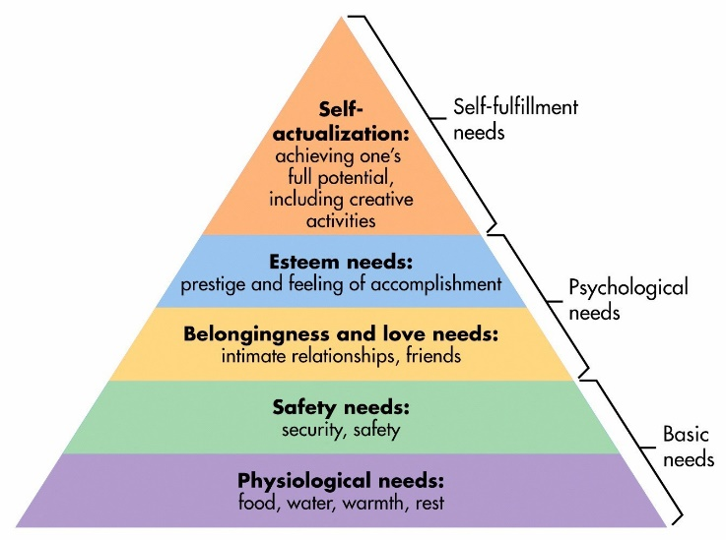

2.2 SWOT analysis
Here it is my SWOT analysis I have created using the SWOT template, I will be using TOWS analysis it is a tool that used to generate and compare and select strategies. At first I will be using SWOT analysis and then I will be using TOWS analysis. TOW analysis has simple rules like many models
Strength
- I am a good listener
- I work good in a team
Positive thinking My strengths will help me get my dream job as an adult nurse, as I am good lister and I work good under pressure.
Weakness
- Language barrier
- It / Digital skills
I will need to improve my weakness by reading more English books and going to a language course. When I apply for a job I will need to be a good speaker and writer as I will need to understand the tablets I am going to my clients. I will also need to have extra IT lessons and get better at it as technology is so important in our life.
Opportunities
- Change career
- Started a new course
Threats
- Racism
- Covid 19
Due to the pandemic many places have closed, we have all been home almost a year our mental health being aren’t been good. I will need to go out and make new friends and get over my emotions.

2.2 Skills Audit
Employability skills are important in every job you will need these general skills to make someone desirable to an organization. Managers will always look for employees with good skills. To have a good employability skill you will need to work with others and work as a team. For you to be successful in a working environment you need to have professional skills that enable you as a worker to be successful. (DOYLE, sept 17 2020)
I have identified three employability skills that I need to improve. There is five steps that needs to be considered when you are doing a skills audit.
Computer skills: most workplaces need computer skills and it is important to have this skill. I will need to have extra computer lessons to improve myself. When I first started this course, I didn’t know how to use Teams, Moodle and how to email but now I am good at computer I have learned how to use all these technologies. In my new job I would need learn to use common programs like Microsoft office specially Word or even Outlook.
Time management : I will need to improve my time management I should start my assignment early not leave it last minute. I will also need to improve myself by waking up early and been more proactive. I will need to set myself a goal where time management is important. If I was working in a hospital I couldn’t be late for my shift as I would have clients waiting for me.
Strong work ethic: I am a very hard working person when I was working full time I made sure that I did my job properly and didn’t leave anything behind for next person to start their shift. I love working and this is so important in a working environment if you are not happy within your work place anything you would do would make you upset.

2.3 Learning Styles & Personnel Development Plan
I am a visual learner I learn better by looking and watching other people doing things. VAST style talks about visual learners that they are not good with written text but they do make sense of images, graphs and other learning materials. When I am learning new things I like that take picture of them to understand how I am going to be doing that new work.
I would like to become a nurse and I believe this learning style is perfect for me as I will be taking bloods of clients and I can learn by watching the head nurse to show me how to do it.
My personal development would be is to become an adult nurse before I can become one I need to finish this course and while studying this course I need to apply for university and hope to get accepted. in 2 years time I would like to become an amazing nurse and work in a big hospital with an amazing view outside.

References
Anon., n.d. Self-Awareness for Professionals: Importance & Examples. [Online]
Available at: https://study.com/academy/lesson/self-awareness-for-professionals-importance-examples.html
[Accessed 24 February 2021].
DOYLE, A., sept 17 2020. careers. [Online]
Available at: https://www.thebalancecareers.com/employability-skills-list-and-examples-4143571
[Accessed 3 March 2021].
Hopper, E., 24 February 2020. Maslow's Hierarchy of Needs Explained. ThoughtCo.
Inc, C. E., 2015 -2021. CFI. [Online]
Available at: https://corporatefinanceinstitute.com/resources/knowledge/other/smart-goal/
[Accessed 25 February 2021].

