

Module name: Entrepreneurship
Assignment 2 –Written assignment
Word count : 2000 +/-
Module code: LCBB5001
Lecturer name : Riaz Bhatti
Student name: Mariana Mihaela Cicu
Student ID number : 2028271
Table of Contents

BUSINESS DESCRIPTION / MARKET OPPORTUNITY 3
INDUSTRY ANALYSIS 4
OPERATIONS AND MANAGEMENT TEAM 8
MANAGEMENT TEAM 10
MARKETING: 10
FINANCIALS 13
REFERENCES 15

BUSINESS DESCRIPTION / MARKET OPPORTUNITY

Wedding planning is a whole process that is a combined portrayal of diversity and inclusivity (Daniels and Wosicki, 2020). However, post the COVID the strain continued through restrictions in gathering, difficulties in finding proper spacious places to gather large number of people; community hall, garden and other event space owners reluctant to rent their spaces due for gathering, moreover lack of access to decorative items, flowers etc. have been creating a huge barrier for brides and grooms to enjoy their desires of dream wedding.
The business plan is to create an online application for wedding planning. The app will make it easier for bride and groom to find nearest venues available on the given wedding date and given number of guests that maintain COVID protocols (Seraphin, 2021). Not only that, the app will strive to serve a huge catalogue to the customers to pick from a huge options of decorations, flowers, themes, colour panels, choice of fabrics, styling, food options, table arrangements etc. Moreover, it will be a two-ways business as it would connect the customers with nearby wedding planners to whom they can pick based on their profile, previous works, experiences etc. The app will help to initiate communication between the customers and the wedding planners through quick chatting, sharing contact details, arranging virtual meetings to make sure everything happens with proper appropriateness. Customers will be given an estimation of pricing by adding the service rate set by chosen wedding planner, rate set by the wedding planner for chosen decoration items, chosen venue rate, and other fees with clear details of all purposes. The app will be known as The Wedding Bell. The business will work as a connector between wedding planners and customers to make the whole actions of wedding planning fuss-free while increasing the business of local small-to-large scale wedding planners. The event management sector of the UK is worth £39.1 billion (Dowson and Bassett, 2018). Among which, the wedding industry of the UK was worth £14.7 billion in 2021 with an expected revenue forecast of £28 billion in the coming two years (Sonas. 2021). Moreover, with the withdrawals of the restrictions of COVID-19 the market is growing with a prospective steady flow. Besides, there are not yet any such prominent apps in the market. Therefore, the idea will be effective with fresh market scopes.

INDUSTRY ANALYSIS

Threat of new entry

Around 278599 weddings take place every year in the UK. There is an estimation worth £14.7bn that gets directly spent on weddings on an annual scale (UK WEDDINGS TASKFORCE. 2022). The wedding industry itself is vast enough in the United Kingdom. Around 400000 people are involved with the wedding industry where 250000 people are engaged in delivery related works and 150000 take part in supporting wedding functions through miscellaneous works ((UK WEDDINGS TASKFORCE. 2022). In other words, the wedding planner market in the UK holds an impeccable source of income which draws the attention of new market entrants on a regular basis. New wedding planning businesses can enter the market effectively with upscaled business shapes to draw the customers. However, even though there are scopes for new entrants, the unique and innovative business plan of The Wedding Bell can still enjoy a market stimulation with unique business proposition . Hence, the threats from new entrants are medium.

Threat of substitutes

There are a huge number of businesses currently serving as wedding planners in the United Kingdom market. They are open or directly available to customers to connect with them and choose a wedding plan suitable for their special day. There are also applications available that offer customers to plan their wedding venue, connect with suppliers and decorators and track their budget etc (Singh, Singh and Bathla, 2020). Whether these apps can serve as an alternative there are not yet any prominent substitutes who can help customers to customise their wedding plan while at the same time get connected to an array of local wedding planners willing to bring forward their extravagance. Hence, the threat of substitutes is low.
Bargaining power of customers

Since there are a bunch of wedding planning services over applications available in the United Kingdom there are multitude of options left for customers to choose from.However The Wedding Bell is planning to have an unique business model where customers will not only be able to plan and customise their wedding event but will also get the chance to connect with a huge list of wedding planners who are ready to give that customised plan the shape of a dreamy reality. Moreover, the wedding tourism market and destination wedding tendency is increasing among the youth (Szczepanik and Wiesner, 2018). Hence, such a wholesome business plan will help them guide through effectively. Therefore, the lack of available market options can control the bargaining power of customers by making it low.

Bargaining power of suppliers

The bargaining of power of suppliers can be a strong effective factor in the case. The success of The Wedding Bell would be highly dependent on the power of the suppliers who deal with wedding essential supplying and delivering. The market is filled with suppliers, hence it would not be difficult to switch to a new supplier if one’s rate is high. However, if the bargaining power of suppliers increases in an overall scale then it will affect the pricing of the business too (Etemaddar, Thyne and Insch, 2018).

Competitive Rivalry:

Name of competitor | Differentiation
Competitor 1  Hitched Wedding Planner | Hitched Wedding Planner is an online wedding planner that enables the customers to plan their nuptial festivity with the help of a wedding checklist. Users can browse venues, and the detailed directory of suppliers in the location and plan their wedding budget.  Compared to Hitched Wedding Planner, The Wedding Bell will offer the features to find venues with COVID protocol details, as per the entered day, location and number of guests. The app will also offer features to customise each and every details of the wedding event and a huge directory of wedding planners with their plan catalogues and pricing details based on your customised plan.
Competitor 2  Lady Marry | This one is another strong competitor as it offers a much handy wedding planning feature to the users. Users can get a personalised checklist and timeline for their wedding event just by entering their preferred date of wedding.  Compared to Lady Marry, The Wedding Bell strives to offer more customisation with chances to personalise by choosing from wide options and effective suggestions which will ensure the customers to have a planning on their own without any improvisation by others.
Competitor 3  The Knot Wedding Lookbook | This competitor application serves a huge suggestion of wedding dress by narrowing down the suggestion of boutiques based on the style the user wants and initiates an appointment with the boutique.  The Wedding Bell goes a few steps ahead by having integrated all such wedding plan related features in it. It will not only offer suggestions for wedding planning and event planners nearby but also offer best flower suggestions based on the season of your wedding date, best wedding dresses, jewelleries and gift shops nearby.

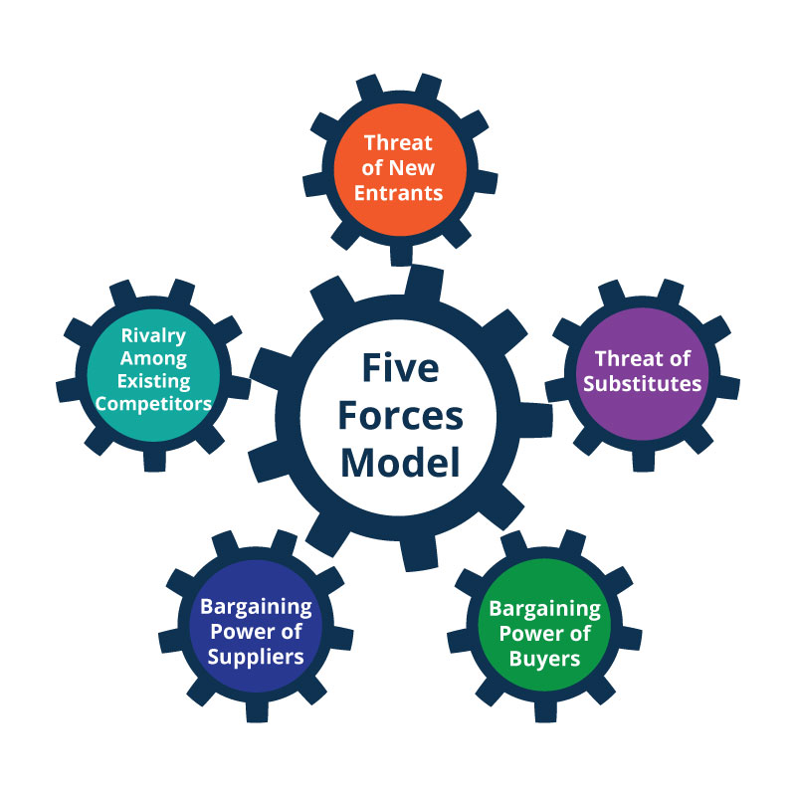
Figure 1: Porter’s Five Forces
(Source: Bruijl and Gerard, 2018)

OPERATIONS AND MANAGEMENT TEAM
OPERATIONS
The business process involves a wholesome wedding planning helping hand for users who are thinking of getting hitched and making their special day a bit more memorable with a fuss free planning guide.
Process of the business:
The first and foremost process is to create an application with necessary features and connect with local wedding planners of all scales, florists, wedding essential suppliers, boutiques, jewellers using a robust geotracking directory that can offer their locations and contact details.
Upon the launch of the app the business will be involved in connecting users with those wedding planning related businesses to benefit both the parties. Around 64% couples prefer to use wedding planning apps (Surplice, 2020). Therefore, using some diversion in the features can be effective to draw users.
App features for customers:
- Easy search features for venues following COVID mandates.
- Venue suggestion as per guest list, preferred location, and wedding date.
- Feature to create a dream wedding plan by choosing options for wedding themes, wedding flowers, table assortments, entry decoration, decoration items, etc.
- Wedding planner suggestions based on the customised plan and budget and location.
- Additional suggestions for seasonal flowers that would be best for the wedding, local boutiques and jewellers for shopping.
App features for wedding planners, and other related businesses:
- Increased visibility through customisable store fronts
- Showcasing the best value profitable pricing and getting assigned with customers ready to pay the amount.
- Chances to get suggested to the customers repeatedly based on ratings and performances.
- Getting suggestions for suppliers and other related businesses to have a smooth project handling process and to grow the network.
Equipment necessary:
The business will need necessary equipment such as a strong technological support and IT setup for increasing the network and connectivity (Emenike, 2019). With the future growth the business is willing to open its own brand to supply best-quality wedding supplies and self-registered venues for grand wedding planning.
Placement of the business:
Customers will be able to find the business easily using their own mobile application and connect with the wedding planners, boutiques, suppliers and jewellers using quick chat options, virtual meeting options etc. A headquarter will be built or hired for employing staff to ensure the whole virtual process of adding businesses and generating customers are taking place smoothly with strong customer support, helpline facilities, etc.
Making revenue out of the business:
A revenue would be made by placing 8% of service charge for using the platform from the users for every wedding planning order placed via using the application. A flat 20% charge will be placed on businesses who will get customers, orders for products or wedding planning assignments using the platform. Moreover, to make up money for the free features the revenue will be generated from advertising, sponsorship and affiliate marketing. The loss of the revenue would be prevented through proper monitoring of the whole process to supervise if any loss is happening due to the connected businesses, policy loopholes or app glitches. Businesses will need to work on boosting their profiles by giving exciting offers, discounts and service qualities with guarantees to make themselves presentable and attractive in front of the customers. A fixed amount would be charged on businesses if they are unable to show at least 5-6 orders through the application within a given 6 months to prevent businesses from contacting customers over the platform and manipulating them to agree with the wedding planning with private transactions.

MANAGEMENT TEAM

Name | Skills | What do they bring to the firm
Senior management team | Project handling, decision making, business modelling, process supervising, leadership | They will help in making decisions for making the projects and functions of the business perform smoothly and to guide all the departments related to the business.
IT management team | App developing, app updating, troubleshooting, query resolving, coding, chatbot handling, virtual assisting, customer service | The role of the IT management team will involve managing the whole technical operations to ensure the app is running smoothly.
HR management team | Recruiting, employee handling, culture developing, employee well-being developing | The team will take part in recruiting staff and managing their talent for running the business successfully.
Finance management team | Financial management, auditing, financial report prediction and strategy building | Managing the revenue sources, arranging finances, taxes and other financial obligations of the company will be the financial teams’ duty.

MARKETING:

Product:
The product will be wedding planning facilities for those who are looking for a helping hand to arrange their wedding with detailed suggestions and booking facilities about nearby venues, wedding planners, florists, boutiques, jewellers, gift stores etc. The Wedding Bell is willing to serve as a one stop destination for customers who can find every necessary guide for planning their wedding and loads of options to customise every little detail of the occasion.
Price:
The wedding planning fee will vary from £6000 to £100000 or more based on the rate offered by the chosen wedding planner, chosen customised wedding planning, other additional service additions, and 8% of the service charge fee.
Promotional Mix:
To promote the product the business will invest in building a strategic marketing plan that would include social media marketing, advertisement, banner printing and placement, press release, pay-per-click advertisement, and influencer marketing. The goal of the promotion will be reflecting the brand’s benefits, aims, goals and messages which are just curated for the customers who are looking for a wedding just like their dream.
Place (Distribution strategy):
The service would be distributed through the small to large business who would be linked and registered with us. After the profit tracking ahead of the launching the distribution will increase through networking with local market suppliers, venue owners, churches, event teams etc.
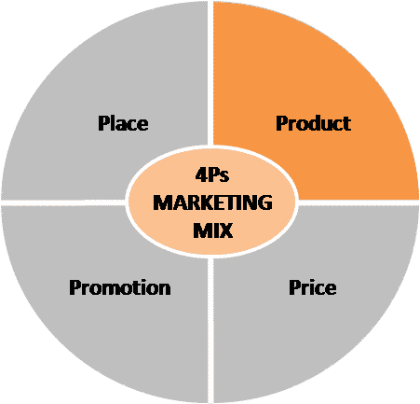
Figure 2: 4Ps of marketing mix
(Source: Rahman and Kuzminov, 2019)

FINANCIALS

Sources of funds:

The government of the UK is quite supportive towards the success of small to medium scale entrepreneurship to boost the economy of the country. Hence, sources of funds can be earned through government loans. Besides, funds can also be generated from foreign investors and angel investors.

Use of funds

 | Month 1 | Month 2 | Month 3 | Month 4 | Month 5 | Month 6
Revenue generated from different sources (£)
Modelling of the business | 1000 | 1200 | 1380 | 1500 | 1600 | 1750
Paying off the debts | 200 | 600 | 700 | 780 | 820 | 900
Streamline the market channels | 210 | 300 | 380 | 420 | 450 | 500
Contracting with the suppliers and wedding planners | 400 | 420 | 480 | 550 | 600 | 640
Training employees | 9000 | 9500 | 10200 | 10600 | 11200 | 11500
Investing the funds for increasing service facilities | 2300 | 2700 | 3400 | 3800 | 4000 | 4500
Total revenue | 13110 | 14720 | 16540 | 17650 | 18670 | 19790
Variable costs
Fixed costs
Labour payrolls | 5000 | 5000 | 5000 | 5000 | 5000 | 5000
Business and labour insurance costs | 2000 | 2000 | 2000 | 2000 | 2000 | 2000
Equipment management, electricity and internet expenses | 700 | 700 | 700 | 700 | 700 | 700
Business and property taxes | 250 | 250 | 250 | 250 | 250 | 250
Business loans | 350 | 350 | 350 | 350 | 350 | 350
Property rent | 100 | 100 | 100 | 100 | 100 | 100
Total Fixed costs | 8400 | 8400 | 8400 | 8400 | 8400 | 8400
Variable costs
Supplier costs | 1000 | 1200 | 1350 | 1450 | 1500 | 1700
Raw materials | 600 | 680 | 780 | 870 | 880 | 940
Distribution cost | 400 | 420 | 480 | 520 | 550 | 800
Production cost | 300 | 400 | 450 | 520 | 550 | 580
App management charges | 600 | 670 | 720 | 750 | 780 | 800
Promotional costs | 900 | 1000 | 1100 | 1200 | 1250 | 1400
Total variable costs | 3800 | 4370 | 4880 | 5310 | 5510 | 6220
Profit | 910 | 1950 | 3260 | 3940 | 4760 | 5170

REFERENCES

Bruijl, D. and Gerard, H.T., 2018. The relevance of Porter's five forces in today's innovative and changing business environment. Available at SSRN 3192207.
Daniels, M. and Wosicki, C., 2020. Wedding planning and management: Consultancy for diverse clients. Routledge.
Dowson, R. and Bassett, D., 2018. Event planning and management: Principles, planning and practice. Kogan Page Publishers.
Emenike, E.C., 2019. Integration of sustainable development in software development: case study: wedding planning.
Etemaddar, M., Thyne, M. and Insch, A., 2018. A taste of home-choosing a destination wedding. Anatolia, 29(3), pp.422-432.
Rahman, M.M. and Kuzminov, A.N., 2019. Marketing mix as a source of increasing the efficiency of marketing activity. Modern Problems of Scientific Activity, pp.66-68.
Seraphin, H., 2021, January. COVID-19: An opportunity to review existing grounded theories in event studies. In Journal of Convention & Event Tourism (Vol. 22, No. 1, pp. 3-35). Routledge.
Singh, R.K., Singh, P. and Bathla, G., 2020. User-Review Oriented Social Recommender System for Event Planning. Ingénierie des Systèmes d Inf., 25(5), pp.669-675.
Sonas. (2021). An Overview Of The UK Wedding Industry. Available at. https://www.sonas.events/blog/an-overview-of-the-uk-wedding-industry/. (Accessed on 20th November 2022).
Surplice, P., 2020. Future of the Wedding industry: Is the party over?.
Szczepanik, U. and Wiesner, W., 2018. Destination wedding-popularity among young students. Ekonomiczne Problemy Turystyki, 43, pp.41-50.
UK WEDDINGS TASKFORCE. (2022). The UK Wedding Industry - Facts & Figures. Available at. https://ukweddings.org/key-facts. (Accessed on 23rd November 2022).

