LCLM 4005
Week 2 Improving Self-awareness
21/09/2024
Journal 2
Today, Dr Iniobong Enang started the lecture by asking us about the last lecture and about the meaning of self-awareness and everyone gave an answer. After, from her explanation I understood that Self-awareness is the ability to understand ones inner self and the things that make him as a person like emotions, thoughts, behaviours, beliefs, and values. Then, she moved to explain the importance of self-awareness to the individual as it make the latter reflect on himself, know how to control their feelings and behaviours, and to know how to interact with other people. Moreover, it is vital as the individual become aware of their strengths and the weaknesses that have to work on. Finally, to be able to accept others’ negative feedback and use it to improve oneself.
There are 4 levels of unconsciousness : 1) Unconsciousness means not to be aware of ones thoughts, feelings. 2) Consciousness is when one is aware of the external surroundings and thinking about external changes. 3) Self-awareness is to understand and accept one’s self and how other individuals see them. 4) meta self-awareness is the stage in which an individual starts to understand one’s self-awareness: How this inner process of the information affect both one’s self-understanding and the other persons.
Self-evaluation is the process of self-reflection. It is a way of study that helps people learn about their strengths and weaknesses to work on. This self-evaluation can create a gap between the real-self and the ideal-self leading to self-criticism. This self-criticism, if it is constant and not encouraging to grow, can cause mental health issues, low-self- esteem, and avoidance of self-awareness. To take control of this self-criticism one has to reduce the gap between the real-self and the ideal-self. This might be done by making self-improvement, reducing the conflicts inside, and accepting one’s self.
As self-awareness is important as it allows to manage ones emotions and have good interactions with others. Thus, to improve it, some tools like the Personal SWOT analysis, Johari window, personality tests and learning styles are used for this purpose. Starting with the SWOT analysis, it is a technique used to identify one’s Strengths like working under pressure or being a problem solving, Weaknesses like being impatient or lacking concentration , Opportunities like asking for feedback to improve any weaknesses, and Threats like destructive feedback and self- criticism.
Another tool is the Johari window that was developed by Joseph Luft and Harry Ingham. It consist of 4 windows that contains all the information regarding the individual. It helps to build trust within a team and the personal development. The first is known by the open area, known to the interested person and the others. Therefore, it needs to grow as it contains good communication and free from mistrust, conflicts, and misunderstanding. The second, the blind area contains the information unknown to the person but others know it, and needs to be reduced to let space to trust and constructive feedback. The third area is the hidden self that only the person knows but does not share, but information related to work should not be kept hidden. The fourth one is the unknown area in which the information is unknown by both the person and the others around him.

The Johari Window – Activity done by Hiba (daughter)

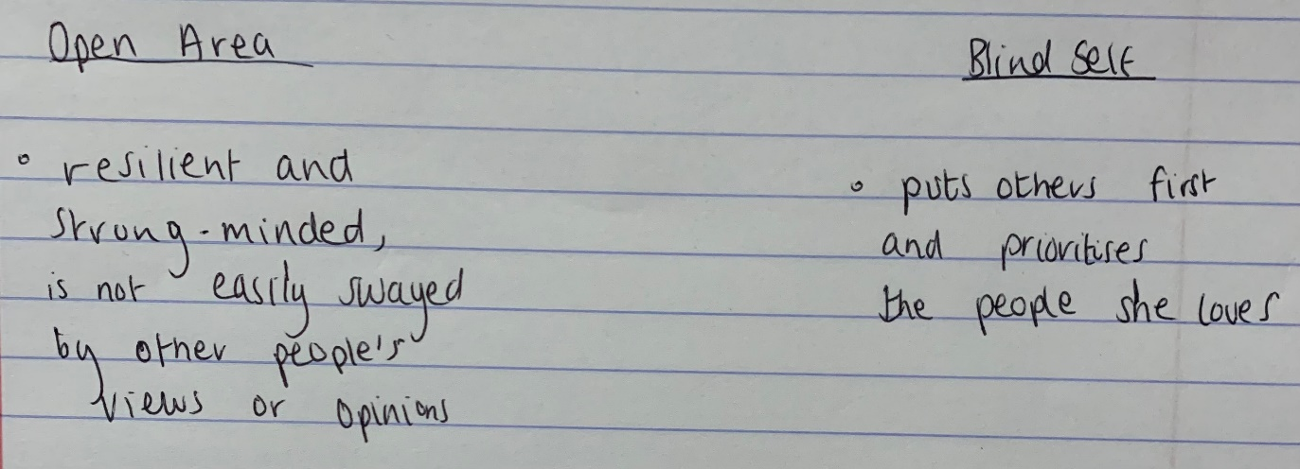

Personality is a set of qualities that characterises an individuals like values, emotions, abilities, interests that determine the behaviour. Personality can be identified by doing personality tests that reveals the type of personality one has.
The Myers-Briggs Type Indicator (MBTI), an assessment developed by Katharine Cook Briggs and Isabel Briggs Myers, is a tool that grouped people into 16 personalities types subdivided into 4 groups of 2 opposites.

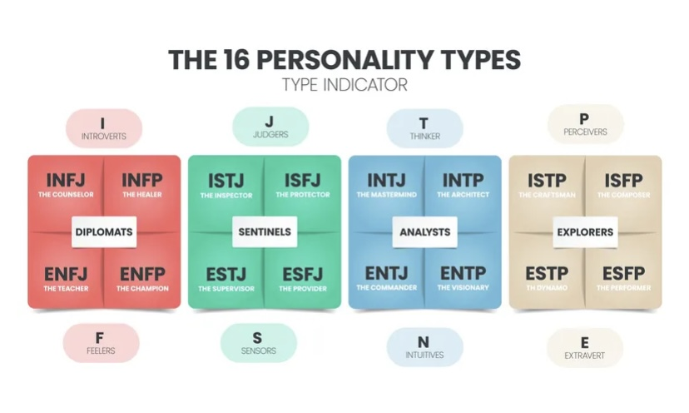

Insights Discovery is used in work environment to help the workers understand each other and create a positive and respectful work atmosphere.
I completed the personality test ( Activity 2.3). My personality type is Commander( ENTJ-A),
Personality traits: Extraverted -60%, Intuitive- 70%, Thinking- 69, Judging- 81%, Assertive-60%
For activity 2.4, the jobs that suits the personality of a commander are many. The ones that I like : Entrepreneur, sales manager, university professor. One of the jobs that attracts me is the entrepreneur as I want to set up my own business.
Learning styles are the different ways to learn and understand the information.
There are different styles of learning:
Kolb’s learning style has four learning stages. It starts with a Concrete Experience( feeling) followed by a Reflective Observation (Watching), the third stage is Abstract Conceptualisation(Thinking) and the fourth stage is Active Experimentation (Doing).
Diverging ( Feeling and Watching), Assimilating (Watching and Thinking), Converging (Thinking and Doing), and Accommodating ( Feeling and doing)
Honey & Mumford have 4 types of learners: The Activist who learns through experience, work as a teamwork, and likes challenging tasks. The Reflector learn through observing and reflecting, planning beforehand. The Theorist learns by understanding theories and concepts, and the last one is the pragmatist who learns through practice.
Neil Fleming identifies four learning style: Visual learners that learn through images, videos, graphs. Auditory learners prefer to hear the information and discussion. The Read/Write learners prefer note taking, reading and writing, and Kinesthetic learns songs with gestures, physical tasks, and role play.
Task : Reflecting on my auditory style: Today, I completed the activity 2.5, a quiz that helped me discover my learning way. I got 55% for the auditory style whereas the visual style was 25% and the tactile style was only 20%. This means that I am an auditory learner that takes information only by listening. This shows that I have good listening skills that will help me in my academic achievement as a student. As an example of my auditory learning style, I was always willing to attend all the lectures of the Effective Teamworking and Communication module last term. The lecturer Dr Eric Osei when explaining the topics, I was able to grasp all the information that he said. I agree that I am an auditory learner because I can pick up the information quickly, but, I think that getting information from written document or written notes can help as well.
To take advantage of this learning skill, I need to sit in a place that I can hear clearly, use the lecture recording if I missed any part of it.
However, sometimes I can find it hard to learn properly. This is because of some barriers that blocks this type of learning ability. The first and the most important is the noise. As I rely on my hearing senses, sometimes I find it hard to get the whole information because of the noises that are in the environment around me. Moreover, low voice and unclear speech can be a barrier to hear and understand what the speaker is saying. Also, if two persons are talking at the same time, I find it hard to pick up any information.

