Alison Jane Davies (1811074)
1811074@student.uwtsd.ac.uk

Analysing Trends and Patterns in Domestic Abuse in England and Wales
BMDP7009

Objective: To analyse and interpret secondary numerical data on domestic abuse and the responses on domestic abuse in England and Wales.

Abstract:
This paper provides a review of the current state of domestic violence, including prevalence, trends and some outcomes by Government and the police. Domestic abuse remains a significant societal issue in England and Wales, affecting individuals across all demographics. To tackle the violence and abuse there needs to be evolving and robust criminal justice responses to ensure victims' safety and hold perpetrators accountable. Our criminal agencies play a key role in identifying and investigating cases, while specialised domestic abuse units provide targeted support. Police forces and support organisations such as voluntary groups work to improve reporting mechanisms, but challenges such as underreporting and inconsistent enforcement persists. Legislative frameworks, including the Domestic Abuse Act 2021, has strengthened protections for victims and expanded legal definitions of abuse. The stricter sentencing and protective orders, aim to deter offenders and safeguard victims. However, challenges remain, including inconsistent enforcement and barriers to reporting. Improved training for police and judiciary, alongside victim-centred approaches, can enhance justice outcomes. Strengthening multi-agency collaboration and support services is crucial to addressing domestic abuse comprehensively and preventing reoffending.

Key words – Domestic Violence; Right to know and ask; Domestic Violence Protection Orders; Domestic Violence statistics, Homicide, Police Forces.

Introduction
Domestic violence remains a significant issue in the UK, affecting millions of individuals across the country. Harwin, (2006) identifies that domestic abuse was considered a family matter and something that was not talked about and hidden away. It was once legal for a man to beat his wife the legal element was that the stick could be no wider than the man’s thumb known as the ‘Rule of Thumb’. The women's movement, in conjunction with feminist movements within the 1970’s has played a pivotal role in advocating for gender equality and women's rights. Within the UK the landmarking case R V R in 1991 changed the view on marital rape. Up to 1991 the law determined that it was possible for a man to rape his wife. Thankfully, the courts rules that within marriage, any non-consensual sexual activity is now a criminal offence. For something that is known to be so wrong and uncomfortable to talk about took many years to change. However, the current state of domestic violence still is very much a social issue within the UK as well as the world. It is a widespread and deeply troubling issue that affects individuals and families across the UK. It encompasses various forms of abuse, including physical, emotional, psychological, and sexual harm, typically inflicted by someone in an intimate relationship. Domestic violence is not confined to any one demographic but disproportionately affects women and men, with an alarming number of children witnessing or experiencing violence in the home (Women’s Aid, 2024). Saferlives (2025) state that domestic abuse can happen to anyone, anywhere, at any time in a relationship. Domestic abuse is not always physical and that it is any form of threatening, controlling or coercive behaviours that is considered abuse. Domestic abuse can impact individuals from any background, any age and at any stage of a relationship. The impacts of domestic violence are profound and far-reaching. Victims often suffer severe physical injuries; however, the psychological effects are equally damaging. According to the British Medical Association (BMA) (2024), the mental health consequences for survivors include depression, anxiety, and post-traumatic stress disorder (PTSD). Children who grow up in homes where violence occurs are at a higher risk of experiencing emotional and behavioural problems and perpetuating the cycle of abuse in future relationships. Furthermore, the societal cost of domestic violence is immense, placing strain on healthcare systems, social services, and the criminal justice system (Radford et al., 2013).

Literature Review
Domestic violence (DV) accounts for a substantial proportion of violent crime in the UK. According to the Home Office (2025a) domestic abuse-related crimes constitute a significant percentage of all record violent crimes. This has led a pledge from the government to address DV as a national emergency, reflected in that the police receive a call about every 30 seconds relating to Domestic Violence. And domestic abuse makes up 18 per cent of all recorded crime in England and Wales (NPCC, 2024a). VAWDASV (2021) state that DV is a major public health problem with human rights issues and has grave consequences for the criminal justice system as well as victims. The impact of DV extends beyond physical harm, affecting mental health, economic stability and over all well-being of victims. Our current law within England and Wales that covers the areas around domestic abuse is the Domestic Abuse Act 2021. This legislation identifies that if the behaviour of a person towards another person is domestic abuse if they are each aged over 16, personally connected to each other and the behaviour is either physical or sexual; violent or threatening; controlling or coercive; psychological, emotional or economic abuse. This can also be a single incident or a course of conduct.
The National Police Chief Council (NPCC) (2021) introduced the first national framework for delivery to address violence against women and girls (VAWG) in 2021. It identified steps police could take centred around three key pillars: fostering trust and confidence, pursuing perpetrators and creating safer spaces (NPCC, 2024a). Furthermore, NCPP developed The National Framework for Delivery (NPCC 2024b). The framework underscores the need for an entire system approach where effective solutions require collaboration across various sectors and communities. It also highlighted the statistics that over one million VAWG-related crimes were recorded during 2022/23, accounting for 20% of all police-recorded crime. However, the National Audit Office (2025) identifies that violence against women and girls is still growing within the UK yet, the Home Office has failed to deliver an effective whole-system response, has not fully utilised available expertise and knowledge to shape the VAWG Strategy, and has made minimal progress in developing measures to prevent violence against women and girls.

WALES
Within Wales there is the Violence Against Women Domestic Abuse Sexual Violence (VAWDASV) strategy (Welsh Government, 2022) where, collaboration with academics, organisations from the criminal justice system and voluntary organisations are through various objectives prioritising the need to tacking this violence. VAWDASV state that violence can happen in any relationship such as violence towards women by men, same-sex relationships, transgender men and women and within family relationships. Wales also has additional powers from the Violence Against Women and Girls, Domestic Abuse and Sexual Violence (Wales) Act 2015 (VAWDSAV Wales Act, 2015) which, The Wales Act applies specifically to Wales and focuses on issues of violence against women, domestic abuse, and sexual violence within the Welsh context. The Act includes several key provisions aimed at addressing and preventing these issues effectively. This means that the Act promotes education and awareness initiatives, requires national and local authorities to promote understanding of the subject and ensures accountability among public bodies through regular reviews and collaboration between public organisations to create a safer environment for everyone (Welsh Government, 2022). The difference between the Violence against Women, Domestic Abuse and Sexual Violence (Wales) Act (2015) and the Domestic Abuse Act (2021) differ in their scope and focus, however the UK Domestic Abuse Act (2021) provides a UK statutory definition of domestic abuse, that recognises various areas of abuse within all laws of the UK. It also introduces measures like Domestic Abuse Protection Orders, a Domestic Abuse Commissioner, and special protections for victims in court. The Wales Act mandates education and awareness initiatives, requiring local authorities to promote understanding of these issues. Both Acts aim to tackle domestic abuse and violence within the UK.

Amount of Abuse and Why
Domestic violence arises from a drive to assert dominance and maintain control over an intimate partner. Abusers often hold the belief that they are entitled to dictate and limit their partner’s autonomy. This mindset may stem from prioritising their own emotions and needs above those of their partner or from deriving satisfaction from the power imbalance created by abusive behaviour. Abusive tactics, regardless of their form, are designed to erode equality within the relationship. These actions aim to diminish the partner’s sense of self-worth, making them feel undervalued and unworthy of respect (Bostock, Plumpton & Pratt, 2009).
Although interpersonal violence is unhealthy and undesirable, it is also a social norm for some families. Boys growing up in this society are surrounded by messages that displaying force and asserting control over others are the ways to gain respect. Whatever widespread social practices, sexist attitudes, physical punishment of both women and men exist within society and within the exaggerated commercial media outlets showing violet images, amplifying violent imagery. This can mean that violence is sensationalised in a way that effects the severity and frequency of violence within society. Thus, making it easy for many offenders to infer that they have the right to dominate victims who are mainly women physically or otherwise. And where the thought of domestic happiness and safety, the home, can be more dangerous for women than the street. However, girls are also now engaging in more violent behaviours and involved in gang culture (Jump & Horan, 2024). Again, a move where within the current statistics where female violence on male’s is increasing including DV.
There are several reasons why people experience DV from social issues, gender socialisation, cultural differences to the result of up-brining and learnt behaviours Geftera et al (2017). Gender inequality and societal norms play a significant role, with patriarchal power dynamics often reinforcing abusive behaviours. Economic instability, unemployment, and substance abuse can also increase the likelihood of domestic violence occurring. Additionally, mental health issues, childhood trauma, and learned behaviours from previous abusive relationships can perpetuate cycles of violence.

How much?
Due to the complicated nature of domestic abuse, which encompasses a broad range of behaviours, this crime often remains concealed, and its analysis is confined when reported to the criminal justice system. Victims may experience a range of complex factors which then prevents them from reporting to the police. Walker (2009) states there is a cycle of abuse where tension building phase, acute explosion phase and the honeymoon phase all contribute to the confusion and emotional entrapment for victims. Perpetrators through the final phase often show affections and gestors of improved behaviours giving hope to victims thus, hesitant or confused about disclosing the abuse. Victim’s may also feel ashamed, left fearful or self-blame for the abuse. Some may also have economic dependence on the abuser and may not know where to turn too which, will feel that leaving the relationship is impossible (Rakovec-Felser, 2014). These lead to abuse being underreported due to fear, stigma, and systemic barriers. Bland and Ariel (2020) emphasize the complexities of defining domestic abuse and the difficulties that the criminal justice faces in responding effectively leads to abuse often being underreported. The UK Domestic Abuse Commissioner’s (Jacobs, 2025) further underscores the need for systemic reform, noting that only 6% of police-recorded domestic abuse cases result in conviction, and just one-fifth of victims feel confident enough to report abuse. These findings indicate gaps in the criminal justice system that hinder effective intervention and support for survivors.
According to Choi (2009) who argues that policies addressing domestic violence have been largely ineffective and have fallen short in safeguarding victims from harm. However, the Welsh and UK governments acknowledge the ongoing inconsistencies in support for victims and survivors and have introduced several policies to address these issues. Cooper (2024) identifies approaches to address and protect victims. This includes such schemes like Domestic Abuse Specialists within 999 call control centres. When a call is made to the emergency services these specialists can give victims immediate support. These were introduced due to Raneem’s Law which addresses improved police responses to DV cases by having those domestic abuse specialists when 999 calls come into the police buy giving specialist advice and support to victims as well as the police (West Midlands Police, 2025). This shows the movement towards cross government collaboration where all departments must help address DV. Hutt (2022) stated that within Wales the Welsh Government’s strategy and laws will build these with the aim to create a safer environment for women and girls. The development of National Partnerships Boards will also be developed in Wales and the wider UK. These will oversee and supporting the implementation of strategies by bringing representatives from different sectors and partnership working to impact the initiatives and reduce DV victims.
Despite legislative measures which expanded legal definitions and protection for victims, challenges remain in effectively addressing DV. From underreporting, a lack confidence in the justice system and inconsistent enforcement of protective measures, such as restraining orders, can leave victims vulnerable to further harm and so figures show that DV is still has high records within UK. The Office of National Statistics (ONS 2024) states that over 2.3 million people broken down to 1.6 million women and 712,00 men over the age of 16 years reported to the 2024 Crime Surve England and Wales (CSEW) that they had experience some kind of domestic abuse in the last year. In the year ending March 2024, police in England and Wales recorded 851,062 domestic abuse-related crimes, marking a decrease from 911,248 in the previous year. During the same period, there were 51,183 domestic abuse-related prosecutions, a slight reduction compared to 51,288 in the year ending March 2023.

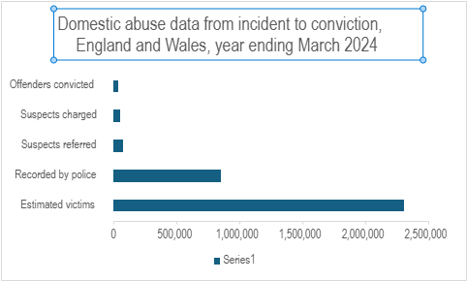(ONS, 2024)

Clares Law Domestic Violence Disclosure Scheme (DVDS)
In February 2009, Clare Wood was killed by her ex-partner, George Appleton. A 2010 case review by the Independent Police Complaints Commissioner (IPCC) identified 'systemic failings' by the police prior to her death (IPCC, 2010). At the time, Appleton had prior convictions for harassment of former partners and common assault. Clare met Appleton on social media and was unaware of his violent criminal history. They separated in October 2008, where Clare contacted the Greater Manchester Police force multiple times over the following five months to report harassment, threats to kill, sexual assault, and criminal damage by Appleton. A week before her death, Appleton received a non-harassment order after smashing Clare's front door. Appleton committed suicide six days after killing Clare. A Coroner's investigation concluded that Clare's death was an unlawful killing by strangulation. The coroner supported the Association of Chief Police Officers' (ACPO) call for a 'right to know' approach, allowing individuals to be informed about their partner's history of abuse (Strickland, 2013). This ‘right to know’ and ‘right to ask’ law was implemented in England and Wales in 2014 where it enables individuals to have the right to ask and know about their partners past abusive behaviours and called Domestic Violence Disclosure Scheme (DVDS). Clare’s Law is a preventive measure to protect individuals from entering or continuing potentially dangerous relationships. It empowers people by giving them access to information about their partner's history of domestic violence where they then can make those informal choices about the relationship. By the law providing this information it hopes that it will reduce the risk of entering an abusive relationship. It provides an early intervention so that by having the knowledge of potential danger family members can support the individual. And finally, the law gives opportunities to those in an unsafe relationship to leave before anything escalates. As Grace (2015) empowers potential victims by offering them the knowledge necessary to evaluate their safety. This empowerment model aligns with contemporary domestic violence prevention strategies that emphasise victim freedoms and informed consent.
There are two elements to DVDS schemes. The first being the right to ask where an individual or a third party can ask the police to check backgrounds of a partner or former partner where they may have displayed abusive or violent behaviour. An application will inform the applicant of any convictions for domestic violence or abuse, reports of behaviours that didn’t lead to a conviction and patters such as coercive control or stalking. The right to know is where a police officer may disclose information on their own initiative when there has been some violent behaviour displayed by the person’s current or former partner. This proactive disclosing of information is assessed by police to ensure that any disclosure is lawful, proportionate and necessary so that individuals can make the decision and encourage them to leave and be safe.
Barlow and Walklate (2024) identify some issues with DVDS. The study over the past decade since its introduction has faced intense examination. This includes the application of DVDs can vary significantly between different police forces, leading to a postcode lottery where the outcome of a request may depend on the area in which it is made. Some disclosures may not reveal any past abuse as perpetrators of domestic abuse may not have a criminal record. Therefore, it does not guarantee that the individual is safe. Some police forces have been slow to respond to requests or have declined them, which can leave potential victims without the information to make those decisions.

Methods
A comprehensive search of identified data bases was conducted using the key words. Various related articles delivered sources that met the criteria of the question. The Domestic abuse prevalence and trends, England and Wales: Year ending March 2024 document was used within the research. This document collects the data from police-recorded domestic abuse incidents and crimes. The research methods employed in the CSEW and the Domestic Abuse Prevalence and Trends report integrate both survey-based and police-recorded crime data to provide a comprehensive understanding of domestic abuse patterns, reporting trends, and criminal justice responses. To frame this research within its philosophical underpinnings, this chapter also explores the ontology and epistemology guiding the study of domestic abuse. The methodological approach is informed by the need to capture both objective police-recorded data and subjective victim experiences, ensuring a nuanced analysis of domestic abuse prevalence.
Figure 1 (ONS, 2024 b) identifies a structured process within the criminal justice system through reporting, investigation to potential conviction. Victims may report abuse to the police, who then assess the situation, gather evidence, and classify the case as domestic abuse related. Police-recorded data capture both incidents and crimes, but not all reports result in criminal charges. Once an offence is identified, the police investigate by interviewing victims, witnesses, and alleged perpetrators, as well as collecting physical and digital evidence. The Crown Prosecution Service (CPS) then reviews the case to determine whether there is sufficient evidence to proceed with prosecution. If charges are filed, the case moves to court, where protective measures, such as restraining orders, may be issued to safeguard victims (ONS, 2024 b). However, police-recorded crime statistics alone do not accurately reflect the prevalence of domestic abuse or its full impact as identified some incidents are not recorded.
When a victim chooses not to report domestic abuse to the police their experience remains undocumented within the criminal justice system and remains a hidden victim. However, such victims may still be accounted for in the statistics gathered by the Crime Survey for England and Wales (CSEW). The CSEW is a victimisation survey designed to capture individuals' experiences with various crimes, regardless of whether they were officially reported. This survey provides crucial insights into the prevalence of domestic abuse beyond police-recorded incidents, helping to highlight the scale of unreported cases. And therefore, the document Domestic Abuse and the Criminal Justice System England and Wales: November 2024 was used. Both documents have the details reported via the police or through the CSEW. The CSEW platform collects the data on crime trends within the UK. It is conducted annually and provides insights into crime levels, victim experiences, and public attitudes toward crime and justice. Unlike police-recorded data, the CSEW includes crimes that may not have been reported, offering a broader picture of crime prevalence.
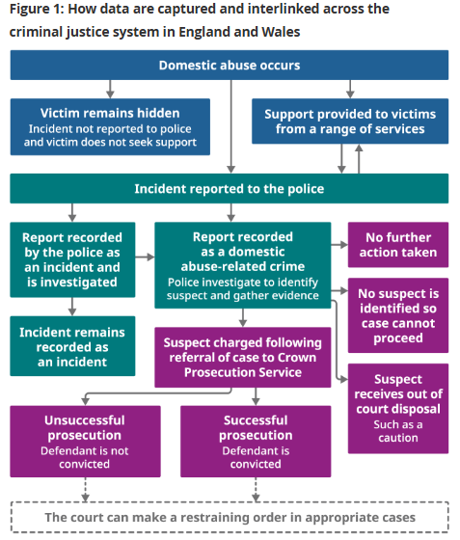(Figure 1 ONS, 2024 b)

Survey Design
The CSEW is a victimisation survey designed to collect data on individuals’ experiences of crime, including domestic abuse, regardless of whether incidents were reported to the police. A random sampling method is employed to ensure broad representation across diverse demographic groups in England and Wales. Data is collected through face-to-face interviews from set questions where respondents discuss their experiences with crime. The CSEW is particularly valuable for capturing underreported cases, providing insights into those hidden victims who do not seek police intervention.
Police recorded data collection considers domestic abuse-related crimes that are recorded by police forces across England and Wales based on Home Office Counting Rules (Home Office, 2025b). And that all reports of incidents, whether from victims, witnesses or third parties and whether crime related or not will be recorded as a crime, result in the registration of an auditable incident report by the police. This integrates both quantitative crime data and qualitative victim narratives so that the police can get a full understanding of the volume of DV cases and identify the vulnerable to offer safeguarding.

Ontology: Understanding the Reality of Domestic Abuse
Ontology refers to the nature of reality within research. In the context of domestic abuse studies, an ontological approach must recognise that domestic abuse is not a singular or universally measurable phenomenon. Instead, it exists as a socially constructed reality. Realist ontology is used by measurable incidents recorded by the police. Constructivist ontology states that DV is shaped individual experiences, social norms, and power dynamics. This perspective acknowledges that abuse may not always be officially reported and thus other approaches such as CSEW is needed to understand lived experiences (Wilcock, 2024).

Epistemology: How Domestic Abuse Knowledge Is Gained
Epistemology refers to how we acquire knowledge and validate findings. The study of domestic abuse incorporates both positivist and interpretivist epistemologies, ensuring a balanced approach. Positivist Epistemology underpins the use of police-recorded crime data, treating domestic abuse as a measurable social problem. Statistical analysis of police reports allows researchers to examine trends, patterns, and prevalence objectively. Interpretivist Epistemology approach informs the CSEW, recognising that lived experiences of abuse may not always align with official statistics. Victims' perceptions, and responses are essential in understanding domestic abuse beyond quantifiable figures.
By integrating both epistemological perspectives, the research acknowledges the limitations of relying solely on crime records while incorporating victim-focused methodologies to offer a comprehensive understanding of DV. Both documents and research consider both realist ontology and epistemological framework. Though surveys and police recording all provide a comprehensive analysis of DV trends. These approaches ensure that both statistical view and lived experiences are considered, informing evidence-based policies, changes in legislation and support to victims.

Results
How much:
The UK Domestic Abuse Commissioner (2025) reports that DV cases are increasing and that they being reported more to the criminal justice system. This is mainly due to better legislation, specialist support as well as further services and advocates for victims. HM Government (2016) strategy to end DV was delivered to the criminal justice system and partners. The strategy focused on prevention, protection, and justice and aimed for improved responses. However, DV cases continued to rise but there were also challenges in underreporting. Figure 2 below shows the number of reported cases from 2015 to 2024. It shows that cases increased each year yet, a decrease of reported cases during the last year.

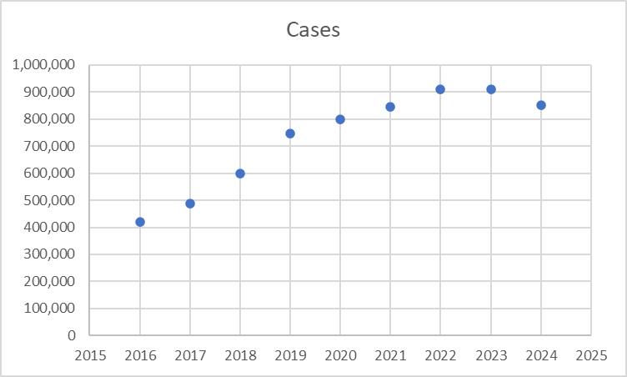 (Figure 2 ONS, 2024a)
Therefore, the ONS (2024a) figures to find the hypothesis the following was found. H0 – there is no difference (null Hypothesis), H1- There is a difference (Alternative Hypothesis). T (degrees of freedom = the t statistics, p=p value. An independent t-test was run on a domestic violence reported crime over the last 4 years to determine if there were differences in the amount reported each year. The study found that the years 2020 to 2022 had statistically significantly lower amount of reported DV cases (878357 ± 46135) compared to years 2022 to 2024 where more DV cases were reported (8811565 ± 42557) t(2)=-0.0630, p=0.9554. The t-score indicates that the years are different. Therefore, reject Ho, at p=0.9554, where p<0.05. There is no statistically significant difference in reported domestic violence cases over the last four years.

Police Forces
There are 43 police forces within England and Wales which cover various boundaries, cities, towns and are all different in size and the population that they police (HMICFRS, 2013). All police forces face different challenges and demand from those forces who cover the larger cities to those forces who face more rural issues and policing. This can also be said for policing domestic violence cases. The following graph shows the level of DV reported to the police to the year end of March 2024:

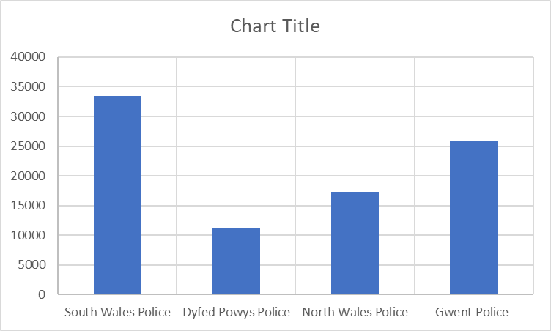(Figure 3 ONS, 2024a)
South Wales Police reported higher DV cases compared to the other Welsh forces. However, compared to English boarding forces the following was found:
An independent t-test was run on a sample of 9 difference police forces to see if there was a difference in the amount of reported domestic abuse-related crimes recorded by the police. The test looked at difference of DV cases between Welsh forces and police forces within the Southwest of England. The study found that Welsh police forces had statistically significantly lower length of reported DV crimes (44326.4 + 2067.3) compared to Southwest who had higher recorded cases (66430.8+4197.7), t(8) =-10.583, p=5.5504. A large t-score indicates that the groups are different. Accept H1, at p=0.000055504, where p<0.05. There is a statistically significant difference in DA crime between Welsh police forces to the southwest police forces which is higher.

Overall violence male's v’s female
Even though the research focused on DV cases, over all men experience more violence up to March 2024 through assaults, violence without injury, DV and acquaintance and stranger attacks. A t-test was undertaken to look at overall violence cases against male and females. Ho - There is no difference (Null Hypothesis). H1 - There is a difference (Alternative Hypothesis). t(degrees of freedom) = the t statistic, p = p value. This study found that males statistically significantly higher number of attacks (208000 ± 105,470) compared to females (167000 ± 84125), t(4)=-2.776, p=0.6264. A large t-score indicates that the groups are different. Therefore, reject Ho, at p=0.6264, where p<0.05. The difference in violence cases between males and females is not statistically significant.

Types of violence
To determine whether there is a statistically significant difference in the number of domestic abuse victims between males and females, an ANOVA test was performed. The results are presented below. The female group had an average of 454.67 victims, with a variance of 84,993.87. The male group had an average of 202.5 victims, with a variance of 16,713.1. The ANOVA results concluded that F-statistic = 3.75; Degrees of Freedom (df): Between groups (1), Within groups (10). The P-value = 0.0815 and Critical F-value = 4.96. Therefore, the p-value is greater that p<0.05 fail to reject the null hypothesis (h0).

Unfortunately, some DV victims fall victims to homicide though the actions of DV by perpetrators. The following chart shows male and females homicide rates for each police force.
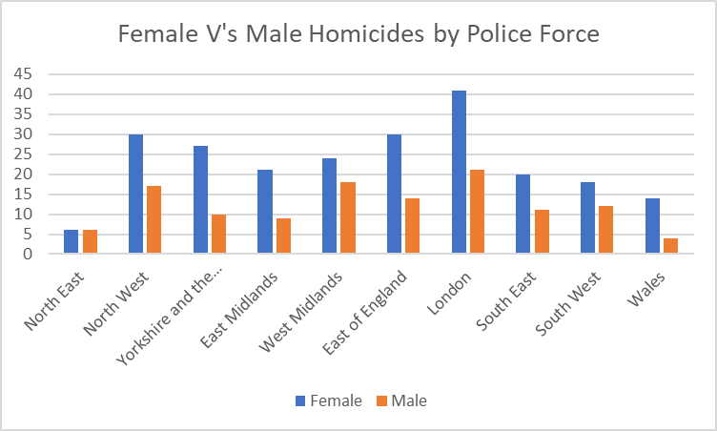 (Figure 4 OSN, 2024d)

Test - T test - look at look at difference of homicide cases within different police forces.
Ho – There is no difference (null Hypothesis)
H1 – There is a difference (Alternative Hypothesis)
T (degrees of freedom) = the t statistics, p = p value.
An independent t-test was run on the statistics reported from 10 police force areas on the number of deaths caused by domestic violence for females and males over that last year to determine of there were significant differences between the sexes.
The study found that females had statistically significantly higher rates of being victims to homicide (23.1 ± 9.700) compared to male victims (5.370 ± 12.2), t(14)=-2.145, p=0.0076.
A large t-score indicates that the groups are different.
Therefore, reject Ho, at p=0.007, where p<0.05.
There is a statistically significant differences with females and male victims where females experience more deaths through DV cases.

Coercive Controlling Abuse
In 2015, the UK government introduced a new offence addressing coercive or controlling behaviour, providing victims with legal protection against perpetrators whose abuse, while not necessarily physical, causes extreme psychological and emotional harm (Home Office 2015). By February 2025 the UK government puts controlling and coercive behaviour on the same level as all other DV offences from physical violence to threats to kill. Figure 4 shows the number of domestic abuse-related stalking and harassment offences recorded by the police, within their police force area.
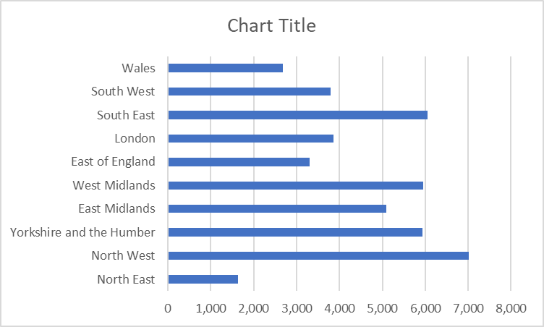 (Figure 5 Home office, 2025)
A Chi test was taken to calculate the expected frequency for each police force region. Where O = observed or actual police recorded cases and E = assumed distribution. The Chi-square statistic = 132.74, degrees of freedom = 10 and p-value = 0.0000004. Since p < 0.05, we reject the null hypothesis (H₀). This means there is a statistically significant difference in the distribution of coercive control offences across police force areas.

DV Disclosure
The Domestic Violence (DV) Disclosures refer to the process of victims, witnesses, or authorities sharing information about domestic abuse cases, either through official reporting channels or disclosure schemes designed to protect individuals at risk. Clare’s Law Domestic Violence Disclosure Scheme (DVDS) allowed individual to request police disclosure about a partner's history of DV. The right to ask where anyone fearing abuse can inquire about a partner's background. The police can there disclose the information, if they feel it is necessary. There is also the Right to know where police can proactively warn individuals at risk if their partner has a violent past. The chart below shows how many applications and how many disclosures ere made from April 2023 to March 20204. There is a clear difference from applications compared to disclosures.
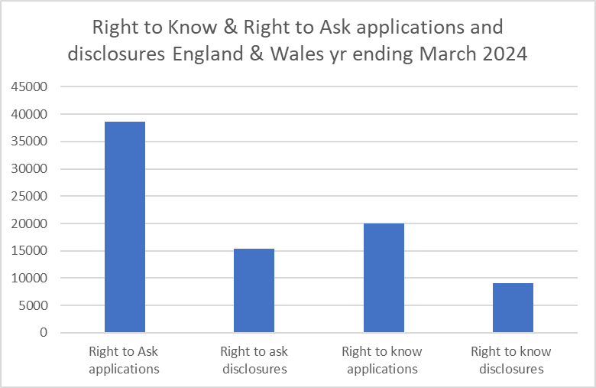 (Figure 6 ONS, 2024a)

Test - T test was undertaken to look at the differences between the Right to ask applications and right to ask disclosures between Welsh forces and forces within the Southwest area of England.
Ho – There is no difference (null Hypothesis)
H1 – There is a difference (Alternative Hypothesis)
T(degrees of freedom) = the t statistics, p = p value.
An independent t-test was run on the statistics reported from All Welsh Forces and all Southwest forces a total of 9 police force areas. The areas reported on right to ask applications and disclosures to determine of there were significant differences between the areas.
The study found that the forces from the Southwest of England had statistically significantly higher rates of reporting and disclosing (1705704. ±1306.9) compared Welsh forces (1384.5 ± 842.1), t(2)=-0.2893, p=0.7995.
Therefore, reject Ho, at p=0.7995, where p<0.05.
There is no statistically significant difference in Right to Ask disclosure rates between the policing areas.
Test - T test was undertaken to look at the differences between the Right to know applications and right to know disclosures between Welsh forces and forces within the Southwest area of England.
Ho – There is no difference (null Hypothesis)
H1 – There is a difference (Alternative Hypothesis)
T(degrees of freedom) = the t statistics, p = p value.
An independent t-test was run on the statistics reported from All Welsh Forces and all Southwest forces a total of 9 police force areas. The areas reported on right to know applications and disclosures to determine of there were significant differences between the areas.
The study found that the forces from the Southwest of England had statistically significantly higher rates of reporting and disclosing (766 ±404.46) compared Welsh forces (1407.5 ± 886.00), t(1)=-0.931, p=0.5225.
Therefore, reject Ho, at p=0.5225, where p<0.05.
There is no statistically significant difference in Right to know disclosure rates between the policing area.

Results discussion
This chapter will reflect on each area discussed from domestic violence rates to experiences of victims. The chapter will be focusing on interpreting the findings and providing context for the statistical outcomes.
How much
Since the introduction of the ‘Rule of Thumb’ in 1782, where wives were beaten by their husbands (Harwin,2006), we see the introduction of the Criminal Procedures Act 1853 which was in place to limit the amount of punishment and assaults a husband could give his wife and children. However, by 1860 we see the Law of Coverture where, a husband was entitled to use physical or verbal abuse on their wives and children to control their behaviour (Centre of Women’s Justice, 2016). Today, domestic violence is a widely global problem which in more recent years victims who are males have also spoken up about the issues and violence that they face. The abuse can take many forms from physical to psychological and although legislation had changed over the years the DV act is a phenomenon that still effects many today. It is hard to know the exact amount of DV victims as the abuse is hidden and not reported. The analysis aimed to determine whether there was a statistically significant difference in reported domestic violence cases across the years from 2020 to 2024, using an independent t-test. The findings indicate that while the number of reported cases fluctuated, there is no statistically significant difference across the observed period. According to Office for National Statistics (ONS) (2024a) who have reported that from March 2015 to April 2023 each year saw an increase of cases. March 2023 DV cases reported to the police were increasing. However, March 2023 to April 2024 the amount of DV cases reported took a decrease.
Several factors could contribute to these fluctuations, including the evolution of reporting mechanisms and police recording practices. Over time, adjustments in how domestic abuse cases are reported, documented, and categorised have contributed to shifts in official statistics. Policy and legislative reforms by our government as well as a push from support groups and victims’ rights have captured DV cases (Jacobs, 2025). However, by encouraging victim reporting through improved access to support services such as Women’s Aid and Men Kind; increased public awareness campaigns, and changes in police attitudes toward domestic abuse victims have encouraged more individuals to report incidents. Previously, victims may have hesitated due to fear of reprisals or distrust by the criminal justice system (Myhill 2019), but reforms aimed at victim protection and anonymity have helped improve reporting rates.

Reports from Police
A comparison was made between Welsh and Southwest England police forces. This was undertaken as the forces were although different in sizes were similar in nature. The policing covers rural, city and coastline in both areas. Several key factors could explain why Southwest England police forces report significantly higher DA crime rates compared to Welsh forces. Southwest England has a larger police force presence (ONS, 2025), and more officers can handle DV cases which may lead to higher recorded reports (ONS, 2024a). Welsh forces with fewer officers and smaller regions may have lower detection and reporting rates. The population is bigger within the southwest England compared to Wales thus will have more DV cases overall. This could also mean more services are available that specialised within DV.
All Welsh police forces, compared to those in Southwest England, operate with fewer officers and a smaller population base, which could contribute to lower recorded domestic violence cases. According to Statista (2025), the four Welsh police forces employed 8,076 officers between April 2023 and March 2024, whereas the five police forces in the Southwest employed 10,913 officers during the same period. Additionally, Varbes (2024) estimates the population of Wales to be 3,105,500, whereas the Southwest has a significantly higher population of 5,764,881.
Given that police force size can impact reporting and enforcement, areas with fewer officers may struggle with response times, victim outreach, and investigative resources, potentially affecting the number of recorded domestic violence incidents. The higher officer count in Southwest England allows for greater intervention, specialised domestic abuse units, and broader victim support services, which may contribute to an increase in reported cases (Home Office 2025a). Furthermore, the larger population in the Southwest could lead to higher absolute numbers of domestic abuse cases, simply due to more individuals at risk. In contrast, Wales, while still experiencing domestic crime forces might record fewer total cases due to its smaller population size, rural conditions and police resources. These differences suggest that domestic violence reporting rates may not solely reflect the actual prevalence of abuse but could be influenced by the availability of policing resources, population density, and victim support systems. For all the police forces within Wales and the Southwest all the Police Crime Commissioners within their policing plans are addressing violence against women and girls (APCC, 2023). Welsh police forces are actively working to address domestic violence through various initiatives and strategies. The Violence Against Women, Domestic Abuse, and Sexual Violence (VAWDASV) Blueprint outlines a partnership approach to tackling these issues, focusing on prevention, protection, and support.

Male v’s female abuse
While this study primarily focused on DV cases, the findings highlight a broader trend: men experience higher overall rates of violence, including assaults, violence without injury, and attacks by acquaintances or strangers up to March 2024. A t-test was conducted to compare total violence cases against male and female victims, assessing whether the differences were statistically significant. The results reinforce that while DV disproportionately affects women, men are more frequently victims of physical assaults and non-DV-related violence (Copping, 2017). These findings underscore the need for targeted interventions, ensuring both male and female victims receive adequate support, legal protections, and access to reporting mechanisms. The study also investigated whether there is a statistically significant difference in the number of domestic abuse victims between males and females by performing an ANOVA test. In addition to analysing overall domestic abuse cases, the study examined controlling coercive behaviour. In both findings females fall victim to more of these incidents compared to males. Donovan & Barnes (2019) identified that most domestic violence and coercive control victims are women, there remains a gap in understanding the gender and sexual identity of perpetrators, as well as the sexual orientation of those victimised. Male victims, who despite lower reported proportions still represent a substantial number of affected individuals. These victims include gay, bisexual, and trans men, as well as heterosexual cisgender men, indicating that domestic abuse is not exclusively a gendered issue but rather a complex societal problem that affects diverse identities.
Overall trends in violent crime, including domestic violence and incidents involving known or unknown perpetrators, show a decline in recorded statistics. As of year-end March 2024, approximately 0.5% of individuals aged 16 and over experienced violence, whether with or without injury, at the hands of an acquaintance, while 0.7% were victims of violence perpetrated by a stranger. Data indicates that men were disproportionately affected by violent crime, and younger individuals aged 16 to 24 were more likely to be victims. However, despite the decline in general violent crime, police-recorded offences involving knives or sharp instruments saw a 4% increase, reaching 50,010 offences in the year ending March 2024, alongside a rise in firearm-related incidents (ONS, 2024c). Yet, DV cases in the last recorded year shows that females experienced more compared male victims. Women face higher rates of repeated victimisation and are significantly more likely to suffer severe harm (Walby & Allen, 2004) or be killed because of domestic abuse compared to male victims (ONS, 2024a). Abuse perpetrated by men against women is deeply connected to systemic gender inequality and reflects a broader societal issue. Widespread sexism and misogyny continue to shape societal structures, prompting organisations, including the police, to implement reforms aimed at addressing these biases within their own operational practices (Casey, 2023). As for male victims the deep ingrained societal expectations of masculinity which, emphasise on strength and emotional restraint often create barriers for male victims of abuse, making it difficult for them to acknowledge or seek help for their experiences and thus many cases go unreported. As Huntley et al (2019) state it is easier for men to suffer in silence and admit the abuse. Domestic violence against men is more prevalent than society often acknowledges. However, by strengthening support systems and providing better resources, male victims can be empowered to confront internal fears and overcome the stigma, enabling them to speak out and seek help.

Types of Violence
Control is a defining factor in domestic violence cases, often escalating to severe harm or even death. DV related deaths remain a critical issue affecting both female and male victims, though women disproportionately experience fatal outcomes the College of Policing (CoP) (2025). Between 2020 and 2024, the Vulnerability Knowledge & Practice Programme (VKPP, 2025) identified that between April 2020 and March 2024 a total of 1,012 female deaths were linked to domestic abuse. This figure includes 501 domestic homicides, 354 suspected suicides of victims, 71 unexpected deaths, 61 child fatalities, and 25 deaths categorised as 'other.' Sharp instruments were identified as the leading cause of death in domestic homicides, accounting for 45% of cases. Additionally, from 2022 to 2024, eight men lost their lives as victims of domestic violence (Mankind, 2025). Perpetrators use coercive control tactics such as financial dependency, isolation, and emotional manipulation to assert dominance over their victims, making escape incredibly difficult. For many victims them and the suspects are known to the police and other support services. CoP (2025) also identified that some of these victims were known to the police and 55% had been involved in Multi-Agency Risk Assessment Conference where information is shared on the highest risk DV cases. Therefore, the use of the Right to know and Ask could have served as a safeguarding tool for those individuals. The study examined the differences between Southwest and Welsh police forces using independent t-tests. The findings indicate that, while Southwest forces reported higher rates of both Right to Ask and Right to Know disclosures this could be due to population differences, reporting and more police resources. However, what should be recognised is that this assistance gives the ability to access information about a partner’s past behaviours. Allowing early intervention and police accountability to protect potential victims and thus reducing DV and potential deaths.

In examining domestic abuse trends, it is evident that while awareness and reporting have increased, significant challenges remain within the crime. Although, not discussed within this paper statistics show that there are disparities patterns in victim demographic and the impact of socioeconomic factors that make the subject difficult to fully understand. Despite improvements in the role of legislation and support systems, underreporting and data limitations make it difficult to fully assess the scope of the issue.
The first areas discussed is how much abuse happens within the UK. It was found that DV increased year after year however, the statistics for March 2024 showed a slight decrease. Although the figures are still seriously high could new legislation, victim support and organisations with the criminal justice system reviewing approaches be addressing the issue. As Cooper (2024) identifies that within the UK Governments response to the approaches to tackling DV a report by the DV commissioner proposed 12 key recommendations. These included multi-agency collaboration, CJS accountability, prioritising DV cases within policing and the courts so that victims feel protected and perpetrators are held accountable. Addressing domestic abuse requires continued policy reform, further legal interventions, enhanced support networks, and societal shifts to break cycles of harm. Our criminal justice system must recognise control as a precursor to potentially fatal violence and that victims should receive protection before any situation reaches a lethal point. Moving forward, further research and proactive intervention are essential in fostering long-term change.

Reference list

Association of Police and Crime Commissioners (APCC) (2023) Campaigns. Available at: Campaigns - The Association of Police and Crime Commissioners (Accessed 24/04/2025)

Baird, K & Mitchell, T. (2014) Using feminist phenomenology to explore women's experiences of domestic violence in pregnancy. British Journal of Midwifery, 22(6). https://doi.org/10.12968/bjom.2014.22.6.418

Barlow, C. and Walklate, S. (2024) Domestic Violence Disclosure Schemes: 10 Years on. Available at: Domestic,Violence,Disclosure,Schemes,-,Clares,Law,10,Years,On.pdf (Accessed 02/03/2025)

Bland, M.P., and Ariel, B. (2020) Domestic Abuse in England and Wales. In: Targeting Domestic Abuse with Police Data. https://doi.org/10.1007/978-3-030-54843-8_2

Bostock, J., Plumpton, M. and Pratt, R. (2009) ‘Domestic violence against women: Understanding social processes and women’s experiences’, Journal of community & applied social psychology, 19(2), pp. 95–110. Available at: https://doi.org/10.1002/casp.985.

British Medical Association (2024) BMA report Domestic Abuse Raising awareness of domestic abuse and strategies for doctors to identify and reduce the damage it does. Available at: Domestic abuse (Accessed 22/02/2025)

Casey, L. (2023) An independent review into the standards of behaviour and internal culture of the Metropolitan Police Service. Available at: BARONESS CASEY REVIEW Final Report (Accessed 24/05/2025)

Centre of Women's Justice (2016) Holding the State accountable for violence against women and girls. Available at: Timeline of Key Legal Developments — Centre for Women's Justice (Accessed 14/04/2025)

Choi, K. (2009) Tackling Domestic Violence in UK: Persistent Problems. International Area Review, 12(1), 17-43. https://doi.org/10.1177/223386590901200103

Clark, D. (2025) Number of applications and disclosures to Clare's Law in England and Wales 2018-2024. Available at: UK Clare's Law figures 2024| Statista (Accessed: 14/04/2025)

College of Policing (2025) Domestic Homicides and Suspected Victim Suicides 2020-2024 Year 4 Report Available at: Executive-Summary-Y4-Report-final.pdf (Accessed 03/05/2025)

Collins, R. (2009) Violence: a micro-sociological theory. 1st edn. Princeton: Princeton University Press. Available at: https://doi.org/10.1515/9781400831753.

Cooper, E. (2024) New measures set out to combat violence against women and girls. Available at: New measures set out to combat violence against women and girls - GOV.UK (Accessed 29/03/2025)

Copping, L. (2017) Gender difference in violence and aggression. Available at: 621751.pdf (Accessed 29/03/2025)

Domestic Abuse Commissioner (2025) Shifting the scales Transforming the criminal justice response to domestic abuse. Available at: dac_cjs-report_summary_FINAL-DIGITAL.pdf (Access 1404/2025)

Donovan, C., & Barnes, R. (2019). Re-tangling the concept of coercive control: A view from the margins and a response to Walby and Towers (2018). Criminology & Criminal Justice, 21(2), 242-257. https://doi.org/10.1177/1748895819864622

Gefter, J. R; Rood, B. A.; Valentine, S. E.; Bankoff, S. M. and Pantalone, D. W. (2017) Why does it happen? Explanations for men’s violence against
women by women with interpersonal victimization histories. Journal of Gender Studies Vol. 26, no. 2, 133–150 http://dx.doi.org/10.1080/09589236.2015.1090305

Grace, J. (2015). Clare’s Law, or the national Domestic Violence Disclosure Scheme: the contested legalities of criminality information sharing. The Journal of Criminal Law, 79(1), 36-45. https://doi.org/10.1177/0022018314564732

Grace, J., (2021) Domestic abuse disclosure schemes: Problems with policy, regulation and legality. Springer Nature.

Harwin, N., (2006) Putting a stop to domestic violence in the United Kingdom: Challenges and opportunities. Violence Against Women, 12(6), pp.556-567. https://doi.org/10.1177/1077801206289134

Hester, M., Walker, SJ. & Myhill, A. (2023) The Measurement of Domestic Abuse – Redeveloping the Crime Survey for England and Wales. Journal of Family violence Vol 38, 1079–1093 https://doi.org/10.1007/s10896-023-00507-9

His Majesty’s Government (2016) Ending Violence against Women and Girls Strategy 2016 – 2020 Available at: VAWG_Strategy_FINAL_PUBLICATION_MASTER_vRB.PDF (Accessed 14/04/2025)

HMICFRS (2013) About Us. Available at: His Majesty’s Inspectorate of Constabulary and Fire & Rescue Services - His Majesty’s Inspectorate of Constabulary and Fire & Rescue Services (Accessed 14/04/2025)

Home Office (2015) Coercive or controlling behaviour now a crime. Available at: Coercive or controlling behaviour now a crime - GOV.UK (Accessed 20/04/2025)

Home Office (2021) Key Findings from analysis of domestic violence homicide reviews October 2019 to 2020. Available at: Key findings from analysis of domestic homicide reviews: October 2019 to September 2020 (accessible) - GOV.UK (Accessed 20/04/2025)

Home Office (2025) Shifting the Scales: Transforming the criminal justice response to domestic abuse. Available at: Shifting the scales: Transforming the criminal justice response to domestic abuse (accessible) - GOV.UK (Accessed 21/04/2025

Home Office (2025b) Crime Recording Rules for Frontline Officers and Staff. Available at: crime-recording-rules-for-frontline-officers-and-staff-2025_26-april-2025-update.pdf (Accessed: 14/04/2025)

Huntley, A.L., Potter, L., Williamson, E., Malpass, A., Szilassy, E. and Feder, G. (2019) ‘Help-seeking by male victims of domestic violence and abuse (DVA): a systematic review and qualitative evidence synthesis’, BMJ open, 9(6), pp. e021960–e021960. Available at: https://doi.org/10.1136/bmjopen-2018-021960

Hutt, J. (2022) Violence against women, domestic abuse and sexual violence: Strategy 2022 to 2026. Available at: Violence against women, domestic abuse and sexual violence: strategy 2022 to 2026 [HTML] | GOV.WALES (Accessed 29/03/2025)

Independent Police Complaints Commission (IPCC) (2010) IPCC independent investigation: Greater Manchester Police contact with Clare Wood prior to her death: Commissioner’s report. Available at: https://www.ipcc.gov.uk/sites/default/files/Documents/investigation_commissioner_reports/clare_wood_report_final_10_march.pdf (accessed 15/02/2025)

Jacobs, N. (2025) Shifting the scales Transforming the criminal justice response to domestic abuse. Available at: dac_cjs-report_main_FINAL-DIGITAL.pdf (Accessed 11/04/2025

Jump, D., & Horan, R. (2024). Girls and Gangs: A Decade on From the Firmin Report and What Has Changed? Violence Against Women, 31(6-7), 1404-1422. https://doi.org/10.1177/10778012241233005

Man Kind (2025) Statistics on Male Victims of Domestic Abuse. Available at: Statistics on Male Victims of Domestic Abuse - Mankind (Accessed 26/04/2025)
Myhill, A. (2019) ‘Renegotiating domestic violence: police attitudes and decisions concerning arrest’, Policing & society, 29(1), pp. 52–68. Available at: https://doi.org/10.1080/10439463.2017.1356299.

National Audit Office (2025) Tackling Violence Against Women and Girls. Available at: Tackling violence against women and girls (Accessed: 15/03/2025)

Nation Police Chief Council (2024) (a) Violence Against Women and Girls. Available at: Violence Against Women and Girls (Access 15/03/2025)

Nation Police Chief Council (2024) (b) Policing Violence Against Women and Girls – The National Framework for Delivery 2024 to 2027. Available at: vawg-framework-for-delivery.pdf (Accessed: 15/03/2025)

Office for National Statistics (ONS) (2024a). Domestic abuse prevalence and trends, England and Wales: Year ending March 2024. Available at: Domestic abuse prevalence and trends, England and Wales: year ending March 2024 (Accessed: 11/04/2025)

Office for National Statistics (ONS) (2024b). How domestic abuse data is captured through the criminal justice system: November 2024. Available at: How domestic abuse data are captured through the criminal justice system - Office for National Statistics (Accessed 14/04/2025)

Office for National Statistics (ONS) (2024c). The Nature of Violent Crime in England and Wales. Available at: The nature of violent crime in England and Wales - Office for National Statistics (Accessed 14/04/2025)

Office for National Statistics (ONS) (2024d) Homicide in England and Wales Year ending March 2023. Available at: Homicide in England and Wales - Office for National Statistics (Accessed 14/04/2025)

Office for National Statistics (ONS) (2025) Crime in England and Wales: Police Force Area Data. Available at: Crime in England and Wales: Police Force Area data tables - Office for National Statistics (Accessed 01/05/2025)

Radford, L.; Corral, S.; Bradley, C. and Fisher, H. (2013) The prevalence and impact of child maltreatment and other types of victimization in the UK: Findings from a population survey of caregivers, children and young people and young adults. https://doi.org/10.1016/j.chiabu.2013.02.004

Rakovec-Felser, Z. (2014) ‘Domestic violence and abuse in intimate relationship from public health perspective’, Health psychology research, 2(3). Available at: https://doi.org/10.4081/hpr.2014.1821
Robinson, A. and Clancy, A. (2021. Systematically identifying and prioritising domestic abuse perpetrators for targeted intervention. Criminology and Criminal Justice 21 (5), pp.687-704. 10.1177/1748895820914380

Scheiwe, K. (2020) Handbook of Family Law and Policy. London, Routledge

Statista (2025) Number of police officers in the UK 2024, by police force. Available at:UK largest police forces 2024| Statista (Accessed 23/04/2025)
Strickland, P. (2013) "Clare's law”: the Domestic Violence Disclosure Scheme Standard. London. Available at: Standard Note (Access date: 15/02/2025)

Tisdall, K. M. (2003) Researching Violence Oxford, Routledge

Varbes (2024) Local Statistics for England and Wales. Available at: England and Wales Local Statistics | Charts, Facts & Comparisons (Accessed: 23/04/2025)

VAWDASV Violence Against Women and Girls Sexual Violence (2021) What Works to Prevent Violence against Women, Domestic Abuse and Sexual Violence Available at: REPORT (Access date: 01/03/2025)

Vulnerability Knowledge & Practice Programme (2025) Executive Summary: Domestic Homicides and Suspected Victim Suicides 2020-2024 Year 4 Report. Available at: Executive-Summary-Y4-Report-final.pdf (Accessed 25/04/2025)

Walby, S. & Allen, J. (2004) Domestic Violence, Sexual Assault and Stalking: Findings from the British Crime Survey. Available at: Domestic violence, sexual assault and stalking: Findings from the British Crime Survey (Accessed 25/04/2025)
Walker, L. (2009) The Battered Women Syndrome. 3rd Ed. New York, Springer Publishing Company

Welsh Government (2022) Violence Against Women Domestic Abuse Sexual Violence strategy 2022 to 2026. Available at: Violence against women, domestic abuse and sexual violence: strategy 2022 to 2026 [HTML] | GOV.WALES (Access date: 01/03/2025)

West Midlands Police (2025) Raneem’s Law in action: Domestic abuse specialists embedded in West Midlands Police 999 control room. Available at: Raneem’s Law in action: Domestic abuse specialists embedded in West Midlands Police 999 control room | West Midlands Police (Accessed: 14/04/2025)

Wilcock, A. (2024) Shifting consciousness: Challenge to ontological assumptions in feminist research. Emotion, Space and Society Vol 50 https://doi.org/10.1016/j.emospa.2024.101004

Women’s Aid (2024) The Domestic Abuse Report 2024 – The annual Report. Available at: Annual Audit 2024 - Women’s Aid (Access date 22/02/2025)

Wools, E. (2025) Police Crime and Justice Plan 2025 to 2029. Available at: C24-0163_PCC_Police-Crime-and-Justice-Plan-2025_Single-Pages-1.pdf (Accessed: 15/04/2025)

List of Figures
Figure 1: How data is captured and interlinked across criminal justice system in England and Wales. Available at: How domestic abuse data are captured through the criminal justice system - Office for National Statistic. (Accessed 14/04/2025)

Figure 2: Domestic abuse prevalence and trends, England and Wales: Year ending March 2024. Available at: Domestic abuse prevalence and trends, England and Wales: year ending March 2024 (Accessed: 11/04/2025)

Figure 3: Domestic abuse prevalence and trends, England and Wales: Year ending March 2024. Available at: Domestic abuse prevalence and trends, England and Wales: year ending March 2024 (Accessed: 11/04/2025)

Figure 4: Homicide in England and Wales Year ending March 2023. Available at: Homicide in England and Wales - Office for National Statistics (Accessed 14/04/2025)

Figure 5: Shifting the Scales: Transforming the criminal justice response to domestic abuse. Available at: Shifting the scales: Transforming the criminal justice response to domestic abuse (accessible) - GOV.UK (Accessed 21/04/2025)

Figure 6: Domestic abuse prevalence and trends, England and Wales: Year ending March 2024. Available at: Domestic abuse prevalence and trends, England and Wales: year ending March 2024 (Accessed: 11/04/2025)

