  Loom talent
  22/06/2026
  Dear Hiring Manager,
  I am applying for the Warehouse Operations Manager position in Lutterworth.
  This role is particularly appealing because it combines operational leadership, team management and process improvement within a large-scale logistics environment. Having worked in warehouse operations and management roles, I understand the importance of maintaining service levels, controlling operational performance and ensuring teams work safely and efficiently.
  My experience has given me a practical understanding of warehouse operations, customer requirements, inventory management and performance monitoring. I am comfortable working in fast-paced environments, making decisions under pressure and supporting teams to achieve operational targets.
  I am particularly interested in the opportunity to contribute to a growing logistics operation where strong leadership, accountability and continuous improvement are key priorities. I believe my operational experience, leadership approach and commitment to delivering results would enable me to make a positive contribution to your organization.
  I would welcome the opportunity to discuss my application further.
  Yours faithfully,
  Remus Gavril
  Sincerely,
  Remus Gavril
  Contact
  Email : gavrilremuss@gmail.com
  Telephone : 07957015616

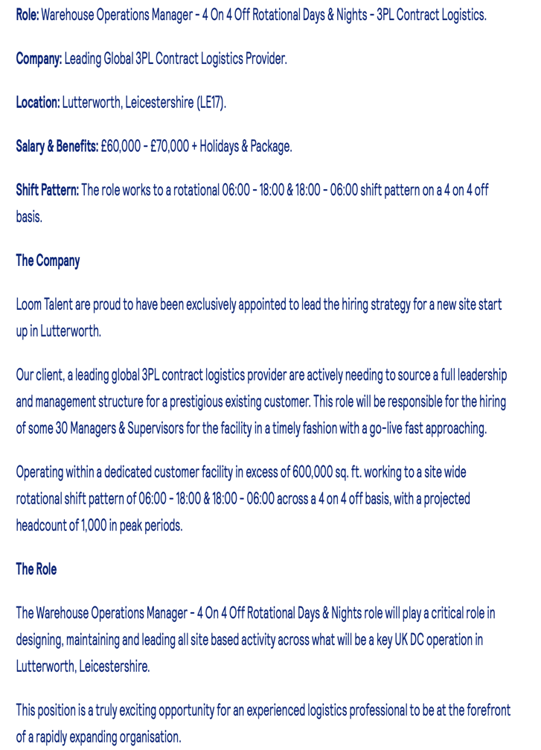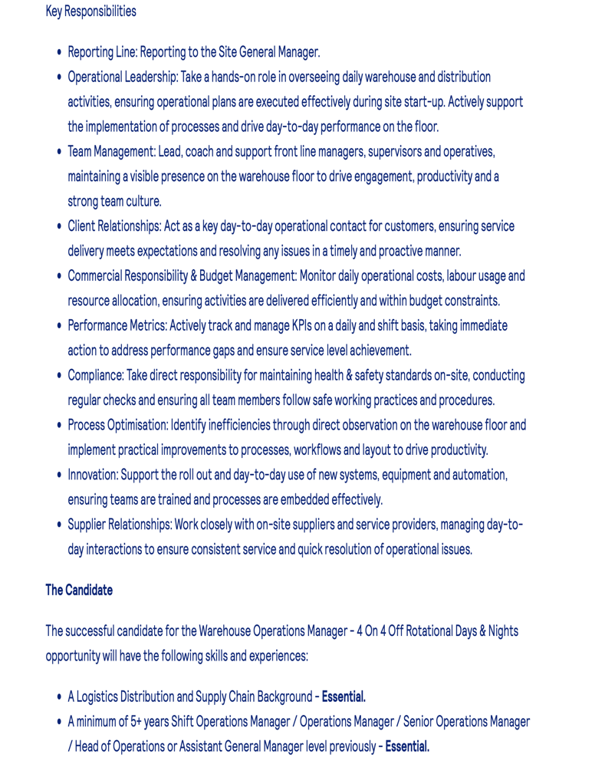
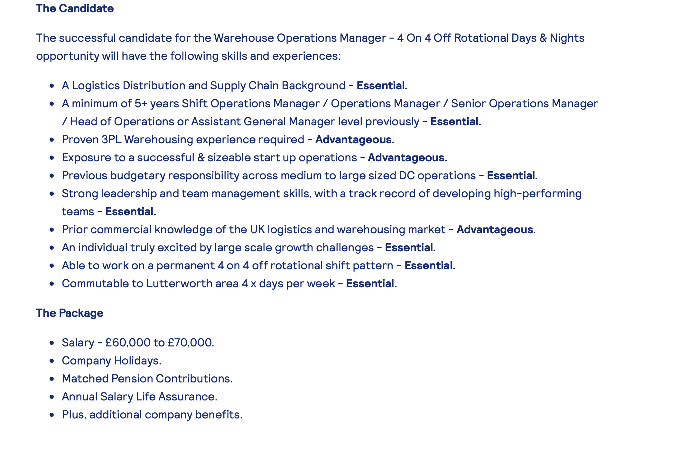

REMUS GAVRIL | Mobile: 07957015616  Email: gavrilremuss@gmail.com

Profile
Results-driven Warehouse and Logistics Professional with extensive experience in warehouse operations, inventory management, team leadership, and customer-focused logistics solutions. Experienced in managing day-to-day warehouse activities, coordinating operational workflows, monitoring KPIs, and supporting continuous improvement initiatives. Strong background in problem-solving, decision-making, team management, and maintaining high service standards within fast-pace environments. Currently studying Business Skills for the Workplace while developing advanced leadership and operational management capabilities.

Core Skills
- Warehouse Operations Management
- Team Leaderships & Staff Development
- Logistics & Supply Chain Operations
- KPI Monitoring & Performance Management
- Inventory Control & Stock Accuracy
- Process Improvement
- Health & Safety Compliance
- Customer Relationship Management
- Problem Solving & Decision Making
- Workforce Planning
- Adaptability & Change Management
- Operational Reporting

Work experience
Fast Fulfillment Centre Ltd / Fast Prep UK 2022 - Present
- Manage daily Warehouse Operations for e-commerce and third-party logistics clients
- Lead warehouse teams to achieve operational targets and service level agreements.
- Coordinate inbound and outbound shipments, inventory management, and order fulfilment activities.
- Monitor operational performance and implement process improvements to increase efficiency.
- Ensure compliance with health and safety regulations and warehouse procedures.
- Act as a key point of contact for customers and resolve operational issues promptly.
- Support business growth through efficient resource planning and workflow management.

Education
Certificate of Higher Education Business Skills for the Workplace University of Wales Trinity Saint David (UWTSD)
2025 - Present
Additional Information
- Full UK Driving Licence
- Eligible to work in the United Kingdom
- Flexible regarding shift patterns, including days, nights, and rotational shifts
- Strong IT and warehouse systems knowledge
References
Adrian Marian Lusneac, Director, Fast Fulfillment Center Ltd, adrianlusneac@gmail.com , 07555384243
Loredana Elena Gavril, Director, Fast Fulfillment Center Ltd, elenaloredanadascaliu@gmail.com , 07492624289

