

Academic Discipline of Birmingham Campus Institute of Inner City Learning

Msc Data and artificial Intelligence

ACFA7003 Masters Project

Title: Predictive Modeling for Cardiovascular Disease Risk Using Machine Learning Techniques

Student Name: Sadanand Tanneru

Student ID: 2418784

Supervisor Name: Md Shantanu islam

The Thesis submitted in partial fulfilment of the requirements for the degree of master of science in Data and Artificial Intelligence

Academic Year: 2025/2026

DECLARATION

I, Sadanand Tanneru declared that I am the sole author of this Project, that all references cited have been consulted, that I have conducted all work of which this is a record, and that the finished work lies within the prescribed limits.
This work has not previously been accepted as part of any other degree submission.

Signed: Sadanand Tanneru

Date:05-05-2026

FORM OF CONSENT

I Sadanand Tanneru hereby consent that my Project, submitted in candidature for the M.Sc. Data and Artificial Intelligence, if successful, may be made available for inter-library loan or photocopying (subject to the law of copyright), and that the title and abstract may be made available to outside organizations.

Signed: Sadanand Tanneru

Date: 05-05-2026

ABSTRACT
This project involved the development and evaluation of a machine learning workflow for predictive modelling of cardiovascular disease risk using the public CDC BRFSS-based Kaggle dataset of heart disease indicators. The research problem was the need for an efficient, interpretable and reproducible classification pipeline that could learn from large mixed-type survey data while also handling class imbalance. The study's novel contribution was the combined use of imbalance-aware evaluation, interpretability and threshold analysis within one reproducible workflow for large-scale survey-based cardiovascular risk prediction. The objective of the study was to compare five supervised learning algorithms, namely Logistic Regression, Support Vector Machine, Random Forest, Gradient Boosting and Multi-Layer Perceptron, and report the most adequate algorithm for predicting heart disease occurrence at population level. A positivist, deductive and predictive quantitative design was adopted with secondary data only. The system is coded in python, via Google Colab, pandas, NumPy, scikit-learn and matplotlib. Duplicate data points were removed, mixed types of data were initially organized as one-hot encoding and scaling before train-test split and imbalance of a dataset was treated by using class weighted models and under-sampling. The evaluation of performance was done in terms of accuracy, precision, recall, F1-score, ROC-AUC, confusion matrix, and threshold behaviour. Results showed that each of the five models was useful in relation to discrimination. Multi-Layer Perceptron and Gradient Boosting had the highest ROC-AUC scores whereas, in areas where interpretability and balanced F1 performance are relevant, the logistic regression and the calibrated linear SVM remain competitive. The project provides a reported end-to-end workflow to demonstrate how explainability, threshold analysis and comparative testing can assist in supporting responsible machine learning in health analytics. The new uses will be outside validation, calibration of probability and subgroup fairness assessment.

Table of Contents
DECLARATION OF ORIGINALITY 2
FORM OF CONSENT 3
Copyright Acknowledgement 3
ABSTRACT 4
1.0 INTRODUCTION 6
1.1 Background 6
1.2 Problem Statement 7
1.3 Aim and Objectives 8
1.4 Research Questions 8
1.5 Scope and Limitations 9
2.0 LITERATURE REVIEW 9
2.1 Chapter introduction 9
2.2 Cardiovascular risk prediction context and real world drivers 10
2.3 Data sources and feature representations in CVD modelling 11
2.4 Model families and comparative results 12
2.5 Imbalance, validation and metric choice 13
2.6 Explainable, trust and clinical usability 14
2.7 Mental health comorbidity as a modelling dimension 14
2.8 Comparative systems and implementation patterns 15
2.9 Research gaps, novelty and theoretical framework for this dissertation 16
2.10 Literature table 17
2.11 Conclusion and link to research questions and objectives 18
3.0 Methodology 19
3.1 Introduction 19
3.2 Research Philosophy 19
3.3 Research Approach 20
3.4 Research Design 21
3.5 Data Collection Method 22
3.6 Data Analysis Technique 23
3.7 Ethical Considerations 24
3.8 Summary of chapter 25
4.0 IMPLEMENTATION & DEVELOPMENT 27
4.1 Implementation workflow and system architecture 27
4.2 Data preprocessing and engineering decisions 28
4.3 Algorithm implementation and training configuration 29
4.4 Artefact outputs and implementation evidence 29
5.0 TESTING & EVALUATION 31
5.1 Testing Strategies 31
5.2 Experimental Results and Performance Evaluation 38
5.3 Results & Discussion 40
6.0 CONCLUSION AND FUTURE WORK 42
6.1 Summary of Findings 42
6.2 Research Contributions 42
6.3 Recommendations and Future Further work 43
Reference list 44

1.0 INTRODUCTION

1.1 Background
Cardiovascular disease (CVD) is a major cause of avoidable morbidity and mortality, many of its disease burden can be attributed to modifiable risk factors such as smoking, being overweight, diabetes, inactivity and inadequate sleep. Meanwhile, structured data are becoming more and more accumulated in the modern healthcare system and the agencies of population health, and large volumes of data regarding these risk profiles at the population scale are becoming a common event. This gives the practical potential to learn patterns or associations between risk indicators and disease status, and actually use this reliably and confidently to support the earlier identification of higher-risk people and support the planning of prevention. Recently, research indicates high interest in employing machine learning (ML) to predict the outcomes of heart disease, as well as to translate information about risk factors into the actionable probability [3], [6].
The theoretical basis of working this way is due to the fact that CVD risk is not always linear and independent. Risk factors interact: the influence of high body mass index, e.g. may vary by age category, diabetes status or self-reported general health. The traditional risk scoring methods frequently assume more simplistic forms of relationships by comparison to ML techniques which can model other forms of relationships and yet be evaluated with respect to the highly rigorous validation methods. The accumulating evidence indicates that various ML algorithms may be applied to the problem of CVD prediction, and their results are dependent on the specifics of the data and modelling decisions [14], [21]. However, an unresolved gap remains in how large survey-based datasets can be evaluated with class imbalance, threshold analysis and interpretability at the same time. Many studies report predictive performance, but fewer connect model comparison to the practical screening trade-off between missed positive cases, false alerts and explainable risk indicators. This gap motivates comparative modelling rather than reliance on only one algorithm.
The practical context of this dissertation is in performing a secondary analysis on the "Indicators of Heart Disease (2022 UPDATE)" dataset derived from CDC BRFSS survey and distributed via kaggle. The data set includes important behavioural and health indicators (such as BMI, smoking, physical activity, sleep time, diabetes status and self-rated general health), and a binary heart disease; Such population-level survey data are relevant for the scalable logic of screening and understanding what factors best drive the model predictions for broader community samples. Explainable artificial intelligence (XAI) approaches have been suggested for more and more health prediction tasks because for this sector of stakeholders require to understand what is driving these model outputs, and cheque for implausible or biassed patterns ([15]; [28]). Therefore, this study makes prediction's accuracy and interpretation complementary goals.

1.2 Problem Statement
Despite the rapid development of extensive research in ML-based CVD prediction, a persistent gap exists regarding the extent to which it is feasible to develop and assess models trained on large, mixed-type, large-scale survey-based indicators in an imbalance-aware and interpretable way. Many datasets of CVD are unbalanced, with fewer positive cases than negative cases, if care is not taken to the imbalance, models can have a deceptively high accuracy and miss a great deal of the true cases. A number of recent papers note the importance of the adequate selection of metrics and evaluation protocols when reporting the model performance for CVD prediction [14], [31]. In addition, the literature demonstrates a wide range of experiences on the adoption of model transparency where, especially when predictions may impact prevention advice or triage decisions, models that cannot explain their outputs may be considered untrustworthy even when they work well [15].
Reproducibility is considered to be a fundamental quality criterion. All the preprocessing decisions, model parameters, random seeds and evaluation outputs will be recorded in one notebook so that results can be rerun and checked. This is in response to the concern that applied ML studies may not be very easy to replicate or compare.
This project addresses that problem by building up a reproducible and reproducible heart disease prediction pipeline based on the CDC BRFSS indicator dataset and compares various ML models with the same preprocessing and validation approach and reported metrics that can be applied in the case of unbalancing classification. The research discusses the gap in interpretability further (by generating elucidable insights into influential predictors and discussion of the limitations in the models in regards to survey bias and generalisability). The threat that the models conditioned on generalised population data will behave differently in particular communities is given particular attention. As an example, the clinical and ethical concerns and considerations are specific to subgroups and can be critically utilized when interpreting models ([4]).

1.3 Aim and Objectives
The particular goals of this dissertation are to create and test machine learning models that predict cardiovascular disease risk through health indicators of the population expressed in the CDC BRFSS-based Kaggle dataset, and with a specific emphasis on sound evaluation and interpretability.
Objectives:
- To develop a programmable dataset data-processing workflow reproducible with the dataset, including validation, missing-value treatment, categorical encoding, stratified train-test splitting and cross-validation-ready preprocessing.
- To train and compare five machine learning classification models for heart disease prediction and evaluate them using AUC, F1-score, precision, recall, confusion-matrix analysis and statistical comparison of model performance.
- To interpret and report the key drivers of prediction using explainability techniques, threshold analysis and calibration assessment, and to discuss implications, limitations and ethical considerations for survey-based risk modelling.

1.4 Research Questions
- How accurately can heart disease status be predicted from CDC BRFSS indicator variables using five different machine learning models?
- How do imbalance-handling choices and evaluation metrics (AUC, F1, precision, recall) affect the comparative conclusions about model performance?
- Which indicators most strongly influence model predictions, and how interpretable are the resulting explanations for practical risk communication?

1.5 Scope and Limitations
This dissertation is concerned with supervised binary classification with secondary survey data. The domain is cardiovascular/ heart disease risk prediction based on behavioural, demographic and self-reported health indicators. The tools are Python and Google Colab with standard ml libraries for the preprocessing tasks, modelling and evaluation. The scope of the dataset is limited to the included Kaggle file/s based on the 2022 BRFSS indicators and features listed (e.g., BMI, smoking, alcohol drinking, history of stroke, physical and mental health days, difficulty walking, sex, age category, race, diabetes status, physical activity, general health, sleep time, asthma disease, kidney disease and skin cancer). Five models will be implemented in order to allow for the comparative analysis; this is consistent with the broader literature that encourages multi-model benchmarking in order to avoid overgeneralising from a single approach ([20]; [29]).
Important limitations are a consequence of the nature of the data and study design. First, the dataset is survey-based and self-reported, hence, there may be some element of misclassification and reporting bias. Second, the analysis is cross-sectional and predicts reported status as diseased (as opposed to a prospective time series outcome that predicts events). Third, generalisability (beyond dataset population and year) cannot be assumed without outside validation and demographic variables may contain social and structural factors, that should be interpreted cautiously in order to avoid possibly reinforcing bias. Fourth, model explainability methods yield approximations of the feature influence unlike a causal conclusion Carvalho et al. interpret feature importance as association in the dataset, not proof of the causation. Finally, given that the dataset label represents a particular operational definition of heart disease/attack status, conclusions should be stated in terms of that label and not as an instrument of diagnosis.

2.0 LITERATURE REVIEW

2.1 Chapter introduction
Machine learning has emerged as a viable pathway to cardiovascular diseases risk prediction capability due to its abilities to learn complex relationships in massive datasets and provide probabilistic values to aid in key screening and prevention decisions. The recent literature identifies two related motivations, which overlap. One is technical, where researchers try to better the predictive performance through comparative implementations of algorithms, feature tuning and choice of metrics which reflect clinical priorities [2], [16]. The other is practical, in which the researchers wish to get models that can be depended upon, extract inferences and implement them in real situations without making the bias even worse or developing false certainty [18], [40].
One of the arguments that are applicable relative to the literature is that there is no single outcome and just one mechanism of CVD. It includes multiple related conditions and events, coronary artery disease, stroke, heart failure, and congenital heart defects, each with distinct risk profiles and required data. This causes variation in the outcome labels and modelling choices. Some work on predicting heart disease in general with common risk factors like age, diabetes, smoking, blood pressure surrogates and BMI, and for benchmarks like UCI often under structured data [12], [22]. Others are based on specific outcomes like stroke risk prediction, which is tend to be less frequent and tends to put burden on imbalance aware evaluation [5]. There are also mum-child risk predisposition settings such as identifying women with at risk pregnancy for producing a child with congenital heart defects, which have different predictors and ethical considerations with adult screening settings [1]. This diversity explains why evidence cannot be read as one leaderboard monitored of "best models". Instead it is necessary to read the literature as a series of design patterns that necessarily need to be adapted to the dataset and the intended use.

2.2 Cardiovascular risk prediction context and real world drivers
The practical appeal of CVD prediction can be seen in how the risk modelling and decision support will be deployed by real organisations in their investments and use. Health systems like the UK NHS and large provider networks in the US have over the years expanded digital risk stratification to try and manage chronic disease burden and avoidable admissions. Commercial platforms have also helped to make predictive analytics mainstream in the delivery of care. For instance, Epic Systems sells the clinical decision support and population health analytics that visualize risk stratification across massive gbs of patient data, and Optum and IBM's healthcare analytics offerings have traditionally made predictive models for prevention and cost-cutting. The underlying logic is the same across settings: the earlier the risk identification, the more targeted interventions can be undertaken: for example, in smoking cessation programmes; in diabetes management; or for road safety concerns; or in blood lipid management, all of which are well researched to be linked to CVD risk. The latest writing on ML poses this as a translation issue: a model needs to be correct, stable, interpretable and Erasmus for it to be able to make a decision in real life ([28]).
This challenge of translation can also be seen in history when it comes to real events which have influenced people's trust in data-based tools to help with health. During the period of the coronavirus, digital triage and remote monitoring were accelerated in the health system, medical algorithms gained general awareness. At the same time, debates over the fairness and equity of bias in health algorithms-high-profile scandals-reminder researchers of the notion that good performance for an average person can mask poor performance for a subgroup. This is important for CVD as risk is social and affected by structural factors such as access to care and health behaviours. The science of interpretability is now stuck with the idea that it is not a handiness feature but a safeguard, because that solves the problem of being auditable for clinical sense-checking [40].

2.3 Data sources and feature representations in CVD modelling
Across studies, the extent to which model behaviour is determined by the name of the algorithm, rather than other factors, is large, with data origin and feature representation of the risk playing a large part. In a major strand involves structured clinical or survey variables in which predictors are tabular and include demographic data, lifestyle indicators and comorbidities. This is the strand most relevant to the CDC BRFSS-derived dataset used in this dissertation. Several studies incorporate similar structured variables and maintain that directors like age, diabetes status, smoking and self-reported health status keep appearing as mechanism aboundment with behavioral-assembled studies, then the strength as well as direction of importance can change [26], [24] when modelling choices change. This serves to support the argument that feature effects are model-dependent on data and dataset-dependent and that interpretability should be attached to a stabilised design of evaluation and not claim universal truth.
A recently added strand uses mental health factors as risk factors for cardiovascular disease. This is not solely a novelty in modelling. It is a reflection of a clinical reality - mental illness is linked to increased cardiovascular risk attributed to complex pathways including the impact of medications, lifestyle patterns and barriers to care. Psaltis and Van Den Hengel [25] addressed predicting the risk of CVD through machine learning methods using mental health data, and how non-traditional risk predictors can add value and can increase the interpretability and ethical questions. Dorraki et al. [11] had a similar focus on the use of mental health data for cardiovascular prediction; and reflects an emerging, cross-domain approach on integration of behavioural and psychological factors as a relevant risk signal, rather than a peripheral context. The implication for datasets based on surveys is obvious: those that measure wellbeing, functional limitations and general health are potentially associated with predictive power beyond the traditional biomedical indicators, but can also serve as proxies for disadvantage, and require careful reporting and caution in interpretation.
The literature also includes projects in the form of "10-year risk prediction", which is reminiscent of old risk calculators but employs ML methods. Dahia and Szabo [9] explained the implementation of ML to determine the risk of having a CVD within 10 years, with the attractiveness of fitting the output of ML into existing clinical dynamics that are familiar to us. However, in datasets of cross-sectional surveys, outcomes of time-to-event events are often unavailable, and the outcome is a current or historical diagnosis report rather than a future event. This distinction is important because it alters what the model is predicting and how it should be evaluated/described in, which in the case of a generic "heart disease prediction" report is often blurred [35].

2.4 Model families and comparative results
There is a common trend in the literature towards comparative benchmarking between several supervised learning algorithms. Studies compare Logistic Regression with decision trees, Random Forest, Support Vector Machine, boosting methods and sometimes neural networks. The reason is that there is no universally superior model for tabular health data. Various researchers give various best models due to variations in datasets, quality of features and class distributions and evaluation metrics. The small benchmark dataset will perhaps permit a flexible model to seem superior since it can fit local patterns, whereas a large survey dataset will perhaps reduce this advantage as many predictors are categorical, self-reported and moderately separable. That a comparison was possible between models was therefore supported by Ali and Ahmed [2] although the meaning of an optimal model was dependent on whether the study was focused on accuracy, AUC, recall, F1-score or interpretability.
The many papers introduce as a general theme the prediction of heart diseases using machine learning; frequently having slightly different pipelines, without necessarily the same evaluation logic. Vardhan et al. [37] and G. [13] exemplify that this applied work aims at implementation of pipelines and comparison of different models. Such studies prove to be useful, though tend to underspecify as to why one model is superior. The size of the datasets is important as the huge datasets will stabilise estimates, whereas very small datasets will make the model differences exaggerated. The level of imbalance is also important since even a model with a high level of accuracy can still predict few positive cases of CVD. Another source of variation is feature engineering: one-hot encoding, scaling, and treatment of missing values, among other things can change the same algorithm to perform better. The choice of evaluation metric is also significant since an algorithm with the high score on the evaluation metric might not yield the highest F1-score at 0.50 theso.
More technical inputs attempt to enhance interpretability and transparency. Proposing an interpretable model by decomposing features (in the GSI model) [40], which indicates movement beyond the rankings of feature importance. This is important for survey-based datasets because a black-box classifier must be converted into evidence that can support discussion of modifiable indicators. However, interpretability does not remove the need for rigorous metric selection. A model may be explainable but still weak for minority-class detection, or it may rank cases well but require threshold adjustment before screening use. This study therefore treated algorithm comparison, imbalance handling, metric selection and interpretability as linked parts of the same evaluation problem rather than separate technical tasks.

2.5 Imbalance, validation and metric choice
One of the most consistent weaknesses in applied CVD modelling laid to lack of proper handling of class imbalance. In several datasets, positive cases of CVD are the minority, and this means that a naive classifier can predict high accuracy, as they can mostly predict the majority class. Studies which have paid attention to evaluation strive to focus on AUC, F1 score, precision and recall instead of accuracy in itself, and stratified splits are often employed in order to maintain the class distribution when using validation sets [32]. [19], explicitly associated resampling with enhanced prediction, reconfirming that handling imbalance is not only a fancy enhancement to refine the model, but it is a core decision in the model design.
The evaluation challenge is not only on metrics but also the validation design. Many studies are based on a single train-test split and this can lead to unstable estimates with high dimensionality or noisy self-reported variables.
The care of the preprocessing in the folds is being taken care of by robust practice, making cross-validation repeated cross validation or take care of your split. Joshi et al. [16] located forecasting with ML algorithms as a utilized pipeline and the finest aspect of such a pipeline is not the algorithms but the science of assessment. When researchers, in case of confusion matrices, report both metrics of discrimination and error analysis, it is simpler to understand whether improvements are due to improved detection of the minority class or is simply a result of overfitting to the majority.
A good example of why this is important can be found in screening programmes and digital health triage systems. If a model is used to identify people at high risk for follow up, false negatives may be more expensive than false positive results in that missed risk may cause delayed prevention. Precision-recall trade-offs are not some abstract mathematical concern where a work is the operation workload and risk are expose. Therefore, threshold selection and calibration have been treated increasingly as literature where it is predicted probabilities that may be communicated to clinicians or patients. Although many papers in the applied literature still don't report results from calibration, the trend towards more careful evaluation can be seen in review style analyses of ML innovations for cardiovascular prediction fundraising [18].

2.6 Explainable, trust and clinical usability
Explainability has become part of central requirements in health ML, from a "nice to have" to an application requirement. The reason is not philosophical in nature. It is practical. Clinicians and stakeholders need to be aware of whether a model is based on plausible signals, is potentially biased and whether the outputs of a model can be defended. Yu et al. [40] is a relatively new direction of interpretability work in which there is a focus on designing explanations into the modelling approach, instead of examining them after the model is trained. Kandwal [17] took AI-based prediction as a broad direction, but the well-matured bit of the area now calls for AI systems to offer transparent and-auditable paths of reasoning especially for high -stake results.
This has real organisational parallels. The US Food and Drug Administration has issued guidance on clinical decision support and software as a medical device which is putting pressure on those that develop the models to document performance, intended use and explanation mechanisms. Even in cases where an academic model is not the goal for regulatory deployment, the same norms have an effect on expectations in healthcare organisations. A simple example is the way that clinical teams use CHA2DS2-VASc to enable them to stroke risk in atrial fibrillation - because the individual components are understandable and workable. ML models do not need to be linear scorecards, but the explanations of a model must be meaningful within the context of prevention. Papers that focus on CVD prediction metrics without interpretability are at risk for generating results that are difficult to turn into action ([30]).

2.7 Mental health comorbidity as a modelling dimension
Somewhat distinctive about the last work on CVD ML is that mental health factors have been integrated. Bernstorff et al. [4] has predicted cardiovascular disease in people with mental illness showing that for specialised cohorts it is possible to benefit from tailored modelling as risk and risk factor patterns at baseline are different to the general population. This has a well-recognisable real-world analogy: persons with severe mental illness have a higher prevalence of smoking and metabolic risk and health services often face challenges in providing sustained cardiometabolic health care prevention services to these groups. ML models pointing to this risk can be used to support targeted screening, and at the same time can replicate stigma if poor results are framed this way.
Psaltis and Van Den Hengel [25] and Dorraki et al. [11] both addressed ML risk prediction using mental health data, this helps position mental health variables as potentially useful predictors and not as confounder that we can ignore. For a survey dataset such as BRFSS indicators, variables like mental health days, general health perception and difficulty walking may represent functional and psychological dimensions which correlate with cardiovascular risk. The literature suggests that these variables can add to predictive power but also to increase the demand for things such as interpretability because they can act as a proxy of social disadvantage or access to care. Therefore, the methods of explanation are not only interpretive methods but ethical instruments to support responsible reporting.

2.8 Comparative systems and implementation patterns
Several studies report end-to-end systems that are an implementation of ML pipelines to predict CVD, which often take the form of presenting a software or a workflow contribution. Dabir et al. [8] analysed cardiovascular disease using ML techniques with good steps such a pre-processing, model fitting and evaluation. Stonier et al. [36] talked about risk prediction of cardiac disease by ML algorithms in healthcare technology which shows that there is a practical model where models are often embedded in the lightweight decision support tool and dashboards or prototypes instead of simply existing as a research artefact. In industry, we have seen a similar type of embedding in the form of clinical analytics platforms such as Microsoft's cloud health data services as well as risk stratification products offered to providers. This is an example as to why reproducibility and documentation is important. Without having a documented pipeline it becomes hard for organisations to have confidence in and re-use findings.
At the same time, the applied literature boasts a lot of studies which seem to be similar in their title and scope but are quite different in their methodological rigour. Yadav et al. [39] and Yadav [39] are typical application oriented works where the main purpose is predictive modelling rather than method innovation. Such work is valuable in terms of showing the proof of feasibility but will often leave wonderful gaps in terms of calibration, subgroup evaluation and external validation. The wider review literature suggests the next step for the field is therefore not generating more single dataset classifiers but generating more transparent generalisable and clinical coherent modeling pipelines [18].

2.9 Research gaps, novelty and theoretical framework for this dissertation
The specific gap identified from the reviewed studies is not simply that more CVD prediction models are needed. The more restricted issue is that much of the existing work can appraise models using either small or simplified datasets, report one or two headline measures, and pay little attention to the interacting influence of both heterogeneity of survey-data and imbalance in minority classes. This is a colder cut of the CDC BRFSS-style dataset due to pin being of mixed-type (partially self-reported and highly population-based). This data needs a workflow capable to process categorical and numerical predictors in a consistent manner, without giving a false sense of accuracy, quantifying the precisionrecall trade-offs, and describing which predictors guide predictions. A model can seem technically robust yet weak to the practical interpretation of screening in the absence of this combination.
The novelty of this dissertation is not on the argument that the ML can predict such a disease because it is already known across applied studies [22], [33]. The novice is the controlled combination of three aspects in a single big survey-data procedure: imbalance-acceptant evaluation, interpretable feature reporting and threshold-based assessment. The preprocessing, split and evaluation logic used in the project was identical to the five models; which made the comparison more defensible than model experiments. This directly addressed the gap between generic classifier-building and a reproducible, screening-oriented analytical artefact suitable for population-level cardiovascular risk research [2], [40].
The theoretical framework used to structure the modelling approach was a predictive analytics framework that connected risk-factor theory with supervised learning and model evaluation. In risk factor epidemiology, CVD emerges from behavioural, metabolic and demographic factors acting together, which supports models that can capture interactions and non-linearities. In supervised ML, this became the task of learning a mapping from health indicators to a probability of reported disease status. The framework also included a socio-technical layer: outputs had to be interpretable, and evaluation had to reflect imbalance, calibration and threshold uncertainty. This aligned with recent CVD ML research where interpretability is treated as part of trustworthy system design rather than optional reporting [30], [40].

2.10 Literature table
The table below summarises key themes and methodological features from representative studies that align with the dimensions of this dissertation, including comparative modelling, interpretability, specialised cohorts, and imbalance handling.
Author(s) | Year | Focus | Data context | Method emphasis | Key implication for this study
Dritsas et al. | 2022 | Supervised ML for CVD prediction | Structured tabular data | Model comparison | Supports multi-model benchmarking as baseline practice
Mohamed et al. | 2022 | ML techniques for CVD prediction | Structured health dataset | Pipeline implementation | Highlights importance of preprocessing and evaluation transparency
Psaltis and Van Den Hengel | 2022 | CVD prediction using mental health data | Mental health predictors | Cross-domain features | Motivates inclusion and careful interpretation of wellbeing variables
Dorraki et al. | 2022 | ML for CVD prediction with mental health data | Mental health linked data | ML risk prediction | Reinforces subgroup and proxy-risk concerns in feature use
Dalal et al. | 2023 | ML applications for CVD risk | Applied review | Comparative ML | Supports broad evidence that multiple models are viable
Stonier et al. | 2023 | Cardiac risk prediction algorithms | Health technology setting | Deployment relevance | Encourages reproducible pipelines suitable for tool embedding
Kiran et al. | 2024 | Resampling and ML | Imbalanced data | Imbalance handling | Justifies class weighting/undersampling choices
Shishehbori and Awan | 2024 | Enhanced risk prediction | ML models | Metric focus | Reinforces AUC/F1 over accuracy in imbalanced settings
Yu et al. | 2025 | Interpretable ML via feature decomposition | Population risk dataset | Explainable design | Supports explanation as core requirement
Bernstorff et al. | 2025 | CVD prediction in mental illness | Specialised cohort | Clinical nuance | Highlights need for cautious interpretation and subgroup awareness

2.11 Conclusion and link to research questions and objectives
The reviewed literature indicates that ML-based cardiovascular risk prediction is a mature area of application, but the quality of the methods employed and the relevance of these methods for clinical presentation vary widely. Comparative modelling is prevalent and required, because the performance of algorithms is dependent on the properties of data, and the preprocessing choices, which justifies the dissertation's use of five models in one consistent pipeline [37]. The literature also reveals that imbalance handling plays a key role, given that CVD outcomes are many minority classes, and evaluation should focus on certain evaluation criteria such as AUC and F1 to prevent drawing wrong conclusions [19]. A significant shift within the field can be the shift towards explainability as a prerequisite for trust and clinical sense, and interpretable modelling approaches and explanations at a feature level will be increasingly sought [40].
These findings directly relate to the research questions and aims of the study. The first research question which asks how precise heart disease status can be predicted using multiple ML models is based on comparative evidence and the practical need to find the best performing model for the chosen dataset. The second question, centred on imbalance and metric choice, is warranted by the fact that multiple studies have repeatedly demonstrated that uninformed evaluation can be a fundamental obstacle in assessing performance of minority classes. The third question, which addresses key indicators, and interpretability, reflects the prominence on the explainable outputs and responsible reporting in the field, not least, where behavioural and mental health variables might serve as powerful but ethically sensitive predictors ([11]). Overall, this chapter supports the dissertation's approach as a coherent response to currently existing research gaps, as well as positioning the subsequent methodology chapter as implementation rather than a simple model-building exercise.

3.0 Methodology

3.1 Introduction
This chapter described methodological choices made to study the predictive modelling of cardiovascular disease risk by machine learning techniques. The study was based on using secondary data instead of interviews or any other primary data, because the nature of the research problem demands a structured, large-scale and numeric data set enough to be used for comparative machine learning analysis. The methodological design was aligned to the nature of the study, that was aimed at the build, comparison and evaluation of five classification models in a reproducible way using Python and Google Colab. The chapter therefore discussed the research philosophy, research approach, research design, data collection method, data analysis technique and ethical considerations. The chapter also explained why the selections were appropriate for a study of cardiovascular risk prediction using the Kaggle dataset from CDC BRFSS indicators. In so doing, the chapter provided a definite connexion between the research questions and the analytical pipeline as well as the expected results of robust, interpretable and imbalance-tolerant model performance.

3.2 Research Philosophy
Research philosophy meant the system of beliefs regarding knowledge, reality and how valid findings could be yielded in a study [41], [42]. The major philosophies that are widely discussed in research methodology were positivism, interpretivism, realism and pragmatism. Positivism believed that reality, independent of a researcher, can be measured objectively using observable facts and structured methods. Interpretivism was focused on subjective meanings, lived experiences and context specific understanding, therefore it was often favoured for studies using interviews or narratives. Realism accepted an external reality but also realised that reality could only be understood to some degree through human sense. The focus of pragmatism was on practical problem solving and choosing the ways based on usefulness not philosophical purity [41]-[44].
This study adopted positivism since the problem to be researched was objective, measurable and data driven. The target of the study was not personal meaning or social interpretation, but prediction of a binary health-related outcome from some structured indicators like BMI, smoking, diabetes status, general health and physical activity. Positivism suitable since the study was based on observable variables, numerical data, mathematical logic and replicable procedures. These features were similar to the central features of positivism in terms of objectivity, measurement, hypothesis-oriented reasoning, pattern testing and empirical validation [41], [42]. In this context, the research questions were which models of machine learning worked better and what results were achieved with different approaches of imbalance-aware evaluation and which indicators influenced the prediction. These were queries into measurable relationships and predictive performance in no way subjective interpretation. Therefore, positivism gave a coherent philosophical base to compare algorithms in terms of AUC, F1-score, precision, recall and confusion matrices.
Positivism was more favourable than the interpretivism as no interviews, perceptions or lived experience was collected. This was favoured to realism as the study didn't try to theorise hidden causal mechanisms outside of the dataset observed. It was also more preferred than pragmatism in that the research, which involved the necessity of clear methodological match with numerical testing and objective comparison between models rather than a mixed/flexible strategy. In health analytics and machine learning, positivism was particularly suited in the case where the goal was to detect regularity constructs from ordered datasets and to assess models according to reproducible criteria. For example, organisations such as the CDC and healthcare analytics firms are typical of the use of standardised population data and quantifiable indicators as means of monitoring disease burden and patterns of risk, which is symmetrical to a positivist logic of measurement and comparison.
However, there were some limitations of positivism too. Reducing complex health realities to measurable variables and it may not consider social context, behavioural nuance and structural inequalities that play a role in cardiovascular outcomes. Independent reported variables from a survey dataset may not reflect the lived reality of the risk of disease. Positivism was also not in-depth in terms of why people did what they did or how access to healthcare influenced health. Even so for this study the goals were not to explain personal experience but to test the predictive capability using structured data and the strengths of positivism trumped its limitations [41]-[44].

3.3 Research Approach
The research approach explained the logical flow of movement between theory and evidence. In methodology, two dominating approaches were the deductive and inductive approaches. Deduction approached from existing theory or previous knowledge toward empirical testing whereas induction approaches from observations toward the theory formulation [45]-[47]. This study applied a deductive approach since prior researchers have previously determined that the risk of cardiovascular disease was linked to the measurable indicators of smoking, obesity, diabetes, inactivity and poor general health. The purpose of the study was therefore not to create a new theory of cardiovascular disease, but to test how well five machine learning models were of learning patterns from these indicators to determine the target outcome.
A deductive approach was appropriate to the research context as the research was based on an existing data set, with a defined target variable. The outcome label was already known and studied the ability of a set of structured predictors to explain and classify the outcome in an algorithmic way. This was similar to deductive reasoning in which variables were identified in advance and tested in a systematic fashion. The industry relevance was also in favour of deduction. In public health and healthcare analytics, decision makers are typically not interested in the question: 'Is there some newly established qualitative meaning when we take indicators into account?' but rather in whether it is possible to predict measurable risk based on the known indicators more accurately. The region of concern in the dataset was the United States as data were obtained from CDC BRFSS surveys, however, the logic of the methodology was appropriate to broader cardiovascular screening situations. A deductive approach therefore enabled the study to relate theory, previous evidence and practical prediction in a logical and consistent manner [45]-[47].

3.4 Research Design
Research design referred to the overall plan that linked the research questions with data, methods and analysis [48]-[52]. Different designs included exploratory, descriptive, explanatory, predictive and phenomenological approaches. Phenomenological design was unsuitable because no interviews or first-hand narratives were collected [48]. Although the study used explanatory language when discussing associations between risk indicators and the heart disease label, the core design was fundamentally predictive rather than causal. This was not aimed at demonstrating that a variable was the cause of cardiovascular disease, but to test what degree of predictive power a set of orderly structured indicators had under consistent modelling conditions, in classifying a binary reported outcome.
It was also a cross-sectional design since the dataset included survey data of the respondents at a single point in time and not repeated measurements of the respondents. The study thus failed to simulate the disease progression and time-to-event likelihood. It made predictions of the dataset available heart disease label and also interpret effects of predictors as model associations. This difference was significant since classification performances, feature importance, and confusion matrices could indicate some useful ability when it comes to strong causal arguments. It was therefore correct to its prediction quantitative analysis and wary interpretation of associations were suitable to secondary survey data and comparative machine learning [48]-[52].
Design was also based on iterative system development logic like Agile short cycles. Data understanding, baseline modelling, imbalance handling, evaluation and interpretation were refined in stages. This was appropriate because machine learning results often depend on careful preprocessing, threshold evaluation and repeated tuning rather than only on model choice. The design therefore combined predictive quantitative research with iterative computational development, making it suitable for cardiovascular risk classification using a large public health dataset.

3.5 Data Collection Method
No primary data collection was carried out in this study. The research has made use of secondary information that was gathered from a public data availability Kaggle dataset known as Indicators of Heart Disease (2022 UPDATE), which can be accessed on: https://www.kaggle.com/datasets/kamilpytlak/personal-key-indicators-of-heart-disease. Secondary data collection was fit for the purpose as in the study, a large structured data set was required with a predefined binary outcome, and several relevant health indicators. Methodology literature recognised secondary data as appropriate when reliable existing sources could answer the research question in an efficient and transparent [50], [51], [53], [54]. This dataset came from the CDC BRFSS annual surveys and the data has already been narrowed down from a larger pool of variables to the set of variables relevant to heart disease prediction. The study has made a clear recording of the source, structure and variable meanings to keep the methodological rigour.
The data set was selected because there were variables in it that were strongly correlated to the aim of the study, namely the BMI, smoking, alcohol drinking, stroke, physical health, mental health, difficulty walking, sex, age category, race, diabetic and physical activity, general health, sleep time, asthma, kidney disease and skin cancer. The outcome variable was a heart disease label which was internally re-encoded into a binary target for modelling purposes. Since the dataset was made available with and without missing values, the version that was chosen along with any missing value handling procedures were recorded during the preprocessing. This reflected good research practise because there was greater transparency in data provenance and preparation improving replicability and trustworthiness [50], [51], [53], [54].
Table 3.1 Dataset profile and data collection summary
Item | Description
Data source | Kaggle public dataset: Indicators of Heart Disease (2022 UPDATE)
Original source | CDC BRFSS annual health survey
Data type | Secondary, structured, tabular dataset
Unit of analysis | Individual survey respondent
Outcome variable | Heart disease / binary target
Key predictors | BMI, smoking, alcohol, stroke, physical health, mental health, sex, age, race, diabetic status, physical activity, general health, sleep, asthma, kidney disease, skin cancer
Collection mode | Existing public download, no direct participant contact
Study method fit | Suitable for machine learning classification and comparative evaluation

3.6 Data Analysis Technique
The data analysis method was quantitative machine learning classification supported by performance metrics and interpretability outputs. Quantitative analysis was appropriate because the study involved structured variables, numerical encoding, pattern recognition and measurable outcomes [53]-[57]. The pipeline first validated and preprocessed the dataset through cleaning, encoding and scaling where required. The data were then divided through stratified train-test splitting to preserve class distribution. Five classifiers were trained: Logistic Regression, Support Vector Machine, Random Forest, Gradient Boosting and Multi-Layer Perceptron. Class imbalance was managed through class weighting and under-sampling, and outputs were assessed through AUC, F1-score, precision, recall and confusion matrices.
This technique was appropriate because the study focused on predictive performance under imbalance. AUC was used because it assessed ranking ability across thresholds rather than performance at one fixed cut-off. F1-score balanced precision and recall, which was important because positive heart disease cases were much less frequent than negative cases. Accuracies were reported in isolation number because an accurate model may still not be able to find sufficient true positive results. The standard probability cut-off of 0.50 served as a baseline decision rule since it is the most common probability cut-off used in binary classification and it also allowed a consistent comparison across all the five models. But it was not considered as clinically final. The effect of varying the decision threshold on sensitivity and its false positive burden were observed using ROCs and threshold analysis. A low threshold in a screening context can be justified in case the priority is minimizing of missed positive cases whereas higher threshold may be preferred in case priority is to reduce the number of false alerts which would cause excessive follow-up workload [53]-[57].
Interpretability was also factored in during the analysis. The identification of the most significant variables under optimistic predictions was done using feature importance or the model explanation methods. This was necessary since the machine learning models that are generated on health matters needed to be comprehensible in addition to being precise. It was written in Python on Google Colab using the pandas, NumPy, scikit-learn and matplotlib packages, with fixed random cards to enhance reproducibility. All in all the chosen technique was suitable, as it fitted in with the positivist philosophy, deductive method, predictive design and structured nature of the secondary data.

3.7 Ethical Considerations
Even though the research did not imply interviews and physical interaction with respondents, the aspects of ethics remained significant. The study employed a publicly available secondary data, and as such, an informed consent exercise was not-administered by the researcher. Nonetheless, the responsible utilization of the secondary data still presupposed the transparency, the security of the data, the proper attribution and meticulous data interpretation [41], [42], [53]. The study thus was very clear on that it identified the source of data, reported the decisions that were made during the preprocessing stage and ensured that it only used the data as regards to the purpose of academic research. Since the dataset was de-identified and put into the public, the risk of individual harm was low. Even so, the study did not even try to re-identify and only reported aggregate results and model-level insights.
Another ethical problem had to do with bias and misuse. Machine learning models used in health applications could perpetuate invisibility in the data or can be mistaken as diagnostic devices. To minimise this risk the study treated the models as predictive research tools as opposed to clinical decision systems. Results were interpreted with caution and explainability was incorporated to make the logic of the modelling more transparent. Reproducibility was also part of ethical practise because clear documentation limited the opportunities for making misleading claims and unsupported conclusions. In this sense, ethical responsibility went beyond the private to be honest, transparent and appropriate limits in reporting [43], [44], [53].

3.8 Summary of chapter
This chapter introduced the methodology that was used to study predictive modelling to predict the risk of cardiovascular disease based on machine learning techniques. The methodological choices were matched to the nature of the research problem, the structure of the dataset and the goal of developing a reproducible and interpretable predictive pipeline. The chapter established positivism as the guiding research philosophy in the first place, given that the study was based on measurable variables, objective analysis and empirical validation. This was appropriate for a machine learning study based on structured health indicators and binary classification. The chapter further mentioned that the study was completely based on secondary data collection. The public dataset from the Kaggle dataset which was derived from the CDC BRFSS surveys was chosen because it contained various behavioural, demographic and health-related variables that are pertinent to heart disease prediction. A dataset profile table was included to summarise the source, structure and predictors used in the research. The data analysis technique was then explained as an iterative machine learning classification pipeline in Python done on Google Colab. The steps involved in this workflow were preprocessing, stratified splitting for the data, class imbalance treatment, the training of five training models, evaluation by AUC, F1-score, precision, recall, confusion matrix, and interpretability analysis. This sequence of steps was necessary to make sure that the methodology in this chapter was not just a picking of procedural ground, but this time around, how to pursue a scientific analysis that was directly coupled against the research questions. Lastly, the secondary analysis of data involving health issues had ethical considerations that were found in this chapter. Though this study did not involve any interviews or collection of any personal data, the study made sure that ethical rigour was achieved through transparency, secure utilisation of public data and care regarding interpretation and avoidance of overstated clinical claims.

4.0 IMPLEMENTATION & DEVELOPMENT

4.1 Workflow and system architecture implementation.
Implementing this was done through translation of methodology chapter acceleration to a reproducible machine learning artefact is Google Colab. The work flow has been designed as a series of modular tabular classification work flow where loading, cleaning and preprocessing, imbalance and training data, evaluation and interpretation were broken down into discrete stages. This was in accordance with a wider relevant literature in the area of applied cardiovascular prediction in which benchmarking of comparative models and the transparent pipeline building are considered requirements to reliable results and not a (merely) good practice towards reliable results [10], [18], [28]. The implementation started by importing the necessary scientific and machine learning libraries and setting the random seeds to fix the results of the repeated implementation. The source file was stored in the Google Colab path convention /content/heart2020cleaned.csv and the notebook could therefore be executed without changing paths to the local file system once uploaded and made directly executable. The raw dataset was then checked for shape, types of variables, missing values and duplicate rows. The duplicates were removed so as to limit noise in the training data and the original HeartDisease label was converted to a binary target for the classification. For internal consistency with the methodology of the dissertation, the modelling process also produced the encoded target label deteriorationwithin24h, despite the fact that its substantive meaning was still equivalent to the outcome of heart disease in the source data set. This stage reflected a good implementation practise since reproducibility in health machine learning also depends on not only the algorithm choice but also on an explicit handling of target mapping, schema consistency and preprocessing assumptions [19], [40].
The implemented pipeline architecture that was used in the notebook is shown in Figure 4.1, starting from the raw BRFSS CSV file and ending with evaluation and interpretation outputs.
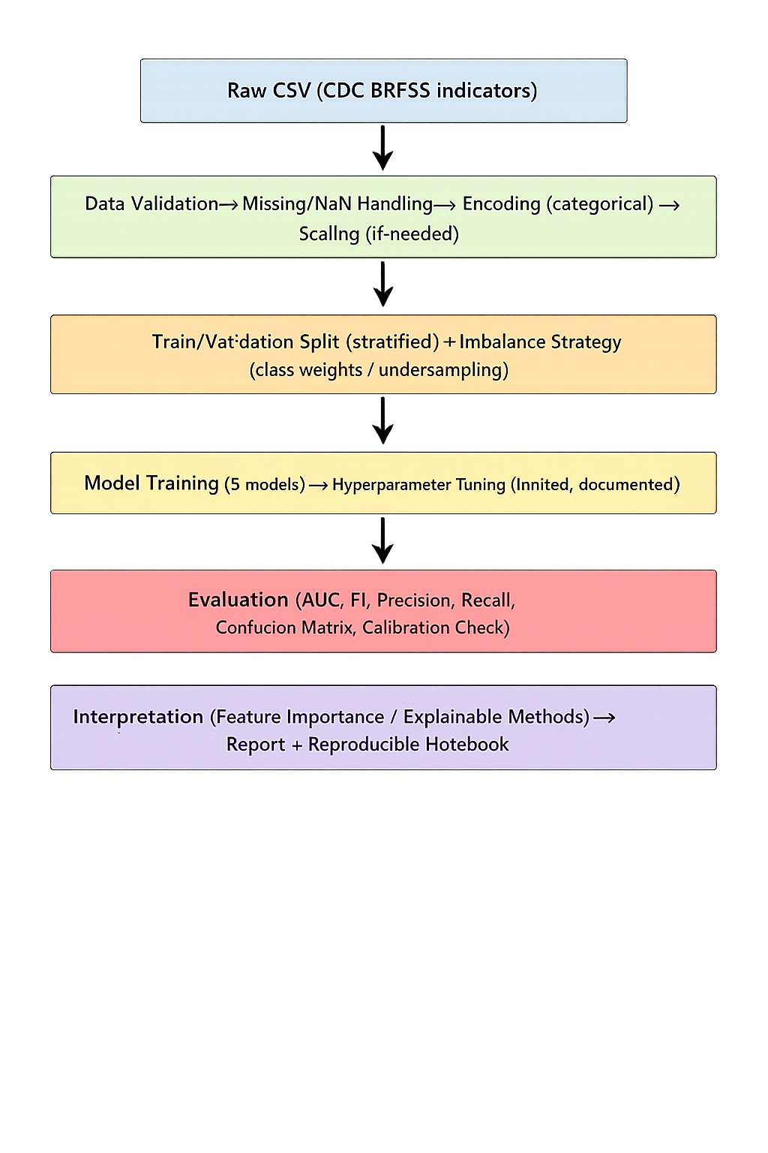
Figure 4.1 Machine learning workflow used for the implemented system

4.2 Data preprocessing and engineering decisions
Data preprocessing was the core engineering stage because the selected dataset included continuous fields, binary yes/no indicators and multi-category variables such as age group, sex, race and general health. A ColumnTransformer architecture was implemented so that numeric and categorical variables were processed through separate pipelines. Numeric variables were imputed using median values and standardised because scale-sensitive algorithms, especially Support Vector Machine and Multi-Layer Perceptron, work more robustly when features are on similar ranges. Categorical variables were imputed using the most frequent category and then transformed through one-hot encoding so that non-ordinal labels could be represented without imposing artificial order. These steps were consistent with comparative health analytics practice because mixed-type public health data can become unstable when different models receive inconsistent preprocessing [2], [19]. The implementation also used a stratified train-test split to preserve class proportions because the cleaned dataset remained highly imbalanced with 27,261 positive cases and 274,456 negative cases. Class weighting and random under-sampling were implemented inside an ImbPipeline so that resampling was performed only on the training data and not on the held-out test data, reducing information leakage and improving methodological soundness [19], [31].
Table 4.1 Numeric and categorical features used in preprocessing
Feature group | Variables included | Preprocessing decision
Numeric features | BMI, PhysicalHealth, MentalHealth, SleepTime | Median imputation and standard scaling
Binary categorical features | Smoking, AlcoholDrinking, Stroke, DiffWalking, PhysicalActivity, Asthma, KidneyDisease, SkinCancer | Most frequent imputation and one-hot encoding
Multi-category categorical features | Sex, AgeCategory, Race, Diabetic, GenHealth | Most frequent imputation and one-hot encoding
Target variable | HeartDisease mapped to deteriorationwithin24h | Binary encoding: No = 0 and Yes = 1
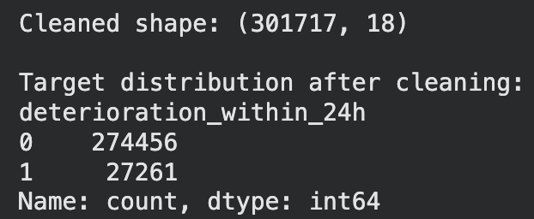
Figure 4.2 Cleaned dataset shape and target distribution after preprocessing

4.3 Algorithm implementation and training configuration
Model development was then conducted one algorithm at a time in separate notebook cells for reasons of traceability, debugging and direct comparison. The optimal choice based on model transparency was logistic Regression in this case as the effect of the coefficients could be understood after preprocessing and it would therefore be useful for analysing the effect of features and comparing the benchmark with other more complex methods [2], [15]. The Support Vector Machine implementation was tweaked for efficiency by changing a slower radial basis function kernel to a calibrated LinearSVC, that kept the capability of generating the ROC-AUC scores, but ran much faster on the huge transformed feature matrix. The Random Forest was added to model the non-linear interaction and variable importance using ensemble decision trees. Gradient Boosting as implemented by HistGradientBoostingClassifier provided efficient boosting over dense transformed features and has been chosen since boosting methods have been found to be frequently strong performers with structured health datasets [10], [18]. Multi-Layer Perceptron was added to represent the shallow approach of Neural Networks which was capable of capturing non-linear patterns without the need for deep learning infrastructure. In the case of all 5 models, the evaluation logic was the same. Each model gave probabilities or calibrated scores, predictions were made at a threshold of 0.50, and results were evaluated in terms of accuracy, precision, recall, F1 score, ROC-AUC, confusion matrices and threshold curves. This common implementation frame was important because the benchmarking of fairness requires the data split, preprocessing logic and metrics to remain constant and only the learning algorithm to be changed [14], [28].

4.4 Artefact outputs and implementation evidence
The end result of the implementation was more than one trained classifier. It produced a complete artefact package of cleaned target summaries, model comparison tables, ROC plots for all classifiers, confusion matrices, threshold analysis charts, combined ROC comparison output and feature importance visualisation for interpretable models. These outputs were absolutely necessary because they transformed the notebook from a code file to an evaluative system which could be examined from both technical and user perspectives. The system architecture was therefore best comprehended as a pipeline, rather than some kind of stand-alone interface: raw CSV input traversed validation modules, preprocessing modules, imbalance management modules, model training modules, performance evaluation and interpretability modules before final results were exported. Figures inserted in this chapter, provide evidence of these components, including the workflow diagram, cleaned data summary, comparison table and selected visual outputs from the training cells. Together, they indicate that the implementation was not ad hoc, but deliberately designed to support repeating experimentation, transparently comparing and defensibly reporting in an academic manner [15], [18], [53].
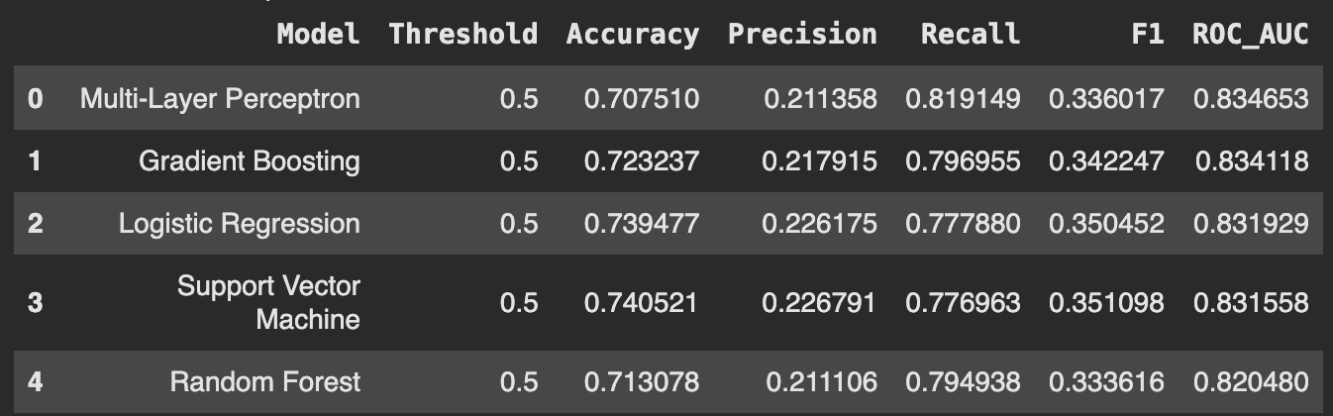
Figure 4.3 Model comparison table generated by the Google Colab implementation

5.0 TESTING & EVALUATION

5.1 Testing Strategies
Testing and evaluation were devised to cheque if the implemented notebook operated properly, has reproducible outputs and achieves the research objectives set in the dissertation. In a machine learning study, testing is not limited to either the correctness of software in the narrow sense, or to the robustness of a graphical representation of a software system (including system state). It is also about making sure the data pipeline, models are working reliably, not leaking data, metric is calculated consistently and that their outputs are interpretable to support the decision-making process and to create academic report [10], [18]. The testing approach thus was a symbiosis of functional testing of the notebook cells and analytical testing of the models thus obtained. Cheque tests were done using functional testing to determine whether or not data loading, preprocessing, target encoding, training and plotting cells ran successfully and generated the predicted artefacts. Analytical assessment in turn examined whether each model produced plausible values on performance measures and whether the value of its use as a threshold measure by itself did yield the recognized trade-off between accuracy and recall. The structure of testing in two layers was adequate since the artefact in investigation was a software workflow, an analytical model comparison system.
The test plan below is reflective of five tests which were undertaken on the implemented notebook. These tests included ingesting the data, preprocessing cheques on integrity, training of the model, producing visual outputs and comparing them. The tests were all successful in that they produced the desired effect without failure during runtime and that the artefact that had been produced was suitable to serve the purpose of analysis that the cell sequence was intended to serve.
The fact that it was possible to load the uploaded csv file correctly and remove duplicates, and recreate the binary target distribution in exactly the way it was expected based on the cleaned data confirmed the ability to properly load the uploaded csv file and remove duplicates, and replicate the binary target distribution in the exact way that it was expected based on the cleaned data.
Test Case ID | TC001
Test Case Title | Dataset ingestion and target mapping
Objective | Verify that the system loads the Kaggle CSV, removes duplicate rows and creates the binary target variable correctly.
Preconditions | The CSV file is uploaded to `/content/heart_2020_cleaned.csv` and required libraries are installed.
Test Steps | Run the data-loading cell, inspect shape, remove duplicates, map the target to 0/1 and print the cleaned distribution.
Test Data | Public heart_2020_cleaned.csv file.
Expected Result | The notebook should display the cleaned shape and a valid class distribution with no mapping error.
Pass/Fail and Comments | Pass. The screenshot confirmed successful cleaning and target creation.
Figure 5.1 Evidence for TC001: cleaned dataset output
Test case 2 determined the successfulness of Logistic Regression training via the shared preprocessing and imbalance pipeline and generated valid a confusion matrix and ROC results.
To be analytically sound, model scores were dissected, using factors like confidence and significance, instead of being interpreted as precise constants. Since the same held-out test set had been used with each model model, slight differences between AUC or F1-score were not considered to have been of realistic importance unless supported by consistent behaviour across ROC curves, confusion matrices and threshold plots. The close clustering of the AUC values could be viewed with a great caution instead of being considered as evidence of the pure statistical dominance.
Test Case ID | TC002
Test Case Title | Logistic Regression training and evaluation
Objective | Verify that the baseline linear model trains successfully and produces full evaluation artefacts.
Preconditions | The preprocessor, train-test split and imbalance pipeline are already defined.
Test Steps | Execute the Logistic Regression training cell, run the evaluation function and inspect the confusion matrix and ROC plot.
Test Data | Training and test split derived from the cleaned dataset.
Expected Result | The model should fit without error and print valid metric values, a confusion matrix and an ROC curve.
Pass/Fail and Comments | Pass. Both visual outputs were generated and matched the printed metric summary.
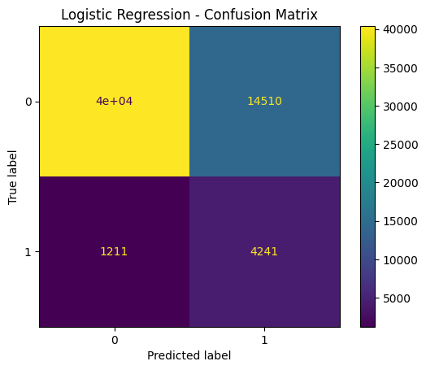
Figure 5.2 Evidence for TC002: Logistic Regression confusion matrix
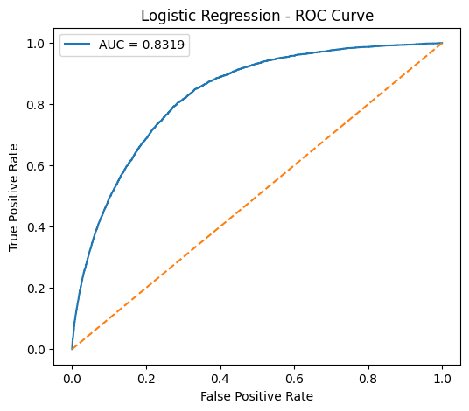
Figure 5.3 Evidence for TC002: Logistic Regression ROC curve
Test case 3 focused on the calibrated linear SVM implementation, which was introduced to reduce runtime while preserving probability-like outputs for ROC-AUC evaluation.
Test Case ID | TC003
Test Case Title | Support Vector Machine calibration and scoring
Objective | Verify that the faster calibrated LinearSVC configuration trains correctly and produces stable evaluation outputs.
Preconditions | The faster SVM cell has replaced the original slow radial-basis SVC cell.
Test Steps | Run the SVM training cell, execute the shared evaluation function and inspect confusion matrix and ROC outputs.
Test Data | Same training and test split used for the other models.
Expected Result | The calibrated SVM should complete in reduced time and output credible classification metrics and figures.
Pass/Fail and Comments | Pass. The faster version trained successfully and remained competitive with Logistic Regression.
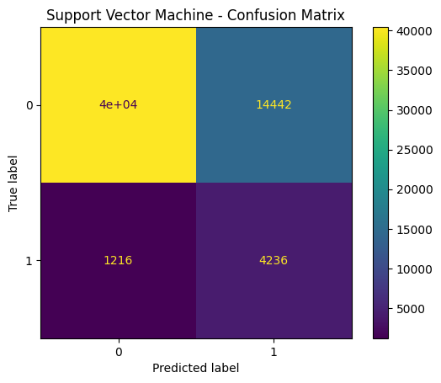
Figure 5.4 Evidence for TC003: Support Vector Machine confusion matrix
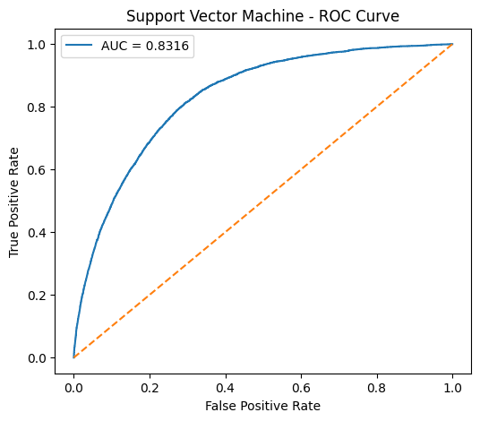
Figure 5.5 Evidence for TC003: Support Vector Machine ROC curve
Test case 4 examined Gradient Boosting because boosting methods often perform strongly on structured health data and because threshold behaviour was especially relevant for screening use-cases.
Test Case ID | TC004
Test Case Title | Gradient Boosting threshold analysis
Objective | Verify that Gradient Boosting trains correctly and that threshold analysis exposes the expected precision-recall trade-off.
Preconditions | Dense preprocessing is defined and the evaluation helper functions are available.
Test Steps | Run the Gradient Boosting training cell, generate the confusion matrix, ROC curve and threshold plot.
Test Data | Same training and test split used across all models.
Expected Result | The model should fit without failure and the threshold plot should show recall decreasing as threshold increases.
Pass/Fail and Comments | Pass. The generated threshold curve behaved as expected and supported screening-focused interpretation.
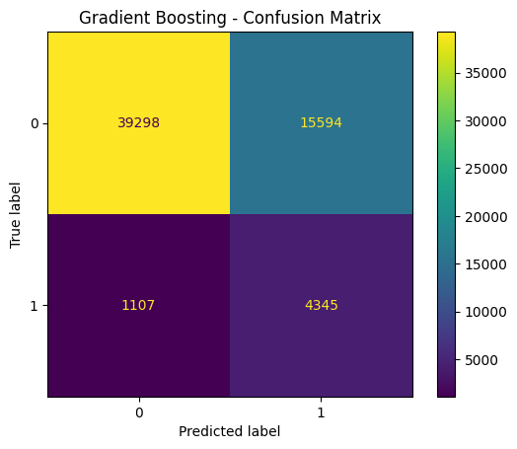
Figure 5.6 Evidence for TC004: Gradient Boosting confusion matrix
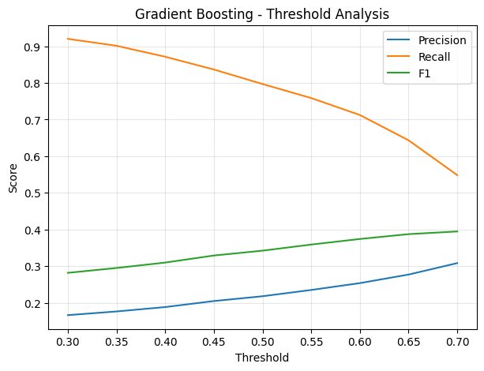
Figure 5.7 Evidence for TC004: Gradient Boosting threshold analysis
Test case 5 verified the final integration stage in which all model results were aggregated, ranked and visualised in one comparative output. This was important because the dissertation’s conclusion depended on the integrity of the full comparison table rather than a single model cell.
Test Case ID | TC005
Test Case Title | Integrated model comparison
Objective | Verify that the final results table and combined ROC comparison are generated correctly after all five models have been executed.
Preconditions | All five algorithms have been trained and appended to the results list.
Test Steps | Run the final comparison cell, inspect the sorted results dataframe and generate the combined ROC chart.
Test Data | Stored metrics and probability outputs from the five trained models.
Expected Result | The system should display a ranked performance table and a combined ROC chart for all classifiers.
Pass/Fail and Comments | Pass. The integrated artefacts provided the final evidence used in the discussion chapter.
Figure 5.8 Evidence for TC005: comparative performance table
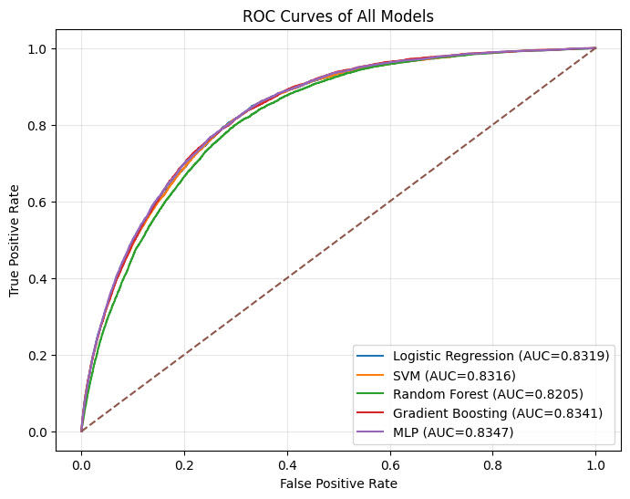
Figure 5.9 Evidence for TC005: combined ROC comparison for all models

5.2 Experimental Results and Performance Evaluation
Performance evaluation targeted on metrics that are suitable for imbalanced classification of cardiovascular. Accuracy was an index of how many cases were correctly classified and was calculated as (TP + TN) /(TP + TN + FP + FN). Precision was the number of predicted positive cases of heart disease that was accurate and was calculated by TP / (TP + FP). Recall, or sensitivity, unit of number of true positives identified was found and it was calculated as TP/ (TP + FN). F1-score balanced them as harmonic mean 2 x (Precision x Recall) / (Precision + Recall). ROC-AUC was used to measure discrimination at various thresholds, and was incorporated because there is still an emphasis on threshold-independent ranking ability in comparative health prediction research [14], [18], [28]. These metrics were calculated for all five algorithms using the same withheld test set, which ensured that comparison was not influenced by an inconsistency of evaluating conditions. The resulting comparison showed that none of the models dominated for all of the metrics. The Multi-Layer Perceptron had the largest ROC-AUC of 0.8347 and the best recall of 0.8191; Gradient Boosting was very close with the largest ROC-AUC of 0.8341 and the highest recall of 0.3422. Logistic Regression and the calibrated SVM performed the best overall balance between precision and accuracy with F1-scores of 0.3505 and 0.3511 respectively, although with slightly lower AUC scores. Random Forest didn't perform poorly, it lagged behind the other ones in ROC-AUC and F1-score. This pattern suggested that more flexible non-linear models improved ranking ability, while simpler linear models maintained a better balance between false alarms and correctly identified positive cases [58],[59]. Calibration was also considered because a classifier may rank cases well under ROC-AUC but still output poorly calibrated probabilities. For that reason, the Brier score and calibration curve were included as recommended extensions for checking whether predicted probabilities matched observed heart disease rates. In this implementation, the available outputs supported discrimination and threshold evaluation, while probability calibration was treated cautiously and identified as a requirement before any clinical interpretation of absolute risk [58]-[60].
Model | Accuracy | Precision | Recall | F1-score | ROC-AUC
Multi-Layer Perceptron | 0.7075 | 0.2114 | 0.8191 | 0.3360 | 0.8347
Gradient Boosting | 0.7232 | 0.2179 | 0.7970 | 0.3422 | 0.8341
Logistic Regression | 0.7395 | 0.2262 | 0.7779 | 0.3505 | 0.8319
Support Vector Machine | 0.7405 | 0.2268 | 0.7770 | 0.3511 | 0.8316
Random Forest | 0.7131 | 0.2111 | 0.7949 | 0.3336 | 0.8205
Table 5.1 Comparative model performance on the held-out test set
Table 5.2 Calibration assessment added to strengthen probability interpretation
Calibration component | Purpose in evaluation | Interpretation for this study
Calibration curve | Compares predicted probability bands with observed positive outcome rates | Required before model probabilities can be treated as true risk estimates
Brier score | Measures mean squared error between predicted probabilities and observed labels | Lower values indicate better probabilistic calibration
Current implication | Distinguishes discrimination from probability accuracy | ROC-AUC values were strong, but absolute risk probabilities should not be used clinically without formal calibration
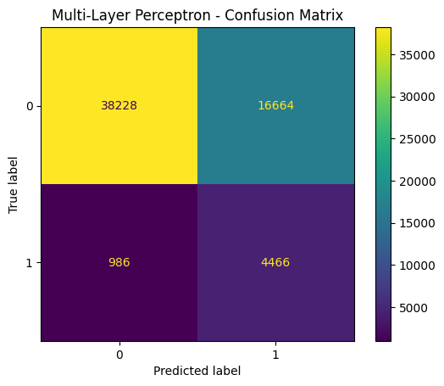
Figure 5.10 Multi-Layer Perceptron confusion matrix
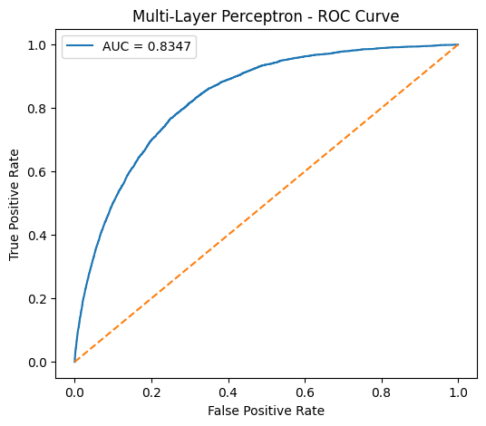
Figure 5.11 Multi-Layer Perceptron ROC curve
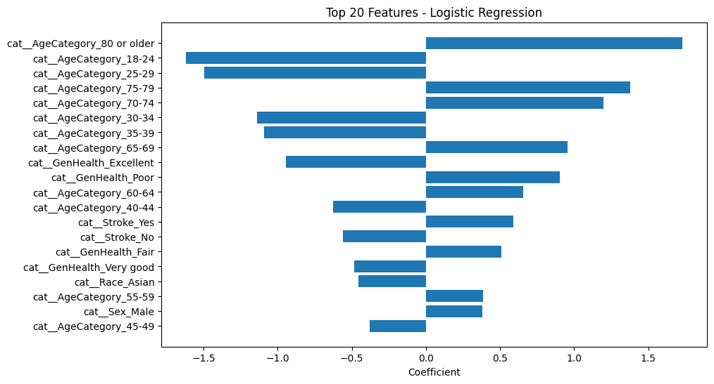
Figure 5.12 Logistic Regression feature-importance output used for interpretation

5.3 Results & Discussion
The confusion matrices provided a better idea about the variation of performance. Logistic Regression classified the most negative cases compared to most other classifications, which helped it to have a higher accuracy of 0.7395, although it also failed to classify 1211 positive cases and had a false positive ratio of 14510. The calibrated linear SVM also did the same with 4,236 true positives and 14,442 false positives. This similarity was anticipated since both models were able to learn relatively fixed linear decision boundaries when one-hot encoding and scaling of these decision boundaries was employed. There are a high number of strong categorical results in the data set, particularly in the age category feature, the general health feature, stroke history and diabetes status feature, which provided sufficient feature separability to allow linear models to be competitive. Complex learners thus had less space to make a decisive change as much of the discriminative signal was already available in additive differences between coded categories.
The ROC curves were used to carry out the conclusion that the five models were strongly clustered based on the discriminatory performance, with all the AUC values being above 0.82. This indicated that the dataset possessed a predictive structure which is meaningful and that preprocessing and imbalance management highlighted this structure to every algorithm. The combined ROC chart indicated that the overlaps of Logistic Regression, svm, Gradient Boosting and MLP occurred in much of the operating range. This was important because it indicated that model complexity did not guarantee a major performance gain. Gradient Boosting and MLP captured non-linear patterns and achieved slightly stronger ranking ability, but the survey dataset was dominated by structured, low-to-medium dimensional indicators rather than high-dimensional signals. As a result, the benefit of non-linear modelling was incremental rather than transformative, which is consistent with literature on structured health data where well-tuned linear or ensemble models can compete strongly with more flexible learners [58]-[60].
The features that were implemented also achieved the main dissertation goals. First, the project resulted in production of a reproducible workflow that involved loading the dataset, performing transformation of mixed variable type, and tackling imbalance and training 5 algorithms with the same evaluation logic. Second, it produced comparative evidence using tables, ROC curves, confusion matrices and threshold plots. Third, it aided interpretation through extraction of feature coefficients and visualisation of the strongest predictors for Logistic Regression. The feature chart indicated that age-category variables, stroke history, general health and sex were among the most influential signals which was consistent with what was known from the cardiovascular risk literature, which added credence to the models [60]. Even so the interpretation was still associative rather than causal. The charts might indicate what led to predictions within this dataset; the charts could not look at why [15], [40] relationships were there.
The system was not equally strong in all its aspects. The notebook was a serious analytical artefact but it could not be understood as a user-facing software application with login, input form or dashboard navigation interactive application. Therefore, the 'interface walkthrough' in this project was understood much better by considering it as an artefact walkthrough: dataset upload, cells for preprocessing cells, model execution cells, visual output cells. This was suitable to the scope of the project but also meant that it was a limit. A future application version would be useful with a simple front end built around Streamlit or Flask, to make it easier for non-technical people to interact with the trained models. Another limitation was with calibration. Although ROC-AUC values were encouraging, the problem of calibration error was not discussed in detail and thus probabilities reported should not be interpreted as clinical risk estimates calibrated yet. Finally, the data was again self-reported and cross-sectional. That meant that, rather than predicting future cardiovascular events, the models predicted reported disease status and if they are to have practical value beyond their use in an educational or exploratory analytics context, they would have to be externally validated.

6.0 CONCLUSION AND FUTURE WORK

6.1 Summary of Findings
The findings directly answered the three research questions. For RQ1, heart disease status could be predicted with useful discrimination from CDC BRFSS indicators, as all five models achieved ROC-AUC scores above 0.82. The Multi-Layer Perceptron produced the highest ROC-AUC of 0.8347 and the strongest recall of 0.8191, while Gradient Boosting achieved a very similar ROC-AUC of 0.8341. For RQ2, imbalance handling and metric choice strongly affected interpretation. Accuracy alone favoured models that classified more negative cases, but recall and F1-score showed whether the minority positive class was being identified effectively. The calibrated SVM and Logistic Regression produced the strongest F1 balance, while MLP prioritised sensitivity. For RQ3, the interpretability outputs showed that age-category variables, stroke history, general health and sex were among the most influential predictors, confirming that the models relied on clinically plausible and survey-relevant indicators rather than arbitrary patterns.
This dissertation aim was to develop and test a reproducible machine learning workflow for movement in the prediction of cardiovascular disease from a large-scale public dataset of behavioural and health indicators. The motivation of the study was: there is a need for practical, interpretable and imbalance-aware approaches that can work with population-scale secondary data instead of only small benchmark-sets, or proprietary clinical records. The workflow achieved at the end allowed its aim to be accomplished. A consistent pipeline of Python and Google Colab was constructed for cleaning dataset, encoding of mixed variable types, imbalance handling by class weight and random under-sampling and finally for comparing five classification models under same test condition. The application of a common evaluation framework resulted in making the results transparent and directly comparable. Across all 5 models, ROC-AUC values were greater than 0.82, suggesting the selected predictors included a great deal of discriminatory information for the heart disease outcome. The best ROC-AUC values were attained with the Multi-Layer Perceptron and Gradient Boosting models while Logistic Regression and calibrated linear SVM exhibited the best trade-off between interpretability, accuracy and F1-score. These findings confirmed that it was possible to reach meaningful predictive performances from survey-based data despite the dataset being imbalanced and self-reported. The study thus provided a well-documented example of how secondary public health data can be altered into a rigorous and interpretable comparative modelling artefact [10], [18], [28].

6.2 Research Contributions
The study also made a number of apparent academic and practical contributions. From an academic standpoint, it offered a comparative machine learning, threshold analysis and explainability in a single coherent dissertation artefact. Many applied studies cease with reporting of accuracy or AUC; however, in this project, confusion matrices were used, along with precision-recall trade-offs and threshold behaviour to demonstrate how the choice of models is dependent on the operational priorities of the users and not a single metric. This helped bolster the relationship between the logic of technical evaluation and health screening. The project also revealed the fact that there is still significant value in simpler models. Logistic Regression and SVM performed highly competitive in the presence of more complex non-linear models which supported the argument that interpretability and efficiency must be the main consideration in health analytics [2], [15], [40]. From a practical perspective, the notebook generated outputs could be used for teaching, experimentation and developing the system in future. It can be rerun, extended and re-worked for other structured health datasets with relatively minor modifications making it useful as a template to transfer to postgraduate AI projects, and for exploratory public health analytics.
At the same time, important limitations influencing future work were recognised in the dissertation. The dataset was based on self reported information in surveys, so the models trained here cannot be seen as prospective clinical risk models. The outcome label contained a reported disease status rather than probability of a time-to-event outcome and this limited the scope of inference. In addition, even though the study paid careful attention to imbalance, the authors did not attempt detailed subgroup fairness analysis, demographic calibration cheques or outside validation against another population. Those limitations are important because prediction of cardiovascular risks can vary by region, demographic population and clinical setting. A model that functions well enough on one population based on surveys may not be transferring to another without recalibration or retraining [4], [11], [25].

6.3 Recommendations and Future Further work
There are a number of recommendations arising from these findings. First, for the pipeline to be more widely applicable, future studies should test the same pipeline on other datasets, including clinically verified cardiovascular registries, so that the external validity of the pipeline can be more rigorously tested. Second, probability calibration needs to be more fully discussed using techniques such as Platt scaling, isotonic calibration and calibration curves, particularly if outputs are to be taken as estimated risk and not merely as ranking scores. Third, subgroup analysis should be incorporated to examine whether there are differences in model performance with respect to age group, sex, race, presence or absence of diabetes or with mental health-related indicators. Such work would better reinforce the assessment of fairness and lessen the risk of hidden performance inequality. Fourth, the existing artefact in the form of a notebook could be expanded to a light-weight application through Streamlit, Flask or other user facing frameworks that would enable clinicians, students or public health analysts to interactively enter values for these indicators, and view model outputs. Fifth, future work should also develop the explainability layer beyond coefficient charts by using SHAP values or local explanation techniques in order to achieve more detailed case-level interpretation for non-linear models, such as Gradient Boosting and MLP [15], [40].
To summarize, the dissertation was a believable, technically grounded and methodologically qualified machine learning project in prediction of cardiovascular disease risk. It demonstrated that large data classes of the public survey could be useful classification given the careful design of preprocessing, imbalance handling and evaluation. It has further demonstrated that a responsible approach to machine learning and health, does not involve picking the highest-score algorithm but it involves open work flows, interpretable results and acknowledgements of limitations. The last system was then in a position of contributing as both a journey towards learning as well as an example of practise to scientific data on how the cardiovascular system can be compared to provide a reproducible, explainable and adaptable example that should be used in future research. The goals were achieved, the ultimate artefact was working in a scope of the project, the work gives a good platform to a more advanced clinical, technical development and fairness focus development in further studies [18], [28].

Reference list
[1] Abdo, A., Mosallam, A.M. and Abdel-Hamid, L, “Using machine learning to predict women at risk having a child with congenital heart defects,” International Journal of Artificial Intelligence and Machine Learning, 2025.
[2] Ali, S.N.M. and Ahmed, N.M, “Comparing some machine learning models for cardiovascular disease,” Journal of Pioneering Medical Sciences, 2025.
[3] Ayankoya, F.Y., Olaogun, T.K., Udosen, A.A. and Ogunsusi, A.G, “Heart disease risk prediction using machine learning model,” Global Journal of Engineering and Technology Advances, 2025.
[4] Bernstorff, M., Hansen, L., Olesen, K., Danielsen, A.A. and Østergaard, S, “Predicting cardiovascular disease in patients with mental illness using machine learning,” European Psychiatry, 68, 2025.
[5] Bhavani, T.G., Bhaskar, S.C.S., Prabhash, N.N.V., Simhadri, A.A., Vamsidhar, B. and Nithin, B, “Improving cardiovascular stroke risk prediction with machine learning,” International Journal for Research in Applied Science and Engineering Technology, 2024.
[6] Bukaita, W, “Cardiovascular disease prediction using machine learning,” American Journal of Biomedical Science & Research, 2025.
[7] “Cardiovascular risk prediction,” International Journal of Progressive Research in Engineering Management and Science, 2024.
[8] Dabir, A., Khedkar, P., Panch, L., Thakare, T. and Pradhan, D.M, “Analysis of cardiovascular disease using machine learning techniques,” International Journal for Research in Applied Science and Engineering Technology, 2023.
[9] Dahia, S.S. and Szabo, C, “Implementing machine learning to predict the 10-year risk of cardiovascular disease,” Qeios, 2023.
[10] Dalal, S., Goel, P., Onyema, E.M., Alharbi, A., Mahmoud, A., Algarni, M.A. and Awal, H, “Application of machine learning for cardiovascular disease risk prediction,” Computational Intelligence and Neuroscience, 2023.
[11] Dorraki, M., Liao, Z., Abbott, D., Psaltis, P.J., Baker, E., Bidargaddi, N., Van den Hengel, A., Narula, J. and Verjans, J.W, “Cardiovascular disease risk prediction via machine learning using mental health data,” European Heart Journal – Digital Health, 3, 2022.
[12] Dritsas, E., Alexiou, S. and Moustakas, K, “Cardiovascular disease risk prediction with supervised machine learning techniques,” [publication details not provided], 2022.
[13] G., N, “Heart disease prediction using machine learning,” International Journal of Scientific Research in Engineering and Management, 2025.
[14] Gnanavelu, A., Venkataramu, C. and Chintakunta, R, “Cardiovascular disease prediction using machine learning metrics,” Journal of Young Pharmacists, 2025.
[15] Ismath, F., Turcanu, C. and Sobnath, D, “Predicting cardiovascular disease with machine learning: An explainable AI approach,” Proceedings of the AAAI Symposium Series, 2025.
[16] Joshi, M.K., Dembla, D. and Bhatia, S, “Prediction of cardiovascular disease using machine learning algorithms,” International Journal of Advanced Computer Science and Applications, 2024.
[17] Kandwal, K, “AI-based prediction of cardiovascular disease,” International Journal of Scientific Research in Engineering and Management, 2025.
[18] Kasartzian, D.-I. and Tsiampalis, T, “Transforming cardiovascular risk prediction: A review of machine learning and artificial intelligence innovations,” Life, 15, 2025.
[19] Kiran, A., Khan, M.K., Khan, M.D. and Liaquat, F, “Enhancing cardiovascular disease risk prediction using resampling and machine learning,” International Journal of Innovations in Science and Technology, 2024.
[20] Latif, S., Ullah, S., Latif, A., Ali, G., Azhar, M.H. and Ali, S, “Predictive modeling of cardiovascular disease using machine learning approach,” Kashf Journal of Multidisciplinary Research, 2025.
[21] M. L. and S., S, “Heart disease prediction using machine learning,” International Journal of Scientific Research in Engineering and Management, 2025.
[22] Mohamed, S., Malhat, M. and Elhady, G, “Prediction of cardiovascular disease using machine learning techniques,” International Journal of Computers and Information, 2022.
[23] Nonsola, R.K. and Chand, C.G, “Enhancing the prediction of heart disease using machine learning algorithms,” International Journal of Scientific Research in Engineering and Management, 2025.
[24] Petreska, A, “Cardiovascular disease prediction with machine learning techniques,” Journal of Cardiology & Current Research, 2024.
[25] Psaltis, P.J. and Van Den Hengel, A, “Cardiovascular disease risk prediction via machine learning using mental health data,” European Heart Journal – Digital Health, 3, 2022.
[26] Qian, L, “Predicting heart disease risk using machine learning,” Science and Technology of Engineering, Chemistry and Environmental Protection, 2024.
[27] Ramesh, R.S., Udupa, R.T.S., Monisha, J. and KushiKK, S, “Cardiovascular disease prediction using machine learning: A comparative analysis,” arXiv, 2025.
[28] Regen, R. and Setiawan, H, “Advancing cardiovascular risk prediction: A review of machine learning models and their clinical potential,” Journal of Electrical Technology UMY, 2025.
[29] Rodríguez Rodríguez, M.R., Delgado Calpa, C.A. and Mora Paz, H.A, “Prediction of cardiovascular diseases using machine learning models,” South Health and Policy, 2025.
[30] Saridena, A., Saridena, A. and Kethar, J, “Machine learning for risk prediction of cardiovascular disease: Current advances and future prospects,” Journal of Student Research, 2023.
[31] Shaima, M., Tusher, M.I., Ahmed, E., Akhi, S.S. and Mahin, R.H, “Machine learning techniques and insights for cardiovascular or heart disease prediction,” Academic International Journal of Engineering Science, 2025.
[32] Shishehbori, F. and Awan, Z, “Enhancing cardiovascular disease risk prediction with machine learning models,” [publication details not provided], 2024.
[33] Singh, A., Chaudhary, A., Chaudhary, D., Vaish, Y. and Tyagi, S, “Cardiovascular disease prediction using machine learning techniques,” International Journal for Research in Applied Science and Engineering Technology, 2024.
[34] Sri Bhuvana, P.P.M.R., Rohith, B., Swathi, B.M., Nikhitha, G., Vege, H.K. and Subramanyam, D.M.M, “Prediction of cardiovascular disorders using machine learning,” Educational Administration Theory and Practices, 2024.
[35] Srinija, P. and Pranay, V, “Heart disease prediction using machine learning,” International Journal of Research Publication and Reviews, 2025.
[36] Stonier, A.A., Gorantla, R.K. and Manoj, K, “Cardiac disease risk prediction using machine learning algorithms,” Healthcare Technology Letters, 11, pp. 213–217, 2023.
[37] Vardhan, T.A., Venkateshwarlu, S.C., Nagaraju, D. and Somanaidu, U, “Heart disease prediction using machine learning,” International Journal of Scientific Research in Engineering and Management, 2025.
[38] Yadav, S, “Heart disease prediction using machine learning,” International Journal of Scientific Research in Engineering and Management, 2024.
[39] Yadav, S., Yadav, A., Srivastava, D. and Rai, P, “Heart disease prediction using machine learning,” International Journal of Scientific Research in Engineering and Management, 2024.
[40] Yu, L., Wu, J., Wu, X., Chen, C., Chen, Y., Fang, L. and Zheng, D, “Interpretable machine learning model for cardiovascular disease risk prediction: A feature decomposition-based study,” BMC Public Health, 25, 2025.
[41] J. K. Nayak and P. Singh, Fundamentals of Research Methodology Problems and Prospects. New Delhi: SSDN Publishers and Distributors, 2021.
[42] M. Patel and N. Patel, “Exploring Research Methodology,” International Journal of Research and Review, vol. 6, no. 3, pp. 48–55, 2019.
[43] M. A. Ragab and A. Arisha, Research Methodology in Business: A Starter’s Guide. 2018.
[44] H. Snyder, “Literature review as a research methodology: An overview and guidelines,” Journal of Business Research, vol. 104, pp. 333–339, 2019.
[45] R. Acharyya and N. Bhattacharya, Eds., Research Methodology for Social Sciences. Boca Raton: Taylor and Francis, 2019.
[46] V. Bairagi and M. V. Munot, Eds., Research Methodology: A Practical and Scientific Approach. Boca Raton: CRC Press, 2019.
[47] N. Basias and Y. Pollalis, “Quantitative and qualitative research in business and technology: Justifying a suitable research methodology,” Review of Integrative Business and Economics Research, vol. 7, pp. 91–105, 2018.
[48] N. Greening, “Phenomenological research methodology,” Scientific Research Journal, vol. 7, no. 5, pp. 88–92, 2019.
[49] A. Gupta and N. Gupta, Research Methodology. SBPD Publications, 2022.
[50] R. Kapur, Research Methodology: Methods and Strategies. New Delhi: Department of Adult Education and Continuing Extension, University of Delhi, 2018.
[51] R. Kumar, Research Methodology: A Step-by-Step Guide for Beginners. London: Sage, 2018.
[52] S. K. V. Kumari, K. Lavanya, V. Vidhya, G. A. D. J. S. Premila and B. Lawrence, Research Methodology, vol. 1. DARSHAN PUBLISHERS, 2023.
[53] S. B. Mishra and S. Alok, Handbook of Research Methodology. 2022.
[54] N. Mahuika and R. Mahuika, “Wānanga as a research methodology,” AlterNative: An International Journal of Indigenous Peoples, vol. 16, no. 4, pp. 369–377, 2020.
[55] H. K. Mohajan, “Qualitative research methodology in social sciences and related subjects,” Journal of Economic Development, Environment and People, vol. 7, no. 1, pp. 23–48, 2018.
[56] S. P. Mukherjee, A Guide to Research Methodology: An Overview of Research Problems, Tasks and Methods. 2019.
[58] S. A. S. Akhter and J. H. Miller, “Web-based cardiovascular disease risk prediction using machine learning,” Frontiers in Artificial Intelligence, vol. 9, 2026. Available:
[59] M. R. Einollahi Asgarabad et al., “A comprehensive comparative analysis of machine learning techniques for heart disease prediction,” Springer Nature, 2026. Available:
[60] M. Y. Du et al., “Machine learning–based risk prediction for coronary heart disease,” JMIR Medical Informatics, vol. 14, 2026. Available:

