
ENTREPRENEURSHIP
Assessment Two

Module: Entrepreneurship
Module code: LCMB7004
Module Lecturer: Dr Nandish Patel
Student name: Wafa Wajeeh Nasser - 1703942

Table of Contents

Introduction 2
Socio-cultural Perspectives 3
Environmental Perspectives 5
Economic Perspectives 6
Part Two 7
Start-up Incubation Stage 8
Incubators 8
Research and Development 9
Financing and Funds 9
Angel Investors 10
Legal and Regulatory Framework 10
Human Resources and its Management 11
Technological Advancement 11
Conclusion 11

Introduction
Entrepreneurship has generally been connected to monetary effectiveness. Landström (2020) states that effectiveness is improved by means of market competition, which is driven by entrepreneurs carrying novel plans to the market. Better and more effective thoughts win, making better and more positions. Wadhwani et al., (2020) consider that the entrepreneurs might assume a vital part in the advancement of social equity also. Current cultural patterns tended to by the Europe 2020 system can be seen as promising circumstances for advancement (Wadhwani et al., 2020). The course of ground-breaking generation of ideas and execution that handles such cultural difficulties is called social advancement and its essential objective is to make social change.
Entrepreneurs persuaded by friendly objectives are specialists in the inception and execution of social development (McCaffrey, 2018). Although there are certain motivational factors and perspectives for the entrepreneurs, but the environmental and socio-cultural perspectives are considered to be the most effective. Critical evaluation based on the current perspectives that influence the entrepreneurial motivation is carried out in this report. Furthermore, the prevailing economic and cultural environment which effects the business start-ups is also discussed in this report.
Part One
According to Landström (2020) Entrepreneurship is described as the process and mind-set that tends to develop and create the economic activity by means of blending the creativity, risk-taking and innovation with sound management in a start-up business or existing organization. However, it is believed by Audretsch and Moog (2020) that entrepreneurship is examined to be linked to democracy which is related to the most compelling social and economic issues. The current perspectives observed to contribute towards the entrepreneurial motivation mainly include the socio-cultural and environmental perspectives. An entrepreneur is known to be a significant booster of growth in economy and due to this it is evaluated for its perspectives that impact and contribute to the entrepreneurial motivation apart from the personal motivations that influences an individual to invest time, energy, and money in the area of entrepreneurship.

Socio-cultural Perspectives
Gupta et al., (2020) states in his article regarding ‘social entrepreneurship research’ that entrepreneurship is multidimensional and the current perspectives that influence it are mainly the social, cultural, economic as well as environmental perspectives respectively. The socio-cultural perspectives that tend to influence the entrepreneurial motivation are referred to as such elements that reflects the way of life of the society. However, it is argued by Méndez-Picazo et al., (2021) that the habits, entertainment, living and buying habits of the individuals develop an interdependent relationship with the businesses.
It is mentioned by Gupta et al., (2020) that the social and cultural environment either encourages or discourages the business start-ups. For example, in the under-developed countries, the undertaking of business based on luxury items or promotion of luxury brands such as Zara, Rolls-Royce etc. is highly disregarded and destined towards failure. In case a society gives high value towards business engagement and innovation then it encourages the entrepreneurial development among the individuals (Buendía-Martínez and Monteagudo, 2020). However, it is believed by Gupta et al., (2020) that when a wide range of entrepreneurs is observed in a society, then it is likely possible to have the young individuals to be motivated to aim towards entrepreneurship and innovative businesses.
Landström (2020) further noted that to increase the number of people engaging in entrepreneurship, it is required to establish such an environment which consists of a robust incentive system, spirit of exploration and also access towards productivity and innovative mechanisms. Social innovation is also considered to be one of the main processes by means of which the entrepreneurs are driven by various motivations that leads towards social justice (McCaffrey, 2018). The European countries, especially England, faces various country-specific issues which go far beyond the issue of economic efficiency i.e., (i) demographic trends, (ii) climatic change, (iii) social isolation of disadvantaged groups, (iv) growth of unemployment, (v) rapid changes in natural and healthcare environment, and (vi) mass level of digital illiteracy. The motivations and attitudes of the entrepreneurs come from the society and culture itself (Audretsch et al., 2020). For example, Jack Ma considered that the decisions are mainly influenced by the values and limitations on risk-taking in a society along with the attitude towards economic growth and financial freedom. The growth and pursuit of Alibaba Group is not only motivated by the wealth acquisition but also for the traditional values of esteem and noble life notions.
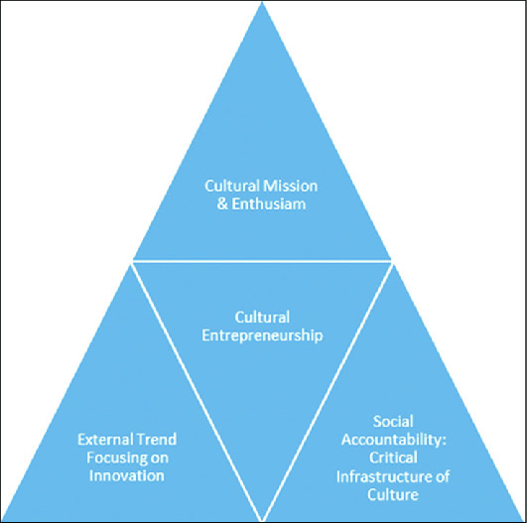
Figure: Components of Cultural Entrepreneurship
Source: Toghraee and Monjezi, 2017
In the figure presented above, the components of cultural entrepreneurship are shown which includes trend and innovation, social accountability and cultural enthusiasm (Toghraee and Monjezi, 2017). On the other hand, it is argued by Reddy (2020) that if the social, cultural, religious, and environmental aspects tend to favour and promote the value of entrepreneurship then the likelihood of growth of entrepreneurship and entrepreneurial motivation is expected. For example, in Mali and Central Africa that have low industrial base and lowest of human development index have limited entrepreneurship due to be under-developed countries and it is also because of the fact that the acquiring material goods is not a priority by its citizens. In the current era, an environment is unfavourable towards entrepreneurship when the entrepreneurs are exploiters or frauds and if they fail, they are not socially forgiven (Aparicio et al., 2019).

Environmental Perspectives
The environmental perspectives are the aspects that are responsible in determining the businesses that can enter the industry, the selection and elimination of a business and availability of resources (Tedmanson et al., 2012). The environmental perspectives are mainly of two levels i.e., (i) exogenous and (ii) endogenous. For example, the exogenous factors include economic changes which includes the shifting flows of investment and money, technological changes that includes the change in ideas and innovations and mainly the city, state, and federal taxes (Luiz, 2010).
As for the endogenous factors, it includes those factors that include the economy pertaining towards any specific product. For example, the endogenous factors mainly include the location, physical geography, infrastructure, economic characteristics, use of land and environment. It can highly affect the business model from inside. For example, in companies like Amazon and Alibaba, the investment and monetary or government fiscal policies tend to impact the business model from within (Murnieks et al., 2020).
According to McCaffrey (2018) and Audretsch et al., (2020) there are certain perspectives and variables which tend to impact the entrepreneurship and its growth as well as entrepreneurial concentration. For example, the propinquity with the universities and research institutions not only focus on providing a qualified staff but it also provides trained entrepreneurs that emerge directly from these institutions (Aparicio et al., 2019). Also, the inclusion of financial incentives in the government policies can effectively contribute to strengthening the entrepreneurship in certain specific regions (such as Japan and Germany) (Kuratko and Audretsch, 2021). When there is a presence of entrepreneurs that have attained success in their business areas tend to enhance the interest of young professionals that are aiming for entrepreneurship. It can increase entrepreneurial concentration in an environment in a particular business (Essers et al., 2017).

Economic Perspectives
As for the economic perspectives, the entrepreneurial motivation is encouraged by a range of factors. One of these aspects include banking systems which can help the business start-ups with favourable terms and conditions such as capital, mortgages, and financial incentives (Aparicio et al., 2019). On the other hand, Chen et al., (2017) states that improvement and enhancement of entrepreneurial education can facilitate development of skill sets and abilities in the individuals and make them able to redistribute the resources in case the economic conditions change in the market (Essers et al., 2017). It is integral for an entrepreneur to have high level of education and technical training to make informed decision when it comes to economic stability of a business. Furthermore, the restructuring of the tax system for young entrepreneurs and business start-ups can also be quite beneficial in entrepreneurship (Tedmanson et al., 2012).

Part Two
According to the theory of planned behaviour, it is claimed that there are three main components which includes the subjective norms, attitude and behaviour that tend to shape the behavioural intentions of an entrepreneur (Alam et al., 2019).
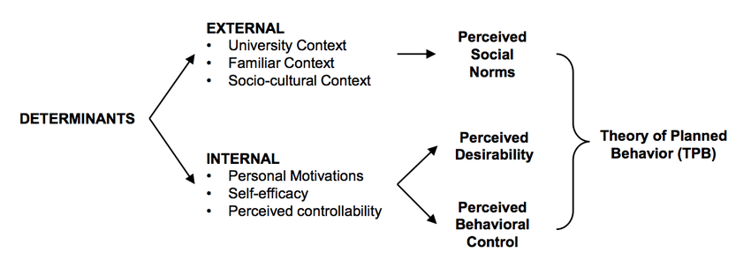
Figure: Determinants of Theory of Planned Behaviour
Source: Alam et al., 2019
According to Alam et al., (2019), it is further stated that these beliefs are linked towards the behaviour of the entrepreneur and affect the start-up and process of the business along the way. These intentions and actions are the components which are responsible of gathering the support systems for the business that further help in embedding growth and development of the business respectively (Mahto and McDowell, 2018). The global pandemic of Covid-19 has shown a huge growth in start-up businesses. This mainly happened due to workers being unemployed and starting up their own businesses which created quite a surge in entrepreneurship (Picazo, 2021). Considering the current scenarios, responding to changing customer demands based on delivery and logistics, it is recommended for entrepreneurs to invest in the area of IT and logistics.

Start-up Incubation Stage
This is a very critical stage for an entrepreneur as it starts from the idea development and tends to cover the initial levels of business development. In this stage, it is important for the entrepreneur to utilize all resources and take all the actions which are required to implement the business model in an effective manner. It is believed by Rivero and Ubierna (2021) that it is an integral stage where the support that is required to be provided by the incubators i.e., the supporters is highly important and based upon the phase or level of business. Such as, the pre-incubators are those that support the business ideas and support in terms of creating a proper inclusive business plan.
On the other hand, the business incubators are those that provide financial support and also provide training and help in exploring provision of facilities, setting-up and developing for start-up. It is argued by Chen et al., (2017) that the business accelerators are the most significant supporters are they provide all the necessary support in the post-incubation stage and promote the goods and services of the business provider in the marketplace. It also includes wide range of workshops, capital investments as well as mentoring (Tyagi, 2021).

Incubators
In terms of entrepreneurship and business start-up, incubators are the supporting parties or promoters that aid in creating the culture of entrepreneurship (Reddy, 2020). These incubators tend to act as promoter which develops cohesive businesses along with support networks that include finance providers, universities, research, and technological institutions as well as government bodies. In context of physical incubation, it refers to maintaining a locating the new businesses in the incubator areas (Yi and Duval, Couetil, 2018). This action is an effective strategy and includes provision of production facilities and fully equipped offices that can further help in reduction of relevant costs (for example, printing, rent and other services) (Rivero and Ubierna, 2021). On the other hand, the incubators can also aid in provision of early-stage funding which includes seed-capital funds, access to public, international, or even local funding and also business angel networks (angel investors). For example, an angel investor would help in the development of the business, its start-up and initiation and afterwards most of the entrepreneurs tend to seek venture capitalists who can help them launch the business into the market (Mahto and McDowell, 2018). In this case, the venture capitalists mainly invest in the business in exchange for the stakes and share in the company. Being a shareholder, the ROI depends upon the growth and profit of the company annually. The venture capitalists invest in the infrastructure and balance sheet of the company till it reaches reliability with expected return and also provides liquidity (Yi and Duval-Couetil, 2018).

Research and Development
The universities and research facilities invest on a large scale in research and development activities to enhance the entrepreneurial skills of the students and broaden their minds (Alam et al., 2019). The academic support is an effective means of creating a certain set of skills in the upcoming entrepreneurs (Reddy, 2020). Due to this, the universities plan to offer collaborations with laboratories and research centres. In result, it attracts a wide range of professionals that are interested in innovative business based on research and development (Faghih et al., 2021).

Financing and Funds
Finding the funding resources aids to building the foundation of the business. There are some examples of funds and financing which depend on the accessibility and availability as well as the stage of business, it includes Crowd funding, Bootstrapping, angel investors and 3Fs i.e., Family, Friends and Fools support (McCaffrey, 2018). These are the financing sources that tend to provide the necessary financial support, networking, and education to the entrepreneurs. In the development phase, these resources help to establish the business and attain stabilisation (Yi and Duval, Couetil, 2018).

Angel Investors
It is recommended for the start-up business to look for an angel investor. The angel investors are those that seek to invest in the businesses when they are at their initial stages of start-up and are looking for support (McCaffrey, 2018). It can be seen in the figure below which shows the process of funding by angel investors to a start-up business where the main components are seeking capital from angel investors and performing due diligence and further carry on with the establishment.
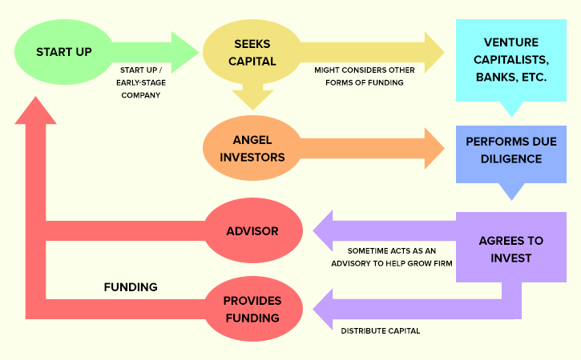
Figure: Process of angel investors funding a start-up business
Source: Su et al., 2020
However, these investments are also considered to be risky as the angel investors provide capital for establishing a business but in exchange, they demand an ownership equity or convertible debt (Su et al., 2020). The angel investors are known to increase valuable learning opportunities for the budding entrepreneurs.

Legal and Regulatory Framework
Wadhwani et al., (2020) believes that maintaining a legal and regulatory model since the start-up of business can aid in managing resources and time in an effective manner. The operations in the organisations can run in a smooth manner when there are no legal threats to the business. However, Liguori and Winkler, (2020) argues that if there is lack of administration and complex issues are advantageous for the business start-ups as for the entrepreneurs, the more effort that is invested, the better it is for the growth of the company (Audretsch et al., 2020). Furthermore, to protect the business, the patents can also be filed by the entrepreneurs to ensure the rights to any invention. For example, Apple patented its original iPhone as an ornamental design of an electronic device to secure its innovation.

Human Resources and its Management
In order to achieve growth in the start-up business or for establishing its foundation, it is highly significant to find the human resources and personnel with appropriate set of skills, both academic and professional (Tyagi, 2021). It is an effective strategy to locate business in a place where the universities, research and technological institutes are based so that it can be ensured that highly skilled staff can be recruited for the business (Gupta et al., 2020).

Technological Advancement
It is considered to be a fundamental support system which enables the start-up business to facilitate the advanced technologies into their production process (Rivero and Ubierna, 2021). On the other hand, technology transfer is a process which is vital to be implicated in a business as it helps in terms of creating innovative products and commercialising it from the inventions and innovations (Yi and Duval-Couetil, 2018). For example, Google has changed virtual life by means of technology transfer, such as, it uses Artificial Intelligence which is the most cutting-edge technology.

Conclusion
In conclusion, it can be stated that, in entrepreneurship the principle of trying hard for making more money is not followed. Instead, planning, working in a smarter way and gathering support is an insolent plan. However, in terms of social and economic perspectives, Toghraee and Monjezi, (2017) states that the support systems mainly function as the roots of entrepreneurship whereas innovation is one of the most crucial determinants to positively and widely impact entrepreneurship. It is the support systems that help the entrepreneurs to achieve their goals and objectives in the business and attain growth and sustainability.
References
- Alam, M.Z., Kousar, S. and Rehman, C.A., 2019. Role of entrepreneurial motivation on entrepreneurial intentions and behaviour: theory of planned behaviour extension on engineering students in Pakistan. Journal of Global Entrepreneurship Research, 9(1), pp.1-20.
- Aparicio, G., Iturralde, T. and Maseda, A., 2019. Conceptual structure and perspectives on entrepreneurship education research: A bibliometric review. European Research on Management and Business Economics, 25(3), pp.105-113.
- Audretsch, D.B. and Moog, P., 2020. Democracy and entrepreneurship. Entrepreneurship Theory and Practice, p.1042258720943307.
- Audretsch, D.B., Belitski, M., Caiazza, R. and Lehmann, E.E., 2020. Knowledge management and entrepreneurship. International Entrepreneurship and Management Journal, 16(2), pp.373-385.
- Buendía-Martínez, I. and Carrasco Monteagudo, I., 2020. The Role of CSR on Social Entrepreneurship: An International Analysis. Sustainability, 12(17), p.6976.
- Chen, M.H., Chang, Y.Y., Wang, H.Y. and Chen, M.H., 2017. Understanding creative entrepreneurs’ intention to quit: The role of entrepreneurial motivation, creativity, and opportunity. Entrepreneurship Research Journal, 7(3).
- Essers, C., Dey, P., Tedmanson, D. and Verduyn, K. eds., 2017. Critical perspectives on entrepreneurship: challenging dominant discourses. Taylor & Francis.
- Faghih, N., Bonyadi, E. and Sarreshtehdari, L., 2021. Comparison of the entrepreneurial motivation in different economic groups. Journal of Global Entrepreneurship Research, pp.1-11.
- Gupta, P., Chauhan, S., Paul, J. and Jaiswal, M.P., 2020. Social entrepreneurship research: A review and future research agenda. Journal of Business Research, 113, pp.209-229.
- Kuratko, D.F. and Audretsch, D.B., 2021. The future of entrepreneurship: the few or the many? Small Business Economics, pp.1-10.
- Landström, H., 2020. The evolution of entrepreneurship as a scholarly field. Foundations and Trends® in Entrepreneurship, 16(2), pp.65-243.
- Liguori, E. and Winkler, C., 2020. From offline to online: Challenges and opportunities for entrepreneurship education following the COVID-19 pandemic.
- Luiz, J.M., 2010. Economic perspectives of entrepreneurship. In Frontiers in entrepreneurship (pp. 63-84). Springer, Berlin, Heidelberg.
- Mahto, R.V. and McDowell, W.C., 2018. Entrepreneurial motivation: a non-entrepreneur’s journey to become an entrepreneur. International Entrepreneurship and Management Journal, 14(3), pp.513-526.
- McCaffrey, M., 2018. Extending the economic foundations of entrepreneurship research. European Management Review, 15(2), pp.191-199.
- Méndez-Picazo, M.T., Galindo-Martín, M.A. and Castaño-Martínez, M.S., 2021. Effects of sociocultural and economic factors on social entrepreneurship and sustainable development. Journal of Innovation & Knowledge, 6(2), pp.69-77
- Murnieks, C.Y., Klotz, A.C. and Shepherd, D.A., 2020. Entrepreneurial motivation: A review of the literature and an agenda for future research. Journal of Organizational Behavior, 41(2), pp.115-143.
- Reddy, C.D., 2020. Entrepreneurial Motivation to Participate in the Circular Economy. In Handbook of Research on Entrepreneurship Development and Opportunities in Circular Economy (pp. 271-283). IGI Global.
- Rivero, C.A.P. and Ubierna, F., 2021. The development of the entrepreneurial motivation from the university. International Entrepreneurship and Management Journal, pp.1-22.
- Su, X., Liu, S., Zhang, S. and Liu, L., 2020. To be happy: a case study of entrepreneurial motivation and entrepreneurial process from the perspective of positive psychology. Sustainability, 12(2), p.584.
- Tedmanson, D., Verduyn, K., Essers, C. and Gartner, W.B., 2012. Critical perspectives in entrepreneurship research.
- Tyagi, S., Meaning and importance, Evolution of term Entrepreneurship, Factors influencing entrepreneurship, Entrepreneurial Motivation. Emerging Issues and Challenges, p.23.
- Wadhwani, R.D., Kirsch, D., Welter, F., Gartner, W.B. and Jones, G.G., 2020. Context, time, and change: Historical approaches to entrepreneurship research. Strategic Entrepreneurship Journal, 14(1), pp.3-19.
- Yi, S. and Duval‐Couetil, N., 2018. What drives engineering students to be entrepreneurs? Evidence of validity for an entrepreneurial motivation scale. Journal of Engineering Education, 107(2), pp.291-317.
- Toghraee, M.T. and Monjezi, M., 2017. Introduction to Cultural Entrepreneurship: cultural Entrepreneurship in developing countries. International Review of Management and Marketing, 7(4), pp.67-73.

