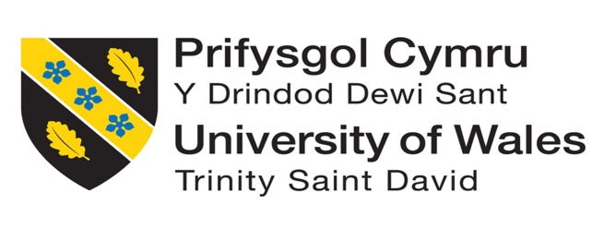

Individual Blog

Proletina Petkova
Student ID:2233645
Module: Marketing Fundamentals
Module Code: LCBB4004

Lecturer : Dr. Piyumika Kithulgoda Gamage

July 29,2023

Table of Contents
1.Introduction 3
2. History of Zara Plc 3
3. Determining segmentation and targeting strategies of Zara 4
4.Positioning strategy of Zara 7
5. Marketing mix strategies of the company Zara 8
6. Conclusion 9
7. References 11

1.Introduction

The purpose of marketing is to engage customers and manage profitable customer relationships. A marketing strategy aims to attract new customers by offering superior value and to maintain and grow existing customers by delivering value and satisfaction. Marketing is not only selling and advertising as many people think, but this is just a small part of it. Understanding the needs of the customers, engaging with them effectively , offering good prices and value of the products helps the products to sell easily (Kotler, et al., 2019). The aim of this blog is to determine the targeting , segmentation and positioning strategies of the big clothing retailer Zara Plc and to describe in details the current marketing mix strategies of the company.

2. History of Zara Plc

In 1975 , the retailer Zara was found in Spain by Amancio Ortega. Nowadays , Zara belongs to one of the largest distribution groups called Inditex LTD (Inditex, 2022). The company sells clothing ,shoes , accessories , perfumes ,beauty products and products for home. Currently Zara operates in 96 countries, and it has around 3000 stores, including kids and home stores, which are located in the biggest cities around the world (Forbes, 2023).

Zara’s first logo
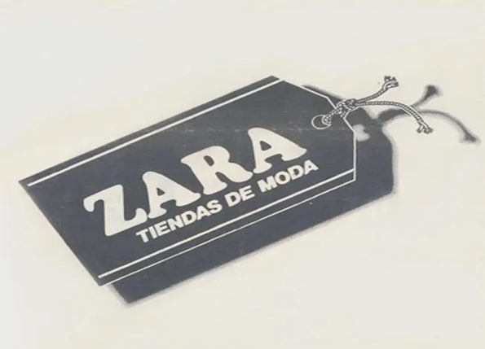
Source: (Inditex, 2022)

Zara is among the most successful fast fashioned businesses, and it manufactures and distributes new designs withing three weeks after they are created. Customers preferences are collected by store managers and this information is fed into the commercial team and the design department , who then work together on developing new items ,based on the information collected. To create a new version of an already existing model takes only two weeks to be designed and delivered to the stores. As a result, Zara is able to launch more than 11 000 new products each year, which is much more than other famous fashion brands such a H&M and Gap. Despite Zara’s inexpensive price tag, its products are very trendy with good quality and its stores look expensive. However, there have been some accusations that Zara is not environmentally friendly, and it is a major source of the greenhouse gases (Kotler, et al., 2019)

3. Determining segmentation and targeting strategies of Zara

A market segmentation process involves identifying the most productive ways of dividing a market, identifying the different segments of customers, and describing the segments (Hooley, 2020). There are four types of segmentations, such as geographic, demographic, psychographic and behavioural (Kotler, et al., 2019).
Major segmentation variables
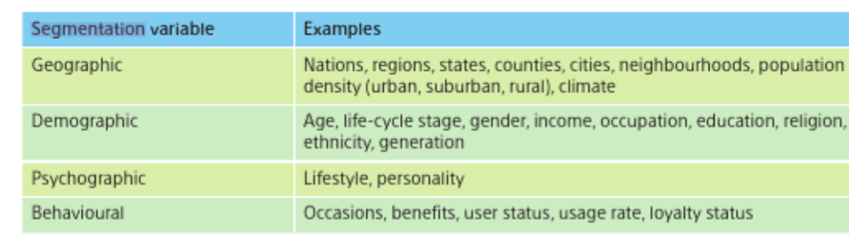
Source: (Kotler, et al., 2019)

It was mentioned already that Zara operates in 96 countries ,thus regarding geographical segmentation Zara’s items everywhere around the world are almost the same , only the prices are different. An example of the difference of the prices is South Korea, where the items are much more expensive than in Spain. The two pictures below are from the websites of Zara South Korea and Zara Spain and in South Korea the price of the T-shirt is 29,900원 (21 Euros), while in Spain it is only 12.99 Euros.

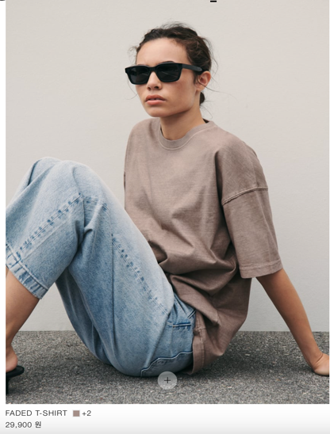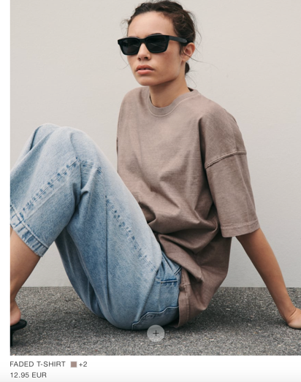
Source: (Zara, 2023) Source: (Zara, 2023)

With that being said , it means that the company does not focus on the customer’s needs in every different country, but concentrates on creating styles that would be attractive for as many customers as it is possible (Martin Roll, 2021) .This could be a disadvantage for the company ,as the Asian countries might not be big fans of the Spanish European styles. They have their own preferences on how to dress, which sometimes are even based on their religion and culture. Nevertheless , Zara is a very famous fashion brand and still scores amazing sales in different continents and operates successfully (Wong, 2021).

When the demographic segmentation is considered, age, gender and income level are used to segment demographics. Zara uses the gender segmentation, in general, they have products targeting women, men and children. However, this could be different ,depending on the country. For example, statistic shows that in the UK, there are more female customers compared to men (Djordjevic, 2022). When the age segmentation is considered, the majority of Zara’s customers are between 18-40 years old. Regarding their income ,usually they are customers with a medium-high income. Moreover, they are professional individuals with busy schedule , who have a good eye for the fashion (Inditex, 2022). Zara’s prices are reasonable , not very high and at the same time the clothes are very fashionable and trendy , thus a lot of high-income famous people have been seen wearing them. One very good example is the Princess of Wales , Kate Middleton , which have been captured by paparazzi many times wearing clothes from Zara (Edwards, 2018).

Kate Middleton wearing Zara
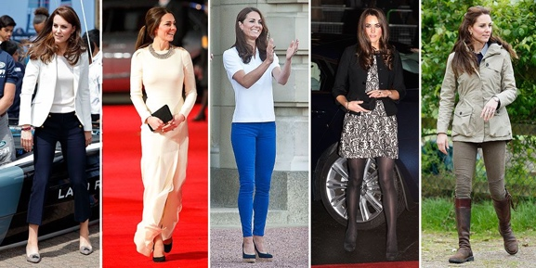
Source : (Edwards, 2018)

On their website they have models from different ethnicities , which represents ethnic diversity, and this is a great thing as the company is international and they have customers from all around the world. One of the disadvantages is that the company does not really offer anything for the plus size people and in that way is losing a large market ,in addition people might feel discriminated (Jordan, 2023).

Zara’s models from different ethnicities
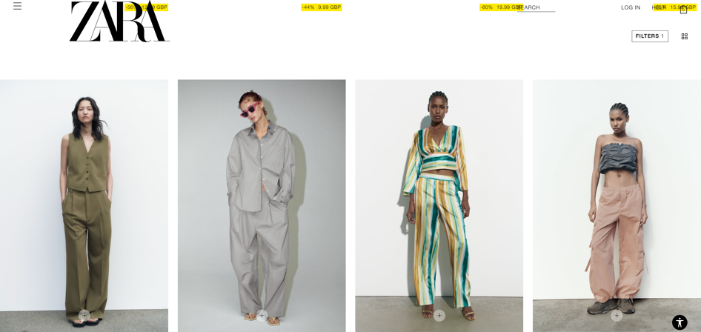
Source: (Zara, 2023)

In terms of behavioural segmentation, the customers of Zara are usually loyal to the company: Zara ranks higher on the Net Promoter Score than its competitors. In the UK ,approximately 14% of the online shopping customers are saying that they would buy from the company again. Based on the brand’s usage share of 17% , this indicates that 82% of their customers are loyal to the brand (Kunst, 2023).

Four primary psychological aspects impact a person’s purchasing decisions , which are motivation, learning, perception, beliefs and attitudes (Kotler, et al., 2019). Based on psychographic segmentation analysis of Zara’s customers , it has been found that they are highly style conscious , technically knowledgeable and value their individuality. It is important for them to have access to the latest fashions , while also expressing their individuality and they desire to have a personalised shopping experience. Zara’s target market is drawn to the brand , because it provides strong emotional components ,such as attractiveness and customer closeness (Start, 2022).

4.Positioning strategy of Zara

The consumer behaviour and the fashion industry are changing rapidly. Customers’ expectations are growing, and the competitive environment is being redrawn . Zara , the flagship brand of the company Inditex has overtaken already H&M from the front position to become the world’s largest fashion retailer by market capitalization. Zara is a brand who is focusing on speed and flexibility, and it can respond fast to the changing trends and offer its customers the latest styles at reasonable prices (Whittington, 2020).

Zara’s positioning map

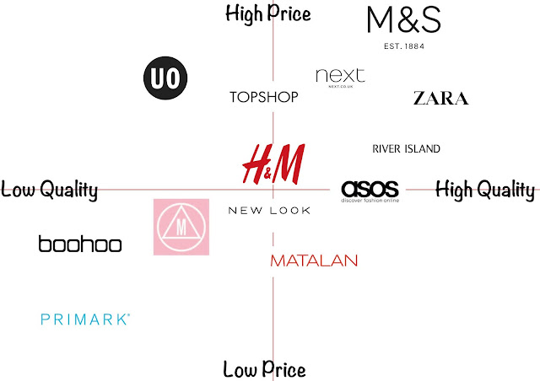
Source: (Topshop, 2019)

The focus on the customers is one of the key elements of the brand’s positioning. The company is dedicated to give each of its clients a unique experience , whether it is in stores or online (Inditex, 2022). Zara is successful ,because it is able to give to its customers what they want, and it is giving it faster than any other brand, which is a good marketing positioning. However, producing such a large amount of clothes has a negative impact on the environment and the workers. A lot of natural resources are being used ,which creates greenhouse gas emissions, and they are responsible for the climate change. According to the UN , the fashion industry contributes 8-10% of global emissions , which is more than aviation and shipping combined (BBC, 2022).

5. Marketing mix strategies of the company Zara

- Product

The product is the combination of goods and services , that the firm provides to its target market (Kotler, et al., 2019). Zara is recognised for providing modern, stylish and fashionable clothes and accessories that cater to its target market’s interests and preferences. Zara sells a wide range of clothes, accessories and shoes for women ,men and children. There is something for everyone in the product categories , which range from casual and formal wear to loungewear and sportswear (The Strategy Story , 2023). Zara is committed to provide its products at affordable prices , but at the same time with good quality. In comparison with its competitors , Zara provides products of relatively higher quality than H&M (In The Fashion Jungle, 2023). As a private label brand , Zara designs, manufactures and sells all its products under its own brand name. This can be considered as an advantage , because that way , the company is able to control strictly the quality and design of its products (The Strategy Story , 2023).

- Price

The price is the amount of money that buyers must spend, in order to get the products, they desire (Kotler, et al., 2019). Zara is following low price strategy , because the company is not spending a lot of money on advertising or raw materials , thus it can afford to keep the prices low. However, Zara’s products continue to be considered high fashion and the brand utilizes a premium pricing strategy, which means that the prices still might be unaffordable for many customers (Wondershare EdrawMind, 2023). Currently Zara’s prices in the UK starts with minimum £5.90 and the maximum is £140 (Inditex, 2022).

- Place and distribution channels

The place consists of the activities undertaken by the company ,to make its products available to its target audience (Kotler, et al., 2019). To ensure maximum visibility , Zara’s retail stores are usually located in prime shopping areas , such as popular malls , big shopping centres and high streets. An example is the busiest street in London – Oxford street ,where Zara is operating successfully four stores in a short distance between each other (West End London, 2023). As it was mentioned already , the fast-fashion retailer has a strong global presence in 96 countries around the world. In addition , with its e-commerce platform the brand has a strong online presence too. While other brands rely mainly on Asian manufacturing for the bulk of their items , the company Inditex makes half of its products in Spain, Turkey , Portugal and Morocco. Distribution is handled by the retailer from Spanish warehouses and then all goods are shipped by manufacturers to the European nation and then sent to retailers worldwide (Orihuela, 2021).

- Promotion

A promotion is the process of communicating the product’s merits to the target audience and persuading them to purchase it (Kotler, et al., 2019). Zara does not really spend any money on advertising, and it is known for being press shy. On the other hand , the company’s outdoor advertising is attractive, and it is based on the fashion trends, that young people are interested in (The Strategy Story , 2023). The company is quite popular on social media as well , as on Instagram it has 59.4M followers and it is posting regularly different pictures of its latest collection (Instagram, 2023). Zara’s Facebook it is a bit less popular than its Instagram , but still, it has 31M followers and 30M likes , which is also very impressive (Facebook, 2023). By collaborating with fashion influencers and celebrities, representing the brand's image, Zara leverages the power of influencer marketing (The Strategy Story , 2023). An example of a big celebrity , with whom Zara is collaborating is the famous French singer Charlotte Gainsbourg , who is also a songwriter and an actress (Goldstone, 2021).

6. Conclusion

In a conclusion, Zara have a reputation as a brand name that produces good quality items , in a short period of time , with very reasonable prices. It is operating internationally in many countries and even tough items are the same everywhere , still the company is running successfully. The brand is offering anything for everyone with the only exception of plus size customers, which Is something that would be good to be considered . Zara is an example , that even without much advertising , but with good targeting and positioning strategy a business can become popular among consumers and be a top leader among other fast-fashion brands. It is very likely , that in the future , the company would continue to expand in new markets and would stay ahead of its competitors , while meeting the customer’s needs , as they change constantly.

7. References

BBC, 2022. Fast fashion: How clothes are linked to climate change. [Online]
Available at: https://www.bbc.co.uk/news/science-environment-60382624
[Accessed 14 07 2023].
Djordjevic, M., 2022. 20 Astonishing Zara Statistics That Show the Brand’s Value. [Online]
Available at: https://fashiondiscounts.uk/zara-statistics/
[Accessed 15 07 2023].
Edwards, J., 2018. Everything Kate Middleton has worn from Zara. [Online]
Available at: https://www.cosmopolitan.com/uk/fashion/celebrity/g19732244/kate-middleton-wearing-zara/
[Accessed 15 07 2023].
Facebook, 2023. Zara. [Online]
Available at: https://en-gb.facebook.com/Zara/
[Accessed 20 07 2023].
Forbes, 2023. About Zara. [Online]
Available at: https://www.forbes.com/companies/zara/?sh=1ad2b2817487
[Accessed 05 07 2023].
Goldstone, P., 2021. Zara has revealed its first ever celebrity collaboration. [Online]
Available at: https://www.marieclaire.co.uk/news/fashion-news/zara-charlotte-gainsbourg-751425
[Accessed 20 07 2023].
Hooley, G. J., 2020. Marketing strategy and competitive positioning. 7 ed. Harlow: Pearson.
In The Fashion Jungle, 2023. Is Zara Considered a Good Brand? Is it Good Or Bad Quality?. [Online]
Available at: https://www.inthefashionjungle.com/is-zara-a-good-brand/?expand_article=1
[Accessed 16 07 2023].
Inditex, 2022. History. [Online]
Available at: https://www.inditex.com/itxcomweb/en/group/history
[Accessed 05 07 2023].
Inditex, 2022. INDITEX GROUP ANNUAL REPORT 2022. [Online]
Available at: https://static.inditex.com/annual_report_2022/pdf/Inditex-group-annual-report-2022.pdf
[Accessed 09 07 2023].
Instagram, 2023. Zara. [Online]
Available at: https://www.instagram.com/zara/
[Accessed 20 07 2023].
Jordan, D., 2023. Everything You Need to Know About Shopping Plus Size at Zara. [Online]
Available at: https://wear-next.com/plus-size-fashion/does-zara-do-plus-size/
[Accessed 15 07 2023].
Kotler, P. T., Armstrong, G., Harris, L. C. & He, H., 2019. Principles of Marketing. 8 ed. s.l.:Pearson Education Limited.
Kunst, A., 2023. ZARA brand awareness, usage, popularity, loyalty, and buzz among fashion online shop users in the UK. [Online]
Available at: https://www.statista.com/forecasts/1252292/zara-fashion-online-shops-brand-profile-in-the-uk#:~:text=Set%20in%20relation%20to%20the,show%20loyalty%20to%20the%20brand.
[Accessed 15 07 2023].
Martin Roll, 2021. The Secret of Zara’s Success: A Culture of Customer Co-creation. [Online]
Available at: https://martinroll.com/resources/articles/strategy/the-secret-of-zaras-success-a-culture-of-customer-co-creation/
[Accessed 15 07 2023].
Orihuela, R., 2021. Zara Owner’s Lesson for Others Is Keep Supplies Close to Home. [Online]
Available at: https://www.bloomberg.com/news/newsletters/2021-03-16/supply-chain-latest-zara-owner-succeeds-with-regional-networks
[Accessed 20 07 2023].
Start, 2022. Who is Zara’s Target Market? Zara Brand Analysis – Customer Segmentation, Marketing Strategy & Competitors. [Online]
Available at: https://www.start.io/blog/who-is-zaras-target-market-zara-brand-analysis-customer-segmentation-marketing-strategy-competitors/#:~:text=Zara%27s%20Behavioral%20Segmentation&text=Zara%20customers%20are%20typically%20loyal,the%20brand%20on%20social%20media.
[Accessed 15 07 2023].
The Strategy Story , 2023. Zara Marketing Mix. [Online]
Available at: https://thestrategystory.com/blog/zara-marketing-mix-4ps/
[Accessed 16 07 2023].
Topshop, 2019. Fashion management and marketing. [Online]
Available at: http://fmckeiraobrien.blogspot.com/2019/02/brand-positioning-map.html
[Accessed 15 07 2023].
West End London, 2023. Zara Oxford Street. [Online]
Available at: https://www.westend.com/oxford-street/zara/#
[Accessed 19 07 2023].
Whittington, R., 2020. Exploring strategy : text and cases. 12 ed. Harlow: Pearson.
Wondershare EdrawMind, 2023. Zara Marketing Mix (4Ps) Analysis. [Online]
Available at: https://www.edrawmind.com/article/zara-marketing-mix-analysis.html
[Accessed 19 07 2023].
Wong, B., 2021. Here’s What You Get Wrong When You Culturally Appropriate Asian Fashion. [Online]
Available at: https://www.huffingtonpost.co.uk/entry/asian-culture-appropriation_l_5cd20d2be4b0a7dffcce2e1e
[Accessed 20 07 2023].
Zara, 2023. T-shirts. [Online]
Available at: https://www.zara.com/kr/en/woman-tshirts-l1362.html?v1=2290973
[Accessed 15 07 2023].
Zara, 2023. T-shirts. [Online]
Available at: https://www.zara.com/es/en/woman-tshirts-l1362.html?v1=2290973
[Accessed 15 07 2023].
Zara, 2023. Woman Trousers. [Online]
Available at: https://www.zara.com/uk/en/woman-trousers-l1335.html?v1=2141374
[Accessed 15 07 2023].

