
Skills for the Workplace
Module Assignment Submission
Student Name: | Samuel Britton
Student Number: | 2016242
Module No: | BMSK4005
Module Title: | Professional Career Development

Statement of Confirmation of Authenticity
By the act of making this submission, the student declares that this is the work of the student named above. The work has not, in whole or in part, been knowingly presented elsewhere for assessment, or where assessment has been built on a previous assessment, this has been identified. Where materials have been used from other sources it has been properly acknowledged. If this statement is untrue, the student acknowledges that an assessment offence has been committed.
Attention is drawn to the plagiarism and unfair practice policies of both the University and of ILM.

Table of Contents
Section 1: Know how to identify development needs 1
1.1 Identifying learning styles for myself and another 1
1.2 Use a simple technique for identifying development needs for self & another 1
1.3 Identify potential barriers to learning for self and another.
11.4 Explain how these barriers to learning can be overcome.
1Section 2: Know how to develop self & others to achieve organisational objectives
12.1 Analyse learning/development options to meet needs of self & another.
12.2 Identify support mechanisms for the development of self & another 1
2.3 Prepare development plans for yourself and another person – Personal Development Plan & SMART objectives. 1
Section 3: Reflection on the recruitment process 1
3.1 Description 1
3.2 Feelings 1
3.3 Evaluation 1
3.4 Analysis 1
3.5 Conclusion 1
3.6 Action Plan 1
References 1
Appendix A 1
Appendix B – Job Application 1
Appendix C - C.V
Appendix D - Cover Letter

Section 1: Know how to identify development needs

Identifying learning styles for myself and another

There are many different learning styles or theories we come to use when identifying an individual’s learning style. I’ve identified various different theories throughout this assignment these are as follows. The VARK learning style (Neil Fleming 1992) which consists of visual, auditory, read/write and kinaesthetic learning styles. Honey and Mumford (1982) using the activist, reflector, theorist and pragmatist learning style. Finally there is the KOLB model of 1976 which also uses a learning cycle based on Accommodating, Diverging, Converging and Assimilating.

I decided on testing out these theories to find a suitable learning style for myself and my colleague. Firstly I tried out the VARK learning model on myself to see what type of learner I am (Appendix A). After completing the questionnaire it concluded my style of learning to be mild aural, which also means auditory, a clear example of this is audiobooks or podcasts. The results explained that my style of learning is improved through listening to information given to me and can reproduce symbols, letters or words by hearing the information given and structure how I need to use this information given and speaking back with the person to ask questions and give an argument for and against if needs be, as to why this information is correct, until I understood what was necessary to complete the task. I also decided to test this model on my colleague to find out how they learn best, their results determined that they were a visual learner so for example they would use learning tools such as diagrams, graphs, charts and directions to learn easier. A visual learner needs to see information to learn it, and this "seeing" takes many forms from spatial awareness, photographic memory, colour or tone, brightness or contrast and other visual information.
Secondly I completed the Honey and Mumford model questionnaire to find out what type of learning style suited me also and to see if it varied from my previous learning model. My result’s show I am an activist, who learn best from “being hands on” which basically means trying something out without necessarily planning or preparing. My colleague’s results showed that they were a theorist, these type of learners enjoy reading through material such as books, gathering facts on all the background information needed for the task.

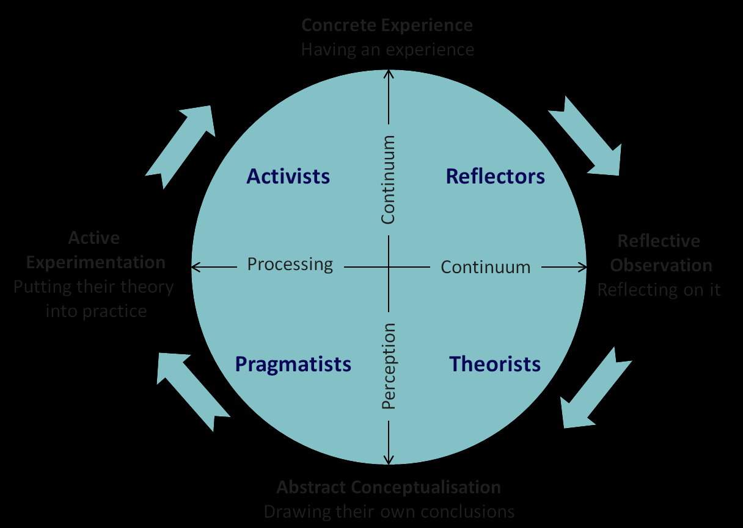

Use a simple technique for identifying development needs for self & another

The technique I decided on using for me and my colleague to identify how we could develop ourselves by working out our strength and weaknesses, is called a SWOT analysis. This simple technique gave us both insight into how we could develop our best and worst attributes into something positive. For example using our strengths to our advantage in any situation and working out how to develop our weaknesses into a strength. Also using our VARK questionnaire results we can process what learning styles we were good at and then put this into practise when overcoming barriers and turning our weaknesses into something positive.
I have now found out that I’m a aural learner and my colleague a visual learner, therefore we can now use these techniques when overcoming barriers to our learning, I will explain this in the next section and make a plan to overcome these weaknesses and threats. Also I have used another method known as a gap analysis (In book: Wiley Encyclopaedia of Management Publisher: John Wiley & Sons, Ltd) which tells us where we are today and what we want to go on to achieve using realistic targets and setting goals. Finally we can use the Johari window technique (The Johari Window – Luft and Ingham, 1955) which gives you insight in how to change what you do know about yourself and the areas that you are unaware of.

SWOT Analysis (Myself)

STRENGTHS  - Good timekeeping skills  - Good at arithmetic  - Efficient at learning new skills  - Preparing for interviews  - Filling in application forms  - Note taking | WEAKNESSES  - Money management  - Keeping concentration on repetitive tasks  - Generating innovative and new ideas in the workplace
OPPORTUNITIES  - Using numeric skills for advanced roles in workplace such as HR and payroll  - Being on time and online at start and beginning of shifts leading to extra paid bonuses  - Learning new skills sets as there are many departments in this organisation | THREATS  - Having a bad credit rating and debts that are current will directly affect my opportunity getting higher paid roles  - Not having a driving license will harm my ability to go to certain workshops or train at different business destinations  - Being too relaxed at work therefore not giving 100% effort will make me overseen by management losing out to other candidates

SWOT Analysis (Colleague – James)

STRENGTHS  - Supervisor position in previous role therefore experience of higher position  - Good at written and oral work  - Generating new ideas  - Problem solving | WEAKNESSES  - Prefer hand written and oral skills, not as good with IT skills  - Bad organisation and planning skills meaning late entry to deadlines  - Untidy handwriting  - Bad presenting skills as confidence is low
OPPORTUNITIES  - Supervisor position in previous role gives me more experience and therefore an advantage over other candidates  - Our competitors may be slow to adapt to new technologies, giving me time to perfect my IT skills  - Organising team bonding trips and setting team goals therefore being recognised by managers | THREATS  - Not being seen as an authoritative figure may hinder my progress in achieving promotion within a growing company  - Not being able to move up higher in previous role, company managers may see this as a weakness  - Advancing technology in the modern world will mean I will need to take classes to enhance my knowledge before new processes are available

Gap Analysis

Objective | Current position | Deficiency | Action
What do I want to do? | What can I already do? | What am I lacking? | How can I fix this?
Complete degree | Complete first module to best of my ability | Resources and classes that haven’t been taken yet | Complete one module at a time and wait for next one to begin
Learn to drive | Revise for theory test | Driving lessons | Take more driving lessons then complete theory test ready for driving exam
(Colleague – James)  Search for management opportunities | Supervisory experience (looked after a team of 12 people) | Management courses | Go to management workshops and complete a management course
Be more confident and have more self-belief | Can communicate well with a team and can construct daily tasks for colleagues | Authority in the workplace and self-belief | Take self-confidence and motivational workshops

Identify potential barriers to learning for self and another.

The barriers I will face when completing the task will be visual and kinaesthetic mainly as when viewing lots of written information I will not process it as well as listening to it in stages then repeating back and asking questions back. I have a structured way of learning and I do not like to try different ideas which needs to be overcome as there are a lot of ways of taking in the information given, I also do not like background noise as I find it very distracting. Furthermore not being able to drive also gives me a disadvantage, as their may be job opportunities in the future which will take me a long time to get too using public transport and some even unreachable from where I currently reside.
My colleague will be disadvantaged by actually being involved kinaesthetically as he is a shy person and will not take leadership in the given task but stand in the background which means he may miss important information due to people discussing and being too far away. Listening to the information over and over is also a barrier, as he doesn’t process the information well in that way as he tends to forget what was said during the lecture/workshop. Also he will not be as quick using a computer as he is not competent with different applications and doesn’t understand how to use them efficiently.

Explain how these barriers to learning can be overcome.

My learning style questionnaire has told me I’m better at using auditory techniques to further enhance my way of learning therefore I can repeat ideas that are verbally presented. So by taking notes when this information is given to me as I’m an aural learner will benefit me, then also asking questions if stuck when the information is given to make sure I understand the objective will further help as my listening skills are stronger than my kinaesthetic, visual and read/writing skills. So by re-watching, note taking and discussing all the information given this will overcome my learning disadvantages. Discussing with my tutor and other colleagues when I need to understand something correctly also helps. My external barrier tells me I will need to book in driving lessons so I can reach these destinations that are far away to further enhance my knowledge at work and also be open to take in information better through different learning techniques.
My colleagues learning style shows that he would learn more efficiently by writing the information given on paper straight away and note take throughout, also by looking at diagrams and graphs for the task ahead he can overcome these barriers using his visual skills. He would also benefit by attending an I.T class and enhance his knowledge of using computer programs as this way may be a lot quicker and an easier process when learning new skills then also taking a management skills class to enhance his job prospects.

Section 2: Know how to develop self & others to achieve organisational objectives

2.1 Analyse learning/development options to meet needs of self & another.

I will analyse our development by using all the information gathered so far through our SWOT analysis and learning techniques. We know what barriers we need to overcome both internal and external and furthermore we will set up a PDP (personal development plan) to help develop skills needed and turn our weaknesses and threats into something positive . We can organise classes to further enhance the strengths we already have and overcome our weaknesses also by using this information which will set us up to be an even better candidate then we both were previously.

2.2 Identify support mechanisms for the development of self.

A support mechanism that is helpful is the GOMAD framework, it helps you to set goals and show you what’s achievable within your skill set currently and how you are going to get there.
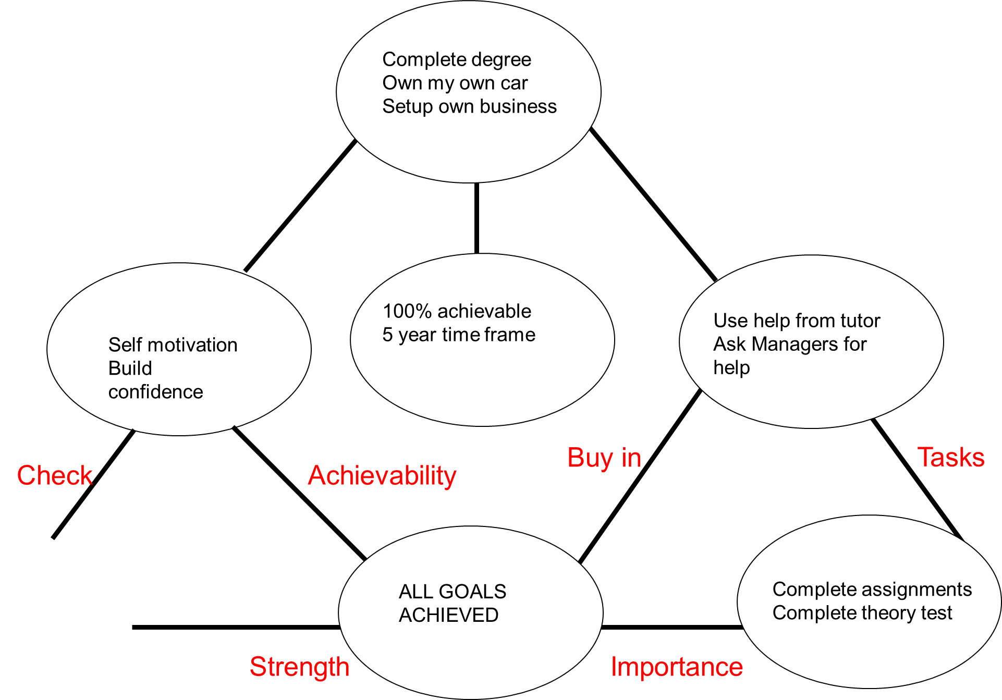
Better jobs

2.3 Prepare development plans for yourself and another person – Personal Development Plan & SMART objectives.

Part 1: Personal Analysis
See SWOT Analysis in 1.2

Part 2: Setting Goals

What do I want to learn? | What do I have to do? | How will I measure my success? | What support and resources do I need? | Target date for review?
Learn how to drive | Book driving lessons | By taking theory test and a final driving test | Use driving theory books and audiobooks to learn road signs and learn how to use my car correctly | 1 year from now
Find better ways to absorb written information | Practise using graphs and diagrams instead of just discussing | Using these in the workplace to complete tasks | Reading more books and taking advice from colleagues on how to absorb this information more efficiently | Over next 2 years
Complete degree in business management | Attend classes and complete modules | Have exams marked by tutor and pass modules | Learn from studying material and online resources | Over 3 years
Colleague (James)
Improve confidence and self-motivation | Take a self-confidence and motivation workshop | By standing in front of classmates and relaying information back | Listening to tutor and gather tips and advice on how to be more self-confident | 1 year from now
Improve I.T skills | Take an I.T skills class | By presenting work using my computer and not just through written pieces | Read guides on how to use computer programs and get knowledge from tutor | In a year from now
Apply for management roles | Increase skill set by taking a management course | Apply for management roles and achieve target | Gain knowledge from management course and speak with existing management to give you feedback on how to be successful in this role | 5 years

Part 3: Personal Objectives

Short Term Goals (next 12 months)
Complete skills in the workplace course and pass
Start driving lessons
Use different techniques when learning new skills

Medium Term Goals (2-3 years)
Start a degree in business management
Take ownership of career and choose career path
Enhance learning skills I may have lacked before
Long Term Goals (3-5 years)
Own a car and start driving
Complete degree and use it to launch new career
Start up my own business

My SMART objective will be as follows : To pass my driving exam within 5 years own my own car, set out to start my own business by planning and applying for a business grant withing the next 5 years also and hire employees for my new business.
My colleagues SMART objective will be as follows : To take an I.T skills course in university which will take a year and improve his skill set, then also apply for a management role at his current job to help his chances he will attend a managers course and this will be completed within a year with looking to secure a management position within 5 years

Section 3: Reflection on the recruitment process

I have decided on using the GIBBS reflective cycle in my reflection process as I believe this fits best when de-constructing how the interview process went and how I could improve in future interviews, using this cycle I can talk about what my thoughts and feelings were going in and coming out of the process. (Gibbs, G., 1988. Learning By Doing. [London]: FEU.)
The C.V and cover letter used to apply for this role can be seen in (Appendix C&D)

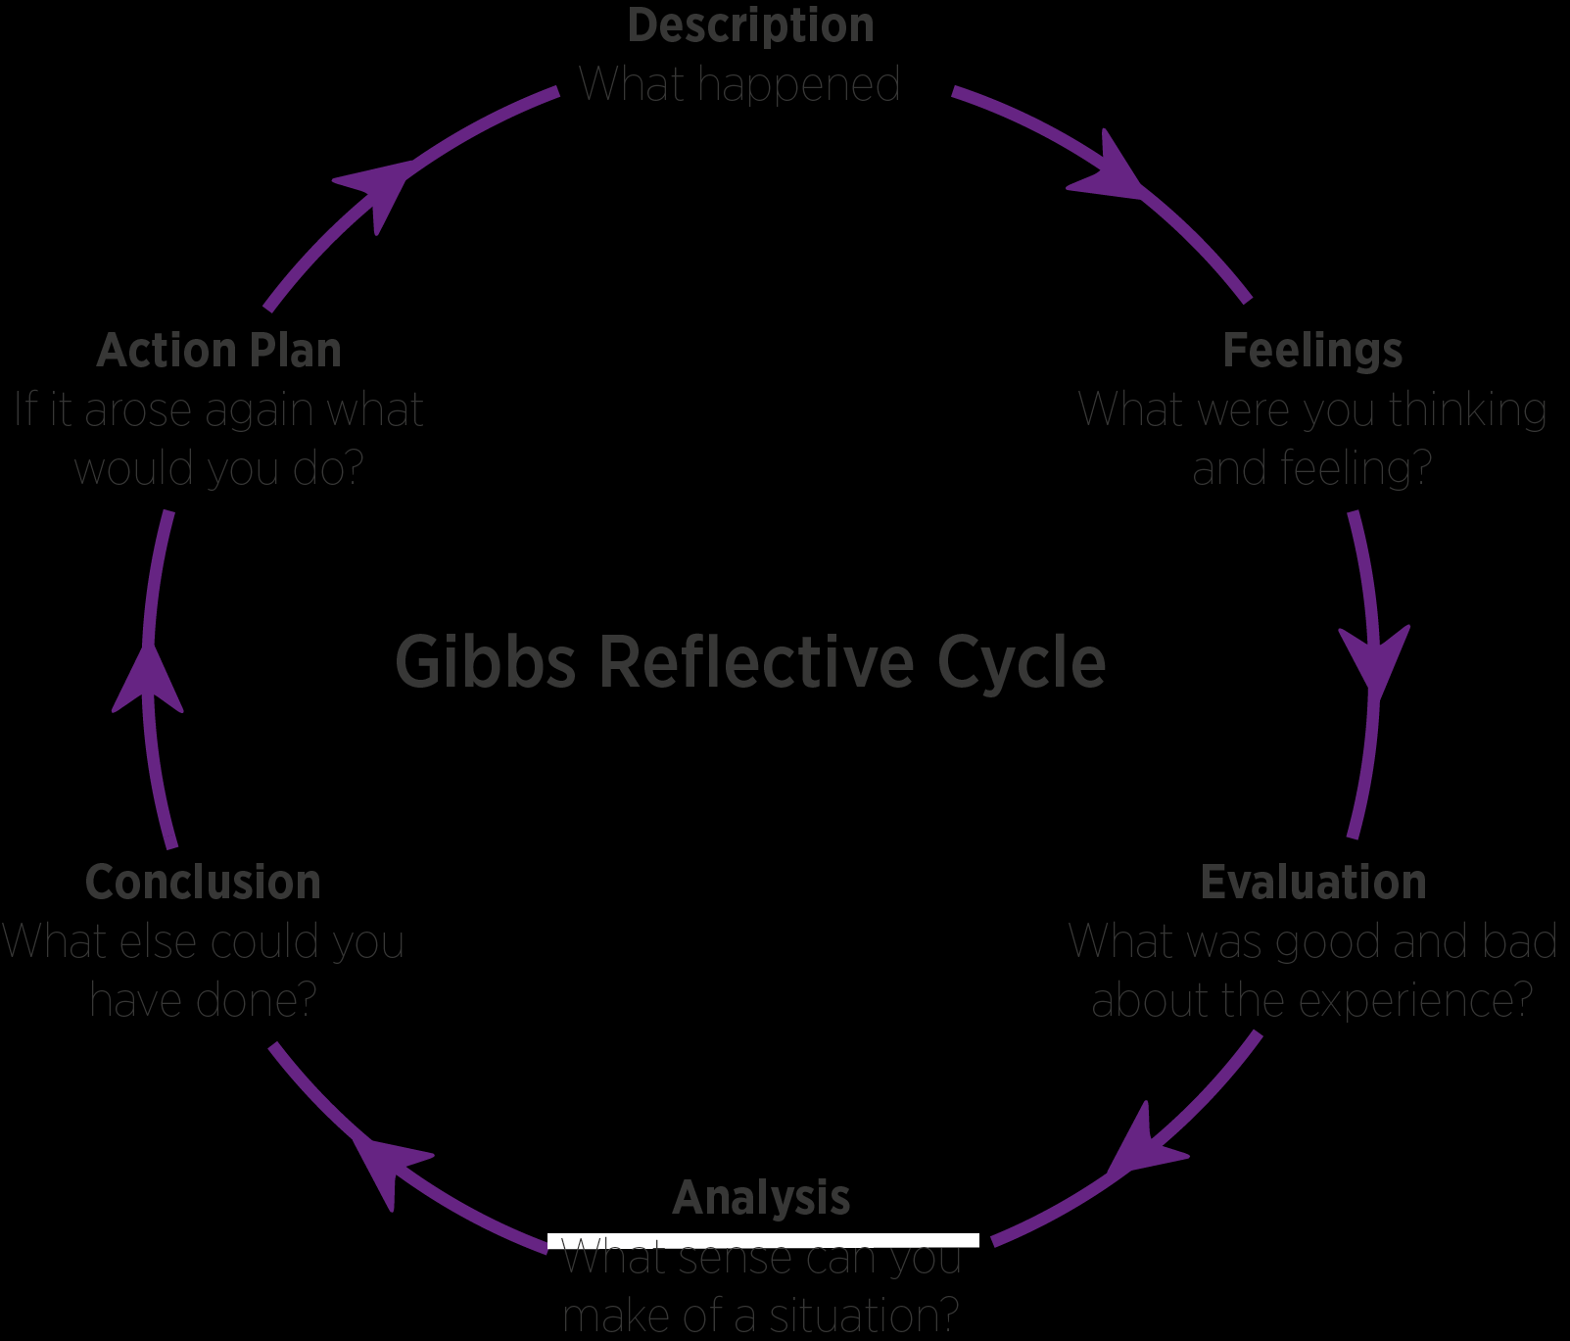

3.1 Description

The manager came to greet me at reception shortly after arriving with a handshake and a smile and told me they would be with me shortly and to wait in the corridor near the interview room in which I felt very anxious. I then was called into the interview room where there was two people sat at a table, being the hiring manager and a note-taker. We then started with introductions, one for myself and they then introduced themselves. Following this they asked to give a brief description about myself and my previous roles and asked a few questions about my duties and what they entailed. Next they gave me a summary of the role I applied for and what attracted me to the position, then was asked to give an example of a difficult situation I had in a previous role or in my day to day life and how I overcame this barrier. They then asked me what experience I had in the role I applied for and to give an example of what I thought excellent customer service was. Finally I was asked where I saw myself in 5 years and what I would do to make sure I achieved this and that concluded the interview, the hiring manager explained when they would let me know if I had been successful and thanked me for coming.

3.2 Feelings

I felt anxious prior to the interview especially sitting around in the corridor when you know you’re about to go in and unsure what questions will be asked, I found a helpful method in dealing with this in future from (https://www.calmclinic.com/anxiety/coping). Once the interview started I felt more at ease after the introductions were over and ready to answer the questions I was about to be faced with. As the interview continued I grew in confidence, as the questions asked I had already prepared for at home and knew I could explain myself clearly and try not to think about what they had asked too much before answering . After the interview was over I felt good and more hopeful of a good outcome.

3.3 Evaluation

The good points about the experience I felt were that the hiring manager and team manager taking notes made me feel welcome, the questions I prepared for came up in the interview which was great and I’ve also learned how to set goals in previous assignments which made this question just as easy to answer.
The bad points about the experience I feel were that I never answered as much in depth as maybe other candidates did and when they asked for previous experiences such as how I overcame a difficult situation and what I thought was excellent customer service I used all my previous work related roles, instead of giving a more varied selection of answers like one personal experience and one work related.

3.4 Analysis

When looking back over the experience as a whole I believe it went well as the question’s I was asked I definitely had a good idea of what my reply would be even though they were a bit short and could have explained myself a bit better by asking the hiring manager if they understood or getting a verbal handshake. There Is a few things I may have changed if I did it again such as using a personal experience for one answer and a work related experience for the other, also letting my employers know that I would be interested in reaching manager level after I have completed my university course which is another area I failed to mention when giving my introduction at the beginning. When comparing this to other interviews I believe it was shorter than I imagined which took me by surprise as I had revised so many more questions then needed too. Finally I should have also shared my eye contact with both hiring manager and team manager instead of focusing on who was asking the questions as your answers come across more genuine when involved in both parties asking you questions.

3.5 Conclusion

I have taken both positives and negatives from my experience which I believe I can implement in future interviews, I know what I could have done better and what I would change next time around. Positives – Good preparation, arriving early and asking questions about the role. Negatives – Giving more varied answers, making more eye contact and introducing myself better not forgetting pieces of information I could use to my advantage.

3.6 Action Plan

Priority areas needed for attention in future interviews are making more eye contact with everyone in the room and using tips on the best way of doing this which I will learn from an online source I have found (Eye Contact – The Definitive Guide by Steven Aitchison) . Writing and practising a great introduction of myself stating all attributes and skills I have for the role firstly on paper then in front of a colleague to make sure it sounds great. Giving a good variation of answers both personal and work related and asking even more questions so it makes me seem more interested in the position then other candidates. Being more knowledgeable about the company, by looking at their company website and finding out all services they provide and what plays to my strengths.
I will also practise different types of interview such as focus group, structured and unstructured to be ready if this situation arises. I will do this by studying a helpful link I have found online. (McLeod, S. A. (2014, February 05). The interview research method. https://www.SimplyPsychology.org/interviews.html

References
Kolb, D. A. (1976). The Learning Style Inventory: Technical Manual. McBer & Co, Boston, MA.
Fleming, N.D. & Mills, C. (1992). Not Another Inventory, Rather a Catalyst for Reflection. To Improve the Academy, 11, 137-155.
Honey, P. & Mumford, A. (1982) Manual of Learning Styles London: P Honey
Gibbs, G., 1988. Learning By Doing. [London]: FEU. A guide to teaching and learning methods. Oxford Polytechnic.
The Johari Window (Luft & Ingham 1969)
Eye Contact – The Definitive Guide by Steven Aitchison (Online page – www.stevenaitchison.co.uk)
McLeod, S. A. (2014, February 05). The interview research method. Simply Psychology. https://www.simplypsychology.org/interviews.html
Coping with anxiety methods - (https://www.calmclinic.com/anxiety/coping)
GOMAD Framework – gomadthinking.com
In book: Wiley Encyclopaedia of Management Publisher: John Wiley & Sons, Ltd

Appendix A

(My results)
The VARK Questionnaire
Your VARK Results
Your scores were:

Visual 5
Aural 12
Read/Write 7
Kinaesthetic 8

Your learning preference:
Mild Aural

(Colleague results)
The VARK Questionnaire
Your VARK Results
Your scores were:

Visual 8
Aural 3
Read/Write 5
Kinaesthetic 5

Your learning preference:
Mild Visual

Appendix B – Job Application

The job’s I will be searching for will be customer service or sales based. I am fully flexible but would prefer somewhere close to where I live as I do not currently drive. I am mainly looking to be in a call centre based role as this is where I have the most experience but also would consider home working and retail also. Furthermore I am looking for a large company that provides many opportunities for promotion in the workplace and can enhance my skill set in many different departments.

Appendix C

Samuel Britton

Cardiff

Sam.Britton1@hotmail.co.uk

07512212479

- Hi, I'm Sam. I have over 10 years of customer service and 8 years of call centre experience. I'm a keen, hardworking individual, whether it be working as part of a team or working individually. I enjoy using my initiative and problem solving skills when finding difficulty in tasks and confident to seek help when needed. I enjoy learning new skills to complete different work duties and revising the knowledge needed to fulfil my role given any task.

Work Experience

Customer service advisor
- BT - Cardiff
- August 2019 to Present
- Taking calls from BT customers about a variation of topics from billing to tech faults. Tech was the main department I worked on, in which we diagnose broadband faults and landline faults and diagnose issue’s with the customer via telephone and if unable to fix we would then book in engineers to fix various issues . Also upselling BT's various products and services to keep customers up to date with price's and new product's.

Customer service advisor
- Which? - Cardiff
- September 2017 to August 2019
- Answering queries from which members and also new customers about specific products, services or any questions customers have on a wide range of topics that our magazines covered. Sign up new customers to the which membership service and take payments from new and existing customers.

Supervisor/Team Leader
- Tesco - Cardiff
- April 2011 to September 2017
- I worked on the meat and fish counter mainly, in which I gained a silver standard award in cutting meat and filleting fish. Served customers to their specific needs, opened and closed the counters in the morning and evening’s. On the evening shift we would wash down counter after closing time and put stock away in holding area. After 3 years of service I was then promoted to supervisor in which I ran a team of 12 people, with duties which included setting daily tasks for staff, completing rotas and making sure we were achieving daily sales targets.

Sales Advisor
- Conduit UK - Cardiff
- January 2007 to April 2011
- Sell and give advice to customers on all sky products such as phone, broadband and television packages. Deal with customer queries, take payments and give customers up to date prices and promotions that were current.

EDUCATION

- BTEC National diploma (Equivalent to 2 A levels) in Engineering
- Barry College 2000-2005
- GCSE Grade B in English language, Maths, P.E and History
- GSCE Grade C in English literature, Welsh, Graphics and Double Science
- Fitzalan High School 2000-2005

SKILLS

- CSCS card membership (4 years)
- Labouring and warehouse experience (5 years)
- Call Centre (8 years)
- Customer Service (10+ years)

Appendix D

Cover Letter

Legal & General
Knox Court 10,
Fitzalan Place,
Cardiff
CF24 0TL

Customer Service Advisor Position

Dear David Jones,
Are you looking for a customer service advisor with:
• Over 8 years of call centre experience
• A candidate competent in using computer systems (MS word, excel and PowerPoint)
• Excellent written and oral communication skills
• A passion to learn new systems and help customers to the best of my ability

If so, then I believe I’m the right candidate for you. You will see from my enclosed resume that I meet all your requirements and more,
I would very much like to discuss opportunities with Legal and general as I believe I would be a great candidate for this role, my contact details are highlighted in my C.V.
Thank you for taking the time to review my resume. I look forward to talking with you.
Yours Sincerely, Samuel Britton.

