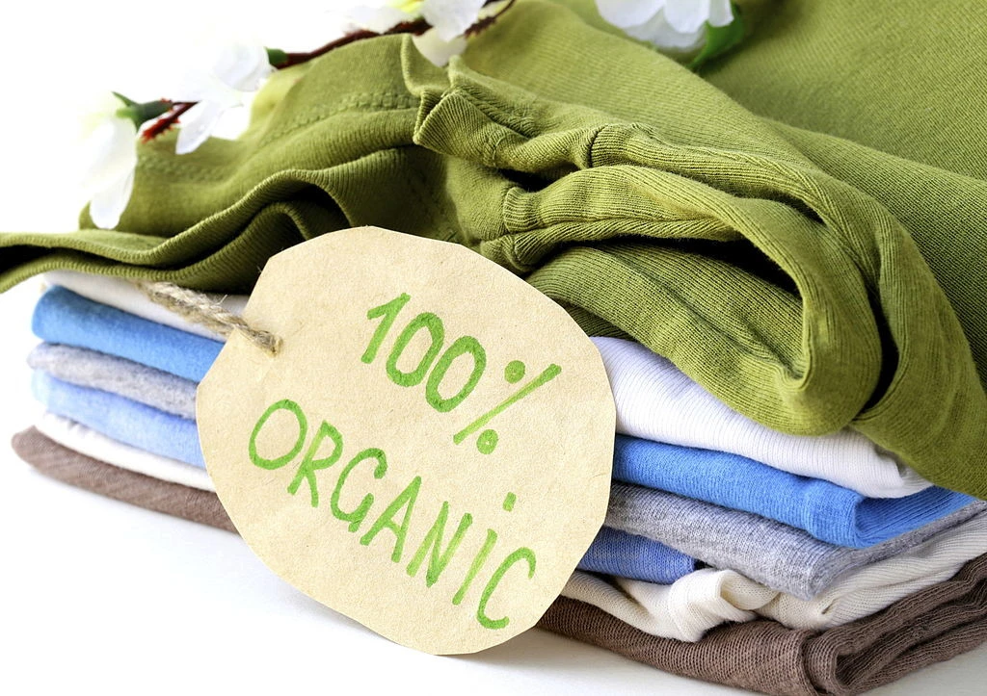  Business plan  D&S | Student Name: Diana Stoyanova  Student Number: 2007366  Module: Entrepreneurship  Module Code: LCBB5001  Lecturer: Vasilios Tavlaridis

Introduction
D&S brand is a startup fashion company that aims to provide various fashions extracted from cotton and hemp. The company will be purchasing the already processed cotton and hemp fabrics both locally and internationally. The D&S brand will be categorized into unique company brands and tailored brands. The individual brands will be those which will be available to the market and ready for the consumers to wear. The tailored will be those which will be done regarding consumers’ requirements. There will be many specializations in vintage clothes which will be used as casual wear and luxurious outlook due to the perceived quality by our fashions. The company will capitalize on providing progressive change and varying fashion designs meant to fit different environments. The D&S brand will major in various artworks, which will be equipped in other vintages to enhance the outlook and uniqueness in the market. The D&S company will be driven by the mission “Quality from nature”.
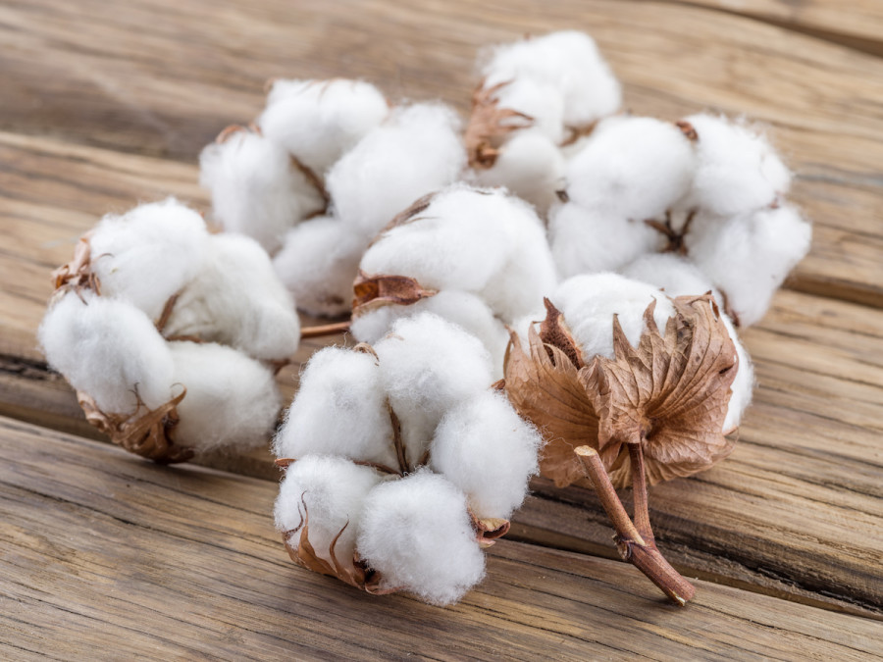
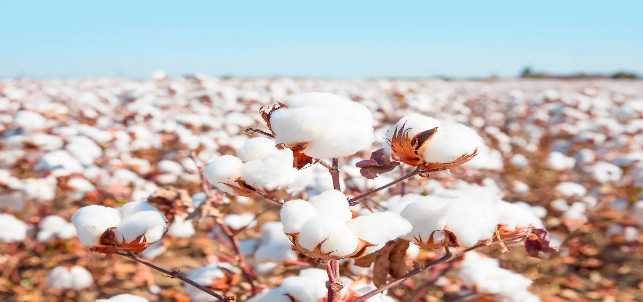
Figures 1: Cotton

Figure 2: Hemp

Personal Expertise
The development of the D&S brands will be based on my desire to develop the business in a different direction. I started studying Business and Management, and all the information I am currently receiving will help to realize the business idea. I have always wanted to make people dress well and at the same time protect nature. That will be the goal of my success.

Opportunity in the market
Birmingham has increased the number of recreational parks and tourist sites that provide an increased number of people for holidays. The approach is creating a high demand for casual clothes, which are required for the events. The available casual wears in the market lack the artwork feature, which is of great interest to most consumers based on the pilot study I conducted. The general casual wear in the market is mainly made from polyester material which is not durable as cotton and hemp made materials. I will thus venture into the opportunity where there is a need to ensure the casual clothes provided have various vintages, varying artworks, and provision of customization regarding customer demands. The company is venturing on a website that will contain most of its products, an approach that is missing along with most retailers who offer the same type of clothing.

Location
The venture will be located along High Street in Birmingham. The selected location receives a mixed number of guests who visit the various places in Birmingham as they search for the most appropriate fashions for their different events. The street is also stated to contain the most unique and the latest styles in the market. Locating the company in the region will guarantee a high number of target customers who flock in, thus increasing sales.
In addition, the company will identify progressive outlets in different localities with the country, which have attraction sites to open outlets in which the D&S products will always be available.

Legal Ownership and Entity
The company will be a limited liability company in which it will have several members as the shareholders depending on the amount of capital they invest. I will be a principal owner of the company in which I will maintain 60% shareholding of the company (Brough, 2005).

Goals for the Company in the first year of Operation
- Build a solid customer base both through an online platform and at the company stalls.
- Reach more than 50% of the target market.
- Participate in charity events which will help in easy awareness of the company products.
- Develop a positive reputation for the D&S brand.
- Build a profitable business with progressive growth in terms of expansion.

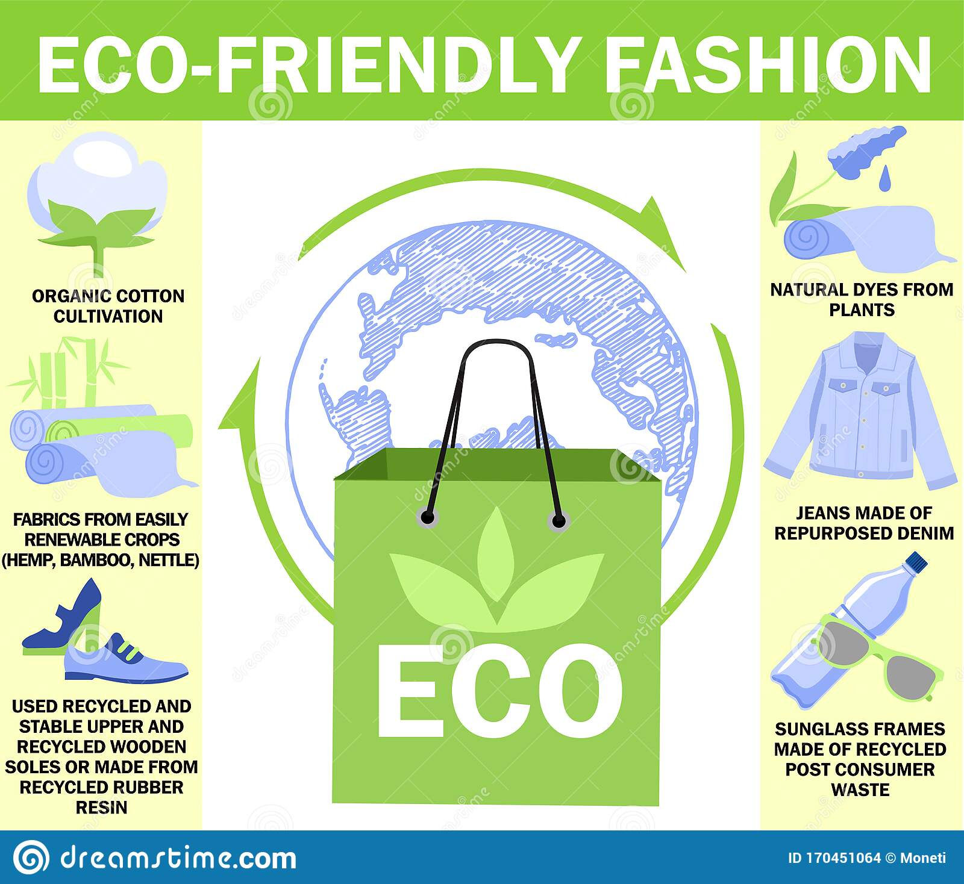
SWOT analysis
Strengths
- High-quality guarantee by the cotton and hemp resources.
- Exceptional customer service regarding customer advice.
- Excellent location along the high street, which has an increased number of target customers.
- Easy availability of the raw materials for the products, i.e., cotton and hemp fabrics.
- Increasing demand for vegan clothes and animal-free clothes across the country.
Weakness
- High-cost products due to the high quality of the fashions.
- Lack of adequate financial capacity to compete with the big and established fashion firms.
- Lack of high machinery to ensure increased production levels and high quality.
Opportunities
- Online access to the products through the company website will increase the consumer base.
- Customer modification will help meet the customer grievances.
- Establish a natural-made luxuries fashion line.
- Establish dynamic artwork in the fashion designs.
Threats
- Increased imitation of D&S brand, which leads to the negative reputation of company’s products.
- High marketing cost.
- Increased taxation on natural-made products.

PESTEL analysis
Political Analysis
The company works under strict legislation in growing cannabis, a major source of hemp fabrics that provide a threat not to have an adequate supply of the resource (Hurley, 2018 p.361). The country's stability encourages more visitors to visit the site, increasing the customer base.
Economic Analysis
The product's pricing varies with the economic conditions escalated by the inflation and exchange rates of the UK currency. The aspect creates unspecific price development for the consequences (Forbes et al., 2021 pp.30-35)). The taxation laws are also varying depending on the product value. The approach is making the business lack certainty in its projections. There is supportive, easy loan access for start-ups in the country, which makes it possible to ensure the venture is set at the required standards without much strain.
Social analysis
The company products are modified to fit other occasions within different areas. The approach will be encouraging more consumers to purchase the product to use on different occasions with much support of the expert advice before purchase. There is a high demand for durable and quality casual fashions to use in different events. The artwork reflects various aspects in a real-life situation that attract much attention of the target consumers.
Technological Analysis
The company developing its website will ensure social media protection of the brand to maintain its reputation in the market (Akko and Ninnimaki, 2018 pp.356-364). In addition, the website will provide remote access to the D&S products with much use of the reviews from the customer to improve the product.
Environmental Analysis
The company is capitalizing on the continued use of natural fabrics to help provide biodegradable waste of the fabrics. The approach helps reduce the increased rates of pollution, which is escalated by the use of non-biodegradable materials.
Legal Analysis
The legal terms for the formation of the company will require registration. In addition, the company will seek patent rights that are meant to promote the uniqueness and protection of the brand.

Target Market
Our target market is all populations as the company will provide products which will fit all age groups. The aspect will help increase the market as it can offer a one-stop approach for the entire family, which is categorical to have access in different fashions. Furthermore, due to the artwork in the styles, we aimed to reach more people who have other social events as the vintage aspect attracts many decorations. In 2020 it was stated that there was an expenditure of more than 54 billion pounds in the clothing industry, an element that guarantees the high demand for fashions (Statista, 2018).
The locals within the city are targets for the products. The increased organization of different forms of events is enquiring to have a uniqueness in terms of fashion. The perspective is provided by D&S, which allows the consumers to state the modifications they will require. The company is targeting to venture on online consumers to ensure that they can provide their products. By 2019, 93% of UK residents had internet access (O2 The Blue, 2019). The aspect creates a significant boost through the use of the company website, which will be easily accessible to the consumers. The approach will help ensure the creation of a distributed and expansive customer base from the online platforms.

Marketing Plan
D&S will capitalize on ineffective marketing, which will ensure that there is efficient customer reach out to increase the company sales (Chenerv, 2020). The company will have its marketing personnel who will engage in direct engagement with the potential clients. There will be dynamic changes in slogans used in the marketing depending on the target market and the product. The approach will help in ensuring that there is positivity in terms of the sales for the company. The company will ensure a combination of outstanding customer service and quality assurance to ensure a continuous flow of consumers. The approach is anticipated to get customers who are one-time and return customers. The marketing approach will major in maintaining all types of customers as they help in the positive growth of the business.
Product Development
The customer's specifications will determine the products provided by the company. Despite the need for specification, there will be the maintaining of the minimum standards for the company, which will focus on retaining the company's quality (Grunert and Van Tripj, 2014 pp.378-381). There will be a free-will development of new designs in the specific product lines that match the current fashion. Utilizing the internet approach through the website will provide the company with easy access to many parts of the country, and thus, it will help in continuous market share growth.

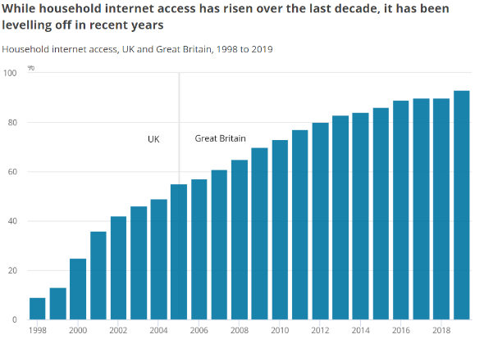
Figure 4 - Internet access in the UK (O2 The Blue, 2019)
Sales Strategy
D&S will develop sales based on various aspects, which will be meant to ensure that there is increased sales volume (Pai, 2017). The new customers will be reached through social media advertising and referrals programs in which customers who bring new customers to our premises are provided with an award. Direct mailing campaigns will be conducted twice every month, whereby they will have 10% coupons. Clearance sales at the end of every year will be a critical approach to ensure that there are many customers as its s during the holiday season when many tourists visit the country. The company will be offering deliveries all over the country the next day after purchase. This approach aims to ensure that there is convenience in the purchase and promote more online sales. The website will have a review section whereby the customers who purchase will rate the products for other customers to view and be an escalating factor to create assurance to the new customers.

Financial Plan
Financial Requirement and Use of Funds
The company will require £10 000 to startup as the owner will offer most of the labour required for the business operations. The finances will be meant to purchase the startup's raw materials, rent, company registration and licensing, website development, branding, and social media promotion fees. As the company operations expand, there will be a requirement for more funds which will help cater for the expansive operations.
Sources of Finance
Shareholder equity:
The capital will be generated from the shareholder's contribution to the company. It will provide the basis which will be used in the sharing up of the capital. As the company's principal owner, I will be obligated to finance 60% of the capital, equal to £6000, with the rest being financed by the investors. The other shareholder in the company is expected to raise 40% of the required capital, which is £4000, to provide total capital requirement.
Income Statement Projection
Sales Forecast
The primary company source of income will be through the sale of the company products. In the first financial year, it is anticipated to gain a revenue of £111 000 from the sales. In the monthly revenue collection, the April, August, and December periods are forecast to have high revenue due to the increased vacations. In addition, online marketing will help increase sales by 20% as it will provide a reach out to all parts of the country. The expansive approach of having outlets in different parts of the country will boost the revenue to increase by 20% for the first five years of operation. That means the year 2026; the company revenue is projected to be at £230,169. The increasing revenues are due to the widening market which the company is gaining.
Figure 5 - Projected sales revenue for five years

Projected Operation Cost
The company projected cost of operation for the entire year is £50,120 for the first year. This aspect will put the company with a margin of £55,880 in the first year. However, the cost of operation is expected to differ as the putting of other warehouses in different localities will bring about a new demand cost. The monthly fixed expenditure is projected to be £1300, which is the rental fee for the initial stall for the business and the marketing of our products. After the new sewing machines purchase, it is expected to have increased fixed cost due to the aspect of the labour cost which the company will be incurring monthly.
Conclusion
In conclusion, D&S will be "Quality from Nature". Our clients will dress according to the trends and depending on what they like. They will receive an extremely personal attitude, depending on what event awaits them. At the same time, this will be combined with the protection of nature and animals. Our customers will be able to freely express their opinion. Addressing customers with great love and attention to them will be successful because our approach is different from everyone else in the UK. We will reach our customers, not so much with the financing of innovations in the company, but with the knowledge and desire to be satisfied in the best way.
Appendix 1
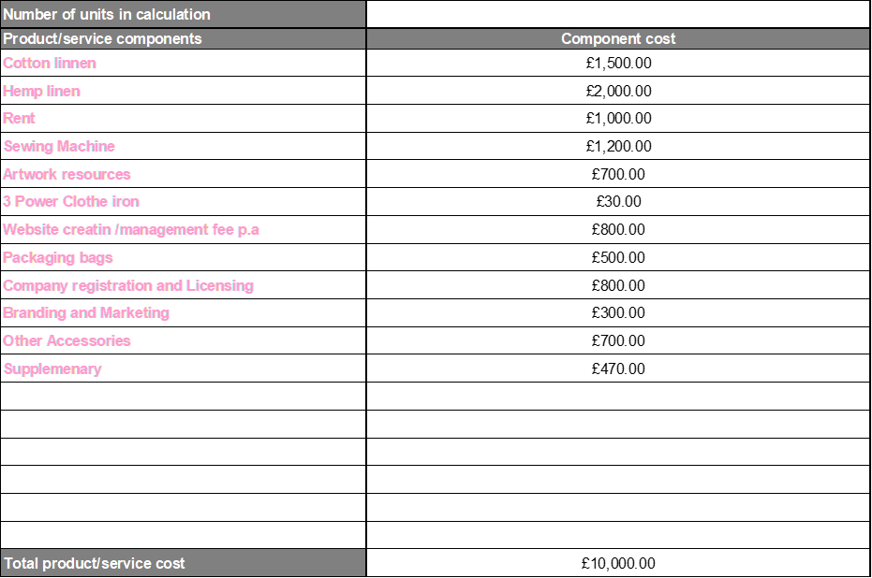

Appendix 2

Appendix 3

References
Aakko, M., & Niinimäki, K. 2018. Fashion designers as entrepreneurs: Challenges and advantages of micro-size companies. Fashion Practice, 10(3), pp. 354-380.
Brough, G.H., 2005. Private limited companies: Formation and management. Sweet & Maxwell.
Chernev, A., 2020. The marketing plan handbook. Cerebellum Press.
Forbes, K., Kirkham, L., & Theodoridis, K. 2021. A Trendy Approach to UK Inflation Dynamics 1. The Manchester School, 89, pp. 23-75.
Grunert, K.G. and van Trijp, H.C., 2014. Consumer-oriented new product development. Encyclopedia of agriculture and food systems, 2, pp.375-386.
Hurley, R. 2018. Cannabis, cannabis everywhere: U\K to review medical cannabis policy as Canada plans imminent legalisation for all uses. BMJ: British Medical Journal (Online), p.361.
O2 The Blue. 2019. Internet access in the UK. [online] Available at: https://news.o2.co.uk/2019/08/13/internet-access-in-the-uk/
Pai, S., 2017. Small business marketing strategies for the first 5 years (Doctoral dissertation, Walden University).
Statista. 2018. Topic: Apparel market in the UK. Www.statista.com; Statista. https://www.statista.com/topics/3348/apparel-market-in-the-uk/

