

Programme:
Master of Business Administration
Module:
Marketing Management | Module Code: LCMB7024
Module Lecturer:
Dr Mustakkima Afrin
Assignment Title:
Marketing Environment Analysis:
Uber & Lyft

Submitted by:
[AJITH NAGARAJAN]
Student ID: [2525947]
Submission Date: 26 March 2026

Table of Contents
1. Introduction: 3
2. Overview of Uber & Lyft: 3
2.1. Uber as the Pioneering Organization: 3
2.2. Lyft as the Follower Organization: 4
3. Task 1-Macro-Marketing Environment Analysis: 5
3.1. Macro-Marketing Actor 1: Legal Regulations 5
3.1.1. Overview of Legal Regulation in Ride-Sharing 5
3.1.2. Opportunities and Threats for Uber: 6
3.1.3. Opportunities and Threats for Lyft: 6
3.1.4. Impact on Competitive Position: 7
3.2. Macro-Marketing Actor 2: Urban Mobility Trends 8
3.2.1. Overview of Urban Mobility Trends 8
3.2.2. Opportunities and Threats for Uber: 8
3.2.3. Opportunities and Threats for Lyft: 8
4.3.4. Influence on Competitive Position: 9
5-Task 2-Strategic Response to Macro-Environmental Factors of Uber & Lyft: 9
5.1. Porter’s Generic Strategies: 10
5.1.1. Porter Generic Strategic Approach of Uber: 10
5.1.2. Porter Generic Strategic Approach of Lyft: 11
5.2. Ansoff’s Growth Matrix 13
5.2.1. Strategic Response Comparative Evaluation of Uber: 13
5.2.2. Strategic Response Comparative Evaluation of Lyft: 14
5.3. Critical Comparison of Uber & Lyft: 16
4. Conclusion: 16
5. Reference list 17

Introduction:
Rapid growth in the ride-sharing business has been achieved within the last decade with the development of mobile technology, the growing urbanization, and the shift in consumer transportation preferences (Seng et al., 2023). Due to the convenience and convenience of the partnerships carried out via applications, the Uber and Lyft platforms have revolutionized the conventional taxi business. Uber is well known as the first company that has brought the large-scale ride sharing model which followed by Lyft as a competitor firm in the same business industry.
The report discusses two major macro forces: legal regulation and mobility trends in the urban setting and analyzes the strategy response in the context of Porters Generic Strategies and Ansoff Growth Matrix.

Overview of Uber & Lyft:

Uber as the Pioneering Organization:
Founded in 2009, Uber has been acknowledged as a leading entity in modern ride-sharing companies with headquarters in San Francisco. The firm launched a mobile application that links passengers to local drivers that transformed the conventional taxi services. With the fast global growth, Uber currently serves dozens of cities in over 70 countries and is one of the biggest mobility platforms in the world. In its early market penetration, it enjoyed a high first-mover advantage that gave the company a high user and driver base (Valdez, 2022).
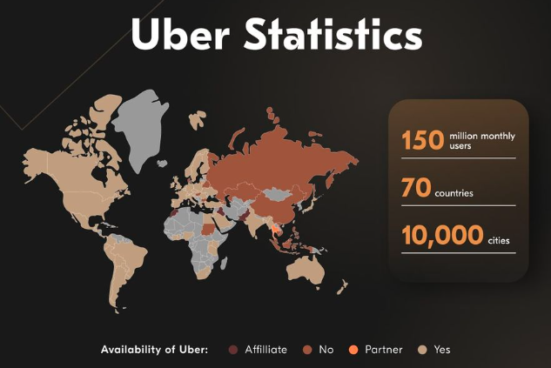
Figure 1: Availability of Uber across the world Source: (Valdez, 2022)

Lyft as the Follower Organization:
Lyft is an American based company which was established in 2012 and emerged as a major player in the ride-sharing industry when Uber had already built the platform-based transportation template. Lyft is largely concentrated in North America and Canada in particular compared to the immense global coverage of Uber. The company adheres to the same model of ride-sharing companies that matches riders and drivers by providing a mobile-based app (Chihara, 2021). In order to compete with Uber, Lyft has aimed at building a great brand identity with respect to customer experience and community values.
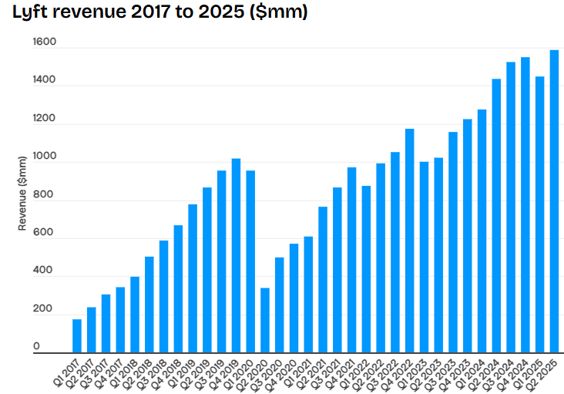
Figure 2: Lyft Revenue from 2017-2025 Source:(Iqbal, 2023)

Task 1-Macro-Marketing Environment Analysis:

Macro-Marketing Actor 1: Legal Regulations

Overview of Legal Regulation in Ride-Sharing
Legal regulation is one of the very important macro-environmental factors that influence the activities of ride-sharing services like Uber and Lyft. It includes labor regulations, licensing provisions, insurance provisions, and standards of passenger safety set by governments (Tu and Xu, 2024). The regulation in platform-based business model is especially crucial as the company relies not on a regular staff but on independent contractors. It has given rise to the continuous controversies regarding worker classification in the gig economy, particularly in places like California (Davlembayeva et al., 2024).

Opportunities and Threats for Uber:
The legislation opens opportunities and challenges to Uber in a serious manner due to the international nature. Amplified market legitimacy is one of the opportunities. With governments codifying ride-sharing policies, Uber will enjoy a higher degree of consumer trust and expansion of its consumer base as a legitimate transport service provider. As an illustration, the regulatory policies that demand driver background verification and insurance policies have enabled the normalization of Uber services in most markets. Besides, the size of Uber gives it a significant lobbying leverage. The company has been actively engaged in policy discussions, especially backing the election of California Proposition 22 in 2020 that allowed app-based drivers to be considered independent contractors, with restricted benefits (Dubal, 2021).
Moreover, the fact that Uber has experience in more than 70 countries in addition to more than 15,000 cities as of 2024 shows that it can operate in various regulatory conditions (Statista Research Department, 2025). This control ability can be used as a competitive edge that allows them to enter and adapt faster to the market than smaller competitors.
These opportunities however come with great threats. Uber encounters complicated compliance issues in different jurisdictions, which make it expensive in terms of administration and operation. The legal problems are still a thorn in the flesh, specifically the classification of drivers, as the UK and the EU have had cases that have questioned its employment paradigm (Stemler et al., 2025).
Importantly, the large size of Uber is a strength as well as a threat globally. Although diversification will enable the company to withstand regulatory shocks in a particular market, it will lead the company to face constant legal interference and excessive compliance expenses that may strain the profitability and strategic adaptability (Isbah, 2022).

Opportunities and Threats for Lyft:
The regulatory environment in which Lyft takes place is more geographically focused on the United States with a few regions in Canada. This generates some benefits. A less complicated regulatory environment also means that less jurisdiction will require compliance, which will make the administrative work of Lyft simpler (Lyft Economic Impact Report, 2024). More than that, Lyft has positioned itself as more driver-friendly, promoting transparency and driver benefits, which can strengthen its reputation in regulatory discussions and can keep up with the demands of workforce in the future.
Nevertheless, Lyft is not geographically diversified enough and thus, is highly exposed to regulatory risks. The firm is also very reliant on U.S. labor and transportation policy and, therefore, any alteration in the policy, by legislation like the tightening of laws on workers classification, can directly and significantly affect the cost structure (Isbah, 2022).
Moreover, Lyft is weaker in politics than Uber, which restricts its ability to impact the regulatory consequences. In a critical view, the advantage of the lower complexity of regulations is outweighed by Lyft having more exposure to the changes in policies. The business model of Lyft is more susceptible to the legal changes in the country compared to Uber because international diversification is not a viable option to counteract regulatory forces.

Impact on Competitive Position:
The effect of legal regulation on the competitive positioning of Uber and Lyft is differentiated. Global diversification provides Uber with strength and enables it to deal with regulatory risks in a variety of markets and operate despite localized restrictions. Conversely, Lyft is more vulnerable to any changes in policy, so it is less flexible in its strategies because of its reliance on the U.S. market. This means that regulatory forces are more likely to limit growth opportunities of Lyft than Uber. On the whole, legal regulation affirms the competitive advantage of Uber using the principles of scale and flexibility, and at the same time, placing Lyft at more operational risk in a highly-concentrated regulatory environment.

Macro-Marketing Actor 2: Urban Mobility Trends

Overview of Urban Mobility Trends
Urban mobility trends can be described as changing trends in urban people movement caused by urbanization, digitalization, and sustainability issues. There is the rapid urbanization that has led to the high population density in the urban areas and the demands of an efficient transport system. At the same time, digitalization, in a form of smartphones, GPS positioning, and mobile payment systems, has facilitated the development of mobility services based on applications like ride-hailing. Transportation decisions have been affected by sustainability issues such as climate change and congestion. These are part of a larger change in ownership of cars into mobility-as-a-service (MaaS) in which consumers are increasingly interested in flexible, on-demand services of transport, rather than car ownership (Zhang et al., 2021).

Opportunities and Threats for Uber:
The trends in urban mobility present great growth opportunities to Uber, especially in the light of its global nature. The growing urban demand of transport services that are flexible has allowed Uber to grow exponentially in leading cities all over the world. To create value on its platform-based business model, the firm has also adopted its services as an extension of a broader mobility platform, including ride-hailing, food delivery (Uber Eats), and freight logistics. Furthermore, Uber uses big data and artificial intelligence to optimize pricing and routing and demand forecasting to enhance operational efficiency. Further investment in the future mobility solutions including autonomous cars and electric mobility places Uber in a better position to grow in the long term (Naumov and Keith, 2022).
Nonetheless, there are also problems with these trends. Uber has been criticized as a cause of urban congestion and environmental effects, and has been the subject of regulatory scrutiny in a number of cities. Furthermore, large-scale operations across the world make it more complex and expensive.

Opportunities and Threats for Lyft:
Lyft can take advantage of such trends in urban mobility, especially the presence of good demand in the key U.S. cities. Lyft has nearly 44 million active riders and had above 828 million rides in 2024 and this is an indicator that it is highly active in urban markets (Lyft, 2025). This is not the case as competitors look at increasing customer experience and improving customer service quality. Lyft has entered into agreements with self-driving car firms like Motional and Waymo that would enable it to take part in the future mobility development without bearing the entire expense of developing them internally (Widiastuti and Irawan, 2024).
Even with these opportunities, Lyft has significant weaknesses. It is small and therefore cannot spread out its services and service and diversify like Uber (Taylor, 2024). The company is also quite reliant on few urban markets which make it more susceptible to changes in demand. Importantly, Lyft is able to adjust to urban mobility trends but it does not have the sizes and resources to capitalize on them to the fullest.

4.3.4. Influence on Competitive Position:
The trends of urban mobility are another strength of Uber that allows the company to capitalize on the benefits of scale, data opportunities, and service diversification across the world. Its market domination is supported by its capability to work in different markets, incorporate various mobility services. On the other hand, Lyft has a competitive position in the United States with service differentiation and the establishment of strategic partnerships but does not have an international presence. These macro-level trends, in turn, further Uber's dominance in the ride-share sector, making Lyft a niche but hemmed-in competition. The scale and diversification of companies is more in line with the prevailing trends of urban mobility, putting Uber in a stronger position than Lyft in the changing landscape of mobility.

5-Task 2-Strategic Response to Macro-Environmental Factors of Uber & Lyft:
The generic strategies on the Porters examples and the Ansoff’s growth matrix can be effectively applied to analyze the macro-environmental forces on Uber and Lyft. These frameworks emphasize the manner in which each company utilizes its resources, market standing, and growth strategy in order to react to the legal requirements and movement of people in the city.

5.1. Porter’s Generic Strategies:

5.1.1. Porter Generic Strategic Approach of Uber:
The response to the macro-environmental pressures, especially the legal regulations and the trends in urban mobility, has been different in Uber and Lyft, which are based on their competitive approaches. Uber fits into the hybrid approach where it combines cost leadership and differentiation (Garud et al., 2020). It has a cost leadership due to the great economies of scale and network effects since the company serves in more than 70 countries and 15,000 cities in the world (Statista Research Department, 2025). The massive scale of such operation allows Uber to lower the average costs per ride and improve the efficiency of its operations by means of data analytics and AI-based pricing mechanisms.
Simultaneously, Uber obtains differentiation by its portfolio of diversified services, i.e., ride-hailing, Uber Eats, and Uber Freight. Interestingly, Uber Eats made a total of more than 12 billion revenue in 2024, which proving the positive results of the diversification strategy (Uber Annual Report, 2024). This multi-service platform will add value to customers and lessen the reliance on one source of income.
Importantly, the hybrid business model allows Uber to juggle the regulatory pressure in a way that diversifies the risk with multiple markets and at the same time capitalize on the trends of urban mobility by expanding the platforms.
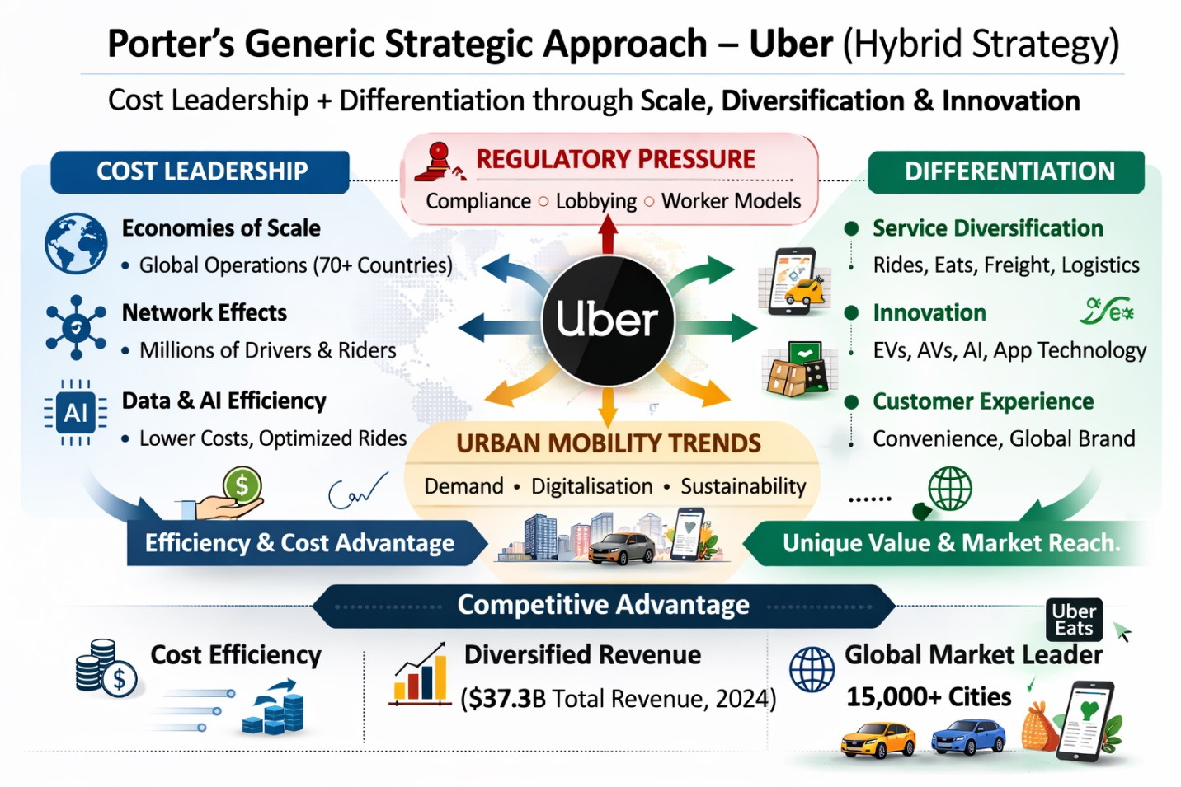
Figure 3: Uber Porter Generic Strategic Approach

5.1.2. Porter Generic Strategic Approach of Lyft:
Lyft, in turn, mostly follows the differentiation strategy since its primary concern is the experience of customers, satisfaction among drivers, and the image that the company creates to compete in the U.S. market (Garud et al., 2020). In comparison to Uber, Lyft lacks a robust cost leadership because of its smaller size and smaller geographical coverage.

The distinctiveness of Lyft is supported by the good performance of the company in the core markets because the company has already registered approximately 828 million rides and 44 million active riders in 2024 (Lyft, 2025). The company emphasizes the quality of the services, transparency, and developer friendly policies in order to build brand loyalty and trust among the users. Also, Lyft uses strategic partnerships, including collaboration with Waymo and Motional, to develop technological potential without having to spend a lot of money on research and development.
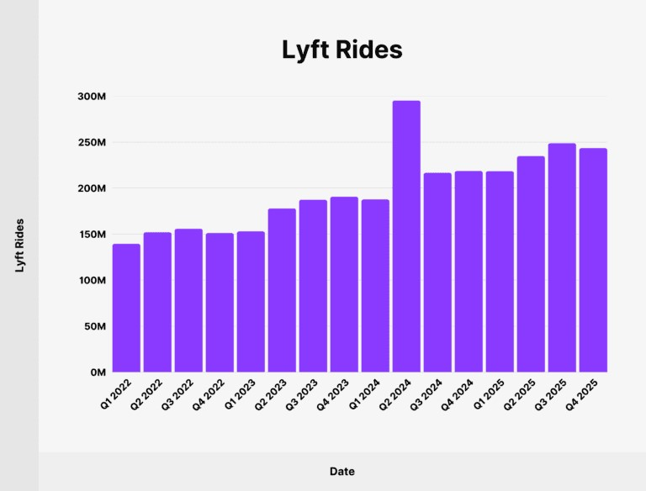
Figure 4: Statistics of Lyft Rides from 2022 to 2025 Source: (Dean, 2021)

Critical comparison: Uber is competing on scale and integration on the ecosystem, but Lyft is competing on differentiation and customer-focused value.
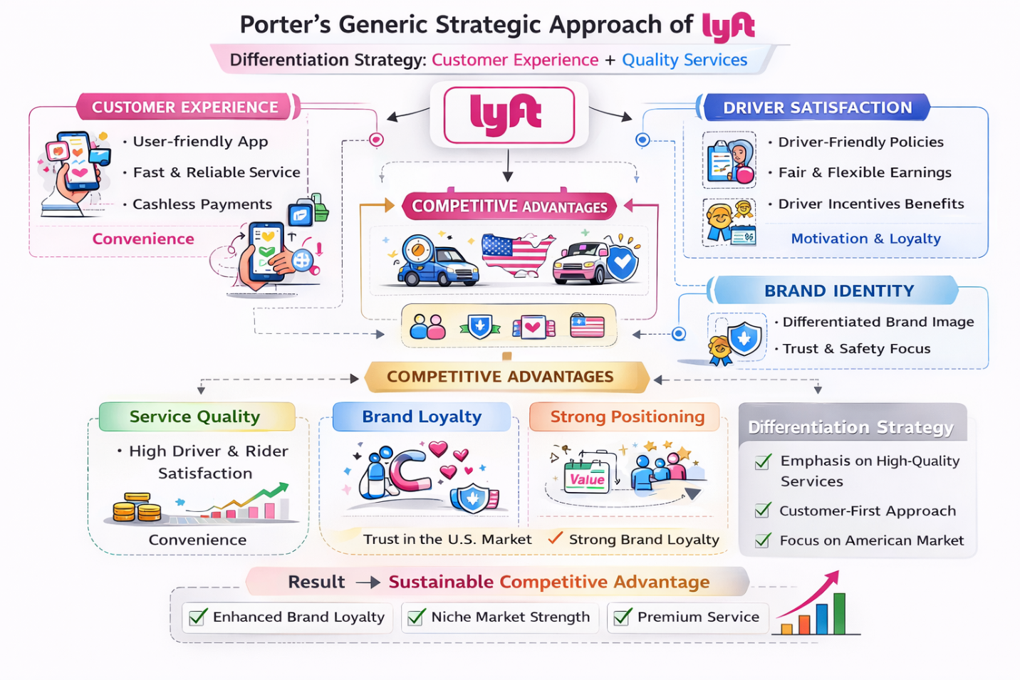
Figure 5: Porter Generic Strategic Approach of Lyft

5.2. Ansoff’s Growth Matrix

5.2.1. Strategic Response Comparative Evaluation of Uber:
The market development and diversification strategies of Ansoff are highly applicable in the growth strategy of Uber. The company has gone global with the presence in more than 70 countries and 15,000 cities, which is a clear indication of market development strategy (Statista Research Department, 2025).
Regarding diversification, Uber has been able to diversify beyond ride-hailing to food delivery and logistic services. Uber Eats has received over 12 billion in revenue alone in 2024, and Uber Freight continues to expand its platform to supply chain and logistics (Uber Annual Report, 2024). It is with this diversification that Uber can become a multi-service mobility platform, which would align well with the trends of urban mobility that focus on integrated and on-demand transportation (Chitla et al., 2023).
The Uber strategy takes the risk of regulation through geographic diversification and at the same time bolsters long term growth prospects with service diversification.

5.2.2. Strategic Response Comparative Evaluation of Lyft:
Lyft, on the other hand, is mostly pursuing the market penetration strategy, creating a presence in the cities of the United States. The expansion of the company is still focused on its main ride-sharing activity with 828 million rides and 44 million active users in 2024 (Lyft, 2025).
Lyft also depends on strategic partnership in its approach like the involvement of Waymo and Motional to gain access to the new technologies like autonomous vehicles. Although this enables Lyft to engage in innovation, it is not expensive as compared to internal development. Lyft though is also not diversified as much as Uber and it is still significantly able to rely on only one geographic market.
This geographic concentration also exposes Lyft more to policy changes in the United States and this means that the business model is more susceptible to policy changes..
Overall Insight: Uber has been in the aggressive, diversified, and expansion-driven strategy, which gives it the ability to have greater long-term competitive advantage, whereas Lyft has been in the focused, adaptive, and partnership-oriented strategy, which is stable but constrained in terms of large-scale growth opportunities.
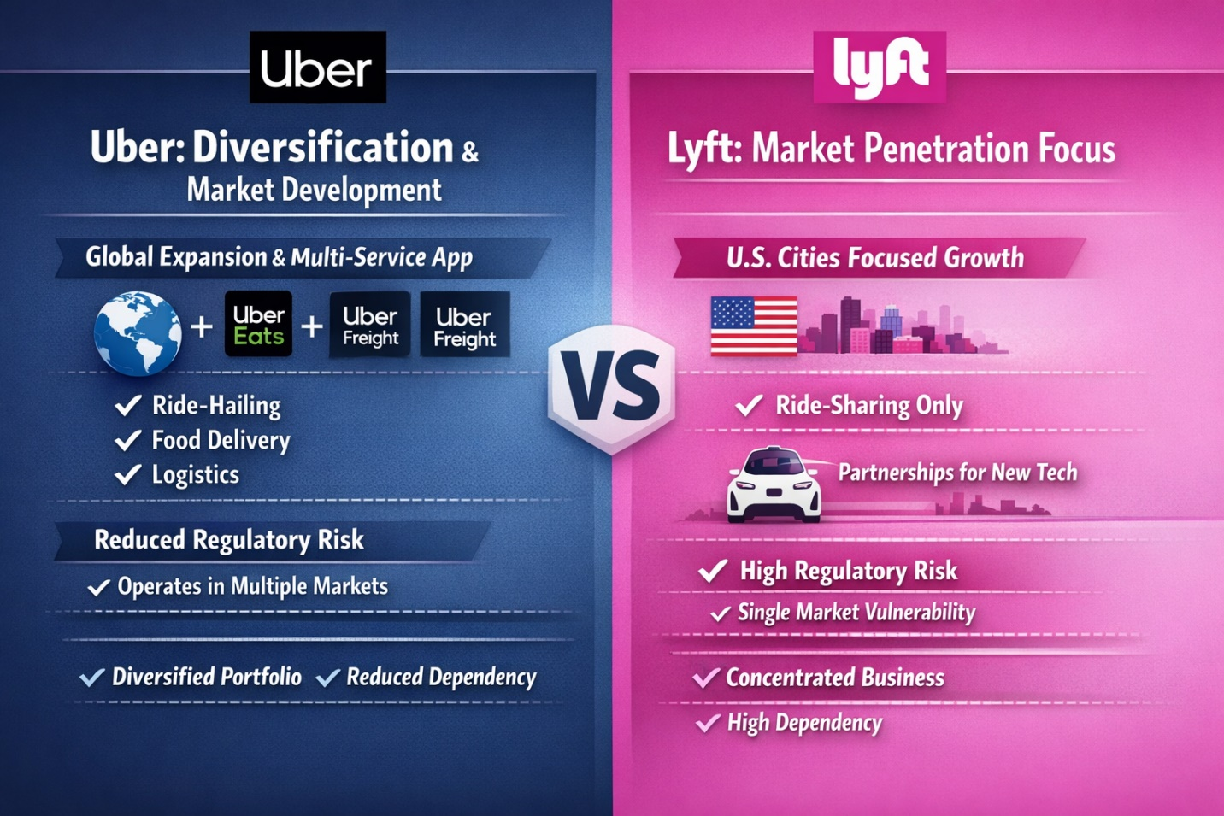
Figure 6: Ansoff Matrix Implementation of Uber & Lyft

5.3. Critical Comparison of Uber & Lyft:

Conclusion:
This report has shown that macro-environmental issues, especially legal regulation and trends in urban mobility have a strong influence on the strategy and competitive positioning of ride-sharing companies. Uber as a leader relies on global scale, diversification and innovation to reduce regulatory risks and its capacity to take advantage of the evolving mobility demands. Lyft, on its part, is narrow and flexible with a differentiation strategy in a small market portfolio. Uber has a stronger long-term competitive advantage whereas Lyft is competitive because it is niching and flexible in its operation.

Reference list
Chihara, M. (2021). Radical flexibility: driving for Lyft and the future of work in the platform economy. Distinktion: Journal of Social Theory, 23(1), pp.1–24. doi:https://doi.org/10.1080/1600910x.2021.1972324.
Chung, H.D., Zhou, Y.M. and Choi, C. (2024). When Uber Eats its own business, and its competitors’ too: Resource exclusivity and oscillation following platform diversification. Strategic Management Journal, 46(2). doi:https://doi.org/10.1002/smj.3659.
Davlembayeva, D., Abbas, R., Laffey, D., Michael, K. and Papagiannidis, S. (2024). The Current State and Future Trajectory of the Sharing Economy: A Multi-Stakeholder Perspective. [online] International Journal of Business Science and Applied Management. Available at: https://eprints.ncl.ac.uk/296745.
Dean, B. (2021). Lyft 2021 User and Revenue Stats. [online] Backlinko. Available at: https://backlinko.com/lyft-users.
Dubal, V.B. (2021). Economic Security & the Regulation of Gig Work in California: From AB5 to Proposition 22. European Labour Law Journal, 13(1), p.203195252110631. doi:https://doi.org/10.1177/20319525211063111.
Garud, R., Kumaraswamy, A., Roberts, A. and Xu, L. (2020). Liminal Movement by Digital Platform-Based Sharing Economy Ventures: the Case of Uber Technologies. Strategic Management Journal, 43(3), pp.447–475. doi:https://doi.org/10.1002/smj.3148.
Investing.com (2025). Uber Q1 2025 presentation: Revenue up 17%, profitability surges amid growth deceleration. [online] Investing.com India. Available at: https://in.investing.com/news/company-news/uber-q1-2025-presentation-revenue-up-17-profitability-surges-amid-growth-deceleration-93CH-4813604.
Iqbal, M. (2023). Lyft Revenue and Usage Statistics (2019). [online] Business of Apps. Available at: https://www.businessofapps.com/data/lyft-statistics/.
Isbah, M.F. (2022). Algorithmic Exploitation: Understanding Labor Process and Control among Ride Hailing Platform Workers. Journal Sosioteknologi, 21(2). doi:https://doi.org/10.5614/sostek.itbj.2022.21.2.5.
Lyft (2025). Lyft, Inc. [online] Lyft, Inc. Available at: https://investor.lyft.com/news-events/press-releases/detail/103/lyft-reports-record-q4-and-full-year-2024-results [Accessed 14 Mar. 2026].
Lyft Economic Impact Report (2024). Economic Impact Report. [online] Available at: https://s27.q4cdn.com/263799617/files/doc_downloads/2024/Lyft-Economic-Impact-Report-2024.pdf.
Market.US (2025). Ride-Sharing Apps Market. [online] Market.us. Available at: https://market.us/report/ride-sharing-apps-market/.
Naumov, S. and Keith, D. (2022). Optimizing the economic and environmental benefits of ride‐hailing and pooling. Production and Operations Management, 32(3). doi:https://doi.org/10.1111/poms.13905.
Robson, K. (2022). Differentiation and Positioning: Uber Versus Lyft. doi:https://doi.org/10.4135/9781529794014.
Sandeep Chitla, Cohen, M.C., Srikanth Jagabathula and Dmitry Mitrofanov (2023). Customers’ Multihoming Behavior in Ride-Hailing: Empirical Evidence from Uber and Lyft. Social Science Research Network. [online] doi:https://doi.org/10.2139/ssrn.4591826.
Seng, K.P., Ang, L.-M., Ngharamike, E. and Peter, E. (2023). Ridesharing and Crowdsourcing for Smart Cities: Technologies, Paradigms and Use Cases. IEEE Access, 11, pp.18038–18081. doi:https://doi.org/10.1109/access.2023.3243264.
Statista Research Department (2025). Topic: Uber Technologies. [online] Statista. Available at: https://www.statista.com/topics/4826/uber-technologies/?srsltid=AfmBOoqkRnKwPR4MJ4pr53hz-NDOJjMlG_WbEpySPZbXdpvdckp6pOmD [Accessed 14 Mar. 2026].
Stemler, A., Evans, J.W. and Shang, C.S. (2025). Data privacy and the regulation of ridesharing platforms. American Business Law Journal. doi:https://doi.org/10.1111/ablj.12259.
Taylor, T.A. (2024). Shared-Ride Efficiency of Ride-Hailing Platforms. Manufacturing & service operations management. doi:https://doi.org/10.1287/msom.2021.0545.
Tu, L. and Xu, M. (2024). An Analysis of the Use of Autonomous Vehicles in the Shared Mobility Market: Opportunities and Challenges. Sustainability, [online] 16(16), pp.6795–6795. doi:https://doi.org/10.3390/su16166795.
Valdez, J. (2022). The Politics of Uber: Infrastructural Power in the United States and Europe. Regulation & Governance, 17(1), pp.177–194. doi:https://doi.org/10.1111/rego.12456.
Widiastuti, N.O. and Irawan, M.Z. (2024). Ride-Hailing Preferences for First- and Last-Mile Connectivity at Intercity Transit Hubs. Sustainability, [online] 16(7), p.2927. doi:https://doi.org/10.3390/su16072927.
Yuan, J. (2024). The competition and comparison among travel service giants – a case study of Didi and Uber. CRC Press eBooks, pp.648–653. doi:https://doi.org/10.1201/9781003564966-97.
Zhang, J., Hasan, S., Yan, X. and Liu, X. (2021). Spatio-temporal mobility patterns of on-demand ride-hailing service users. Transportation Letters, pp.1–12. doi:https://doi.org/10.1080/19427867.2021.1988439.

