Industrial Placement
and Team Management

M5X02199
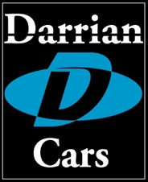

Darrian Logo
(Image source - http://www.darrian.co.uk/2015_darrian_t90gtr.html)

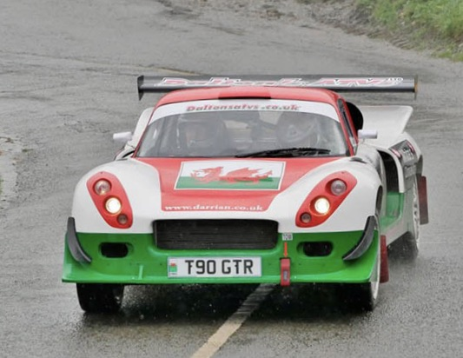

Darrian T90 GTR +
(Image source - http://www.darrian.co.uk/images/jd_gtr_wcr19.jpg)

By: Daniel Davies.
Student Number: 1801345.
Date commenced: 7th May 2019.
Duration of placement: 7 weeks.

Contents.

Section 1.0

Purpose and Introduction.

1.1 Purpose of assignment.

1.2 Introduction to Darrian.

1.3 Brief history.

1.4 Davrians through the years.

1.5 Current Car, Darrian T90GTR+.

Section 2.0
Work Placement Assignment. May 2019.
2.1 Business Model
2.2 Business Facts.

2.3. Staffing structure.

2.4 Premises.

2.5 Summary of workplace duties.

Section 3.0
Marketplace Factors.
3.1 Competitors / Threats.

3.2 Business Enhancements.

Section 4.0

Summary.

4.1 The type of work involved in.

4.2 Values of the placement towards personal development.

4.3 View on the motorsport industry as a career option.

4.4 Whether the placement made a positive contribution.

Appendices.
Appendix 1. Detailed Record of Activities.
Table 1. Diary, Week 1.

Table 2. Diary Week 2.

Table 3. Diary Week 3.

Table 4. Diary Week 4.

Table 5. Diary Week 5.

Table 6. Diary Week 6.

Table 7. Diary Week 7.

Appendix 2. Photographs.

Appendix 3. References. / Acknowledgements.

Section 1.0

Purpose and Introduction.

1.1 Purpose of assignment.

To gain an insight into the social and commercial context of the motorsport engineering industry.
A six-week work placement at Darrian Cars, Llangybi will provide the opportunity to experience a placement directly within the day to day happenings of the company. The assignment will investigate the history and background behind Darrian Cars, identifying its competitors and any business threats and enhancements. Together with the organisational structure, size and nature of the business. It will consider whether the placement will result in pursuing a future career within the industry and if it was felt that a positive contribution was made to Darrian Cars.

1.2 Introduction to Darrian Cars.
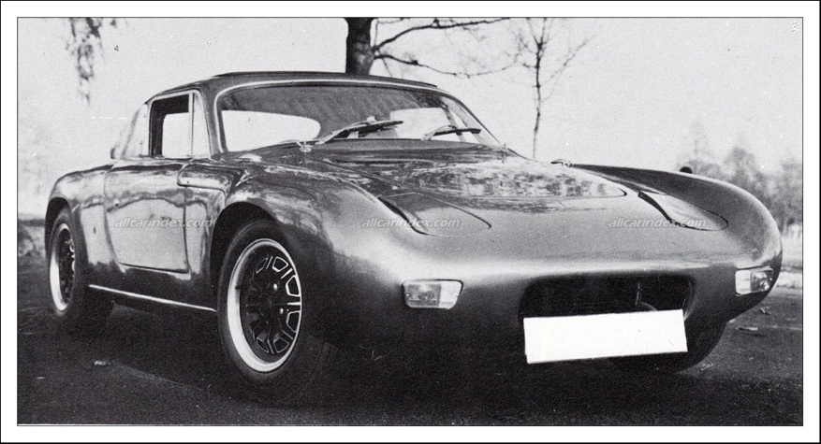

(Darrian line drawing courtesy of Davrian/Darrian Register. Image source:
http://www.john.rawlins.com/ndr1/wpimages/wp0_wp5f2613d2.png)

Darrian has been involved in the production of glass-fibre reinforced plastic competition cars for over thirty years with its origins as Davrian cars over fifty years ago. They have proved extremely successful in club rallying over the years and continue to do so.
Today, Darrians compete from club level racing and rallying to national level and the British GT Championships.
They are the sole Welsh car building company that has manufactured successful competition cars since 1986, with its roots as far back as the mid 1960s.
Launched in Clapham, London in 1965 as Davrian cars by Adrian Evans, the company began by building a limited number of sports cars for both road and race track. Based on Hillman Imp components and suspension. Moving production to Tregaron, Wales in 1976. Shortly taken over in the early 80s by the Corry Car Company who planned to produce an affordable and adaptable competition car. The name evolved into the Corry Cultra as production was transferred over to Lisburn, Northern Ireland with only a handful of cars being built.
Tim Duffee, a previous employee of Davrian, took over the helm in 1985 and Darrian cars were born. In 1986 the car was re-born as the Darrian T9 where it was considerably modified to become a lightweight fibreglass mid-engined monocoque construction. A formula which still exists today.
Under Duffee’s management, a Ford BDA Twin Cam powered Davrian with Geoff Kitney driving won its first outing on the Eppynt Stages Rally in mid Wales. The current car being produced at their Llangybi workshops is the T90GTR + and is used in club and national rallying, track racing and British GT Race Championship Events.

1.3 Brief history of Davrian/Darrian Cars.
Conceived in 1965/66, the very first car was designed and constructed for competition use by Adrian Evans, a structural engineer in London. Fabled as a replacement for a family owned Hillman Imp, which had been written off in an accident against a brick wall. The first car was an open top two seater sports car followed by 2 further plywood/fibreglass, with following designs changed to full fibreglass construction. Evans based his cars on a ‘curved and contoured interior mould or ‘tub’ attached to a very comprehensive and sturdy one piece undertray’. The bodyshell was strong and rigid which resulted in stiffness and taught handling. A design legacy which continues even in today’s Darrians.

The original cars utilised bog standard Hillman Imp front and rear suspension units, however later models changed over to using unique tailor-made swinging and trailing arms, which again continues even on today’s cars. The first series of cars were rear-engined where they were fitted with tuned and modified Imp engines/ transaxles. The later Mk7 and Mk8 cars were designed and adapted to being able to accommodate various suitable performance engine/gearbox options as requested or fitted by the individual customers.
The Davrian prototype was later raced in competition by both Evans and a colleague Robert Jarvis, with some success, resulting in wins from the beginning.

In the 70s and 80s Davrian Developments set up and ran its own works team and proved to be extremely dominant in both modsports and kitcar events. Achieving an outright victory in Modsports in 1974.

1.4 Davrian / Darrian models through the years.

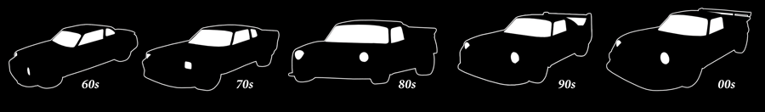

Davrian / Darrian Cars body profiles.

(Image source- http://www.darrian.co.uk/images/darrian_history_bar.png)

Davrian Prototypes; 1965 -67.

Number produced - 3.

Built purely as a hobby. Basic and simple spec.

Davrian Mk 1,2, and 3. ;1967-68. Open-top models. 1967-73.

Number produced - 39.

Difficult to identify marks 1 and 2 models. The Mk3 being the first car that can be identified with certainty.

Davrian Mk 4.; 1969-70.

Number produced - 39.

Considered as a serious business attempt rather than a hobby.

Davrian Mk5.; 1970-1973.

Number produced - 53.

The longest running production model so far. Considered as the first ‘quality’ Davrian.

Davrian Mk 6; 1973-74.

Number produced - 54.

The most attractive Davrian so far.

Davrian Mk 7; 1974-78. Davrian Imp saloon; 1974-78

Number produced - 46. Number produced – 15.

Offered with many power train options. Based on Imp / Mini components. Directly aimed at the competition car market. The basis of the ‘fabled’ one-off Davrian Imp saloon.

1.5 Current Car, Darrian T90GTR+.

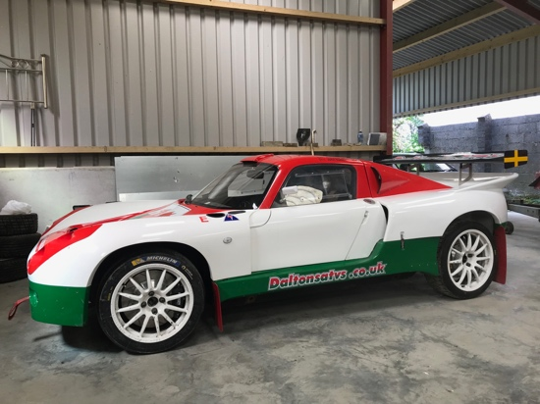
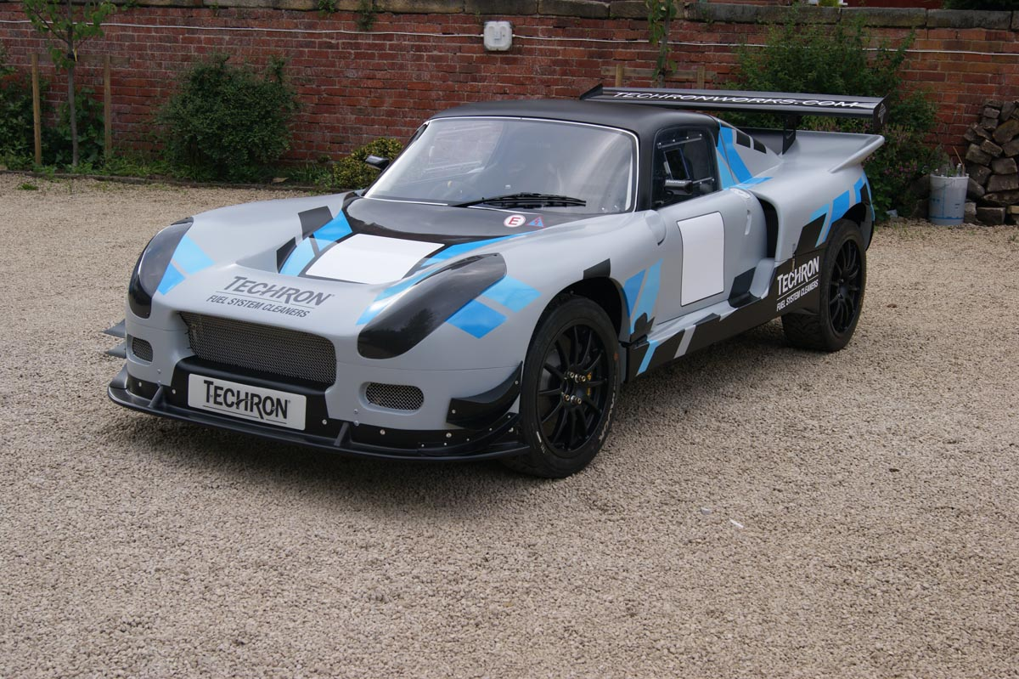

(Image source http://www.darrian.co.uk/2015_darrian_t90gtr.html)

The current 2019/20 model Darrian T90GTR+ is a 2 seater, mid-engine rear wheel drive car.

Available with a wide range of power units, the most popular being the robust Millington S2+ 2.5 litre engine. Rally spec 4cyl 16vProducing 300bhp @ 7,800rpm, 230lb/ft torque @6,500rpm.

Transmission is via a Hewland TMT 6 speed sequential transaxle unit with paddle gear shift. Coupled by an AP twin plate clutch with concentric release.

The chassis is a glass fibre reinforced monocoque construction. High strength composite tub with aramid/ carbon reinforcement. With an integral 45mm dia T45 roll cage built at Darrian Cars to full FIA spec.
Bodywork is restyled GTR+ with choice of splitters. With radiator guard, front skid and full underbody protection.
Seats are Motor drive or Tillet, to full FIA spec.
Available to a choice of specification from £80,000 + VAT.
(Info source: Darrian T90 GTR+ Promotional Literature)

2.0 Work Placement Assignment. May 2019.

2.1 Business Model
Davrian’s business model is the design, manufacture, retail and repair of competitive rally/race cars. By running their own ‘works Darrian’ at club level rallying they are able to promote the brand at ‘grass roots’ level.
Their fully in-house engineering capability enables them to adapt and re-engineer their cars to address motorsport's ever changing needs. Being the only car manufacturing company in Wales, they have achieved success due to their design uniqueness and motorsport pedigree. Celebrating their 50th anniversary in 2017, they have evolved into a brand synonymous with traditional hand-built craftsmanship and modern race-bred technology.
Based solely at Llangybi they also prepare, maintain and crash-repair customer’s cars as well as carrying out on-event servicing.
They also design and manufacture ‘one off’ commissions such as fibre glass body panels for other specialist manufacturers. In progress at the time of placement was the fabrication and supply of 10 sets of full body panels for 10 red Italian Alfa Romeo ‘Stradale’ project cars.

2.2 Business Facts.
Darrian’s success lies in its pedigree and fully in-house capabilities.
All Darrians are designed, fabricated and built exclusively at Llangybi.
During the work placement, they were working on completing 4 new cars. They are geared at building 4 cars at any one time with the most cars Darrian being built in one year being 14.
They repair, rebuild and service an average of 3 to 4 customer cars and 2 special commissions a month. Repair bills can vary between £3k to £25K.
Although no figures were made available at the time of placement it is estimated that the company has an average turnover above £800k.
This estimate is based on; Building 4 new cars @ £100k avg (=£400k).
Repairing/servicing 40 cars @ £10k avg.(=£400k).
2 special commissions @ £12k avg. (=£24k).

The most cars they have had out on a single rally is 13, which was on the Tour of Cornwall 2019. With the most Darrian rally cars, out in one weekend of rallying being 17 entries.
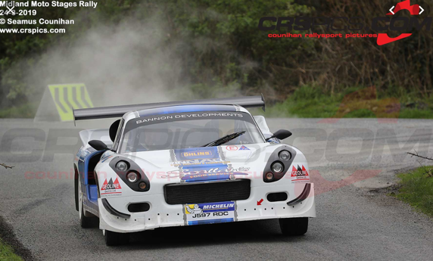
This was on the 8/9th Sept 2019 where they had: -
8 cars on Rali Bae Ceredigion. 5 cars on the Promenade stages.
2 cars on the 3 shires rally. 2 cars on the Wexford Rally
Resulting in: -
1st O/A on the Wexford Rally
2nd O/A on the 3 Shires Rally
3rd O/A on the Promenade stages
Darrian’s future orders rely on the race and rally results of their products. Similar to why manufacturers get involved in Formula 1, where ‘wins’ sell cars. Other than using social media and attending promotional events such as the “Motoring at the Manor” Darrian Cars’ main mode of advertising is the performance of their own cars.
2.3 Staffing structure
James Stafford and Jeff Case 1st O/A in Wexford Rally
3 Management staff members.
2 Full time staff members.
1 part time staff member.
The family-run and owned business is based around Tim Duffee, Mrs Duffee and Rhodri Duffee. With two full time mechanics and one part time mechanical engineer.
Tim Duffee is passionate about Darrian Cars and is responsible for the success that the business has accomplished. Adopting a ‘hands-on’ approach where even at 70 years old, he often works a 70-hour week.
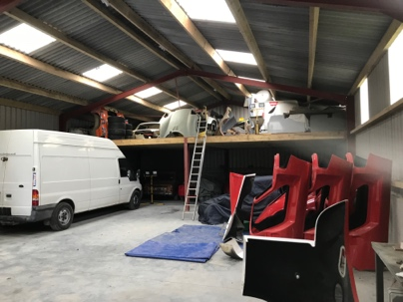
2.4 Premises
The facilities exist behind an ordinary agricultural setting with the workshops based at the rural farm of Nantglas, near the village of Llangybi.
Located on a minor road off the A485 between Tregaron and Lampeter. Access to services and main transport ‘corridors’ are poor due to the distances involved and the lack of motorways/dual carriageways nearby. Access to the important Irish Tarmac rally market place being via the ports of Holyhead, Fishguard or Swansea.
Bottom shed for storage
The M4 corridor is 40 miles, (approx 1 hour) away, Fishguard Port is 50miles (1hour 20mins) , Holyhead Port is 128 miles (3hours+) and the Swansea Port is 56 miles (1.5hrs) away.

Within the normal farm premises are the more modern interiors of fully equipped workshops.
Workshop 1. Fully fitted and tooled. The main prep/assembly room together with a metal/fabrication workshop.
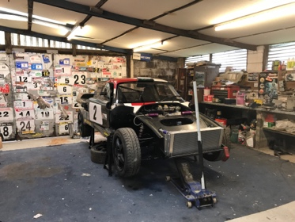
Workshop 2. Lathe room. Contained within a small barn/workshop.
Workshop 3. Fibreglass shop. Housed within the loft area of an old barn.
Storage Room. Housing parts, stock, tools and equipment.
Storage Building/future workshop. Modern, recent storage building for workshops.

Within the walls of seemingly ‘innocent’ farm buildings, exciting new competition cars are manufactured. Darrians of different ages come back to be serviced and repaired and even older Davrians return to be rebuilt, and reborn. It was interesting to learn from Tim Duuffee that over 95% of the cars built are used solely for motorsport competition purposes.

2.5. Summary of workplace duties.
(A fully detailed diary is included in Appendix 1.)

The very first task of the first day was to carry out the removal of the rear bumper of the ‘works’ competition Darrian T90 GTR+. The car had suffered damage during an ‘off’ on a recent Irish rally. As the weeks continued, and as my capability and confidence increased more detailed and responsible duties were entrusted and carried out.

Duties carried out in week 1 ranged from basic prep and removal of suspension parts. Brake assemblies. Roll cage. Refitting brake discs and workshop “housekeeping” duties.

Duties carried out in week 2. Included disassembling and removing complete rear end assembly and suspension. Cutting metalwork. Welding. Assembling components and adjustment of shock absorbers and springs. Cutting profile shapes in sections of tubing to create wishbones. Prep and painting of Alfa Romeo ‘Stradale’ panels.

Duties carried out in week 3. Removing/refitting road wheels. Fitting seats/belt harnesses. Assisted to fabricate trailing arms. Folding and formed metal to make up trailing arms. Preparing trailing arms in jig ready for welding. Removal of bodywork sections. Folding blank metal pieces to create section of the trailing arms. Positioning of templates, and cross-drilling ventilation holes in brake discs. Fitting body panels. Sand blasting brackets and mountings. Damaged-repairing suspension wishbone. Painting ‘Stradale’ panels.

Duties carried out in week 4. More intricate, detailed and responsible duties.
Removing road wheels and damaged body panels, sump-guard brackets and top wishbone arm. Examining brake callipers and discs for inspection ordering new pads. Fitting a new steering rack into position. Removed front centre hub carrier assemblies. Chiselling out/remove wheel bearings. Cleaned down hubs, checking over and press-fitting new bearings. Fitted brake callipers back on to hub carrier and torqued bolts. Assembling disc brakes / callipers together in vice. Fitting hub carriers to rear arms and torque up bolts. Fitting front bumper mounting. Sandblasting steering brackets.
Removing rear quarter-bumper out of mould. Cleaning and washing rear trailing arms. Sanding down/cleaned with gun wash various components such as; bottom wishbones, steering plate and steering bracket. Prepared and primer painted all items and finished off with satin black acrylic paint.

Duties carried out in week 5. Duties now include torqueing bolts and welding.
Removing wheels, disconnecting brake pipes and removing brake callipers. brake pads/cleaned up callipers. Refitting top mounts. Replacing brake discs, pads and new callipers / torque bolts (75Nm). With assistance, fitted steering plate underneath car. Fitted/connected battery, anti-roll bar and torque up bolts to wishbones. Securing front bumper mounts. Practice TIG welding in the workshop with Dafydd. Fitted new front bumper panel. Fitted new fire extinguishers and brake pads torqued bolts (75Nm), attaching lock wire. Straightening and pressure-washing front radiator. Testing and repairing damaged areas with solder. Fitting new fuel tanks on new Darrian shell, bulkhead panel, fuel tank and bonding into position. Marked up and cut out bars for wishbones with disc cutter. Setting up drill equipment. Bending bars to angle and stored as stock items. Assisting Dafydd to make up top wishbones.
Preparing and spray painting bumper/bonnet panels. Sandblasted metal brackets. Prepared parts for making up wishbone on jig. Helping Tim Duffee in repair to inside of bumper with bonding resin.
(Meeting with Abigail Summerfield and Tim Duffee for progress meeting.)
Setting up jig, preparing and cutting out 2 middle sections for suspension wishbones.

Duties carried out in week 6. Now assisting the inspection of a Hewland Gearbox.
Removing rear bumper and jacked up car onto stands. Helped Tim Duffee to drain off gearbox oil and removed top cover, assisted in carrying out an inspection and dismantling of gearbox. Fitting and connecting headlights electric harness to bumper. Cutting out 31-degree central recess and making up new sections for top wishbones. Removing and refitting road wheels. Carried out final pre-delivery checks and loaded car on to trailer. Helping Tim Duffee to fibreglass fuel tank cover panels. Fitting bulbs in indicator lamp assembly and clips to hold wiring loom. Fitted front grille. Helped Tim Duffee to bond fibreglass mount
Sandblasted, degreased and primer painting.

Duties carried out in week 7. Assisting T.Duffee in dismantling gearbox.
Fitting new brake pads, helping T.Duffee to bleed brakes. Fitting new ‘N’ plate to mount aerofoil/spoiler. Draining gearbox oil Assisted Tim Duffee in dismantling and examining gearbox. Removed and replaced new idler shaft. Cleaned gear selector forks. Fitted mud flaps, rear reflector and o/s/r lamp unit to works Darrian. Helped Tim Duffee to wire up. Observed/assisted Tim Duffee in reassembling the gearbox of the ‘works Darrian’ and check operation/carry out computer diagnostic check. Fitted rear end to ‘works’ Darrian.
Assist in measuring corner weights and adjusted dampers all round. Fitted mudflaps to works Darrian. Checked over car.
Prepared and packaged up new front bumper panel ready for delivery to customer. Prepared and sprayed black acrylic paint to inside of repaired bumper
Cleaned mud off rear wheel arch. Tidied up workshop.

Other duties. Attended ‘Motoring at the Manor’ motorsport day at Newport. (Sun 16th).
Visited Gelligarneddau Farm (Sun 23rd) to attend the shakedown and testing session of both the Huw Reed Darrian T90 GTR and the ‘works Darrian’ driven by John Dalton.

3.0. Marketplace Factors.
3.1 Competitors / Threats.
Darrian Cars is a specialist company. Directly involved in the design and manufacturing of components, partially built and complete brand new rally bred competition cars, dependent on customer’s requirements. It is also involved in the retailing of used competition bred race cars as well as preparing, maintaining and crash-repairing customer’s cars and carrying out servicing on motorsport events both nationally and internationally.
It may seem that while the business does not have any direct competitors, it may possibly suffer from a limited amount of ‘indirect competition’ from organisations such as;
Viking Motorsport. 44 Mochdre Ind Est, Newtown, Powys.
Established in 2008. Viking Motorsport specialises in building and preparing Group 4 Ford Escort Mk 2s. Offering full on-event services.

Scott Williams Motorsport, Lampeter, Ceredigion.
Established in 2016 by the Professional Welsh Rugby player. SW Motorsport specialises in the preparation of Ford Escort of all ages, at all levels of trim and spec. Offering pre-event prep, testing and full on-event services.

M-Sport Ltd. Dovenby Hall, Cockermouth, Cumbria. Lake District.
Established in 1997 by expert rally driver Malcolm Wilson. M-Sport is the largest of any such organisation and operates at a global level in rallying and racing. Originally specialising in Ford Escorts and Fiestas the company now provides race expertise to Bentley with the GT3. M-Sport offers competitive Fiesta R1, R2 and R5 packages at clubman level. With over 250 cars currently being campaigned.
Although the above three organisations offer rally prepared cars way above the £100k mark, they do so using other ‘main stream’ manufacturers cars. With the M-Sport Fiestas cosing from £250k - £500k. Unlike Darrian Cars, who offer a fully bespoke service on its own unique cars and products with prices pitched below £100k.
It is difficult to identify any other threat to the organisation. The company is wholly owned, managed and run as a family business. Tim Duffee concentrating on manufacturing/repairs. Mrs Duffee on accounts and admin and Rhodri Duffee on marketing/promotion.

3.2 Business Enhancements.
To quote the words of Tim Duffee at ‘Motoring at the Manor’, during a promotional PR car show event held the grounds of The Celtic Manor Hotel.
“It’s not what goes on here that sells our cars, it’s what’s going on five miles down the road in the forests.”
Quote - Tim Duffee, June 2019.
Whilst showcasing their cars at The Celtic Manor, the Caerwent Stages Rally was taking place nearby. 5 Darrian T90s were entered, resulting in class positions for three cars.
One of Darrian’s business enhancement is that it rallies its own T90GTR+ and therefore promotes the brand at ‘grass roots’ level. It’s in-house engineering facility can adapt and re-engineer very competitive cars quickly.

Their Facebook page constantly provides reports and feedback of event entries and results relating to Darrian owners.
The New Davrian Register, although not run by Darrian Cars, established in 1993 provides a central point for owners and enthusiasts and offers a valuable promotional ‘tool’ for Darrian Cars. The register currently lists 200 owner/members.

4.0. Summary.

4.1 Values of the placement towards personal development.

The work placement provided the opportunity to experience how a specialist competitive rally car is created, built and prepared for competition. To have actually experienced working at the birthplace of such a legendary rally car as the Darrian was something that would be remembered for quite some time. Even more so, to having the opportunity to assist the legendary Tim Duffee to rebuild a Hewland sequential gearbox was amazing. As was the experience of working on customer’s cars ‘real’ competition cars. The placement has greatly helped towards my personal development. It has provided the opportunity of being part of a team as well as being left to carry out tasks such as dismantling and re building brake assemblies. The experience has helped to develop not only mechanical skills but also interpersonal and ‘people’ skills.

4.2 View on the motorsport industry as a career option.

To witness first hand of how an organisation such as Darrian works was an amazing experience. To discover at grass roots level what drives the company and how the success of Darrian rally cars can not only bring in orders for brand new cars but make the brand popular has strengthened the wish to seek a career within motorsport. The placement provided an insight into the challenges and excitement of being part of a team that produces rally winning cars.

The placement has further strengthened the desire to choose the motorsport industry as a career option. Following this, an Accredited Marshall status (Motorsport UK) has been attained with a view towards attaining Motorsport Scrutineer status.

4.3 Whether the placement made a positive contribution to Darrian Cars.

The placement gave the valuable opportunity to be involved in virtually every aspect of creating a Darrian. The cutting of profiled pieces from a blank metal sheet to create a trailing arm, preparing and painting fibreglass panels and dismantling and rebuilding the AP brakes provided the opportunity to make a positive contribution.

This was possibly confirmed when Tim Duffee asked if it was possible to extend the period for an additional week. To assist in the final preparation of the ‘Works’ Darrian T90 GTR+ driven by John Dalton. The car exact car would be competing in a forthcoming Irish Tarmac Rally. This request provided the feeling that a positive contribution had been made.

Following on from the placement an invitation was offered to attend the Darrian stand at the ‘Motoring at the Manor’ event in Newport and also attend a practice test session of the ‘Works” Darrian at John Dalton’s farm. Both offers were gratefully accepted and turned out to be interesting and exciting experiences.

l

Appendices.

Appendix 1. Detailed Record of Experiences/Activities. (Log Sheets)

HND Automotive/Motorsport – Industrial Experience
Log Sheet (Record of Experiences/Activities)

Name: Daniel Davies Placement Provider: Darrian Cars

Table 1. Week Number: 1 (7th – 10th May)
Tues – Fri 8.30 – 5.30
Date. Experience. | Experience / activities. Summary description/details.
Tues 7th  Workshop.  Weds 8th.  Workshop.  Thurs 9th  Workshop.  Fri 10th  Workshop. | Welcomed with a familiarisation of engineering workshops, set up, procedures, equipment and cars worked on.  Instructed on and carried the removal of the rear bumper of the ‘works’ competition Darrian T90 GTR+.  Removed wheel studs from brake discs/hubs.  Sandblasted suspension parts and brackets. Cleaned with ‘gunwash’. Finished with emery cloth. Prepared and applied lacquer coat.  Prepared and sanded down lower and upper suspension wishbones and applied primer. Prepared and sandblasted cockpit components and brackets. Removed brake calipers and replaced disc brakes. Detached discs and floating hub assemblies. Cleaned hubs in parts washer and finished off on lathe. Cleaned ‘torque screws’ with gunwash. Replaced new disc brakes.  Prepared roll cage ready for bonding to fibreglass body / ‘tub’.  Prepared and sanded down suspension wishbones and applied primer. Prepared and sandblasted mounting arms and brackets. Cleaned components in parts washer.

Appendix 1. (cont.) Record of Experiences/Activities. (Log Sheets)
HND Automotive/Motorsport – Industrial Experience
Log Sheet (Record of Experiences/Activities)

Name: Daniel Davies Placement Provider: Darrian Cars

Table 2. Week Number: 2 (13th – 17th May)
Mon – Fri 8.30 – 5.30
Date. | Experience / activities. Summary description/details.
Mon 13th  Workshop.  Tues 14th  Weds 15th.  Workshop.  Thurs 16th  Workshop.  Fri 17th  Workshop. | Worked on Darrian works rally car. Sanded, rubbed down, prepared and primer-painted sub-frame brackets and steering rack mounting plates.  Disassembled and removed complete rear end assembly – rear suspension, engine mounts and subframe. Stored all parts in order. Tidied up and covered car.  (Orthodontist appointment - Clydach, Swansea.)  Sanded and rubbed down inner surfaces of front and rear body panels of 3 sets of the Alfa Romeo ‘Stradale’ project cars. Blew over with air-line. Cleaned and spray-painted with Satin Black Acrylic paint. Washed and cleaned off overspray with gunwash. Moved panels for safe storage.  Washed down and cleaned rally car tarpaulins. Primer painted metal brackets (x3). Sandblasted, gunwashed and cleaned. Primer painted mounting plates. Assisted Dafydd in the welding of reinforcement plates on to roll cage.  Assembled and adjusted shock absorber and springs of both n/s and o/s struts and fit to works Darrian. Pressure washed front bumper on customer’s Davrian Mk8. Sanded down and gunwashed roll cage, prepared, masked-off and primer painted.  Prepared, marked up, cut and drilled out with special tooling on pillar drill profile shapes in sections of tubing to create wishbones for lower suspension.  Cut away using pillar drill and special tooling, sections for making up suspension wishbones. Cleaned off rubber seal from scuttle panel and hoovered up mess. Sanded down gearbox and engine mounts and applied grease for protection. Sandblasted both rear trailing arms, cleaned off with ‘gunwash’ and finished off in primer paint.

Appendix 1. (cont.) Record of Experiences/Activities. (Log Sheets)
HND Automotive/Motorsport – Industrial Experience
Log Sheet (Record of Experiences/Activities)

Name: Daniel Davies Placement Provider: Darrian Cars

Table 3. Week Number: 3 (20th – 24th May)
Mon – Fri 8.30 – 5.30
Date. | Experience / activities. Summary description/details.
Mon 20th  Workshop.  Tues 21st  Workshop.  Weds 22nd  Workshop.  Thurs 23rd  Workshop.  Fri 24th  Workshop. | Cleaned and sprayed with primer the damaged-repaired part of the suspension wishbone on the works Darrian car. Positioned, aligned and rivetted the rear back quarter panel. Bolted road wheels on to car. Sanded down roll cage arms, cleaned with gunwash and applied coating of material to prevent corrosion.  Rubbed down and cleaned off adhesive from around roof air-vent ‘scoop’ of works Darrian. Hoovered, cleaned inside and fitted bucket seats and seat belt harnesses. Sandblasted brackets and mountings. Cleaned engine and gearbox housing with ‘Fix-it 400’.  Finished cleaning and jacked up works Darrian. Removed axle stands and lowered car on to wheels. Guided car out of workshop. Jacked up car and pressure washed underneath. Cleaned up and hoovered workshop mats used under car.  Helped Dafydd in workshop – drilled end sections and grooves of fabricated trailing arms. Folded and formed sheet metal to make up trailing arms. Prepared and placed trailing arm in jig ready for welding.  Stripped down front bumper section of customer’s Darrian GTR+. Took damaged end to clean with Upol. Cleaned damaged front bumper of works Darrian. Folded blank metal pieces that form into an ‘arm’ section of the trailing arms. Sand blasted small brackets. Set and positioned templates, and cross-drilled ventilation holes in sets of brake discs.  Marked out, attached template and cross drilled vent holes in last brake disc. Removed front bumper from T. Rees’s Darrian GTR+. Removed damaged front inner valance panel. Sandblasted and taken to workshop for Dafydd to weld on new section. Sandblasted and cleaned with ‘gun wash’. Applied primer, then painted with acrylic satin black. Fitted bottom half of front bumper to customer’s Davrian Mk8.  Sanded down trimmed side of Alfa Romeo Stradale rear body panel and apply satin black paint.  Painted front Stradale panel with satin black paint. Generally tidied up workshop.

Appendix 1. (cont) Record of Experiences/Activities. (Log Sheets )
HND Automotive/Motorsport – Industrial Experience
Log Sheet (Record of Experiences/Activities)

Name: Daniel Davies Placement Provider: Darrian Cars

Table 4. Week Number: 4 (28th – 31st May)
Tues – Fri 8.30 – 5.30
Date. | Experience / activities. Summary description/details.
Mon 27th  Tues 28th Workshop.  Weds 29th  Workshop.  Thurs 30th  Workshop.  Fri 31st  Workshop. | (Bank Holiday.)  Jacked up T. Rees’s Darrian GTR+ and removed wheels. Helped to move the Stafford Darrian GTR into workshop. Jacked up and removed wheels. Dismantled and removed damaged body panels. Removed sump-guard and brackets. Removed top wishbone arm.  Helped move chassis from top floor to ground floor of Laminating workshop.  Cleaned and masked off sill mould. Removed rear quarter-bumper out of mould. Tidied up and stored away tools.  Jacked up T. Rees’s Darrian GTR+ and removed front wheels. Cleaned, sanded down and washed rear trailing arms. Sanded down and cleaned with gunwash various components such as; bottom wishbones, steering plate and steering bracket. Prepared and primer painted all items and finished off with satin black acrylic paint. Tidied up workshop.  Dismantled and removed front brake calipers and brake discs from Darrian GTR+. Took brake discs to workshop for inspection and clean down. Examined and checked over brake calipers and brake pads for wear. Ordered new brake pads. Sandblasted steering brackets, prepared and painted with primer. Fitted new steering rack into position. Removed front centre hub carrier assembly. Chiselled out and removed wheel bearings. Cleaned down hub, checked over and pressed new bearings into position. Fitted brake calipers back on to hub carrier and torque bolts. Tidied up workshop and put away tools. Cleaned down and sandblasted brackets. Helped Tim to move front bonnet of works Darrian GTR+ to lower workshop.  Assembled disc brakes and calipers together in vice. Fitted hub carrier to rear arm and torqued up bolts. Fitted disc brakes and caliper on to Darrian. Fitted front bumper mounting. Cleaned, sanded down and prepared upper wishbones. Applied primer and painted in acrylic black. Prepared and painted spacers and steering plates. Tidied away tools and equipment.

Appendix 1. (cont.) Record of Experiences/Activities. (Log Sheets)
HND Automotive/Motorsport – Industrial Experience
Log Sheet (Record of Experiences/Activities)

Name: Daniel Davies Placement Provider: Darrian Cars

Table 5. Week Number: 5 (3rd – 7th June)
Mon – Fri 8.30 – 5.30
Date | Experience / activities. Summary description/details.
Mon 3rd  Workshop.  Tues 4th ^{Workshop}.  Weds 5th  Workshop.  Thurs 6th  Workshop.  Fri 7th  Workshop. | Removed wheels from the works Darrian GTR+. Disconnected brake pipes and removed brake calipers. Removed brake pads and cleaned up calipers. Use the n/s caliper to replace broken caliper on Staton’s Darrian. Refitted top mount back onto car. Replaced brake discs, brake pads and new brake calipers on to Darrian and torque bolts to 75Nm. With assistance, fitted steering plate underneath car. Fitted and connected battery back on to car. With assistance fitted anti-roll bar and torqued up bolts to wishbones. Tidied up tools in the bottom workshop. Tidied up top workshop and hoovered up.  Secured front bumper mounts. Prepared and spray painted the spare front bumper/bonnet panel to fit to Staton’s car. Cleaned off overspray with ‘gunwash’. Met up with Abigail Summerfield and Tim Duffee for progress meeting. Sandblast metal brackets. Set up jig, prepared and cut out 2 middle sections ready to make up suspension wishbones. Practice TIG welding in the workshop with Dafydd. Prepare and primer paint lower mounting brackets for front bumper/bonnet panel.  Fitted new spare front bumper panel on to the Staten Darrian GTR. Fitted new fire extinguishers and brake pads on to Tony Rees’s Darrian, torqued bolts up to 75Nm and attached lockwire. Helped to put car on to trailer. Prepared parts for making up wishbone on jig. Clean and sandblast mounting brackets and plates.  Cleaned up and hoovered workshop floor. Removed bracket off damaged part of the front bumper of Tony Rees’s Darrian. Straightened and pressure-washed front radiator. Pressure tested radiator for leaks and repaired damaged areas with solder. Pressure tested again to check repairs. Fitted two fuel tanks either side of new Darrian shell. Fitted bulkhead panel against the tank and bonded into position.  Retrieved O/S front corner bumper from trailer. Replaced rusted bolts with new. Prepared and spray painted satin black acrylic to inside of front bumper of Tony Rees’s Darrian. Cleaned off overspray with gunwash. Helped Tim Duffee in repair to inside of bumper with bonding resin. Hoovered and cleaned up workshop. Assisted Dafydd to make up top wishbones. Sandblasted brackets. Marked up and cut out bars for wishbones with disc cutter. Setted up drill with 32 degree and 5 degree offset for 400mm bar and 0 degree offset for 355mm bars. Bent bars to angle and stored as stock items.

Appendix 1. (cont) Record of Experiences/Activities. (Log Sheets )
HND Automotive/Motorsport – Industrial Experience
Log Sheet (Record of Experiences/Activities)

Name: Daniel Davies Placement Provider: Darrian Cars

Table 6. Week Number: 6 (10th – 14th June)
Mon – Fri 8.30 – 5.30
Date. | Experience / activities. Summary description/details.
Mon 10th  Workshop.  Tues 11th ^{Workshop}.  Weds 12th  Workshop.  Thurs 13th  Workshop.  Fri 14th  Workshop. | Sandblasted, degreased and primer painted new top front wishbone. Left to dry before packing for parts stock. Cleaned rear end of engine bay on the T.Rees Darrian. Cut out 31-degree central recess and made up new sections for 3 top wishbones and bent to shape, checked and aligned as necessary on the jig. Sandblasted sets of door hinges. Carried out a general tidy up. Fitted wheels back on to the T. Rees Darrian.  Cleaned and prepared the T.Rees Darrian and sprayed maintenance liquid to inside of front and rear lower bumpers, engine bay and inner wheel arches. Cleaned footwells and inside of car with ‘gun wash’. Removed rear bumper and jacked up car onto stands. Helped Tim Duffee to drain off gearbox oil and removed top cover, drained off the remaining oil and assisted in carrying out an inspection and dismantling of gearbox.  Carried out final pre delivery checks on T.Rees Darrian before loading on to trailer ready for collection. Tidied up workshop. Fitted brackets on to the works Darrian front bumper. Prepare and spray paint black acrylic to inside of front bumper. Fit bulbs. Hoover carpet in workshop.  Helped Tim Duffee to bond fibreglass mount to ‘works’ Darrian. Fitted and connected headlights electric harness to bumper. Assembled bodywork mount on jig. Sanded down front bumper. Cleaned, prepared and sandblasted brackets. Tidied up workshop.  Helped Tim Duffee to fibreglass fuel tank cover panels to the rear of a ‘new build’ Darrian. Prepare and spray painted repaired section of the bumper of ‘works Darrian’. Drilled out hole for and fitted indicator lamp assembly. Fitted ‘P’ clips to hold wiring loom into place. Fitted front grille into place.

Appendix 1. (cont.) Record of Experiences/Activities. (Log Sheets)
HND Automotive/Motorsport – Industrial Experience
Log Sheet (Record of Experiences/Activities)

Name: Daniel Davies Placement Provider: Darrian Cars

Table 7. Week Number: 7 (Requested by T. Duffee.16th – 21st June)
Sun – Fri 8.30 – 5.30 Sun 23rd pm.
Date | Experience / activities. Summary description/details.
Sun 16th  Event.  Mon 17th  Workshop.  Tues 18th Workshop.  Weds 19th  Workshop.  Thurs 20th  Workshop.  Fri 21st  Workshop.  Sun 23rd  John Dalton’s Farm. | Attended ‘Motoring at the Manor’ motorsport day at Newport. Visited the Darrian stand to view how they marketed themselves during a public event. Displaying a total of 5 cars, both current and historic and participating in demonstration runs on a rally stage.  Fitted new brake pads on the Dalton “works” Darrian after applying copper grease to backs of pads. Help T.Duffee to bleed brakes. Collected rear body section from laminating shop to workshop. Cleaned mud off rear wheel arch with ‘gun wash’. Prepared and packaged up new front bumper panel ready for delivery to customer. Fitted new ‘N’ plate to mount aerofoil/spoiler. Paint ‘N’ plate. Tidied up workshop.  Prepared and sprayed black acrylic paint to inside of repaired bumper. Removed overspray with ‘gun wash’. Tidied up workshop. Drained gearbox oil from customer’s Darrian. Assisted Tim Duffee in dismantling and examining gearbox. Removed and replaced new idler shaft. Cleaned gear selector forks.  Fitted mud flaps to works Darrian. Fitted rear reflector and o/s/r lamp unit. Helped Tim Duffee to wire up. Polished and buffed driver’s door. Prepared and sanded down sets of both upper and lower wishbones. Cleaned with ‘gun wash’ and sprayed with primer. Unpacked 3 rads to dry out. Cleaned and tidied up.  Fitted rear end to ‘works’ Darrian. Assist in measuring corner weights and adjusted dampers all round. Fitted dowel and new clip to the rear end. Help to move 2 Darrian body shells around to carry out bonding on one of them.  Observed and assisted Tim Duffee in reassembling the gearbox of the ‘works Darrian’ and then running through the gears to check to check if it runs ok. Helped to carry out computer diagnostic check and help with preparing the car for the forthcoming Irish rally event. Carried out general tidy up.  Visited Gelligarneddau Farm to attend the shakedown and testing session of the Huw Reed Darrian T90 GTR and the ‘works Darrian’ driven by John Dalton. Both cars driven competitively on a test road and I was fortunate to be taken for a test run by John in the works Darrian GTR+…Wow!
Appendix 2.
Photographs.
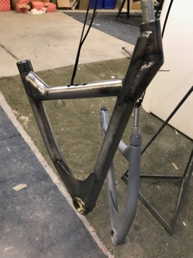
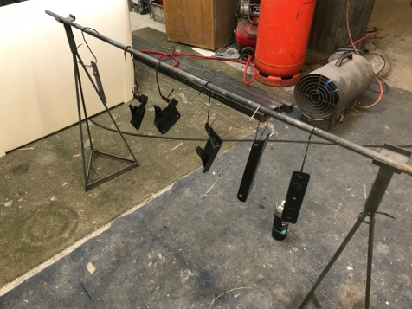
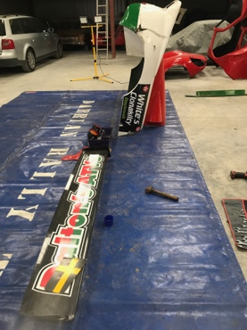
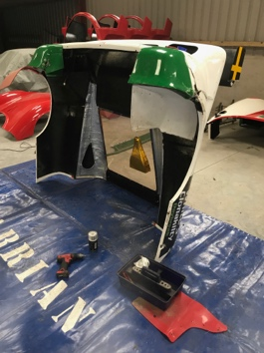
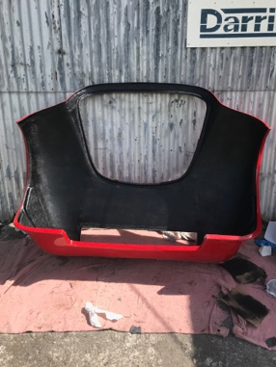
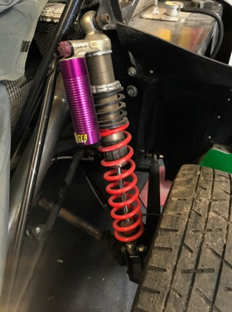
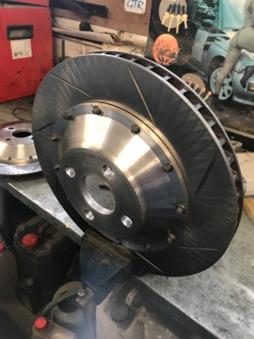
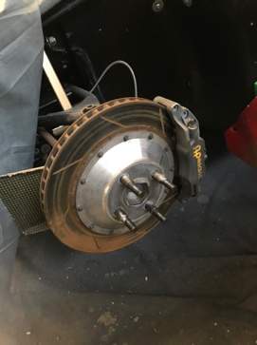

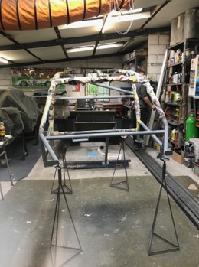
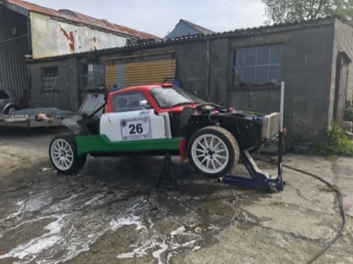
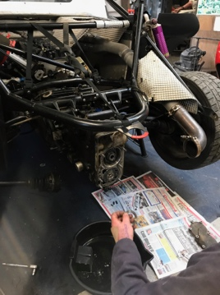
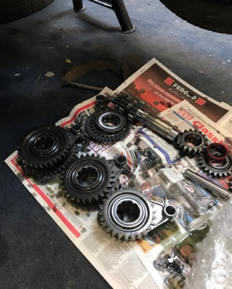

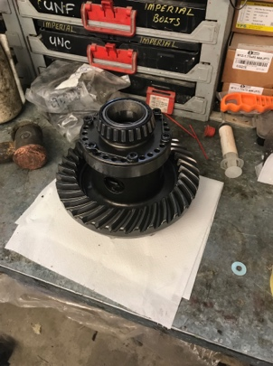
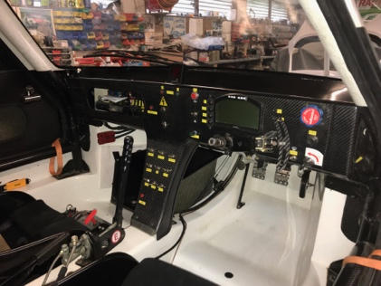
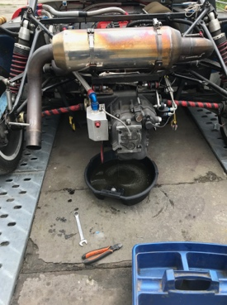
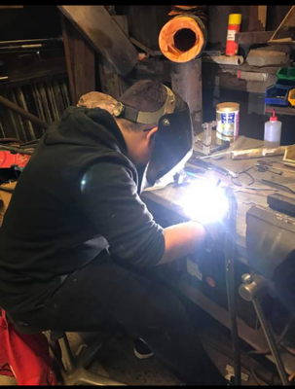

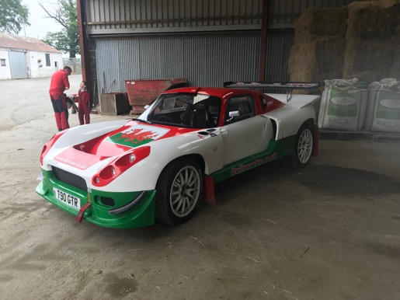
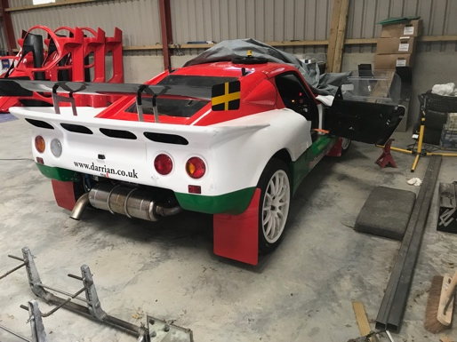
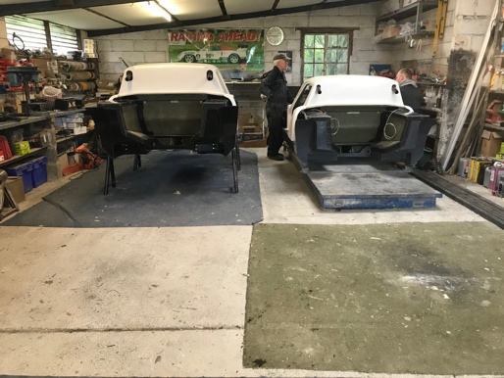
Photographs of diary activities.
Source of photographs - own camera.
Appendix 3. References.

Cars, D. (2019). Darrian Cars Homepage. [online] Darrian.co.uk. Available at: http://www.darrian.co.uk/index.html [Accessed 11 Sep. 2019].

Remzi, A. (2019). A Brief History Of The Darrian. [online] FinishLineSports.net. Available at: http://www.finishlinesports.net/2016/12/12/brief-history-darrian/ [Accessed 11 Sep. 2019].

Jones, M. (2001). Davrian to Darrian. Witney: Bookmarque.

Imps4ever.info. (2019). Davrian - The Imp Site. [online] Available at: http://www.imps4ever.info/specials/davrian.html [Accessed 18 Sep. 2019].

John.rawlins.com. (2019). [online] Available at: http://john.rawlins.com/ndr1/wpimages/wp0_wpc29c7a75.png [Accessed 20 Sep. 2019].

Acknowledgements.

Tim Duffee and all the crew at ‘Team Duffee’, Darrian Cars, Nantglas, Llangybi. For providing a valuable experience during the ‘extended’ work placement.

John Dalton (Driver -Darrian works car) For a memorable run in the Darrian GTR+ during a testing session.

“Davrian to Darrian” The Illustrated History. Martin Morgan Jones. BookMarque Publishing.

Darrian T90 GTR+ Promotional Literature.

Siwan Davies (sister). For assisting with the translation of placement diary notes from Welsh into English.

