
Skills for the Workplace
Module Assignment Submission
Student Name: | Kirsty Owen
Student Number: | 2008962
Module No: | BMSK4008
Module Title: | Academic and Research Skills

Statement of Confirmation of Authenticity
By the act of making this submission, the student declares that this is the work of the student named above. The work has not, in whole or in part, been knowingly presented elsewhere for assessment, or where assessment has been built on a previous assessment, this has been identified. Where materials have been used from other sources it has been properly acknowledged. If this statement is untrue, the student acknowledges that an assessment offence has been committed.
Attention is drawn to the plagiarism and unfair practice policies of both the University and of ILM.
Permission for ILM to use this script
ILM uses learners’ submissions – on an anonymous basis – for assessment standardisation. By submitting, both the centre and the learner agree that ILM may use this script on condition that identifying information is removed. However, if you are unwilling to allow ILM use this script, please refuse by ticking the box: □

Table of Contents
Managing Remotely: Is it the Way Forward? 3
Part 1 3
1.1 Introduction 3
1.2 Research & Findings 3
Advantages of remote working 3
Disadvantages of remote working 5
Requirements for effective remote managing and working 6
Managing or Leading? 7
Part 2 10
Personal Reflection on Managing Remotely 10
2.1 Description 10
2.2 Feelings 11
2.3 Evaluation 11
2.4 Analysis 12
2.5 Conclusion 16
References 17

Managing Remotely: Is it the Way Forward?

Part 1

Introduction

According to Rossi (2017), globalisation and advances in technology such as the internet and mobility of communication methods transformed 21st Century working environments allowing for flexible, remote working. A key element to evolve from technological advances is work becoming increasingly decentralised, leading to employers gaining the ability to adopt remote working policies.
Martino and Wirth (1990, p. 530) define remote working as “a flexible work arrangement whereby workers work in locations, remote from their central offices or production facilities, the worker has no personal contact with co‐workers there, but is able to communicate with them using technology”.
The remote working trend has been further exacerbated by the COVID-19 pandemic which has seen national lockdowns with millions of workers forced to work from home where possible for most part of the year, regardless of readiness of businesses or willingness of individuals (News18, 2021). This trend is likely to continue after the COVID-19 pandemic with 92% of employees expecting to work from home at least once a week in future (Owllabs, 2020).
This report will analyse research into the advantages and disadvantages of remote working, whilst also discussing the practices required for advantageous remote working and managing. This report will also consider alternate management styles which are required for effective remote working, before finally concluding with a reflective analysis of the writer's own experience of working remotely.

Research & Findings

Advantages of remote working

According to Judkins, West and Drew (1985), many benefits of managing remotely were recognised by companies as early as the 19th Century. Such benefits were found to be advantageous to both employers and employees.

Employers:

Zavylov (2020), an experienced HR expert claims that as a result of remote working combined with effective remote managing skills, employers can benefit from the option of global recruitment and time zone advantages, improved communications and self-discipline of staff, better outcomes and a decrease in overhead costs.
With remote working procedures in place, employers have ability to recruit from a wider geographical area, therefore this allows employers to recruit from the best global talent pools rather than finding themselves limited to recruiting local candidates that may not be as suitable for the role. Fried and Hansson (2013) suggest the basis for allowing employees to work remotely is to gain the ability to access the best talents regardless of location.
Due to global timezones, Guay (2019) found particular benefits from increased collaboration and constant productivity due to staff being available 24/7, combined with an increased level of customer support without the need for any members of staff being required to work additional hours or night shifts.
Afshar (2020) highlights findings that 81% of employees working remotely rated their communication with fellow employees as excellent or good. Furthermore, 55% of remote workers wanted regular communication to continue even in the absence of working onsite. Nevogt (2020) also highlights that remote working helps to reduce random communication and distractions between staff.
Bloom et al’s (2014) findings from a Work from Home experiment back theory that contentment and productivity of staff can be increased through the offering of flexible working arrangements. The randomised, controlled trial found that performance levels of home workers significantly increased by 13%. It was also found that staff turnover with regards to home workers reduced by 50% compared to office workers. This is further backed by a more recent survey which found that on average, staff are 25% more likely to engage at higher levels with their duties when remote working is an option (Willis Towers Watson, 2020).
Another key advantage is the reduction in overhead costs for businesses with a decrease in costs associated with renting and maintaining buildings. A survey on 250 UK small-medium enterprises found on average 70% seen a reduction in costs resulting from remote working (Hitachi Capital (UK) PLC, 2020).

Employees:

Mulki et al. (2009) claim that remote working employees experience greater flexibility and autonomy and a reduction in time and costs spent on commuting.
Jay (2020) promotes remote working with findings that additional flexibility improves personal health and relationships and reduces undesirable effects of employees becoming overwhelmed.
Autonomy during remote working is also thought to boost productivity and engagement. Studies show that autonomy embraces an entrepreneurial mindset leading to increased motivation levels of employees, with a desire for power in relation to autonomy helping to keep employees engaged (Lammers, 2016; Osborne, 2020; Heathfield, 2021).
In addition to time and cost savings associated with a reduction in commuting, it also provides additional flexibility, allowing employees to juggle a work-home balance easier. Prior to the pandemic, TUC (2019) found that the average daily time spent commuting in the UK was 58.8 minutes, a rise of 21 hours annually since 2008. There are also claims a reduction in commuting can be beneficial to health and stress levels, findings indicate long commutes have a negative effect on physical and mental health (Halonen, 2020).

Disadvantages of remote working

Precup et al. (2006) state remote working attracts a multitude of advantages, however, it also sets rise to fresh challenges, in addition to previous challenges becoming critical to success. There are further claims that remote teams face additional challenges simply because they lack face-to-face interactions (Gaudes et al., 2007). Mulki et al. (2009) also believe a lack of face-to-face communication to be a critical aspect to emerge from remote working. Whilst many workers have the ability to communicate from anywhere, at any time, many believe digital communication is not an equal substitute for face-to-face communication (Goman, 2018; Work.Life, 2020).
Furthermore, Mulki et al. (2009) state three additional negatives to arise are work-life balances, feelings of isolation and lack of recognition for remote workers’ achievements.
Dimitrova (2003) claims that remote working does not necessarily improve working hours and removing a structured routine may escalate work levels. Furthermore, Hartig, Kylin and Johansson (2007) argues that lines between work and home life can become blurred, eventually having a negative effect on employees.
Claims that remote working attracts feelings of isolation were proven by Bloom et al. (2013). In spite of all participants in the home-worker group still attending the office one day per week, 50% of the group favoured a return to the office, with loneliness being cited as the overriding reason. Feelings of isolation experienced by remote workers can lead to disengagement, ultimately resulting in disrupted job performance and wellbeing (Golden, Veiga and Dino, 2008; Collins, Hislop and Cartwright, 2016).
Another important challenge remote workers’ face is recognition for completion of work. Views of remote working differ significantly, with many holding negative views on the productivity of remote workers. Parker, Knight and Keller (2020) found that 40% of managers surveyed disagreed that remote workers were less productive than non-remote workers. Furthermore, only 42% of managers believed that remote workers could endure appropriate motivation levels long term. There are also claims remote working can impact non-remote workers more than those working remotely, creating a negative impact on co-worker relationships and a cultural divide within workplaces, ultimately impacting productivity (Bailey and Kurland, 2002; Cooper and Kurland, 2002; Golden, Veiga and Dino, 2008).

Requirements for effective remote managing and working

The Chartered Institute of Personnel and Development (CIPD), a professional body responsible for setting professional standards and championing for better work and working lives provides advice on how to achieve the best from remote working (CIPD, 2021).
Whilst remote working, CIPD (2020) suggests having a suitable working environment, access to required technological resources, access to IT support, and maintaining regular communication with colleagues is essential. Finding time for non-work-related conversations by utilising technology to maintain face-to-face contact and asking colleagues for support when required is also essential. To remain focused, CIPD suggests compiling a daily task list and dressing in work clothes to help keep a clear divide between home and work life. CIPD also recommends switching off after normal working hours to avoid overworking, whilst ensuring that written communication is concise to make up for a lack of body language and tone.
Furthermore, CIPD highlights practices for effective remote management. There are suggestions that managers should agree appropriate ways of working with employees’ and focus on results-based performance rather than presence, whilst also promoting trust. Managers should also ensure regular meetings and arrange virtual huddles to monitor on staff wellbeing. Managers should also ensure employees are fully supported with resources and equipment and ensure employees are goal focused by providing them with achievable short term aims. CIPD highlights vitality for managers to provide appropriate and relevant information to staff, whilst communicating feedback wisely and in a sensitive way, providing praise as well as criticism, if required.

Managing or Leading?

Jarvenpaa and Leidner (1999) claim that many managers are apprehensive of remote working based on the need for effective management of remote workers requiring modern, advanced skills which may not already be held. However, Ranta (2020) believes that effective leaders already possess most skills required to manage remotely.
Gibson et al. (2002) claim during times of a rapidly growing uptake in remote working, the difference in management and leadership is of utmost importance. Kotter (2001) defines management as achieving goals set through controlling staff and other key functions such as planning, budgeting, organisation and solving problems. Whereas, rather than providing control, leadership provides direction and alignment, preparing others for change and assisting in coping strategies as they transpire. Key differences and how both styles overlap to complement success are shown below (Figure. 1).

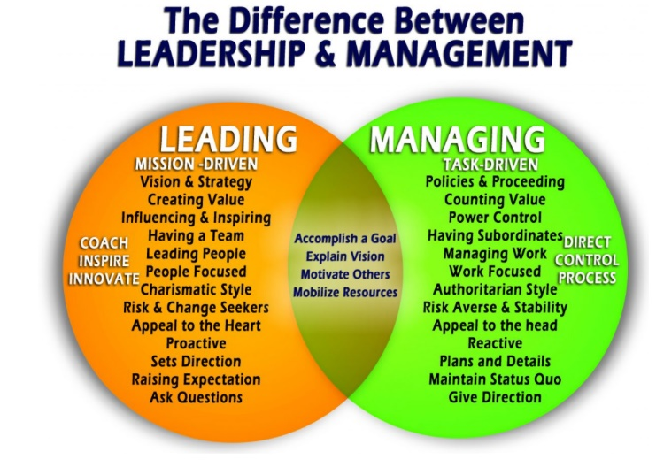
Figure 1: The Difference Between Leadership & Management (Grainger, 2019)

Gibson, J et al. (2002) believe transformations in remote working practices constitute a paramount shift in manager and employee relationships, where effective leadership, in addition to management is also required to attract positive results for all. Furthermore, they identify a Situational Leadership model developed in the 1960’s as a successful tool which can be applied by managers to achieve effective leadership of both remote and non-remote employees (Figure. 2) .
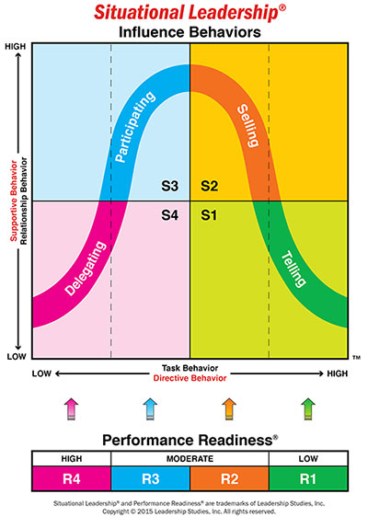
Figure 2: Situational Leadership Model (Leadership Studies, 2017)

The diverse model allows managers to place emphasis on the ability and commitment levels of each employee, allowing the behaviour of managers to be matched with individual employee requirements to apply an effective leadership style (Leadership Studies, 2017). The model addresses four influence behaviours and four performance readiness levels, with the goal to influence and develop employees to the low delegation, high performance stage (S4/R4).
Whilst at the S4/R4 stage the managers’ roles transform to delegation, ultimately relying on employees to complete tasks with limited supervision. It is at this stage where effective manager-employee interaction is crucial to success, particularly in remote working environments. Even at the optimum stage there is a crucial requirement for a powerful leadership relationship to be maintained, whilst also providing the employee with such delegated responsibility earned (Gibson, J et al, 2002).
Complementing the CIPD’s advice and the Situational Leadership model, Kowalski (2005) lists three crucial success factors which are required at all levels within an organisation to allow for effective remote working; support, communication and trust. The importance of manager’s forming a culture of trust using multiple techniques such as sharing of goals, empowerment methods, appropriate delegation and effective performance management based on output rather than presence is also highlighted.

Part 2

Personal Reflection on Managing Remotely

Baird (1993) states that reflection is a cornerstone of learning and personal and professional development. With this in mind, I have used the Gibbs (1988) reflective cycle (Figure 3) to reflect upon and learn from my own research and experience.

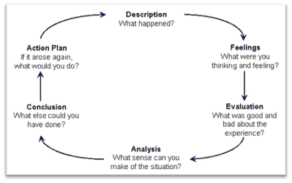
Figure 3: Reflective Cycle (Gibbs, 1988)

2.1 Description

As a result of the COVID-19 pandemic, there was an urgency for employees within my organisation to compulsory switch to remote working. Prior to this I had no previous experience or knowledge of remote working. Whilst my role as an administrative assistant provided a possibility for a large part of my duties to be completed remotely, this option had not been considered by my employer, nor had the eventuality been planned for. Within my department, such a sudden change to work routines and the requirement for enhanced use of digital technology resulted in extreme disruption for all staff within my department. Due to COVID restrictions changing, I have gained experience of working and being managed remotely on a full-time basis for 6 months, in addition to a mixture of on-site and remote working for a further 7 months. I have completed research into important aspects of remote working by examining literature and analysing data and this has allowed me to consider the question; ‘Is managing remotely the way forward?’.

2.2 Feelings

Prior to the pandemic, I had given little thought to remote working as it was not a practice adopted by my employer. Following the compulsory adoption of remote working, the prospect of ‘How will I carry out my duties correctly?’ was a worrying thought in my mind.
The change to routine and the requirement for my department to invent new procedures caused much confusion and anxiety for all. Although completing the same role, due to processes changing I felt that most duties were new to myself and harder to complete. Following research, I believe that remote work commonly attracts new challenges, in addition to previous challenges transpiring to be critical to success (Precup et al. 2006).
However, as I became more familiar with remote working and the newly learned processes I began to feel more productive and content whilst working remotely.
My experience and research have since allowed me to form an opinion that whilst there are negative aspects resulting from remote work, it can also prove beneficial when managed effectively by employees, managers and colleagues. This links with Kowalski’s (2006) belief that remote working is only effective when appropriate levels of support, communication and trust are present throughout an organisation.

2.3 Evaluation

I have experienced both positive and negative impacts resulting from remote working. However, overall, I enjoyed the remote working experience and would welcome the option in future as I believe the positive aspects outweigh the negatives. I feel that once I overcame the obstacle of change, I worked well and my productivity and well-being improved.
Working remotely allowed me increased flexibility with my working hours, allowing my working day to be shaped around my family commitments. This did however, cause my work life to overlap into my home life, where I was often required to work late at night to catch up and ensure my duties were fulfilled. This flexibility also proved beneficial to the company, particularly at one point where urgent work was required to be completed outside of normal working hours. The flexibility also changed my mindset where I was happy to complete work out of my normal working hours, whereas I may have been more reluctant in the absence of remote working.
A reduced amount of commuting provided myself with additional personal time, which in turn allowed myself to place additional focus on family responsibilities. Also, I believe my productivity benefited from a reduction in interruptions from colleagues.
At certain times I did feel isolated in the absence of workplace chat, the benefit of always having someone at hand to ask a question was also missed, mirroring claims remote workers experience extra challenges simply due to the lack of face-to-face communication (Gaudes et al., 2007).
Whilst I am digitally literate, I experienced the impact of many of my colleagues and manager not holding the necessary digital skills to enable effective remote working, negatively affecting the wider team’s collaboration and communication levels, in addition to their own productivity levels.
Some of my colleagues also held negative views on remote working, with the practice often being seen as the easy option or even a day off, this for me however was not the case as my work was always completed to the same standard.
Parker, Knight and Keller’s (2020) findings of remote working perceptions were also echoed by my manager holding negative views on productivity and motivation. This resulted in a negative impact on my well-being, with feelings that my commitments were overlooked and unappreciated. Often contact was only received when something needed to be done or went wrong and the focus was solely based on task completion, with employee well-being and other issues disregarded.

2.4 Analysis

My personal remote working experience was hampered due to the nature of the forced situation and lack of preperation. This experience has formed my opinion that managers may be reluctant to remote management due to their own lack of skills (Jarvenpaa and Leidner, 1999). This was particularly apparent with regard to my manager who did not alter their management style to aid manager-employee relationships. I have found claims such a change to management techniques is a paramount requirement to manage effectively (Gibson, J et al. 2002).
I have conducted my own research on remote work and will now discuss some of my findings. Research has been gathered from fellow students in the Skills for the Workplace course.
Figure 4 indicates a range of occupations held by respondents, however with only 13 responses, this research is limited and drawing valid conclusions is difficult.

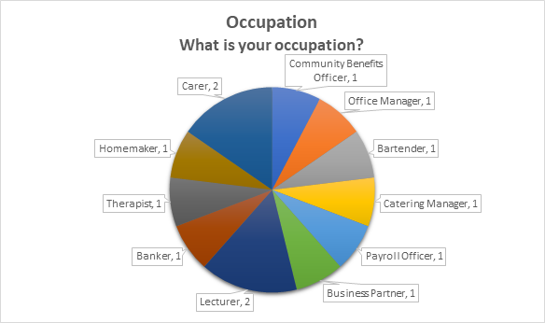
Figure 4: Occupation

Figure 5 indicates that the modal number of respondents are currently working remotely. Interestingly, four of the respondents indicated that they are unable to work remotely, this reasons for this would be interesting to investigate.

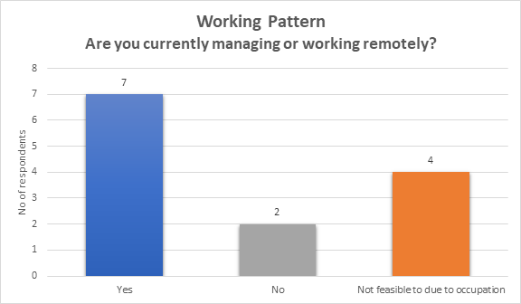
Figure 5:.Working pattern

From Figure 6, it is surprising to see that the mode of respondents would not like to work remotely in the future. Despite benefits to employees highlighted by Mulki et al. (2009) suggesting that remote working employees experience greater flexibility and autonomy, and a reduction in time and costs spent on commuting.

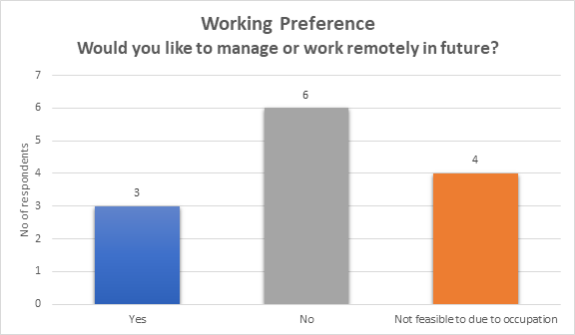
.Figure 6: Working Preference

From Figure 7 It is evident that reduced commuting is a large part of respondents' belief in the advantages of remote working. TUC (2019) found that the average daily time spent commuting in the UK is 58.8 minutes. Other advantages include flexible working hours and no distractions from the workplace.
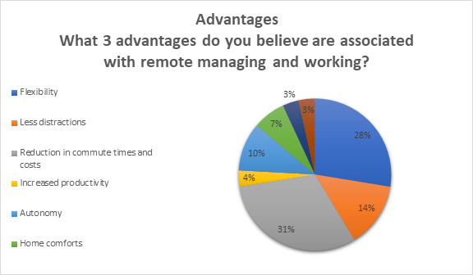
.Figure 7: Advantages
From Figure 8, it can be concluded that isolation and a lack of social interaction are the main disadvantages. Further backing Bloom et al’s (2013) findings who found that loneliness was the main reason for workers wanting to return to the workplace.

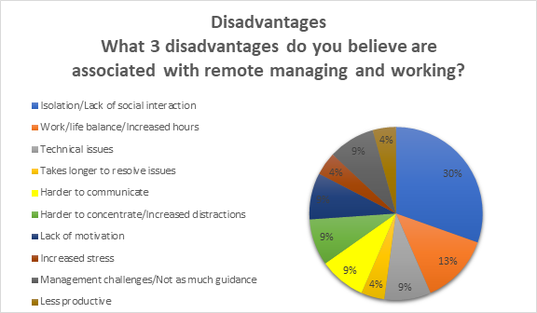
.Figure 8: Disadvantages

2.5 Conclusion

Such developments have inevitably highlighted the need for businesses and organisations to adapt the way in which they manage their workforce, with a key requirement of managerial staff possessing the ability to manage their workforce efficiently and effectively whilst working remotely.
Following my experience, I have found that I have the ability to complete a majority of my work remotely. However, there are certain aspects which require an on-site presence and as such, I believe that remote working on a full-time basis would not allow me to carry out my duties fully. On this basis, I hold the thought that my manager could consider remote working on a rotational basis for the department and with appropriate training for all, this can be completed effectively, leading to many benefits.
Research in part 1 has strengthened my beliefs that when managed effectively, the advantages of remote working outweigh the negatives and this builds a case that managing remotely is ultimately the way forward.
If I were to manage a team of employees remotely in future, research in Part 1 has allowed me to develop the theoretical knowledge to do so effectively and efficiently, whilst also allowing me to develop a remote working philosophy in which I believe and will utilise when the opportunity arises. I have taken particular interest in the Situational Leadership and believe by utilising this model in combination with CIPD’s advice will allow me to apply an effective leadership style in order to positively manage remotely in future (Leadership Studies, 2017; CIPD, 2020).

References

Afshar, V. (2020) Majority of remote workers are more productive and communicative. Available at: https://www.zdnet.com/article/majority-of-workers-are-more-productive-and-communicative-at-home/ (Accessed: 10 March 2021).

Bailey, D. E., & Kurland, N. B. (2002) ‘A review of telework research: Findings, new directions, and lessons for the study of modern work’, Journal of Organizational Behavior, 23(4), pp. 383-400. DOI: 10.1002/job.144

Baird, J. R. (1993). Collaborative reflection, systematic inquiry, better teaching. In Russell, T. & Munby, H. (Eds.) Teachers and teaching: From classroom to reflection. New York: Falmer Press, Taylor & Francis.

Bloom, N. et al. (2014) ‘Does Working from Home Work? Evidence from a Chinese Experiment’, The Quarterly Journal of Economics, 130(1), pp. 165–218. DOI: 10.1093/qje/qju032

CIPD (2020) Getting the most from remote working. Available: https://www.cipd.co.uk/knowledge/fundamentals/relations/flexible-working/remote-working-top-tips (Accessed: 24 March 2021).

CIPD (2021) Our purpose and vision. Available: https://www.cipd.co.uk/about/who-we-are/purpose (Accessed: 24 March 2021).

Collins, A. M., Hislop, D., & Cartwright, S. (2016) ‘Social support in the workplace
between teleworkers, office-based colleagues and supervisors’, New Technology,
Work and Employment, 31(2), pp. 161-175. DOI: 10.1111/ntwe.12065

Cooper, C. D., and Kurland, N. B. (2002) ‘Telecommuting, professional isolation, and
employee development in public and private organizations’, Journal of
Organizational Behavior, 23(4), pp. 511-532. DOI: 10.1002/job.145

Dimitrova, D. (2003) ‘Controlling teleworkers: supervision and flexibility revisited’, New Technology, Work and Employment, 18(3), pp. 181-195. DOI: 10.1111/1468-005X.00120

Forbes (2009) Business Meetings: The Case for Face-to-Face. Available at: https://images.forbes.com/forbesinsights/StudyPDFs/Business_Meetings_FaceToFace.pdf (Accessed: 23 March 2021).

Fried, J. & Hansson, D. H. (2013) Remote: Office Not Required. New York: Crown Publishing.

Gaudes, A., Hamilton-Bogart, B., Marsh, S. & Robinson, H. (2007) ‘A Framework for Constructing Effective Virtual Teams’, The Journal of E-working, 1, PP. 83-97. Available at: https://www.researchgate.net/publication/26492382_A_Framework_for_Constructing_Effective_Virtual_Teams (Accessed: 23 March 2021).

Gibbs, G. (1988) Learning by doing; A guide to teaching and learning methods. London: FEU.

Gibson, J. W. et al. (2002) ‘Telecommuting in the 21st Century: Benefits, Issues, and a Leadership Model Which Will Work’, Environment and Urbanization, 8(4), pp. 465–482. DOI: 10.1177/0956247813490908

Golden, T. D., Veiga, J. F. & Dino, R. N. (2008) ‘The Impact of Professional Isolation on Teleworker Job Performance and Turnover Intentions: Does Time Spent Teleworking, Interacting Face-to-Face, or Having Access to Communication-Enhancing Technology Matter?’, Journal of Applied Psychology, 93(6), pp. 1412-1421. DOI: 10.1037/a0012722

Goman, C. K. (2018). Has Technology Killed Face-To-Face Communication? Available at: https://www.forbes.com/sites/carolkinseygoman/2018/11/14/has-technology-killed-face-to-face-communication/?sh=30dd36e9a8cc (Accessed: 24 March 2021).

Grainger, S. (2019) The difference between Leadership & Management [Venn Diagram]. Are You Ready to Be the Boss? [Online]. Available at: https://borsa401k.com/2019/10/are-you-ready-to-be-the-boss/ (Accessed: 22 March 2021).

Guay, M. (2019) The pros and cons of working across time zones: What to expect when you work in a distributed company. Available at: https://zapier.com/learn/remote-work/remote-work-time-shift/ (Accessed: 18 March 2021).

Halonen, J. I., et al. (2020) ‘Commuting time to work and behaviour-related health: a fixed-effect analysis’, Occupational and Environmental Medicine, 77, pp. 77-83. DOI: 10.1136/oemed-2019-106173

Hartig, T., Kylin, C. & Johansson, G. (2007) ‘The Telework Tradeoff: Stress Mitigation vs. Constrained Restoration’, Applied Psychology, 56(2), pp. 231-253. DOI: 10.1111/j.1464-0597.2006.00252.x

Heathfield, S. M. (2021) The Pros and Cons of a Flexible Work Schedule. Available at: https://www.thebalancecareers.com/advantages-and-disadvantages-of-flexible-work-schedules-1917964 (Accessed: 18 March 2021).

Hitachi Capital (UK) PLC (2020) SME business cost savings from remote working. Available at: https://www.hitachicapital.co.uk/business-finance/invoice-finance/invoice-finance-blog/sme-business-cost-savings-from-remote-working/ (Accessed: 20 Dec 2020).

Hoehner, C. M. et al. (2012) ‘Commuting Distance, Cardiorespiratory Fitness, and Metabolic Risk’, American Journal of Preventive Medicine, 42(6), pp. 571-578. DOI: 10.1016/j.amepre.2012.02.020

Jarvenpaa, S. L. and Leidner, D. E. (1999) ‘Communication and Trust in Global Virtual Teams’, Organization Science, 10(6), pp. 791-895. DOI: 10.1111/j.1083-6101.1998.tb00080.x

Jay, R. (2020) Survey Finds Job Flexibility Significantly Improves Health, Personal Relationships. Available: https://www.flexjobs.com/blog/post/survey-flexible-work-mental-health/ (Accessed: 24 March 2021).

Judkins, P., West, D. & Drew, J. (1985) Networking in Organisations: The Rank Xerox Experiment. United Kingdom: Gower Publishing.

Kotter, J. P. (2001) Best of HBR: What Leaders Really Do. Havard Business Review. Available at: https://enterprisersproject.com/sites/default/files/What%20Leaders%20Really%20Do.pdf (Accessed: 23 March 2021).

Kowalski, B.K. and Swanson, J.A. (2005) ‘Critical success factors in developing teleworking programs’, Benchmarking: An international Journal, 12(3), pp. 236-249. DOI: 10.1108/14635770510600357

Lammers, J. et al. (2016) ‘To Have Control Over or to be Free from Others? The Desire for Power Reflects a Need for Autonomy’, Personality and Social Psychology Bulletin, 45(4), pp. 498-512. DOI: 10.1177/0146167216634064

Leadership Studies (2017) Situational Leadership: Relevant Then, Relevant Now. Available at: https://www.situational.com/content/uploads/2017/10/FINAL_CLS_History_CaseStudy_Digital.pdf (Accessed: 22 March 2021).

Martino, D. V. & Wirth, L. (1990) ‘Telework: A new way of working and living’, International Labour Review, 129(5), pp. 529-552. Available at: https://heinonline.org/HOL/LandingPage?handle=hein.journals/intlr129&div=54&id=&page (Accessed: 23 March 2021).

Mulki, J. et al. (2009) ‘Set Up Remote Workers to Thrive’, MIT Sloan Management Review, 51(1), pp. 63-69. Available at: https://www.researchgate.net/publication/264844669_Set_Up_Remote_Workers_to_Thrive (Accessed: 23 March 2021).

Nevogt, D. (2020) ‘Are remote workers more productive? We’ve checked all the research so you don’t have to’, Hubstaff Blog [blog]. 31 August. Available at: https://blog.hubstaff.com/remote-workers-more-productive/ (Accessed: 9 March 2021).

News18 (2021) COVID-19 Pandemic Pushed us into a Global Work-From-Home Experiment. But Will it Last? Available at: https://www.news18.com/news/buzz/covid-19-pandemic-pushed-us-into-a-global-work-from-home-experiment-but-will-it-last-3365693.html (Accessed: 18 March 2021).

Osborne, B. (2020) How to Create Autonomy in the Workplace. Available at: https://rallybright.com/autonomy-in-the-workplace/ (Accessed: 18 March 2021).

Owllabs (2020) State of Remote Work. Available: https://resources.owllabs.com/state-of-remote-work/2020 (Accessed: 24 March 2021).

Parker, S. K., Knight, C. & Keller, A. (2020) Change Management, Remote Managers Are Having Trust Issues. Available at: https://hbr.org/2020/07/remote-managers-are-having-trust-issues (Accessed: 23 March 2021).

Precup, L. et al. (2006) 'Virtual team environment for collaborative research projects', International Journal of Innovation and Learning, 3(1), pp. 77-93. DOI: 10.1504/IJIL.2006.008181

Ranta, M. (2020) Three Leadership Skills Necessary for Managing Remote Employees. Available at: https://www.forbes.com/sites/forbesbusinessdevelopmentcouncil/2020/11/04/three-leadership-skills-necessary-for-managing-remote-employees/?sh=6a9347852fca (Accessed: 24 March 2021).

Rossi, B. (2017) Technology is ready to define the future of the workplace. Available at: https://www.information-age.com/technology-ready-define-future-workplace-123465776/ (Accessed: 19 Jan 2021).

TUC (2019) Annual commuting time is up 21 hours compared to a decade ago, finds TUC. Available at: https://www.tuc.org.uk/news/annual-commuting-time-21-hours-compared-decade-ago-finds-tuc (Accessed: 18 March 2021).

Willis Towers Watson (2020) 2019/2020 Global Benefits Attitudes Survey. Available at: https://www.willistowerswatson.com/en-GB/Insights/2020/02/global-benefits-attitudes-survey-report (Accessed: 15 Jan 2021).

Work.Life (2020) ‘How Important Is Face To Face Communication In Business?’, [blog]. 8 April. Available at: https://work.life/blog/face-to-face-communication-in-business/#:~:text=One%20of%20the%20key%20advantages,body%20language%20and%20facial%20expressions. (Accessed: 24 March 2021).

Zavylov, M. (2020) ‘We Are Online: How to Effectively Manage a Remote Team’, Diceus [blog]. 6 April. Available at: https://diceus.com/we-are-online-how-to-effectively-manage-a-remote-team/ (Accessed: 9 March 2021).

