Name: Rabina Akhtar
Student id: 2421435
Lecturer's Name: Mumtaz Goolam

LCH4003 Introduction to health and social care:
The Origins, Current Functioning, and Significance of Community Antenatal Midwifery Services in the UK
Table of Contents
Task 1 3
Task 2 4
Introduction 4
Origins and Historical Development 4
Critical Evaluation of Current Functioning 4
Significance for Quality of Life and Outcomes 5
CONCLUSION 5
REFERENCES 6

Task 1
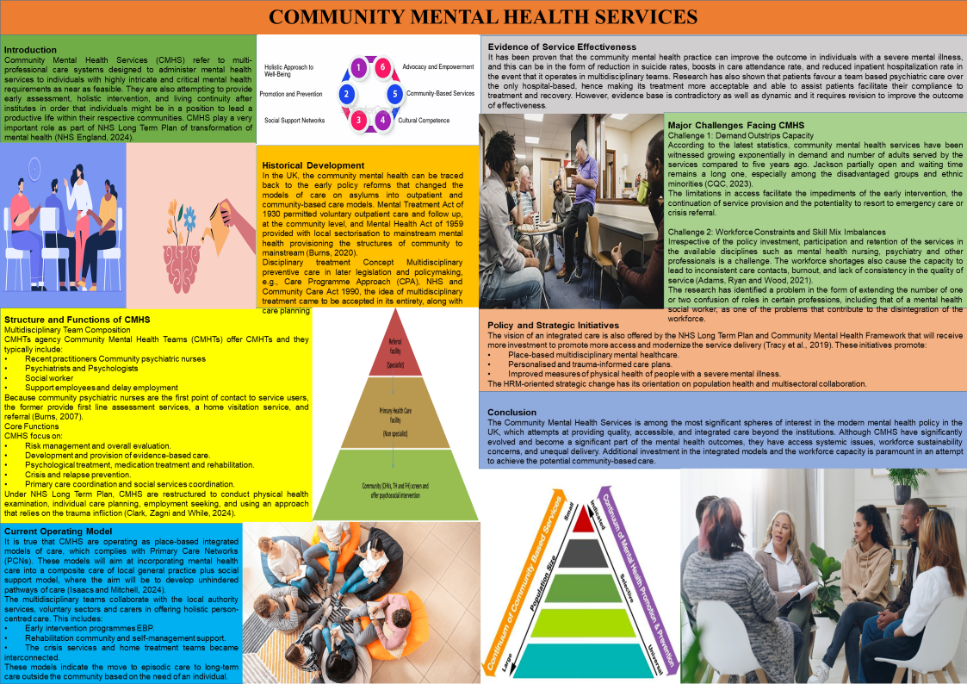

Task 2

Introduction
Community antenatal midwifery refers to the delivery of organised pregnancy services by the midwife at communal level and it entails continuous check-ups, assessment of risks, health education and support that is given to the expectant mothers in a customised way (Lanyo et al., 2025). This essay shall put into perspective the historical context of these services, the manner of their functioning as a policy under consideration as well as how they have contributed towards the quality of life of mothers and babies.

Origins and Historical Development
Medical practice In England and Wales Laws Midwifery in England and Wales Medical practice Laws, Practitioners. The application of the law brought about a legal standard of certified training and regulation of practitioners, the foundation of a normalised profession (Woodward and Bassett, 2025). It was brought the right of everyone to midwifery when the NHS was set up in 1948 which brought the connection between the medical care setting and the community setting. After policy review, such as the Better Births national review (2016), evidently indicated continuity of carer, whereby women would have a coordinated team of the specified midwife throughout the entire time of pregnancy, birth, and postnatal follow-up (National maternity Review, 2016). The same is continued in the NHS Long Term Plan whereby the continuity models have been listed as priorities in an attempt to improve the outcomes and mitigate the health disparities in maternity services.

Critical Evaluation of Current Functioning
The UK currently offers community antenatal midwifery in community hubs, primary care networks and continuity-based models, community hubs typically entails a female patient having continuous contact with a named midwife or small mob of midwives who will support her throughout pregnancy, labour and postpartum period. This arrangement makes it simpler to have frequent clinical check-ups, risk assessment, health education and personal discussions of ideas and care plan. Relational continuity, trust and individualised care are the supposed improvements that the continuity of care model (MCoC) advocated by Better Births cares to promote and the main aspect of the NHS maternity transformation agenda (Milton et al., 2025). Evidence-based models of midwife continuity of care are associated with increased positive maternal experience and improved clinical outcomes, including increased rates of spontaneous vaginal delivery and reduced rates of instrumental delivery compared to standard care, potential cost-efficacy and more therapeutic relationships (Sandall et al., 2024).
However, the implementation problems are elevated. The adoption of continuity models has been slow because of membership limitations in the labour market and the organisational constraints too in addition to unequal access to the continuity even after it was given priority in the policy particularly to women in the disadvantaged regions and ethnic minority backgrounds.

Significance for Quality of Life and Outcomes
The Community antenatal midwifery services do add a significant contribution to the quality of life and clinical results. The continuity based care is already introduced to reduce maternal anxiety and depression that can occur during the pregnancy process, which enhances positive emotional state. The continuity of midwifery experiences has been linked to the improvements in maternal experiences and cultures, increased cases of spontaneous births of the maternity, and potential cost reductions in the maternity care. Follow-ups Continuity-based antenatal care also provides females with increased levels of satisfaction, increased empowerment and greater health behaviour participation. The community-based continuity models have shown a promise to have an effect of reducing health disparities and improving outcomes of socially at-risk women, which meet the national equity targets (Bradford et al., 2022).

CONCLUSION
Contemporary UK midwifery healthcare is based on the efforts of community antenatal midwifery workers. Being historically based on reform, with continuity-based policy; all of them are useful to maternal experience, clinical outcomes, and equity. They need to invest in the labour force in the long-term and alleviate inequality, which will enlarge its long-term social health benefits.

REFERENCES
- Adams, R., Ryan, T. and Wood, E. (2021). Understanding the factors that affect retention within the mental health nursing workforce: A systematic review and thematic synthesis. International Journal of Mental Health Nursing, [online] 30(6), pp.1476–1497. doi:https://doi.org/10.1111/inm.12904.
- Bradford, B.F., Wilson, A.N., Portela, A., McConville, F., Fernandez Turienzo, C. and Homer, C.S.E. (2022). Midwifery Continuity of care: a Scoping Review of where, how, by Whom and for whom? PLOS Global Public Health, [online] 2(10). Available at: https://www.ncbi.nlm.nih.gov/pmc/articles/PMC10021789/.
- Burns, T. (2007). Community mental health teams. Psychiatry, 6(8), pp.325–328. doi:https://doi.org/10.1016/j.mppsy.2007.05.009.
- Burns, T. (2020). Community-Based Mental Health Care in Britain. Consortium Psychiatricum, 1(2), pp.14–20. doi:https://doi.org/10.17650/2712-7672-2020-1-2-14-20.
- Clark, L.L., Zagni, M. and While, A.E. (2024). ‘No health without mental health’: where are we now?. British journal of community nursing, 29(6), pp.282–287. doi:https://doi.org/10.12968/bjcn.2024.29.6.282.
- CQC (2023). Mental health - Care Quality Commission. [online] Cqc.org.uk. Available at: https://www.cqc.org.uk/publications/major-report/state-care/2023-2024/access/mh.
- Isaacs, A.N. and Mitchell, E. (2024). Mental Health Integrated Care Models in Primary Care and Factors That Contribute to Their Effective implementation: a Scoping Review. International Journal of Mental Health Systems, [online] 18(1). doi:https://doi.org/10.1186/s13033-024-00625-x.
- Kingdon, D. (2019). Care Programme Approach – Time to Move beyond? BJPsych Bulletin, [online] 43(3), pp.101–103. doi:https://doi.org/10.1192/bjb.2018.73.
- Lanyo, T.N., Zielinski, R., Kukula, V.A., Apetorgbor, V.E.A., Ghosh, B., Lockhart, N.A. and Lori, J.R. (2025). Improving Respectful Maternity Care Through Group Antenatal Care: Findings from A Cluster Randomized Controlled Trial. Midwifery, p.104457. doi: https://doi.org/10.1016/j.midw.2025.104457.
- Milton, R., Channon, S., Sanders, J., Kenyon, S., Middlemiss, A., Strange, H., Davies, K., Choudary-Salter, L., Barry, S., Prendeville, T. and Jones, A. (2025). The SIMCA Study Protocol: Factors influencing the implementation of the Midwifery Continuity of Carer (MCoC) model of care in NHS maternity care in England: A mixed methods cross case analysis involving clinicians, women and policy makers. NIHR Open Research, [online] 5, p.4. doi: https://doi.org/10.3310/nihropenres.13745.2.
- National maternity Review (2016). Better births: Improving Outcomes of Maternity Services in England. [online] NHS England. NHS England. Available at: https://www.england.nhs.uk/wp-content/uploads/2016/02/national-maternity-review-report.pdf.
- NHS England (2024). NHS England Community Mental Health Services. [online] England.nhs.uk. Available at: https://www.england.nhs.uk/mental-health/adults/cmhs/.
- Sandall, J., Fernandez Turienzo, C., Devane, D., Soltani, H., Gillespie, P., Gates, S., Jones, L.V., Shennan, A.H. and Rayment-Jones, H. (2024). Midwife continuity of care models versus other models of care for childbearing women. Cochrane Library, [online] 2024(4). doi: https://doi.org/10.1002/14651858.cd004667.pub6.
- Tracy, D.K., Hanson, K., Brown, T., James, A.J.B., Paulsen, H., Mulliez, Z. and Shergill, S.S. (2019). Integrated care in mental health: next steps after the NHS Long Term Plan. The British Journal of Psychiatry, [online] 214(06), pp.315–317. doi:https://doi.org/10.1192/bjp.2019.46.
- Woodward, S. and Bassett, S. (2025). Supervision, Learning and Assessment in Clinical Practice E-Book. [online] Google Books. Available at: https://books.google.com/books

