My Academic Employability Skills

Author--- Elizabeth Oladeji Johnson
Module---Academic and Employability Skills
Course---Certificate for Higher Education in Skills for Workplace
Lecturer-Timothy Hopkins
Date-------January 2020

Acknowledgements
I would like to use this opportunity to appreciate all those who have supported me in various ways to enable me complete this report, I wish you the very best of the year 2020 and beyond!

Content Page
Title Page Number
Title page……………………………...……………………………………………………………1
Acknowledgement………………………………………………………………………………2
Content page……………………………….………………………………………………………3
Summary..………………………………….………………………………………………………..4
Introduction………………………………………………………………………………………..5
Methodology……………………………………………………………………………………..6-7
My Academic Employability skills………………………………………………………7-8
Discussion
SWOT Analysis………………………………………………………………………………….9-10
PDP Analysis……………………………………………………………………………………10-11
Paraphrasing………………………………………………………………………………...…11-12
Conclusion………………………………………………………………………………………12-13
References………………………………………………………………………………………14
Appendix…………………………………………………………………………………………15-26

Summary
Universities and colleges of higher learning support students through developing skills that are useful for them to succeed in their learning as well as carry on to their process of applying for job roles during or after their education. This report will look at employability skills and identify how important the skills are to academic as well as at work to find if employability skills should be encouraged in higher institutions of learning.

Introduction
In recent times, academic institutions are doing more than in the past to help students achieve better grades in their academics as well as prepare them for the work place. It is not just to secure a position but to also be efficient in their tasks. One of the most valuable strategies is developing the skills that can be used to succeed as a student and carried forward to be used continuously in the workplace.
This report will define academic skills and employability skills. It will discuss the academic employability skills that I have learnt so far. It will also analyse my progress in the skills using class exercises as my examples. It will identify skills that I will need to develop further to enhance my performances.
Skills- are the experience or ability to be able to perform a task to expectation, According to Martin (2010) suggests that skills can be linked to the competency to perform a task. Also, Cottrell (2008) describes skills as the ability to perform a learned activity well at will.
Academic skills- are the skills required for a student to perform in order to achieve high grades in their studies. They are the skills that demonstrate learners understanding of subjects taught Martin (2010).
Employability skills - are transferable skills that are needed to make individuals employable. According to Martin (2010) employers specify skills they require from employees to help them perform well on the job in addition to the subject matter.

Methodology
There are quite a number of skills that are transferable from academics to the workplace that helps to improve employee performances for the purpose of increasing organisation performance and productivity.
Skills can also be categorised into soft and hard as well as transferable skill and are discussed as follows:
Soft skills also known as interpersonal skills are described as the personal qualities that enable an individual or group of employees to be good employees, for example; listening, etiquette, communication and the ability to get on well with people Maund et al (2017).
Hard Skills are described as the quantifiable and teachable abilities for example, proficiency in a language such as German, a certificate or degree in a subject and competency in computer programs, Maund et al (2017).
Transferable Skills are qualities that can be transferred between jobs; they are skills that can be enhanced as an individual progress through education, training and employment, Maund et al (2017). Some examples of transferrable skills are listed below;
- Time management skills
- Team working skills
- Planning skills
- Communication skills
- Listening skills
- Analysing skills
- Problem solving skills
- Paraphrasing skills
- ICT skills
- Report writing skills
- In this section, I will be discussing some of the skills that have been discussed in the class.
- Time management skills

My academic employability skills
The following section discusses some of the academic and employability skills that have been discussed in the class and how I have used them on a regular basis, it also focuses on skills that I will require to strive well in the retail industry according to Nickson et al, (2017). Some of the skills highlighted for the retail industry are therefore discussed as follows;
Time management skills
I have used my time management skills to plan to attend my lectures by planning the time to arrive such that I am not late. Also I have used time management to plan my daily activities placing them in order of importance and priority. This skill will also help me in the workplace to manage my workload by prioritising in order of importance and priority.
Team working skills
I have been privileged to work as a part of a group of individuals from different background but all working towards the same purpose of achieving success. I have successfully adapted to the type of arrangement and sure that this will enable me to enhance my working ability as part of a team in my current and future roles.
Communication skills
I have been able to communicate with colleagues at the same level as well as senior level lecturers in the learning environment, I have communicated effectively through writing, verbal and presentations. I can use the transferable skills to stand me out during interviews to build my confidence as well as to communicate with colleagues and senior managers through all various modes of communication such as emails, verbal and for presentations.
Problem solving skills
I have been able to solve problems from the coursework and class activities, identifying what the issue is and what is expected of me, based on this, I have produced results to solve a variety of issues. This skill is useful and will be transferable within the work environment, once a task is presented to me, I can then use my problem solving skills to identify what is required of me.
ICT skills
I have been working on various computer applications using Microsoft Office to produce my reports and essays for academic assessment; this has helped me to enhance my knowledge of using this applications and I believe that the skills will be transferable in the work environment considering that organisations are now going computerised.

Discussion
In examining myself for skills that I already have and those that I wish to enhance, I carried out a SWOT analysis to identify strengths, weaknesses, opportunities and threats in myself. After identifying areas that require further development, I then used a Personal Development Plan (PDP) to plan to develop those skills that I have weaknesses in areas where I am good at but where I can benefit from further enhancing my skills in the areas.
SWOT analysis
The abbreviation SWOT is for Strengths, Weaknesses, Opportunities and Threats. I initially conducted an analysis of SWOT on myself to know the skills I already possess and those that are required for me to progress with my studies and employment. The following was analysed;
Strengths- I listed the things I am good at doing as follows;
- Management
- Communication
- Problem solving
- Analytical ability
- Organising events
- Advise through consultations
Weaknesses- I also listed the area that I believe I have a weakness in so that I can start to work on this area; I have purchased a laptop to start with so that I can develop myself as follows;
- ICT
Opportunities- I also plan to enrol on an ICT course to help me improve on my knowledge in ICT. My opportunity to develop my ICT knowledge will be as follows;
- ICT course
Threats – I found that it can be a challenge for me to manage time between work, studies and attending the ICT course due to;
- Time management

PDP Analysis- Personal Development Plan is a process that enables the ability to think and plan academic, career and professional plan. It helps to think and identify what is required to perform certain roles and what to do to achieve them within a space of achievable time.
The following sections were identified in my PDP and the plans to work on them are discussed below;
My goals
- Short-term-to build a professional portfolio
- Mid-term goals- to become a business manager
- Long-term-to become a business area manager
Skills and Knowledge
- Short-term-to learn basic ICT skills e.g. word, excel and PowerPoint
- Mid-term- to learn intermediate, more than the basic including office outlook.
- Long-term- to learn advanced skills in ICT i.e. Microsoft office package.
Next Steps
- Short-term-I will buy a laptop and get myself used to the applications.
- Mid-term goals- I will enrol on an ICT course.
- Long-term-gain more confidence working by myself.
Resources
- Short-term- a laptop
- Mid-term goals- funding and free time
- Long-term-office environment
Time schedule/start/finish
- Short-term-6 months/ 1-11-2019/1-05-2020
- Mid-term goals- 2 years/1-06-2020/1-06-2022
- Long-term-2 years/1-06-2020/1-06-2022

Paraphrasing
This is the ability to express a sentence with different words but having the same meaning or explaining a sentence in a clearer and more understandable form. According to Chowdhury and Miah (2019), paraphrasing is the ability to write another person’s idea in your own words such that it has the same meaning or makes the sentence even clearer.
In my learning, paraphrasing will help me to read, understand, analyse and interpret paragraphs in my coursework and other academics assessments in a manner that demonstrate my understanding of the subject.
I participated in two (2) in class paraphrasing exercises where I read a case study to understand, I was firstly required to paraphrase the case study using my own words but having the same meaning as the author and secondly to complete blank spaces from sentences extracted from the case study using another sentence with exact same meaning to replace the original sentence used.
I demonstrated a clear understanding of ways of paraphrasing in my class exercise, according to the tutor; I made a good start however he advises to paraphrase all the text and check the grammar. Although I have picked the tutors recommendation but the reason why I did not paraphrase all the text is because the time given was not enough for me to complete the task of paraphrasing.
In the second part however, I made adjustments to my timing and was able to complete my task within the time given hence the tutor’s comment on my exercise that described my work as very good work.
This in class exercise has given me a practical experience of paraphrasing sentences which I find very useful in future academic assessments and also in the work place when I have to write reports or during the process of note or minute taking of a professional meeting.

Conclusion
In conclusion, developing employability skills is useful for developing as well as enhancing academic skills because it will help to gain better understanding of what is required in assessments. Also developing employability skills will help to prepare me for the work environment to help me perform my task appropriately. The ability to use SWOT analysis to determine skills that needs to be enhanced and PDP to plan the development process as well as paraphrasing to be able to summarise or use other words to make the same meaning are quite useful tools for me to succeed in my academics as well as at work, therefore developing employability skills should be recommended in higher education.

References
- Chowdhury, T. and Miah, M. (2019). Perceptions of students and employers regarding employability skills for entry-level positions in marketing and sale. Australian Journal of Career Development. 28 (1), p 3-13.
- Cottrell, S. (2008). The Study Skills Handbook. 3rd ed. United Kingdom: Palgrave Macmillan.
- Graham. D. (2017). Embedding Employability Behaviours. Journal of Work-Applied Management. 9 (1), p35-50.
- Martin, J. (2010). Employee Communication and Consultation. In: Key Concepts in Human in Human Resources Management. London: Sage Publication. 95.
- Maund, A., Schriek, M. and Tinkler, P. (2017). Certificate in Higher Education: Skills for the Workplace Student Yearbook. United Kingdom: Sage Publishing.
- Morgan, P. (2016). The Business Student’s Guide to Study and Employability. Sage Publication.
- Nickson, D., Price, R., Baxter Reid, H. and Hurrell, S. (2017). Skill requirements in retail work: the case of high-end fashion retailing. Work, Employment and Society. 31 (4), p 692-708.
- Sanyal, S. and Hisam, M. (2018). The impact of teamwork on work. Performance of employees. Journal of Business and Management. 20 (3), p 15-22.

Appendix
Paraphrasing 1
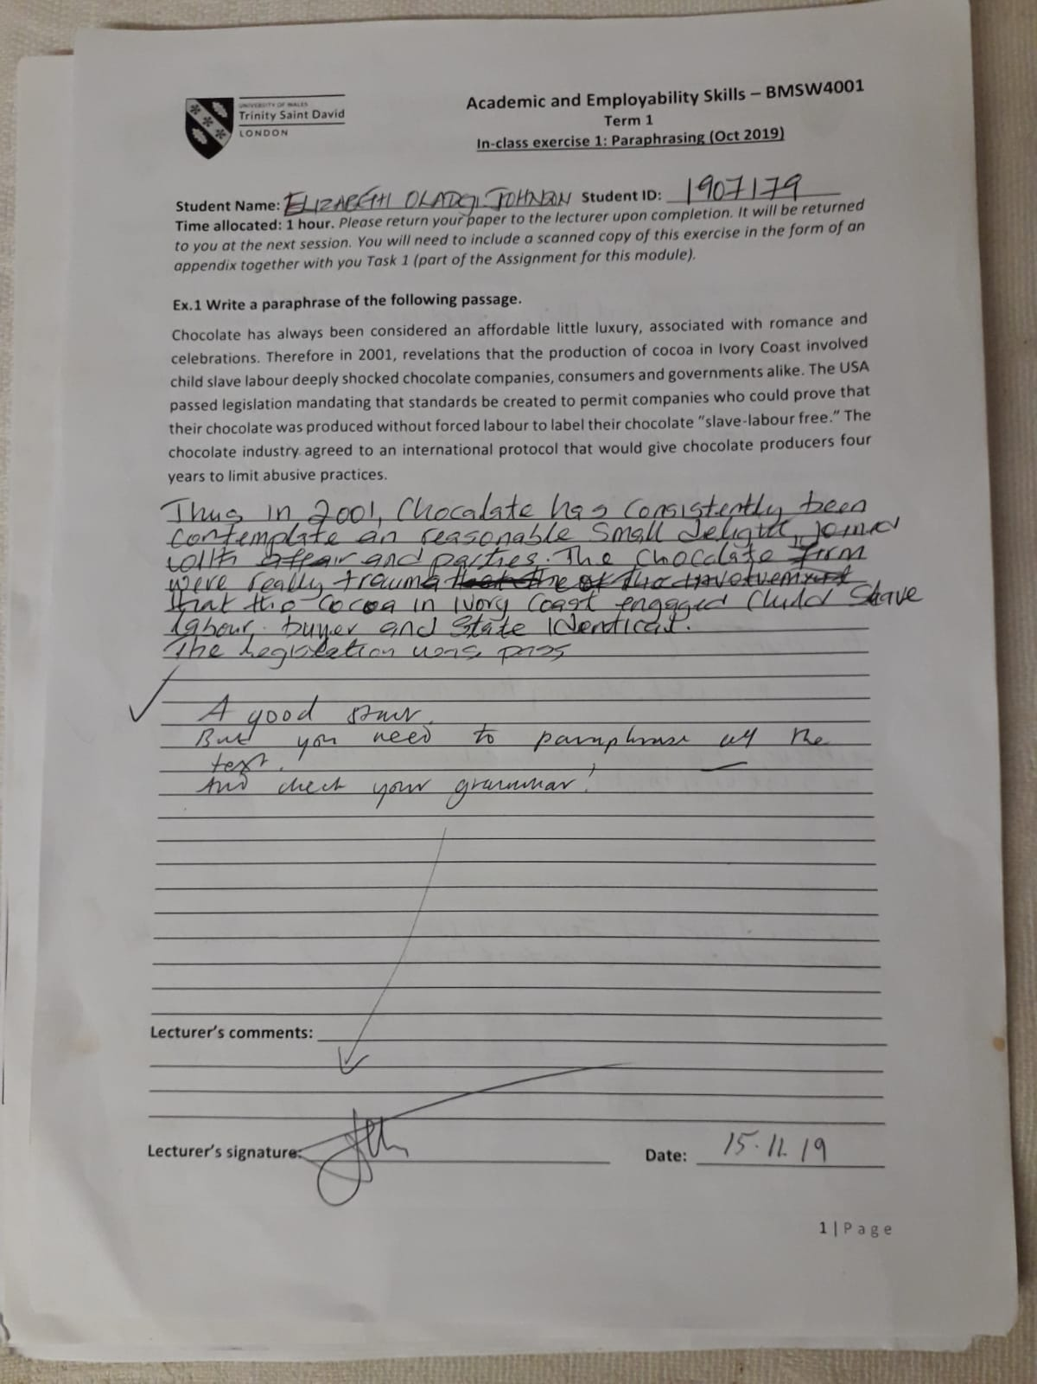
Paraphrasing 2
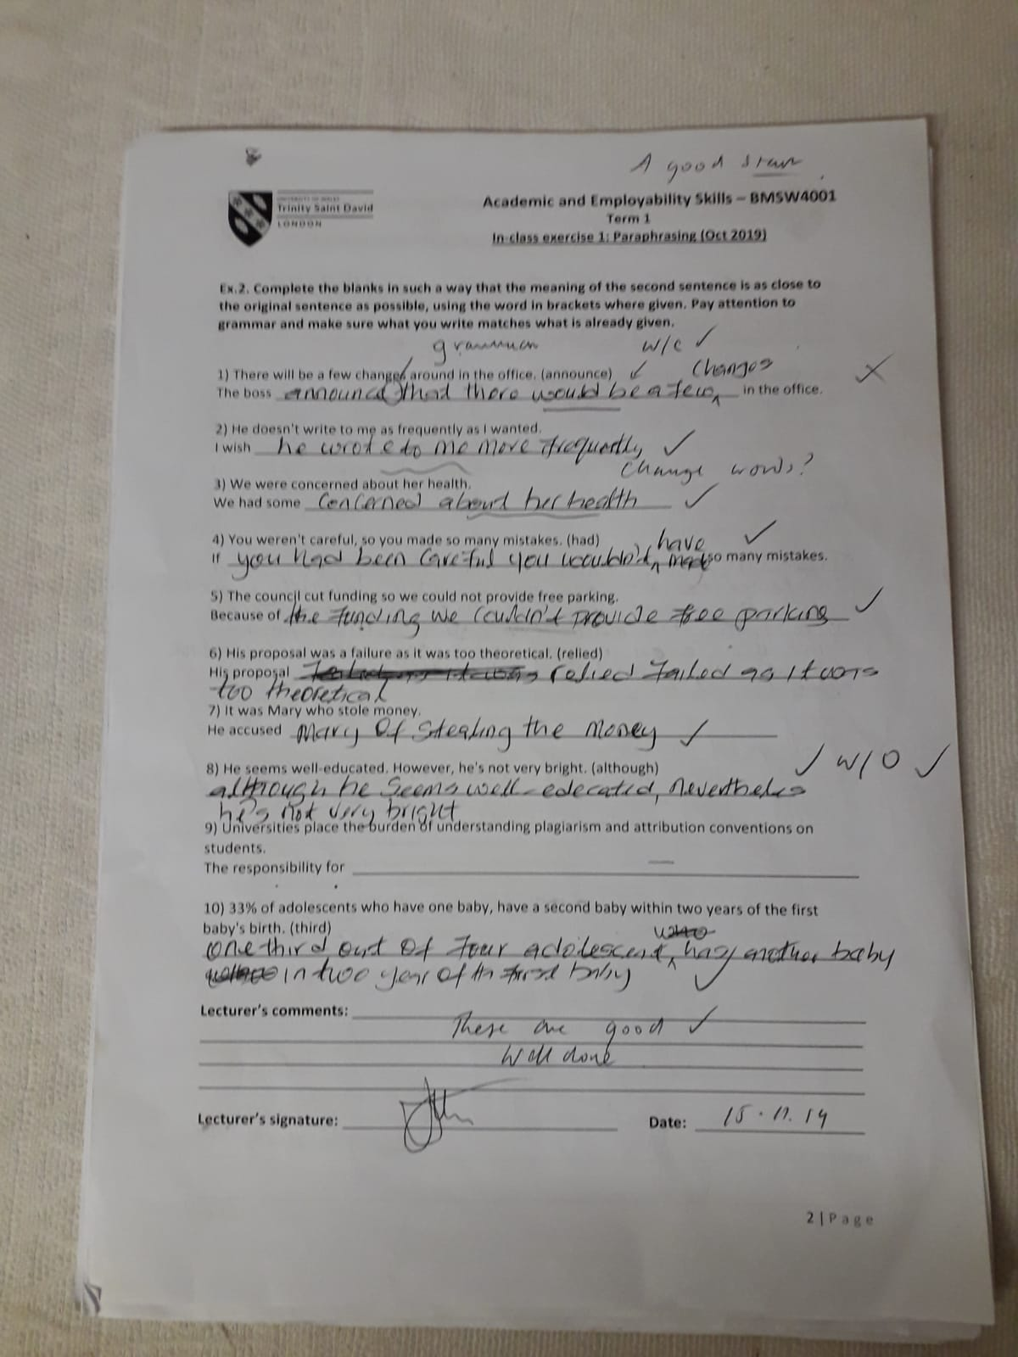

Paraphrasing 3
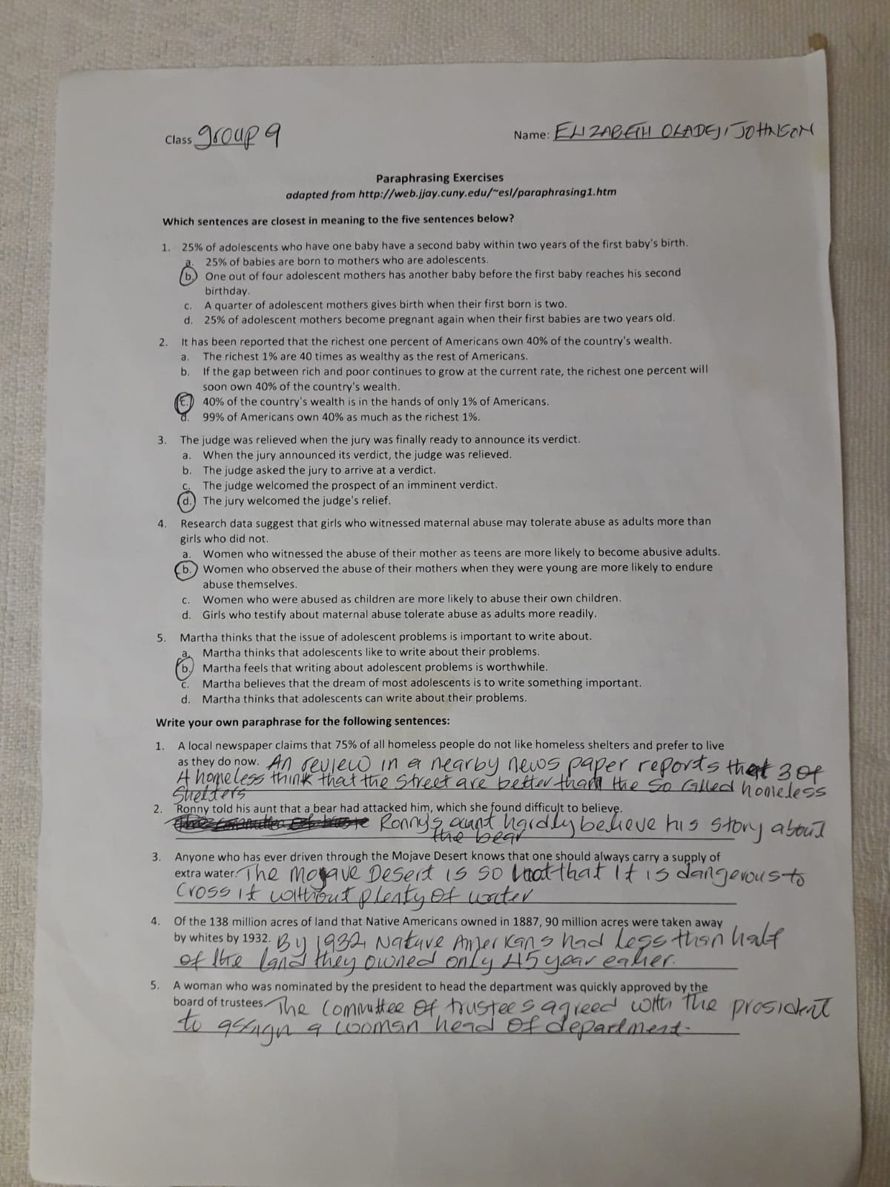

Paraphrasing 4
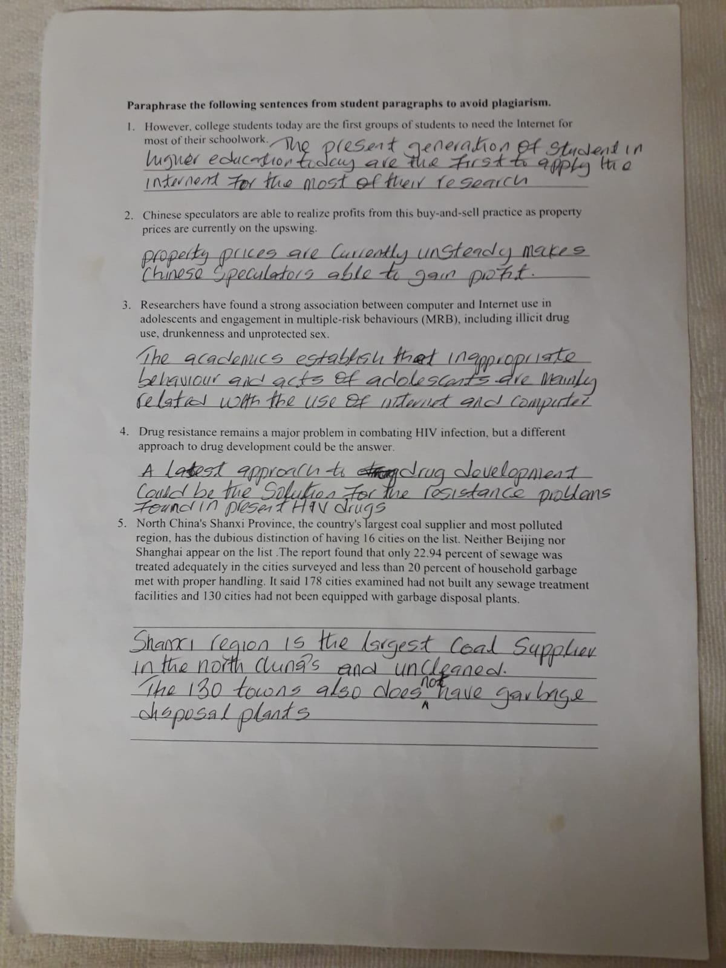

Summarising 1
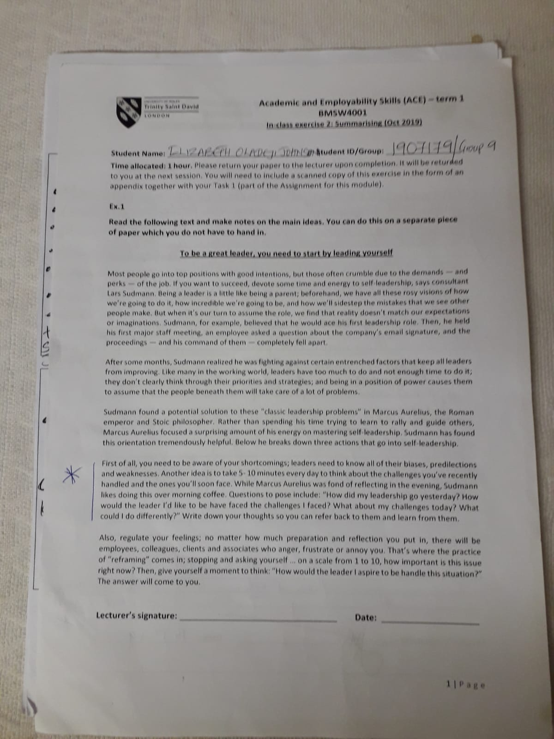

Summarising 2
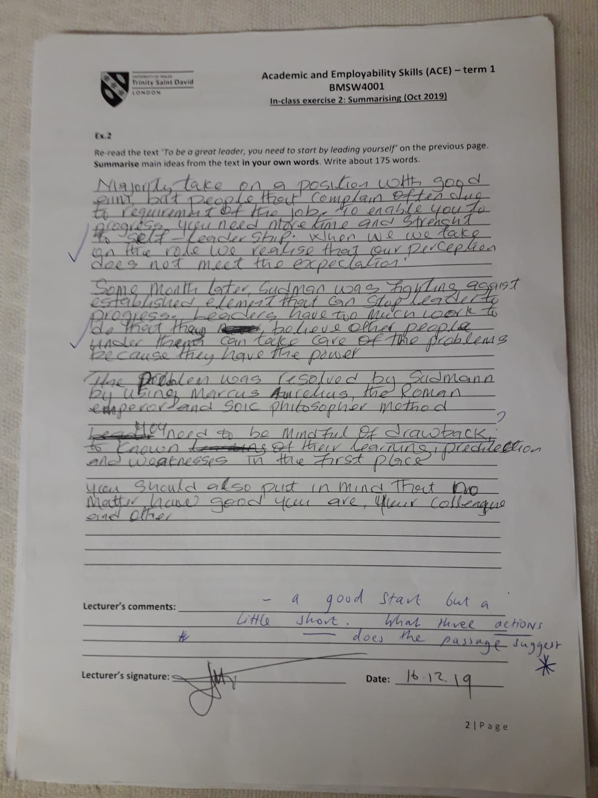

SWOT Analysis
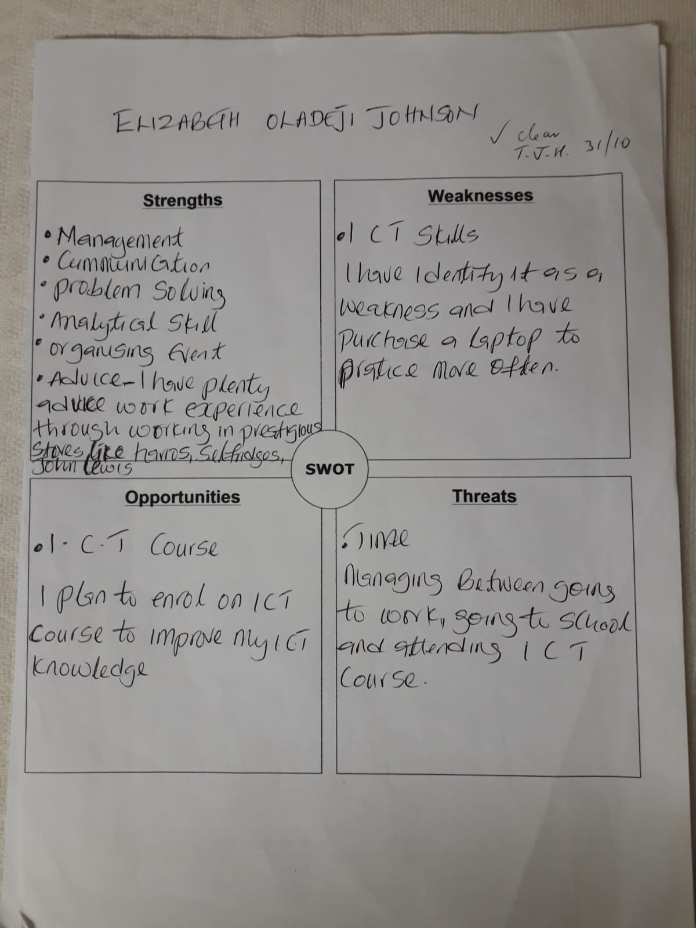

Time management
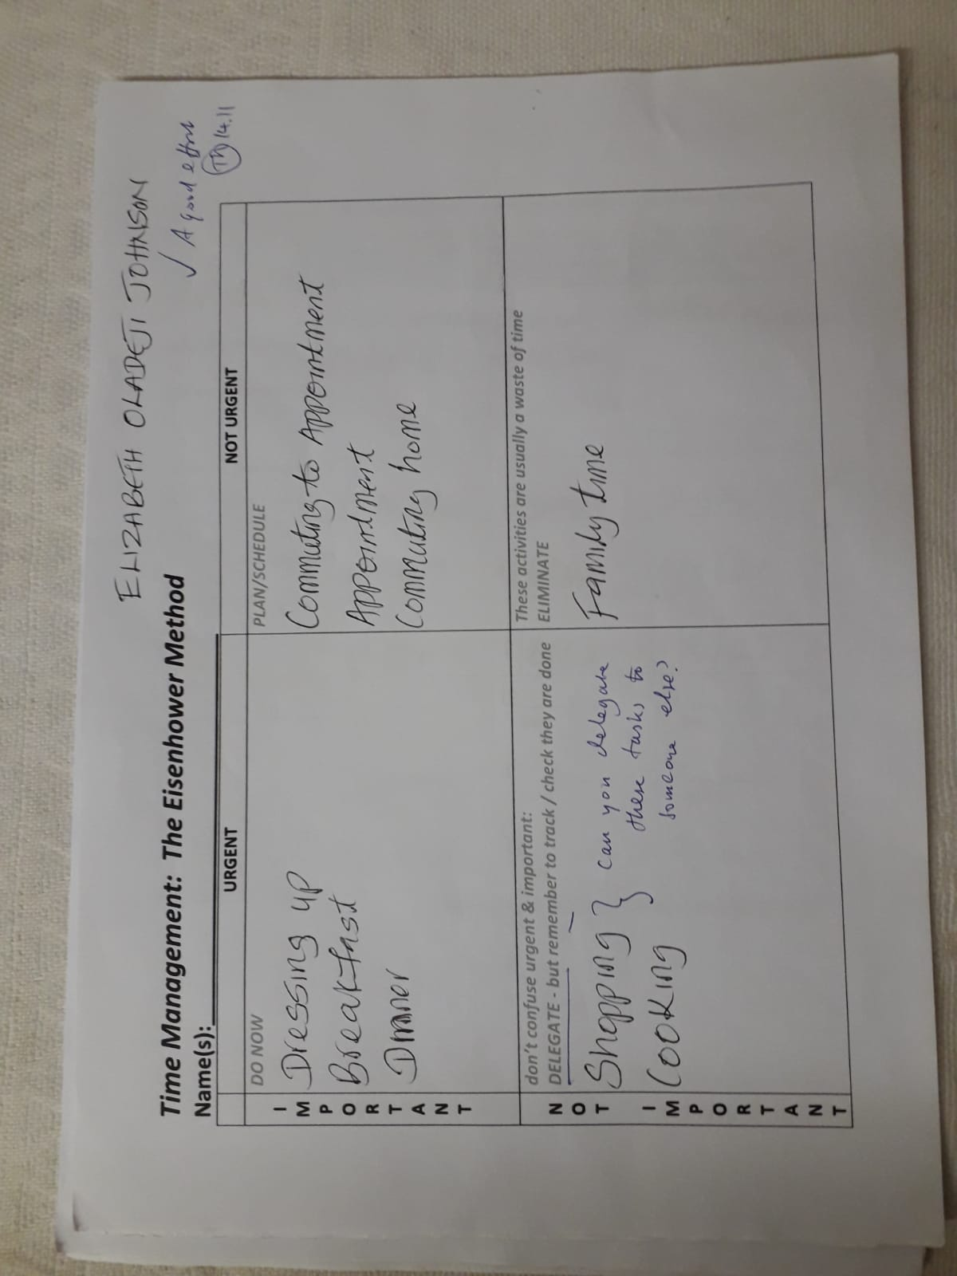

PDP 1
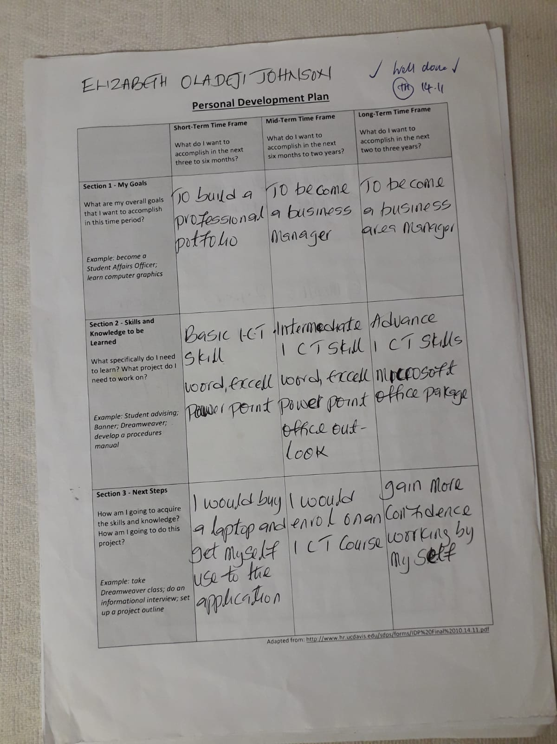

PDP 2
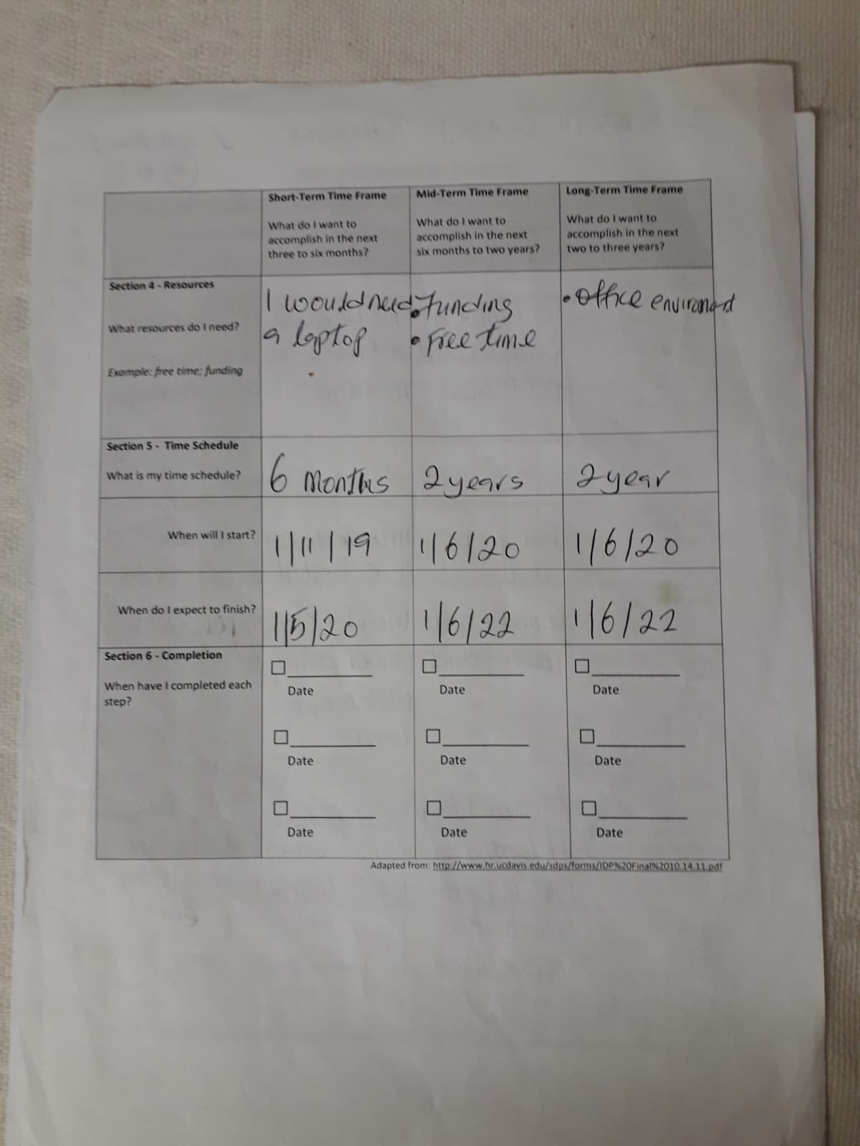

Weekly Diary Management
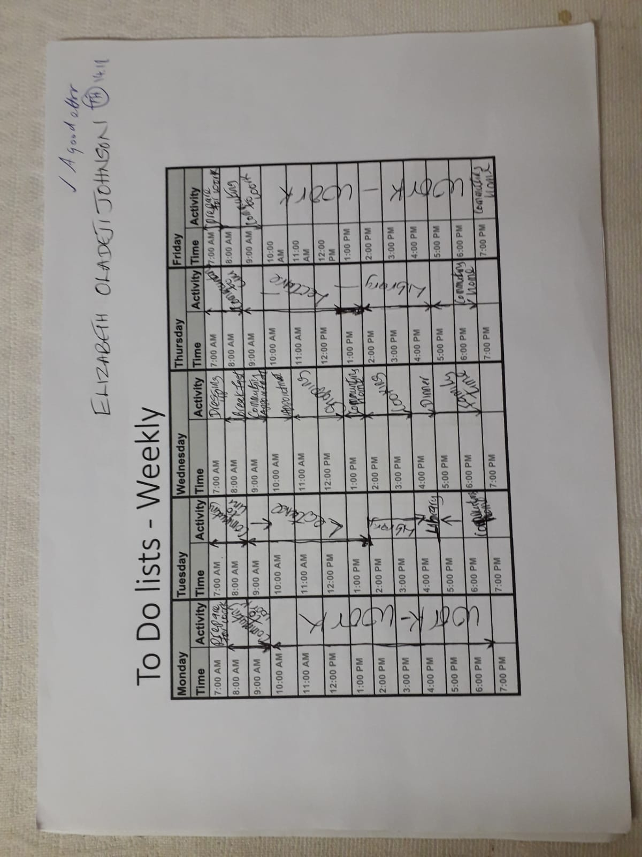

Daily Diary management


