Destination Management

Module name: Sustainable Hospitality & Tourism Management
Module code: BMIH5006
Student Name: Nicolae Eduard Gura
Student number:211789
Lecturer’s name: Ruth Taylor-Davies

Introduction
Tourism and hospitality are one of the largely affected industries due to the breakout of the COVID-19 pandemic. The pandemic has stopped all commercial activities related to this industry and shown the importance of sustainable tourism that reduces the negative impact of economic, socioeconomic, and environmental factors (Scott, 2021). Sustainability in the tourism and hospitality industry refers to the mindful use of resources and providing services that do not damage or use up resources (Guo et al., 2019). Sustainable good practices in the tourism and hospitality industry increase tourists' visits and reduce negative impacts on the environment. This report is going to evaluate the principles of sustainability and sustainable good practices in the hospitality and tourism industry. It will include an evaluation of a renowned tourist spot ‘Lake District National Park’ in North West England.

Principles of sustainable tourism
Sustainable tourism matters as tourism mainly depend on natural beauty and cultural heritage that attracts people from around the world. For example, London city is one of the oldest cities with strong and glorious history with numerous cultural heritages scattered around the city that attracts millions of tourists every year around the world (Scott, 2021). Similarly, Lake District National Park is famous for its mountains, lakes, and natural beauties that attract hundreds of thousands of people every year. Sustainable tourism can be defined as the mindful use of resources that do not harm the environment, society, and economy surrounding the area of tourist attraction (Chang et al., 2020).
Sustainable tourism is a way of using resources that could meet the demand for future generations after meeting the current demand. Mass and unplanned tourism is a threat to the area and can damage the attractiveness of the area. To maintain sustainable tourism individuals and organisations involved must follow some principles to preserve the socio-economic culture and environment. The World Wide Fund for Nature, a Switzerland-based international ono-government organisation, has provided ten principles of sustainable tourism which are described below (Hall, 2019).
- Sustainable use of resources: organisations and individuals should consume natural resources in such a way that makes sound business sense and preserve the environment (Scott, 2021).
- Reduce over-consumption and waste: overconsumption and waste increase the cost of restoring and damage the living standards of future generations.
- Preserve biodiversity: preserving social, cultural, and natural diversity increases environmental resilience and sustainable tourism.
- Planned tourism: tourism should integrate into national and local development and growth planning and assess the impact on the environment to take collective actions that increase sustainability (Scott, 2021).
- Support local economies: tourism should support local economic activities and minimise environmental damages to sustain long term (Guo et al., 2019).
- Involve local society and communities: the industry should involve local communities, societies, and cultures to provide the best services to travellers and achieve sustainability.
- Consult stakeholders: the businesses and individuals in the industry should consult stakeholders regarding their concerns and expectations from tourism to achieve the validity of tourism (Rasoolimanesh et al., 2020).
- Provide training to staff: training and development improve the ability and knowledge of employees working in the sector which can enhance service quality and customer satisfaction.
- Promote tourism responsibility: businesses and authorities should communicate the expected behaviour from tourists visiting natural and cultural heritage to protect the environment from human damage (Hall, 2019).
- Undertake research and development: research about biodiversity regarding nature and changes in environmental patterns could help the authority and businesses to prevent damages.

Association of sustainable tourism principles with the general principles of development.
The general principles of development are principles of continuity, integration, and sequential, and constant interaction between all factors. Sustainable tourism principles are required to be associated with general development principles to achieve sustainable development that benefits all stakeholders. Development must be continuous process organisations and individuals related to the tourism industry continuously develop their products, services, and business process until it reaches maximum social, economic, and environmental benefits (Fan et al., 2018). Sustainable tourism also requires tourists to follow some guidelines to respect cultural and social differences and avoid activities that could damage the environment, and cultural heritage of the place (Guo et al., 2019).
Lake District National Park is one the largest tourist attraction in the UK with annual visits of over 15.8 million and it is increasing every year. The businesses and local firms operating in the area should take steps to preserve natural beauty with proper guidelines and follow the principles of sustainable tourism. Another important principle of general development is that it requires the integration of all factors and stakeholders into the development. The residents and local businesses surrounding Lake District National Park must be integrated with the planning and development of tourism in the area. For example, the surrounding agricultural land of the area is mostly owned by farmers who reside there. The support of the local community to increase and retain visitors in the area as their behaviour largely affect the experience and satisfaction of tourists.
The principle of integration, involvement of local society and communities, and support to local economies are followed by the authority of Lake District National Park as most of the land business organisations operating in the area are privately owned by the residents. For example, 55% of the total area of the national park is registered as agricultural land to support local farmers where public access is restricted. Moreover, 25% land is owned by the national trust with most of the scenic places and lakes providing tourist access to the most beautiful sights in the area. The forestry commission is responsible for overlooking the forest and woodland areas that allow for preserving biodiversity and reducing the the consumption of natural resources to achieve sustainable tourism (Rasoolimanesh et al., 2020).
Some authorities are also involved in preserving the national park which is United Utilities, and Lake District National Park Authority which owns 8% and 3.9% of the total land, respectively. These authorities are responsible for setting guidelines, planning tourism, training employees, and undertaking research and development initiatives (Grilli et al., 2021). Tourists can move around on public routes, but access is restricted on farmlands and private properties to preserve local assets. The practices help the Lake District National Park to achieve sustainable tourism. The National Park Authority provides different services to tourists through an information centre, boating centre, and country house (Scott, 2021). The authorities involved in Lake District National Park have developed sufficient parking areas, doubling capacity on lake lines, EV charging stations, connection to national highways, and other transportation facilities.

Butler’s life cycle model
Prof. Richard W. Butler has developed the model to understand the relationship between tourism carrying capacity and sustainability. He argues that tourist attractions are fragile and need to carefully be handled without exceeding the total capacity and damaging the attractiveness of the spot (Holladay, 2018). The Lake District National Park is in the Consolidation Stage where the total number of visitors has reached the total capacity and the local economy is tied with tourism.
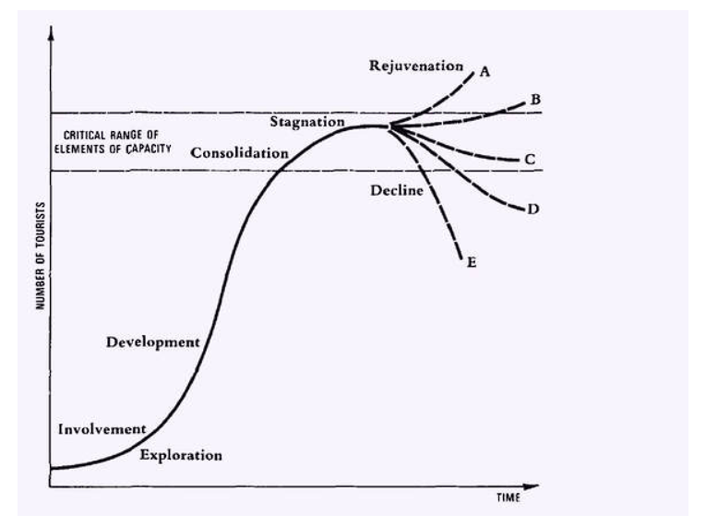
Figure 1 Butler’s life cycle model (Holladay, 2018)

The stages of tourism according to Butler’s life cycle model,
- The Exploration Stage: in this stage, the area is explored, and a small number of tourists come to the spot. The natural beauty of the place attracts tourists in the case of The Lake District National Park. Tourism has little or no social and economic significance to the area.
- The Involvement Stage: in this stage, local people and businesses involve with the tourism industry and differentiate products and services according to the expectations of tourists (Grilli et al., 2021). Dedicated tourism facilities such as restaurants, guests house, and hotels are developed in the area.
- The Development Stage: in this stage, diffident governmental and local authorities are formed to provide facilities to tourists and improve infrastructure in the area (Scott, 2021). There are several local and government authorities are involved in The Lake District National Park to preserve the rights of both tourists and local communities.
- The Consolidation Stage: The Lake District National Park is in this stage where it attracts many tourists in the area that exceeds the total number of populations in the area. The economy of The Lake District National Park is tied to tourism and different businesses and authorities have taken marketing programs to attract tourists.
- The Stagnation Stage: in this stage, the number of annual visitors reaches the maximum level and causes different problems to society, the economy, and the environment of the area (Holladay, 2018).
- The Decline Scenario: it is the last stage where the number of visitors declines as the environmental and social factors damage due to over-tourism. Authorities of the Lake District National Park should be prepared to overcome such incidents with proper planning and integration of residents.

Doxey’s Irridex model
The Irridex model is developed by Doxey in 1975 where he demonstrated the residents’ attitude towards tourism in the area.
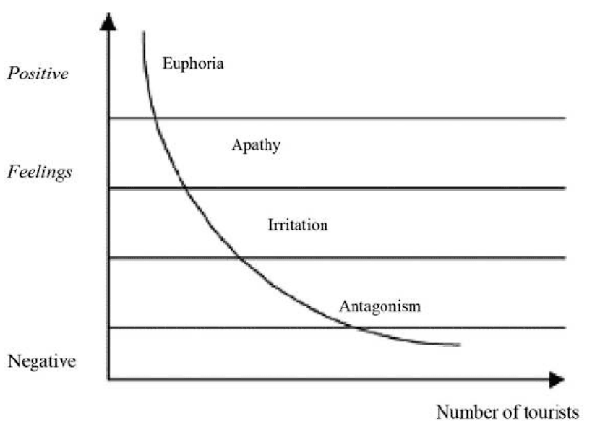
Figure 2 Doxey’s Irridex model (Pavlić and Portolan, 2015)
Euphoria: In the first stage, the people may feel positive regarding the tourism prospect in the area and support the local government or form authority to exploit the opportunity. They feel enthusiastic about new development in the area and see it as an opportunity to gain economic independence. The residents of Lake District National Park have passed the stage with numerous infrastructural developments in the area.
Apathy: In the second stage, the population possess neutral feelings and see tourist as their sources of income and economic growth. The residents of Lake District National Park are on the stage and see the tourists as an opportunity for economic development in the region.
Annoyance: in this stage, people start feeling irritated about the movement of people and the increased traffic and pollution in the area (Pavlić and Portolan, 2015).
Antagonistic: in the last stage, people express their irritation and annoyance to tourists in different ways and travel in the area starts to decrease.

Recommendations
- The Lake District National Park should increase research and development regarding preserving the forest areas, lakes, and scenarios to track changes in biodiversity and ecology.
- Tree plantation, restricting access to sensitive areas, improving water quality, and installing new EV charging stations will help them to achieve sustainability and reduce environmental damage.
- Authorities should provide financial incentives to firms and farmers in the area to increase the development of the living standard of the local community which will create a positive and supportive environment for tourism (Streimikiene et al., 2020).

Conclusion
The tourism industry has one of the most dynamic and complex supply chains that require constant development and innovation to become competitive in the market. The changing business environment and customer behaviour are requiring new shapes in the tourism industry to attract and survive in the market (Fan et al., 2018). Sustainability is vital for the survivability of the industry as damaging social, and environmental attractions could lead to damaging the tourism prospects of an area (Chang et al., 2020). The report has evaluated the importance of sustainable tourism and how it can be achieved. It has also evaluated the opportunities and conditions of tourism prospects in The Lake District National Park.

References
Chang, C.-L., McAleer, M. and Ramos, V. (2020) ‘A charter for sustainable tourism after COVID-19’, Sustainability, 12(9), p. 3671. doi:10.3390/su12093671.
Fan, D.X., Liu, A. and Qiu, R.T. (2018) ‘Revisiting the relationship between host attitudes and tourism development: A utility maximization approach’, Tourism Economics, 25(2), pp. 171–188. doi:10.1177/1354816618794088.
Grilli, G. et al. (2021) ‘Prospective tourist preferences for sustainable tourism development in Small Island Developing States’, Tourism Management, 82, p. 104178. doi:10.1016/j.tourman.2020.104178.
Guo, Y., Jiang, J. and Li, S. (2019) ‘A sustainable tourism policy research review’, Sustainability, 11(11), p. 3187. doi:10.3390/su11113187.
Hall, C.M. (2019) ‘Constructing Sustainable Tourism Development: The 2030 agenda and the managerial ecology of Sustainable Tourism’, Journal of Sustainable Tourism, 27(7), pp. 1044–1060. doi:10.1080/09669582.2018.1560456.
Holladay, P.J. (2018) ‘Destination Resilience and Sustainable Tourism Development’, Tourism Review International, 22(3), pp. 251–261. doi:10.3727/154427218x15369305779029.
Pavlić, I. and Portolan, A. (2015) ‘Irritation index, tourism’, Encyclopedia of Tourism, pp. 1–2. doi:10.1007/978-3-319-01669-6_564-1.
Rasoolimanesh, S.M. et al. (2020) ‘A systematic scoping review of sustainable tourism indicators in relation to the Sustainable Development Goals’, Journal of Sustainable Tourism, pp. 1–21. doi:10.1080/09669582.2020.1775621.
Scott, D. (2021) ‘Sustainable tourism and the Grand Challenge of Climate Change’, Sustainability, 13(4), p. 1966. doi:10.3390/su13041966.
Streimikiene, D. et al. (2020) ‘Sustainable Tourism Development and competitiveness: The Systematic Literature Review’, Sustainable Development, 29(1), pp. 259–271. doi:10.1002/sd.2133.

