Using Inputs in Python

So far, we have hard-coded the contents of variables.

We can also prompt the user to enter their own values using the input() function.

We always input into a variable (because we need to store the value somewhere!)

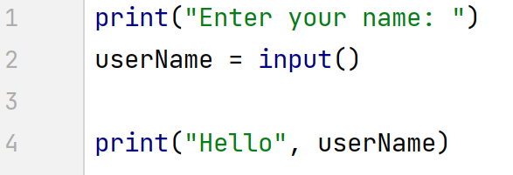
whatever the user types in
is stored in userName

Above, the Python console will pause on line 2 above until the user has input something. Then it will continue to line 4.

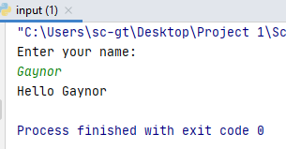

You can have as many inputs as you like:

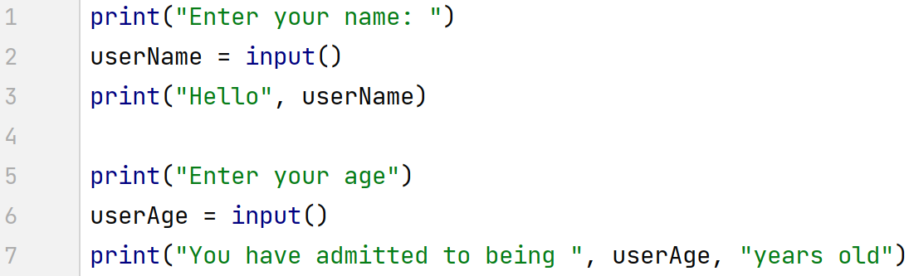

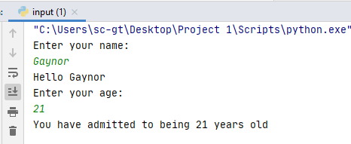

Shorter syntax

Above I wrote the inputs like this:

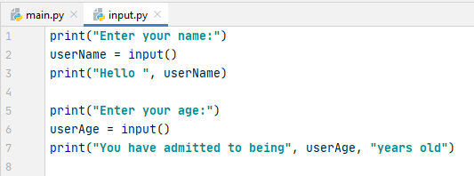

However, you can also write inputs like this:

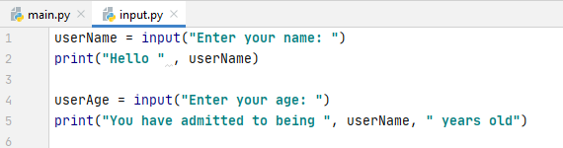

There is a slight difference in the console output, as it invites you type on the same line as the print statement automatically.

(You can also achieve this when using the long method by supressing the line break – print("Enter your name", end="")

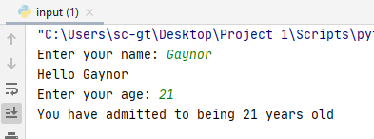

Setting types for inputs

You can also specify the types for inputs. By default, Python infers that any input is a string, even if a number is entered. To prove it, I've printed out the type of userAge below. You might expect that because my input is a number (21), Python would infer an int type– but it doesn't!

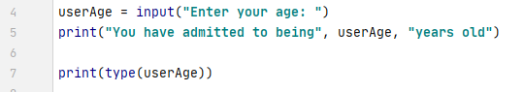

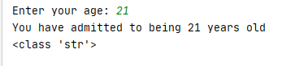

We can, however, force Python to think of userAge as a number by specifying the type. We add this to the input line.

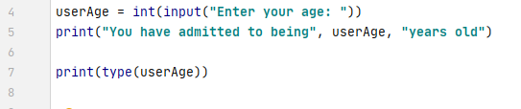

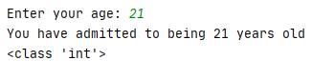

It is important to think about the types your input will need to be and get them right. Otherwise your program might start doing unexpected things. To highlight the problem, look at the following code:

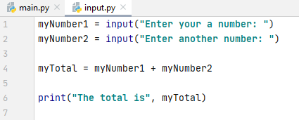

At face value, this looks like a program to allow the user to enter two numbers, add them, and then print out the answer. However, something isn't right:

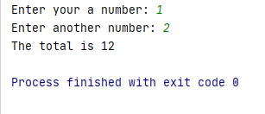

Python has automatically inferred myNumber1 and myNumber2 to be strings. Therefore it has simply concatenated (stuck together!) the numbers, as if they were strings. This is why it has printed out 12 instead of 3.

If I add input types however, all becomes well:



