
Databases and Application Development
(ACCA5026)

Component 1Part B
Report Documentation

Student Name: Adefemi ADETUNJI
Student ID: 2408970
Course Name: BSc (Honours) Applied Computing
Module Code: ACCA5026

Contents
1
Part B – SQL Injection and Security 3
SQL Injection Overview 3
Identifying Vulnerabilities in SwiftRide 6
Anti-SQL Injection Defences 9
SQL Injection Testing 11
Weaknesses and Improvements 14
IEEE References 16

Part B – SQL Injection and Security

SQL Injection Overview
SQL Injection is a security vulnerability that occurs when an attacker manipulates input submitted to a website to alter an intended SQL query. This is particularly relevant to database-driven websites such as SwiftRide, which uses PHP to communicate with a MySQL database[1]. If user input is directly inserted into SQL statements without suitable protection, an attacker may attempt to access, modify or delete information without authorisation. For example, an attacker could enter ‘OR ‘1’=’1 into a vulnerable login form to manipulate query logic. Successful SQL Injection may compromise confidentiality, integrity and availability by exposing personal information, changing records or damaging databases [2],[3]. Therefore, secure database access is essential for protecting SwiftRide customer and booking information.
Username: admin
password: admin123
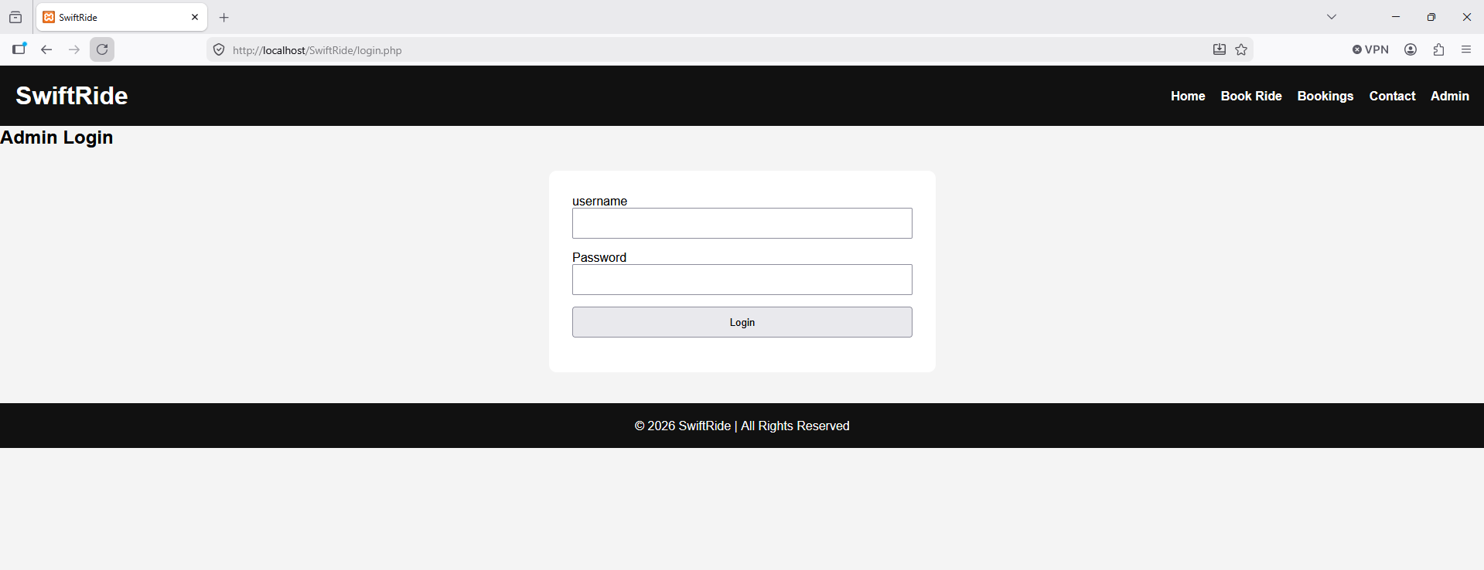
Figure1:: Screenshot of blank admin login detail.
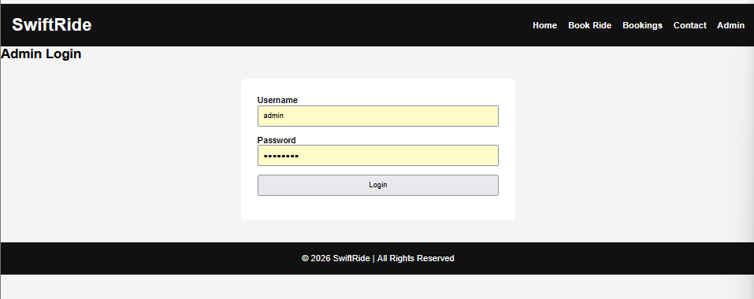
Figure 2:: Screenshot of customer login details
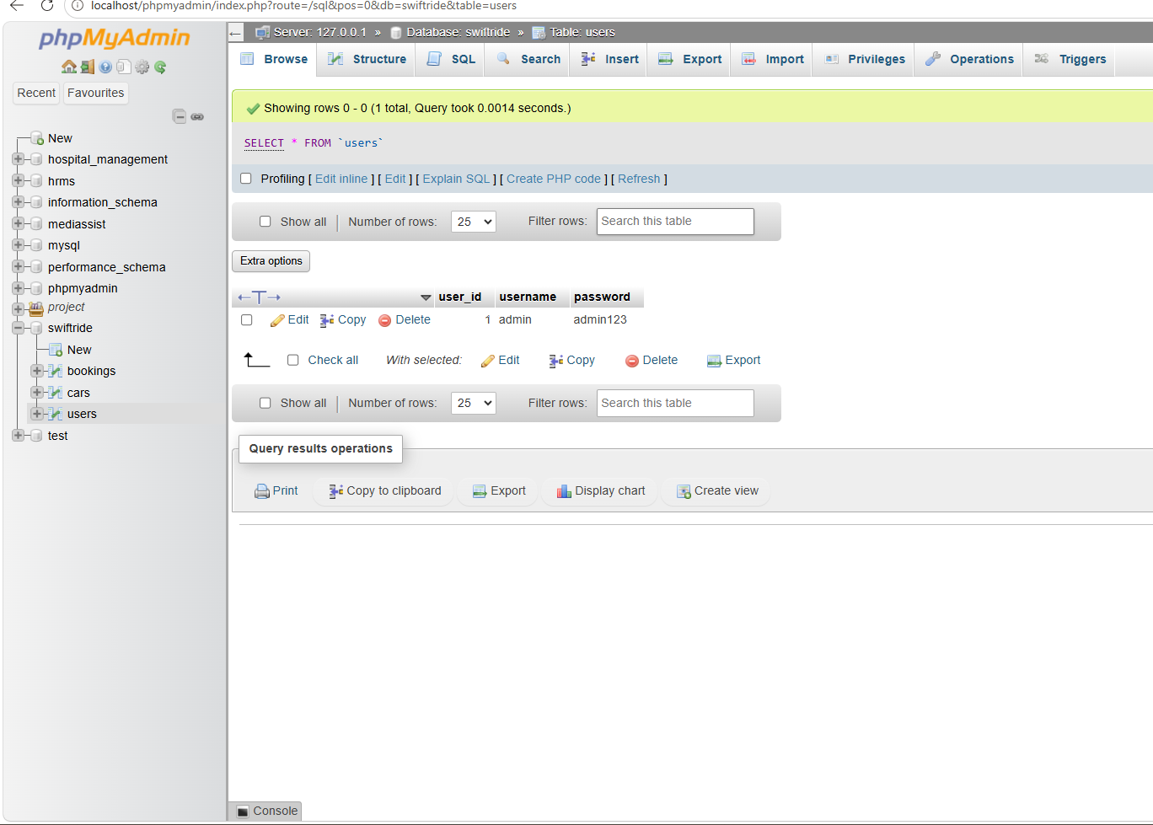
Figure3: screenshot of PHP user login details.
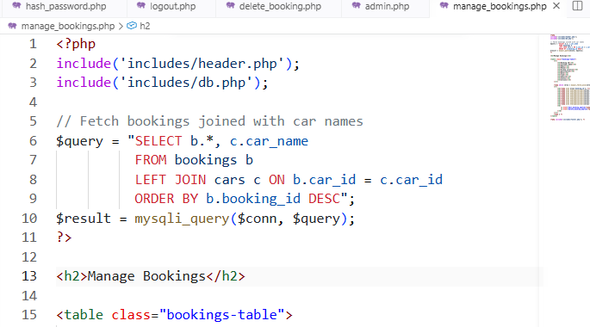
Figure 4 illustrates a vulnerable SQL query where user input is directly concatenated into the SQL statement. An attacker could enter malicious input such as ' OR '1'='1 to alter the query logic and potentially bypass authentication. This type of coding practice should be avoided because it allows SQL commands to be manipulated.

Identifying Vulnerabilities in SwiftRide
SwiftRide processes user-controlled information through its booking form, administrator login, editing and cancellation functions. For example, the booking ID used by the Edit and Cancel buttons may be passed through a URL using a GET parameter, such as edit booking.? id=1, while booking details are submitted through POST requests. These values should be considered untrusted because users can modify information sent to the application. If they were directly concatenated into SQL queries, the website could become vulnerable to SQL Injection. CWE identifies improper neutralisation of special elements in SQL commands as a weakness that can allow attackers to alter database queries [4]. NIST also recommends identifying and addressing software vulnerabilities throughout development [5]. Therefore, SwiftRide's database operations should be reviewed to identify where external input enters SQL queries [6].
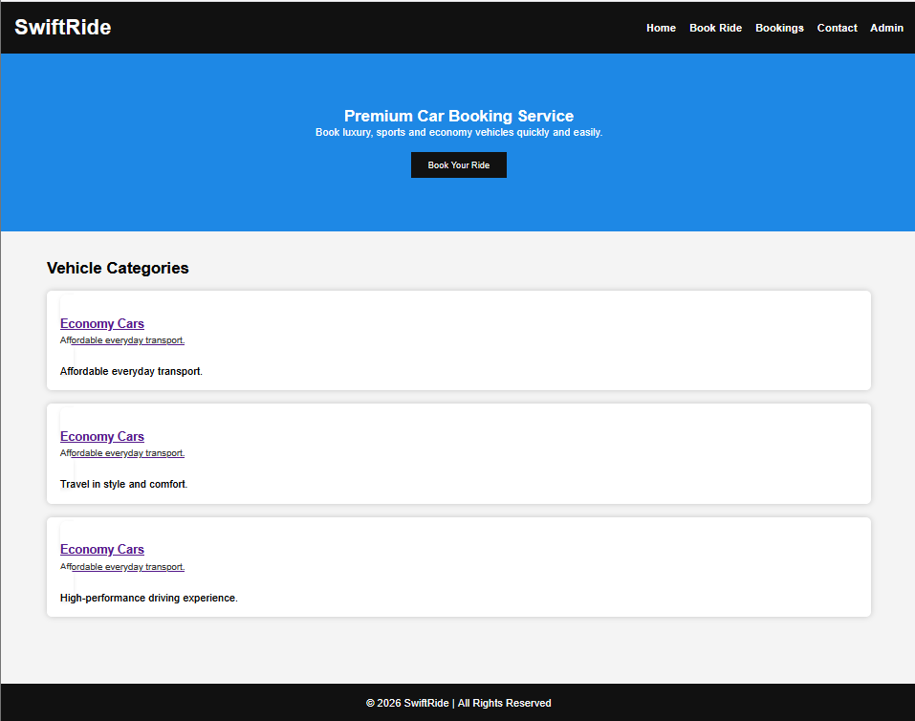
Figure 5: The screenshot of SwiftRide booking webpage.
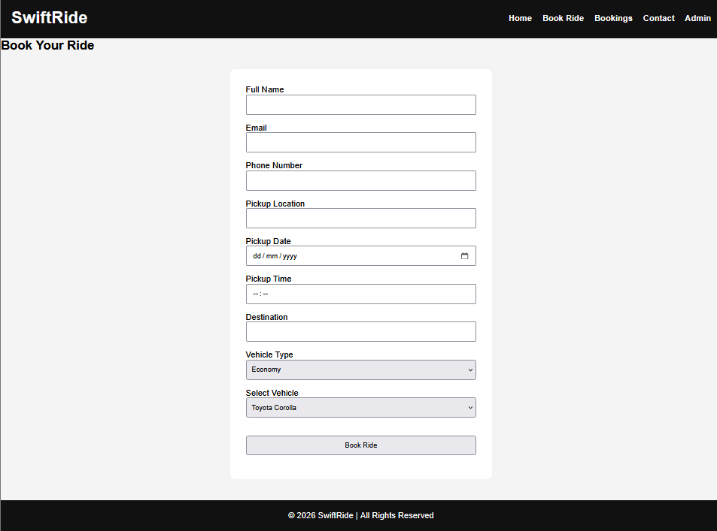
Figure 1: The screenshot of booking page with customer information.

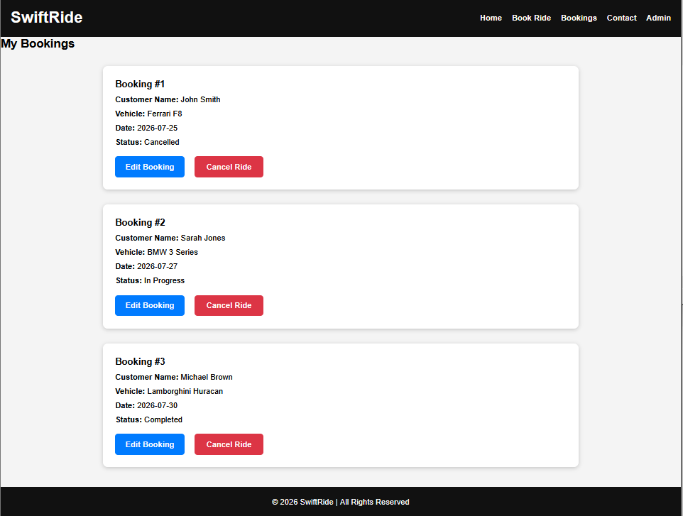
Figure 6: Screenshot of booking category of cars available.

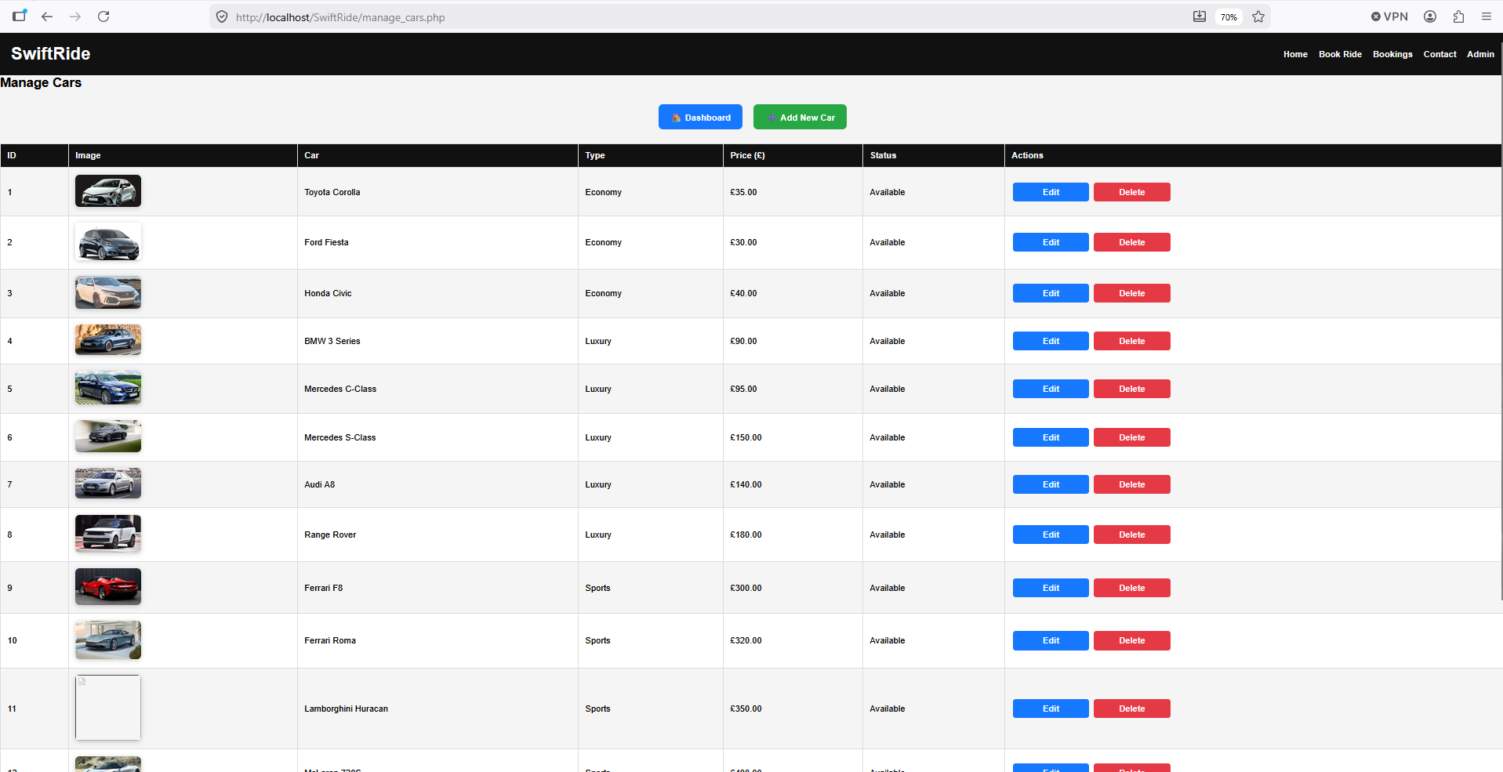
Figure 7: The screenshot of car category with price, edit and delete.

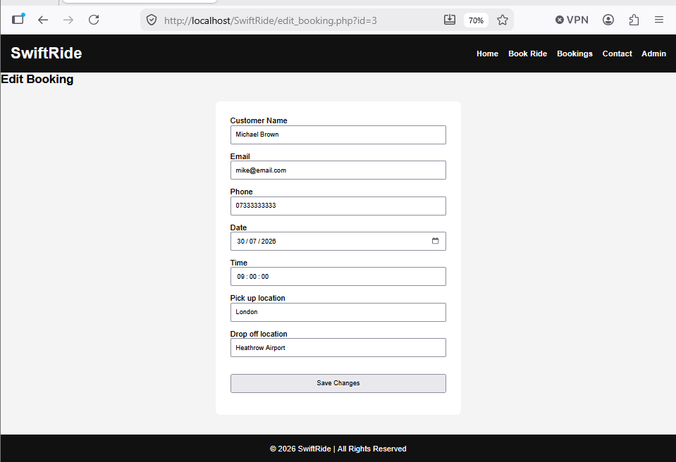
Figure 8: The screenshot of edit booking take place.

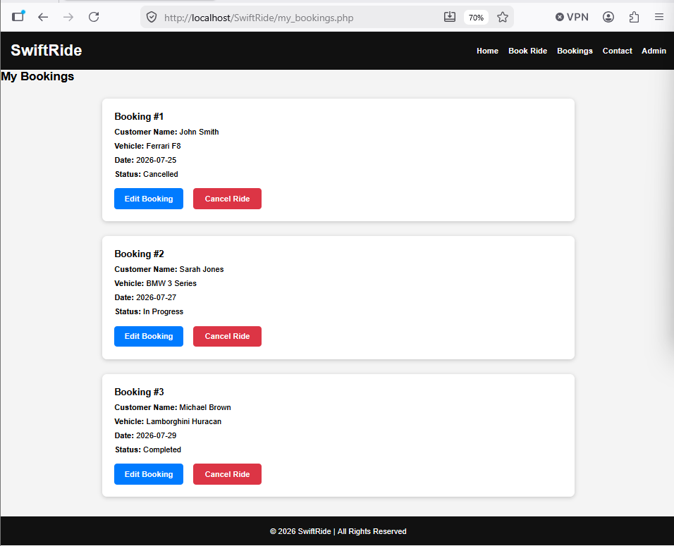
Figure 9: Screenshot of bookings has been made.

Anti-SQL Injection Defences
The main defence implemented in SwiftRide is the use of prepared statements and parameterised queries. Instead of directly inserting user input into an SQL command, prepared statements use placeholders represented by? with values supplied separately through functions such as bind Param(). For example, when cancelling a booking, the booking ID is passed as a parameter to an UPDATE statement. This ensures that the value is treated as data rather than executable SQL syntax [7]. Parameterised queries are widely recommended for preventing SQL Injection because they separate SQL instructions from user-supplied values [8]. Additional protection includes validating input, checking booking IDs are valid integers and using HTML special chart () when displaying database information [9].
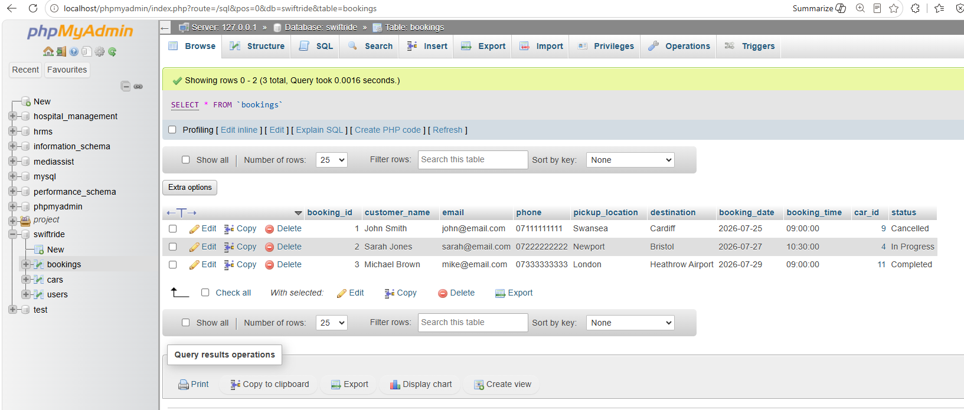
Figure 10: The screenshot of booking page on PHP.
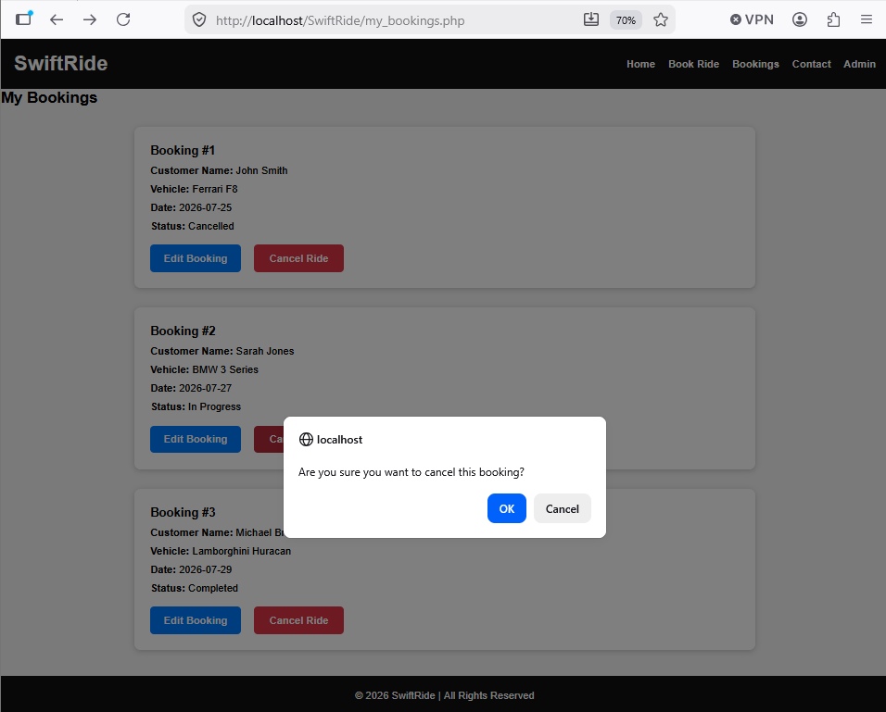
Figure 11: The screenshot of cancelation in process.
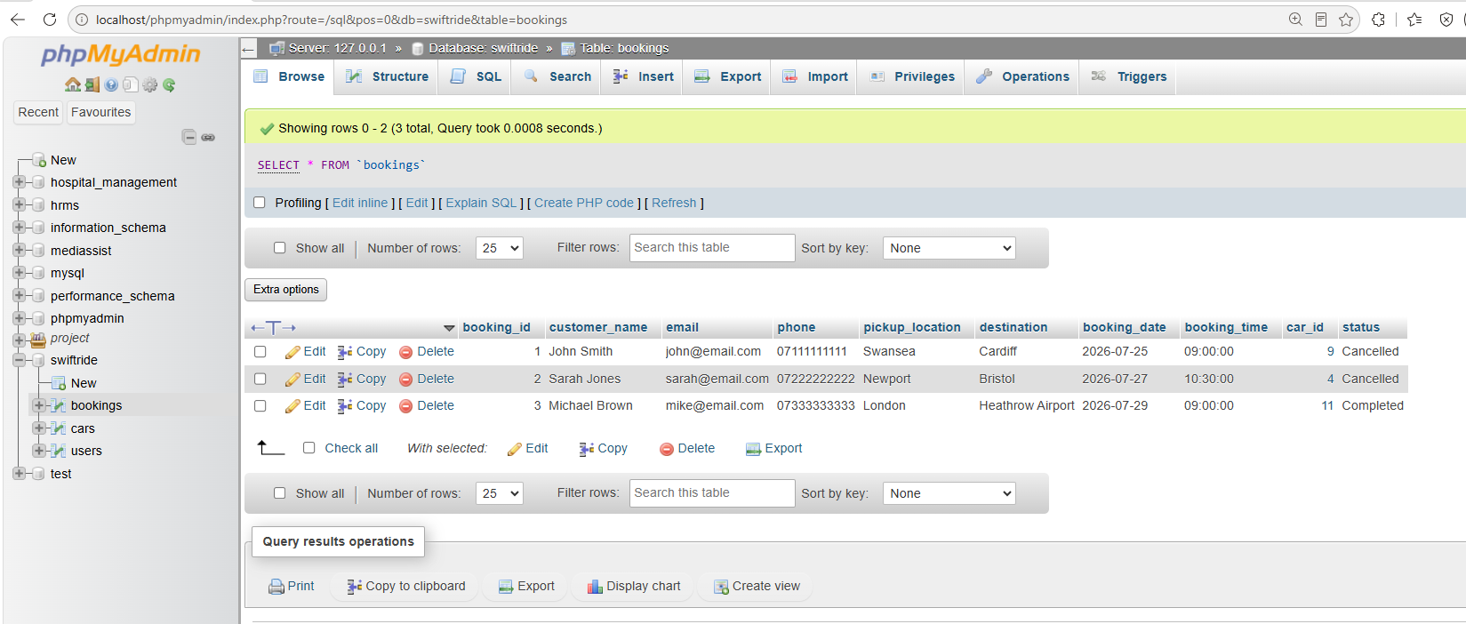
Figure 12: Screenshot of cancelation has been made.

SQL Injection Testing
SwiftRide should be tested using controlled SQL Injection attempts to determine whether its security measures are effective. For example, an attempted login using ‘OR ‘1’=’1’ can test whether authentication can be bypassed. Screenshots showing the attempted input and resulting response should be included in the report. If prepared statements are correctly implemented, the input should be treated as ordinary data and should not alter the intended query [10],[11]. Similar tests can be performed on booking IDs and search fields. Testing should only be conducted on the developer's own website or an authorised environment. The results can demonstrate whether SwiftRide security controls are effective and identify areas requiring improvement [12].
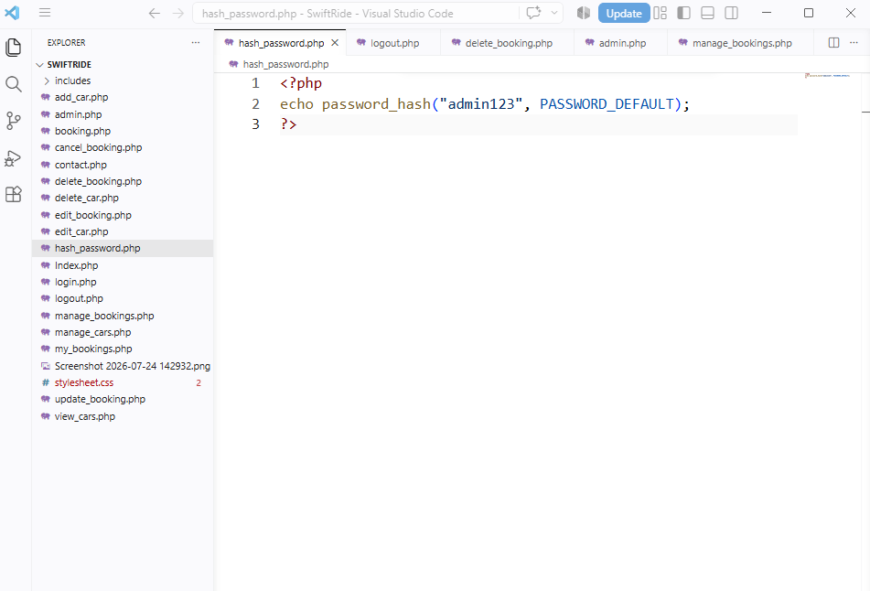
Figure 13: Screenshot of default password.
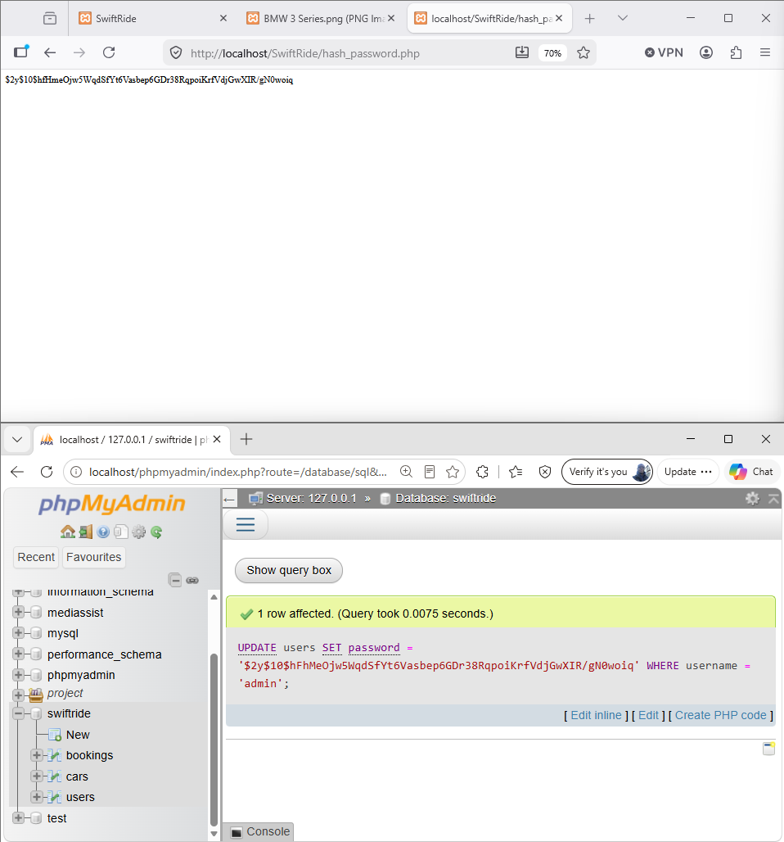
Figure 14: The screenshot of username and hash password in my PHP page.

Weaknesses and Improvements
Although prepared statements provide strong protection, security should be applied throughout the entire application. Any SQL queries that directly concatenate $_GET or $_POST values should be replaced with parameterised queries [13]. Administrator passwords should be securely hashed using functions such as password hash() rather than stored in plain text [14]. Input validation should also be applied to names, emails, telephone numbers and booking dates. Database permissions should follow the principle of least privilege, ensuring that the application only receives the access it requires [15].
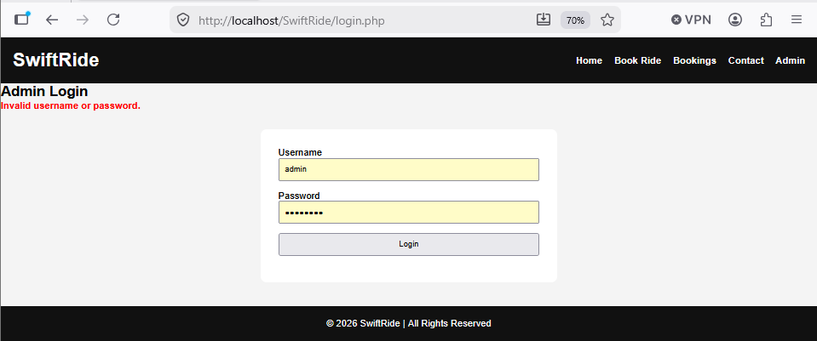
Figure 15: the screenshot of wrong login details
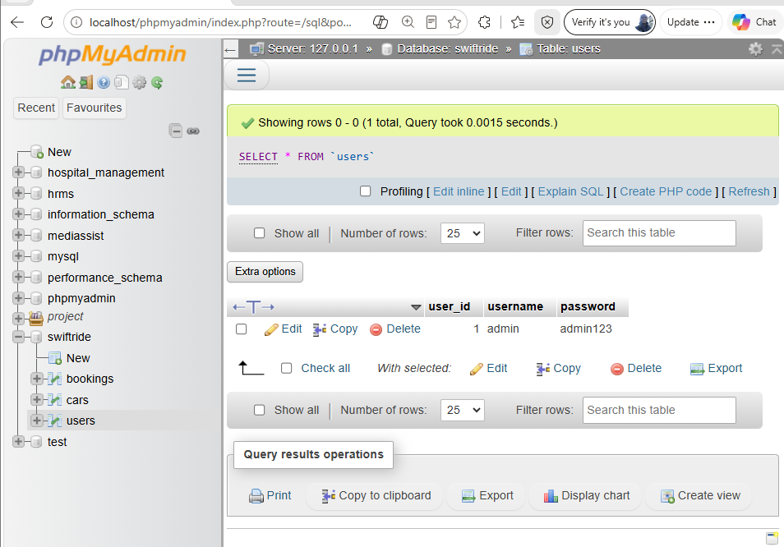
Figure 16: Users booking login detail on PHP.
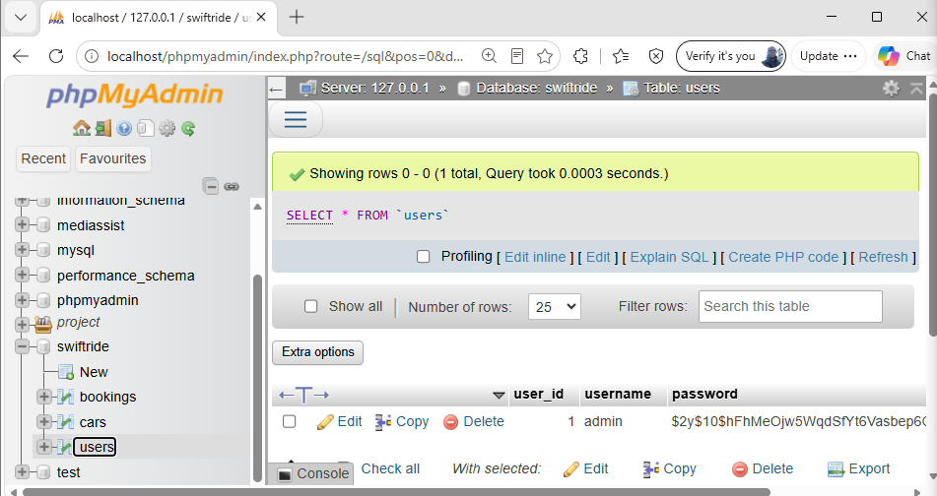
Figure 17: Users login detail and hash password on PHP page.

Conclusion
SQL Injection presents a significant risk to PHP/MySQL websites such as SwiftRide because it can expose or manipulate sensitive customer and booking information. Prepared statements, parameterised queries, input validation and output escaping provide important protection. However, security should be reviewed continuously and all database operations should follow secure coding practices. Controlled testing and documented results provide evidence that implemented security measures are effective while helping identify areas requiring further improvement.

References
[1] OWASP Foundation, OWASP Top 10: A03:2021 – Injection, 2021. [Online]. Available: https://owasp.org/Top10/A03_2021-Injection/. [Accessed: 31-Jul-2026].
[2] OWASP Foundation, SQL Injection Prevention Cheat Sheet, OWASP Cheat Sheet Series, 2025. [Online]. Available: https://cheatsheetseries.owasp.org/cheatsheets/SQL_Injection_Prevention_Cheat_Sheet.html. [Accessed: 31-Jul-2026].
[3] S. Neupane, Detecting and Mitigating SQL Injection Vulnerabilities in Web Applications, arXiv, 2025. [Online]. Available: https://arxiv.org/. [Accessed: 31-Jul-2026].
[4] MITRE Corporation, CWE-89: Improper Neutralization of Special Elements used in an SQL Command ('SQL Injection'), Common Weakness Enumeration, 2025. [Online]. Available: https://cwe.mitre.org/data/definitions/89.html. [Accessed: 31-Jul-2026].
[5] K. Scarfone, M. Sapucaya and D. Dodson, Secure Software Development Framework (SSDF) Version 1.1: Recommendations for Mitigating the Risk of Software Vulnerabilities, NIST Special Publication 800-218. Gaithersburg, MD, USA: National Institute of Standards and Technology, 2022. [Online]. Available: https://csrc.nist.gov/publications/detail/sp/800-218/final. [Accessed: 31-Jul-2026].
[6] MITRE Corporation, CWE-89: Improper Neutralization of Special Elements used in an SQL Command ('SQL Injection') – Potential Mitigations, Common Weakness Enumeration, 2025. [Online]. Available: https://cwe.mitre.org/data/definitions/89.html. [Accessed: 31-Jul-2026].
[7] Oracle Corporation, MySQL 8.4 Reference Manual – Prepared Statements, 2025. [Online]. Available: https://dev.mysql.com/doc/refman/8.4/en/sql-prepared-statements.html. [Accessed: 31-Jul-2026].
[8] W. G. J. Halfond, J. Viegas and A. Orso, "A Classification of SQL-Injection Attacks and Countermeasures," Proceedings of the IEEE International Symposium on Secure Software Engineering, pp. 13–15, 2006.
Note: This is the correct publication information. Although it is older, it is still one of the most widely cited academic papers on SQL injection. It should not be cited as 2021.
[9] Microsoft, Input Validation, Microsoft Security Development Lifecycle, 2022. [Online]. Available: https://learn.microsoft.com/security/. [Accessed: 31-Jul-2026].
[10] K. Scarfone, M. Souppaya, A. Cody and A. Orebaugh, Technical Guide to Information Security Testing and Assessment, NIST Special Publication 800-115. Gaithersburg, MD, USA: National Institute of Standards and Technology, 2008. [Online]. Available: https://csrc.nist.gov/publications/detail/sp/800-115/final. [Accessed: 31-Jul-2026].
Note: SP 800-115 is officially from 2008, not 2022.
[11] PortSwigger Ltd., SQL Injection, Web Security Academy, 2025. [Online]. Available: https://portswigger.net/web-security/sql-injection. [Accessed: 31-Jul-2026].
[12] OWASP Foundation, OWASP Web Security Testing Guide, 2025. [Online]. Available: https://owasp.org/www-project-web-security-testing-guide/. [Accessed: 31-Jul-2026].
[13] Oracle Corporation, MySQL 8.4 Reference Manual – Security Considerations for Prepared Statements, 2025. [Online]. Available: https://dev.mysql.com/doc/refman/8.4/en/sql-prepared-statements.html. [Accessed: 31-Jul-2026].
[14] PHP Documentation Group, password_hash, PHP Manual, 2025. [Online]. Available: https://www.php.net/manual/en/function.password-hash.php. [Accessed: 31-Jul-2026].
[15] Center for Internet Security, CIS Critical Security Controls Version 8, 2021. [Online]. Available: https://www.cisecurity.org/controls/v8. [Accessed: 31-Jul-2026].

