

Consultancy Report

Bohemi Hotel Sunny Beach Bulgaria



12.11.2024

- Student ID number: 2133909
- Student name: Roxana Ionica Macarie
- The module title: Organisational Consultancy
- Module code: BMIH6005
- Module Lead: Jaliya De-Silva
- Word count: 5021

I acknowledge the use of Grammarly App and Microsoft Word Editor on 13th November 2024 to check my grammar, syntax and misspellings.
I confirm that I have not presented any Al generated text as my own work. I confirm I have copies of my drafts, notes, and other resources I used before, and after the use of Al tools which I may be asked to provide in evidence.

Executive Summary

Core Issues Identification

The main challenges facing Bohemi Hotel are inconsistent customer service, operational inefficiencies, and a declining online reputation. Housekeeping delays, unprepared accommodations, and insufficient amenities lead to guest dissatisfaction, as evidenced by negative reviews on platforms like TripAdvisor. These issues affect guest retention and online visibility, complicating the acquisition of new bookings.

Analytical Frameworks
- PESTEL, SWOT, Porter’s Five Forces, and TOWS analyses were used to assess these challenges fully. PESTEL identified external factors such as financial instability and an increasing demand for sustainable practices that impact Bohemi’s strategy. SWOT identified strengths, including advantageous location and competitive pricing, while Porter’s Five Forces underlined the intense competition and the necessity for differentiation from competitors. The TOWS analysis distilled these insights into strategies to improve service quality and operational efficiency.

Recommendations
- Standardise Customer Service: Implementing service protocols and a real-time feedback mechanism may improve response uniformity. It is advisable to provide staff training in communication and problem-solving to guarantee consistent guest interactions.
- Operational Efficiency: Implementing service protocols and a real-time feedback system may improve response consistency. Staff training in communication and problem-solving is essential to ensure uniform guest interactions.
- Dining and Menu Improvements: Updating the menu with regional ingredients and optimising food temperature regulation will reduce common complaints, leading to a better dining experience.
- Proactive Online Reputation Management: An organised approach for managing online feedback and review responses will build an excellent digital image while promoting future reservations.

Cost Overview

Bohemi Hotel would require an estimated budget of £42,000 over 6 months to implement these recommendations successfully. Key allocations include:
- Customer Service Training and Protocols: £6,400
- Real-Time Feedback Mechanism: £5,200
- Dining and Menu: £8,000
- Employee Engagement Programs: £4,000
- Operational Efficiency Improvements: £9,600
- Online Reputation Management: £2,800
- Performance Benchmarking: £6,000

Measurement and Review

To evaluate progress, Bohemi should implement key performance indicators (KPIs) such as guest satisfaction scores and service response times. Quarterly evaluations will monitor changes, facilitating modifications to align with guest expectations effectively.

Conclusion

By executing these customised recommendations, Bohemi Hotel may improve customer satisfaction, optimise operations, and improve its online reputation. These strategic upgrades are anticipated to better Bohemi’s market standing, increase occupancy rates, and cultivate guest loyalty, thereby contributing to sustained success in the competitive Sunny Beach hospitality sector.

Peak Guest Experience Consultants

Peak Guest Experience Consultants is a consultancy firm that offers specialised solutions for hotels experiencing issues with guest satisfaction, operational efficiency, and market reputation. Our team is dedicated to improving the guest experience using evidence-based strategies and innovative management practices to facilitate sustainable improvements for hotels. Bohemi Hotel has engaged Peak Guest Experience Consultants to deliver actionable insights and solutions for addressing critical issues impacting guest satisfaction, service quality, and competitive positioning in the dynamic market of Sunny Beach.

Introduction

Bohemi Hotel, situated in the vibrant resort region of Sunny Beach, Bulgaria, has always offered an economical lodging alternative for travellers desiring convenient access to the Black Sea shoreline. Situated in a bustling tourist area, the hotel enjoys a strategic location close to beaches, entertainment facilities, and renowned nightlife destinations. Bohemi attracts primarily younger travellers, budget-conscious families, and international tourists seeking economical accommodations during peak season due to its competitive pricing and focus on affordability. Bohemi Hotel faces significant competition from other hotels and, increasingly, from alternative lodging options like Airbnb, particularly as new, modern businesses, such as the nearby Ensana Aquahouse Hotel, appear in the local hospitality sector with superior services.

This report identifies three primary challenges Bohemi Hotel faces: inconsistent customer service, operational inefficiencies, and a deteriorating online reputation, all impacting the hotel's overall performance. Guests have reported that customer service at Bohemi Hotel could be more consistent, characterised by delayed responses and insufficient attention to detail, adversely affecting the guest experience. Operational inefficiencies, especially in housekeeping and facility management, contribute to guest dissatisfaction. The hotel’s online reputation is compromised, as reviews on platforms like TripAdvisor and Google reflect dissatisfaction with multiple facets of the stay, consequently impacting prospective bookings.

This report will utilise various analytical frameworks to thoroughly examine these issues and propose viable solutions for Bohemi Hotel. The PESTEL analysis will assess external macro-environmental factors affecting the hotel. The SWOT analysis will clarify the hotel's internal strengths and weaknesses, as well as external opportunities and threats. Porter’s Five Forces will offer an analysis of the competitive dynamics within the hospitality market of Sunny Beach. The TOWS analysis will transform SWOT insights into strategic recommendations to improve the hotel's operational quality, customer experience, and online reputation. This report intends to furnish Bohemi Hotel with a detailed action plan to address existing challenges and improve its market standing.

5.1 Identification of Core Issues

The Bohemi Hotel has significant difficulties in 3 primary domains that affect guest satisfaction, reputation, and financial performance. These areas include variable customer satisfaction, operational inefficiencies, and adverse online reviews. These factors significantly impact the hotel's overall performance and illustrate broader challenges in the hospitality industry.

Customer Satisfaction and Guest Experience

Customer satisfaction is essential to a hotel’s reputation and loyalty, directly affecting guests' intention to revisit. Gagnon and Roh's study on the U.S. lodging industry indicates that service reliability and personalisation are significant factors in customer satisfaction and loyalty, increasing the hotel's brand strength. In Bohemi's case, inconsistent service standards and insufficient facilities have been frequently identified as sources of guest dissatisfaction. Numerous TripAdvisor reviews indicate that guests found unclean rooms upon arrival and reported deficiencies in housekeeping, including the failure to replenish toiletries and provide fresh bedding. A TripAdvisor reviewer remarked that rooms were inadequately cleaned, and towels were absent, even if they had to make several calls for replacements. (TripAdvisor, 2024). Thi et al. (2021) claim that such feedback indicates a deficiency in the hotel's operational management to consistently fulfil guest expectations, potentially discouraging customers from returning and weakening brand loyalty.

Operational Inefficiencies

Operational inefficiencies, especially in housekeeping and facility management, may negatively impact customer experience by disregarding fundamental service standards (Zagade and Tyagi, 2017). Anagnostopoulou et al. discovered that operational quality, especially cleanliness and maintenance, is crucial for guest satisfaction and financial performance. Numerous reviews on Google and TripAdvisor for Bohemi Hotel bring out persistent problems with delayed housekeeping and substandard room conditions. A guest review on Google stated, “We arrived to find our room unprepared and had to wait an hour for cleaning to be finished” (Google Reviews, 2024). Operational deficiencies result in guest dissatisfaction and may cause reduced occupancy rates, as prospective customers frequently depend on online reviews to assess a property's quality before making a reservation.

Online Reputation and Financial Impact

In the hospitality industry, online reputation is a crucial determinant of revenue. A study by Worsfold et al. highlighted that guest satisfaction with service quality and the hotel's physical characteristics (e.g., room quality and cleanliness) affect guests' intentions to return. Online platforms such as TripAdvisor and Google Reviews indicate numerous complaints regarding Bohemi Hotel, negatively impacting its reputation. For instance, one guest submitted a TripAdvisor review, asserting, “The hotel appears outdated, and the images are deceptive.” The hotel looks outdated, and the pictures are misleading. Facilities were not as promised, and the pool area was dirty” (TripAdvisor, 2024). Public complaints may significantly damage the hotel's appeal to prospective customers, as travellers frequently base their booking decisions on overall impressions posted online.

Mohamed's (2021) research on customer experience and reputation underscores the significance of relationship quality for determining corporate reputation within the hospitality industry. Inconsistent guest experiences may reduce relationship quality, eventually impacting a hotel's reputation and decreasing guest trust. This is especially apparent in reviews mentioning the absence of promised amenities, including Wi-Fi and dependable air conditioning. Adverse guest experiences create a ripple effect, weakening the hotel's capacity to secure reservations and maintain customer loyalty. Nobar and Rostamzadeh assert that robust customer loyalty is essential for maintaining an excellent brand image in the competitive hospitality sector (Nobar and Rostamzadeh, 2018).

Summary of Core Issues
The challenges faced by Bohemi Hotel regarding customer satisfaction, operational inefficiencies, and online reputation highlight systemic issues that affect guest experience and profitability. The interaction between these issues indicates that the hotel must invest in quality management and service consistency to meet guest expectations. Improving these areas could significantly raise guest satisfaction, build a more positive online reputation, and improve financial performance.
5.2 SWOT Analysis
 | Details
Strengths | - Prime location in Sunny Beach, a popular tourist destination, provides easy access to beaches and entertainment venues, attracting a steady flow of tourists. (Kiritharannair and Amresh, 2016).  - Competitive pricing appeals to budget-conscious travellers, increasing occupancy during peak seasons.  - Positive aspects noted by guests include friendly staff and reasonable proximity to local attractions (Coman and Ronen, 2009).
Weaknesses | - Limited amenities and outdated facilities are common complaints in reviews, reducing guest satisfaction and retention (Coman and Ronen, 2009).  - Inconsistent service quality, especially in housekeeping, negatively impacts guest experience, with delays and unfulfilled promises in service delivery.  - Lack of differentiation in offerings compared to other hotels in the area (Helms and Nixon, 2010).
Opportunities | - Investment in facility upgrades and service training can improve guest satisfaction and competitive positioning.  - Expanding services or packages to appeal to specific segments, such as family or eco-tourists, can attract a broader customer base (Ommani, 2011).  - Utilizing digital marketing to enhance online visibility and reputation management (Nuryakin and Priyo, 2018).
Threats | - High competition from surrounding hotels in Sunny Beach puts pressure on pricing and guest retention (Fiori and Forini, 2019).  - Seasonal fluctuations impact occupancy rates and financial stability, with high dependency on peak tourist seasons.  - Negative online reviews have a compounding effect on new bookings and guest perceptions (Sevkli et al. 2012).

  - PESTEL Analysis
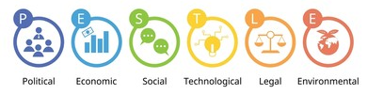
The Bohemi Hotel, located in Sunny Beach, Bulgaria, functions within a dynamic context shaped by various macro-environmental factors. This PESTEL analysis elucidates the factors and their influence on the hotel's operations.
Political: The Bohemi Hotel capitalises on Bulgaria's political stability and its European Union membership, helping to improve travel accessibility for EU tourists. Fluctuating visa requirements for non-EU visitors can affect international visitor statistics (Kara,
Economic: Economic volatility, especially regarding inflation and currency fluctuations, impacts customer spending on travel. This may decrease Bohemi's average daily rates and occupancy. Research indicates that financial instability necessitates adaptive pricing strategies in the hospitality industry (Matović, 2020).
Social: A pronounced inclination towards economic travel corresponds with Bohemi’s cost-effective pricing strategy, appealing to younger, budget-aware travellers. Demographic changes favouring experience-oriented travel may necessitate adjustments in service provisions (Fernández and Cala, 2011).
Technological: Investment in digital booking platforms is essential for Bohemi, as most travellers conduct research and make reservations through online channels. Incorporating technology for better customer service may raise guest satisfaction (Pulido et al., 2011).
Environmental: Growing awareness of sustainable travel practices compels hotels like Bohemi to implement eco-friendly policies. Energy efficiency and waste management changes can positively influence brand perception with environmentally aware customers (Pham Phu et al., 2018).
Legal: Compliance with EU and local regulations, including labour laws and health codes, is imperative. Failure to comply may result in penalties that impede operations (Yüksel, 2012).
This analysis demonstrates the necessity for Bohemi Hotel to modify its strategies in response to these factors to maintain flexibility and competitiveness in the hospitality sector.

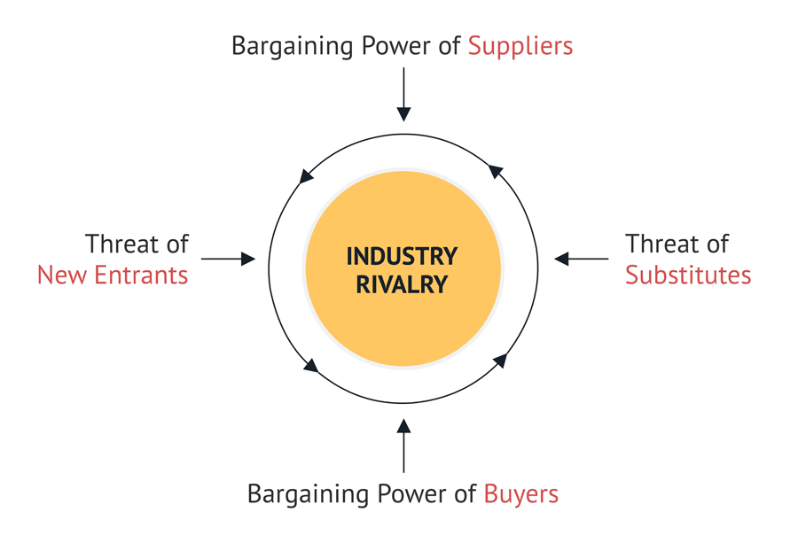
5.4 Porter's Five Forces Analysis
Competitive Rivalry
The hospitality sector in Sunny Beach is highly competitive, featuring numerous hotel choices, including the newly inaugurated Ensana Aquahouse Hotel, which appeals to tourists pursuing wellness and luxury experiences (Esana, 2024). A study on hotel competition indicates that properties with distinctive attributes, such as health and wellness amenities, gain a competitive advantage by addressing niche demand, prompting nearby hotels to differentiate their offerings (Göral, 2015). Ensana's unique positioning forces Bohemi Hotel to improve its offerings and service quality to maintain guest appeal.
Threat of New Entrants
The tourism attractions of Sunny Beach and reasonable starting costs attract new entrants, intensifying competition. New hotels capitalise on increasing tourist numbers but must provide unique services to secure a competitive advantage. Research indicates that significant market appeal and comparatively low entry barriers make the hospitality industry vulnerable to new competitors, especially in sought-after tourist locations (Bruijl, 2018). Therefore, Bohemi Hotel must use its brand and locational advantages to protect itself from future competition.
Threat of Substitutes
Alternative accommodations like Airbnb have become significant substitutes, attracting tourists searching for economical or homely lodging options. Research indicates that the growth of sharing-economy platforms has profoundly affected traditional hotels, forcing them to draw attention to distinctive benefits such as customer service, security, and supplementary amenities that competitors may not provide (Isabelle et al., 2020). Bohemi Hotel may reduce this threat by accentuating its service offerings, convenience, and guest experience.
Bargaining Power of Suppliers
Bohemi Hotel depends on outside companies for food services and maintenance, giving these suppliers a degree of control. Guest reviews on TripAdvisor highlight concerns regarding food quality and improper serving temperatures, indicating a potential need for supplier or in-house management improvement. Dependency on suppliers for maintenance may make hotels vulnerable, as research suggests that delays or substandard service may negatively affect guest satisfaction and perception (Kaya and Azaltun, 2012).

Bargaining Power of Buyers
In the digital age, online review platforms give customers significant bargaining power. Studies indicate that today's customers significantly depend on recommendations and reviews when making booking choices, prompting hotels to focus on customer satisfaction to protect their online reputation (Dobbs, 2014). Negative reviews on platforms like Booking.com may damage Bohemi Hotel's attractiveness, prompting prospective guests to opt for better-rated competitors.

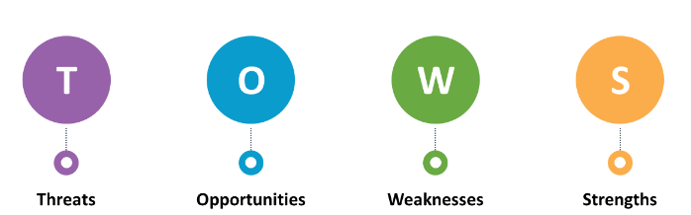
5.5 TOWS Analysis
Bohemi Hotel can transform the strengths, weaknesses, opportunities, and threats identified in the SWOT analysis into feasible strategies utilising the TOWS matrix. This matrix correlates internal strengths and weaknesses with external opportunities and threats to develop strategic responses that foster growth and resilience.
Strengths–Opportunities (SO):
The Bohemi Hotel's strategic location and cost-effectiveness provide an advantage in appealing to budget-conscious travellers. By improving its accessibility to local attractions, Bohemi may capitalise on the increasing demand for economical and convenient travel. Zulkifli et al. (2022) propose that hotels prioritising digital marketing to highlight their accessibility and value, particularly within the budget sector, may appeal to more people. Bohemi may improve its online visibility by promoting its closeness to Sunny Beach's attractions and reasonable prices to attract the younger traveller demographic.
Strengths–Threats (ST):
Bohemi's strategic location gives it an advantage that can minimise the threat from the appearance of luxury hotels such as Ensana Aquahouse. By offering discounts or supplementary incentives during peak season, Bohemi can draw in tourists who may be hesitant to pay premium costs. Sahir and Dachyar (2021) highlight that customised discount strategies can effectively attract cost-sensitive travellers from expensive competitors.

Weaknesses–Opportunities (WO):
Bohemi's strategic positioning offers a benefit that can mitigate the risk posed by the appearance of luxury hotels like Ensana Aquahouse. Bohemi can attract tourists who may be hesitant to pay premium costs by providing discounts or extra bonuses during peak season. Sahir and Dachyar (2021) point out that tailored discount strategies can attract price-sensitive travellers from higher-priced competitors.
Weaknesses–Threats (WT):
Bohemi Hotel should adopt a proactive strategy to address guest feedback by creating a system for timely responses to customer complaints on platforms like TripAdvisor and Google Reviews to reduce its vulnerabilities to negative online reviews. Chu and Choi (2000) claim that hotels that interact with online feedback and show responsiveness often see better customer perceptions and increased bookings. By addressing complaints and showcasing improvements on social media, Bohemi may mitigate the effects of negative reviews.

6.1 Recommendations
The following recommendations for Bohemi Hotel seek to optimise customer service, create systematic training programs, and refine menu selections to resolve the critical issues identified. Every recommendation is based on research and defines practical measures for realisation (Dat a Hang, 2023).
Improving Customer Service
- Standardised Customer Service Protocols
Research shows that standardised customer service procedures improve guest satisfaction by maintaining consistency in service delivery. Bohemi Hotel should set explicit guidelines for guest interactions, including response times, complaint resolution procedures, and greeting protocols, to equip staff with a framework for fulfilling guest expectations. The hotel might develop a quality manual defining service standards for front-line employees, accompanied by regular training to reinforce these standards. This method improves consistency and minimises service errors that could irritate guests (Peng et al., 2015).
- Personalised Services Through Guest Profiles
Creating guest profiles facilitates personalised service, improving guest satisfaction and loyalty. Sigala (2006) suggests that eCRM systems monitoring guest preferences allow staff to customise services according to previous interactions. For instance, Bohemi could monitor guest preferences regarding room amenities, dining selections, or activity preferences, allowing staff to provide tailored experiences proactively.
- Establish Real-Time Feedback Mechanisms
Gathering and responding to real-time feedback has proven effective in promptly resolving issues and enhancing service. Zhang et al. (2021) advocate using digital platforms to collect guest feedback throughout their stay, facilitating prompt corrective measures. Bohemi could implement in-room tablets or a mobile application that allows guests to report issues or submit requests, guaranteeing prompt responses from the service team.

Implementing Full Training Programs
- Skills Training in Communication and Problem-Solving
Effective communication is essential for managing guest expectations and addressing issues. Educating front-line staff in attentive listening, compassion, and conflict resolution has increased guest satisfaction (Jawabreh et al., 2022). Bohemi can implement role-playing exercises for staff to practise addressing typical guest complaints and requests, which improves their ability to manage real situations with increased confidence and professionalism (Jawabreh et al., 2022).
- Cross-Training for Service Flexibility
Cross-training allows staff to support various roles during high-demand periods, minimising service delays. Siguaw and Enz (1999) claim that cross-trained employees increase operational efficiency by addressing deficiencies, particularly during peak occupancy. Bohemi could instruct housekeeping employees to handle essential front-desk responsibilities, ensuring service consistency despite varying demands.

- Cultural Sensitivity and Inclusivity Training
Cultural sensitivity training can improve staff interactions with a diverse international clientele. Tsaur and Lin (2004) discovered that training in tourist hotels can significantly raise customer satisfaction, as guests perceive greater understanding and respect. Bohemi should conduct workshops to educate staff on cultural etiquette and preferences, which would improve guest relations across diverse demographics.
Dining and Menu Options
- Regular Menu Updates with Local Ingredients
Incorporating seasonal and local ingredients into the menu will improve the dining experience by providing customers with distinctive, region-specific choices. Eccles and Durand (1997) propose that menu revisions should align with seasonal variations to enhance freshness and diversity, increasing overall guest satisfaction. For Bohemi, this could mean collaborating with local farms to procure fresh ingredients and developing a rotating menu that accentuates regional flavours.
- Implementing Temperature Control Protocols for Food Quality
A frequent complaint at Bohemi has been about the variable temperature of the dishes served. Evans and Woolfe (2008) point out that meticulous kitchen protocols, including hot plates and timing controls, can preserve dish quality from the kitchen to the table. Bohemi could invest in improved heating equipment and set standards for plate preparation times to guarantee that dishes are served at the appropriate temperature.
- Dining Ambiance
Changing the ambience of the dining area can significantly transform the guest experience. Research indicates that illumination, table configuration, and music improve guests' perceptions of food quality and service. Bohemi can implement nuanced yet impactful environmental modifications, such as incorporating warm lighting or live music, thus creating a welcoming and unforgettable dining experience (Heijden et al., 2021).

Streamlining Operational Efficiency
- Knowledge Management Systems for Service Consistency
Implementing a knowledge management system (KMS) helps hotels archive and utilise guest preferences and service history, guaranteeing consistent service across staff shifts (Bouncken, 2002). Bohemi can utilise a KMS to document guest feedback and preferences, facilitating personalised experiences for returning guests. This technology guarantees the retention of knowledge within the business despite employee turnover.
- Resource Allocation with Occupancy Forecasting
Proper resource allocation, including staff and supplies, is essential for successful hotel operations. Tang (2014) defines occupancy forecasting as a significant factor in anticipating demand and optimising resource allocation. Using occupancy forecasting software, Bohemi can improve staff scheduling and reduce expenses, guaranteeing sufficient service levels during peak times.
- Dynamic Benchmarking for Continuous Improvement
Dynamic benchmarking allows hotels to evaluate and improve service quality by contrasting performance metrics against industry standards. Min and Chung (2002) claim that ongoing benchmarking will enable hotels to recognise service deficiencies and sustain competitiveness. Bohemi could establish quarterly benchmarks for guest satisfaction scores, response times, and other essential metrics, modifying operational practices according to performance outcomes.
End Remarks on Recommendations
These recommendations will allow Bohemi Hotel to resolve its fundamental issues, boosting customer satisfaction and operational efficiency. Bohemi may improve its reputation, draw a repeat customer base, and compete more successfully in the Sunny Beach market by focusing on standardised customer service, extensive training programs, and effective resource management.

6.2 Change Management Strategies
To implement the recommendations effectively at Bohemi Hotel, management strategies that focus on structured training, internal communication, and employee engagement are essential. These strategies are supported by industry research and target fostering adaptability, reducing resistance, and ensuring alignment across staff and management.
1. Structured Training Programs for Skill Development and Adaptability
A structured training program is essential for the successful integration of service improvements. Dhoundiyal and Mathur (2022) assert that training improves employee satisfaction and engagement, essential components of change management. Bohemi's targeted training programs should focus on service standards, guest interaction competencies, and adaptability. Using simulations, as proposed by Cox (2018), helps employees practice real-world situations in a regulated setting, which boosts their confidence in managing guest requests and concerns effectively.
Additionally, Bohemi should implement regular refresher courses to help employees adjust to new standards. Gazija (2011) notes that ongoing training improves employee performance, resulting in more effective and engaged participation in organisational change. Training has to include cross-departmental sessions that encourage collaboration and a unified understanding of new service standards across various roles.
2. Effective Internal Communication Plans
Clear and constant communication is essential for facilitating change and mitigating employee resistance. Li et al. (2020) highlight the significance of transparent communication strategies involving all staff levels in their research on change management within the hotel industry. Bohemi may develop a communication strategy incorporating weekly meetings to address changes, monthly progress updates, and anonymous feedback mechanisms for employees to express their concerns.
Furthermore, according to Shulga (2021), meaningful communication that clarifies changes' goals and expected benefits promotes higher employee engagement. Bohemi should conduct an initial information session with visual presentations explaining each recommendation's anticipated impact. This guarantees that employees understand the overall organisational objectives and how their positions facilitate these transformations.
3. Fostering a Culture of Engagement and Ownership
Creating an environment where employees participate in the change process reduces resistance. Rotich (2021) affirms that employee engagement and participation in decision-making may improve performance. At Bohemi, involving staff members in planning and execution through feedback sessions or task forces focused on implementing changes can cultivate a sense of ownership. Staff could be asked to propose improvements in guest service, empowering them to influence the hotel's success directly.
Nieves, Quintana, and Osorio (2016) illustrate the necessity of modifying organisational routines to incorporate external innovations, including new service protocols and guest management technologies. Bohemi can form an employee-led team to supervise the changes, allowing staff representatives to direct teammates and promote shared accountability in implementing change.
4. Leadership Support and Role Modeling
Effective change initiatives necessitate evident backing from management. Chiang (2010) believes leaders should exemplify the behaviours they desire to cultivate in their employees, as this builds trust and aligns employee actions with organisational objectives. Bohemi's management must engage actively in training sessions and attend important meetings to show their dedication to the new standards.
Donaghy et al. (1997) claim that managers are essential change facilitators, connecting front-line employees with the executive team. Bohemi’s leadership can offer reassurance and sustain motivation during the change process by remaining available to staff for enquiries or guidance.
5. Continuous Feedback and Monitoring
Continuous feedback systems allow management to detect problems quickly and modify the change process accordingly. Maroofi and Nazaripour (2012) discovered that ongoing evaluation and responsiveness to employee feedback improve adaptability and reduce resistance. Bohemi could establish a system of quarterly evaluations and anonymous surveys to assess the opinion of staff members, promptly addressing concerns to maintain high morale.
According to Albrecht et al. (2023), consistent progress updates may encourage growth, with management communicating achievements and confronting challenges during regular meetings. This transparent feedback mechanism promotes employee engagement and a sense of value during the change process.
6. Incentives and Recognition Programs
Recognising employee efforts in adapting to change increases positive behaviours and boosts motivation. Akrivos et al. (2007) claim that recognition programs designed for particular change-related achievements may increase commitment to organisational objectives. Bohemi might create monthly recognition awards for employees who demonstrate competence in adopting new service standards, offering incentives such as gift cards or additional leave.
This organised and supportive change management method will facilitate Bohemi Hotel's easy adjustment to new service standards, increase employee confidence, and guarantee continued achievement in executing the recommendations.

6.3 Measurement and Review
A systematic measurement and evaluation process is crucial to guarantee the efficacy of the proposed modifications at Bohemi Hotel. This procedure involves setting clear standards, identifying relevant key performance indicators (KPIs), and planning future assessments.
Setting Benchmarks for Success
Setting realistic standards allows Bohemi Hotel to assess the initial effects of implemented modifications. Standards can include specific guest satisfaction ratings, average response times for enquiries, and decreased complaints about particular services. Ositashvili and Nadareishvili (2021) argue that benchmarking allows hotels to set a comparative standard by aligning their performance with comparable businesses. Bohemi might develop benchmark values by analysing competitor performance and industry standards.
Identifying Key Performance Indicators (KPIs)
Key performance indicators will provide measurable data to evaluate changes. Essential KPIs for Bohemi may include:
- Customer satisfaction scores derived from guest surveys and online reviews (Wu and Ko, 2013).
- Service response times for room service and maintenance requests are key to operational efficiency (Dasandara et al., 2022).
- Employee training completion rates guarantee that all staff members are up-to-date with new service protocols (Lai and Choi, 2015).
- Facility management effectiveness, measured through guest feedback on cleanliness and maintenance quality, has directly impacted satisfaction (Dasandara et al., 2022).
Planning Follow-Up Evaluations
Regular assessments will facilitate ongoing modifications and continuous improvement. Min and Chung (2002) advocate for quarterly evaluations to monitor KPIs and resolve any emerging issues. For Bohemi, future assessments should include re-examining guest surveys, contrasting KPI data with benchmarks, and facilitating staff feedback sessions. According to Khairat (2015), a balanced scorecard approach can combine financial and non-financial performance metrics, providing an extensive perspective on the hotel's advancement.
This systematic method will allow Bohemi Hotel to monitor the efficacy of modifications, implement necessary adjustments, and maintain service quality that corresponds with guest expectations.

Issue | Solution | Desired Outcome | Timeline | Completion Date | Estimated Budget (£)
Inconsistent Customer Service | Implement standardised customer service protocols and training programs | Improved service consistency and increased guest satisfaction | 3 months | April 30, 2024 | £6,400
Delayed Response Times | Introduce real-time feedback mechanisms and a mobile app for in-room service requests | Faster response to guest needs, reducing wait times for services | 2 months | March 31, 2024 | £5,200
Poor Dining Experience | Recreate the menu with local ingredients and improve kitchen protocols for temperature control | Enhanced dining experience with consistent food quality | 3 months | April 30, 2024 | £8,000
Low Employee Engagement | Create a staff feedback system and recognition program | Increased employee satisfaction, motivation, and reduced resistance to change | 2 months | March 31, 2024 | £4,000
Operational Inefficiencies | Implement a knowledge management system and cross-training to improve staff adaptability | Smoother operations with reduced bottlenecks and more efficient use of staff resources | 4 months | May 31, 2024 | £9,600
Negative Online Reviews | Launch an online reputation management program and proactive review response strategy | Improved online ratings, increased booking rates, and more substantial brand reputation | 2 months | March 31, 2024 | £2,800
Low Benchmark Performance | Establish regular KPI-based benchmarking and quarterly performance reviews | Continuous improvement in service delivery aligned with industry standards | 6 months | July 31, 2024 | £6,000

The Bohemi Hotel's action plan defines systematic solutions focused on service consistency, response efficiency, dining quality, employee engagement, operational optimisation, reputation management, and performance benchmarking, all intended to improve guest satisfaction, streamline processes, and strengthen the hotel’s market position. The estimated budget is £42,000, and the plan is scheduled for completion within six months, providing effective integration of each solution for optimal results.

Conclusion
In summary, Bohemi Hotel faces significant obstacles in guest satisfaction, operational efficiency, and online reputation, especially regarding service inconsistency, delayed responsiveness, and insufficient facility maintenance. This report by Peak Guest Experience Consultants has identified these issues and offered specific recommendations to improve service quality, streamline operations, and strengthen the hotel’s market position.
The suggested solutions include standardised customer service protocols, extensive training programs, improvements in dining quality, and the execution of operational efficiencies. These measures are designed to enhance the guest experience by improving timely service delivery, consistent food quality, and attentive guest interaction, which are anticipated to result in favourable online feedback and heightened customer loyalty.
If these recommendations are carried out, Bohemi Hotel has the potential to gain considerably. Improved consistency in customer service will improve guest satisfaction, resulting in favourable reviews and potentially increased return rates. The dining experience, supplemented by local ingredients and temperature regulation protocols, will provide guests with a more pleasurable and unique experience. Operational improvements, including cross-training staff and instituting real-time feedback mechanisms, will refine service delivery and decrease expenses.
Furthermore, Bohemi may improve its visibility on review platforms by actively overseeing its online reputation, fostering favourable perceptions that affect booking choices. These strategic upgrades will strengthen the hotel’s market position and produce enduring financial advantages through heightened occupancy and guest loyalty.
We express our gratitude for the opportunity to deliver these consultancy services. By executing these customised recommendations, Bohemi Hotel will soon revolutionise guest experiences, improve operational efficiencies, and establish a competitive advantage in Sunny Beach's hospitality sector. We have no doubt that these strategic measures will help Bohemi Hotel to attain sustainable growth and success.
Peak Guest Experience Consultants
Appendix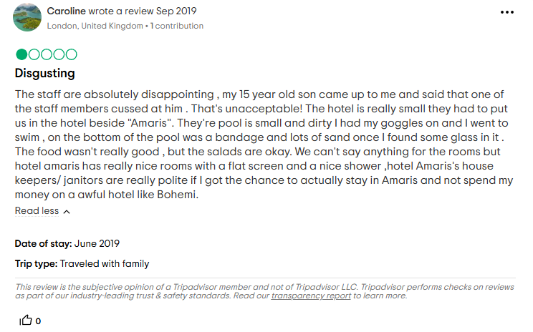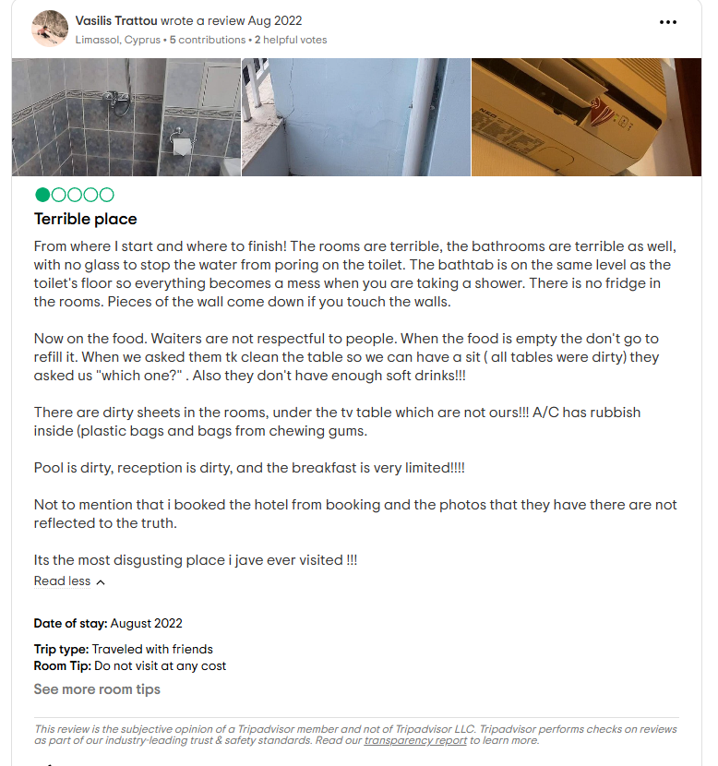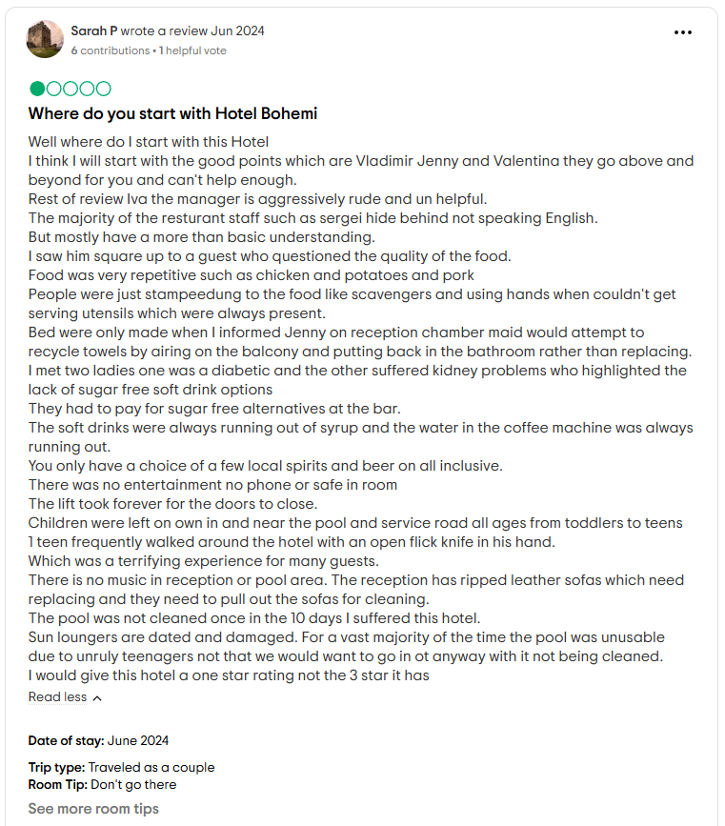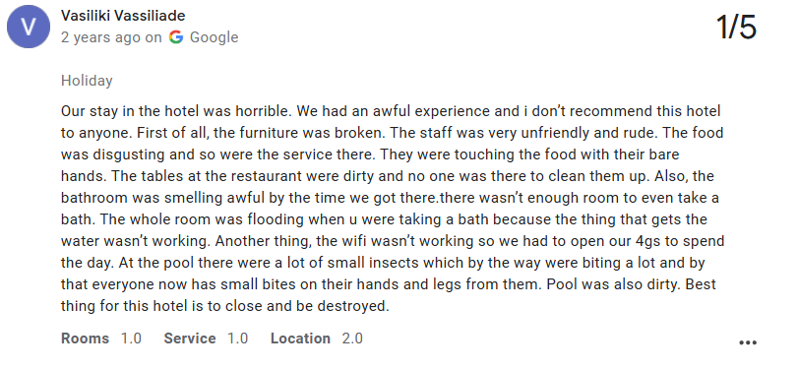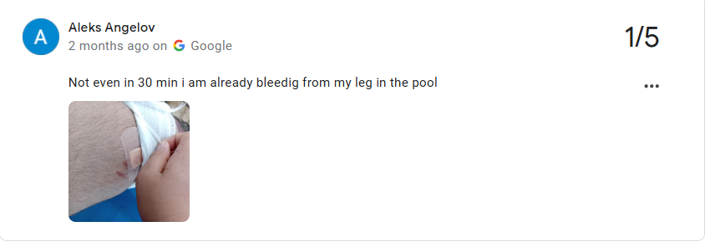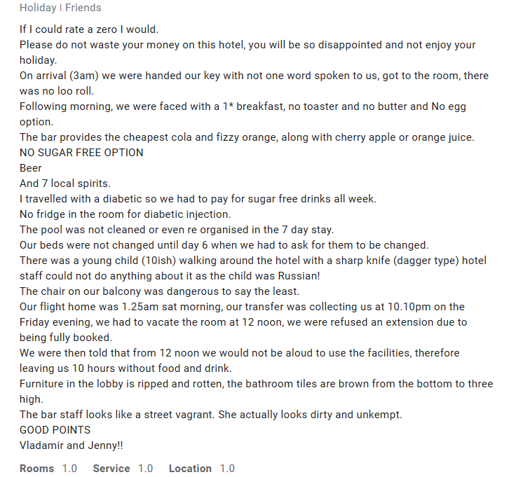

References
- Albrecht, S., Furlong, S., and Leiter, M., 2023. The psychological conditions for employee engagement in organizational change: Test of a change engagement model. Frontiers in Psychology, 14. https://doi.org/10.3389/fpsyg.2023.1071924.
- ANAGNOSTOPOULOU, S.C., BUHALIS, D., KOUNTOURI, I.L., MANOUSAKIS, E.G. and TSEKREKOS, A.E., 2020. The impact of online reputation on hotel profitability. International Journal of Contemporary Hospitality Management, 32(1), pp. 20-39. https://www.proquest.com/scholarly-journals/impact-online-reputation-on-hotel-profitability/docview/2336176781/se-2?accountid=130472
- Barsky, J.D., 1996. Building a Programn for World-Class Service. Cornell Hotel and Restaurant Administration Quarterly, 37(1), pp.17-27. https://doi.org/10.1177/001088049603700112
- Bouncken, R.B., 2002. Knowledge management for quality improvements in hotels. Journal of Quality Assurance in Hospitality & Tourism, 3(3-4), pp.25-59. https://doi.org/10.1300/J162v03n03_03
- Božac, M.G. and Tipurić, D., 2006. Top management's attitudes-based SWOT analysis in the Croatian hotel industry. Ekonomski pregled, 57(7-8), pp.429-474. https://hrcak.srce.hr/file/12805?origin%3Dpublication_detail
- Bruijl, G., 2018. The Relevance of Porter's Five Forces in Today's Innovative and Changing Business Environment. Sources of Innovation eJournal. https://doi.org/10.2139/ssrn.3192207.
- Chiang, C.F., 2010. Perceived organizational change in the hotel industry: An implication of change schema. International Journal of Hospitality Management, 29(1), pp.157-167. https://doi.org/10.1016/j.ijhm.2009.08.002
- Chu, R., and Choi, T., 2000. An importance-performance analysis of hotel selection factors in the Hong Kong hotel industry: a comparison of business and leisure travellers. Tourism Management, 21, pp. 363-377. https://doi.org/10.1016/S0261-5177(99)00070-9.
- Coman, A., and Ronen, B., 2009. Focused SWOT: diagnosing critical strengths and weaknesses. International Journal of Production Research, 47, pp. 5677 - 5689. https://doi.org/10.1080/00207540802146130.
- Cox, C., 2018. A simulation approach to hotel revenue management training. Journal of Revenue and Pricing Management, 17, pp.356-364. https://link.springer.com/content/pdf/10.1057/s41272-018-00159-1.pdf
- Dasandara, M., Dissanayake, P. and Fernando, D.J., 2022. Key performance indicators for measuring performance of facilities management services in hotel buildings: a study from Sri Lanka. Facilities, 40(5/6), pp.316-332. https://www.proquest.com/scholarly-journals/key-performance-indicators-measuring-facilities/docview/2634112809/se-2?accountid=130472
- Dat, N., and Hang, N., 2023. Service Quality and Performance Results through Customer Satisfaction at Small-Scale Hotels in Hanoi Area. International Journal of Scientific Research and Management (IJSRM). https://doi.org/10.18535/ijsrm/v11i11.em07.
- Dhoundiyal, A. and Mathur, D., 2022. Impact of training on employee satisfaction and change management: A pragmatic study with special reference to employees working in luxury hotels of Mumbai. PUSA Journal of Hospitality and Applied Sciences, 8(1), pp.1-17. https://www.academia.edu/download/109831623/3256.pdf
- DOBBS, M.E., 2014. Guidelines for applying Porter's five forces framework: a set of industry analysis templates. Competitiveness Review, 24(1), pp. 32-45. https://www.proquest.com/scholarly-journals/guidelines-applying-porter-s-five-forces/docview/1491112407/se-2?accountid=130472
- Donaghy, K., McMahon‐Beattie, U. and McDowell, D., 1997. Implementing yield management: lessons from the hotel sector. International Journal of Contemporary Hospitality Management, 9(2), pp.50-54. https://www.proquest.com/scholarly-journals/implementing-yield-management-lessons-hotel/docview/228380974/se-2?accountid=130472
- Eccles, G. and Durand, P., 1997. Improving service quality: lessons and practice from the hotel sector. Managing Service Quality: An International Journal, 7(5), pp.224-226. https://www.proquest.com/scholarly-journals/improving-service-quality-lessons-practice-hotel/docview/198072911/se-2?accountid=130472
- Ensana Hotels, 2024. Aquahouse hotel winter sale. https://ensanahotels.com/
- Evans, J., and Woolfe, M., 2008. Temperature monitoring and measurement. , pp. 404-442. https://doi.org/10.1533/9781845694883.2.404.
- Fernández, J.I.P., Cala, A.S. and Domecq, C.F., 2011. Critical external factors behind hotels' investments in innovation and technology in emerging urban destinations. Tourism Economics, 17(2), pp.339-357. https://doi.org/10.5367/te.2011.0033
- Fiori, A., and Foroni, I., 2019. Reservation Forecasting Models for Hospitality SMEs with a View to Enhance Their Economic Sustainability. Sustainability. https://doi.org/10.3390/SU11051274.
- Gagnon, G.B. and Roh, Y.S., 2008. The impact of customization and reliability on customer satisfaction in the US lodging industry. Journal of Quality Assurance in Hospitality & Tourism, 8(3), pp.60-78. https://doi.org/10.1080/15280080802080276
- Gazija, A., 2011. Importance of staff training in hotel industry Case Study: Hotel Dukagjini. ILIRIA International Review, 1(2), pp.1-11. https://www.academia.edu/download/33381191/16_Albana_Gazija.pdf
- Göral, R., 2021. Competitive Analysis of the Hotel Industry in Konya by Using Porter’s Five Forces Model. https://revistia.com/index.php/ejes/article/view/5248/5101
- Heijden, K., Festjens, A., and Goukens, C., 2021. On the bright side: The influence of brightness on overall taste intensity perception. Food Quality and Preference. https://doi.org/10.1016/J.FOODQUAL.2020.104099.
- Helms, M., and Nixon, J., 2010. Exploring SWOT analysis – where are we now?. Journal of Strategy and Management, 3, pp. 215-251. https://www.proquest.com/scholarly-journals/exploring-swot-analysis-where-are-we-now/docview/758229537/se-2?accountid=130472
- Huang, Y., Mesak, H.I., Hsu, M.K. and Qu, H., 2012. Dynamic efficiency assessment of the Chinese hotel industry. Journal of Business Research, 65(1), pp.59-67. https://doi.org/10.1016/j.jbusres.2011.07.015
- Isabelle, D., Horak, K., McKinnon, S. and Palumbo, C., 2020. Is Porter's Five Forces Framework Still Relevant? A study of the capital/labour intensity continuum via mining and IT industries. Technology innovation management review, 10(6). https://www.proquest.com/scholarly-journals/is-porters-five-forces-framework-still-relevant/docview/2425004441/se-2?accountid=130472
- Jawabreh, O., Al Fayoumi, T. and Bareya, A., 2022. Customer satisfaction towards communication skills of the front office staff at the hotel (case study five stars Hotels in Aqaba). Geo Journal of Tourism and Geosites, 44(4), pp.1312-1318. https://www.proquest.com/scholarly-journals/customer-satisfaction-towards-communication/docview/2735925625/se-2?accountid=130472
- Kara, E., 2018. A contemporary approach for strategic management in the tourism sector: pestle analysis on the city Muğla, Turkey. İşletme Araştırmaları Dergisi, 10(2), pp.598-608. https://www.isarder.org/index.php/isarder/article/download/599/589
- Kaya, E., and Azaltun, M., 2012. Role of information systems in supply chain management and its application on five‐star hotels in Istanbul. Journal of Hospitality and Tourism Technology, 3, pp. 138-146. https://www.proquest.com/scholarly-journals/role-information-systems-supply-chain-management/docview/1029909892/se-2?accountid=130472
- Khairat, G.M., 2015. The balanced scorecard approach is a tool for performance evaluation in the hospitality industry. Journal of Association of Arab Universities for Tourism and Hospitality, 12(2), pp.135-158. https://jaauth.journals.ekb.eg/article_67445_5c293a5eeb6dd7516935293d6d994832.pdf
- Kiritharannair, C., and Amresh, P., 2016. Development of Strategic Plan for Hotel Industries through Swot Analysis. Indian Journal of Medical Ethics, 3, pp. 6-10. https://doi.org/10.14445/23488360/ijme-v3i3p103.
- Lai, J.H. and Choi, E.C., 2015. Performance measurement for teaching hotels: A hierarchical system incorporating facilities management. Journal of Hospitality, Leisure, Sport & Tourism Education, 16, pp.48-58. https://doi.org/10.1016/j.jhlste.2015.02.002
- Li, J., Sun, R., Tao, W., and Lee, Y., 2020. Employee coping with organizational change in the face of a pandemic: The role of transparent internal communication. Public Relations Review, 47, pp. 101984 - 101984. https://doi.org/10.1016/j.pubrev.2020.101984.
- Matović, I.M., 2020, September. PESTEL analysis of external environment as a success factor of startup business. In ConScienS conference proceedings (pp. 96-102). Scientia Moralitas Research Institute. https://www.society.education/wp-content/uploads/2022/06/ConScienS-Proceedings.pdf#page=101
- Min, H., Min, H. and Chung, K., 2002. Dynamic benchmarking of hotel service quality. Journal of Services Marketing, 16(4), pp.302-321. https://www.proquest.com/scholarly-journals/dynamic-benchmarking-hotel-service-quality/docview/212651652/se-2?accountid=130472
- Mohamed, E.S.A., 2021. The impact of customer experience and relationship quality on corporate reputation in the hotel sector. International Journal of Customer Relationship Marketing and Management (IJCRMM), 12(2), pp.53-79. https://www.proquest.com/scholarly-journals/impact-customer-experience-relationship-quality/docview/3079522935/se-2?accountid=130472
- Nieves, J., Quintana, A., and Osorio, J., 2016. Organizational knowledge, dynamic capabilities and innovation in the hotel industry. Tourism and Hospitality Research, 16, pp. 158 - 171. https://doi.org/10.1177/1467358415600208.
- Nobar, H.B.K. and Rostamzadeh, R., 2018. The impact of customer satisfaction, customer experience and customer loyalty on brand power: empirical evidence from hotel industry. Journal of Business Economics and Management, 19(2), pp.417-430. https://www.proquest.com/scholarly-journals/impact-customer-satisfaction-experience-loyalty/docview/2296393245/se-2?accountid=130472
- NURYAKIN and PRIYO, J.S., 2018. Service Quality, Trust and Customer Loyalty: The Role of Customer Satisfaction at the Hotel Services Industry in Indonesia: Acces la Success. Calitatea, 19(166), pp. 50-55. https://www.proquest.com/scholarly-journals/service-quality-trust-customer-loyalty-role/docview/2113240553/se-2?accountid=130472
- Ommani, A.R., 2011. Strengths, weaknesses, opportunities and threats (SWOT) analysis for farming system businesses management: Case of wheat farmers of Shadervan District, Shoushtar Township, Iran. African journal of business management, 5(22), p.9448. https://academicjournals.org/journal/AJBM/article-full-text-pdf/21F95E420498?fbclid=IwAR0ysvlXg_WKp0nfcIE884yGbzOlSGs3FPrWu4xqwczl7I5SJEJDdRGc-rc
- Ositashvili, N., and Nadareishvili, N., 2021. The Role of Benchmarking in Hotel Management Improvement. Economics. https://doi.org/10.36962/104/3-5/202101166.
- Peng, J., Zhao, X. and Mattila, A.S., 2015. Improving service management in budget hotels. International journal of hospitality management, 49, pp.139-148. https://doi.org/10.1016/j.ijhm.2015.06.005
- Pham Phu, S.T., Hoang, M.G. and Fujiwara, T., 2018. Analyzing solid waste management practices for the hotel industry. Global Journal of Environmental Science and Management, 4(1), pp.19-30. https://www.proquest.com/scholarly-journals/analyzing-solid-waste-management-practices-hotel/docview/2010278673/se-2?accountid=130472
- Polinar, M.A.N., Nardo, G.O., Delantar, A.F.A. and Buntiago, J.L.G., 2022. Training and Development of the Rank-and-File Employees among Select-ed Hotels in Cebu City. International Journal of Multidisciplinary: Applied Business and Education Research, 3(7), pp.1309-1318. https://www.ejournals.ph/article.php?id=18013
- Rotich, N.C. and Deya, J., 2021. Influence of change management practices on performance of hotels in Nairobi County Kenya. Sciences, 11(7), pp.1653-1671. https://hrmars.com/papers_submitted/10669/influence-of-change-management-pratices-on-performance-of-hotels-in-nairobi-county-kenya.pdf
- Sahir, A., and Dachyar, M., 2021. Hotel Revival Strategy Planning with SWOT-Fuzzy AHP-TOPSIS: A Case Study of 4-star Hotel. Proceedings of the International Conference on Industrial Engineering and Operations Management. https://doi.org/10.46254/an11.20210302.
- Sevkli, M., Oztekin, A., Uysal, Ö., Torlak, G., Turkyilmaz, A., and Delen, D., 2012. Development of a fuzzy ANP based SWOT analysis for the airline industry in Turkey. Expert Syst. Appl., 39, pp. 14-24. https://doi.org/10.1016/j.eswa.2011.06.047.
- Shulga, L.V., 2021. Change management communication: The role of meaningfulness, leadership brand authenticity, and gender. Cornell Hospitality Quarterly, 62(4), pp.498-515. https://doi.org/10.1177/1938965520929022
- Sigala, M., 2006. e-Customer relationship management in the hotel sector: guests' perceptions of perceived e-service quality levels. Tourism: An International Interdisciplinary Journal, 54(4), pp.333-344. https://librarysearch.uwtsd.ac.uk/permalink/44WHELF_UWTSD/igoone/cdi_hrcak_primary_oai_hrcak_srce_hr_161564
- Siguaw, J.A. and Enz, C.A., 1999. Best practices in hotel operations. Cornell Hotel and Restaurant Administration Quarterly, 40(6), pp.42-53. https://doi.org/10.1177/001088049904000616
- SunnyBeach-Hotels.org, 2024. Bohemi Hotel. Google Reviews. https://bohemi-sunny-beach.sunnybeach-hotels.org/en/
- Tang, T.W., 2014. Becoming an ambidextrous hotel: The role of customer orientation. International Journal of Hospitality Management, 39, pp.1-10. https://doi.org/10.1016/j.ijhm.2014.01.008
- Thi, N., Hung, V., Tučková, Z., Pham, N., and Nguyen, L., 2021. Guest Online Review: An Extraordinary Focus on Hotel Users’ Satisfaction, Engagement, and Loyalty. Journal of Quality Assurance in Hospitality & Tourism, 23, pp. 913 - 944. https://doi.org/10.1080/1528008X.2021.1920550.
- TripAdvisor.com, 2024. Bohemi Hotel. Sunny Beach Bulgaria. https://www.tripadvisor.com/Hotel_Review-g499086-d1137621-Reviews-Bohemi_Hotel-Sunny_Beach_Burgas_Province.html
- Tsaur, S.H. and Lin, Y.C., 2004. Promoting service quality in tourist hotels: the role of HRM practices and service behavior. Tourism management, 25(4), pp.471-481. https://doi.org/10.1016/S0261-5177(03)00117-1
- Worsfold, K., Fisher, R., McPhail, R., Francis, M. and Thomas, A., 2016. Satisfaction, value and intention to return in hotels. International Journal of Contemporary Hospitality Management, 28(11), pp.2570-2588. https://www.proquest.com/scholarly-journals/satisfaction-value-intention-return-hotels/docview/1844596567/se-2?accountid=130472
- Yüksel, I., 2012. Developing a multi-criteria decision making model for PESTEL analysis. International Journal of Business and Management, 7(24), p.52. https://www.academia.edu/download/32018742/Developing_a_Multi-Criteria_Decision_Making_Model_for_PESTEL.pdf
- Zagade, S., and Tyagi, H., 2017. Impact of Outsourced Housekeeping Services on Guest Satisfaction with Respect to Star Hotels. International Journal of Trend in Scientific Research and Development, pp. 1076-1080. https://doi.org/10.31142/ijtsrd7187.
- Zhang, C., Xu, Z., Gou, X. and Chen, S., 2021. An online reviews-driven method for the prioritization of improvements in hotel services. Tourism Management, 87, p.104382. https://doi.org/10.1016/j.tourman.2021.104382
- Zulkifli, Z., Agoestyowati, R., Prasetyningsih, N., Heriyanti, Y., and Marsudi, E., 2022. Analysis of Digital Optimization Strategy at Al Eiman Royal Hotel Madinah during Pandemic. Ilomata International Journal of Management. https://www.ilomata.org/index.php/ijjm/article/view/355/225.

