Portfolio of Written Tasks
Employability and Career Development
Student name: George Antonio Campean
Student ID number: 2516676
Programme: Cert HE Business Skills for the Workplace
Module: Employability and Career Development
Module code: LCLM4005
Lecturer: Inderjit Grewal

Task 1: Select Job Adverts and Identify Key Skills
Two real, currently live job adverts for the role of Car Mechanic / Vehicle Technician were compared to identify the key skills and knowledge areas expected within the profession, both sourced from Indeed.com (Indeed, 2026a; Indeed, 2026b).
According to Indeed (2026a), the first advert, for a Light Commercial Vehicle Technician at Campersales Ltd in Burgess Hill, required proven experience as an Automotive or LCV Technician, strong mechanical and electrical diagnostic skills, and experience working with modern vehicle systems and accessories across brands including Mercedes-Benz, Volkswagen and Fiat. The advert also called for good IT and diagnostic software skills, the ability to work independently and as part of a team, and personal qualities including a positive, proactive attitude and a commitment to customer satisfaction (Indeed, 2026a).
The second advert, for a Land Rover Vehicle Technician at Listers in Hereford, focused on the servicing, repair and diagnostics of vehicles, including electrical and mechanical repairs to suspension, steering, brakes and exhausts, alongside diagnostic work on EV and hybrid systems such as batteries and drive motors (Indeed, 2026b). According to Indeed (2026b), the role required an NVQ Level 3 or equivalent qualification in Vehicle Maintenance and Repair, a full understanding of customer satisfaction, the ability to complete service paperwork to manufacturer standards, and welcomed applicants from backgrounds including Vehicle Technician, Mechanic and Car Mechanic roles.
Comparing the two adverts highlights several common skills central to the profession: diagnostic and fault-finding ability, competence across mechanical and increasingly electrical/EV vehicle systems, strong customer service skills, and accurate record-keeping (Indeed, 2026a; Indeed, 2026b). Both employers valued teamwork alongside independent working, and both treated a recognised qualification as an important marker of competence. A key difference is that the Hereford role placed particular emphasis on emerging EV and hybrid diagnostic skills, while the Burgess Hill role placed more weight on broad multi-brand servicing versatility.
One key skill common to both adverts, diagnostic fault-finding, is one I could apply directly in my future role. Scotty Kilmer, an automotive expert with over five decades of hands-on experience as a working mechanic, has long emphasised that practical, hands-on diagnostic experience is central to becoming a genuinely competent mechanic, rather than relying on qualifications alone (Kilmer, 2017). In a live workshop environment, I would use a systematic approach to fault-finding, relying on diagnostic equipment to isolate an issue accurately before beginning any repair, rather than replacing parts speculatively. This would reduce unnecessary costs for customers, minimise vehicle downtime, and build trust with employers and clients, since accurate diagnosis is repeatedly identified as one of the most valued technical skills within this profession (Indeed, 2026a; Indeed, 2026b).
Task 2: Self-Assessment and Evidence of Readiness
SWOT Analysis
To understand my readiness for a career as a Car Mechanic / Vehicle Technician, I conducted a SWOT analysis, examining my personal strengths, weaknesses, opportunities and threats in relation to entering this profession.
Strengths
Leadership is one of my core strengths. I am comfortable taking the initiative on a task, coordinating with others and taking responsibility for outcomes, which would be valuable when progressing towards a senior technician or workshop-lead role. My organisational skills allow me to plan my workload logically, prioritise urgent repairs, and keep accurate records, a quality identified as important in Task 1, since completing service paperwork to manufacturer standards was an explicit requirement (Indeed, 2026b). I am also a smart, fast thinker, able to process information quickly and make sound decisions under pressure, which suits the diagnostic nature of vehicle repair work, where faults must often be identified efficiently to minimise vehicle downtime. Finally, my social-emotional intelligence means I can read situations and people well, communicate clearly with colleagues and customers, and remain calm and professional when a customer is frustrated about a vehicle fault or a delay, which supports strong customer service, an area explicitly valued in both adverts reviewed (Indeed, 2026a; Indeed, 2026b).
Weaknesses
My main area for development is that I generally prefer working independently rather than as part of a team. I tend to focus best when I can concentrate fully on a single technical problem without needing to coordinate constantly with others. While this suits highly technical, detail-focused diagnostic work, the automotive industry frequently requires collaboration, for example when handing over a vehicle between shifts, supporting a mentor or apprentice, coordinating with a service advisor about timescales, or working alongside a more senior technician on a complex repair. I am, however, able to work effectively in a team when it is necessary, and I recognise that consistently building this collaborative capacity, rather than only using it situationally, will be important for long-term progression, particularly in dealership environments such as the one referenced in Task 1, where teamwork was explicitly valued as part of the workshop culture (Indeed, 2026b).
Opportunities
The automotive sector currently offers strong opportunities for entry-level and developing technicians, including structured apprenticeships, NVQ and City & Guilds training routes, and manufacturer-led training programmes offered by dealerships. The growth of electric and hybrid vehicles is also creating demand for technicians willing to develop new diagnostic and electrical skills, an area where my fast, analytical thinking could be an advantage. Mentorship from experienced technicians, as seen in several adverts researched, would also allow me to develop technical confidence while gradually building my comfort working alongside others in a structured, low-pressure way. Many employers in this sector also welcome applicants of varied experience levels, which widens the realistic entry points available to me as I begin my career.
Threats
Potential threats include strong competition from more experienced, fully qualified technicians for permanent roles, and the pace of technological change in the industry, which requires ongoing learning to remain competent with new diagnostic systems and vehicle technologies. Economic pressures affecting the wider used-car and servicing market could also influence the availability of entry-level positions. On a personal level, my preference for independent working could also become a limiting factor if not actively managed, since roles offering purely solitary work are less common than those requiring at least some day-to-day collaboration.
Evidence of Readiness for Employability
I can provide several forms of evidence of my readiness for employability and personal advancement. Academically, my coursework on this module has required me to research real job adverts, critically compare employer expectations, and reflect honestly on my own strengths and weaknesses, demonstrating self-awareness and analytical ability that I would carry into a professional setting. In group tasks and coursework requiring peer collaboration, I have received feedback from peers describing me as organised and decisive, someone who is comfortable stepping in to coordinate a task when needed and who keeps a group focused on deadlines. Outside of academic study, I have taken on informal leadership responsibilities, such as organising activities among friends or family and taking charge when quick decisions were needed, which required planning, clear communication and problem-solving under time pressure, all directly transferable to a workshop environment where jobs must be scheduled, prioritised and completed to deadline. My organisational strength has also been evident in how I structure my own study and personal commitments, breaking larger goals into manageable, time-bound steps rather than leaving tasks until the last minute. Together, this evidence suggests I already possess several of the core behavioural strengths valued in this profession, including the leadership, organisation, quick decision-making and interpersonal awareness that employers implicitly or explicitly valued, according to Indeed (2026a, 2026b), while remaining clear-sighted about the specific area, sustained team collaboration, that I need to continue developing as I move into employment. This aligns with Kilmer's (2017) broader view that genuine competence in this trade is built through consistent, hands-on practice rather than qualifications alone, reinforcing the importance of continuing to develop both my technical and collaborative skills once in employment.
Task 3: Employment Goals and Personal Development Plan
Employment Goals
Based on the weaknesses identified in my SWOT analysis, particularly my preference for independent work over sustained team collaboration, I have set the following employment goals. My short-term goal is to secure an entry-level or apprentice Vehicle Technician position within six to twelve months, using it to build hands-on technical experience while deliberately practising day-to-day collaboration with mentors and fellow technicians. My long-term goal, within five years, is to progress to a fully qualified, then senior or lead technician role, combining my strengths in leadership and organisation with reliable teamwork skills. These goals matter because they align with my aspiration of building a respected, technically excellent automotive career, while ensuring the collaborative side of the role does not hold back my progression into supervisory positions.
Personal Development Plan
To address this weakness, I have created the following development plan. Within three months, I will actively volunteer for team-based tasks during my studies and any placement, rather than defaulting to independent work; progress will be measured through informal feedback from tutors or peers. Within the first year in role, I will seek regular supervisor feedback on collaboration and request pairing with an experienced technician for at least one shift weekly, measured through six-monthly reviews. Resources required include university careers support, free online learning platforms, and employer mentoring opportunities. I will also keep a short reflective log after any notable team-based task, noting what worked well and what I would do differently, to give myself concrete evidence of improvement over time rather than relying on general impressions. Reviewing this plan every six months, alongside any formal workplace appraisal, will let me adjust actions and timelines as my confidence and circumstances develop.
References
Indeed (2026a) Light Commercial Vehicle Technician, Campersales Ltd, Burgess Hill. Available at: https://uk.indeed.com/viewjob?jk=af86e3726d1382ee (Accessed: 18 August 2026).
Indeed (2026b) Land Rover Vehicle Technician, Listers, Hereford. Available at: https://uk.indeed.com/viewjob?jk=a4a4e46bf1d82706 (Accessed: 18 August 2026).
Kilmer, S. (2017) Everyone's Guide to Buying a Used Car and Car Maintenance. Independently published.

Appendix: Screenshots of Job Adverts
The screenshots below were taken directly from Indeed.com on 18 August 2026 as evidence that both adverts referenced in Task 1 were live and publicly accessible at the time of writing.
Appendix A: Light Commercial Vehicle Technician (Campersales Ltd, Burgess Hill)
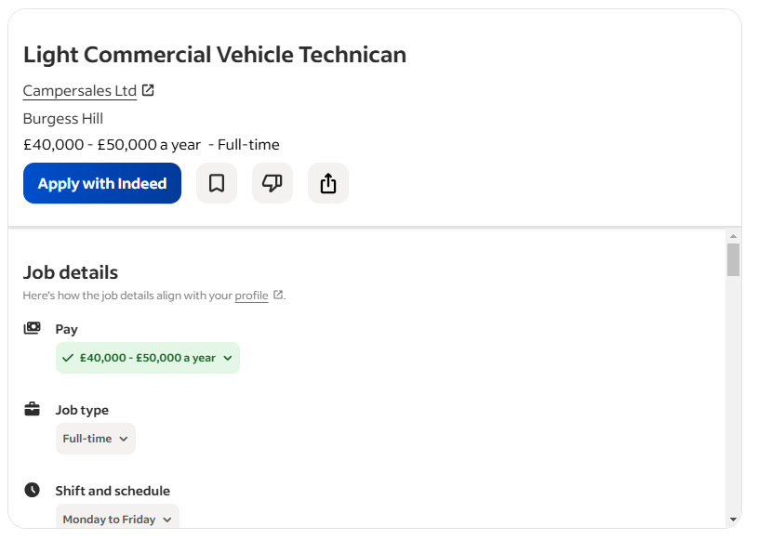
Appendix B: Land Rover Vehicle Technician (Listers, Hereford)


