
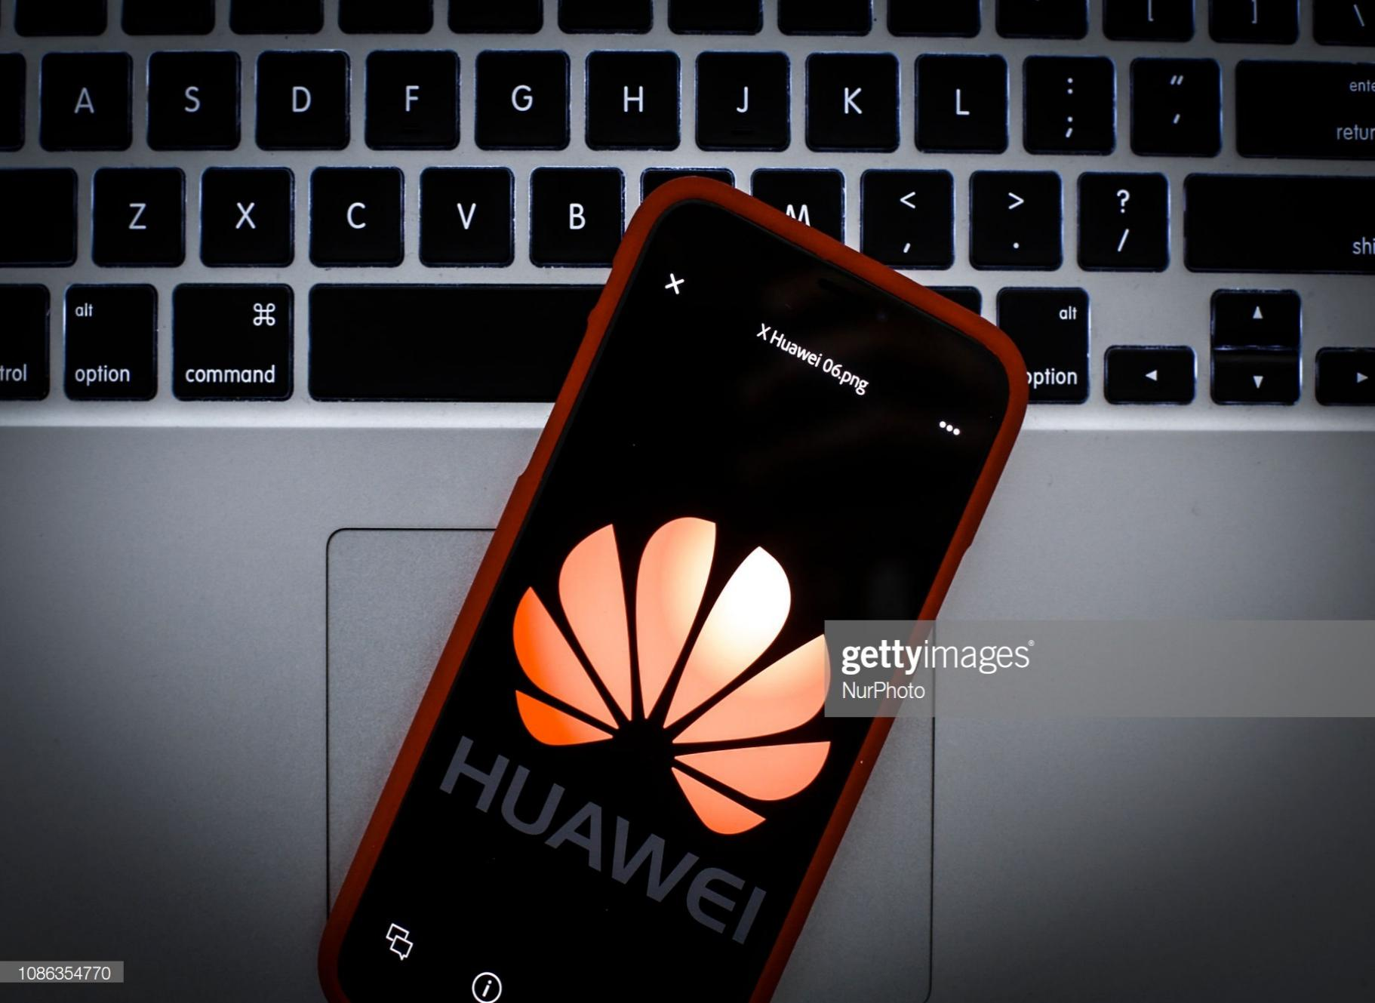
Student number:1806648
Marketing Plan of Huawei Smart Phone Group in Global Market

Executive summary
By conducting a comprehensive situation analysis of the leading player in smart phone industry – Huawei, this report analyses the business environments of the company in the global smart phone market. This report also identifies the key competences of the companies and its weaknesses as well as threats in the market.
Based on the result of the situation analysis, this report uses the STP modelling and 7P marketing mix model to design a robust and practical marketing plan for the company. This report also offers the methods on how the implementation could be controlled to avoid possible negative issues.

Table of Contents
Executive summary
1. Introduction 1
2. Situation scanning 3
2.1. Overview of Huawei smart phone group 3
2.2. Internal scanning 4
2.3. Micro environmental analysis 6
2.4. Macro environmental analysis 10
2.5. Summary & SWOT 14
3. Mission statement and objective setting 18
4. STP modeling 19
4.1. Segmentation 19
4.2. Targeting 20
4.3. Positioning 20
6. Tactics – marketing mix 22
7. Evaluation and control 25
8. Conclusion 26
Reference List 27

- Introduction
The mobile device production has fostered the most valuable company in the history – Apple. Though Apple has been the leader in the market in terms of profitability and brand valuation, the company has been faced with many competition challengers from Samsung of South Korea to Huawei of China. In the Q1 of 2019 fiscal year, the year-on-year growth of smart phone shipment of Huawei has reached 50%, making the company the only one that maintained growth in the past six months and that ranked the second in the global smartphone shipment share. As the scandals of battery explosion in some latest models of Samsung smartphones and dysfunctional pricing strategies of Apple in Chinese market, many forecasts that Huawei is to be the leader of global smart phone market (Deloitte, 2018).
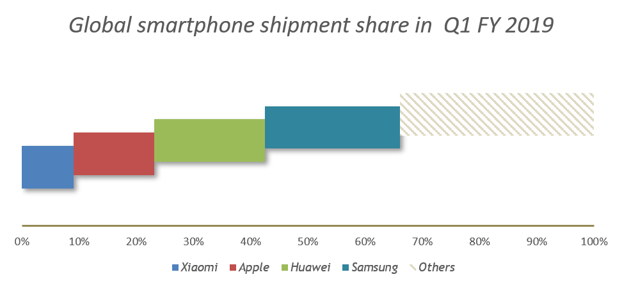
Huawei smart phone has been successful in developing and expanding the global market during the past years. However, it is evident that the global smart phone market has already passed the phase of high growth. As shown in the graph below (Statista, 2019c), the growth of global smart phone shipment has reached plateau since 2015.
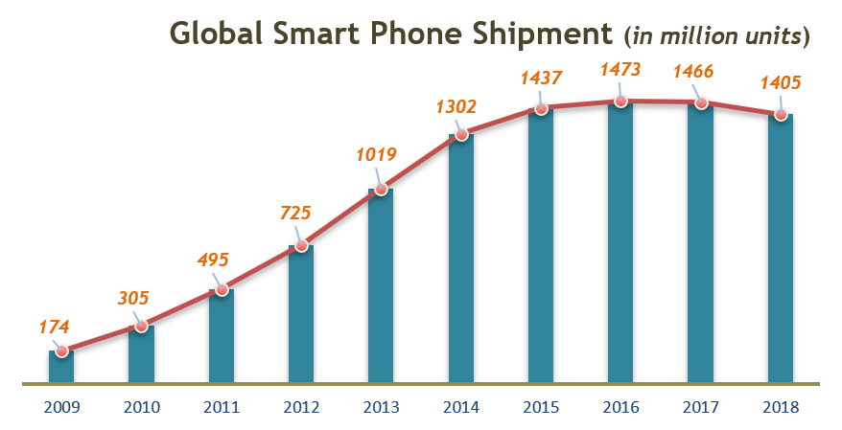
Thus, this report is to analyse the global smartphone market as macro environmental analysis of Huawei and internal auditing using VRIO model, the summary of both is to be the basis of a robust SWOT analysis of the company. Based on the extensive analyses, this report is to evaluate the current marketing strategy of the company in smart phone business and formulate practical marketing plans based on STP model and 7P marketing mix model.

- Situation scanning

  - Overview of Huawei smart phone group
The first smart phone of Huawei was introduced to the market in 2003, at which time the brand was widely deemed as being low quality controlled and low level of product design. In 2008, after several reorganizations and strategy shifts of the market phone group of the company (Xia and Gan, 2017), the rich experience accumulated in the past years started to help the company design and produce smart phones welcomed by the market.

Situation scanning is to understand the status of case company from internal scanning and external environmental scanning. The situation scanning is the crucial step fro evaluating the company’s current marketing strategy and formulating practical marketing strategy. The situation scanning is produced in the fashion as illustrated in the graph below.
  - Internal scanning
The VRIO represents the value, rarity, inimitability and organization of the resources in the enterprises.
Huawei has strong competence in R&D from two perspectives. The first is that China is now the county educating the largest number of engineers in the world. The salary of a smart phone related engineer in China is only 1/4 to 1/3 of those in EU and North America. The low cost of human resources allows the company to invest more on key parts development of smart phones such as CPU fabrication and production line upgrade. The second is that smart phone R&D in Huawei smart phone group can benefit directly from the parent company Huawei technology (Deng, Zou and Mao, 2018). The Huawei technology has accumulated rich experiences in telecommunication device development and manufacturing.
Huawei hasn’t been listed in any stock exchanges. According to the CEOs and founder of the company, the company has no imminent plan for IPO. The shares of the company are distributed into employees with decision-making power centralized in senior managerial teams. This rather typical Chinese managing style has allowed the company to selectively disclose information to the public and maintain the confidentiality of many key financial performance or organizational status (Haveman and Vochteloo, 2016). Set the sustainability aside, the company has proven that this financial managing style has established competitive advantage for the company to direct funds into R&D and production line upgrade.
The company advocates on the so called “wolf culture” which basically means that the employees in the company should work together as wolves in the wilderness. The company promotes the employees who sacrifices for the company in the expense of personal life, family or even health. The human resource management model and organizational culture has allowed the company to aggressively expand its market in recent years.
Throughout years of telecommunication contract projects in the world, Huawei technology has accumulated significant customer resources and has been maintaining friendly relationships with many local telecommunication companies. Huawei smartphone group has been leveraging these resources to progressively expand into EU and other markets. Huawei has also established vast supplier network centered in China (Xu and Li, 2016). During the years, the company has been taking the loss from high R&D cost from key chips in smart phones which used to be too low quality to be used in Huawei products. With the maturing of technology and production, the company is now able to produce any key part in one smart phone, which significantly elevates its controlling power on supply chain.
Based on the above analysis and analytical reports from other sources, this report summarizes the VRIO of Huawei smart phone as in the chart below. The numbers are indicative without quantitative underlying meanings. The score of each index in each dimension is a summary from public accessible resources such as analytic reports and annual reports of the company.
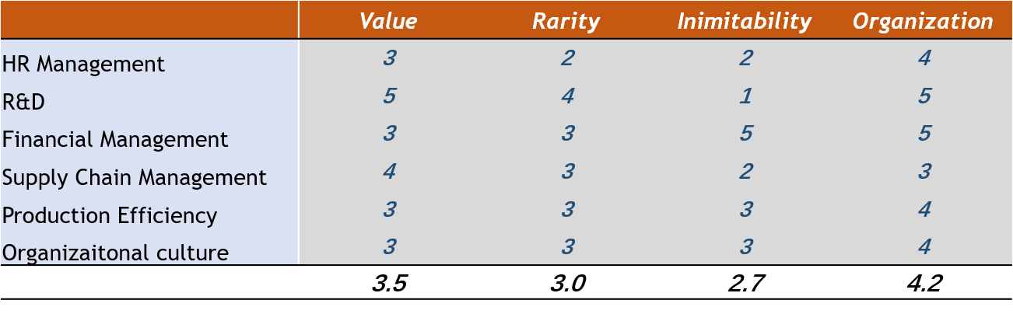
  - Micro environmental analysis
he five forces are the threats from market entrants, threats from substitutes, bargaining power of customers, bargaining power of suppliers and the incumbent competitors in the market.
- Threats from market entrants
The entrants of the global phone markets have limited threats to the company. Smart phone design and production requires high level of R&D and production investment. As the industry is the hub for hundreds of different industries, the entrants in this market are required to produce significant economies of scale to control the supply chain and maintain the profitability. As mentioned in the introduction, the growth of the global smart phone market has reached a plateau. The high entry level and almost freezing market has been hampering the entry of new players in the market. As shown in the graph below (Kyle Wiggers, 2018), the growth of global smart phone user and smart phone penetration has maintained a same level as of 2013. The growth rate has been declining since 2013.
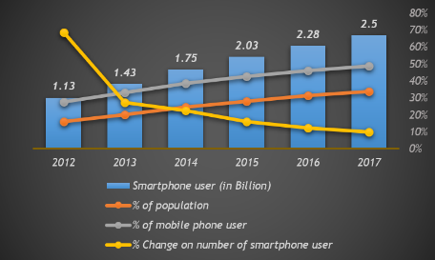

- Market substitutes
The product that sweep the Sony Walkman out from portable music player was not a new Walkman but an entire new product. By far there is sign of such product emerging against smart phone in the market.
- Bargaining power of the suppliers
The suppliers of Huawei mainly come from the manufacture of spare parts in smart phones. With being able to design and manufacture CPU and other processing units in the smart phone by itself, Huawei has been gaining strong bargaining power against the major suppliers in the market such as QUALCOMM and Intel. The other minor spare parts are less centralized unlike the smart phone producer industry (Drahokoupil et al., 2017), the bargaining power of theses supplier are further lowered with the increasing procurement volume from Huawei.
- Bargaining power of the customers
As Huawei has been targeting the high-end smart phone market, the bargaining power of the customers are divided in terms of the market segment. For its high-end smart phone market, the bargaining power of the customers is increasing as both Samsung and Apple are launching progressive pricing strategies to lower the prices for expanding customer base. However, in the middle and low-end smart phone market, the bargaining power of the customers is low as these smart phones are typically distributed through various sales channels. The information barrier is blocking the bargaining power of the customers.
- Incumbent competitors in the market
The incumbents in the market are competitive for Huawei. In the low-middle end market, there are Chinese companies Xiaomi, OnePlus, Vivo and Oppo. These companies can take more aggressive pricing strategies against Huawei as they can leverage even lower cost of labor (Kim, 2018). On the product R&D, despite they lack the same level of research capacity, they can tap the needs from small market segments (such as the portrait tuning smart phone by Vivo) and gain competitive advantage. In the middle to high end smart phone market, Samsung and Apple are still the strongest competitors for Huawei. Samsung is the only company in the world that can produce every part of one smartphone, it is leading in processing unit manufacturing and touchscreen development. Apple has strong capacity in controlling the supply chain. The growth trend of Huawei is largely threatened by both companies.
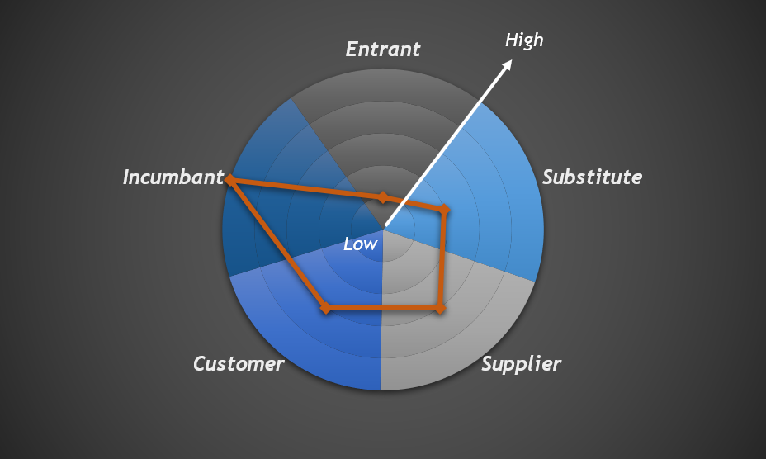

  - Macro environmental analysis
The PEST denote the political, economic, social and cultural, technological factors.
- Political
Global political environments have comprehensive impacts on Huawei smart phone group. In the European market, the relationship between European countries with China has experienced ups and downs in the past two years due to many global or geopolitical issues. However, with China being the second largest trade partner to EU, the European countries are maintaining a steady relationship with China. In the African markets as Chinese governments have been investing heavily in the infrastructure and natural resources in Africa, many African governments have been keeping a cooperative bilateral relationship with China (Lu, 2018). A steady relationship is crucial for customer-oriented companies such as Huawei smart phone. As in the example of Huawei in US, the trade war between US and China has been damaging to the brand image as well as the revenue of Huawei smart phone in the north American market.
- Economic
The global economy recession since the 2008 financial crisis has been hampering the consumption growth in many economies. As shown in the graph below (Statista, 2019a), major economies in the world are still suffering from low growth and recession. The trade wars happening between China and the US is making the global market more nervous in investment. The global economy is thus posing negative effect on the smart phone industry.
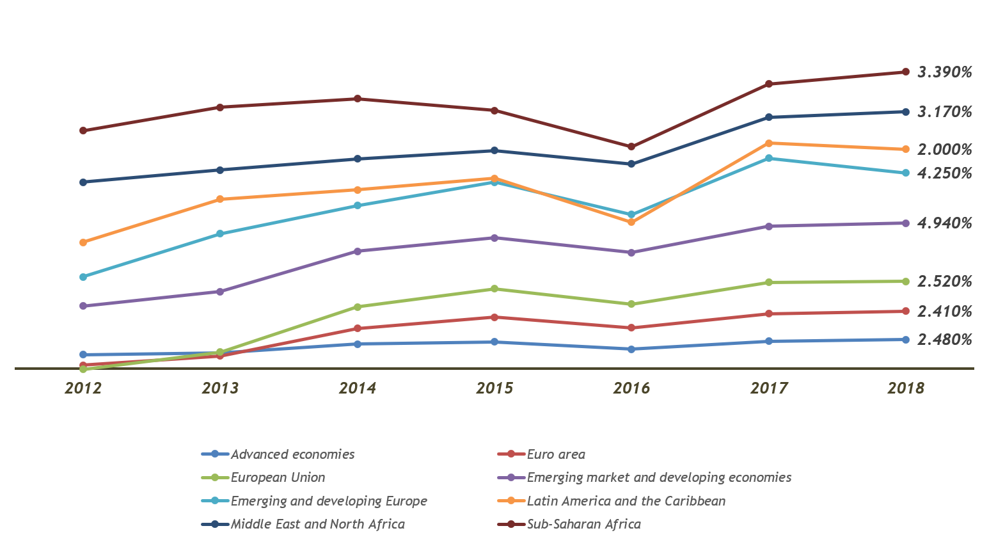
- Socio and cultural
Years of international strategy implementation of Huawei have developed competitive teams in the company to conduct effective business communication and market research in distinctive countries.
Chinese products used to be deemed as low in quality and price. As shown in the Google search index below (Google, 2019), the flagship smartphone model P20 from Huawei was gaining similar awareness (based on the times and locations of the searches) from global customers compared with those in Apple i.e. iPhone XS and Samsung S9. The global awareness of Huawei smart phone products show that the company has conducted effective international strategies and lowered the impact from cultural barriers.
- Technological
Technological factors are crucial for players in the smart phone industry. The multi-finger touch screen brought by first iPhone was the fundamental building block of competences of Apple at that time.
The technological advancements are favoring the development of Huawei. Huawei has been particularly good at leveraging the edge-cutting technologies such as artificial intelligence and mobile lens to establish competitive marketing advantages. For example, by cooperating with world renowned photo system producer Leica, Huawei has been offering portable photographing experiences to its customers with images tuned as Leica photographs whereas an entry level Leica camera set would cost 1,000 GBP or more. By specifically tuning its camera performance, Huawei has occupied three positions on the top ten best mobile phone cameras ranked by DxO (Nguyen, 2018).
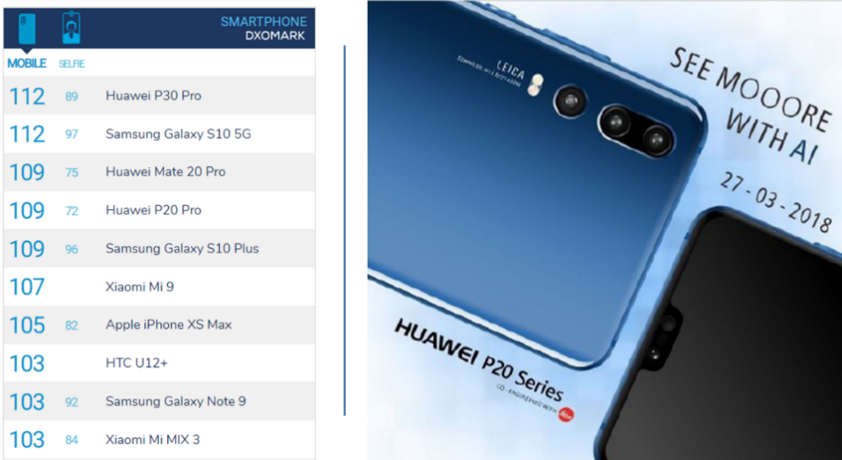
Based on the analysis from internal and external of Huawei smart phone, it is clear that the marketing is offering multiple opportunities as well as challenges to the company. The red ocean nature of the smart phone market in the world is requiring the companies to leverage their established advantages and strengths to keep growing or survive in the market. This report thus conducts a SWOT analysis of Huawei smart phone as a summary of the situation analysis of the company.

  - Summary & SWOT
Based on the above internal and external scanning, the SWOT analysis can offer a comprehensive overview of the competences of Huawei smart phone.
- Strength
- Well-established corporate structure
The founder of Huawei Mr. Ren Zhengfei, as a former military officer, established the fundamental principles of corporate governance of Huawei as the Huawei Basic Law. After decades of development, the company has conducted several organizational transformations to adapt to the changing environment (Tao, De Cremer and Chunbo, 2016). The basic principles of the corporate governance in Huawei especially in the younger subsidiary Huawei smart phone group, emphasizes on the sacrifices members of the company should make for the development of the company. Though being criticized by many as inhumane, this system has been the core of competences within Huawei.
- Robust HR management
Huawei has been investing in R&D departments by hiring PhD and master graduates with high salary since more than a decade ago when there were much less PhD graduates in China. HR managers in Huawei believe that well-paid salary is the strongest motivation for team members and can solve most of the problem’s employees might encounter (Nankervis et al., 2013). Despite that this system has been opposed by some employees even some senior managers in the company, many found that Huawei is currently the company in china offering the most competitive salary package.
- Strong R&D capacity
In 2018, Huawei became the company with most international patents applied in the world with 60% of which are smart phone related. As shown in the graph below (Statista, 2019b), the R&D expenditure has been maintained at around 14% of its revenue which is among the highest in the global technology companies.
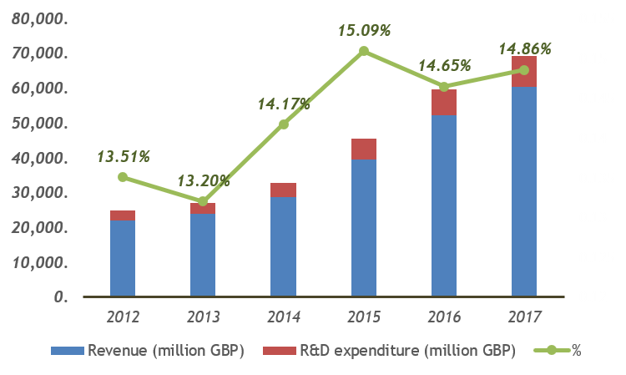
- Well-established overseas supplier &customer relation
The parent company has offered Huawei smart phone with competitive advantages by connecting its customers in telecommunications to Huawei smart phone sales distributors.
- Weakness
- Brand image
The Huawei smart phone, as has been influenced by the typical images of products made in China, has been criticized in many reports as being lacking the proper product design and taste. As in the early times when Huawei smart phone was entering the global market, the low-price strategy was the major weapon of the company to fight against its competitors, which led to the impression that Huawei is mainly building cheap yet reliable smart phones but not as fancy as other brands. Despite the high-end smart phones launched in recent years have gradually shifted this attitude, many still think Huawei cannot manage to produce the same level of products as Apple.
- Organizational culture
The organizational culture of Huawei has helped it to established competitive advantage. However, with the labor right being emphasized by both the public and the government in China, companies such as Huawei is under extreme pressure of being criticized as ripping off its employees. The so-called wolf culture also leads to the dictatorship in the managerial teams in the company. Only in 2018, several senior engineers resigned from Huawei for bad communications with their reporting managers.
- Private-funded
Not being listed in stock exchanges have created a gap between the need for funding in Huawei and external investors. The funding model of Huawei can centralize the power of the members in the enterprise to maximize business outcome. However, with its competitors being the most valued companies in the world, such private funding model of Huawei can lead to serious financial deficiencies especially in the smart phone industry.
- Opportunity
- China has been one of the most dynamic markets in terms of adopting emerging data and internet technologies such as artificial intelligence and cloud computing. Huawei smart phone can leverage these technological advancements to establish its competences in the next decade.
- Its major competitors are facing severe or lesser crises at the moment. The explosion of lithium battery in Samsung Galaxy series smart phones almost wiped the related models from some markets such as China (Yun et al., 2018). With the launch of iPhone Xs in 2018, Apple has been constantly criticized as being lack of innovation.
- Threats
- The US-Sino trade war has escalated in recent months. The uncertain trade relationship between US and China has impacted many Chinese companies operating on a global scale.
- The rising of protectionism in EU. Huawei smart phone has targeted EU as one of its core markets overseas. However, with the stricter regulation commenced by EU and rising protectionism, Huawei may face significant threats from regulation uncertainty.
- The CEO of Huawei was arrested in Canada which can lead severe damages to the brand image of Huawei as well as the Huawei smart phone.

- Mission statement and objective setting
The mission of the marketing plan, based on the situation analysis, is to maintain the growth of Huawei smart phone in the global market in terms of number of smart phone shipment, and to maintain its position as the second largest smart phone producer in the world in terms of market share. The marketing plan is also to consolidate the brand image as being diverse and embracing edge-cutting technologies. The marketing plan is to leverage the R&D and organizational strengths of the company to minimize the effect from market threats and to maintain or expand its market share.

- STP modeling
STP strategy was proposed in 1950s to choose the right market segment, target market and positioning of the enterprise or products/service they provide.

  - Segmentation
Global customer of smart phones is rapidly changing on their needs. The smart phone industry, though with high entry barrier, is still filled with fluctuated market entrants. A market segmentation is thus crucial for the proper marketing mix.
- Geographically differentiated market segmentation
As shown in the global economic growth graph, the emerging markets are still experiencing high level of economic growth whereas the developed economies are experiencing slow growth even significant recession. As Huawei smart phone group has extensive product lines currently in the market. It should make market segmentation separately considering the local economic situation. For example, in African market, the market segmentation should be defined as low price and quality assured smart phone with focus on price competence.
- Industry Standard differentiated market segmentation
As parent company Huawei technology holds large number of patents in telecommunications such as 5G. Huawei smart phone should make market segmentations based on the different standards adopted in the market. For example, Huawei smart phone should emphasize on the market segments that are demanding on next generation technologies such as 5G.
  - Targeting
The targeting market, based on the strengths of Huawei smart phone, should be mainly developing countries and developed countries. As in developing markets Huawei smart phone has significant cost advantage and thus can adopt aggressive pricing strategies. In the developed markets Huawei should target the high-end customers who require finely designed smart phone products that can replace dubious Samsung products and do not want to shift to iOS platforms.
  - Positioning
The positioning of Huawei should be divided in terms of the target markets. In developing markets, the positioning of Huawei smart phone should be middle priced with featured functions such as strong photographing capacity to differentiate itself from competitors such as Xiaomi. In the developed markets Huawei should be positioned as lower pricing than Apple products yet with same level of product design, and with featured functions that surpasses Apple products such as wireless connection quality and photographing.

- Strategy composition
The strategy composition is based on the STP modeling of Huawei smart phone to fulfill its strategic objectives. The composition is conducted using the Ansoff Matrix as below:
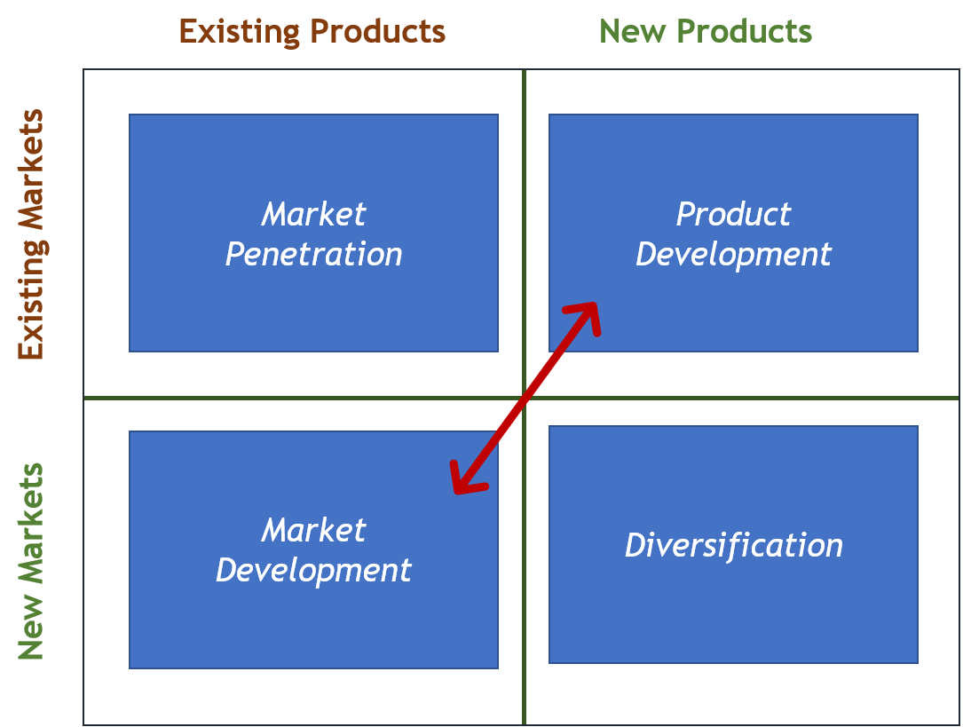
As the market penetration of Huawei smart phone has already completed in terms of penetrating into major markets in the world, the priority task is to conduct effective market development to discover more market segments that its current or to-be-developed products can fit in to. To leverage its advantage in R&D and temporal advantage in cost of human recourses, the company should also adopt a product development strategy to introduce more diversified products that can help it maintain the position in already developed markets. To defend itself from possible strong market entrants and competitive market incumbents, the development of new products is crucial to maintain even increase its market share in global smart phone market. The market development strategy is to ensure that the company can take certain losses even if the new products were not to be accepted by the market.
- Tactics – marketing mix
The marketing mix is formulated using the 7P theory i.e. product, place, price, promotion, people, process and physical evidence. The 7P marketing mix is shown in the graph below.
- Product
The product strategy should be focused on using edge cutting technologies in high-end models to offer functions that other competitors cannot follow up in the short notice.
The product strategy should also be diversified product line targeting different market segments.
- Price
The pricing strategy should be aggressive as to maintain the minimal marginal profit in developing countries to consolidate market share.
The pricing strategy in developed markets should be as to hold the high-price of flagship products to avoid the impression on the products as easily being depreciated.
- Place
The placement in development markets should be controlled as much as possible by Huawei smart phone to ensure the uniamosity of the pricing and purchasing experiences such as in-store demon smart phone experiencing.
The placement in developing markets should be relied on local distributors and local telecommunication companies to fully leverage the advantages of parent company Huawei technology.
- Promotion
The promotion of the products should be covering more high-end markets such as Nordic Europe, UK and north America. The promotions should also be collaborated with KOLs (key opinion leaders) on various social platforms such as Instagram, Facebook and YouTube to develop the brand image as close to future rich in technology adopted.
The promotion of the products in the developing markets should follow similar strategies as that in high-end market with differences on the product lines to be introduced to the market. This is to avoid the situation that the market development would lead to another deterioration of the brand image as being cheap and lousily designed.
- People
As a company led by engineers, the company should always focus the needs of the customers instead of being too pursuit on displaying the R&D capacity of the company.
The company should also care more about its employees as the sustainable development of individual employees can lead to the sustainable development of the company.
- Physical evidence
The company should learn from Apple to build multiple flagship stores in major global cities to demonstrate its product design and adopting of latest technologies.
- Process
The company, during the process of implementing the marketing mix, should appoint specific teams on monitoring the effect of the marketing mix and conduct necessary modifications. With the technological strength in the company, Huawei smart phone could leverage the power of big data and cloud computing to monitor the process more effectively.
- Implementation
The implementation of the marketing mix is crucially reliant on the human resources. Even the “wolf” culture might not be sustainable in today’s business environment, the company should still remain the positive parts in this organizational culture such as diligence and team work. The implementation should be led by the marketing department and HR department of the company to ensure its effectiveness. Every other department such as R&D and production, quality control and finance, should all step in to make sure that the marketing mix is properly implemented. The marketers and HR managers can use the strategic wheel to allocate resources and tasks.
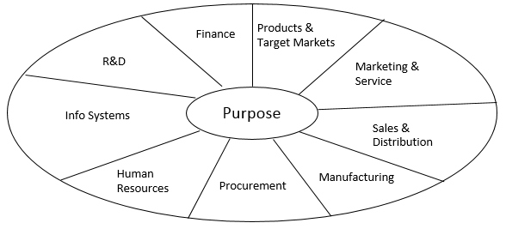

- Evaluation and control
The marketing mix requires the company to act in a global scale and with effort devoted from the entire company from every level and functioning department. The coordination between the marketing strategy implementation in developing markets and developed markets can be the possible issue hindering the proper implementation of the marketing plan. As in the developed market there are many senior local managers and on-site engineers who tend to trust their instincts more than the strategic objective from the headquarters, conflicts may occur during the implementation.
Besides, the cost of the marketing plan can be another issue during the implementation. As the marketing mix is prioritized in the high-end market, collaborations with multiple promotion channels can lead to significant overbudgeting during the implementation process.
Thus, the control is mainly on the communication of the global teams and control on the overall budget. The first can be achieved by KPI based regional manager assessment on the effect of the implementation of the marketing plan. The second should be carefully catered by the financial department of the company.

- Conclusion
This report analyzed the internal and external situation of the leading smart phone company – Huawei in the global market. The analysis concludes that the market is becoming rather competitive for the company as it is now confronting with strong competitors i.e. Apple and Samsung. The analysis also concludes that the company is competitively strong in R&D and global operation from the aspect of financial management, organizational culture and human resource management. The market offers the company many opportunities such as the recent scandals in its major competitors and mature of smart phone related technologies such as artificial intelligence on chip.
Based on the extensive analysis, this report summarized the SWOT situation of the company and proposed a practical marketing plan with STP modeling, marketing mix and implementation with monitoring methods. The company should focus on product and market development to maintain its market share in global smart phone industry and to consolidate its advantages.

Reference List
Deloitte (2018) ‘Global Mobile Consumer Survey 2018; The constraints on smartphone sales’, pp. 1–11.
Deng, Z., Zou, Y. and Mao, J.-Y. (2018) ‘Unconventional Internationalization of Huawei: The Role of Core Values’, in Business Despite Borders. Springer, pp. 179–191.
Drahokoupil, J. et al. (2017) ‘Huawei in Europe: strategic integration of local capabilities in a global production network’. European Trade Union Institute (ETUI).
Google (2019) Google Trends. Available at: https://trends.google.com/trends/?geo=US (Accessed: 9 May 2019).
Haveman, M. and Vochteloo, J. (2016) ‘Huawei: A Case Study on a Telecom Giant on the Rise’, in Multinational Management. Springer, pp. 75–94.
Kim, S. H. (2018) ‘Emergence and Success of Xiaomi in the Transitional Situation of Chinese Smartphone Industry’, East Asian Journal of Business Economics, 6, pp. 16–23.
KYLE WIGGERS (2018) IDC: Smartphone shipments declined 4.9% in Q4 2018, Apple regains second from Huawei | VentureBeat. Available at: https://venturebeat.com/2019/01/30/idc-global-smartphone-shipments-declined-4-9-percent-in-q4-2018/ (Accessed: 9 May 2019).
Lu, N. (2018) The dynamics of foreign-policy decisionmaking in China. Routledge.
Nankervis, A. R. et al. (2013) New Models of Human Resource Management in China and India. Taylor & Francis (Routledge Studies in the Growth Economies of Asia).
Nguyen, V. (2018) ‘Smartphone Photography : the Use of Smartphone Camera in Smartphone Camera in 2018’.
Statista (2019a) • Global economy | Statista. Available at: https://www.statista.com/study/14781/global-economy-statista-dossier/ (Accessed: 9 May 2019).
Statista (2019b) • Huawei: R&D activity spending 2012-2018 | Statistic. Available at: https://www.statista.com/statistics/566266/huawei-research-and-development-spending/ (Accessed: 9 May 2019).
Statista (2019c) • Smartphones | Statista. Available at: https://www.statista.com/study/10490/smartphones-statista-dossier/ (Accessed: 9 May 2019).
Tao, T., De Cremer, D. and Chunbo, W. (2016) Huawei: Leadership, Culture, and Connectivity. SAGE Publications India.
Xia, W. and Gan, D. Z. (2017) ‘The Marketing strategy of HUAWEI Smartphone in China’.
Xu, H. and Li, W. (2016) ‘Analysis on Impact of Marketing Dynamic Capabilities’ Against the Value of Stakeholders-A Case Study Based on Huawei’, Management & Engineering. St. Plum-Blossom Press Pty Ltd., (24), p. 131.
Yun, J. et al. (2018) ‘Benefits and costs of closed innovation strategy: analysis of Samsung’s Galaxy Note 7 Explosion and withdrawal scandal’, Journal of Open Innovation: Technology, Market, and Complexity. Multidisciplinary Digital Publishing Institute, 4(3), p. 20.

