Factory Control – Box Sorting System Using an Industrial PLC

ACDA6000

Niall Rees

May 2024

Contents

List of Figures 2
List of Tables 4
1.0 Introduction 5
2.0 PLC Review 6
2.1 PLC Construction 6
2.2 PLC Types 7
2.1.1 Rack Mounted PLC. 7
2.1.2 Compact PLC Systems 8
2.1.3 Distributed Control Systems 10
3.0 Factory IO Control System 12
3.1 System Operation 12
3.2 Alarm and Warning Strategies 14
3.2.1 Large Box Alarm and Warning Strategy 14
3.2.2 Medium Box Alarm and Warning Strategy 15
3.2.3 Palletiser Box Alarm and Warning Strategy 16
3.2.4 Total Box Warning and Alarm Strategy 17
3.2.5 Emergency Stop Monitoring 18
3.2.6 Excess Weight Alarm 18
3.2.7 Pusher Fault Alarm 18
4.0 Factory Design 19
5.0 PLC Program and HMI Design 20
5.1 PLC Tags 20
5.2 PLC Ladder Logic 22
5.2.1 Alarm Logic 31
5.3 HMI Design 38
6.0 Conclusions 41
Bibliography 42

List of Figures

Figure 1 - RX3i Rack Mounted PLC With Rack Mounted IO Modules 7
Figure 2 - Siemens S7-1200 PLC [7] 9
Figure 3 - RSTI Distributed IO controlling Valve Cabinet 10
Figure 4 - System Operational Flowchart 13
Figure 5 - Large Box Warning and Alarm Process 14
Figure 6 - Medium Box Warning/Alarm Process 15
Figure 7 - Palletiser Box Warning/Alarm Process 16
Figure 8 - Total Box Alarm/Warning Flow 17
Figure 9 - Box Sorting Line 19
Figure 10 - Sample List displaying configured PLC tags 20
Figure 11 - HMI Tags 21
Figure 12 - Start System Flag 22
Figure 13 - Conveyor startup delay timers. This is replicated for all 14 conveyors. 22
Figure 14 - Conveyors running check flags. 23
Figure 15 - Box emitter control 23
Figure 16 - Pusher Control 24
Figure 17 - Total boxes entering the system from the emitter. 25
Figure 18 - Large Box counter 25
Figure 19 - Large boxes out of the system 26
Figure 20 - Medium boxes into the system counter 26
Figure 21 - Heavy box counter 27
Figure 22 - Light boxes counter 27
Figure 23 - Palletiser box count into the system. 28
Figure 24 - Palletiser boxes leaving the system. 28
Figure 25 - Scale conveyor motor control 29
Figure 26 - Box loaded on to scales check. 29
Figure 27 - Control allowing the scales to stop and take a measurement when a box is loaded. 29
Figure 28 - Pop-up sorter control 30
Figure 29 - Moving analogue input to analogue output for panel LCD display. 30
Figure 30 - Alarm word comparison, driving indicator outputs. 31
Figure 31 - Warning comparison 31
Figure 32 - E-Stop Monitoring 32
Figure 33 - large box error calculation 32
Figure 34 - Warning level 33
Figure 35 - Alarm Level 33
Figure 36 - total medium boxes leaving the system. 33
Figure 37 - Medium box error calculation 34
Figure 38 - Medium Warning Limit 34
Figure 39 - Medium Alarm Limit 34
Figure 40 - Palletiser error level calculation 35
Figure 41 - Palletiser warning comparison and output 35
Figure 42 - Palletiser alarm comparison and output 35
Figure 43 - Total boxes out check. 36
Figure 44 - Total error level calculation. 36
Figure 45 - Alarm and warning comparison 36
Figure 46 - Pusher failure alarm detection logic 37
Figure 47 - Root Screen 38
Figure 48 - Engineering Screen 39
Figure 49 - Alarm configuration 39
Figure 50 - Alarm Screen with displayed messages 40

List of Tables

Table 1 - Advantages and Disadvantages of Rack Based PLC Systems 7
Table 2 - Advantages and Disadvantages of Compact PLCs 8
Table 3 - Advantages and disadvantages to Remote/Distributed Control Systems 10

Introduction

Programmable logic Controllers (PLC) are standalone industrial computers, that are used for automation and control of industrial processes. They feature hardware that allows plant analogue sensors and discrete inputs to be interfaced using dedicated input terminals. The PLC can then control processes via output terminals connected to actuators, solenoids, drives and indicators. These controllers require programming to carry out their specified tasks, using specialist software and instruction sets in the form of ladder logic, sequential function charts or function block diagrams. Due to the variety of suppliers of industrial PLC’s, these programming instruction sets and styles have been standardised in IEC 61133 – 3:2013 Programmable Controllers - Programming Languages [1].
This report demonstrates the use of simulation software, Factory IO, and an industrial standard PLC programming software, Siemens TIA Step 7, to create an automated box sorting system. The system sorts and arranges different boxes, depending on their size and weight. The control system features standard components that would be found in a real-life automation project, such as conveyors, pneumatic actuators, signalling lights, push buttons and emergency stops.
This report will demonstrate the use of ladder logic programming methods to control the equipment in the system and generate alarms and warnings in the event of a malfunction or process error. The configuration and use of a Human Machine Interface (HMI) will be demonstrated to allow operators to interact with the plant, starting and stopping the process entering data, and monitor any alarms present.
This report will discuss the common styles of PLC currently used in industry, such as distributed control systems, rack mounted PLC and compact controllers. Their components, construction, and applications will be shown, along with their individual merits and disadvantages.

2.0 PLC Review

This section discusses the common types of PLC available, and the main manufactures of these items for industrial use. Their construction, application, and advantages/disadvantages of each.

2.1 PLC Construction

Fundamentally, PLCs are constructed of the following items:
- Power Supply Unit (PSU)
This is normally the first element in a PLC rack, providing power to the PLC processor and in some cases field power to input and output modules to drive equipment. These PSUs are commonly 24VDC for standard industrial applications.
- Central Processing Unit (CPU)
This is the area of the PLC where the program data is stored to control the various inputs and outputs.
- Input/Output (IO) Modules.
These are where incoming and outgoing signals from sensors or switches are interfaced to the PLC via terminal blocks. These modules can be in the form of digital inputs, analogue inputs, digital outputs, and analogue outputs. Digital inputs and outputs are often opto-isolated from the microprocessor inputs. This physical separation of the high voltage plant signal and low voltage microprocessor input, protects the PLC circuitry in the event of a fault in the field.
Analogue input modules are used to interface standard industrial signal types, such as 4-20mA current loops, or 0-10V signals. The CPU then uses an analogue to digital converter to convert the varying signal into discrete logic levels for scaling in the ladder program. Similarly, analogue output modules can drive items such as Current/Pressure (I to P) regulators for pressure control, valve positioners and other actuators. The analogue outputs may also be used to drive displays for plant equipment.
- Communication Modules
These may be separate items, or incorporated into a rack PLC. These may be used to expand the PLCs networking ability, and connectivity to items such as HMI, VFD’s and distributed IO modules. These communication modules use industrial networks such as Profinet, ModbusTCP and EthernetIP.

2.2 PLC Types

PLCs range in form factors and are configured for the application they are required. These range from compact, small form factor units for simple control applications, to large rack mounted PLC or distributed control systems. Each topology of controller should be considered on the number of IO, plant location, if functional safety is required and complexity of the automation system. Some of the different PLC types from main manufacturers are shown below.

2.1.1 Rack Mounted PLC.

These PLCs consist of a PSU, CPU, and IO modules, mounted to a rack that can then be in a main control cabinet of a plant or automation system. Rack based systems from manufacturers such as Siemens have the S7-1500 series of controllers [2], GE/Emerson have the PAC System RX3i family of backplane mounted controllers [3] and Rockwell Automation by Allen Bradley have the ControlLogix 5580 Controllers [4]. These CPU controllers utilise additional hardware such as IO modules, PSU, and communications modules, mounted to a chassis. An example of a rack mounted PLC within a control cabinet is shown in figure 1.

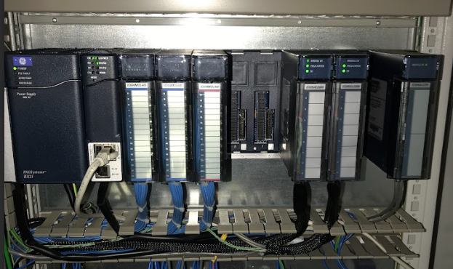
Backplate
Digital IO and Analogue IO Modules
PSU and CPU
Figure 1 - RX3i Rack Mounted PLC With Rack Mounted IO Modules

Rack based PLC systems are very common in industrial applications. Some of the advantages and disadvantages are displayed in table 1.

Table 1 - Advantages and Disadvantages of Rack Based PLC Systems

2.1.2 Compact PLC Systems

Compact PLC systems are an automation solution for less complex tasks with smaller amounts of IO and processing power required. They are lower cost items that enable automation to be implemented on individual machinery or allow retrofitting to older plant reliant on traditional ladder logic. The compact systems often have the CPU integrated with a set amount of digital and analogue IO in one unit. Some example items available include the Siemens S7-1200 [5], The Emerson VersaMax Micro PLC [6]. These units are expandable using add on modules to the main CPU for additional functionality. Table 2 displays a list of advantages and disadvantages of compact PLC solutions.

Table 2 - Advantages and Disadvantages of Compact PLCs

Figure 2 displays a Siemens S7-1200 Compact PLC.
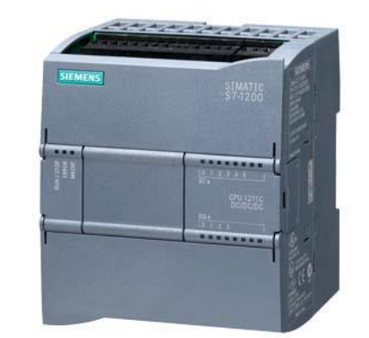
Figure 2 - Siemens S7-1200 PLC [7]

2.1.3 Distributed Control Systems

Another common topology for utilising PLCs in industrial automation is the use of distributed control systems, or distributed IO. This is where a local controller, or IO module is near the item it is controlling. The IO modules, or distributed CPU are then connected using an industrial network, such as Profibus, EthernetIP or Modbus TCP. The use of remote IO requires a standard CPU to store the program, however, all field wiring is connected to the local IO module, and only a single network cable needs to be connected to the CPU, minimising installation times and costs. Some common remote IO and distributed control systems are the Siemens Simatic EP200SP modular distributed IO system [8], which is a fully modular system, comprising of analogue and digital modules. These can also be configured with a distributed CPU. Another distributed IO system from Emerson is the RSTI system [9], which is a fully modular IO system that can be connected to an industrial network. Figure 3 displays an RSTI remote IO block within a local valve control panel, where the number of signals would have been impractical to run to a central PLC location. Table 3 summarises the advantages and disadvantages of Remote IO PLC topology.

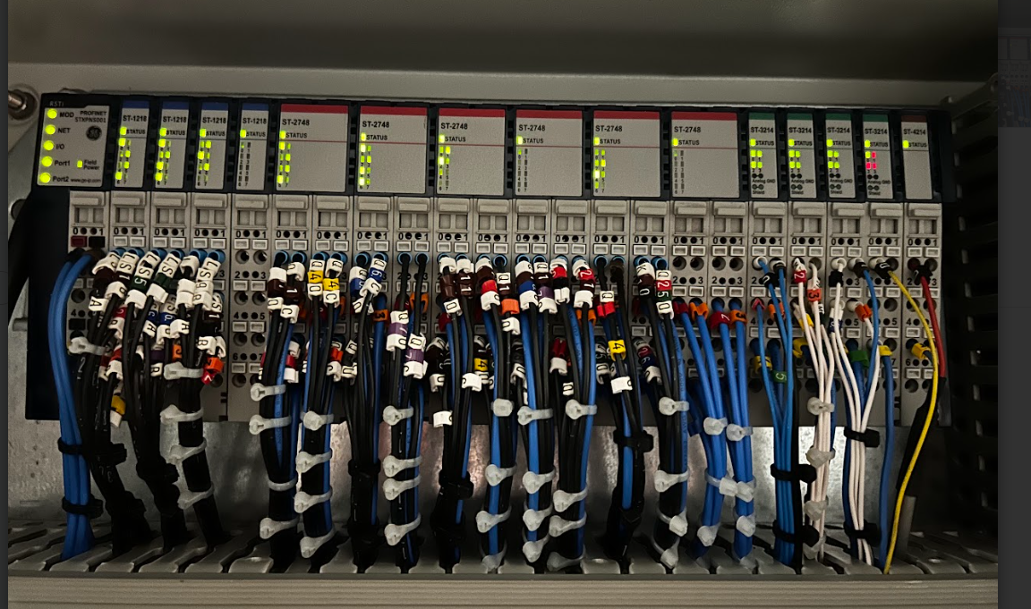
Figure 3 - RSTI Distributed IO controlling Valve Cabinet

Table 3 - Advantages and disadvantages to Remote/Distributed Control Systems

3.0 Factory IO Control System

3.1 System Operation

The system designed in factory IO sorts large, medium boxes of varying weight, and small palletiser boxes. These are emitted on to a conveyor system and sorted into individual lines using pneumatic pushers. Once on the individual belts, the boxes are counted as they exit the system into the removers. The medium size boxes are sorted by weight using a pop-up sorter. The scales are used to capture the box weight, and the sorter moves the weighed packages to their respective lines.
After a start signal, the conveyors are started individually to limit current draw that would be expected from direct online starting. Each conveyor is started in sequence after a set period. During startup, a warning siren indicates the system is live. Once all conveyors are started, the emitter releases boxes into the system at 5 second intervals. Figure 4 displays the operational flow chart of the system.
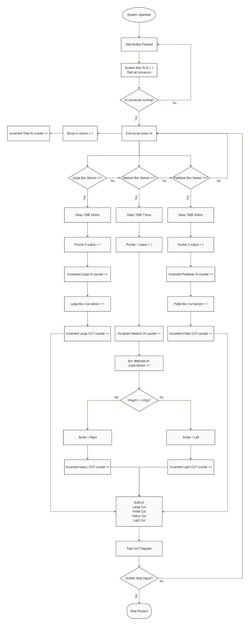
Figure 4 - System Operational Flowchart

3.2 Alarm and Warning Strategies

The designed system contains programmed alarms and warnings to provide operators with the status of the line. Warnings issued by the plant will indicate an orange light on the stacks located on the plant and display a message on the HMI. Once the fault has cleared, the warning will go away without acknowledgement. Warnings will not stop the plant from operating.
Alarms are configured in the logic to stop the process when they occur and notify operators via a red stack light, process stop and an HMI display. Once the fault has been rectified, an alarm can be acknowledged and manually reset. The system can then be restarted. The following alarms and warnings have been configured for operation in the logic.

3.2.1 Large Box Alarm and Warning Strategy

This warning indicates the number of large boxes lost on the system is greater than an entered value in the engineering screen of the HMI. This warning takes the difference of the large boxes counted into the system and the boxes out of the system. This error value is then stored in a register, where it is compared to the warning level input register. If this limit is exceeded, after a delay timer has finished, the system issues a large box warning. The same error value is passed to another comparator, where it is compared to the alarm level input value. If this is exceeded, it sets the alarm bit to 1 and stops the system and displays an HMI message. Figure 5 displays the process flow for the alarm and warning.
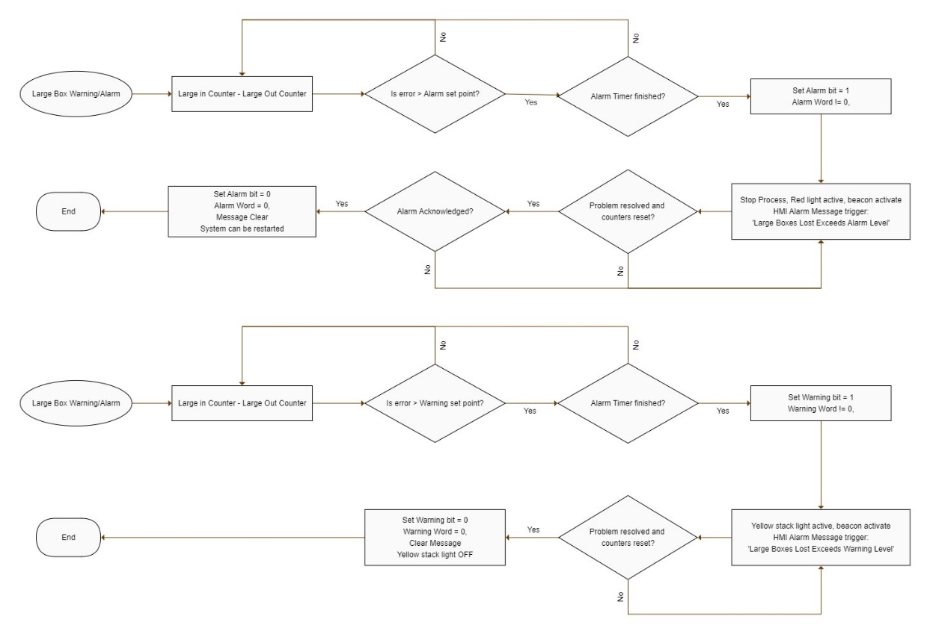
Figure 5 - Large Box Warning and Alarm Process

3.2.2 Medium Box Alarm and Warning Strategy

The medium size box warning and alarms follow the same strategy as the large boxes. The total number of medium boxes into the system is counted by the rear limit of the pusher. The heavy boxes are counted by an outgoing sensor, as are the lighter boxes. These are summed together and the difference between this value and the number of boxes into the system is taken and stored as an error register. This error value is compared to the alarm and warning limits set in the HMI, where the relevant messages are displayed. Figure 6 displays the alarm process.
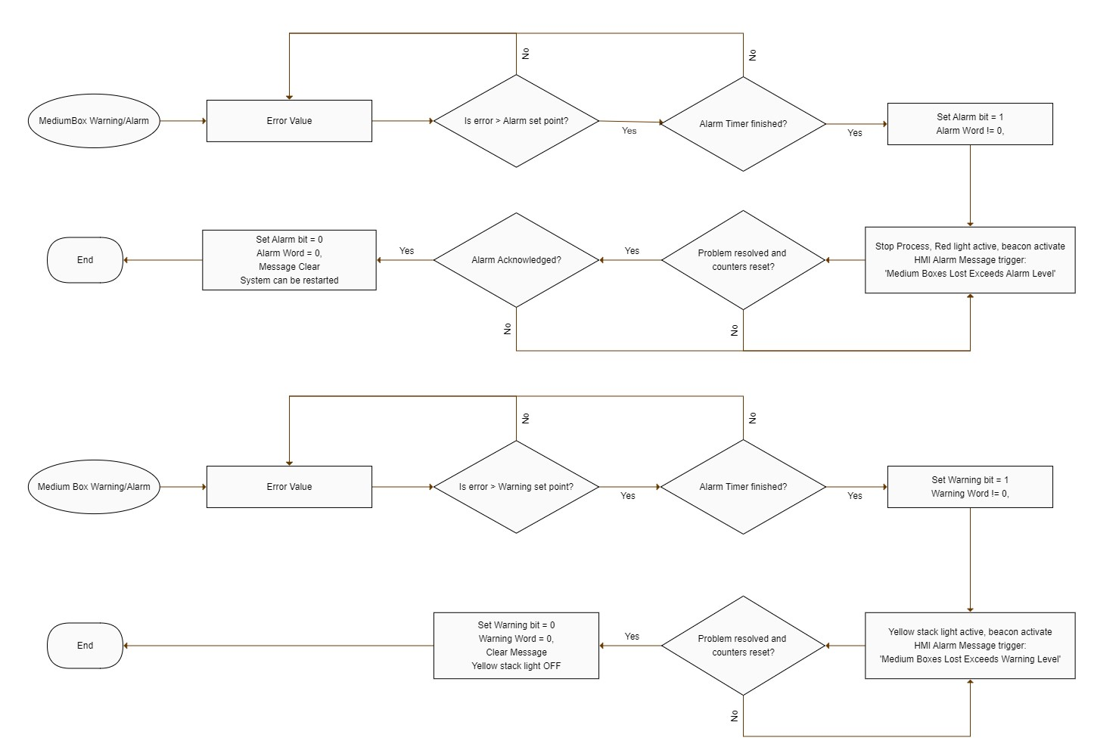
Figure 6 - Medium Box Warning/Alarm Process

3.2.3 Palletiser Box Alarm and Warning Strategy

Palletiser boxes into the system are counted from the pusher limits. The boxes are then counted out of the system via a diffuse sensor at the end of the belt. The difference between the outgoing boxes to the incoming boxes is taken and stored as an error. If this error is greater than the set limits within the delay time, the relevant alarm and warnings are displayed. Figure 7 shows this alarm and warning process.
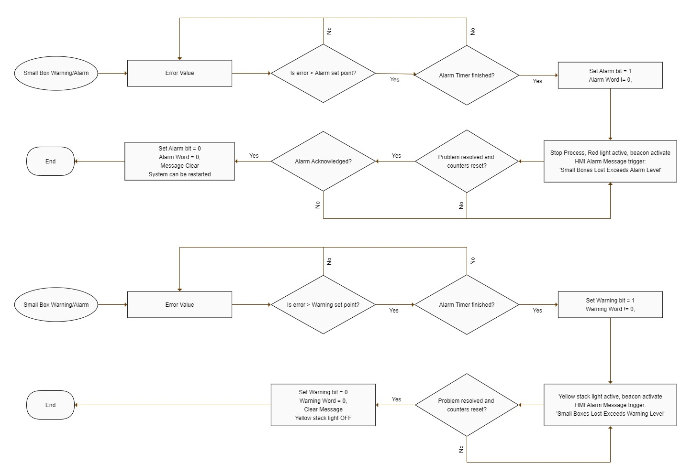
Figure 7 - Palletiser Box Warning/Alarm Process

3.2.4 Total Box Warning and Alarm Strategy

The total box warning and alarms are to indicate a loss in boxes that have entered the system but have not been counted by their respective lines. An example would be where boxes have been detected entering the system but have fallen off the line or got stuck before being sorted. This alarm and warning are generated by summing all the boxes leaving the system and taking the difference from the boxes entering the system. This creates a total error value, which is compared to a preset warning and alarm level. Figure 8 displays the warning and alarm strategy.
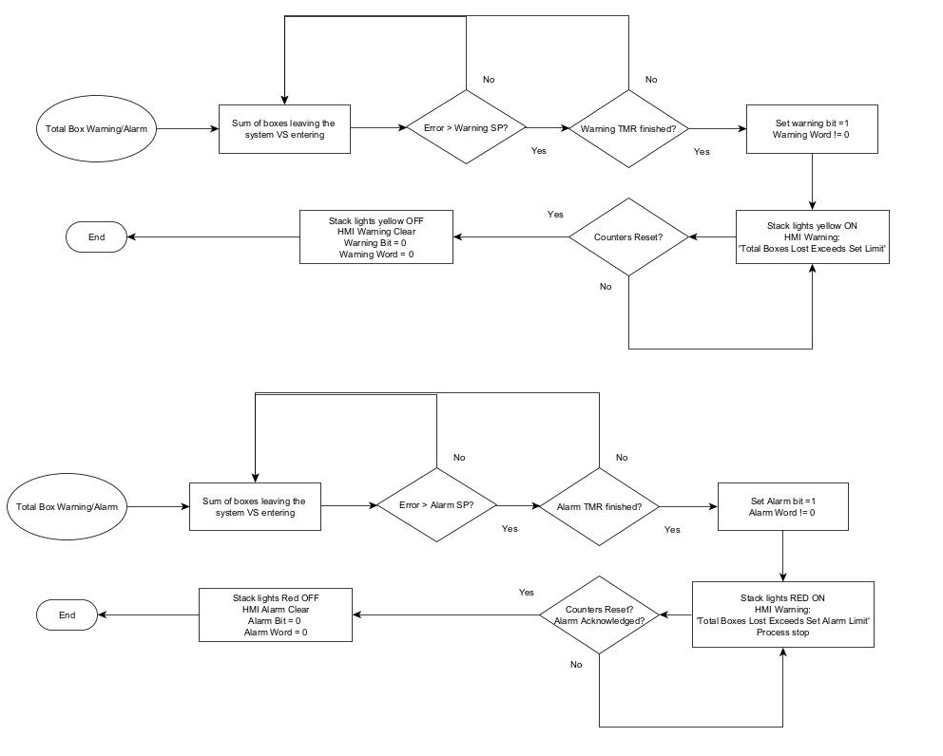
Figure 8 - Total Box Alarm/Warning Flow

3.2.5 Emergency Stop Monitoring

Alarms have been configured for each of the elements of the emergency stop circuit of the system. These include the panel E-stop, HMI stop and the safety gate limit. When any of these become true in the ladder logic, their respective alarm bits in the alarm word will be true, triggering an alarm message. The alarm flag is brought on, and is in the system run sequence, when this becomes true, the system will stop. When the fault has been cleared the alarm can be reset and the message disappears, and the system can be restarted. Individual alarm bits have been used to monitor each emergency shutdown feature, to pinpoint what stop has been operated.

3.2.6 Excess Weight Alarm

The system is designed to sort boxes of differing weights, if a weight is detected far outside the maximum expected, from multiple boxes getting stuck on the scales, the system will stop until these are removed. The weight analogue signal register is compared to a programmed limit. If the weight exceeds this, an alarm message ‘Excess Weight Detected’ will be displayed on the HMI, with the red stack indicator displayed, and rotating warning beacon triggered.

3.2.7 Pusher Fault Alarm

Alarm bits have been configured if a pusher has failed to activate due to a fault. This uses the two limits off the pusher and the output signal. If the pusher has been told to fire, but the rear limit remains on, and the front limit hasn’t been activated within a set time, the pusher has not moved. This then stops the system and displays an HMI message ‘Pusher Failed to Activate Alarm’. This is configured for each pusher.

4.0 Factory Design

The factory has been simulated using Factory IO. The main features include multiple conveyors to move boxes through the system, three pushers, sorting large medium and small boxes on to branch conveyor lines, diffuse sensors for box detection and scales to weigh individual boxes. A pop-up sorter is then used to move the medium boxes to the left or right into their respective areas. A warning siren is used to indicate when the system is starting, along with stack lights to indicate the plant status. The main weight display, Estop, start/stop buttons and counter reset buttons are located on the control panel. The system features a safety door, with interlock stopping access to the pushers when the system is live. Figure 9 displays the factory overview.
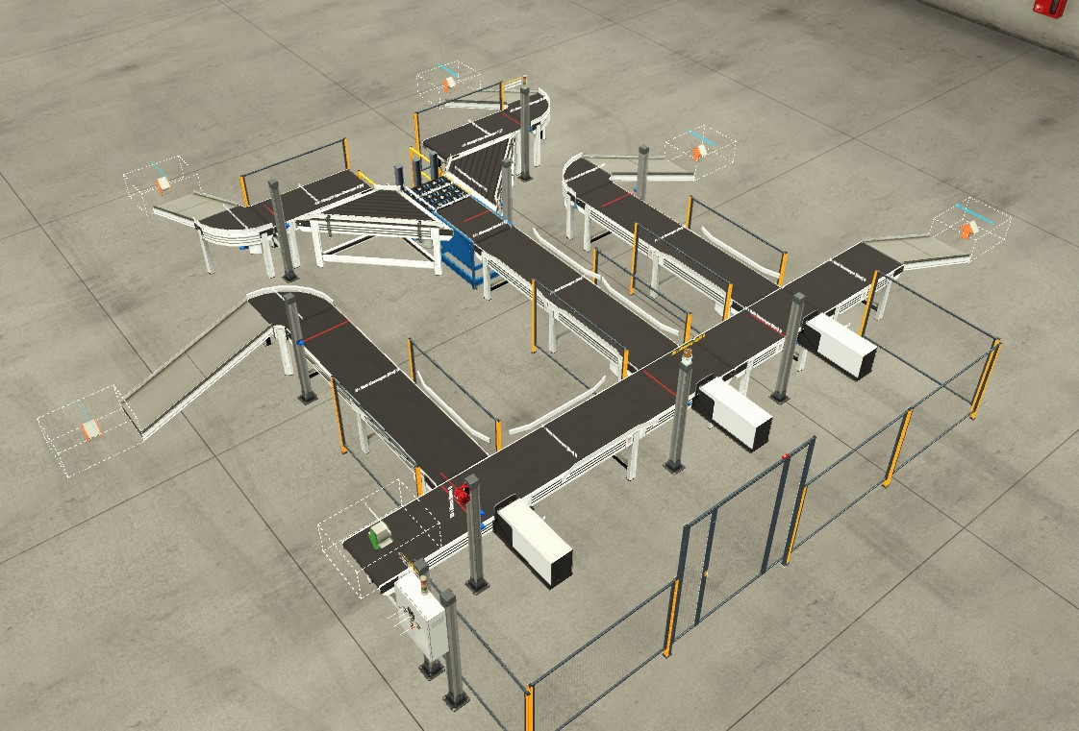
Scales and sorter
Pushers
Control Panel
Box emitter
Figure 9 - Box Sorting Line

5.0 PLC Program and HMI Design

The program for the factory simulation has been programmed using Siemens Step – 7, with the ladder logic and HMI graphical design being carried out in this software. This section shows the functions of each ladder rung, system tags and variable configurations, alarm and warning configuration and the HMI design.

5.1 PLC Tags

Each discrete input/output function, memory areas and integer registers are configured using the PLC tag configuration. Figure 10 displays the list of some of the configured PLC tags, with figure 11 displaying the list of configured HMI tags.
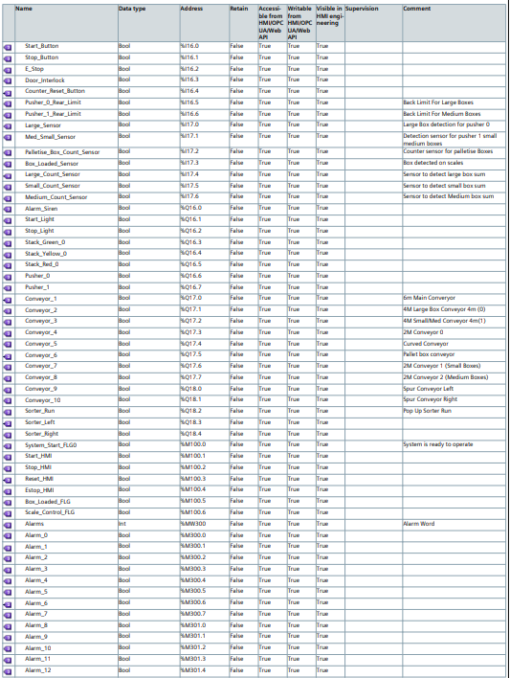
Figure 10 - Sample List displaying configured PLC tags.

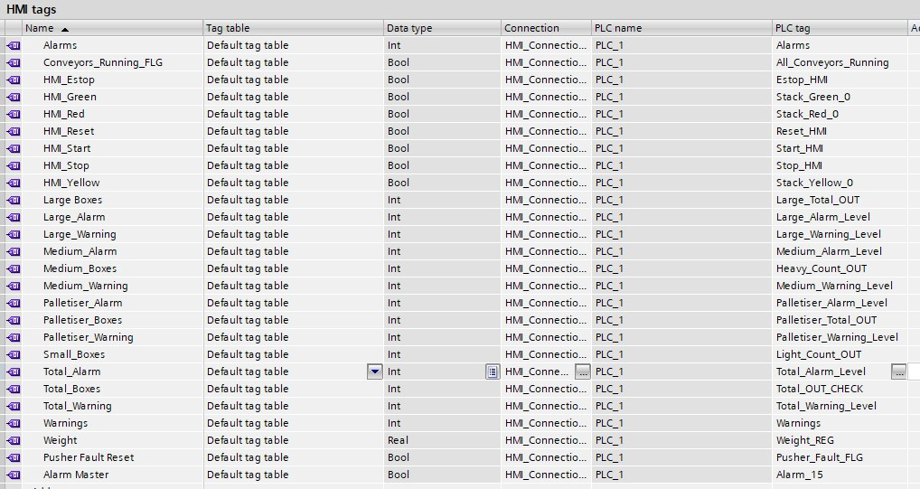
Figure 11 - HMI Tags

From figure 11, each HMI tag has an allocated PLC tag that its associated too. This allows the HMI functions such as buttons and data entry points to modify the bits in the PLC to operate the system.

5.2 PLC Ladder Logic

The first network in the PLC program handles the system start operation. Figure 12 displays the logic. To start the system, either the HMI button or physical push button can be used. The stop buttons and alarm flag are in series with these contacts to cancel the output coil, removing the start flag. The start flag is in parallel with the start buttons to latch the output when the momentary push button signal is lost. This rung also triggers the green stack lights and animates the green stack replica on the HMI root screen.
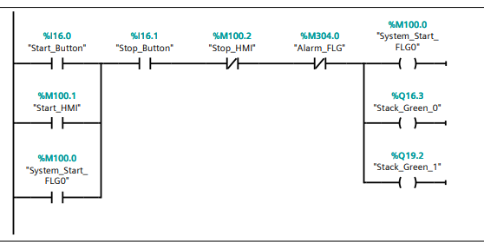
Figure 12 - Start System Flag
With the system start flag true, the warning siren is started for 2 seconds using an on timer. Each conveyor start output contains a series delay timer of increasing time per conveyor, ensuring they start sequentially to limit current draw on startup. Figure 13 displays this sequence.
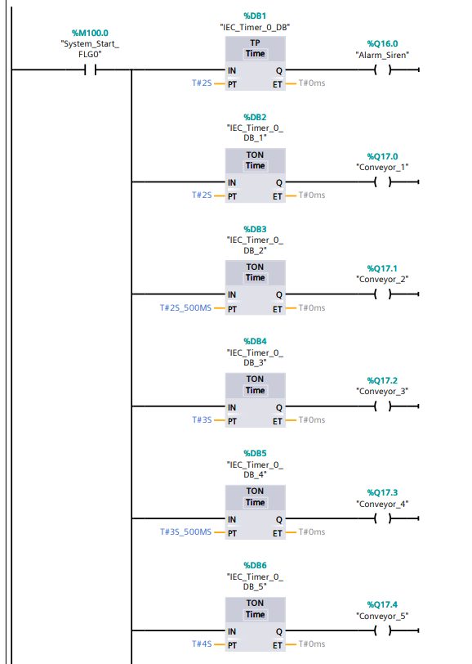
Figure 13 - Conveyor startup delay timers. This is replicated for all 14 conveyors.
The next network uses the output signals from each conveyor in series, to trigger a check flag ensuring all conveyors have started successfully, shown in figure 14.
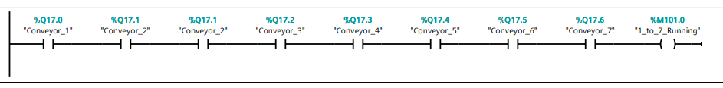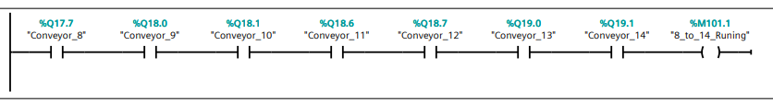
Figure 14 - Conveyors running check flags.

Using these check flags, the box emitter sequence can be started. This logic emits a box every 5 seconds into the system. The emitter output Q19.6 and the emitter control flag control the timers DB42 and DB43. The normally closed contact allows the control flag to become true. This starts a timer DB42. When this 5 second timer finishes, the emit output is set, triggering a half second timer to emit one box. When this timer finishes, this resets the emitter output, making the control flag output true, repeating the process until the whole system is stopped. This results in a box emitted every 5 seconds, with the emitter turned on for half a second every cycle. The logic can be seen in figure 15.
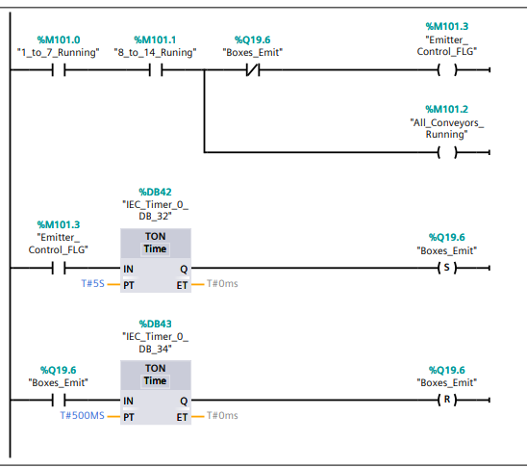
Figure 15 - Box emitter control

The pushers are controlled by the logic in figure 16. Each pusher is controlled by a diffuse sensor before the unit, set at the height of each type of box. When these sensors are made, a delay timer begins to allow the box to pass in front of the pusher. When this timer becomes true, a pulse timer is triggered, holding the output on for 1 second, ensuring the pusher fully extends.
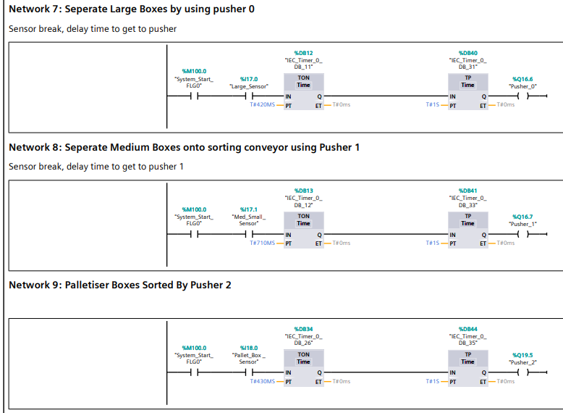
Figure 16 - Pusher Control

The total number of boxes into the system are counted using an up counter, incremented by a diffuse sensor after the box emitter. This counter value is stored in a register and is reset either by the HMI reset button or the HMI reset button. Figure 17 displays the counter.
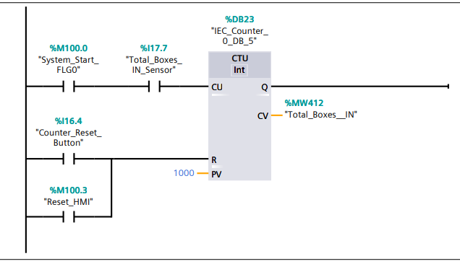
Figure 17 - Total boxes entering the system from the emitter.

The number of large boxes on to the large conveyor is captured by an up counter, incremented from the rear limit of pusher 0 becoming not true. This value is stored in a register and reset using the HMI or panel buttons. Figure 18 displays the counter.
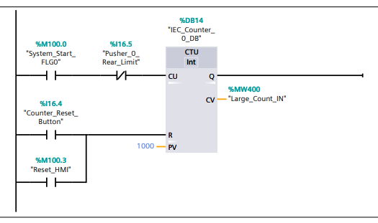
Figure 18 - Large Box counter

Large boxes off the belt are captured by an up counter incremented by a diffuse sensor at the end of the large box line and stored in a register. This is shown in figure 19.
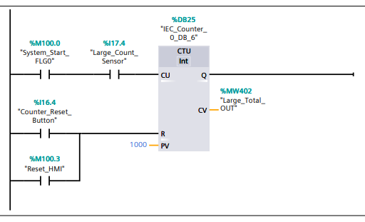
Figure 19 - Large boxes out of the system

Medium boxes are counted on to the sorter line by an up counter incremented by the rear limit of pusher 1 becoming not true. This is stored in a register and reset by the HMI or Panel button. This is shown in figure 20.
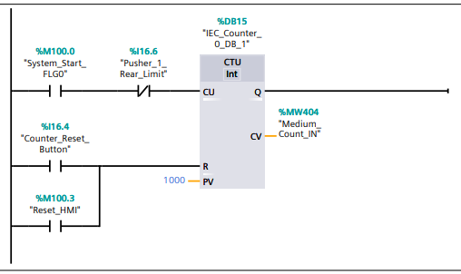
Figure 20 - Medium boxes into the system counter

The medium boxes are sorted by weight. Any light boxes or heavy boxes are diverted to the left or right lanes. Their quantity is captured via up counters, incremented by a diffuse sensor at the end of each line. Each value is then stored in a register. Figures 21 and 22 display the counters.
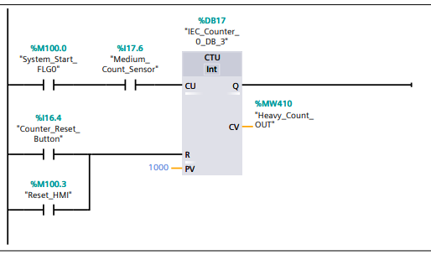
Figure 21 - Heavy box counter

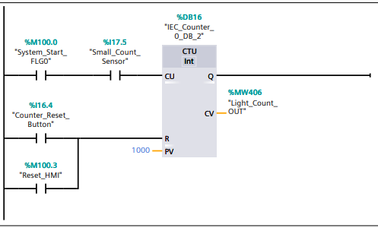
Figure 22 - Light boxes counter

The number of palletise boxes on to the sorting line is captured by an up counter incremented by pusher 2 rear limit and stored in a register. The boxes leaving the system are stored in a counter register incremented by a diffuse sensor at the end of the conveyor. This is shown in figures 23 and 24.
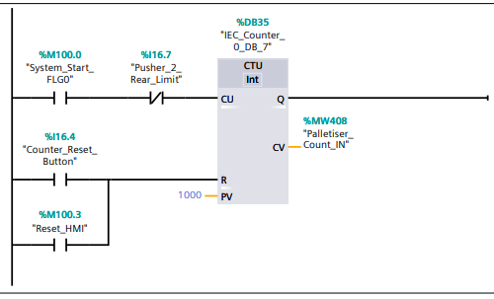
Figure 23 - Palletiser box count into the system.

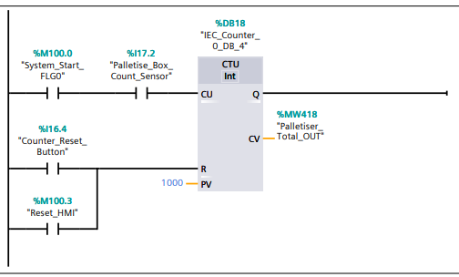
Figure 24 - Palletiser boxes leaving the system.

Figure 25 displays the conveyor scale output. When the system is running and the scale control flag is false, from not needing to stop and weigh, the scale conveyor output is true, and it moves.
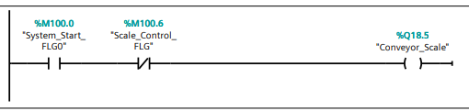
Figure 25 - Scale conveyor motor control

As a box is moved on to the scales, a diffuse sensor detects its present, this makes a check flag, box loaded true and is maintained until the off-delay timer is complete. This is shown in figure 26.
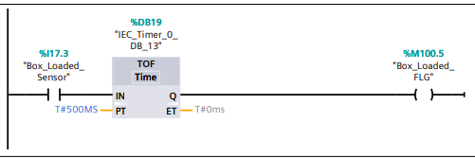
Figure 26 - Box loaded on to scales check.

When a box is loaded, the scale control flag is set, stopping the conveyor, and starting a timer. Once this timer finishes, a scales ready flag is set to allow time to take a measurement. Once this timer has finished, the flags are reset, allowing the scale to move the box to the sorter. This is shown in figure 27.
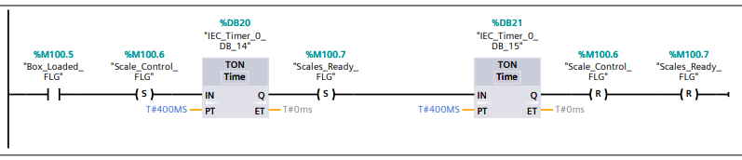
Figure 27 - Control allowing the scales to stop and take a measurement when a box is loaded.

With the scales ready flag made, a 5ms timer is started, to capture the analogue input, and a move function is then used to echo this raw signal to a register memory area. The weight register is compared to a set limit. If the weight is less than or equal to 4.5kg, the pop-up sorter output is set to the left, and resets the last orientation. Similarly, if the weight is greater than or equal to 4.6kg, the sorter moves right. This network also compares the weight to an alarm setpoint and will trigger if greater than 8kg. This detects if multiple boxes are stuck on the scales. This is shown in figure 28.

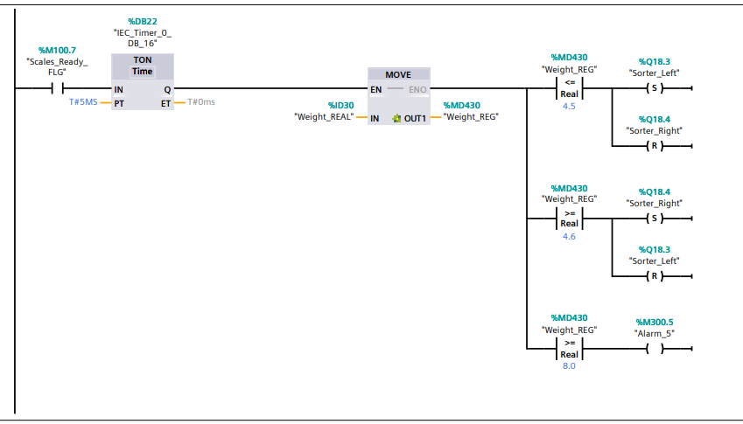
Figure 28 - Pop-up sorter control

The analogue value from the scales is moved to an analogue output to drive an LCD display on the panel, shown in figure 29.

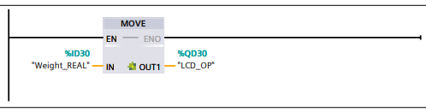
Figure 29 - Moving analogue input to analogue output for panel LCD display.

5.2.1 Alarm Logic

Siemens HMI alarm banners process alarms and warnings as integer or word registers, where individual bits can be configured per alarm. An alarm and warning integer value containing 16 bits is configured. If any alarm is true, this integer value is nonzero. When not equal to zero, the alarm flag is set, as is bit 15 of the alarm register as a master alarm. This network also drives the stack lights and beacon. The alarm flag is in the system start rung, when true, this will stop the process. The alarm comparison can be seen in figure 30. Warnings follow the same philosophy, shown in figure 31, but do not stop the system and do not need resetting.

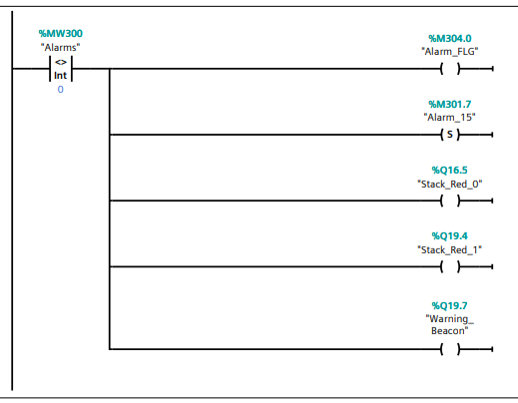
Figure 30 - Alarm word comparison, driving indicator outputs.

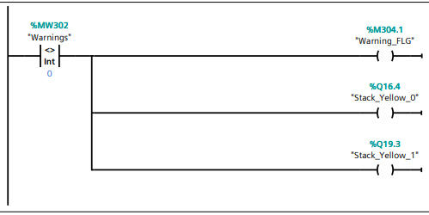
Figure 31 - Warning comparison

Each emergency stop feature is used to trigger individual alarm bits in the alarm integer, shown in figure 32.

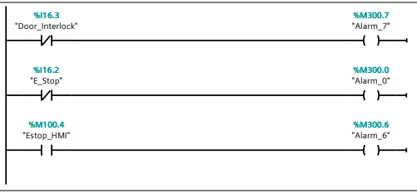
Figure 32 - E-Stop Monitoring

The difference in large boxes entering and leaving the system is stored in the error register from a subtraction function block shown in figure 33.

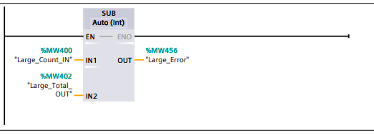
Figure 33 - large box error calculation

This error value is compared to the alarm and warning setpoint limits. A delay timer serves to dampen the output. These comparisons are shown in figures 34 and 35.

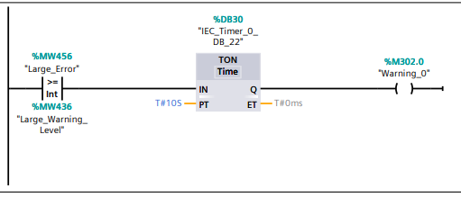
Figure 34 - Warning level

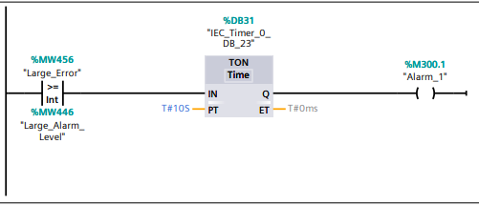
Figure 35 - Alarm Level

The medium box error level is difference between the total number of boxes entering the line and the sum of the heavy and light boxes leaving the system. The addition and subtraction of these values is shown in figure 36 and 37.

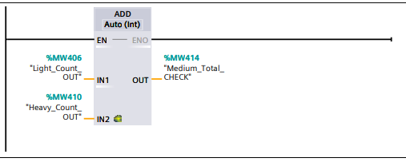
Figure 36 - total medium boxes leaving the system.

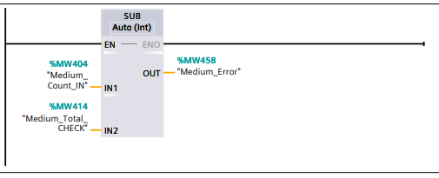
Figure 37 - Medium box error calculation

This error is then compared to the alarm and warning limits shown in figures 38 and 39.

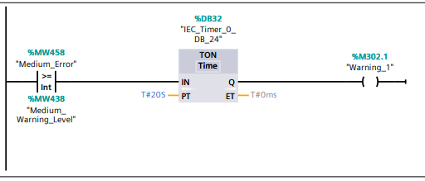
Figure 38 - Medium Warning Limit

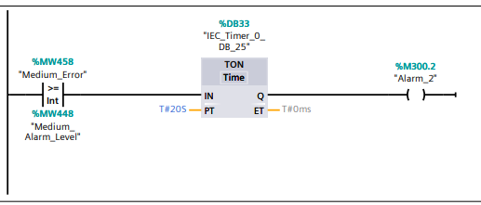
Figure 39 - Medium Alarm Limit

The palletiser box error is calculated from the difference of the boxes on to the sorting line and the boxes leaving. This error value is then compared to the entered warning and alarm limits. The error calculation is shown in figure 40, with the warning and alarm outputs shown in figures 41 and 42.

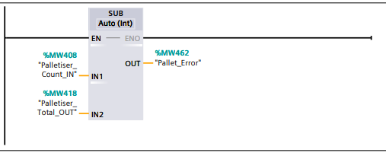
Figure 40 - Palletiser error level calculation

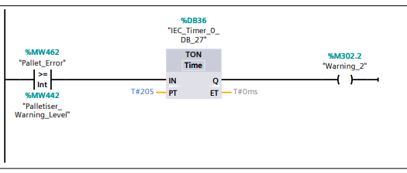
Figure 41 - Palletiser warning comparison and output

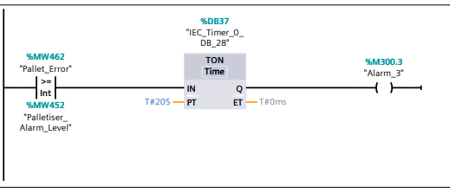
Figure 42 - Palletiser alarm comparison and output

The total boxes lost alarm and warning are derived from summing the total boxes leaving each line, this is then stored in a register, shown in figure 43.

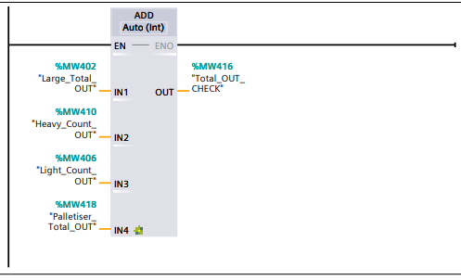
Figure 43 - Total boxes out check.
The error level register is the difference between the boxes entering the system and the sum of the boxes leaving each line, shown in figure 44. This error value is then compared to set limits for the alarm and warning outputs shown in figure 45.
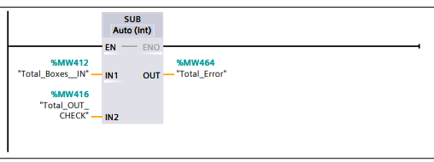
Figure 44 - Total error level calculation.

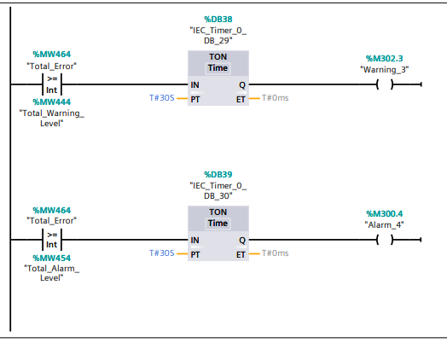
Figure 45 - Alarm and warning comparison
Alarm outputs from each pusher have been configured to detect failure. These alarms trigger if the pusher has been told to activate but not moved. Motion is detected by using the rear and front limits with a delay timer. If the pusher output is on and the rear limit is made, if the front limit has not been made within 400ms an alarm bit is set. This can only be reset once the fault has been cleared and acknowledged via the HMI alarm screen. The logic is displayed in figure 46.
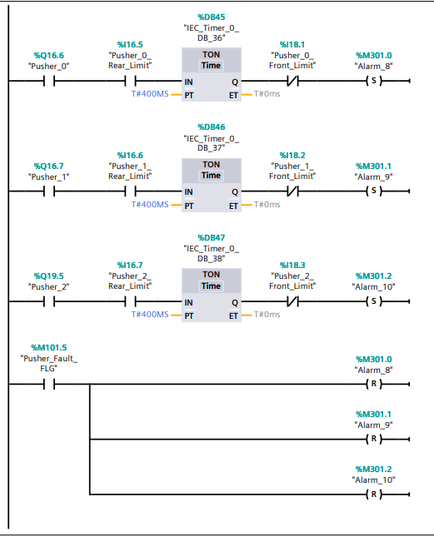
Figure 46 - Pusher failure alarm detection logic

5.3 HMI Design

Via the root screen, the HMI allows the system to be started and stopped, emergency stopped, displays all counters, displays package weight, reset of counters and replicates the stack lights using animations triggered via PLC tags. Figure 47 displays the root screen.
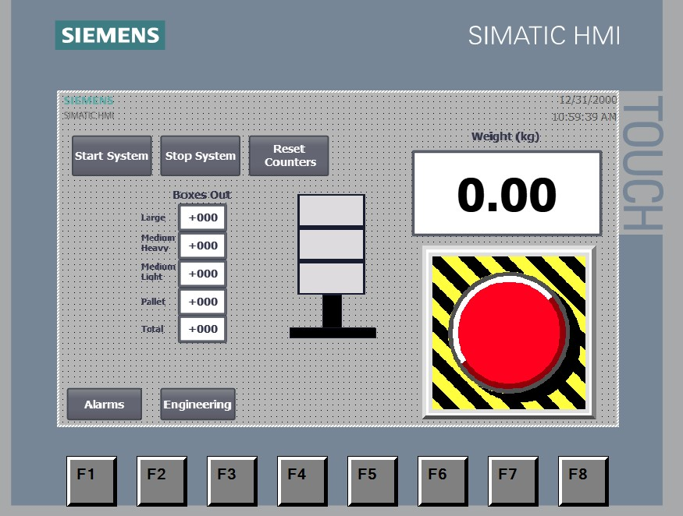
Figure 47 - Root Screen

The engineering screen allows users to input alarm and warning limits for the counters. These are written to registers in the PLC. Figure 48 displays the Engineering screen.

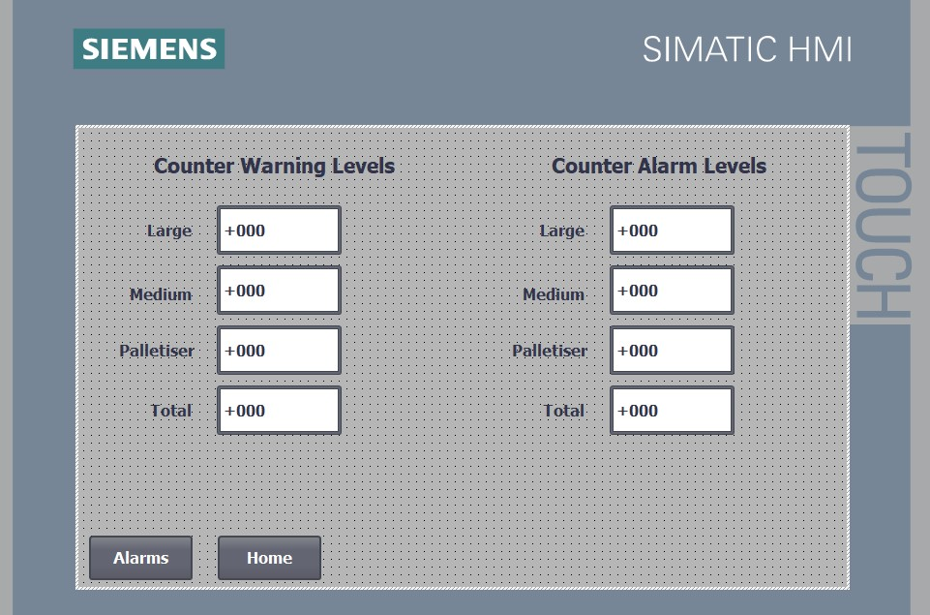
Figure 48 - Engineering Screen

The HMI alarm screen has been configured with an alarm graphical window. Alarm and warning messages are displayed here. Figure 49 displays the alarm configuration, with figure 50 displaying the alarm screen.
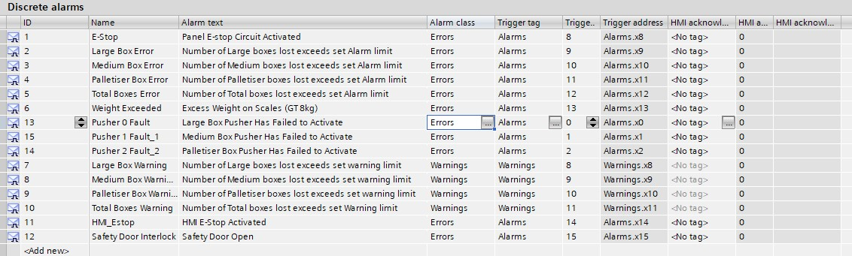
Figure 49 - Alarm configuration

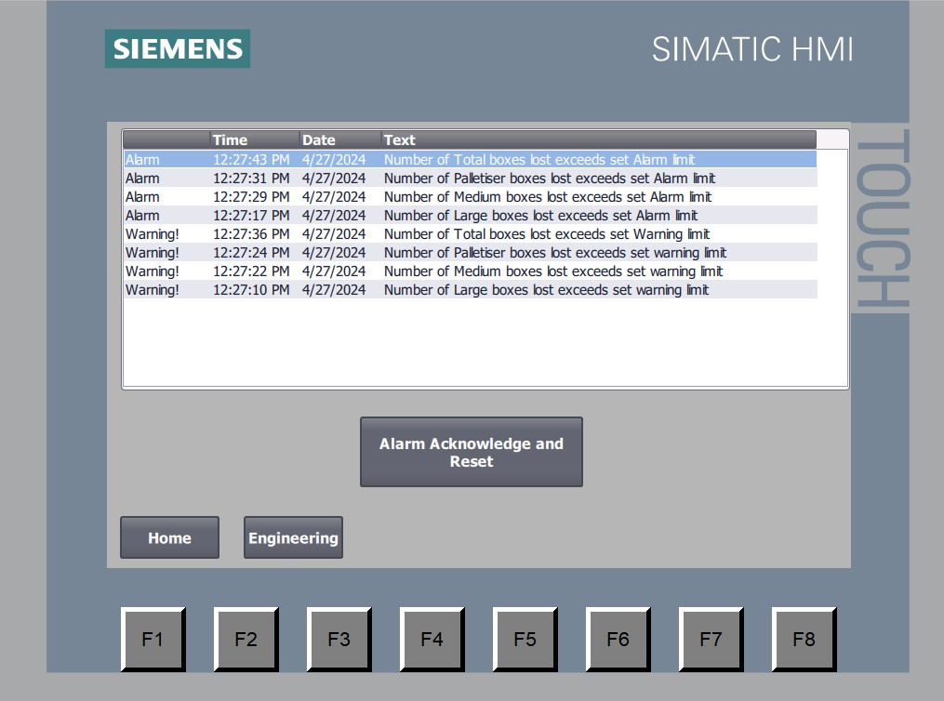
Figure 50 - Alarm Screen with displayed messages

6.0 Conclusions

This report has detailed the creation of a simulated box sorting factory using Factory IO and siemens TIA software. The ladder logic to sort boxes of varying sizes and weights has been shown, as well as the alarm configuration parameters. All alarm functions work well, and boxes are sorted accordingly. The HMI functions as expected, displaying accurate count levels, and alarms where necessary.
Improvements to the system would be to add individual error alarms for light and small boxes by using extra sensors to detect when they have entered their individual lines. This could also be achieved by using the sorter input to increment a counter on the times it has moved left or right.
The alarm HMI banner works well; however, the info text feature of the system could be utilised to give further insight to the nature of specific problems, as well as colour coding the messages for greater impact.
Additional alarms may be introduced from the conveyors failing to start or tripping. In a real-life scenario this would be achieved using a normally open contact from an overload device. This could not be easily simulated in Factory IO.

Bibliography

[1] | British Standards Institute, BS EN 61131 - 3 Programmable Logic Controllers - Programming Languages, British Standards Institute, 2013.
[2] | Siemens, “Simatic S7-1500 Getting Started A5E03981761-AD,” 10 2021. [Online]. Available: https://cache.industry.siemens.com/dl/files/272/71704272/att_92235/v1/s71500_getting_started_en-US_en-US.pdf. [Accessed 28 04 2024].
[3] | Emerson, “PACSystems™ RX3i Controllers "Datasheet",” 2023. [Online]. Available: https://www.emerson.com/documents/automation/product-data-sheet-pacsystems-rx3i-controllers-pacsystems-en-6156720.pdf. [Accessed 28 04 2024].
[4] | Rockwell Automation, “ControlLogix® 5580 controllers "Publication 1756-PP001G-EN-P",” July 2023. [Online]. Available: blob:https://www.rockwellautomation.com/207ecaa3-6cec-4fab-91b4-6f7e47287761. [Accessed 28 04 2024].
[5] | Siemens, “SIMATIC S7-1200,” Siemens, 2024. [Online]. Available: https://www.siemens.com/global/en/products/automation/systems/industrial/plc/s7-1200.html. [Accessed 28 04 2024].
[6] | Emerson, “VersaMax Micro Datasheet,” 05 2020. [Online]. Available: https://www.emerson.com/documents/automation/product-data-sheet-versamax-micro-emerson-en-6156736.pdf. [Accessed 28 04 2024].
[7] | Siemens, SIMATIC S7-1200 Datasheet "6ES7211-1AE40-0XB0", Siemens, 2024.
[8] | Siemens, “Simatic ET 200SP,” Siemens, [Online]. Available: https://mall.industry.siemens.com/mall/en/WW/Catalog/Products/10144488?tree=CatalogTree. [Accessed 28 04 2024].
[9] | Emerson, PACSystems™ RSTi-EP I/O Datasheet February 2024, Emerson, 2024.

