University of Wales Trinity Saint David

BSc Ordnance, Munitions & Explosives



Application of Computer Aided Engineering Processes
Computer Aided Engineering (ACDB5007)

Finn Mallon

2031021

Date (05/2023)

Lecturer: Andrew Noble

Contents
1.0 Introduction 3
1.1 Aims & Objectives 3
2.0 Background 3
2.1 Advantages and Dis-advantages 3
2.2 How CAE Is Used In Industry 5
2.3 How CAE Is Used In the OME Industry 5
3.0 Methodology 5
3.1 Solid works Steps - 5
3.2 Ansys Steps – 6
4.0 Validation 7
5.0 Results & Analysis 10
6.0 Conclusion 12
7.0 References 13

Introduction

This report will give an introduction to how CAE has become a significant part of engineering over the last few decades. Explaining how it can be used to assist in test and design of component development but also its limitations with regards to other possible Test and design routes.

The report will also give an example model showing the different components used as well as showing the kinematics analysis of the system under realistic operating conditions as well as an elastic bending assessment of one component within the assembly.

Aims & Objectives

- Critically analyse and evaluate techniques for structural and fluid problems and CAE results.
- Demonstrate competence in the application of suitable software packages to investigate engineering structural and fluid problems and cognitive skills in the formulation and analytical solution of a problem within the chosen engineering specialism.

2.0 Background

CAE is a widely used practise in all industries that require some element of design. It has many benefits that prove that it is definitely the way forward for design and simulation however, there are also some downsides that may affect the idea that it is a beneficial way of doing things. Some of these advantages and disadvantages are listed below:

2.1 Advantages and Dis-advantages
Advantages:

- Saves Time. When doing the initial drawings CAE will save lots of time. This is vital in industry and allows the team to meet more deadlines to keep the customers happy. It is a lot simpler and less time consuming to create a drawing using the software than it would be using old methods of drawing boards.
- Easy to Amend. Making alterations in designs and simulations is essential and having the ability to do this using CAE is a great benefit. Customer requirements may change, meaning modifications to the design may need to be made ultimately effecting how the simulation runs, leading to different results.

- Decrease in Error Percentage. CAE software is very accurate and shows the measurements and parameters on screen meaning the user can easily see if they have inputted the correct
Information. CAE software also allows the user to copy various different parts to enable no differentiation between each one allowing for more accurate designs and simulations.
- Decrease in Design Effort. The amount of effort required to create a model and to simulate the results of different affects has significantly decreased. This is ultimately down to having the option to automate certain parts of the design and copy and paste parts that have been made. The simulation aspects also requires no effort from the user apart from initiating the simulation.
- Easy to Share. Saving and storing the files that have been created and having the ability to share with anyone is another great benefit of having CAE. This allows different users to all have access to different files and to be able to amend them when necessary.
- Improved Accuracy. The accuracy within CAE is second to none and cannot be replicated by any other means of design. The tools within the various different software packages is so precise and will only allow the user to use certain parameters if it is physically possible to do so. [1]

Dis-advantages:

- Easy to lose. Work can be lost easily if the computer decides to malfunction or breakdown whilst a task is being carried out. Although not very common nowadays this is always a possibility and shows how important it is to save work on a regular occasion.
- Easily Hacked. Computers can be hacked and corporations are big targets for hackers trying to get information.
- Learning to Use Software. Learning to use the CAE software is very time consuming as there is a lot to learn.
- Simulation. The simulation aspect of CAE is very time consuming if there are lots of different parts and parameters involved.
- Price. CAE Software can be very expensive depending on the type of software package that is purchased. There are many different packages available some cheaper than others. [1]

Most of the disadvantages listed above can be easily avoided with the correct precautions in place. For example, (Easy to lose), how often does a modern computer these days just magically decide to malfunction. This is very uncommon and the chance it will happen to a company that uses CAE that doesn’t have the files backed up is minuscule. Another example, (Easily hacked), yet again having the correct precautions in place such as using a firewall or having anti-virus protection will reduce the chance of this occurring.

Also, CAE has a great future and the level and detail of simulations in the future will only become better and better. Engineers will be able to spot design defects early on as a result, which will decrease the need for physical prototypes and shorten time-to-market therefore decreasing the amount of budget used ultimately making more profit for companies. As seen from an article titled ‘The Future of CAD and CAE in Industry 4.0’ the writer says “CAE systems have revolutionized the way engineers analyse and optimize designs before they are physically manufactured”. This shows that CAE was a great invention for all industries and is the future for all aspects of all industries. [2]

2.2 How CAE Is Used In Industry

Architecture, engineering, product design, and manufacturing are just a few of the sectors where CAE is used. It can be applied to the design of prototypes, the creation of 2D and 3D models, and the simulation of how goods will function in the actual world. Manufacturing procedures like CNC machining and 3D printing can be automated using CAE. Also, CAD can be used to perform stress analysis, fluid flow analysis, and other types of simulations to optimize the performance and reliability of products.

2.3 How CAE Is Used In the OME Industry

CAE is also used in the OME industry and is typically used for the design and simulation of explosive devices, such as missiles and bombs. Additionally, it can be used to plan and model the consequences of explosions on buildings and other objects. The use of CAE in the explosives sector is, however, strictly controlled and necessitates specialised education and certificates. It is also used in military applications, such as the design of land mines and improvised explosive devices (IEDs), to plan and simulate the placement and detonation of explosives.

3.0 Methodology

The first step to any CAD / CAE project is engineering drawings. Before online drawings were a thing all engineering drawings were drawn out by hand using drawings boards and a straight edge. Nowadays all engineering drawings are done on the computer which makes it a lot simpler and easier to understand. Engineering drawings can be as simple or as complex as the creator wants those to be however, having more detailed displayed on them will mean for an more accurate set of results at the end. Although, having too much detail can become confusing and in some cases the program being used to obtain the results may not let the user do such things. It’s all about having that happy medium of parameters set. Once the engineering drawings have been obtained from the customer then the following steps can be made to start to create the desired result:

3.1 Solid works Steps -

- Create the individual parts. On a suitable program such as (Solid works) make sure that all of the measurements are accurate and match whatever the measurements are on the engineering drawings.
- Assembly. Once all of the individual parts have been created they can start to be assembled together. This can be done using fasteners such as bolts or screws. Having bolts or screws in place will alow the two components to be able to be separated when a prototype model is made however, if no fasteners are used then within the CAD packages there is a tool called ‘mate’ this will attach separated parts to one another and they will not be able to be separated once the prototype mode is made. This is done by selecting the separate faces of the different components then by selecting the mate tool, which will join the part together.
- Test for interference. This will test for interference between components, which will help you to examine and evaluate those interfaces. This is very useful in complex assembly’s where it is difficult to visual determine whether components interfere with each other. [3]
- Check for Errors. A list of errors that have been made can be selected and brought up by clicking on the feature menu design tree. This will display all errors and warnings where the user can work through them one by one. [3]

3.2 Ansys Steps –

- Import into Ansys. Once the components have been made into an assembly it can then be imported into Ansys for the finite element analysis (FEA). This is where different material properties can be added to the assembly and different tests can be carried out on the component such as static structural studies, thermal studies or rigid dynamic studies.
- Mesh model. Once the component has been imported into the Ansys system a mesh needs to be applied. The reason for this is that it turns any irregular shapes in the assembly into more recognisable volumes named elements. Having the meshing applied will significantly reduce the time it takes to obtain the results. However, meshing is a required a decision to be made on what size to use. Having the meshing too fine will mean obtaining the results from the analysis will take far too long. Having the meshing too large will mean crucial data will be missed from the analysis. [4]
- Assign Material Properties. Next step is to decide what materials the component needs to be made from. Material data packages will help with this such as (Granta Edu pack), these packages know all about the different materials and there properties such as the young’s modulus of elasticity, Poisson’s ratio, density, tensile yield stress and much more. This makes results much more accurate as the analysis takes much more material properties into account.
- Define boundary conditions. Once the material properties have been identified and selected to the component then boundary conditions can start to be applied. For example if a part of the component is going to withhold a load or then this is a boundary condition that will be applied.
- Setup analysis. What type of analysis is going to be carried out? Is it a static structural analysis? A static structural analysis determines the steady loading conditions on a structure whilst omitting inertia and damping effects such as those caused by time varying loads. [5]

Is it a Thermal study? Thermal study is where analysis is carried out to show the time and temperature at which physical changes occur when the component is heated or cooled. [6]

- Solve the problem. Once all of the material properties have been entered, all boundary conditions have been applied and a mesh has been created the solve button can now be used to run the analysis to gain a set of results. The user may incur some problems at this stage however, these can be easily worked through by accessing the feature menu design tree.
- Post process the results. This is an efficient way of validating the results of an analysis. Post processing can be done within Ansys, where the general post processor is used to review the entire model in one moment in time or frequency. The time-history processor is used to review the output at specific locations through the time of frequency range. [4]
- Validate and refine model. Once all results have been obtained it is important to validate the results. A method for predicting how an entity will react to real forces, vibration, heat, liquid flow, and other physical effects is called limited component examination (FEA). Each component of a complicated system is subjected to mathematical equations by FEA before being divided into more manageable pieces. These equations are then merged to create a model of the complete system that can be examined and improved to satisfy certain design requirements. FEA is typically used in designing and assembly to simulate and test an item's exhibition before it is built. Finite element analysis (FEA) is a vital component of computer-aided engineering (CAE). By using FEA, CAE software may simulate a product's performance under a range of circumstances, such as different loads, temperatures, and pressures. This enables experts to streamline an item's design before it is manufactured, which can help to save time, cut costs, and improve overall item quality. Additionally, FEA is used to assess how a system will behave under situations that may be challenging or impossible to recreate in the real world, such as severe pressures or temperatures.

- Report findings. You want to present the findings in a straightforward and organised manner when presenting the outcomes of a validation test using Computer-Aided Design (CAD) software. This makes it more likely that readers will comprehend the validation method, the findings, and the conclusions.

To ensure that your report is understood by readers who are unfamiliar with the specific CAD programme or validation procedure, use clear, concise language and provide adequate context and explanations. Your work will be more credible and useful if your validation test and results are properly documented.

4.0 Validation

It would be advantageous to carry out a validation study to make sure the software programme used to do simulations is accurate. The accuracy of the software package can be verified using a variety of validation experiments. A validation experiment is primarily carried out to make sure that the calculations made by the programme on newly formed objects correspond to physical-mathematical calculations. The accuracy of the software is demonstrated by how closely the value of the validation simulation figure resembles the mathematical calculation.

Ansys was used for a validation test to demonstrate the value of this phase in the process. Ansys was used to set up the validation test, which involved fixing a cantilever beam to one side of the beam and adding a pressure load to the other.

The size of the Cantilever beam that was created is shown in (Figure 1) below.
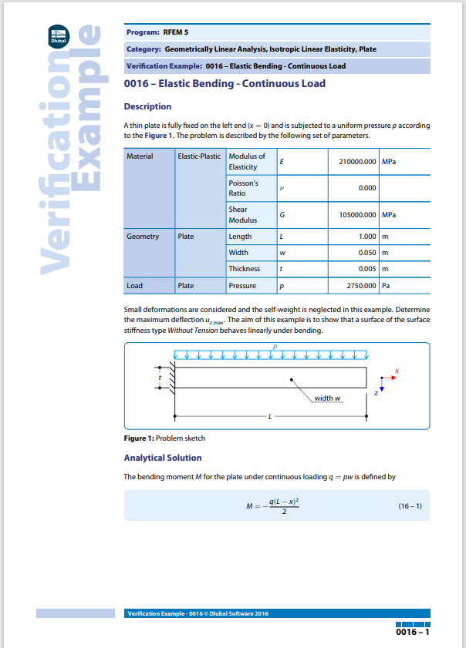

(Figure 1) – Cantilever Beam

As can be seen from (Figure 1) the measurements for the Cantilever beam are:
- Length = 1m
- Width = 0.05m
- Thickness = 0.005m

Also, as seen in (Figure 1) the Pressure load 2750.00Pa was then added to the beam.

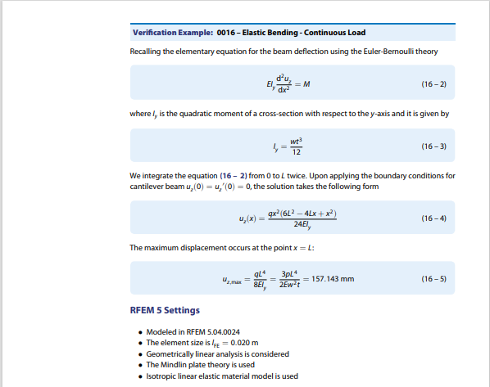

(Figure 2) – Cantilever Beam

By performing this test validation within Ansys, the main goal was to ensure the figure generated would be as close as possible to the analytical solution, proving the software can be deemed suitable for use. Based on the mathematical calculations seen in (Figure 2), the figure came to 157.143mm as seen below in (Figure 3).
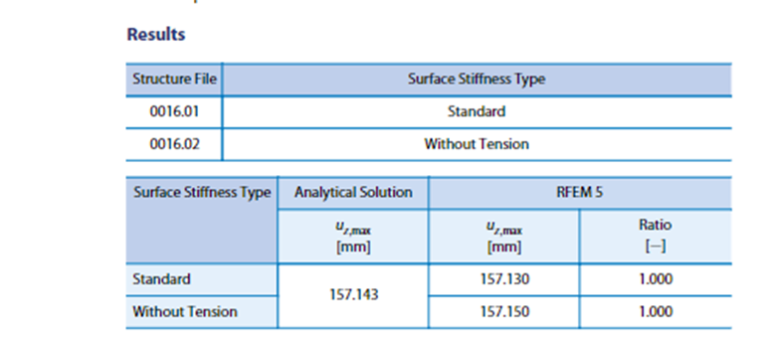

(Figure 3) - Results

As is known already the result from the validation test study example came out to be 157.143mm. As can be seen from (Figure 4) below when the validation test was carried out within Ansys the result was 157.15mm. These two figures are almost identical to one another proving that Ansys is a great piece of software for running this type of validation as the disparity between the validation study and the test is miniscule. To confirm that the validation test is 100% accurate and wasn’t just accurate by chance further validation tests should be carried out.
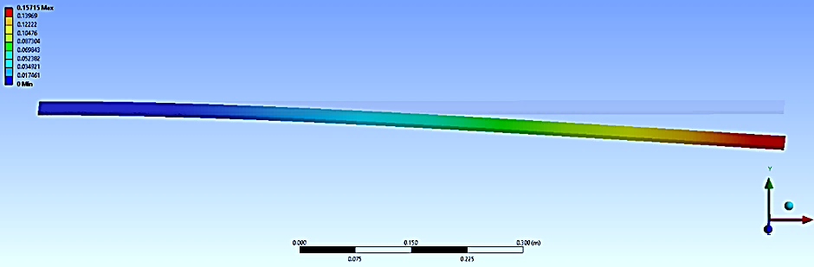

(Figure 4) – Cantilever Beam with Uniform Load Validation Test

5.0 Results & Analysis

A projectile with a high density will often misshape, fragment, or ricochet off of a target plate with a low density. The relative densities of the projectile and the target plate as well as the projectiles velocity will all have an impact on the precise behaviour of the projectile. The projectile is more likely to misshape or fragment upon impact the larger the density difference between the target plate and the projectile. Although, if the target plate has a higher density than the projectile, and the projectile is moving at a fast enough velocity it may still be able to penetrate through the target plate.

This may occur due to the mesh size of the target plate. If the mesh size of the target plate is not accurate and is either too coarse or too refined this may affect the results of the analysis. In comparison to a coarser mesh, a refined mesh can deliver more accurate findings and better reflect the behaviour of a model. When the projectile first impacts the target plate the plate will begin to stretch then split allowing the projectile to pass through.
The Results obtained are entirely down to the type of materials used in both the projectile and the target plate. As well as, the density of the materials, the mesh sizing used, the speed of the projectile and the angle of attack.
Several elements, including the projectile's speed, size, and shape, as well as the characteristics of the target material, affect how a projectile behaves when it passes through a target with varying densities. In general, while passing through a target with lower density, a projectile with higher density and adequate kinetic energy may produce distinct results. This can be down to the following factors:
- Penetration: A projectile with a high density and sufficient kinetic energy may occasionally be able to pass through a target with a lower density. The projectile's high density enables it to concentrate greater mass in a smaller space, possibly piercing the target material.
- Fragmentation: Alternately, if the projectile is extremely dense and travelling at a high speed, it may fragment when it collides with the target that has a lesser density. Due to the projectile's great kinetic energy, it may shatter into smaller fragments, distributing its energy throughout the target and damaging it.
- Bouncing or Deflection: If the projectile hits the lower-density target at a shallow angle or if it has particular characteristics that make it behave elastically, it may occasionally bounce off of it or be deflected by it.
- Disintegration: If the target material is much denser or tougher than the projectile itself, the projectile may disintegrate upon impact, breaking apart.
It is crucial to keep in mind that additional elements, such the projectile’s and targets shape and hardness, the angle of attack, and the unique characteristics of the materials involved, will affect the result.
In conclusion, the interaction of a projectile and a target is a complicated theory that is influenced by a variety of variables. Density is only one factor in this interaction; the final result will also depend on the unique circumstances and characteristics of the materials used. An example is explained below.
If a projectile made entirely from Tungsten Carbide with a density of $15,700kg/m^{3}$ travelling at $500m/s$comes into contact with a target plate made from Mild Steel with a density of $7,850kg/m^{3}$ the projectile will penetrate straight through. The target plate will start to deform as the projectile progresses through. The tip of the projectile will be under stress but less stress than the layers of the target plate as it makes its way forward until it fully penetrates through creating a full penetration hole in the target plate. This happening comes down to all of the factors listed above, the density of the two materials and difference between them, the velocity of the projectile, the angle of attack, the shape of the projectile and the shape and hardness of the target.
Sometimes simulations do not run all the way to the end. The simulation results produced could not be as accurate as required if the mesh is not made small enough but if the mesh is too fine, running the simulation will take far too long. This is why it is very important to find and decide on the correct mesh size. It comes down to having the simulation take a seriously long time to gather accurate and reliable results or have the simulation not run all of the way through until the end.

6.0 Conclusion
After undertaking a simulation within Ansys it is clear that the results obtained matched what was expected. After understanding which factors affect the results of the simulation and how each one of them affects the simulation in different ways it was clear that the results would turn out how they did. After the materials were chosen for the projectile and the target plate, the size and thickness of the target plate was set and the velocity of the projectile was finalised it was clear that the results would turn out this way.

Ansys is a good simulation program for running these types of tests however, choosing the correct mesh sizes is essential and gives the user a big decision to make whether they want to go with a larger mesh that may not show as accurate results as possible or do they want to go with a finer mesh that will take a long time to run to gather the results. This is the only downside to running this type of simulation within the program used.

If this simulation was to be looked into further, lots more tests like this would have to take place first before manufacturing took place. This is to make sure that this simulation wasn’t just a fluke and to make sure the results obtained were not just achieved by chance. Multiple other tests would have to take place to ensure the money was being spent on the correct project that gathers correct results.

7.0 References

[1] | “ARCVERTEX,” 2018. [Online]. Available: https://www.arcvertex.com/article/advantages-and-disadvantages-of-using-computer-aided-design-cad/. [Accessed 20 04 2023].
[2] | ELEATION, “The Future of CAD and CAE in Industry 4.0,” 2023.
[3] | D. Systemes, “Dassault Systemes,” 2021. [Online]. Available: https://help.solidworks.com/2021/english/SolidWorks/sldworks/c_interference_detection.htm#:~:text=Interference%20Detection%20identifies%20interferences%20between,components%20interfere%20with%20each%20other.. [Accessed 25 04 2023].
[4] | “Ansys,” [Online]. Available: https://www.ansys.com/en-gb/blog/fundamentals-of-fea-meshing-for-structural-analysis#:~:text=Meshing%20is%20the%20process%20of,to%20begin%20the%20simulation%20process.. [Accessed 20 04 2023].
[5] | “Simu Tech Group,” [Online]. Available: https://simutechgroup.com/services/consulting/structural-thermal-applications-fea/static-structural-analysis/#:~:text=A%20static%20structural%20analysis%20determines,caused%20by%20time%20varying%20loads.. [Accessed 25 04 2023].
[6] | “Shimadzu,” [Online]. Available: https://www.shimadzu.com/an/service-support/technical-support/analysis-basics/fundament_thermal/1/index.html#:~:text=Thermal%20analysis%20is%20a%20general,substance%20is%20heated%20or%20cooled.. [Accessed 25 04 2023].

