University of Wales Trinity Saint David
Wales Institute of Science & Art



Mechanics and Dynamics Technical Report
Mechanics and Dynamics (ACHA4026)

Aidan O’Brien
2500916
January 2025
1,353 Words
Contents
1. Introduction 3
2. Experimental procedure 4
2.1 – Setting up the experiment 4
2.2 – Zeroing the rotating chuck 4
2.3 – Conducting the test 4
3. Results 5
3.1 – Collected data 5
4. Analysis 6
4.1 – Interpreted data 6
4.2 – Shear modulus graphs 7
5. Conclusion 9
5.1 – Comparison to textbook shear modulus values. 9
6. Evaluation 10
6.1 Optimisation of the experiment 10
7. Further work 11
7.1 – How could the experiment be improved? 11
References 12

1. Introduction
In this assignment, an experiment is conducted for torsion of circular sections. Different bars of metal (Brass, Aluminium and Steel) are inserted into a rotating chuck and weight is applied in increments, the degree of twist in the bar is measured when the weight is applied. The data is then collected and inserted into tables and graphs to help calculate the shear modulus of the material. These results are then taken and compared against the textbook shear modulus values for each of the materials. The experiment is then evaluated for how errors are eliminated to optimise the experiment. Further consideration into how the experiment could be further optimised with different methods, timings and equipment and how this can increase accuracy within the experiment results.

2. Experimental procedure

2.1 – Setting up the experiment
A rotating chuck assembly is used for the torsion experiment. Allen keys are used to loosen the grub screws of the chucks on each end of the assembly, a bar e.g. steel bar, is precisely inserted into the fixed chuck on the right hand side of the assembly and then pushed through the rotating chuck as far as it can possibly go. Once the bar is secured between the fixed and rotating chuck, the grubscrews can be re-tightened using the Allen keys and the rotating chuck can be zeroed ready for the experiment to be conducted.
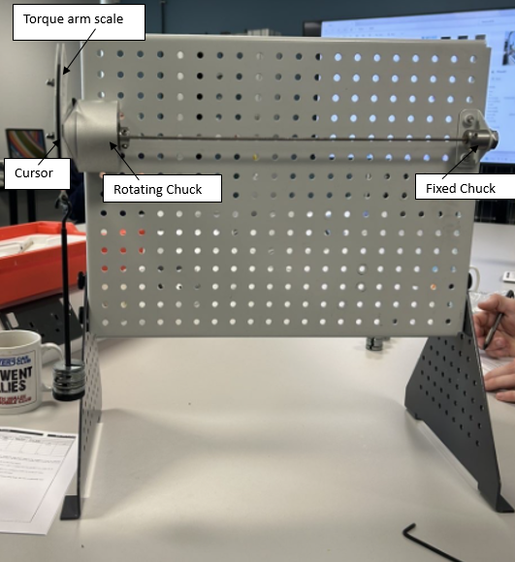
Figure 2.1 – Annotated torsion of circular shafts kit assembly

2.2 – Zeroing the rotating chuck
Once the bar is fitted in between the two chucks, the rotating chuck can be zeroed. This is done by loosening the grub screws on the chuck, allowing for the torque arm to move freely without causing movement or twisting of the bar. Then using the transparent cursor, align the cursor with the zero mark on the torque arm scale and hold it still while re-tightening the grubscrews to lock back in place. The zero can then be tested by putting on maximum load on the assembly for a few seconds before taking it back off. If the cursor still sits at the zero mark, then the zero is correct, if not, then the bar has slipped in one of the chucks. If this is the case then the chucks need to be checked for damage and the bar needs to be carefully re-inserted.

2.3 – Conducting the test
Once the rotating chuck has been zeroed and tested, the test for torsion on the 3 bars can be conducted. The first bar inserted into the equipment was the Brass bar. The brass bar had a diameter of 3.32mm. The experiment starts by applying the first load to the bar by attaching the 0.1 kg to the cord. The mark on the cursor then moves to read an angle of twist, for 0.1 kg, the angle of twist was 6 degrees. The weight is then removed and another 0.1 kg is added. This is repeated up to 0.5 kg. The same process is completed for the Aluminium and Steel bars however, the aluminium bar was only loaded to 0.4kg due to the risk of exceeding the material’s elastic limit. Once all of the data is collected, the data can be interpreted in excel to calculate the shaft modulus. The shaft modulus can be worked out and the gradient can be found and put into a graph.

3. Results

3.1 – Collected data
Shown below is the raw data that has been taken from the experiment. The angle of twist has been found out for the brass, aluminium and steel bars at 0.1 up to 0.5 kgs of load. The data collected is presented in the table below.
 | Brass | Aluminium | Steel
Mass (Kg) | Actual twist (Degrees) | Actual twist (Degrees) | Actual twist (Degrees)
0.1 | 6 | 7 | 2
0.2 | 11.6 | 14.5 | 4.5
0.3 | 17.9 | 22.5 | 7
0.4 | 23.5 | 30 | 9.7
0.5 | 30 | n/a | 12.5

Figure 3.1 – Material twist data table
This data will then be interpreted into a shear modulus for each material to then calculate the gradient so that the data can be interpreted into a graph.

4. Analysis

4.1 – Interpreted data
The data from section 3 was taken and interpreted into a spreadsheet that is used to work out the shear modulus of the material. The load in mass from 0.1 – 0.5 kg is stated as well as the load in Newtons and the torque in Nm. The length of the bars are all the same at 0.34m and the diameter (D) of each bar is measured. The polar moment (J) is calculated by converting the diameter into meters (m) and using the equation : (πD⁴)/32. The values for torque and load are then worked out for the other mass loads. The twist angles that are stated are then interpreted into radians. Once the angle of twist in radians is calculated. The Jθ can be calculated by multiplying the twist angle (θ) by the polar moment (J). Finally the TL can be calculated by multiplying the torque (Nm) by the length of the bar (m). Once the Jθ and the TL have been calculated. They can be put into graphs to find the Shear modulus (G).

Figure 4.1 – Brass shaft modulus

Figure 4.1.1 – Aluminium shaft modulus
Figure 4.1.2 – Steel shaft modulus
Shown above are the three shaft modulus tables for the brass, aluminium and steel bars. Each table presents the same necessary data for calculating the shear modulus for the material.

4.2 – Shear modulus graphs
Once the necessary data being the Jθ and the TL have been calculated, they can be put into graphs to show the shear modulus gradient. All 3 graphs should show a near linear line.
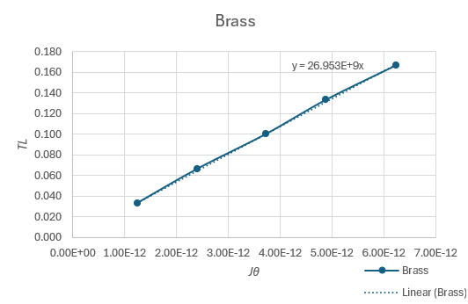
Figure 4.2 – Brass shear modulus graph
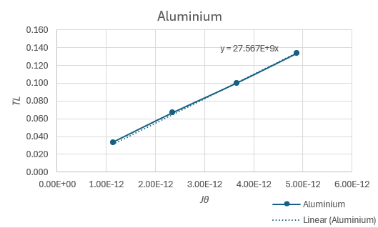
Figure 4.2.1 – Aluminium shear modulus graph
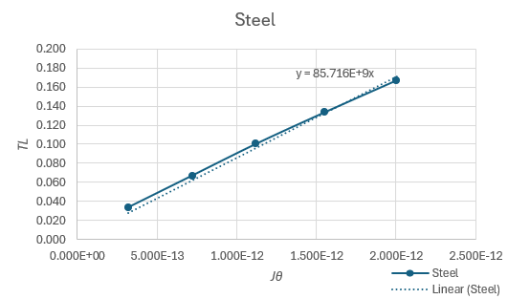
Figure 4.2.2 – Steel shear modulus graph
Shown above are the three graphs for the shear modulus of the three bars of material. Each graph shows a near linear line with a fully linear trendline. Each three graphs display the equation for the gradient of the line. This is then used to be compared against the textbook shear modulus value.

5. Conclusion

5.1 – Comparison to textbook shear modulus values.
The results gained from the shear modulus tables and graphs result in a gradient. As seen in the graphs in segment 4, the shear modulus values are given for the 3 materials:
Brass – 26.95 GPa
Aluminium – 27.56 GPa
Steel - 85.71 GPa
After researching multiple sources, the average shear modulus ranges have been found for the three materials (Brass, Aluminium and Steel). The average shear modulus values given are:
Brass 35-40 GPa
Aluminium – 26 GPa
Steel – 75-80 GPa
When comparing the calculated values against the researched values, the main outlier is brass, with the calculated value being around 9 GPa below the average range. This could be for a few reasons, the first reason being a weaker alloy, meaning that the material is more deformable as a result of reduced stiffness. Calibration and alignment errors within the setup could also lead to inaccurate readings as a result of unequal bending moments and uneven stress. On the other hand, the shear modulus calculated for the aluminium bar is very close to the average number and the steel shear modulus is within 10% of the average range. The results for the aluminium and steel bars show the accuracy of the experiment and the calculations when compared to the textbook values.

6. Evaluation

6.1 Optimisation of the experiment
When conducting the torsion experiment, there are a few ways that the experiment was optimised to allow for the best and most accurate results to be achieved. The first way is by testing the zero multiple times to ensure that the equipment holds up. By applying maximum load and making sure that the cursor returns to zero, it means that the equipment can hold the material and load without slipping, ensuring accurate readings. The second way that the experiment was optimised was by ensuring that all measurements taken were accurate. By ensuring that all measurements such as lengths, diameters and correct force applied to the bar means are correct means that all calculations can best align with the textbook values.

7. Further work

7.1 – How could the experiment be improved?
One way that the experiment could have been improved is by using ultrasonic testing. Shear waves are introduced into the material and the time taken for the wave to travel a certain distance is used to calculate the shear modulus using the equation G=ρV_{s}² where ρ is material density and V_{s} is the velocity of the shear wave. This process is great as it is non-destructive, meaning it is repetitive however the method is very precise within the velocity and density measurements.
Another way to improve the experiment is to experiment with different diameters of bar with the same material. By experimenting with thicker and thinner diameters of bar, twist angle can be calculated and compared to see the difference in how weight affects the twist angle at different diameters.

References
“Measuring Elastic Modulus Using Thickness and Flaw Inspection Solutions.” Evidentscientific.com, 2025, ims.evidentscientific.com/en/applications/elastic-modulus-measurement.
“Nondestructive Evaluation Techniques : Ultrasound.” Www.nde-Ed.org, www.nde-ed.org/NDETechniques/Ultrasonics/ultrasonicFormula.xhtml.
“Shear Modulus for Brass: A Guide to Its Top 5 Key Values - Answerpoint.blog.” Answerpoint.blog, 12 Aug. 2025, answerpoint.blog/shear-modulus-brass-guide-top-5-key-values. Accessed 3 Jan. 2026.
“Shear Modulus of Common Materials - Table.” Matmake.com, matmake.com/properties/shear-modulus-of-common-materials.html.
“Shear Modulus of Rigidity | Engineers Edge | Www.engineersedge.com.” Engineersedge.com, 18 Dec. 2013, www.engineersedge.com/materials/shear_modulus_of_rigidity_13122.htm.

