Effective team working & communication
Student name: Vesela Kyurchieva
Student ID: 1908344
Class:BMSW4002
Lecture Name:Christopher Mafuva

Table of Contents

Introduction 3
Main body 3
What are the different types of communication 3
How communication can be made effective in a business organization 4
Relevant Theories 5
Importance of effective communication 7
The role of culture in communication 8
How does communication work between management and employees along with its purposes 8
Effective Communication Strategies 9
Conclusion 10
Reference List 11

Introduction
In this present scenario of business management, communication plays a vital role based on which the overall business process are being conducted. This study aims to discuss the aspect of communication with proper reference to the models of communication. Additionally, the importance of effective communication is going to be enumerated so that the focus of this study can be demonstrated properly.

Main body

What are the different types of communication
Communication is nothing but the mode of sharing information based on which two or more parties act or respond. In the development of healthy and effective workplace environment proper communication plays the most important role used (Turaga, 2016). As the business process is proper collaboration of various human resources, without proper communication proper progress of the workplace activities is not possible.
A multiple ranges of communication is available and being practiced within the workplaces including verbal, non-verbal, written and visual communication. The types of communication are being described below.
Verbal Communication: Verbal Communication refers to the use of various languages including sign language. This is the most used communication pattern within the working environments of the organizations. In fact, it is the most common way of communicating the employees as well as the teams for conducting a work process. Face to face, video conference, phone calls and meetings are the cases where this mode of communication is being used (Turaga, 2016).
Non-Verbal Communication: This is another mode of conducting communication within the workplaces which includes detail information related to the behavioural approaches of the communicator. It includes both intentional and unintentional from the context of the communicator. With this mode of communication the communicators portray body gestures of nodding head or shaking shoulders. As an example, in case of hearing sudden sad news the listener can swivel the head can be counted as unintentional non-verbal communication and on the other hand in case of asking questions the respondent can nod the head in order to portray that the answer is unknown can be counted as the intentional non-verbal communication. It can be used as the tool to display the emotion and opinion of the communicators with just a signal (Salas et al. 2015).
Written Communication: In the types of communications, written communication can be considered as the formal mode of communication. In the business processes and workplaces this type of communication is mostly being used for recording the communications in various channels such as employee management portals or various domains. This mode of communication is being used in forms of books, letters, modules, emails and different types of messaging applications. It is the transcription of the verbal communication and just displays the thought of communicators in written forms (Sacks et al. 2015).
Visual communication: In the recent days visual communication is taking a wide part within the business organizations. In this mode of communication visual arts, graphics, online presentation, videos and photographs are being used to communicating the employees. With this communication process the communicators can easily communicate with a large number of audiences peacefully. Apart from that it is the most unique way of saving times compared to the other mode of communication (Mundt et al.2016).

How communication can be made effective in a business organization
According to Mercer (2019), without effective communication the organizational work processes can become inefficient and that is why proper methods need to be applied for improper communication mode. In a business organization the communicators should develop a relationship so that the overall performances of the organizations can be enhanced; as a result the business process can expand its activity based on its organizational goal. In order to make the communication within a business institution, there are few ways by which the communication process can be more effective. Understanding the needs of communication, being a good listener, managing passive communication, consideration of non-verbal images and knowing the audience are the ways based on which proper as well as effective communication can be conducted within a business process (Mihai and Mihai, 2016).

Relevant Theories
Shannon and Weaver’s Model of Communication: This communication model shows the communication process between the message sender and receiver with an effective cycle. The mode of communication uses a platform which could be a machine or a human being. Here in this model the sender is the communicator and the receiver is the person to whom the message has been sent. Encoder in this model is the machine which encrypts the message and the channel is the transmission process. The factor noise is the potential aspects of interruption which might affect the overall communication process. Decoder is the overall transformation process of the message and feedback refers to the response of the receiver to the sender (van Ruler, 2018).
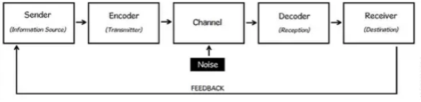
Figure 1: Shannon and Weaver’s Model of Communication
(Source: van Ruler, 2018, p.3)
Berlo’s SMCR Model: This model is the extension of the Shannon and Weaver’s Model of Communication. This model portrays the four main stages of communication process, including Sender, Message, Channel and the Receiver. As per this model sender sends the message to the receiver with the help of the channel which encodes as well as decodes the process with a continuous cycle. The skills and behavior of the sender and receiver plays a vital role in this process (van Ruler, 2018).
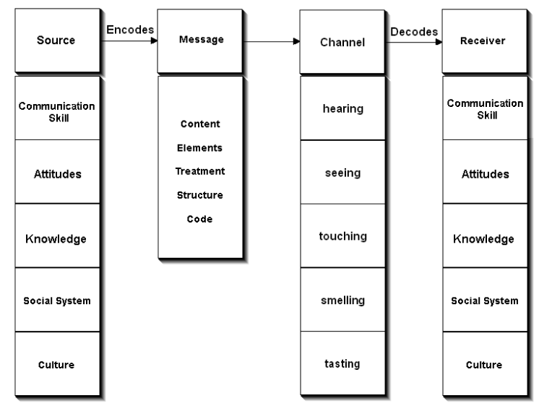
Figure 2: Berlo’s SMCR Model
(Source: van Ruler, 2018, p.7)
Schramm’s Model of Communication: This is the most simple and useful model which has been derived from both the models. With this process the continuous communication cycle runs between the sender and receiver with the help of encoder, decoder as well as interpreter (van Ruler, 2018)
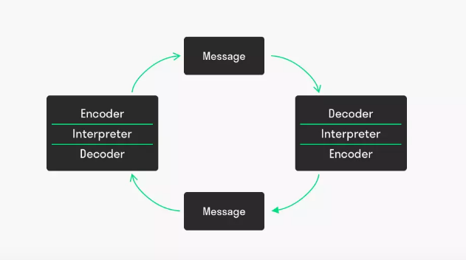
Figure 3: Schramm’s Model of Communication
(Source: van Ruler, 2018, p.5)

Importance of effective communication
As per the opinion of Zambas (2019) communication is the fundamental unit of positive performance of a business organization. In case of ineffective communication the employees might fail to conduct the assign task in an inappropriate way. Effective communication helps in the development of strategies and explaining the business motifs so that the employees can understand the organizational objectives.
Without understanding the business objectives the employees might not get the clear vision or path for the work process. Thus, it can be stated that effective communication is important for the demonstration of organizational vision to the key human resources so that they can find a way to attain the targets. I have noticed in my workplace that my organizational management states the organizational goals and objectives so that the employees can define a path for attaining those (Johnston et al.2015).
Apart from that it helps in the development of relationship among the employees; as a result effective team building as well as proper collaboration can be found within the business process. Additionally, effective communication improves business growth, enhances efficiency, skills, innovation and creativity, develops organizational productivity, promotes employee engagement and loyalty along with mitigates workplace conflicts effectively (Kennedy et al.2015).

The role of culture in communication
In the communication process culture plays a vital role as it determines the habits, behaviour, psychology and understanding of various people. In a workplace a wide ranges of people who work together considering the assigned job responsibility. The employees belong to the different cultures which might possess different language, set of mind and activities. As culture is not only about the dressing pattern or the food habits, it is about the way the people decide in interaction with the outside world. Based on the culture an individual decides how to communicate with other party who might belong to other cultural background. Language is the main element for multi-cultural communication what the employees might use for communicate with each other (Jackson, 2015).

How does communication work between management and employees along with its purposes
Within an organization the management and the employees works so that the organizational performance can be enhanced considering the projected strategies. Without proper and effective communication between the management and the employees the overall purpose of the business might not serve properly. In a business organization an employee needs to communicate with the other employees, management and clients for effective completion of the assigned task (Foronda, MacWilliams and McArthur, 2016).
In most of the cases, improper communication in the business process leads to utter failure in projected success. In order to develop a transparent vision the management and employees need to indulge in effective communication process so that the employee might develop a clear vision related to organizational objective. On the other side, effective communication with the other employees develops proper relationship as a result workplace environment becomes healthy as well as sound which encourages innovation and creativity (Hewitt, Sims and Harris, 2015).
Additionally, proper communication with the customers helps in retaining them within the business process as the customers are the main aspect for conducting a business. In the communication process proper adoption of tone and level of formality needs to be considered based on the other party. When an individual is communicating with other employees the tone need not be formal. On the other side, the improper tone might affect the dealing with the customers. On the other side, being casual with the management might create a negative impression about the employee (Elleström, 2018).

Effective Communication Strategies
In a business process communication process there are some elements which might work as communication barrier within a workplace. Ego and attitude, passive listening, cultural differences, improper presented written communication as well as lack of motivation and interest are the major reason which might affect the mode of communication within an organization. In order to eliminate those issues proper strategies needs to be developed as well as implemented so that the business never suffer due to ineffective communication (El Ansari et al. 2016).
For effective communication there are few keys which might help in the development of a better communication skill. First of all, knowing the message properly might help the communicator to identify the proper ways of demonstrating that. The information should well understand the communicators as well. Context of the message should be relevant and use of proper tone and emotion is important for effective communication. Moreover, adoption of healthy communication style along with being receptive is the strategies what one should implement for being an effective communicator. Providing helpful feedback and being a god on-verbal communicator is the other strategy what one should implement properly. Being consistence and positive brings the confidence based on which the communicator might be able to demonstrate the relevant information related to the message (Alliger et al. 2015).
Completeness, Concreteness, Courtesy, Correctness, Clarity, Consideration and Conciseness are the 7C’s of communication which helps in the development off better strategies for effective communication. While starting a proper communication process the communicators should consider all the aspects for communicating effectively with the audience (Adler, Rodman and Du Pré, 2016).

Conclusion
From the above discussed study it can be concluded that communication is the key to attain success from the context of organizational work process. In this study the importance of communication and the role of culture within the communication have been demonstrated so that proper understanding related to workplace communication process can be developed. Moreover, various theories of communication such as Shannon and Weaver’s Model of Communication, Berlo’s SMCR Model as well as Schramm’s Model of Communication have been discussed effectively as the relevant theories for demonstrating the concept of communication theoretically.

Reference List
Adler, R.B., Rodman, G.R. and Du Pré, A., 2016. Understanding human communication. Ed 1, UK: Oxford University Press.
Alliger, G.M., Cerasoli, C.P., Tannenbaum, S.I. and Vessey, W.B., 2015. Team resilience. Organizational Dynamics, 44(3), pp.176-184.
Boies, K., Fiset, J. and Gill, H., 2015. Communication and trust are key: Unlocking the relationship between leadership and team performance and creativity. The Leadership Quarterly, 26(6), pp.1080-1094.
El Ansari, W., Lyubovnikova, J., Middleton, H., Dawson, J.F., Naylor, P.B. and West, M.A., 2016. Development and psychometric evaluation of a new team effectiveness scale for all types of community adult mental health teams: a mixed‐methods approach. Health & social care in the community, 24(3), pp.309-320.
Elleström, L., 2018. A medium-centered model of communication. Semiotica, 2018(224), pp.269-293.
Foronda, C., MacWilliams, B. and McArthur, E., 2016. Interprofessional communication in healthcare: An integrative review. Nurse education in practice, 19, pp.36-40.
Hewitt, G., Sims, S. and Harris, R., 2015. Evidence of communication, influence and behavioural norms in interprofessional teams: a realist synthesis. Journal of interprofessional care, 29(2), pp.100-105.
Jackson, D., 2015. Employability skill development in work-integrated learning: Barriers and best practice. Studies in Higher Education, 40(2), pp.350-367.
Johnston, M.J., King, D., Arora, S., Behar, N., Athanasiou, T., Sevdalis, N. and Darzi, A., 2015. Smartphones let surgeons know WhatsApp: an analysis of communication in emergency surgical teams. The American Journal of Surgery, 209(1), pp.45-51.
Kennedy, N., Armstrong, C., Woodward, O. and Cullen, W., 2015. Primary care team working in I reland: a qualitative exploration of team members’ experiences in a new primary care service. Health & social care in the community, 23(4), pp.362-370.
Mercer, S., 2019. Team-Working, Chapter. Obstetric Decision-Makng Simulation, 12(7), pp.40-45.
Mihai, C.G. and Mihai, R.L., 2016. Communication management and team working sale. Valahian Journal of Economic Studies, 7(3), pp.91-96.
Mundt, M.P., Agneessens, F., Tuan, W.J., Zakletskaia, L.I., Kamnetz, S.A. and Gilchrist, V.J., 2016. Primary care team communication networks, team climate, quality of care, and medical costs for patients with diabetes: a cross-sectional study. International journal of nursing studies, 58(7), pp.1-11.
Sacks, G.D., Shannon, E.M., Dawes, A.J., Rollo, J.C., Nguyen, D.K., Russell, M.M., Ko, C.Y. and Maggard-Gibbons, M.A., 2015. Teamwork, communication and safety climate: a systematic review of interventions to improve surgical culture. BMJ Qual Saf, 24(7), pp.458-467.
Salas, E., Shuffler, M.L., Thayer, A.L., Bedwell, W.L. and Lazzara, E.H., 2015. Understanding and improving teamwork in organizations: A scientifically based practical guide. Human Resource Management, 54(4), pp.599-622.
Turaga, R., 2016. Organizational models of effective communication. IUP Journal of Soft Skills, 10(2), pp.50-56.
van Ruler, B., 2018. Communication theory. The International Encyclopedia of Strategic Communication, 19(5), pp.1-7.
Zambas, J., 2019. The Importance of Effective Communication in the Workplace. Available at: https://www.careeraddict.com/the-importance-of-effective-communication-in-the-workplace [Accessed on: 22/12/2019]

