Name: Njillan
Student number: 2505686
Module code: Professional Development within Health and Social Care
Lecturer’s name: Besty Jose
Job
https://www.jobs.nhs.uk/candidate/jobadvert/C9371-26-0560?searchFormType=main&keyword=nursery&language=en
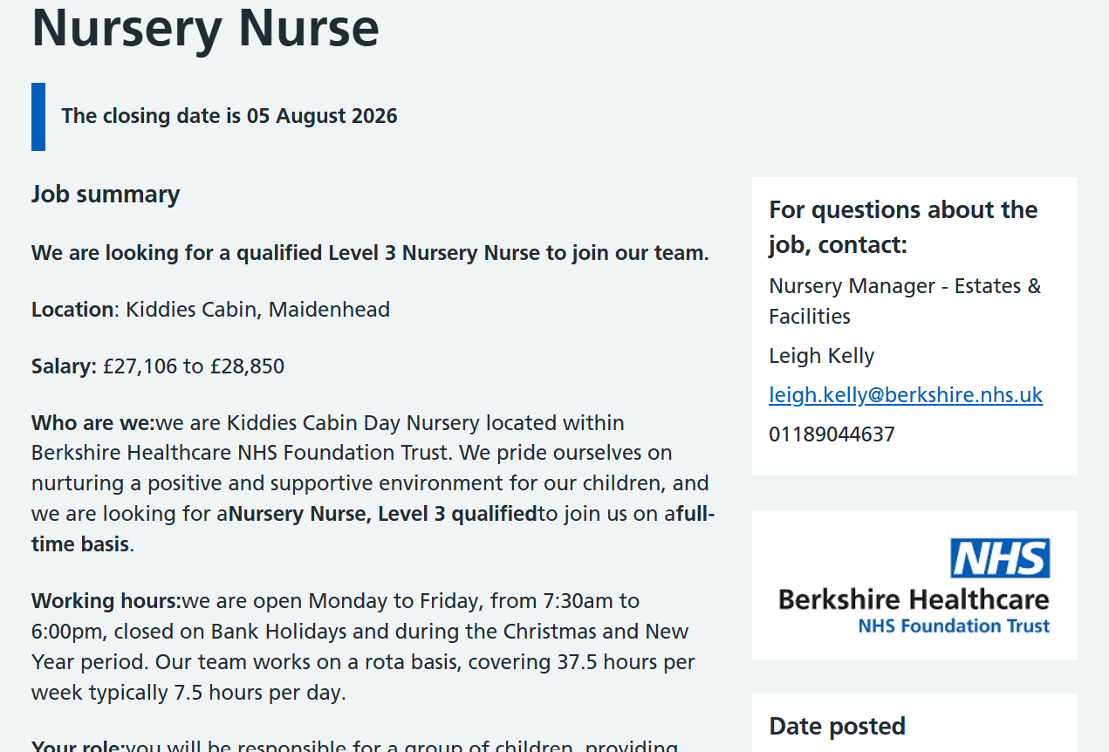
CV
Njillan Sawaneh | Mobile: 07000000000  Email: 2505686@student.uwtsd.ac.uk

PROFILE
I am caring, compassionate, enthusiastic and have studied Health and Social Care, I have gained a good knowledge of safeguarding, communication, child development and the importance of delivering person centred care. Being passionate about supporting young children, helping them to learn, grow and reach their full potential in a safe, nurturing environment. I can work well in a team, communicate effectively with others and am organised, patient and reliable. I am keen to start my training as an NHS Nursery Nurse in a role where I can learn more and gain the skills needed to help children and their families.

KEY SKILLS
- Teamworking
- Communication & Presentation
- Critical Thinking
- Listening
- Time management
- Patience
- Caring and compassionate
- problem solving

WORK EXPERIENCE
For work experience – No paid work experience yet.
Health and Social Care student
- Studied child development, safeguarding, communication, and person-centred care.
- Developed an understanding of supporting children’s physical, emotional, and social needs.
- Worked on practical activities and case studies that strengthened my teamwork, communication, and problem-solving skills.
- Learned the importance of supporting confidentiality, promoting equality and diversity, and ensuring a safe environment.
I am currently seeking my first opportunity as a Nursery Nurse. Through studying Health and Social Care, I have gained relevant knowledge and transferable skills, including communication, teamwork, safeguarding awareness, and providing compassionate care, which I am eager to apply in an NHS setting.
EDUCATION
University of Wales Trinity Saint David– CertHE in skills for the workplace Health and Social Care level 4,
September 09, 2025 – July 15, 2026

INTERESTS & HOBBIES
- In my free time I love spending quality time with friends and families
- I also love reading, it is something incredible fulfilling about diving into different worlds
- Once a while I love taking a walking breathing in and exploring the nature around
Task 2
I am caring, compassionate and enthusiastic with a true passion for supporting babies and young children's health, development and wellbeing. I am applying to be a Nursery Nurse for the NHS because I love assisting children to learn, grow and become to their full potential in a secure, caring and stimulating nursery. In the long-term, my goal is to have a successful career in the NHS that I can make a difference to the lives of children and their families with and that I am continuing to develop my knowledge and professional skills in.
I'm undertaking Health and Social Care, and it has given me great insight into child development, safeguarding, communication, equality and diversity, health and safety and person-centred care. My studies have enabled me to have a solid understanding of the needs of children to be supported in all areas of their development, including physical, emotional, social and cognitive, and always in keeping with the child's safety and wellbeing. They have also helped me to understand the importance of professionalism, confidentiality and working within policies and procedures to deliver high quality care.
During my studies I've acquired a variety of transferable skills that I think will help me to be successful as a Nursery Nurse. Excellent teamworking skills and an awareness of the need for effective collaboration between members of the team and other health care professionals for the benefit of children. I have good communication and presentation skills which enable me to develop positive relationships with children, parents/carers and members of the multi-disciplinary team. I am also a good listener who can understand the needs, concerns and feelings of others and respond with empathy and respect.
This has enhanced my critical thinking and problem-solving skills in Health and Social Care and enabled me to think about a situation thoroughly and make relevant decisions in high pressure situations. Enveloped with effective time management skills that help me to organize my work, prioritize my tasks, and execute tasks effectively under high stress. These are important attributes that are required when working with children, ensuring that all work is done safely and effectively.
I have one of the best traits in my body and that is being patient. I realise that all children have their own developmental speed and that they need encouragement, understanding and individual support. I am caring and compassionate and I feel that all children deserve to feel safe, valued and respected. I like to build positive relationships with children and families, treating them all with kindness, dignity and respect, and promoting equality, diversity and inclusion.
My knowledge acquired from my Health and Social Care course combined with my personal strengths and professional skills would enable me to be a worthwhile employee of the NHS team. I can work cooperatively with staff to deliver quality care through my teamwork skills. Face-to-face interactions enhance children and families' sense of support and involvement through my communication and listening skills, which foster trust and connection. My patience, compassion and caring nature allows me to provide nurturing care that meets the individual child's needs. I use critical thinking, problem solving, and time management skills to appropriately react to problems and keep the area safe and organized.
I am reliable, hardworking and motivated, and am committed to learning and developing in the NHS. I hold the values of the NHS which are compassion, respect, teamwork and commitment to quality care. I am sure my knowledge, ability and commitment will help me to contribute positively as a Nursery Nurse, to help children to get the best start in life.

Task 3
SWOT analysis is a strategic planning tool that brings to the forefront and evaluates an individual's or organisation's Strengths, Weaknesses, Opportunities and Threats. It enables individuals to evaluate internal factors like skills and growth areas, as well as external factors like opportunities and challenges that could impact on an individual's personal or professional objectives (CIPD, 2024; Mind Tools, 2024).
The SWOT analysis is crucial because it enables an individual to identify their strengths and pinpoint areas in which they can make improvements as well as planning to reach their objectives. It also helps individuals make decisions, plan, and take advantage of learning, career growth and self-development opportunities. For a healthcare industry, such as a job application for an NHS Nursery Nurse position, a SWOT analysis will help to highlight potential strengths and weaknesses of the job and should also identify areas for improvement for the candidate through further training or experience (CIPD, 2024). It is also part of reflective practice, which is an essential element of ongoing CPD and enhancing patient and family care (NHS England, 2023).

Strengths | Weaknesses
Caring  Compassionate  Good at communicating  Teamwork  Patience  Good listening skills | No work experience  Less confident  Need more practical experience  Learning more
Opportunities | Threats
Progress to higher roles within the NHS  Having experience through placements or volunteering  Attend to training courses | Others may have more experience  Hard demanding work environment

Personal Development Plan Template
Goals | List the actions to complete to achieve the goal | Support/resources needed | Target date | Review date
Having experience in childcare | Getting into placements | A placement supervisor | October 2026 | January 2027
Improving more communication | Having the confidence to communicate to when doing placements | More presentation can help | September 2026 | July 2027
Getting into a nursery nurse job | Finishing my health and social care course and applying for the job | NHS website | August 2027 | December 2027

Task 4
The presentation was a component of my LCHS4009 assessment for the self-awareness topic. I read and researched the topic, made a PowerPoint presentation and sorted materials into logical sections. I had some rehearsal periods prior to the presentation to get used to the content. The presenter was able to explain the key points of each slide and answer questions at the end of the presentation. Once completed, verbal feedback was given by my lecturer. The lecturer said it was organised and informative, but to not read from the powerpoint slides and increase my eye contact with the audience.
Throughout I could not help but feel nervous before I was to present because I wanted to do good and give my knowledge clearly. I had prepared but I thought that I might forget something important, but I heavily used my power point slides and as I went through the presentation, I gained more confidence. When I got feedback from the lecturer, I was disappointed as I knew this will impact my presentation. I also felt thankful as the feedback was constructive and pointed out an area that I can work on to improve my presentation in the future.

