Adam Horton

Programing Assignment 2
By Adam Horton 1702203

Part A
The problem solving technique I use is writing the problem down on paper to better understand it. I do this so it allows me to understand the problems within the code and how they can be solved. This also allows me to organise the problems into difficulty and work on the ones I see fit to do so.
Part B

Part C
1.
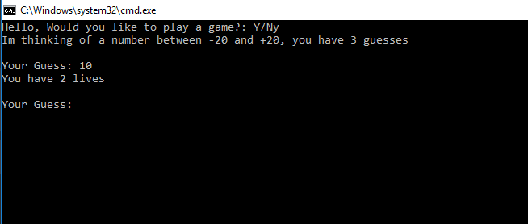

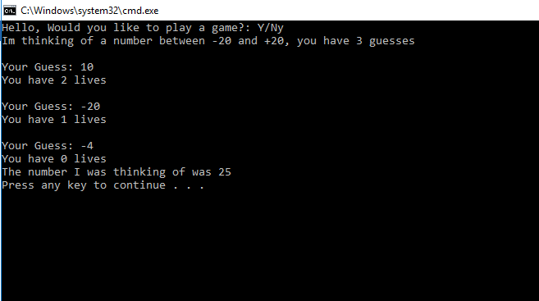
2.

3.
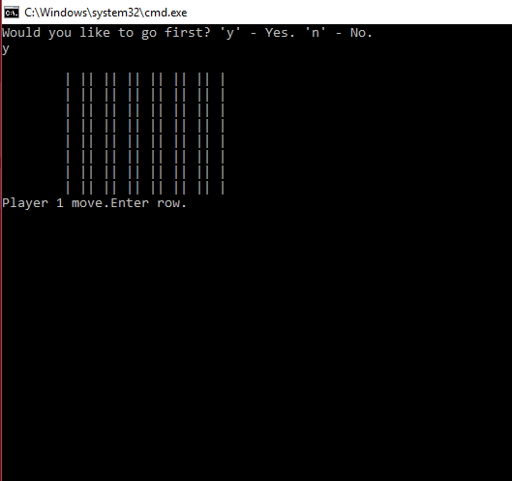
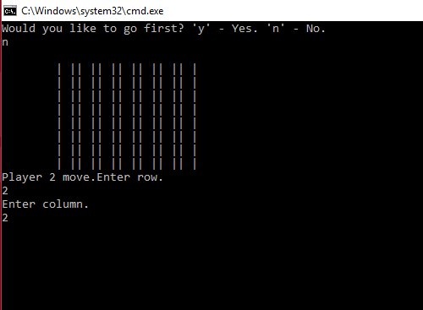

Appendix
Part2

Part3
1.
#define _CRT_SECURE_NO_WARNINGS
#include <stdio.h>
#include <string>

using namespace std;

int main(int argc, char** argv)
{
char text[100];

int lives = 3;
int numbers[40];
int count;
int numb = -20;
int number;
int r;
int guess;
string answer;

int i = 0;
while (i++ < 10)
{
r = (rand() % 40) + 1;
}

for (count = 0; count < 40; count++)
{
numbers[count] = numb;
numb = numb + 1;
}
number = numbers[r];

printf("Hello, play game?: Y/N ");
scanf("%99s", text);
answer = text;
if (answer == "Y"||answer=="y")
{
printf("Im thinking of a number between -20 and +20, you have 3 guesses\r\n");
guess = 0;
while (guess != number && lives != 0)
{
printf("\r\nYour Guess: ");
scanf("%i", &guess);
if (guess == number)
{
printf("Congratulations you guessed correctly with %i lives left", lives);

}
else
{
lives = lives - 1;
printf("You have %i lives\r\n", lives);
}
}
printf("The number I was thinking of was %i\r\n", r);
}
else
{
printf("Oh Ok BYE THEN\r\n");
return 0;
}
return 0;
}
2.
Main.c
#define _CRT_SECURE_NO_WARNINGS
#pragma warning(disable:4996)

#include "stdafx.h"
#include <string>

#include "Console.h"
#include "Application.h"

using namespace std;

int main(int args, char* argv[])
{
Console* console = new Console();
Application* application = new Application(console);
bool quit = false;

console->PrintLine("*****************************************************************************");
console->PrintLine("* This application is designed to allow you to select the number of numbers *");
console->PrintLine("* you wish to enter, and sum the numbers that you provide. *");
console->PrintLine("*****************************************************************************");

while (quit == false)
{
application->DisplayMenu();
application->ChooseOption();
quit = application->ProcessOption();
}

console->Pause();

delete application;
delete console;
return 0;
}

Console.h
#pragma once
#pragma warning(disable:4996)
#include <conio.h>
#include <string>

using namespace std;

class Console
{
// Attributes
// NONE

// Constructors
// NONE

// Properties
// NONE

// Methods
public:
string ReadString();
int ReadInteger();
double ReadDouble();
void Print(string text);
void PrintLine(string line);
void Pause(void);

private:
void ClearInputBuffer();
};

Console.cpp
#include "Console.h"

string Console::ReadString()
{
char text[100];

scanf("%99[^\n]s", text);
ClearInputBuffer();

return (string)text;
}

int Console::ReadInteger()
{
int number;

scanf("%i", &number);
ClearInputBuffer();

return number;
}

double Console::ReadDouble()
{
double number;

scanf("%lf", &number);
ClearInputBuffer();

return number;
}

void Console::ClearInputBuffer()
{
char ch;
while ((ch = getchar()) != '\n' && ch != EOF);
}

void Console::Print(string text)
{
printf("%s", text.c_str());
}

void Console::PrintLine(string line)
{
Print(line + "\r\n");
}

void Console::Pause(void)
{
while (1) { if (_kbhit()) break; } // Pause
_getch();
}

Application.h

#pragma once
#include "Console.h"

class Application
{
// Attributes
private:
Console* _console;
int _chosenOption;
int _numNumbersReqd;

// Constructors
public:
Application(Console* console);

// Properties
// NONE

// Methods
public:
void DisplayMenu();
void ChooseOption();
bool ProcessOption();
private:
int ReadNumber(string prompt);
int GetTotal();
void DisplayResult(int result);
bool IsQuitting();
};

Application.cpp
#include "Application.h"

Application::Application(Console * console)
{
_console = console;
_chosenOption = 0;
_numNumbersReqd = 5;
}

void Application::DisplayMenu()
{
_console->PrintLine("Select an option");
_console->PrintLine("1. Add numbers");
_console->PrintLine("2. Change amount of numbers to be entered");
_console->PrintLine("3. Quit");
}

void Application::ChooseOption()
{
_chosenOption = ReadNumber("Please choose an option:");
}

int Application::ReadNumber(string prompt)
{
_console->Print(prompt);
return _console->ReadInteger();
}

bool Application::ProcessOption()
{
bool quit = false;

switch (_chosenOption)
{
case 1:
int total;
total = GetTotal();
DisplayResult(total);
break;
case 2:
_numNumbersReqd = ReadNumber("Please enter the number of numbers to be entered:");
break;
case 3:
quit = IsQuitting();
break;
default:
_console->PrintLine("Unknown option value entered");
break;
}

return quit;
}

int Application::GetTotal()
{
int total = 0;
int index;

for (index = 0; index < _numNumbersReqd; index++)
{
total = total + ReadNumber("Please Enter Number:");
}

return total;
}

void Application::DisplayResult(int result)
{
_console->PrintLine("###############################################################################");
_console->PrintLine("###############################################################################");
_console->PrintLine("################## " + to_string(result) + " ##################");
_console->PrintLine("###############################################################################");
_console->PrintLine("###############################################################################");
}

bool Application::IsQuitting()
{
string response;
bool quit = false;

_console->Print("Do you really wish to quit?");

response = _console->ReadString();

if (response == "YES")
{
_console->PrintLine("Quitting");
quit = true;
}

return quit;
}

3. Connect 4
Players.cpp
#define _CRT_SECURE_NO_WARNINGS
#include <stdio.h>
#include <string>

#include "Players.h"
#include "Gameboard.h"
#include "Gamerule.h"

using namespace std;

int Players::getRowPosition(const Gameboard& board) const
{
int R = 0;
bool positionAllowed = false;
while (!positionAllowed)
{
std::cout << "Enter row.\n";
std::cin >> R;

if (R >= 1 && R < Gamerule::ROWS - 1)
positionAllowed = true;
else
std::cout << "Position out of bounds. Please enter again.\n";
}
return R;
}

int Players::getColPosition(const Gameboard& board) const
{
int R = 0;
bool positionAllowed = false;
while (!positionAllowed)
{
std::cout << "Enter column.\n";
std::cin >> R;

if (R >= 1 && R < Gamerule::COLUMNS - 1)
positionAllowed = true;
else
std::cout << "Position out of bounds. Please enter again.\n";
}
return R;
}

void Players::move(Gameboard& Gameboard)
{
int R = 0;
int C = 0;
bool moveComplete = false;
while (!moveComplete)
{
R = getRowPosition(Gameboard);
C = getColPosition(Gameboard);

if (Gameboard.isMoveLegal(R, C))
{
Gameboard.addPlayerPiece(R, C, getGamePiece());
moveComplete = true;
}
}

}

void Players::grabPiece(const char gamePiece)
{
m_GamePiece = gamePiece;
}

char Players::getGamePiece() const
{
return m_GamePiece;
}
Players.h
#pragma once
class Gamerule;
class Gameboard;
class Players
{
private:
char m_GamePiece = ' ';
int m_Score = 0;

int getRowPosition(const Gameboard& board) const;
int getColPosition(const Gameboard& board) const;

public:

void move(Gameboard& board);
void grabPiece(const char gamePiece);
char getGamePiece() const;
};
Gameboard.cpp
#define _CRT_SECURE_NO_WARNINGS
#include <stdio.h>
#include <string>

using namespace std;
#include "Gameboard.h"
#include "Gamerule.h"

Gameboard::Gameboard()
{
initGameboard();
}

void Gameboard::initGameboard()
{
std::vector<char> tempBoard;

for (int i = 0; i < Gamerule::ROWS; i++)
{
tempBoard.push_back(Gamerule::EMPTY);
}

for (int i = 0; i < Gamerule::ROWS; i++)
{
m_Board.push_back(tempBoard);
}

}

void Gameboard::displayBoard()
{
std::cout << "\n";
for (int R = 0; R < Gamerule::ROWS - 1; R++)
{

std::cout << "\t";

for (int C = 0; C < Gamerule::COLUMNS - 1; C++)
{
if (C != 0)
std::cout << "|" << m_Board[R][C] << "|";
}
std::cout << "\n";
}
}

bool Gameboard::isMoveLegal(int R, int C)
{

if (m_Board[R][C] == Gamerule::EMPTY)
{
if (R == Gamerule::ROWS - 2 && m_Board[R][C] == Gamerule::EMPTY)
{
return true;
}

else
{
int newR = R;
newR++;
if (m_Board[newR][C] != Gamerule::EMPTY)
{
return true;
}

else
{
std::cout << "You cannot move here.\n";
return false;
}

}
}

else
{
std::cout << "You cannot move here.\n";
return false;
}
}

void Gameboard::addPlayerPiece(int R, int C, char playerPiece)
{
m_Board[R][C] = playerPiece;

}

char Gameboard::getBoardPosition(int R, int C) const
{
return m_Board[R][C];
}

bool Gameboard::checkForWinner(Gamerule& gamerule, char playerPiece)
{
bool foundWinner = false;

searchForWinner(gamerule, playerPiece, m_SrchHorizontal, foundWinner);
searchForWinner(gamerule, playerPiece, m_SrchVertical, foundWinner);
searchForWinner(gamerule, playerPiece, m_SrchRightDiagonal, foundWinner);
searchForWinner(gamerule, playerPiece, m_SrchLeftDiagonal, foundWinner);

return foundWinner;
}

void Gameboard::searchForWinner(Gamerule& gamerule, char playerPiece, std::string searchDirection, bool& foundWinner)
{
if (!foundWinner)
{
int i = 0;
for (int R = 0; R < Gamerule::ROWS; R++)
{
for (int C = 0; C < Gamerule::COLUMNS; C++)
{
while (m_Board[R][C] == playerPiece && !foundWinner)
{
i++;
gamerule.setWinner(playerPiece);

if (searchDirection == m_SrchHorizontal)
C++;

if (searchDirection == m_SrchVertical)
R++;

if (searchDirection == m_SrchRightDiagonal)
{
R++;
C++;
}

if (searchDirection == m_SrchLeftDiagonal)
{
R++;
C--;
}
if (i == Gamerule::WINNING_ROWS)
{
foundWinner = true;
}
}
i = 0;
}
}
}
else
{
return;
}
}
Gameboard.h
#pragma once
#include <vector>
#include <iostream>

class Gamerule;
class Gameboard
{
private:
std::vector<std::vector<char>> m_Board;

std::string m_SrchHorizontal = "Horizontal";
std::string m_SrchVertical = "Vertical";
std::string m_SrchRightDiagonal = "DiagonalRight";
std::string m_SrchLeftDiagonal = "DiagonalLeft";

void initGameboard();
void searchForWinner(Gamerule& gamerule, char playerPiece, std::string searchDirection, bool& foundWinner);

public:
Gameboard();

char getBoardPosition(int R, int C) const;

void displayBoard();
bool isMoveLegal(int R, int C);
void addPlayerPiece(int R, int C, char playerPiece);
bool checkForWinner(Gamerule& gamerule, char playerPiece);
};
Gamerule.cpp
#define _CRT_SECURE_NO_WARNINGS
#include <stdio.h>
#include <string>

using namespace std;
#include "Gamerule.h"
#include "Gameboard.h"
#include "Players.h"

void Gamerule::allocateFirstTurns(Players & player1, Players & player2, char choice)
{
if (choice == 'y')
{
player1.grabPiece(X);
player2.grabPiece(O);
}

if (choice == 'n')
{
player1.grabPiece(O);
player2.grabPiece(X);
}
}

void Gamerule::decideFirstTurn(Players& player1, Players& player2)
{
bool chosen = false;
char choice = ' ';
while (!chosen)
{
std::cout << "Player one go first? 'y' - Yes. 'n' - No.\n";
std::cin >> choice;

if (choice == 'y' || choice == 'n')
chosen = true;
}

allocateFirstTurns(player1, player2, choice);
}

void Gamerule::game(Gameboard & board, Players& player1, Players& player2, Gamerule& gamerule)
{

char turn = X;
decideFirstTurn(player1, player2);

while (!m_FoundWinner)
{
gameRound(board, player1, player2, gamerule);
}

board.displayBoard();

std::cout << "Winner: " << m_Winner << "\n";

if (m_Winner == player1.getGamePiece())
std::cout << "Player 1 wins the game.\n";

if (m_Winner == player2.getGamePiece())
std::cout << "Player2 wins the game.\n";
}

void Gamerule::gameRound(Gameboard & board, Players & player1, Players & player2, Gamerule& gamerule)
{
while (!m_FoundWinner)
{
if (m_Turn == player1.getGamePiece())
{
board.displayBoard();
std::cout << "Player 1 move.";
player1.move(board);
m_FoundWinner = board.checkForWinner(gamerule, player1.getGamePiece());
swap(player1.getGamePiece());
}

else
{
board.displayBoard();
std::cout << "Player 2 move.";
player2.move(board);
m_FoundWinner = board.checkForWinner(gamerule, player2.getGamePiece());
swap(player2.getGamePiece());
}
}
}

void Gamerule::swap(char turn)
{
if (turn == X)
m_Turn = O;

else
m_Turn = X;
}

void Gamerule::setWinner(char gamePiece)
{
m_Winner = gamePiece;
}
Gamerule.h
pragma once
#include <string>

class Gameboard;
class Players;
class Gamerule
{
private:
char m_Turn = X;
bool m_FoundWinner = false;
char m_Winner = ' ';

void allocateFirstTurns(Players& player1, Players& player2, char choice);
void decideFirstTurn(Players& player1, Players& player2);
void gameRound(Gameboard& board, Players& player1, Players& player2, Gamerule& gamerule);
void swap(char turn);

public:
static const int ROWS = 9;
static const int COLUMNS = 9;
static const int WINNING_ROWS = 4;

static const char X = 'X';
static const char O = 'O';
static const char EMPTY = ' ';

void game(Gameboard& board, Players& player1, Players& player2, Gamerule& gamerule);
void setWinner(char gamePiece);
};

