The changing face of Media Consumption and Advertising

History of media consumption

The origins of advertising can be traced back to the etchings on the cave walls by the ancient Egyptians to the engravings on the temples of the Mayan tribes of Polynesia. One of the earliest examples of advertising is believed to be from the ancient city of Thebes, a tablet that was removed from the ancient ruins details the story of a pharaoh seeking a reward for a slave named Shem who had fled from the city. An article from the website tripandtravelblog.com by (Nikolau ,2012) mentions how “A seller of fabrics named Hapu inscribed the details of the reward for the slave, stating the pharaoh would reward the person one piece of gold who gave information about the missing slave”. Hapu was able to advertise his business as well as the information on the reward for the slate. The information inscribed on the slate is believed to be the first example of advertising.
As time evolved into the industrial age, an invention would be created know as the printing press. The machine was created by Johannes Guttenberg in the 15th century, which soon gave rise to the mass production of books, newspapers and later on billboards. Shops could now have their name above the windows which made the business more appealing and gave a broader use of the information for the general public to notice, due to colour now being added into the process, making the advertisement of the business more appealing because at the time print was usually in black ink only.
As technology advanced so did the advertising methods of the corporations involved. In the 1960’s at the height of the hippy counter culture movement, advertising was now becoming more youth targeted, especially from a marketing standpoint. Movie stars and pop bands were being used to promote cigarettes and cars hoping to attract the rebellious nature of the teenager in order to sell the products. In example film star Michael Caine became famous for his role as Harry Palmer in the film The Ipcress File, Michael Caine would smoke Marlboro cigarettes in the role.
In the modern era advertising has become more sophisticated due to advertisers targeting certain demographics, mainly the youth. Focus groups were now being employed by companies to help survey consumer interests, a group of people with skills in psychology, Sociology and market research. The downside of using focus groups in advertising is an emphasis to appeal to the most popular trends at the time, an article online called ‘Learn how focus groups are used in advertising’ by (Suggett, 2014)
“One of the biggest problems of focus groups is trying to please all of the people, all of the time, if ad campaigns do not offend anyone in the room or even cause fiery discussion then they are considered good but that is a counter to what advertising is supposed to do”
The article focuses on the negative side of advertising and how creative freedom is strained under the rule of market research and what products sell the most and what style of advertising works due to the number of sales involved in the research.
The rise of the internet has changed the face of advertising, social media apps like Facebook, Instagram and You Tube, can now be used for commercial purposes as well as conventional content. A celebrity in the public eye can now expand their brand through the use of social media, also corporations will pay large sums of money for celebrities to endorse their products, clothing, jewellery and even cars can now be advertised on a famous person’s Instagram page and gain thousands of likes and comments. This will increase awareness of the company’s products and also bolster the status of the celebrity involved due to wearing the latest high-end fashion or driving the newest top of the range automobile.

Advertising – Analogue Traditional Media

The invention of the radio would increase the opportunity for advertising in a different medium. In 1922 in the U.S debuted the very first radio commercial for an apartment complex. The golden age of radio came to prominence in the 1930’s and peaking in the late 1940’s, an example was given by writer, producer (N. Corwin) said
“the shortest golden age in history.” During its brief heyday, however, dramatic radio thrived and was a vital part of American culture.

The first known commercial on television was aired in 1941, it was only ten seconds long and costs approximately four dollars to make (ref), however the advert was a landmark in television history, now households across the country could view television programmes from all forms. In the years that would follow, advertising would see a great advancement in the technology, and now popular sponsors would begin to appear such as Coca-Cola, Matel and Colgate, all companies with a vested interest in acquiring air-time to increase product sales.
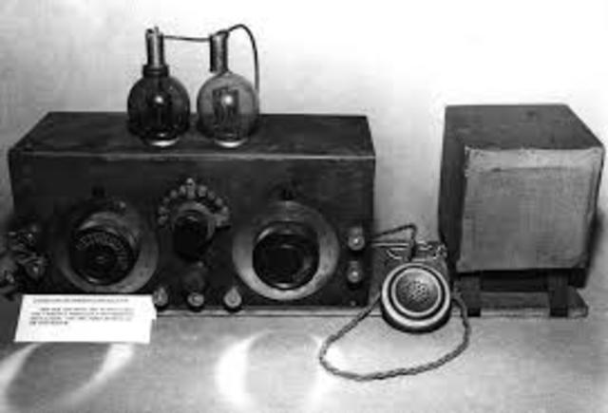
Marconi G. (1901) The Invention of Radio

Audience Theory

When it comes to audience theory, the audience is perceived as not lazy couch potatoes, but as individuals who have the option to interact with the communication process and use media texts for their own purposes. An example of audience participation is the increasing amount reality-based entertainment programmes where participants are set against one another in the name of competition to see who can win the contest.
Programmes like The X Factor, The Voice etc give the audience the option to vote either through text or phone call in order control the outcome of the participants future on the television show.
According to the creator and executive producer of the television show “The Bachelor (M.Fleiss,2012) has said that “70 to 80 percent of what people see on reality television is fake”.
“They’re loosely scripted. Things are planted. Things are salted into the environment so things seem more shocking,” Fleiss said.
What is clear about Fleisse’s statement is the admittance that certain forms of media that claim to be based in reality are not what they seem. When an audience is told that the participants involved are real people taking part and later are exposed as being manufactured by comities there is a level of authenticity has now come into question, the audience can now question whether what they are watching is real or not.
A dangerous notion as the public can now be manipulated into believing anything that is presented to them and the general public also has a false sense of control due to the truth being challenged.
In contrast passive audience interaction occurs when a person does not take action but instead allows things to happen to them, as far as technology is concerned various forms of media can be used in a passive manor.
The radio is a good example of passive interaction as the person listening can engage with day to day activities whilst listening to a radio programme, with sound emitting from the audio device and the listener is either listening intently or casually only taken in a majority of the sound due to the brain being occupied with other things. People have admitted that whilst working audio and music can have a positive effect on their attitude and mood even when working uninteresting jobs. In example according to an online video entitled Should You Study with Music?, The Science-Backed Verdict by K. Jubal (2019)
“Take, first, the case of the housewife or the student who is completely preoccupied with work. The loud-speaker emits its stream of sound, but it falls on deaf ears. The distraction is completely inhibited. (2015)

The Hypodermic Model
In this model, the media is seen as powerful and controlling, able to inject ideas into an audience who are seen as weak and passive. The theory is based on the idea that mainstream media and advertising can inflict values and attitudes on a passive audience as the audience will not question or challenge what they are being told. According to author (H. Laswell) writes about in the book Propaganda technique for the world war stated that
“From a propaganda point of view, it was a matchless performance, for Wilson brewed the subtle poison which industrious men injected into their veins of a staggering people, until the smashing powers of the allied armies knocked them into submissions”
The theory was in 1927 and since then has been long criticized and challenged and then in 1938 actor and director Orson Welles and the mercury theatre presented H.G. Welles novel War of The Worlds. The broadcast that was being presented as a news bulletin claimed that there is an Alien invasion happening on earth, the broadcast startled the general public as there had never been such a realistic depiction of what had been described.
The War Of The Worlds programme showed that a fraction of the general public believed what was being broadcasted as real and therefore became hysterical which suggests that if the media can have an effect on the general public through manipulation the a democratic society would be challenged due having value systems changed through fear and control.

Cultivation Theory
Much like the Hypodermic theory, Cultivation Theory originates from professor George Gerbner, the idea that media manipulation over time can have an adverse effect on the publics overall opinion, In example bestowed by K. Leach (2017) claims that in the modern era social media applications like Facebook require people to check their facebook status on a constant basis and to interact by pressing the like button to display affection towards a person post.
Another theory is that watching to much television can have an effect on the public’s opinion of society, Violence on television has become a topic of interest by psychologists and social intellects for a long time. A study that was conducted by theorist P. Signorielli said that
"In short, children who are frequent viewers of media violence learn that aggression is a successful and acceptable way to achieve goals and solve problems; they are less likely to benefit from creative, imaginative play as the natural means to express feelings, overcome anger, and gain self-control"
In essence Cultivation theory needs time in order for it to be authentic, It is not enough to just repeat a message but how many times that message is repeated.

Two Step Flow Theory
In order to entice the public into absolute engagement, the audience cannot be told constantly by advertising that they must buy our products and listen to our political philosophies. The theory is not sustainable as the general public can become weary and jaded of media’s bias, however if there is a mediator or someone involved to represent opinion that needs to be enforced by the media.
A good example is a political candidate whom has policies that may engage the general public, in order to engage the public, there has to be a figure head, Someone the public can trust and even relate to, these people are conduit between the public and the media.
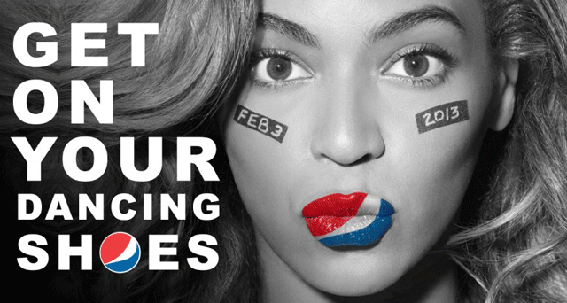

Chai. C (2016) Beyonce, Get on your dancing shoes
The power of celebrity endorsement cannot be underestimated, In 2013 an endorsement by Pepsi used pop star Beyonce as a spokes person for their ad campaign.
Beyonce made 50 million dollars from the Pepsi endorsement, but one has to wonder whether or not the morality of what is being sold is a good thing as lead author A. Miller(2016) of a social health study concludes “The popularity of music celebrities among adolescents makes them uniquely poised to serve as positive role models. Celebrities should be aware that their endorsements could exacerbate society’s struggle with obesity – and they should endorse healthy products instead,”
The statement opens up a lot of debate, on one hand there is huge financial incentive for someone famous or in the public eye and whether or not that is egregious enough and there is also the health debate. Is it a good thing for our society that the public obsession over celebrity culture leads to psychological health concerns but now also an effect on the physical wellbeing?.

Noam Chomsky
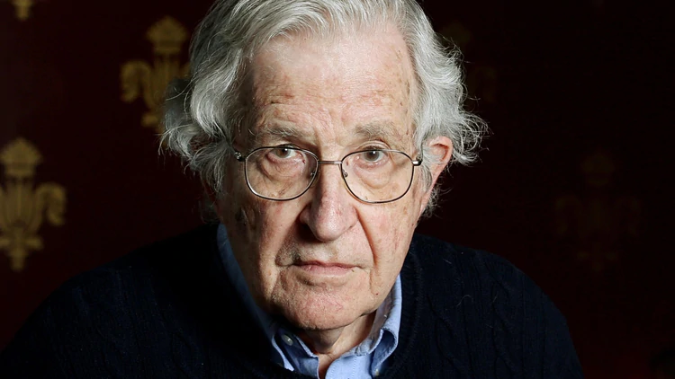
N. Chomsky (2015) A portrait of Noam Chomsky
“Advertising is tax deductible, so we all pay for the privilege of being manipulated and controlled” - Noam Chomsky
Noam Chomsky is a renowned linguist, Philosopher and author who throughout his long career has been an outspoken critic of American Capitalism and government, Social and economical speaker. Chomsky has always spoken out against the mechanics of advertising in his book Manufacturing Consent (N. Chomsky) talks about the propaganda machine and how the elite politicians utilise these methods. Chomsky quotes “the Propagandist cannot reveal the true intentions of the principal of how he acts…That would be to subject projects to public discussion, to the scrutiny of public perception and thus to prevent their success, Propaganda must serve its self as a veil for such projects, Masking their true intentions”
Noam Chomsky’s statement is a polarising proclamation that can easily fall in to the realm of Conspiracy theory due to how manipulating public opinion through consent does clearly not have the public’s best interest at heart.

Conclusion
In conclusion to the essay, the research that I have acquired has led me to believe that there is definitely an opinion of media manipulation. When one looks back of the history of how media was first created, one can see of how the powers that be at the top would use media narratives and advertising to create social and political commentary.
For myself the one thing that becomes apparent is that “What is the truth”?, Living in a time where news itself is being questioned as fake I feel that unless a person does enough to question and do the research themselves, then most will only ever be told what to believe and not question what they read and what they hear.
We live in a time where there are so many news stories, all fleeting in an era of fast clicks and page scroll ups. Once a media news storm breaks its only a matter of time before the story dies. The truth is in a modern era of instant gratification, the news media is slowly fading,
newspapers are not selling ,less people are watching the news due to the rise of streaming services and free tv subscriptions.
In closing I do not know what to believe in the news, even if there is a kernel of truth.

Referencing List
Websites

M.Fleiss. (2012) Reality TV Can Be Unhealthy for Participants as Well as Viewers. Available at: https://www.healthline.com/health-news/reality-tv-unhealthy-for-participants-and-viewers/ Accessed: 14/03/2018
Nikolau. (2016) The Origins of advertising .Available at:
https://tripandtravelblog.com/
Accessed: 02/05/2018
N.Corwin. (1998) On a note of triumph. Available at:
https://www.oldtimeradiodownloads.com/actors/norman-corwin/
Accessed: 03/05/2015
P. Signorielli. (2017) Television violence and behaviour. Available at:
https://www.soundvision.com/article/television-violence-and-behavior/
Accessed: 30/10/2019
Images
Marconi. G., (1901) The Invention Of Radio. Available at:
https://www.timetoast.com/timelines/technology-over-time-82f3f582-2ab9-41f5-ae39-9630e02f66e7/ Accessed: 03/05/2019
Chai.C., (2016) Beyonce, Get on your dancing shoes. Available at:
https://globalnews.ca/news/2743649/here-are-all-the-celebrities-hawking-fast-food-and-soda-according-to-a-new-study/ Accessed: 06/05/2016
Chomsky. N., (2015) A portrait of Noam Chomsky. Available at:
https://creativesystemsthinking.wordpress.com/2015/02/21/noam-chomsky-on-the-dangers-of-standardized-testing/
Accessed: 21/02/2015

Video
K. Jubal (2019) Should You Study with Music? | The Science-Backed Verdict
https://www.youtube.com/watch?v=k2EAdxB8dXw/
Accessed: 26/02/2019

Books
Laswell.H., (1927) Propaganda in the World War, London, Martino Fine Books
Herman. E., (2008) Manufacturing Consent, London, The Bodley Head

Upon thinking about how to address my essay I had written a list of words that felt suitable for the subject matter. When looking at the list the word integrity started to have an appeal, in the modern world of advanced technology, and an immediate consumption of information can have a startling effect on ones wellbeing, according to professor Noam Chomsky in a statement that was made in the documentary ‘Manufacturing Consent’, Chomsky mentions the powerful influence on advertising by saying
“The average person is very unaware of the effect that advertising has on them psychologically, the public is kept in a perpetual state of unconscious salesmanship that very sophistically caters to their every need and want whilst simultaneously does not have their best interest at heart whatso ever due to corporate greed and insidious business practices”. (ref)
Noam Chomsky began his career as a professor of linguistics but received much more notoriety as a political activist, Chomsky would use his linguistic skill to write his own political and social philosophies and would begin to write literature. Academic in concept Chomsky’s book was about Linguistics, however what would set him apart from a lot of academic writings at the time was Chomsky’s disposition to incorporate his beliefs in politics and social awareness into the writing.

