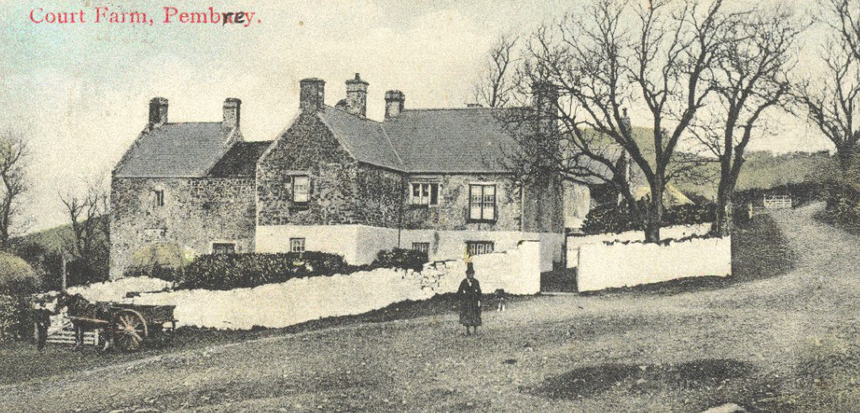

#

(Peter Davis, 1908)

Project Design
  - Court farm, pembrey.
Shauni Waller | May 2020

Contact: Shauni Waller ○ Project Manager ○ 01656 644733 ○ 1904380@student.uwtsd.ac.uk





Table of Contents
Project Name 3
Non Technical Summary 3
Site Location 3
Approximate grid references. 3
Project Context 4
Geographical and Topographical Background 4
Archaeological and Historical Background 5
Reference to Legislation 6
General and Specific Aims of Fieldwork 6
Aim 1 6
Aim 2 6
Aim 3 7
Methodology 7
Phase 1 7
Phase 2 8
Fieldwork Methodology 8
Arrangements for Immediate Conservations of Artefacts 8
Phase 3 8
Collection and Disposal Strategy for Artefacts and Ecofacts 8
Phase 4 9
Post-Fieldwork Methodology and Report Preparation 9
Phase 5 9
Publication and Dissemination Proposals 9
Social Media 9
Copyright 9
Archive Deposition 10
Timetable 11
Staffing 12
Use of Volunteers 13
Stakeholders 13
Health and Safety 13
Monitoring Procedures 14
Costings 14
Staffing Costs 14
15
Bibliography 16

Project Name
Court Farm, Pembrey Community Excavation

Non Technical Summary
To conduct a community based project to investigate the structural framework of any pre-existing buildings or significant constructs at Court Farm, Pembrey, Carmarthenshire. We will be working in support of research already established by the organisation Friends of Court Farm regarding the conservation and preservation of Court Farm and it’s history.
This project represents the first major archaeological investigation into Court Farm since its abandonment in 1962. The results of these works will contribute to the future of its restoration and revival of the site. With the ultimate goal of opening the site as a respected, sympathetic tourist attraction celebrating its unique history in the distinctive town of Pembrey, Burry Port.
This document will outline questions posed for archaeology and history, roles within the project, recommendations for future projects, stages and timescale.
It will also outline the over-arching outreach objective that encourages engagement with the public in fieldwork and post-fieldwork activities to publicise the heritage of the site.
The final purpose of this project will be to assist and advise on further restorations of the highly anticipated garden and provide insight to the prospective older on site mansion of Le Boteler during the 14th and 15th century.

Site Location
Court Farm is situated approximately NW to Burry Port, a small harbour town to the West of Llanelli. Court Farm was regarded during a period as a landmark for incoming ships due to its prominently white-washed stone and it’s height (Cryer)
The site of the building in situated in the village of Pembrey, Carmarthenshire approximately 400m North of the parish church. It is conveniently located next to Mountain Road for access and transportation and is accessed up a short driveway to the left (when north facing).
A Quarry, farmer’s fields and vast woodland surround the property N – NW – W, and a residential area to the East.

Approximate grid references.
Latitude: 51.690964
Longitude: 4.276217

Project Context
There has been a long-standing interest in the conservation and restoration of Court Farm on a local and regional scale. Major contributors include CADW, who have previously offered substantial grant percentage to fund assessments and projects. The current project is an accumulation of years of hard work and perseverance of many individuals to comprehend the nature of the standing building and understand it’s history to a point of a plausible illustration. Results pending, our findings would serve as a catalyst in the prospect for restoration of the manor and befitting it as a heritage site for tourism and local educational investment.

Geological and Topographical Background
A topographical survey of the Court Farm site indicated that the overall level of preservation of the site is significantly poor. The building itself is solid and sound structure of sedimentary. The ground is uneven throughout the site, the house is built into a slope. Lack of regular upkeep has created extra layers of fertile soil that has gathered from leaves from the excessive number of trees that surround the area over softer, sedimentary rock. The terrain is rough with overgrown unkept vegetation disrupting the view of the property and further preventing a clear view of the building and stone features. There is evidence of previous efforts to cut back the greenery, but it has since grown back.
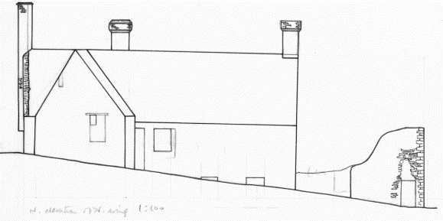
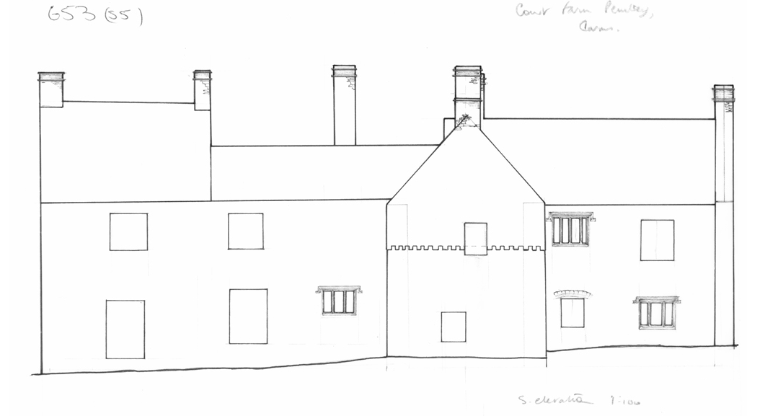
Figure 1. North Facing Slope at Court Farm (RCAHMW) Figure 2. South Facing slope at Court Farm, (RCAHHMW)

Archaeological and Historical Background
Unfortunately, there is very limited archaeological work that has been carried out on the site of Court Farm and involving the existing structure. Knowledge of the history is therefore limited to written sources and speculation, yet the site still holds infallible local interest in its preservation and restoration due to it’s evident grandeur and enigma.
Analysis of the present standing structure has concluded the building is dated 16th century, as evidenced by the ornate fireplaces and the angular, double Elizabethan chimneys; however there are records indicating John le Boteler resided at the residence earlier in the 14th century. The house has since been left vacant since the final resident evacuated the premises in 1962 where the building was left to ruin.
Many attempts over the years to save Court Farm have been made over the years and the property is now owned by CADW.
In 2006, an organization formed called Friends of Court Farm to recruit various individuals with various expertise but unifying passion for Court Farm in a bid to restore the building. There have been ‘energetic’ attempts to unveil a cobbled floor in the courtyard (Friends of Court Farm). It is implied that this dig was not executed by professional archaeologists, but the pictures provide fascinating comparison and insight to the life of Court Farm as a working home. The findings concluded that there was a simple drainage system that could either suggest a brewhouse or a laundry room at the house.
In 2010, Elizabeth Whittle of CADW conducted a topographical survey on the site regarding the garden and concluded that further survey ‘might reveal elements of original layout or built structures that have gone (Friends of Court Farm). It is her survey of the site that has provided the ‘extra push’ for further investigation of the site. Her findings provide useful information and interpretation for focus during the survey and excavation. The Friends of Court Farm website is primitive and does not acknowledge external sources which would be useful for further research.
Identified as one of the only surviving Elizabethan Manor Houses of Carmarthenshire, the building has also evoked interest on a regional level, involving CADW who have in the past offered grant financing on more than one occasion to fund Court Farms restoration (Friends of Court Farm).
Left unhabitable since 1960s
In 2010, the property was visited by Richard Stugget on behalf of the Royal Commission on the Ancient and Historical Monuments of Wales (from here on referred to as RCAHMW). Information recorded online lists the property as a domestic residence, dated 16th and 17th century with a ruined wing. (Stugget, 2010)
Further research into the property includes the 2014 Digital Heritage project by students of University of Leicester. After a short process of working with Friends of Court Farm, the university manufactured a two-minute-long, 3d digital personification of the house in video format. The video provides a fantastic fresh perspective on the house as a reconstruction of it’s former glory prior to neglect. While the project enhances the visuals of the houses heritage, it further instilled confidence into the heritage groups as they felt a ‘sense of pride and being taken seriously’(Vergunst, 2017, p. 93); these emotional investments into a project are vital aspects when striving to promote, preserve and study heritage. The research provided a useful perspective shift of the house, illustrating it with a more refined impression without the excessive vegetation and aged stone.
There are no local museums to the property of note, but major works costing £1.2 million (Carmarthenshire County Council, 2020) are presently being undertaken at Carmarthenshire Museum. Boosting potential for interest in heritage of the area, it is a promising prospective for the dissemination stage.

Reference to Legislation
Working and complying by the legislative framework as specified by Carmarthenshire County Borough Council.
The building is Grade II listed therefore we are working under advice of CADW regarding placemaking and planning (CADW, 2017)

General and Specific Aims of Fieldwork

Aim 1
Define and establish the physical extent and character of the gardens and determine the existence of additional structures through non-intrusive survey.

- We aim to gather quantifiable data and compare to Whittles previous assertions that there is a structured garden within the grounds. This is also a primary aim stipulated by Friends of Court Farm as an area of interest and by establishing a more explicit illustration of the surrounding grounds, we can potentially broaden our understanding of the site and house. What shape do they take? What is a plausible date for their construction? Are they comparable to other gardens in the county?
- Furthermore, does the survey illustrate potential extensions, additional buildings or structures that are not visible above ground? How do the results of the survey compare with ordnance surveys and layouts drawn by RCAHMW in 2010.
- Gather quantifiable data to compare with Whittle’s survey.

Aim 2
Dependent on evidence collated for Aim 1, the aim will be delivered in order to target potential archaeological remains indicated by the previous geophysical survey through test pits.

- What potential do findings in garden have for enlightening our understanding of the chronology of the house and gardens.
- Do the findings also enrich the historical background of the previous occupants of Court Farm?
- Can we make further recommendations for restoration and revival?

Aim 3
Generate learning and engagement opportunities for members of the public and local community through physical and digital mediums.

- Using social media platforms, specifically Instagram, to provide updates and insight into the projects progress and finds.
- Providing basic training and volunteering opportunities for the local community to assist with the excavation, engaging children on school tours and updating our social media platform.
- Project correlates with a wider outreach agenda.
- Increase local awareness of the property and its heritage, then amplify it through social media platforms.
- Promotion

Methodology
The project will be undertaken according to the format and procedures described in Management of Research Projects in the Historic Environment: The MoRPHE Project Managers’ Guide.

Phase 1
Project initiation and formulating a costed Project Design (this document) has been completed.

Phase 2

Fieldwork Methodology
The interpretation of the sites history and development is provided by good form and relative chronology (Bowden, p. 25) which is supplied by a combination of both survey and chronological information, which can be provided by excavation.
Preparation of the site will commence with the clearing of the vegetation covering the prospective site area will begin by hand. This will take place during the months regarded as peak period for archaeological geophysics immediately following harvest when conditions are considerably enhanced (Gaffney and Gater, 2003, p.80).
A magnetometry survey will commence the investigation into structures to be found in key areas specified below to detect any subsurface hard details that coincide with the specific topographic and geophysical anomalies observed above soil that may indicate previous structures such as the garden or buildings. (Aim 1)
The results from the investigation will be used to inform the location of where target test pits will be conducted. Six target test pits will be conducted at 1m² using hand spades to clear top soil and the rest also being dug by hand. Specialist samples will be collected from obviously rich’ deposits and photographic evidence will be made immediately. The area is in a poor state. Despite the poor condition of the ground, any intact top turf will be removed, stored appropriately and reinstated the correct side up; ground surface, top soil and subsoil will also be stored and reinstated. (Aim 2)
The site has public access and is a popular destination for ramblers and dog walking. To avoid site disturbance, we will ensure all tools and equipment are packed away at the end of the working day and test pits covered with appropriate coverings to avoid spoiling of work area.
In order to find balance between public outreach but maintain integrity of excavation site, appropriate signage will be erected to divert the public but allow for viewing and advertise applicable social media platforms. (Aim 3)
Assess artefacts found, update project design and potential to continue analysis.

Arrangements for Immediate Conservations of Artefacts
Immediate conservation will be undertaken following A Guide to the Theory and Practice of Methods, from Sampling and Recovery to Post-excavation (second edition).
Photographic record will be made for each test pit regardless of the number of samples collected for reporting and dissemination purposes.

Phase 3

Collection and Disposal Strategy for Artefacts and Ecofacts
Any materials collected will be handled in line with the Standard and guidance for the collection, documentation, conservation and research of archaeological materials (2011).
Specialist samples will be taken and all recorded before being excavated and kept for analysis.

Phase 4

Post-Fieldwork Methodology and Report Preparation
Reports illustrating findings and artefacts details will be constructed by the Project Manager and submitted to the Project Executive for quality assurance before being made available on different platforms for public and professional viewing. (Aim 3)
Information will be reviewed at each stage in order to update the Project Design by the Project Manager. All information will be recorded for the benefit of future archaeological projects.

Phase 5

Publication and Dissemination Proposals
Final fieldwork findings will be submitted to Archaeology in Wales for public recording.
A small exhibition comprised of photographs, aerial views with marked test pits and posters comprised by the Project Support Officer will be donated to the local library for public viewing. Archaeologists and a volunteer will also host a group talk in the local library describing phases and finds and what the next logical steps will be for the site. (Aim 2 and 3)

Social Media
Findings will further be published to a purpose-built Instagram account throughout project stages to incorporate and engage and satisfy public interest. This will be managed by the Project Support/Admin Assistant who will update ‘Instagram stories’, create blogs from content provided by the archaeologists and publish said blogs on focf.co.uk (Friends of Court Farm) and any other local channels that express interest to maximise exposure of the project.

Copyright
The Copyright on all reports submitted will reside with the local authority – Carmarthen County Borough Council. The original copyright holder will retain copyright in pre-existing data. Any publications resulting from the project will be subject to agreement with the project partners and will bear an acknowledgement of the support of CADW.

Archive Deposition
Results will be secured with Archaeology of Wales, however this may vary dependent on results.
We are waiting affirmation from Carmarthenshire Museum regarding the potential to store a comprehensive detailed listing of findings and archives at the new museum.

Timetable
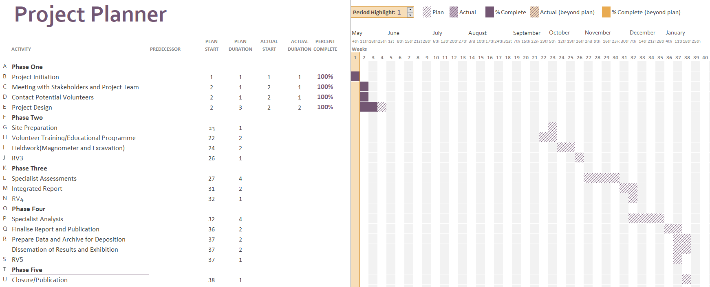

Staffing
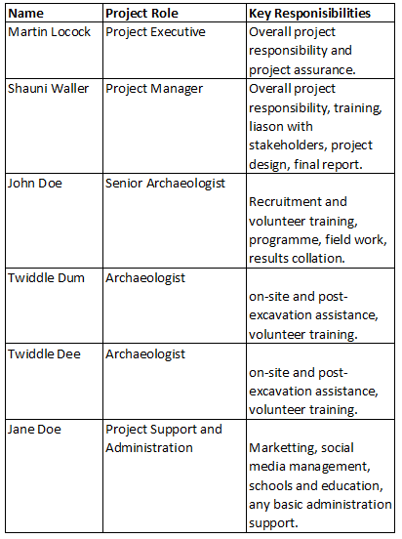

Use of Volunteers
The use of volunteers will be widely used for certain task areas in fieldwork and post reporting. The farm has extensive local interest involving the public will create a more widespread awareness of the project and higher attendance to post excavation exhibitions and maintain interest in the property for potential further projects.
They will be advertised and recruited throughout project stages with an initial five volunteers recruited at the start. The number of volunteers may increase depending on local interest with visits, the scope of fieldwork and the quantity of post-excavation findings.
Volunteers will be trained by both archaeologists available on a rotation basis using a training program created by the senior archaeologist to provide skills and knowledge for basic fieldwork duties and historical knowledge to enable volunteers to assist with school visits and trips. Their progress and results will also be monitored by the project archaeologist before submission of findings.

Stakeholders
CADW are sponsoring the project, Person A and Person B are the primary contacts for enquiries and advice on 01234 567890, projects@cadw.gov.wales.
We are working in close proximity to Friends of Court Farm to provide context, invaluable knowledge and a clear perspective of the project through each stage.
Numerous local archaeological consultants will be approached during the project to provide opinion and further perspective on findings and strategy.

Health and Safety
The County Borough Council will provide information guidance and literature regarding:
• Accidents, emergencies, fire and first aid.
• Action in unbearably hot workplaces.
• Display screen equipment
• General risk assessment.
• How to set up your workstation.
• Lone working.
• Moving and handling of objects.
• No smoking policy.
• Personal protective equipment.
• The handling, storage and use of hazardous substances.
• Violence and personal safety.
• Workplace (health safety and welfare).
Appropriate Risk Assessments will be completed for school group visits to the site.

Monitoring Procedures
Regular reports to project executive
Regular reviews and update of project design at the end of each project phase abiding by MoRPHE guidelines.
The Project Manager is to provide quality assurance of data reports and the Project Executive to provide quality assurance for full document prior to publishing.

Costings


Staffing Costs
Costings have been acquired as a result of previous meetings and agreed with stakeholders.
Further fieldwork costings will be finalised shortly.

OS Map as depicted on RCAHMW site
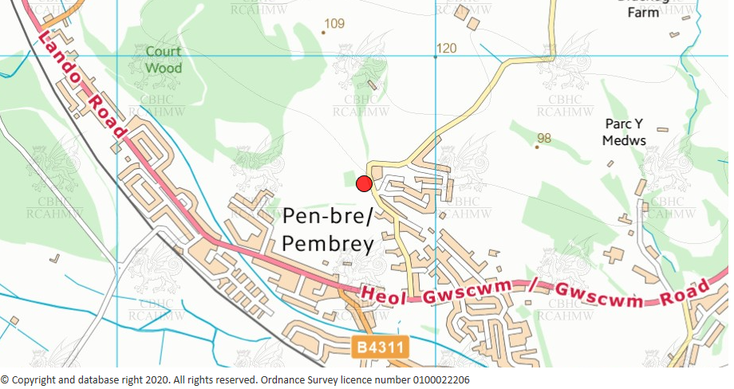

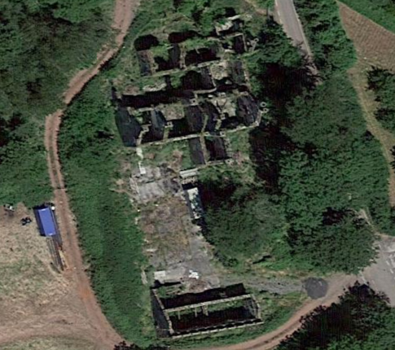
Aerial View of Court Farm
Bibliography

Bowden, M (1999), Unravelling The Landscape: An Inquisitive Approach to Archaeology, Gloucestershire: Tempus Publishing Ltsd
CADW, (2017) Planning Policy Wales – Technical Planning Advice Note 24: The Historic Environment, https://cadw.gov.wales/advice-support/placemaking/cadws-role-planning/planning-applications, (Accessed: May 2020)
Cryer, A.B, (no date), Pembrey Explained, https://everything.explained.today/Court_Farm%2c_Pembrey/, (Accessed: May 2020)
Davis, P. (1908) Court_Farm_Pembrey, [digitized photo], Coflein Archives, https://coflein.gov.uk/en/archive/6222113/details/504, (Accessed: May 2020)
English Heritage (2011), Environmental Archaeology: A Guide to the Theory and Practice of Methods, from Sampling and Recovery to Post-excavation (second edition)
English Heritage, (2006) Management of Research Projects in the Historic Environment: The MoRPHE Project Managers’ Guide
Friends of Court Farm (no date), Friends of Court Farm, http://focf.info/court-farm-garden.html (Accessed: May 2020)
Gaffney, C and Gater, J. (2003) Revealing the Buried Past: Geophysics for Archaeologists, Gloucestershire: Tempus Publishing Ltd.
RCAHMW(no date), RCAHWM drawing showing North elevation of Court Farm, Pembrey. https://coflein.gov.uk/en/archive/6004249/details/504, (Accessed: May 2020)
RCAHMW(no date), RCAHWM drawing showing South Facing slope at Court Farm, Pembrey. https://coflein.gov.uk/en/archive/6004249/details/504, (Accessed: May 2020)
Vergunst, Jo, Graham, Helen, (2019) Heritage as Communities Research: Legacies of Co-production, Bristol: Policy Press.

Word Count: 2725

