Reflective journal 4000 words

This reflective journal will be looking at key issues within the education system, and placement experience. Firstly, the journal will look at what happened in placement and what activities were carried out during the experience. The setting is not a school but a charitable setting that supports children with Additional learning needs (ALN) within the community. In placement it was clear to see that some key issues stood out more than others and the main key issues that were more obvious that others were funding/budget and also mental health and wellbeing. The reflective journal does include some information on other issues within the education system.

Day 1: 11/12/2019

On this day we were doing crafts, we were designing our own tea light snowman candles for the children to take home. The children were able to use different resources such as glitter snow, glue, glitter, paper, googley eyes and many other accessories they wanted to add to their tea light candle. The activity was a very good idea, on the other hand some of the children struggled to use some of the resources such as scissors due to their developmental needs. Some of the children do not have the same opportunity as every other child therefore it is important when planning this activity that all children are able to access the resources. Whilst doing this activity it was clear to see that the children enjoyed and that they were very pleased with the outcome of their own tea light candle. This provided the children with the experience to design their own candle and for their learning to be enhanced. Whilst some of the children were not able to use the scissors we had a adult guidance scissors which allow the child to use the scissors with your assistance, this supported many of the children an will enhance their skills. Whilst doing this activity the children used their fine motor skills, picking up the resources and sticking them on, using the glitter to sprinkle onto the heir jar. The children used a range of skills doing this activity and were able to take it home to show their family, it is important to encourage children to use their imagination whilst being creative to see what they think a tea light candle should look like.

Whilst preparing this activity it was clear to see budget was an issue, due to the setting being a charitable organisations, the funding is very limited. Therefore we had to use alternative resources so the children were able to do the activity. We were still able to complete the activity and the children enjoyed.

The group was split so that there was enough focus on the children who were doing the activity as having a smaller group will work better for children with Additional learning needs (ALN) it is clear to see that they need the attention to be able to complete the task. Within this setting the group sizes are around five to seven children maximum to ensure that they provide the right care for the children and also to ensure that they have the care they need.
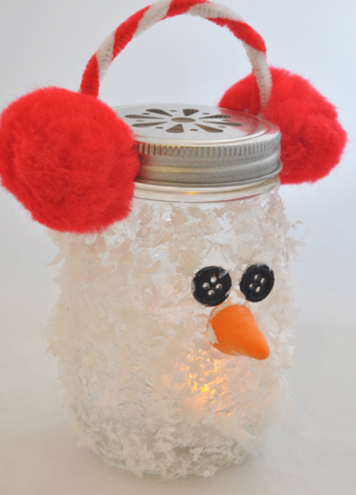

Day 2: 12/12/2019

On this day we went to Winter Wonderland as it was a outing for the children. The children enjoyed going on rides with the workers, this group is smaller than the rest due to the needs of the children. Whilst looking at this activity it was beneficial for the children as they went on the train, the snow slide and other rides, and this is important for the children as they are engaging with each other and building friendships. The children enjoy going out and doing different activities as it requires the children to socialise with others, and this benefits the children as it will enhance their confidence skills. Budget can be an issue whilst going out as the children pay £6 to attend but their money each week adds up for the children to go out, as there is only 2 children in this group there is very limited money for the children to go out to do activities.

After going to Winter Wonderland, we went for food, going for food is very challenging for this group due to their needs, and requires a lot of assistance. It is important for this group to go to outings so that the children overcome their barriers such as socialising or anxiety with support from the workers they are able to support the children whilst on outings.

Whilst attending Winter Wonderland, there were barriers that some children were facing such as the music was loud for the children and some rides were more extreme. Children with ALN can be sensitive to noise, and this become and issue due to the children being frustrated to the noise. It would be beneficial for Winter Wonderland to have days where the music may be quieter on occasional days, this would include all children’s needs.

Within the education system many settings face funding issues due to not having enough money for resources, and within this group the children pay to come and the money goes towards their outings, this can be an issue for this group as there is only two children, and therefore this group may not be able to go to outings that other groups are able to go to. This can be seen as a negative point for these children due to them not being able to do different activities as there is only two of them, on the other hand it can be seen as a positive point for these children as they do not do well with big groups and prefer to be alone, therefore their needs are met within the group but funding can be an issue.

Day 3: 13/12/2019

On this day, it is my 1-1 child and we went to the arcades, the child suffers from ADHD, with support and constant reassurance from myself the child felt comfortable going to the arcades and playing the machines. This was allowing the child to use different skills such as concentration, fine motor skills, listening skills whilst playing different games it was clear to see the child was enjoying playing different games. After the arcades we went for food to McDonalds, the child was able to choose what they wanted for food and therefore allowing the child choice. Due to the child’s circumstances providing choice was an important part, due to no choice given at home. By providing choice the child felt as if they were able to choose what they wanted and not what they had to have. Funding can become an issue due to not much money for the child to do activities, as there is only £6 a day that’s how much the child is able to spend on that day. With the funding it is important to ensure there is a activity the child is able to do, after going to McDonald’s we went to pets at home and the child was able to hold the animals and feed them, therefore the child learnt about the care and feeding requirements of the different animals.

Whilst taking the child out I was able to plan activities for the upcoming days, to provide the child with a consistent approach so the child knew what they were doing each day. It is important to have structure so that the children are not overwhelmed with different activities or changes.

Whilst going to the arcades it was clear to see the engagement with the activities, and that the child enjoyed, due to funding the child was not able to do everything, on the positive side the child understood that there was not enough money to go on everything.

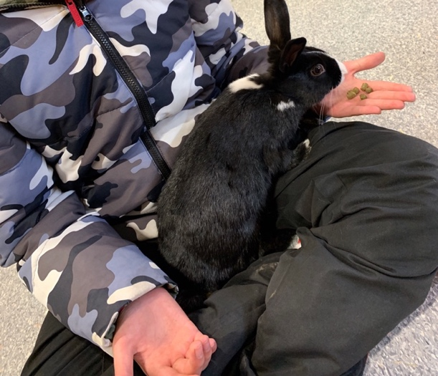
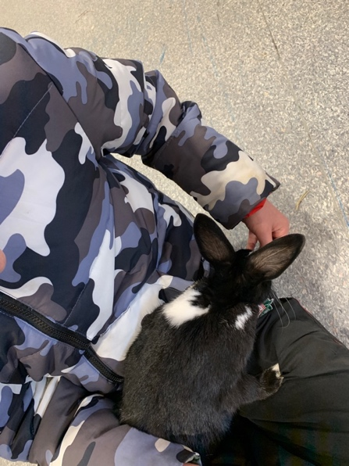
Day 4: 14/12/2019


On this day, we done Christmas cooking the children were able to decide what they wanted to cook, the choice was reindeers or the grinch made out of different fruit. This provided the children with the healthy eating option and they were able to design their own. Using their imagination the children done some amazing ideas, and it allowed the children to express their ideas of using different fruit for different parts. This was a non structured activity and allowed the children to use their imagination. Whilst doing this activity it was important to understand the needs of the children, if they were able to do the activity, and whilst carefully planning this activity all children were able to design their own using their imagination.



Day 5: 16/12/2019

On this day, it is my 1-1 child and we went bowling, the child was able to communicate with me and the child was able to have fun. The child was nervous at the start but the child did come round when we started to play. With this child being in busy environments can be challenging but the child managed it well, and when asked after the activity would they like to go back again the child replied yes as they really enjoyed. This was allowing the child to overcome their barriers of being anxious in busy environment whilst having fun with the support off myself. Providing the child with the support was improving the child’s mental health and wellbeing, as the child does not get this support at home, and therefore the child was able to overcome the barrier of being in a busy environment where there are a lot of children and people around.

Day 6: 17/12/2019

On this day, it is my 1-1 child and we went to limitless, this was a fun activity for the child to burn some energy. The child enjoyed jumping around on inflatables and trampolines, and got the chance to meet other children of their age. This is good for this child as it helps the child overcome their anxiety, and therefore they felt comfortable playing with others in limitless. With doing activities in the community it can be difficult to judge wether the activity is suitable for the child, and wether or not there will be children there who may impact on their development, whilst trampolining the child felt uncomfortable as there was children staring at them, and this may have had an impact on their mental health, and also the child felt a little anxious. Another issue whilst doing activities in the community can be budget, as said in the previous days, some activities can be expensive and can go over the budget the company may want to spend on the child. It is important whilst doing activities that there is careful preparation for the activities to ensure that the activities will fit into the budget set.

Day 7: 18/12/2019

On this day, we went to Winter Wonderland with another group this group has different. Needs therefore it can be difficult when some children want to go on the rides and others do not. Whilst doing this activity it can be expensive as the rides do cost and when there is a few children going on it adds up. Within the company there is a set budget for the children to use, on the other hand when doing activities that are expensive than others it can become an issue and may go over the budget. Whilst doing this activity there was an activity where wheelchair users were not able to access the ride, this can be very challenging for children to process due to the other children being able to go on and not the child in the wheelchair. There is only 2 ride in Winter Wonderland that is appropriate for wheelchair users. This may have an impact on the child’s mental health as they may feel excluded from activities.

Whilst attending Winter Wonderland, there were barriers that some children were facing such as there was not many rides that were wheelchair accessible, this could have impacted on the children’s mental health and wellbeing due to the children not feeling included within their society. To improve visits for children with ALN or in a wheelchair, having rides that children are able to access regarding their disability would encourage children with ALN to feel included.

Day 8: 19/12/2019

On this day, we done Christmas crafts, and we painted reindeer hands and made Christmas cards. This group is the smallest group therefore a lot of attention is required for the children. The children enjoyed making their own Christmas cards and using paint on their hands. On the other hand, some of the children did not like putting the paint on their hands as it was very sensory for them. It can be difficult for children to process having paint on their hands as some children do not like having things on their hands or the sense of being dirty. With this activity to meet the needs of the children it was important to look at what was beneficial for them, allowing the child to explore paint in a tough tray so that they had the opportunity to use their senses and to discover the paint. This was the most beneficial way for the children to use paint as they had the experience to use the paint to do Christmas reindeers and Christmas cards.

Day 9: 20/12/2019

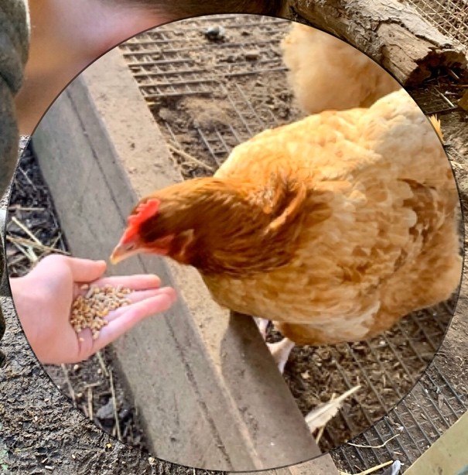
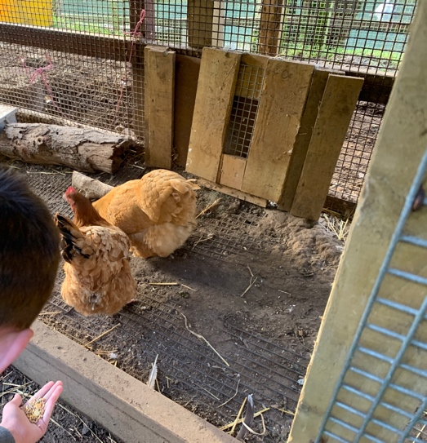
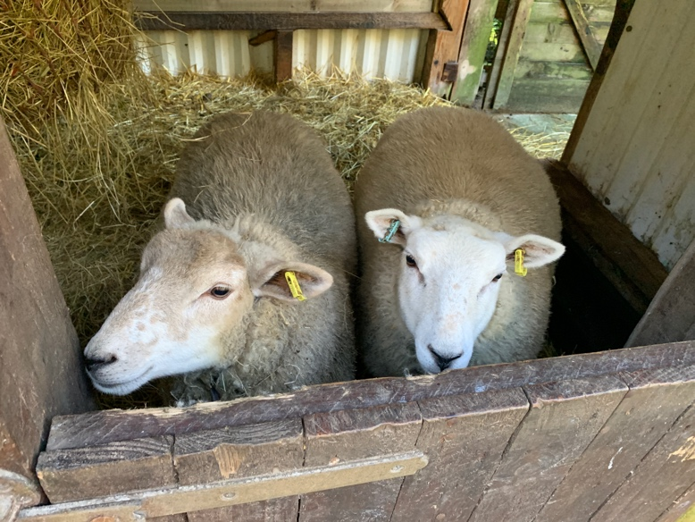
On this day, this child is my 1-1 and we went to see Santa in the Gower heritage Centre, the child really enjoyed seeing Santa followed by seeing the animals. This was one of my favourite experiences with this child, as it was nice to see how caring and gentle the child was with the animals. The child enjoyed stroking the animals and feeding the chickens and ducks. This prided the child with a unique experience nice that does not happen very often. This activity was not expensive and therefore the budget was not an issue for this day. After seeing Santa and feeding the animals we went for food, the child enjoys going for food where they want to go as this provides the child with an option of choice.
Day 10: 21/12/2019

On this day, we went to the cinema and we watched Frozen 2, the children sat quietly in the cinema with pop corn and sweets. It was a nice trip for the children just before Christmas as they were exited, it was nice for them to go somewhere of their choice and watch the film of their choice. The children are involved with the planning and choice fo activities to ensure that we do activities that the children want to do. We focus on the children’s needs when planning activities, some children are only able to access the disabled toilet so it is important when planning that there is a disabled toilet near so that the children are able to access. Funding can become an issue due to tickets being expensive, but as there is enough children in the group there is enough funding so that the children are able to go to the cinema. Whilst choosing the appropriate film for the children it is important to take into consideration the children’s circumstances at home, as there may be a film where it may trigger an emotional part in the children therefore can cause upset ness or for the child to feel frustrated. It is important when we gave the children sweets and pop corn that they did not have any allergies or any additives that may trigger them.

Overall, whilst having the opportunity to attend this setting it was clear to see there were issues relating to the mental health and wellbeing of the children and the budget that the company has to stick to. Budget can become an issue in schools and other settings and whilst in placement there were issues regarding how much money they were able to spend on art supplies, and Sellgren (2019) noted that there was a survey done to see how many teachers were paying for classroom supplies as there was not enough funding in the school to buy anything. They surveyed around four thousand teachers and around forty five percent of those stated that they had bought some food or clothing or supplies for the children or classroom. Whilst looking at this it is clear to see that many schools have a budget that is not realistic to stick to, and many teachers have stated that they have bought resources for their classroom, and whilst in placement there was a certain amount of budget that they had to stick to. This can be challenging whilst working with children due to needing the resources to support their learning, and getting supplies for the children to complete the task. Jeffreys (2018) noted that schools were cutting back on creative subjects to save funding, this can become an issue to children’s mental health and well being as some children with ALN learn through sensory which may relate to arts and crafts. Davis and Florian (2004) noted that children with ALN learn best through sensory based activities such as arts or light, with out the creativity children with ALN may not be included in activities in schools.

Another issue that could have an impact on children’s mental health and well being was that there is not enough funding for resources for the children to have sensory toys, this could effect their mental health due to not having the opportunity to learn through their senses. Pearsons (2020) noted that schools and education settings need to be supporting children with mental health issues to ensure that their needs are being met, and they also noted that the NHS released figures about mental health and that the increased pressure in schools due to exams and high expectations needs to be addressed, to ensure that children are not suffering. It also stated that within schools around fifty seven percent of teachers were said to be leaving the teaching industry due to the stress on them and children, this clearly shows that there is a lot of pressure on staff to achieve the highest grades out of the children and the teachers are putting the stress on the children. Within the setting it is clear to see there is opportunities for children to learn and discover, but on the other hand there is room for improvements to ensure that children are fully engaged and also their needs are met within the setting. Whilst looking at the setting the walls were not decorated to provide the children with stimulation and for the children to gain knowledge from it.

Moving on to another issue within the setting it is clear to see that it is not structured and that there is room for the children to do what they would like to do. This can be beneficial and not beneficial as some children require structure and therefore would meet their needs, on the other hand children who do not like structure may find this setting frustrating due to set activities on each day, and may cause conflict due to not being interested. Some days there is activities such as art that the group do not want to do as they are not interested therefore the setting will put the activity out and encourage the children but if not interested they will not be forced, this allows the other children who are interested to have access to the activity and children who are not interested to have access. This can cause conflict as some children would get distracted with other children doing other activities while they are doing another, therefore having consistency within the setting would support the children’s mental health and wellbeing due to having that structure.

There are many issues within the education system such as increasing the classroom size, this would not be beneficial for children with ALN due to not having the support that they need and may get overwhelmed with the amount of people that they are in a classroom with. Schleicher (2019) noted that the smaller the classroom sizes the more teachers, and this then means that the more funding they will have to spend on employing and paying the teachers. In many ALN schools the class sizes are far smaller that mainstream schools and whilst looking at ALN school websites it was clear to see that the class sizes were smaller with a higher staffing ratio. Heronsbridge school (2018) noted that their pupils are taught within a small year group with a higher ratio of staff to support and provide the children with the care they need. This is seen to be a more effective way of teaching children in smaller classroom sizes, therefore children’s needs are met and are having the care that they need.

In settings it is clear to see that technology has taken over, and whilst looking in schools it is clear to see that there is some form of technology within the classroom. In the placement they had a tv so that children could watch tv or play games and also a multi sensory room, in this setting technology was not the main focus and interacting with one another was seen to be more important to the children. Not only is it more important to the children but to the setting it would cost to have more technology such as iPads and this is the funding that the setting does not have and teachthought (2019) noted that the problems with technology is the cost and the distraction it causes for children. On the other hand, Cox (2019) noted that the benefits of having technology in the classroom can be a fun learning environment for the children and also it can prepare children for the future. Whilst looking at technology it can support children with ALN as it can support children to learn at their own pace, also it is seen that technology helps the students retain information better and that it can improve their skills for the twenty first century.

Overall to improve the setting it would be ideal for the setting to introduce technology to allow children with ALN to engage with the technology that the twenty first century use. It will also be beneficial for children who are non verbal and are able to use a digital PECS book. The setting would benefit from more funding, being on the realistic side it may be difficult to get extra funding and this then would allow the children to explore different activities in the community to allow them to engage. To support the children’s itch their mental health and well being it would be beneficial for the setting to have people in to do activities with the children relating to their mental health and well being and getting the children to understand that it is important to speak to people when there is an issue. The small improvements would engage the children better within the setting and would further benefit their skills. Whilst looking at different activities within the setting arts and crafts is seen to have been the most beneficial for the children as it engages the children in using their imagination and the Government (2015) noted that children must engage within art and crafts as it allow the children to express their feelings and thought in a different way, and to explore a wide range of stimuli to develop their creative ideas. Rtor (2018) noted that art therapy can support students to build their self esteem, and will support them in emotional release and allow them to express their feeling and fears.

To conclude, it is evident that the setting supports children well, and focuses on their development. Whilst looking at the key issues within education it is clear to see that the setting is effected most by budget and funding, this causes problems for schools and other organisations within the education system. Whilst attending placement it was clear to see that the setting get effected with many key issues and try to support the children without those barriers effecting the children. The setting offers a variety of activities that support children with their sensory needs, and therefore the setting try to ensure the children have their needs met whilst attending their setting.

Reference list

Cox, J. (2019) ‘Benefits of technology in the classroom’. Available at: https://www.teachhub.com/benefits-technology-classroom. (Accessed: 14th January 2020).

Florian, L. and Davis, P. (2004) ‘Teaching Strategies and Approaches for Pupils with Special Educational Needs: A Scoping Study’. Available at: https://dera.ioe.ac.uk/6059/1/RR516.pdf. (Accessed: 14th January 2020).

Government (2015) ‘Foundation Phase’. Available at: https://hwb.gov.wales/storage/d5d8e39c-b534-40cb-a3f5-7e2e126d8077/foundation-phase-framework.pdf. (Accessed: 14th January 2020).

Heronsbridge school (2018) ‘School information’. Available at: http://moodle.bridgend.gov.uk/heronsbridge/mod/resource/view.php?id=270. (Accessed: 14th January 2020).

Jeffreys, B. (2018) ‘Creative subjects being squeezed, schools tell BBC’. Available at: https://www.bbc.co.uk/news/education-42862996. (Accessed: 14th January 2020).

Pearsons (2020) ‘ We need to tak about mental health and wellbeing in schools’. Available at: https://www.pearson.com/uk/educators/schools/issues/working-together-to-build-healthy-and-happy-schools/we-need-to-talk-about-mental-health-and-wellbeing-in-schools.html. (Accessed: 14th January 2020).

Rtor (2018) ‘Creativity and Recovery: The Mental Health Benefits of Art Therapy’. Available at: https://www.rtor.org/2018/07/10/benefits-of-art-therapy/. (Accessed: 14th January 2020).

Sellgren, K. (2019) ‘Teachers paying for resources out of own money’. Available at: https://www.bbc.co.uk/news/education-47964154. (Accessed: 14th January 2020).

Schleicher, A. (2019) ‘When class sizes fall so does teachers pay’. Available at: https://www.bbc.co.uk/news/business-47281532. (Accessed: 14th January 2020).

Teachthought (2019) ‘5 problems with technology in classrooms’. Available at: https://www.teachthought.com/technology/5-problems-with-technology-in-classrooms/. (Accessed: 14th January 2020).

