Skills for The Workplace

Student Name: | Ivanovitch Girao paiva
Student Number: | 1916038
Module No: | BMSW4002 LON
Module Title: | Effective Team Working and Communication
Module Lecture Name: | Afzal Munna

Table of Content

1 – Introduction …………………………………………………………………………….2
2- Communication………………………………………………………………………….3
2.1 – Importance of Communication………………………………………….4
2.2 – Importance of Effective communication at workplace……….5
3 – Theories Of Communication……………………………………………………..6
3.1 – Shannon and Weaver Model of communication…………………7
3.2 – Berlo´s Model of Communication……………………………………….9
3.3- Schramm´s Model of Communication………………………………….12
3.4- My Opinion and Justification……………………………………………….14
4 – Effective Communication at My Workplace………………………………15
5 – Conclusion………………………………………………………………………………..16
6 – References……………………………………………………………………………….17

Introduction

Once open a time human being found the necessity to communicate with each other, to share information and express they needs so with that they saw the reason to create ways of communication, but before we starting talking about we need to understand what is communication, and in this work we will define, we will talk about the importance, theories and types of communication.

- Communication

Communication is a process that include transmission and reception of a massage, exchange of ideas and information. (KAUL, 2009)
Communication is when someone transfers information from one person to another. (skillsyouneed.com, 2018)
We can have so many ways to define communication but essential is not to forget the process, that is, sender message and recipient.
Communication is the act of understand and reply the information in the way that is requiring.
Communication in the simple words is the exchange of ideas.
2.1- Importance of Communication

Communication is very important is a necessity that we must have to keep running this world.
In this world we sort everything with communication, that’s why we always try to find more ways to get in touch with each other.
Make everyone be capable to communicate is very important, that’s why in communication we have types of communication:
- Verbal Communication: is all the information that we pass by speaking, that include voices.
EX: Conversation face-to-face, Tv, Radio
- Non-Verbal Communication: is when we pass information by gesture, body language or figures.

- Written Communication: is when we provide a written information. (skillsyouneed.com, 2018)
EX: magazine, journal, articles
Communication is a constant development because of that we will have more types more theories and ways to communicate.

2.2- Importance of Effective communication at Workplace
Communication at workplace is very important and must to be effective, so like that they will avoid a lot of mistakes in the basic tasks.
With a good effective communication at workplace you will have a good and happy team, and everything is going to look easier. But only a good communication its not enough, you need to know how to communicate, how to explain, witch word you are going to use, witch gesture you are going to do, you need to have a good knowledge about communication.
Managers are helped by communication to have their jobs and duty done. Rules and duty’s must be communicated to the workers who will implement the information to change the behaviour and know how the work must be done.
To have a good and organized workplace we need to be effective in communication that will help with job task. Managers must have the skill to communicate effectively with the workers like that they will achieve the goals They can implement a lot of types of communication to understand effectively written and non-verbal communication could help a lot. (Juneja, 2015)
We can say that effective Communication is the key to run a good business, resuming effective communication in workplace can bring
- Motivation;
- Make the right decisions and take the best action;
- Change individual’s attitudes and behaviour;
- Improves a lot in socialisation and the atmosphere;
- Have the management in control. (Juneja, 2015)
Efficient communication system helps the manager have everything under control it makes easy to solve all the problems and barriers, analyse all the threats for the business. (Juneja, 2015)
3-Theories of Communication
The reason of those theories of communication is for help us understand the development of the communication representing by models. That will offer a visual representation with definition, explaining all the process and the purposes that the owners presented to reach a good result that how communication works. (Z, 2013)
With communication technology it starts to appear new theories and models of communication, to help and simplify and to better understand how it works, we will talk about the most relevant model.

3.1- Shannon and Weaver Model
Shannon Weaver was a scientist that presented his model in 1948. Weaver The Mathematical theory that now we call Shannon Weaver model of communication or “mother of all models.” This model is more technological than other linear models. (Communication, 2018)
Concepts in Shannon Weaver Model

- Sender: is person that writes the message that choose how it is going to be the communication and send the message.
- Encoder: is the person that sends the message via machine that convert in to signs.
- Channel: is the way that they send the massage
- Decoder (Receiver): is where the massage will arrive to be converted
- Receiver (Destination): the person who gets the message
- Noise: loud sons made people or objects that will not allow the receiver to understand the massage.


(Communication, 2018)

Advantages of Shannon Weaver Model
- Let us know that removing noises we can understand the message the way it is.
- Gives to us two different ways how is the communication process, that is valid to understand all the communication process.
- It shows us how the binary signs are converted by message. (Communication, 2018)

Criticisms of Shannon Weaver Model
- Is valid for two persons only is not applicable into a mass of group.
- He gave less importance to the receiver (Destination) feedback.
- The representation of this model had a lot of critics because is mathematical, not everyone would understand. (Communication, 2018)

3.2- Berlo’s Model
Berol’s in 1960 had ideas to make Shannon weaver´s model of communication created in 1949 better, he created Berol’s (SMCR) Sender-Message-Chanel-Receiver model of communication, he wanted to make the communication more efficient. (Ben, 2018)
The focus was to change the way that the machine convert signs to a massage before gets to the receiver (Destination). The best way to understand this model is by representation so he tried to put every component that is affected by many factors. (Ben, 2018)

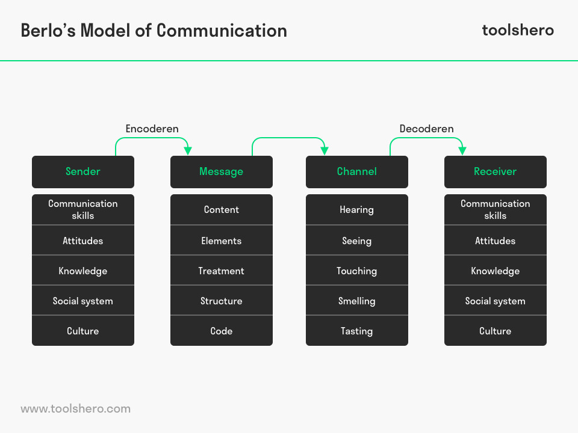

Components of Berlo’s SMCR Model of Communication

SMCR Model includes four components of communication process:
- Sender: The person who create the message and sends the message.
- Message: is all the information that sender will send to the receiver, and that can be in various form, audio, text, video.
- Channel: Is the way that the sender will send the message, and the way that the receiver will get the message, that can involve the human sensors, vision, sound, smell, taste or touch.
- Receiver: Is the person that will get and interpret the message. (Ben, 2018)

Factors that influenced the components of the model:

- Communication skills
reading, listening, speaking etc.
- Attitude
That can be the way that they will speak.
- Knowledge
Know how to have a effective communication
- Social systems
Circumstance, religion, location that will influence the way that the sender will communicate.
- Culture
Different belief or other cultures can be a influence to understand the message.

- Content
Subject of the message.
- Elements
Signs and gestures, that can change the interpretation of message.
- Treatment
Its how the relationship is so the treatment will be different.
- Structure
Organization of the message.
- Code
Method that the sender will send the message, text, video, gestures, music, etc.
.
- Noise
Misunderstand caused by loud sound during the communication (Ben, 2018)

Berol’s SMCR Model was a representation with a lot of details a simple way to better understand the factors and the components of the communication.
Made understand that communication skills is very important and crucial, also the other factors are vital to know how to send the message and understand as well. (Ben, 2018)

3.3 – Schramm´s Model of Communication

Schramm´s model of communication was created in 1954, for him communication was a reciprocal system, he mentions about incomplete communication when the sender doesn’t receive the feedback from the recipient. He believed that communication is a process of receive and give the feedback a two-way process between the sender and recipient. (Drew, 2020)

His representation is based in Shannon weaver model of communication, but he creates a rotative system, for him communication was a circular not linear process. (Drew, 2020)

EX:1
EX:2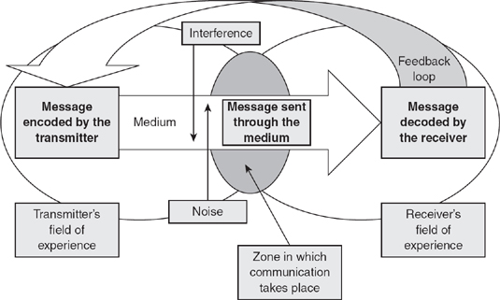
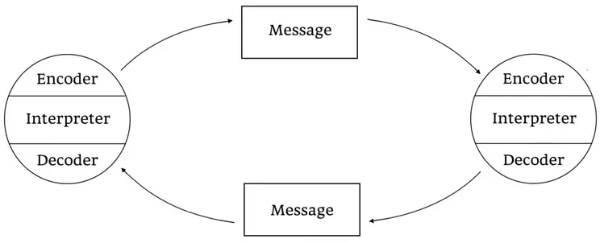

Components of Schramm´s Model of Communication

Encoder: Person that sends the message but, in this model, needed to be a clearly message, with the intentions to make the receiver understand.
Decoder: person that receives the message.
Interpreter – Person that analyse and understand the message. (Drew, 2020)

Advantage of Osgood- Schramm model of communication
- Proved that feedback can work
- Proved that communication is complex, and we can misunderstand by not hear properly.
- Shows that the sender and the receiver are actives communicators
- Proved that communication can be circular and not linear. (Drew, 2020)

Disadvantage of Osgood- Schramm model of communication

- Doesn’t talks about the noise.
- Doesn’t work for group of communicators. (Drew, 2020)

3.4- My opinion and Justification About the models

We can easily understand their thoughts about communication, all of them are good represented, but one completes other.
Berlo´s theories of communication touched every aspect it might be the best one to make you understand what can happen in a communication process, all the explanation about the factors that influenced the components of communication.
All of them came with new ideas and new way to see In different perspective, the model that we use in those days belongs to Berlo´s theories and Schramm´s because communication is a circular process to communication be effective we need feedback, to know if the receiver really understood the message.

4 – Effective Communication at My Workplace

Effective communication is a crucial tool at my workplace, I work at Pret A Manger as a supervisor so we use a lot of communication with the employees and customer.
It is a circular system witch we listen and after that we give the feedback, we use many types verbal non-verbal and written communication to pass the important information.
We need to use the effective communication for give a instruction for pass some rules, and training.
For the training the most of the times we use written communication and verbal communication, and we always wait for the feedback to make shore that they understood the message, written communication is very important because like that we are always remember the employees what should be done.
For the instruction we use most of the times verbal and non-verbal communication, we use a lot of gesture to show how the tasks should be done the right way, we lead always by the example.
For socializing we use voice and a lot of gesture because is a place with a lot of nationalities not everyone understands the current language.
We know that the communication was effective by the results after passing the information, instruction etc.
We avoid using technical communication because of the dominance of the language, so we try always use verbal and non-verbal at the same time, so like that is more effective.

5- Conclusion

In this work I passed my perception of communication and my opinion about the theories of communication, and I learned more is very important to have skill of communication, understand all the process the factors that influenced you can avoid a lot of miscommunication.
I changed my way to communicate a lot know I make shore that when the information reaches me was not affected by any factor that could change the information and lead to a misunderstand.
We use communication for almost everything and everywhere even in the simple gesture that you do you must be careful because gesture can be interpreted in many ways depending where you are and where you come from.
For a better understand and perception you need see careful the representation of each theories, so like that you will understand the difference, and will help you improving your communication a lot.

6 – References

Ben, J., 2018. toolshero. [Online]
Available at: https://www.toolshero.com/communication-skills/berlos-smcr-model-of-communication/
[Acedido em 28 April 2020].
Communication, B. i., 2018. Businesstopia. [Online]
Available at: https://www.businesstopia.net/communication/shannon-and-weaver-model-communication
[Acedido em 27 APRIL 2020].
Drew, C., 2020. HelpfulProfessor.com. [Online]
Available at: https://helpfulprofessor.com/osgood-schramm/
[Acedido em 29 April 2020].
Juneja, P., 2015. Management Study Guide. [Online]
Available at: https://managementstudyguide.com/importance-of-communication.htm
[Acedido em 26 April 2020].
KAUL, A., 2009. BUSSINES COMMUNICATION. 2 ed. NEW DELHI: PHI LEARNING.
skillsyouneed.com, 2018. What is communication. [Online]
Available at: https://www.skillsyouneed.com/ips/what-is-communication.html
[Acedido em 23 April 2010].
Z, G., 2013. The Communication Process. [Online]
Available at: http://thecommunicationprocess.com/models-of-communication/
[Acedido em 27 April 2020].

